Supplementary information
Soil suppressiveness against Pythium ultimum and Rhizoctonia solani in two land management systems and eleven soil health treatments
Viola Kurm^{1*}, Johnny Visser², Mirjam Schilder¹, Els Nijhuis¹, Joeke Postma¹ & Gerard Korthals¹
¹Wageningen University and Research, Biointeractions and Plant Health, P.O. Box 16, 6700 AA Wageningen, The Netherlands
²Wageningen University and Research, Field Crops, Edelhertweg 1, 8219 PH Lelystad, The Netherlands
*e-mail: viola.kurm@wur.nl
Table S1 Mean annual climate data in the years 2018 and 2019 at the site of the “Soil Health Experiment” in Vredepeel, The Netherlands.
Year | Annual precipitation (mm) | Average annual temperature (°C) | Average minimum temperature (°C) | Average maximum temperature (°C)
2018 | 541 | 12.5 | 7.4 | 17.7
2019 | 663 | 12.3 | 7.3 | 17.2

Table S2 Average of chemical soil properties for the two landmanagement systems and the different treatments measured in 2019.
System | Treatments | Total N (mg N/kg) | pH | Organic matter (%) | CEC (mmol+/kg) | C/N | Sand (%) | Silt (%) | Anorganic C (%) | Organic C (%)
Organic | AHC | 1687.50 | 5.53 | 4.20 | 65.50 | 14.25 | 88.25 | 7.50 | 0.03 | 2.43
Organic | ASD | 1110.00 | 5.40 | 3.75 | 55.25 | 19.50 | 89.00 | 7.50 | 0.03 | 2.20
Organic | CHI | 1080.00 | 5.50 | 3.70 | 63.50 | 19.00 | 88.75 | 7.50 | 0.03 | 2.05
Organic | CMP | 1170.00 | 5.45 | 3.98 | 65.75 | 19.25 | 87.00 | 8.75 | 0.03 | 2.25
Organic | CTR | 1112.50 | 5.45 | 3.53 | 56.50 | 17.75 | 87.50 | 9.25 | 0.03 | 2.00
Organic | GCC | 1055.00 | 5.45 | 3.48 | 55.00 | 19.00 | 87.75 | 8.75 | 0.03 | 2.03
Organic | HRM | 1230.00 | 4.98 | 3.85 | 47.25 | 17.50 | 89.00 | 6.75 | 0.04 | 2.18
Organic | MIX | 1172.50 | 5.40 | 3.85 | 57.00 | 18.25 | 88.50 | 7.75 | 0.03 | 2.20
Organic | OSD | 1175.00 | 5.33 | 4.05 | 62.50 | 19.25 | 88.25 | 7.25 | 0.03 | 2.30
Organic | TAG | 1157.50 | 5.48 | 3.78 | 59.00 | 18.50 | 88.75 | 7.25 | 0.03 | 2.18
Conventional | AHC | 1390.00 | 5.40 | 4.03 | 62.00 | 16.50 | 87.00 | 8.25 | 0.03 | 2.30
Conventional | ASD | 1112.50 | 5.40 | 3.65 | 54.25 | 19.25 | 88.75 | 7.25 | 0.03 | 2.13
Conventional | CHI | 1182.50 | 5.50 | 3.70 | 63.50 | 17.75 | 89.00 | 6.75 | 0.03 | 2.10
Conventional | CMP | 1165.00 | 5.30 | 3.95 | 58.25 | 19.75 | 87.75 | 7.50 | 0.04 | 2.25
Conventional | CSD | 992.50 | 5.28 | 3.55 | 52.25 | 20.75 | 88.75 | 7.50 | 0.04 | 2.05
Conventional | CTR | 1060.00 | 5.55 | 3.60 | 56.00 | 19.50 | 88.00 | 8.50 | 0.04 | 2.05
Conventional | GCC | 1075.00 | 5.40 | 3.68 | 54.75 | 20.00 | 89.00 | 6.75 | 0.03 | 2.18
Conventional | HRM | 1215.00 | 5.05 | 3.88 | 49.00 | 19.25 | 88.25 | 8.00 | 0.03 | 2.33
Conventional | MIX | 1115.00 | 5.25 | 3.78 | 55.50 | 20.25 | 87.00 | 8.75 | 0.03 | 2.28
Conventional | TAG | 1070.00 | 5.25 | 3.68 | 55.25 | 20.00 | 88.50 | 7.25 | 0.04 | 2.18

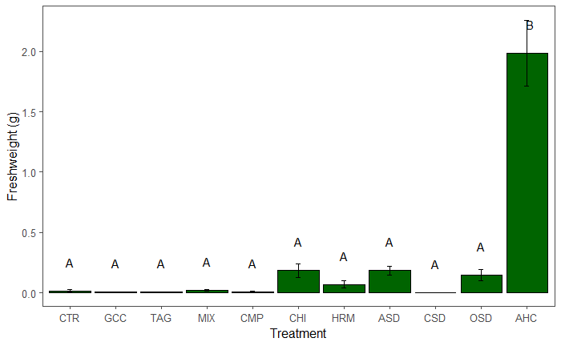
Fig. S1 Average fresh weight of garden cress after inoculation with P. ultimum in 2018 in the treatments; error bars represent the standard error; different letters indicate significant differences between the treatments (p<0.05)

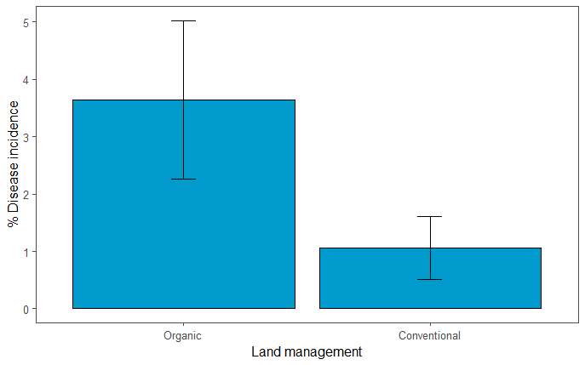
Fig. S2 Average disease incidence for natural infection of R. solani in 2018 in the two land management systems; error bars represent the standard error.

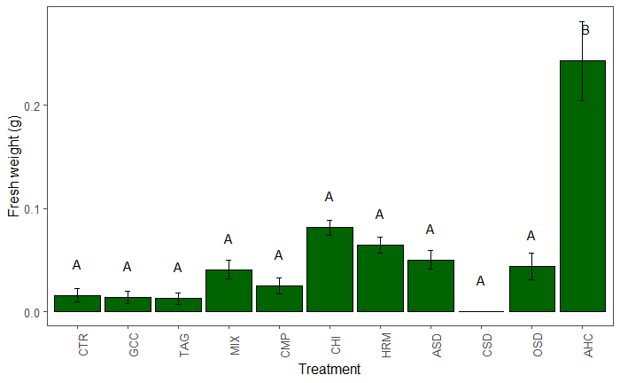
Fig. S3 Average fresh weight of garden cress after inoculation with P. ultimum in 2019 in the treatments; error bars represent the standard error; different letters indicate significant differences between the treatments (p<0.05).

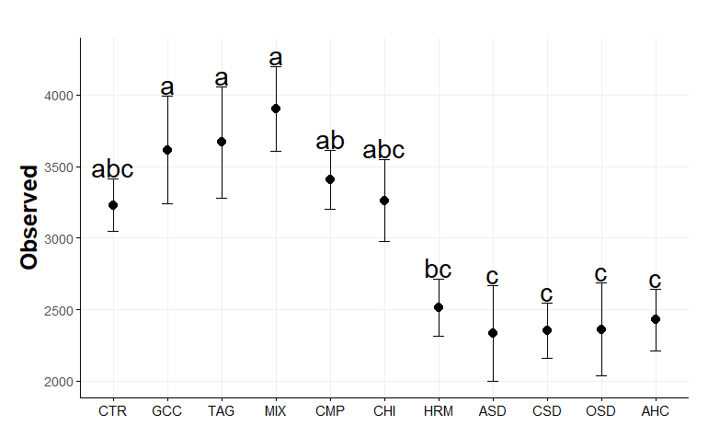
Fig. S4 Observed diversity (i.e. OTU richness) of bacteria in the 11 treatments; different letters indicate significant differences between the treatments (p<0.05).

a
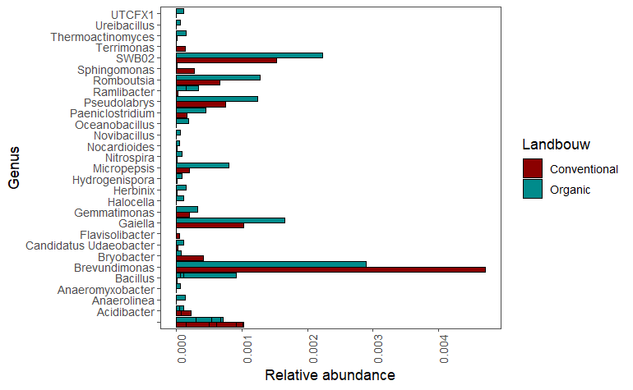
b
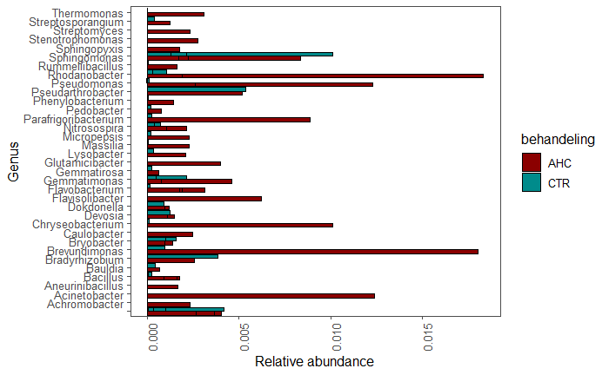
Fig. S5 Relative abundance of bacterial genera significantly differing in abundance between a) conventional and organic agriculture and b) the CTR and AHC treatment.
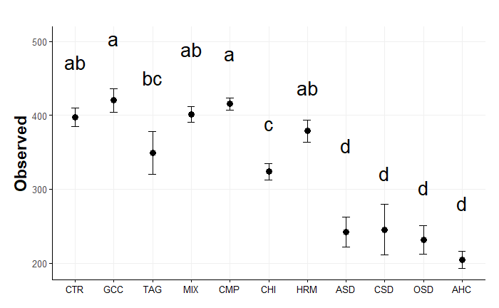
Fig. S6 Observed diversity (i.e. OTU richness) of fungi in the 11 treatments; different letters indicate significant differences between the treatments (p<0.05).

a
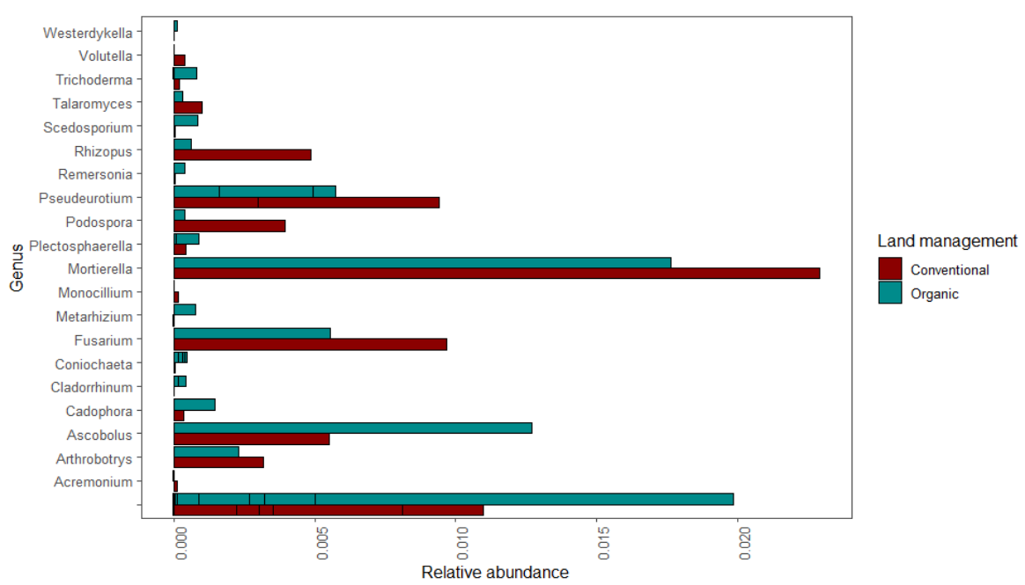

b
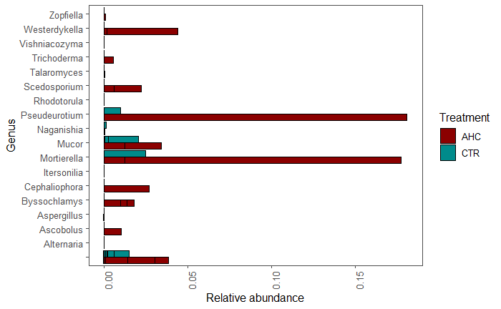
Fig. S7 Relative abundance of fungal genera significantly differing in abundance between a) conventional and organic agriculture and b) the CTR and AHC treatment.

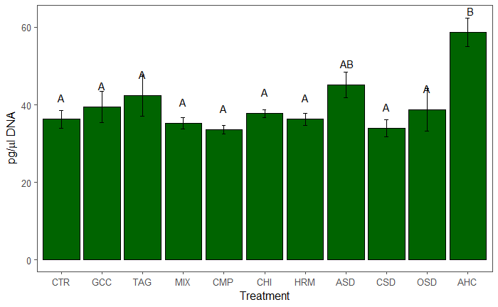
Fig. S8 Average amount of bacterial DNA in the different treatments; error bars represent the standard error; different letters indicate significant differences between the treatments (p<0.05).

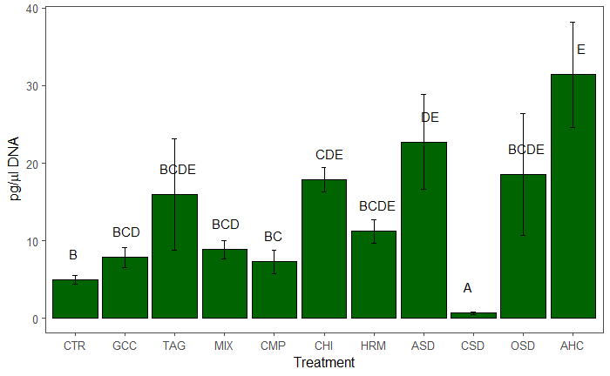

Fig. S9 Average amount of fungal DNA in the different treatments; error bars represent the standard error; different letters indicate significant differences between the treatments (p<0.05).

Table S3 Average crop yield of leek in 2019 in the two management systems and ten treatments.
Management | Soil Health Treatment | Crop yield of leek
Organic | CTR | 38.7
Organic | GCC | 41.94
Organic | TAG | 43.47
Organic | MIX | 41.7
Organic | ASD | 39.15
Organic | CHI | 42.87
Organic | OSD | 38.42
Organic | CMP | 42.12
Organic | HRM | 43.48
Organic | AHC | 40.27
Conventional | CTR | 43.45
Conventional | GCC | 42.48
Conventional | TAG | 42.41
Conventional | MIX | 46.48
Conventional | ASD | 46.08
Conventional | CHI | 47.23
Conventional | CSD | 44.06
Conventional | CMP | 46.41
Conventional | HRM | 47.27
Conventional | AHC | 48.1

