Fig. S1
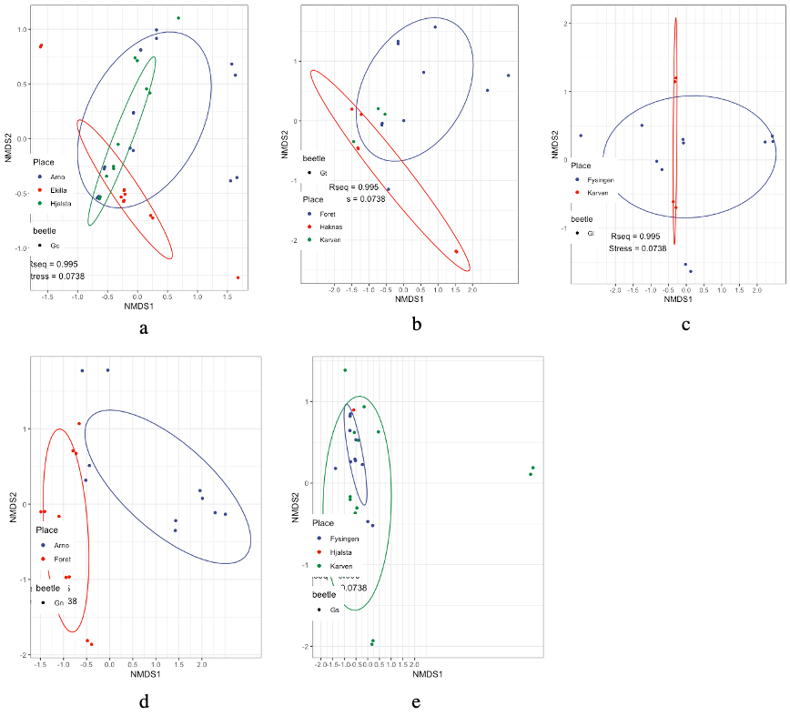

Fig. S2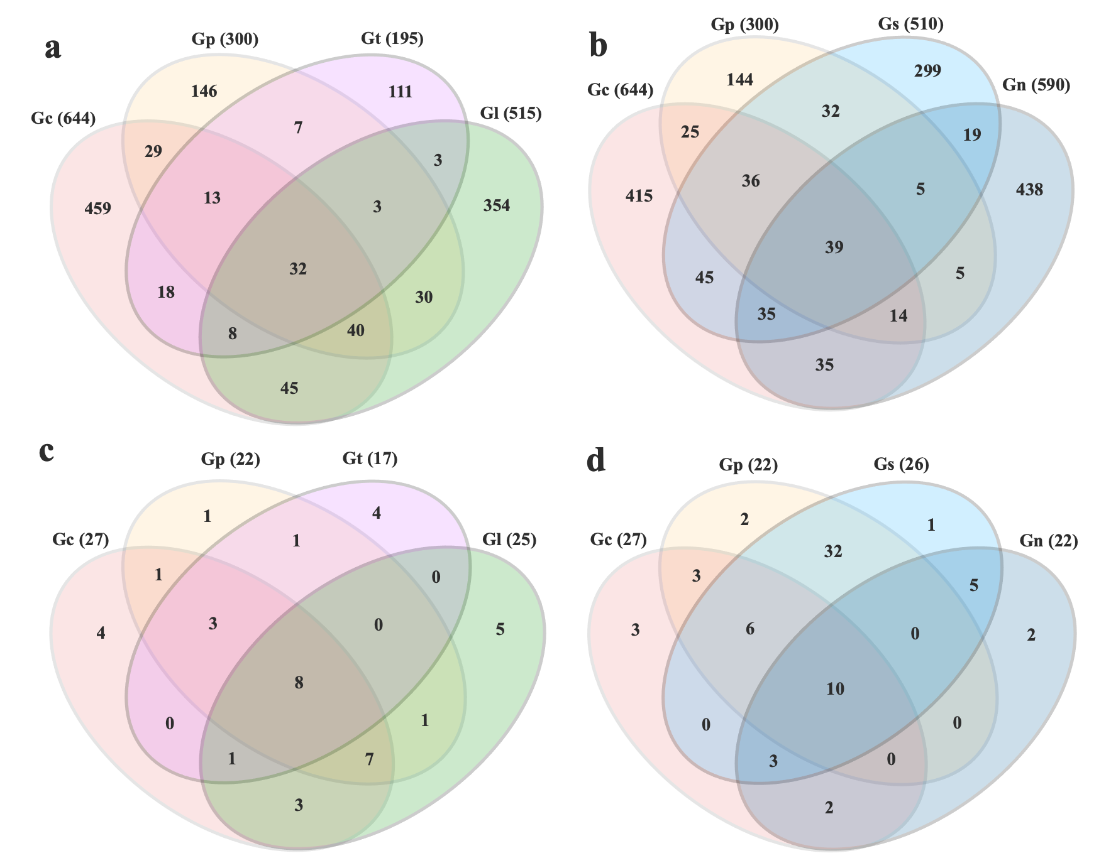

Table 2 10 most abundant ASV table in six Galerucella species
Taxonomy | domain | phylum | class | order | family | genus | species
ASV8 | Bacteria | Firmicutes | Bacilli | Entomoplasmatales | Spiroplasmataceae | Spiroplasma | Spiroplasma ixodetis
ASV10 | Bacteria | Firmicutes | Bacilli | Entomoplasmatales | Spiroplasmataceae | Spiroplasma | Spiroplasma ixodetis
ASV96 | Bacteria | Firmicutes | Bacilli | Entomoplasmatales | Spiroplasmataceae | Spiroplasma | Spiroplasma ixodetis
ASV103 | Bacteria | Firmicutes | Bacilli | Bacillales | Bacillaceae | Aeribacillus | Anaerobacillus isosaccharinicus
ASV42 | Bacteria | Firmicutes | Bacilli | Lactobacillales | Streptococcaceae | Lactococcus | Lactococcus laudensis
ASV109 | Bacteria | Firmicutes | Bacilli | Lactobacillales | Leuconostocaceae | Weissella | Weissella confusa
ASV84 | Bacteria | Bacteroidota | Bacteroidia | Bacteroidales | Dysgonomonadaceae | Dysgonomonas | Dysgonomonas macrotermitis
ASV41 | Bacteria | Bacteroidota | Bacteroidia | Flavobacteriales | Weeksellaceae | Chishuiella | Chishuiella changwenlii
ASV64 | Bacteria | Bacteroidota | Bacteroidia | Flavobacteriales | Flavobacteriaceae | Flavobacterium | Flavobacterium chungnamense
ASV46 | Bacteria | Verrucomicrobiota | Chlamydiae | Chlamydiales | Simkaniaceae | Candidatus Rhabdochlamydia | Candidatus Protochlamydia naegleriophila
ASV39 | Bacteria | Actinobacteriota | Actinobacteria | Micrococcales | Micrococcaceae | Micrococcus | Micrococcus cohnii
ASV30 | Bacteria | Actinobacteriota | Actinobacteria | Corynebacteriales | Nocardiaceae | Nocardia | Nocardia aurea
ASV66 | Bacteria | Proteobacteria | Alphaproteobacteria | Rhizobiales | Beijerinckiaceae | Beijerinckia | Beijerinckia doebereinerae
ASV79 | Bacteria | Proteobacteria | Alphaproteobacteria | Rhizobiales | Rhizobiaceae | Rhizobium | Rhizobium tumorigenes
ASV77 | Bacteria | Proteobacteria | Gammaproteobacteria | Burkholderiales | Oxalobacteraceae | Herbaspirillum | Herbaspirillum aquaticum
ASV50 | Bacteria | Proteobacteria | Gammaproteobacteria | Burkholderiales | Burkholderiaceae | Limnobacter | Limnobacter alexandrii
ASV44 | Bacteria | Proteobacteria | Gammaproteobacteria | Salinisphaerales | Sinobacteraceae; | Nevskia | Nevskia lacus
ASV37 | Bacteria | Proteobacteria | Alphaproteobacteria | Sphingomonadales | Sphingomonadaceae | Novosphingobium | Novosphingobium capsulatum
ASV161 | Bacteria | Proteobacteria | Alphaproteobacteria | Caulobacterales | Caulobacteraceae | Brevundimonas | Brevundimonas huaxiensis
ASV6 | Bacteria | Proteobacteria | Gammaproteobacteria | Sphingomonadales | Pseudomonadaceae | Pseudomonas | Pseudomonas spelaei
ASV20 | Bacteria | Proteobacteria | Gammaproteobacteria | Pseudomonadales | Pseudomonadaceae | Pseudomonas | Pseudomonas paracarnis
ASV62 | Bacteria | Proteobacteria | Gammaproteobacteria | Pseudomonadales | Pseudomonadaceae | Pseudomonas | Pseudomonas kairouanensis
ASV67 | Bacteria | Proteobacteria | Gammaproteobacteria | Pseudomonadales | Pseudomonadaceae | Pseudomonas | Pseudomonas spelaei
ASV23 | Bacteria | Proteobacteria | Gammaproteobacteria | Diplorickettsiales | Diplorickettsiaceae | Rickettsiella | Rickettsiella massiliensis
ASV45 | Bacteria | Proteobacteria | Gammaproteobacteria | Diplorickettsiales | Diplorickettsiaceae | Rickettsiella | Rickettsiella massiliensis
ASV26 | Bacteria | Proteobacteria | Gammaproteobacteria | Burkholderiales | Sphaerotilaceae | Sphaerotilus | Sphaerotilus montanus
ASV32 | Bacteria | Proteobacteria | Gammaproteobacteria | Burkholderiales | Sphaerotilaceae | Sphaerotilus | Sphaerotilus montanus
ASV34 | Bacteria | Proteobacteria | Gammaproteobacteria | Burkholderiales | Sphaerotilaceae | Sphaerotilus | Sphaerotilus montanus
ASV71 | Bacteria | Proteobacteria | Gammaproteobacteria | Burkholderiales | Sphaerotilaceae | Sphaerotilus | Sphaerotilus montanus
ASV60 | Bacteria | Proteobacteria | Alphaproteobacteria | Sphingomonadales | Sphingomonadaceae | Sphingomonas | Sphingomonas radiodurans
ASV139 | Bacteria | Proteobacteria | Alphaproteobacteria | Sphingomonadales | Sphingomonadaceae | Sphingomonas | Sphingomonas polyaromaticivorans
ASV141 | Bacteria | Proteobacteria | Alphaproteobacteria | Rhizobiales | Beijerinckiaceae | Beijerinckia | Beijerinckia doebereinerae
ASV65 | Bacteria | Proteobacteria | Gammaproteobacteria | Burkholderiales | Methylophilaceae | Methylotenera | Methylotenera versatilis
ASV61 | Bacteria | Proteobacteria | Gammaproteobacteria | Burkholderiales | Comamonadaceae | Rhodoferax | Rhodoferax aquaticus
ASV12 | Bacteria | Proteobacteria | Gammaproteobacteria | Enterobacterales | Erwiniaceae | Pantoea | Pantoea anthophila
ASV16 | Bacteria | Proteobacteria | Gammaproteobacteria | Enterobacterales | Erwiniaceae | Pantoea | Pantoea anthophila
ASV150 | Bacteria | Proteobacteria | Gammaproteobacteria | Enterobacterales | Yersiniaceae | Serratia | Serratia liquefaciens
ASV22 | Bacteria | Proteobacteria | Gammaproteobacteria | Enterobacterales | Erwiniaceae | Pantoea | Pantoea anthophila
ASV75 | Bacteria | Proteobacteria | Gammaproteobacteria | Enterobacterales | Erwiniaceae | Pantoea | Pantoea vagans
ASV14 | Bacteria | Proteobacteria | Gammaproteobacteria | Enterobacterales | Enterobacteriaceae | Enterobacter | Enterobacter quasihormaechei
ASV43 | Bacteria | Proteobacteria | Gammaproteobacteria | Enterobacterales | Enterobacteriaceae | Enterobacter | Enterobacter cloacae
ASV54 | Bacteria | Proteobacteria | Gammaproteobacteria | Enterobacterales | Enterobacteriaceae | Leclercia | Leclercia adecarboxylata
ASV169 | Bacteria | Proteobacteria | Gammaproteobacteria | Enterobacterales | Enterobacteriaceae | Enterobacter | Enterobacter quasihormaechei
ASV7 | Bacteria | Proteobacteria | Alphaproteobacteria | Rickettsiales | Anaplasmataceae | Wolbachia | Unassigned
ASV48 | Bacteria | Proteobacteria | Alphaproteobacteria | Rickettsiales | Anaplasmataceae | Wolbachia | Unassigned

