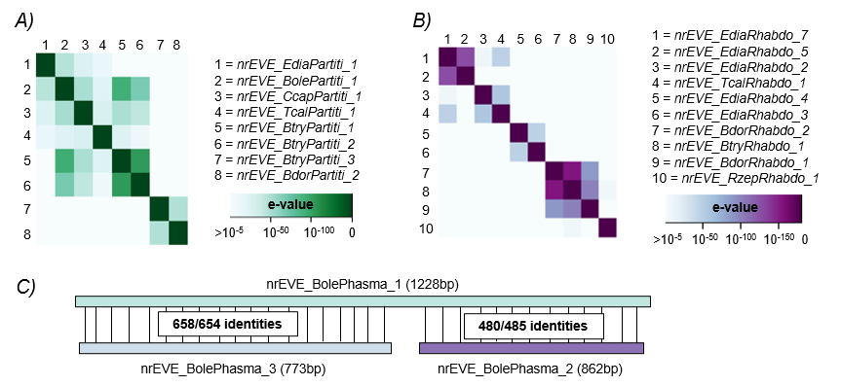
Figure S1. Homology at the nucleotide level between the nrEVEs classified within the A) Partitiviridae, B) Rhabdoviridae and C) Phasmaviridae families. For the first two, results were visualized as a HeatMap containing the e-value of the pairwise sequence comparisons. Additional nrEVEs derived from the Partitiviridae or Rhabdoviridae families which presented a similarity below the threshold (e-value > 10⁻⁵) were not displayed in the graph. For the three nrEVEs derived from the Phasmaviridae family, results were shown as a representation of the mapping, with the indication of the number of identities between the sequences.

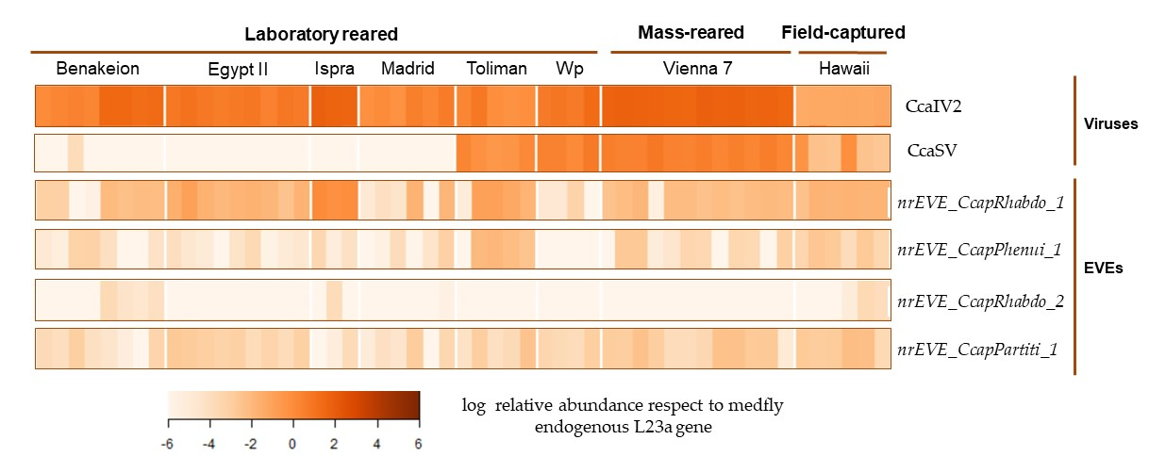
Figure S2. Expression of the 4 nrEVEs described in C. capitata in 53 transcriptomes of the species obtained from the Sequence Read Archive (SRA) on NCBI. Additionally, the expression of two viruses of the species was assessed. Ceratitis capitata Iflavirus 2 expression was obtained as positive control since it has been shown that CcaIV2 is ubiquitously distributed in C. capitata. Ceratitis capitata Sigmavirus (CcaSV) expression was calculated due to the sequence similarity between this virus and nrEVE_Rhabdo_1.

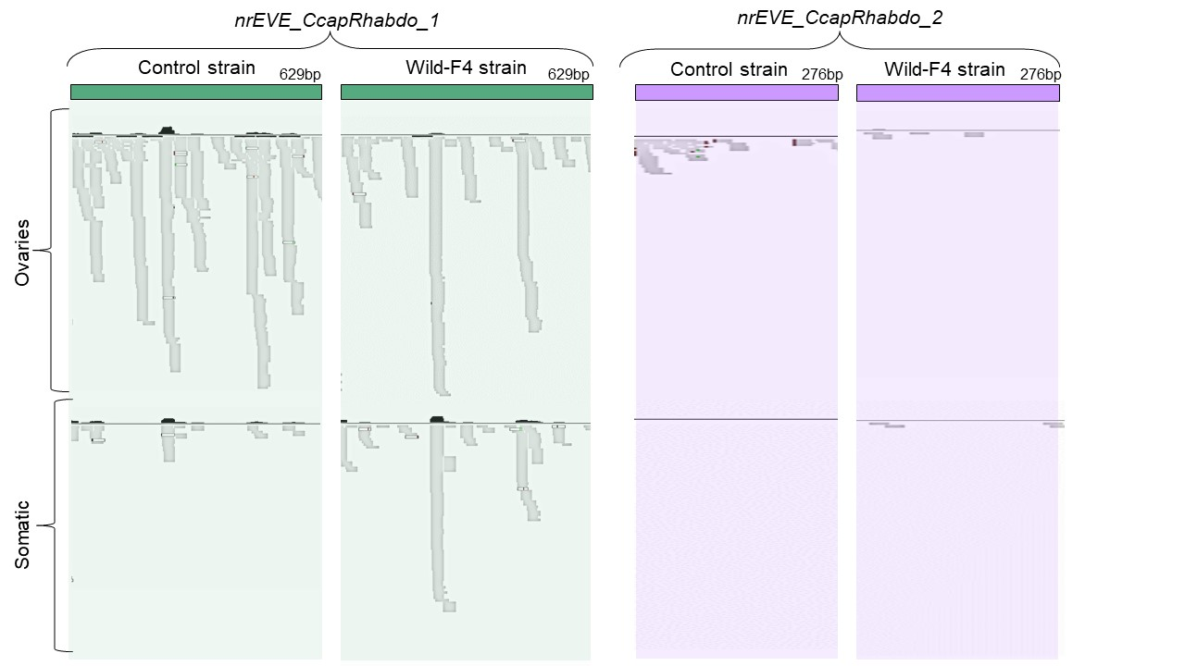
Figure S3. Mapping profile of the small RNAs across the sequence of the nrEVEs identified in the genome of C. capitata: nrEVE_CcapRhabdo_1 and nrEVE_CcapRhabdo_2.

Table S1. Viral genomes used to test the similarity between nrEVEs and circulating viruses. The last column represents the groups of RNA viruses which share more than 95% similarities at the nucleotide level after blastn. A proposed common name has been added for each group of viruses fulfilling the 95% similarity criteria.
Virus | GenBank | Taxon | >95% nucleotide similarity with: | Proposed common name
Bactrocera bryoniae dicistrovirus 1 | HG994131.1 | 2814032 | Bactrocera frauenfeldi dicistrovirus 1  Bactrocera kraussi dicistrovirus 1  Bactrocera musae dicistrovirus 1 | Bactrocera species dicistrovirus 1
Bactrocera bryoniae dicistrovirus 2 | HG994132.1 | 2814033 | Bactrocera frauenfeldi dicistrovirus 2  Bactrocera musae dicistrovirus 2 | Bactrocera species dicistrovirus 2
Bactrocera bryoniae iflavirus 1 | HG993808.1 | 2812444 | Bactrocera tryoni iflavirus 1  Bactrocera tryoni iflavirus 2 | Bactrocera species  iflavirus 1
Bactrocera dorsalis borna-like virus | MN745081.1 | 2760893 | Bactrocera dorsalis xinmovirus 2 | Bactrocera dorsalis xinmovirus 2
Bactrocera dorsalis cripavirus | MN738553.1 | 2739222 | - | -
Bactrocera dorsalis negev-like virus 1 | MW310386.1 | 2933669 | Bactrocera dorsalis negev-like virus 2  Bactrocera dorsalis negev-like virus 3 | Bactrocera dorsalis negev-live virus 1
Bactrocera dorsalis negev-like virus 2 | HG993812.1 | 2812452 | Bactrocera dorsalis negev-like virus 1  Bactrocera dorsalis negev-like virus 3 | Bactrocera dorsalis negev-live virus 1
Bactrocera dorsalis negev-like virus 3 | HG993813.1 | 2812453 | Bactrocera dorsalis negev-like virus 1  Bactrocera dorsalis negev-like virus 2 | Bactrocera dorsalis negev-live virus 1
Bactrocera dorsalis nora virus | MN738554.1 | 2739231 |  | -
Bactrocera dorsalis picorna-like virus 1 | MW310352.1 | 2933678 | Bactrocera dorsalis picorna-like virus 2 | Bactrocera dorsalis  picorna-like virus 1
Bactrocera dorsalis picorna-like virus 2 | HG994136.1 | 2814078 | Bactrocera dorsalis picorna-like virus 1 | Bactrocera dorsalis  picorna-like virus 1
Bactrocera dorsalis sigmavirus | MN745080.1 | 2760896 | - | -
Bactrocera dorsalis toti-like virus 1 | MN745082.1 | 2760897 | - | -
Bactrocera dorsalis toti-like virus 2 | MN745083.1 | 2760898 | - | -
Bactrocera dorsalis xinmovirus 2 | HG994135.1 | 2814077 | Bactrocera dorsalis borna-like virus | Bactrocera dorsalis xinmovirus 2
Bactrocera frauenfeldi dicistrovirus 1 | HG994130.1 | 2814031 | Bactrocera bryoniae dicistrovirus 1  Bactrocera kraussi dicistrovirus 1  Bactrocera musae dicistrovirus 1 | Bactrocera species dicistrovirus 1
Bactrocera frauenfeldi dicistrovirus 2 | HG993809.1 | 2812449 | Bactrocera bryoniae dicistrovirus 2  Bactrocera musae dicistrovirus 2 | Bactrocera species dicistrovirus 2
Bactrocera jarvisi toti-like virus 1 | HG994127.1 | 2814076 | Bactrocera tryoni toti-like virus 1 | Bactrocera species  toti-like virus 1
Bactrocera kraussi dicistrovirus 1 | HG994128.1 | 2814036 | Bactrocera frauenfeldi dicistrovirus 1  Bactrocera bryoniae dicistrovirus 1  Bactrocera musae dicistrovirus 1 | Bactrocera species dicistrovirus 1
Bactrocera kraussi iflavirus 1 | HG993805.1 | 2812441 | Bactrocera kraussi iflavirus 2  Bactrocera kraussi iflavirus 3 | Bactrocera kraussi  iflavirus 1
Bactrocera kraussi iflavirus 2 | HG993806.1 | 2812442 | Bactrocera kraussi iflavirus 1  Bactrocera kraussi iflavirus 3 | Bactrocera kraussi  iflavirus 1
Bactrocera kraussi iflavirus 3 | HG993807.1 | 2812443 | Bactrocera kraussi iflavirus 1  Bactrocera kraussi iflavirus 2 | Bactrocera kraussi  iflavirus 1
Bactrocera kraussi negev-like virus 1 | HG994129.1 | 2814080 | Bactrocera tryoni negev-like virus | Bactrocera species  negev-like virus 1
Bactrocera musae dicistrovirus 1 | HG994133.1 | 2814034 | Bactrocera frauenfeldi dicistrovirus 1  Bactrocera bryoniae dicistrovirus 1  Bactrocera kraussi dicistrovirus 1 | Bactrocera species dicistrovirus 1
Bactrocera musae dicistrovirus 2 | HG994134.1 | 2814035 | Bactrocera bryoniae dicistrovirus 2  Bactrocera frauenfeldi dicistrovirus 2 | Bactrocera species dicistrovirus 2
Bactrocera tryoni dicistrovirus 1 | MW208808.1 | 2795007 | - | -
Bactrocera tryoni dicistrovirus 2 | MW208809.1 | 2795008 | - | -
Bactrocera tryoni dicistrovirus 3 | HG994979.1 | 2815578 | - | -
Bactrocera tryoni dicistrovirus 4 | HG993802.1 | 2812446 | - | -
Bactrocera tryoni iflavirus 1 | MW208810.1 | 2795009 | Bactrocera bryoniae iflavirus 1  Bactrocera tryoni iflavirus 2 | Bactrocera species  iflavirus 1
Bactrocera tryoni iflavirus 2 | HG994125.1 | 2814058 | Bactrocera bryoniae iflavirus 1  Bactrocera tryoni iflavirus 1 | Bactrocera species  iflavirus 1
Bactrocera tryoni iflavirus 3 | HG994126.1 | 2814059 |  | No similarities
Bactrocera tryoni negev-like virus | HG993804.1 | 2812448 | Bactrocera kraussi negev-like virus 1 | Bactrocera species negev-like virus 1
Bactrocera tryoni picorna-like virus | MW208812.1 | 2795010 | - | -
Bactrocera tryoni rhabdovirus 1 | MW208811.1 | 2795014 | - | -
Bactrocera tryoni toti-like virus 1 | HG993803.1 | 2812447 | Bactrocera jarvisi toti-like virus 1 | Bactrocera species toti-like virus 1
Ceratitis capitata iflavirus 1 | Undefined |  | - | -
Ceratitis capitata iflavirus 2 | OL957305.1 | 2932852 | - | -
Ceratitis capitata iflavirus 3 | HG994137.1 | 2814060 | - | -
Ceratitis capitata iflavirus 4 | HG994138.1 | 2814061 | - | -
Ceratitis capitata narnavirus | OL957306.1 | 2932853 | - | -
Ceratitis capitata negev-like virus 1 | HG994139.1 | 2814079 | - | -
Ceratitis capitata negev-like virus 2 | OL957307.1 | 2932854 | - | -
Ceratitis capitata nodavirus | OL957308.1 | 2932855 | - | -
Ceratitis capitata nora virus | Undefined |  | - | -
Ceratitis capitata reo-like virus 1 | OL957310.1 | 2932856 | - | -
Ceratitis capitata totivirus 1 | OL957313.1 | 2932857 | - | -
Ceratitis capitata sigmavirus | NC_076146.1 | 1802949 | - | -
Ceratitis capitata virga-like virus 1 | Undefined |  | - | -
Zeugodacus cucurbitae toti-like virus | MW310353.1 | 2933690 | - | -
Zeugodacus cucurbitae negev-like virus | MW310350.1 | 2933687 | - | -

Table S2. Reference genomes used for the analysis of endogenous virus elements in tephritid fruit flies.
Scientific name | RefSeq | Assembly | Size (Mb)
Bactrocera cucurbitae | GCF_000806345.1 | ASM80634v1 | 374.8 | Fruit
Bactrocera dorsalis | GCF_000789215.1 | ASM78921v2 | 415 | Fruit
Bactrocera latifrons | GCF_001853355.1 | ASM185335v1 | 462,5 | Pepper
Bactrocera oleae | GCF_001188975.3 | MU_Boleae_v2 | 484,9 | Olive
Bactrocera tryoni | GCA_000695345.1 | Assembly 2.2 of Bactrocera tryoni genome | 519 | Fruit
Ceratitis capitata | GCF_000347755.3 | Ccap_2.1 | 436,5 | Fruit
Eutreta diana | GCA_001015115.1 | ASM101511v1 | 233,1 | A. tridentata.
Rhagoletis zephyria | GCF_001687245.2 | Rhagoletis_zephyria_1.1 | 1100 | Cherry
Tephritis californica | GCA_001017515.1 | ASM101751v1 | 342,3 | Unc.
Trupanea jonesi | GCA_001014665.1 | ASM101466v1 | 97,3 | Unc.

Table S3. Available SRA datasets of 6 tephritid fruit fly species used to assess the expression of the nrEVEs.
SRA accession number | Experiment Accession | Organism Name | Instrument | Submitter
SRR1993650 | SRX1007579 | Bactrocera latifrons | Illumina HiSeq 2000 | USDA-ARS Pacific Basin Agricultural Research Center (PBARC)
SRR1993648 | SRX1007578 | Bactrocera latifrons | Illumina HiSeq 2000 | USDA-ARS Pacific Basin Agricultural Research Center (PBARC)
SRR1993646 | SRX1007576 | Bactrocera latifrons | Illumina HiSeq 2000 | USDA-ARS Pacific Basin Agricultural Research Center (PBARC)
SRR1993647 | SRX1007577 | Bactrocera latifrons | Illumina HiSeq 2000 | USDA-ARS Pacific Basin Agricultural Research Center (PBARC)
ERR3219438 | ERX3246919 | Bactrocera tryoni | NextSeq 500 | UNIVERSITY OF NEW SOUTH WALES
SRR9302948 | SRX6078240 | Bactrocera tryoni | Illumina HiSeq 2000 | QUT
SRR8662649 | SRX5459372 | Bactrocera tryoni | Illumina HiSeq 2000 | University of New South Wales
SRR8662654 | SRX5459367 | Bactrocera tryoni | Illumina HiSeq 2000 | University of New South Wales
SRR5559327 | SRX2822449 | Bactrocera oleae | Illumina Genome Analyzer | Bachtrog Lab, UC Berkeley
SRR5559328 | SRX2822448 | Bactrocera oleae | Illumina Genome Analyzer | Bachtrog Lab, UC Berkeley
SRR826666 | SRX265051 | Bactrocera oleae | Illumina Genome Analyzer | UC Berkeley
SRR826665 | SRX265050 | Bactrocera oleae | Illumina Genome Analyzer | UC Berkeley
SRR10058476 | SRX6792367 | Zeugodacus cucurbitae | HiSeq X Ten | Southwest University, China
SRR10058486 | SRX6792357 | Zeugodacus cucurbitae | HiSeq X Ten | Southwest University, China
SRR10058487 | SRX6792356 | Zeugodacus cucurbitae | HiSeq X Ten | Southwest University, China
SRR10058496 | SRX6792347 | Zeugodacus cucurbitae | HiSeq X Ten | Southwest University, China
SRR9945666 | SRX6694156 | Bactrocera dorsalis | Illumina HiSeq 2500 | Key laboratory of Entomology and Pest Control Engi
SRR9945677 | SRX6694145 | Bactrocera dorsalis | Illumina HiSeq 2500 | Key laboratory of Entomology and Pest Control Engi
SRR1032039 | SRX378864 | Bactrocera dorsalis | Illumina HiSeq 2000 | College of Plant Protection, Southwest University,
SRR526902 | SRX170663 | Bactrocera dorsalis | Illumina HiSeq 2000 | College of Plant Protection southwest university
SRR16562767 | SRX12764798 | Ceratitis capitata | Illumina HiSeq 2000 | University of Valencia
SRR915844 | SRX312188 | Ceratitis capitata | Illumina HiSeq 2000 | USDA-ARS Pacific Basin Agricultural Research Center (PBARC)
SRR915848 | SRX312191 | Ceratitis capitata | Illumina HiSeq 2000 | USDA-ARS Pacific Basin Agricultural Research Center (PBARC)
SRR836188 | SRX272876 | Ceratitis capitata | Illumina HiSeq 2000 | Baylor College of Medicine (BCM)

Table S4. SRA datasets of Ceratitis capitata selected to assess the expression of the nrEVEs.
NCBI accession number | Sequencing method | C. capitata origin | Library details |  | SRA accession number
SRP133427 | Illumina HiSeq 2000 | Benakeion | Sexed 4-8h embryos | Male | SRR6780761
 |  |  |  |  | SRR6780762
 |  |  |  | Female | SRR6780763
 |  |  |  |  | SRR6780764
ERP119522 | Illumina NovaSeq 6000; pair end | Benakeion | Pool of 3 larvae | Immobilized larvae | ERR4026378
 |  |  |  |  | ERR4026379
 |  |  |  | Jumping larvae | ERR4026375
 |  |  |  |  | ERR4026376
SRP073787 | Illumina HiSeq 2000, single | Egypt II | Gastrointestinal tract | Virgin female | SRR3436822
 |  |  |  |  | SRR3436813
SRP073787 | Illumina HiSeq 2000, single | Egypt II | Reproductive tract | Mated male | SRR3436821
 |  |  |  | Mated male | SRR3436820
 |  |  |  | Mated female | SRR3436819
 |  |  |  | Mated female | SRR3436818
 |  |  |  | Virgin male | SRR3436817
 |  |  |  | Virgin male | SRR3436816
 |  |  |  | Virgin female | SRR3436815
 |  |  |  | Virgin female | SRR3436814
SRP021914 | Illumina Genome Analyzer Iix; pair end | Ispra | Adult | Male | SRR836190
 |  |  |  | Female | SRR836189
SRP021914 | Illumina Genome Analyzer Iix; pair end | Ispra | Embryo |  | SRR836188
ERP124511 | Illumina HiSeq 2000 paired end sequencing | Madrid | Whole adult,  Control strain | Replicate 1 | ERR4690327
 |  |  |  | Replicate 2 | ERR4690326
 |  |  |  | Replicate 3 | ERR4690325
SRP343008 | Illumina HiSeq 2000 paired end sequencing | Madrid | Whole adult,  W-1Kλ strain | Replicate 1 | SRR16562767
 |  |  |  | Replicate 2 | SRR16562768
 |  |  |  | Replicate 3 | SRR16562769
SRP075464 | Illumina Genome Analyzer II | Toliman | Female ovary |  | SRR3554596
SRP075464 | Illumina Genome Analyzer II | Toliman | Elongated spermatids |  | SRR3554595
SRP075464 | Illumina Genome Analyzer II | Toliman | Round spermatids |  | SRR3554594
SRP075464 | Illumina Genome Analyzer II | Toliman | Late spermatocytes |  | SRR3554593
SRP075464 | Illumina Genome Analyzer II | Toliman | Early spermatocytes |  | SRR3554592
ERP119522 | Illumina NovaSeq 6000; pair end | Wp | Pool of 3 larvae | Immobilized larvae | ERR4026384
 |  |  |  |  | ERR4026385
 |  |  |  | Jumping larvae | ERR4026381
 |  |  |  |  | ERR4026382
SRP026213 | Illumina HiSeq 2000 | Vienna 7 | Non-irradiated | Pupae | SRR915844
 |  |  |  |  | SRR915840
 |  |  |  |  | SRR915839
 |  |  |  | Adult | SRR915838
 |  |  |  |  | SRR915837
 |  |  |  |  | SRR915836
SRP026213 | Illumina HiSeq 2000 | Vienna 7 | Irradiated | Pupae | SRR915835
 |  |  |  |  | SRR915834
 |  |  |  |  | SRR915833
 |  |  |  | Adult | SRR915832
 |  |  |  |  | SRR915831
 |  |  |  |  | SRR915830
SRP026213 | Illumina HiSeq 2000 | Hawaiian | Whole body | Wild pupae | SRR915852
 |  |  |  |  | SRR915851
 |  |  |  |  | SRR915850
 |  |  |  | Wild adults | SRR915848
 |  |  |  |  | SRR915846
 |  |  |  |  | SRR915845

Table S5. Medfly nrEVEs presence in whole genome sequencing datasets of different medfly strains and conditions.
Run accession | Strain | Experiment Title | strain | Geographic location | nrEVEs presence
ERR4026339 | Vienna 7 (female) | Illumina HiSeq 4000 paired end sequencing | 4-4_V7_F | Vienna | 4/4
ERR4026338 | Vienna 7 (male) | Illumina HiSeq 4000 paired end sequencing | 3-3_V7_M | Vienna | 4/4
ERR4026337 | Egypt II (female) | Illumina HiSeq 4000 paired end sequencing | Sample_6-6_EGII_F | Egypt | 4/4
ERR4026336 | Egypt II (male) | Illumina HiSeq 4000 paired end sequencing | Sample_5-5_EGII_M | Egypt | 4/4
SRR847379 | Ispra (female) | WGS sequencing of Ceratitis capitata female | Ceratitis capitata- inbred Ispra strain | Italy, Pavia | 4/4
SRR847380 | Ispra (male) | WGS sequencing of Ceratitis capitata pooled males | inbred Ispra strain from pooled male organism | Italy, Pavia | 4/4
SRR11649129 | TSL , Hawaii (male) | DNAseq of Ceratitis capitata | F2 of CDFA TSL strain cross wild type HiMed, White male 3M | USA: Hilo, Hawaii | 4/4
SRR11649132 | TSL , Hawaii (female) | DNAseq of Ceratitis capitata | F2 of CDFA TSL strain cross wild type HiMed, Brown Female 44F | USA: Hilo, Hawaii | 4/4
ERR171452 | Field (Italy: Sardania) |  | fresh specimen, head and thorax (2010-2012) | Italy: Sardania | 4/4
ERR171450 | Field (USA: Los Angeles) |  | archived specimen (1995-2004) thorax and head | USA: Los Angeles | 4/4

