Supplementary Materials

Beyond the bloom: unraveling the diversity, overlap and stability of free-living and particle-attached bacterial communities in a cyanobacteria-dominated hypereutrophic lake

Guijuan Xie^{1, 2}, Chuanbo Sun¹, Yi Gong ², Wenlei Luo^{2,3}, Xiangming Tang^{2,4*}

¹ College of Biology and Pharmaceutical Engineering, West Anhui University, Lu’an 237012, China
² State Key Laboratory of Lake Science and Environment, Nanjing Institute of Geography and Limnology, Chinese Academy of Sciences, Nanjing 210008, China
³ The Fuxianhu Station of Plateau Deep Lake Field Scientific Observation and Research, Yunnan, Yuxi 653100, China
⁴ College of Resources and Environment, University of Chinese Academy of Sciences, Beijing 100049, China

* Corresponding author:
Xiangming Tang
xmtang@niglas.ac.cn

Contents of this file:
Figure S1-S5

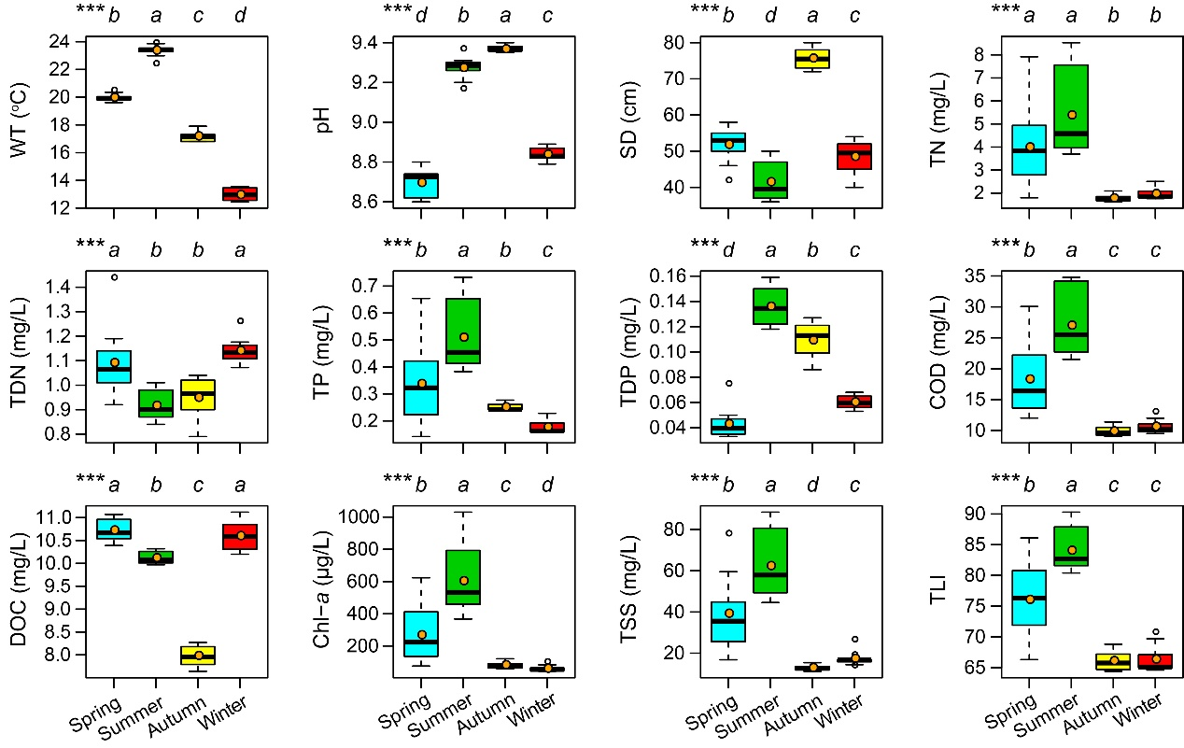
Fig. S1. Comparative analysis of the primary environmental parameters across various seasons in Lake Xingyun. WT: water temperature; SD: Secchi disk of transparency; TN: total nitrogen; TDN: total dissolved nitrogen; TP: total phosphorus; TDP: total dissolved phosphorus; COD: the permanganate index; DOC: dissolved organic carbon; Chl-a: chlorophyll-a; TSS: total suspended solids; TLI: trophic level index. Kruskal-Wallis test was conducted to assess differences across seasons. Different italic lower-case letters at the top of each boxplot indicate significant differences (P < 0.05). In the boxplot, bold short black lines and yellow dots represent the median and mean of each parameter in each season, respectively.

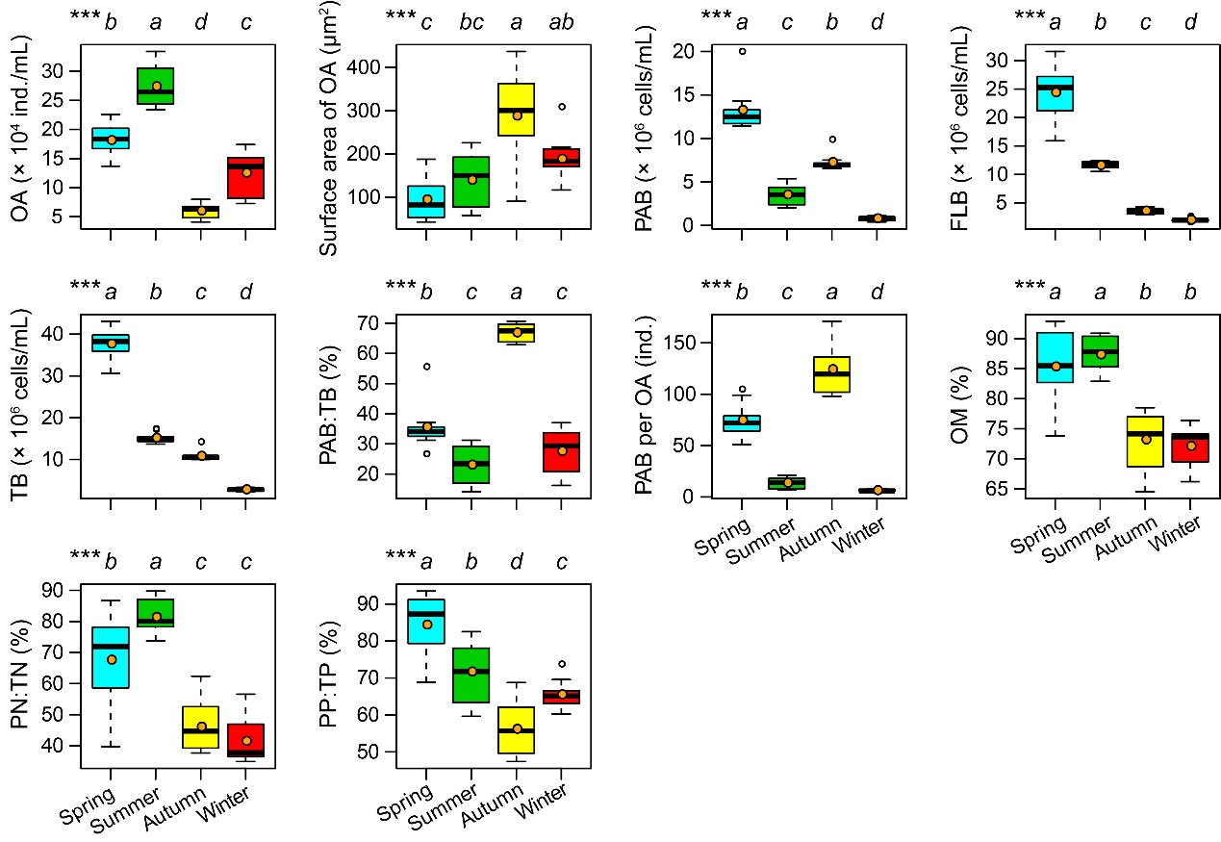
Fig. S2. Comparison of the main parameters related to organic aggregates (OA) among different seasons in Lake Xingyun. PAB: OA-attached bacterial abundance; FLB: free-living bacterial abundance; TB: total bacterial abundance; OM: percentage of organic matter in total suspended solids; PN: particle-related nitrogen; TN: total nitrogen; PP: particle-related phosphorous; TP: total phosphorous.

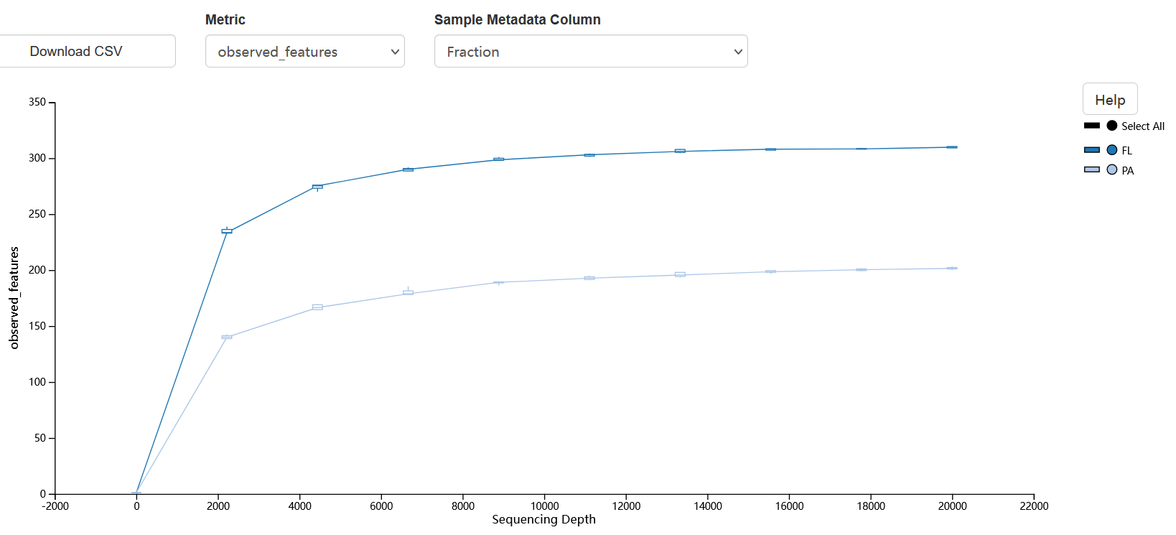
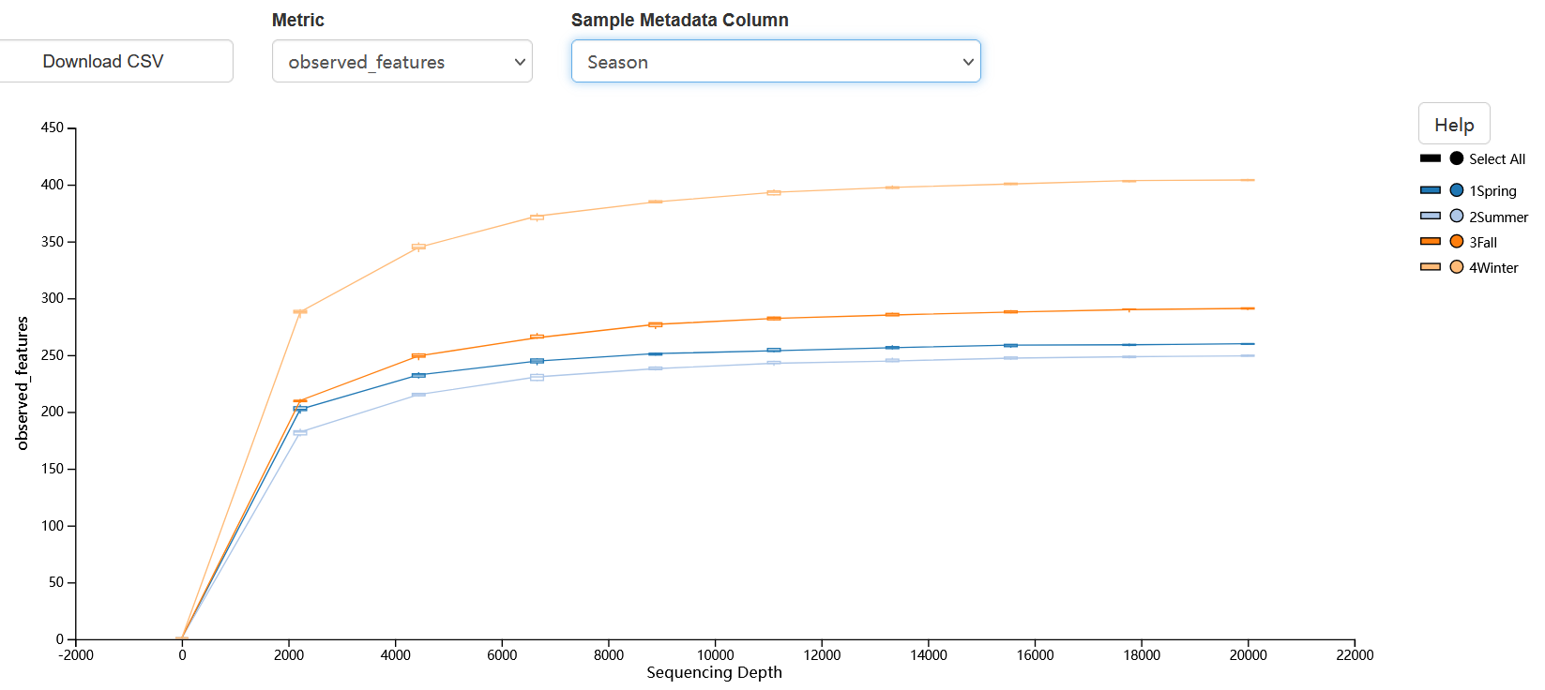
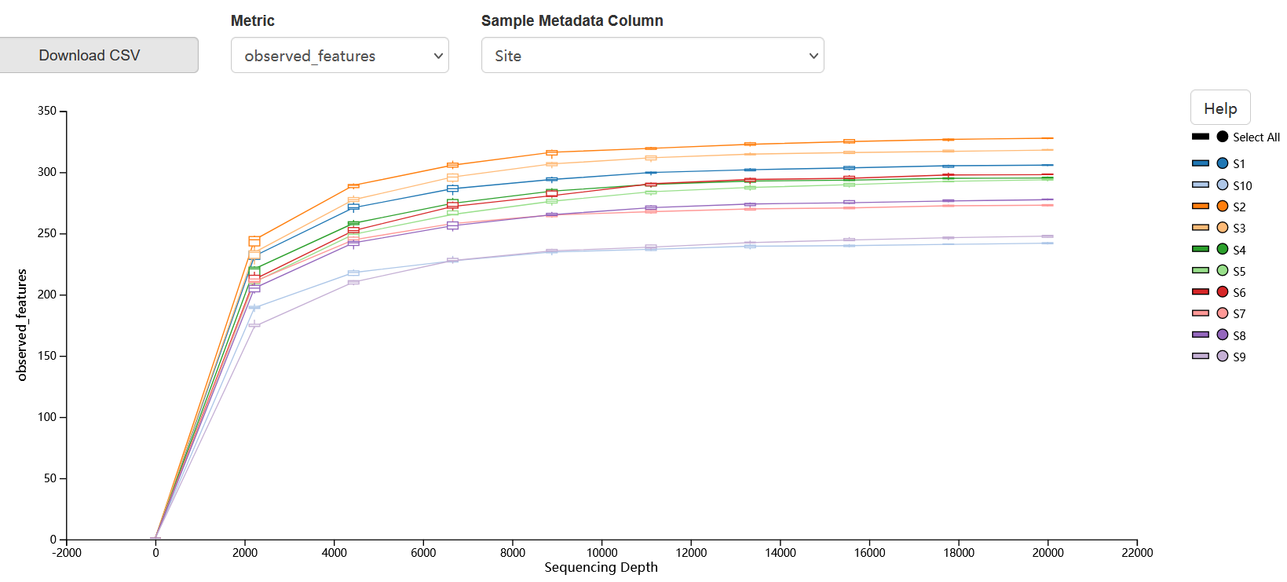
Fig. S3. The rarefaction curves for the observed features, i.e., Amplicon Sequence Variants (ASVs), demonstrating their distribution across different fractions, seasons, and sampling sites. These curves approach an asymptotic maximum once the sequencing depth exceeds 10,000, which suggests that the sequencing depth is adequate to provide a stable and unbiased estimation of species richness.
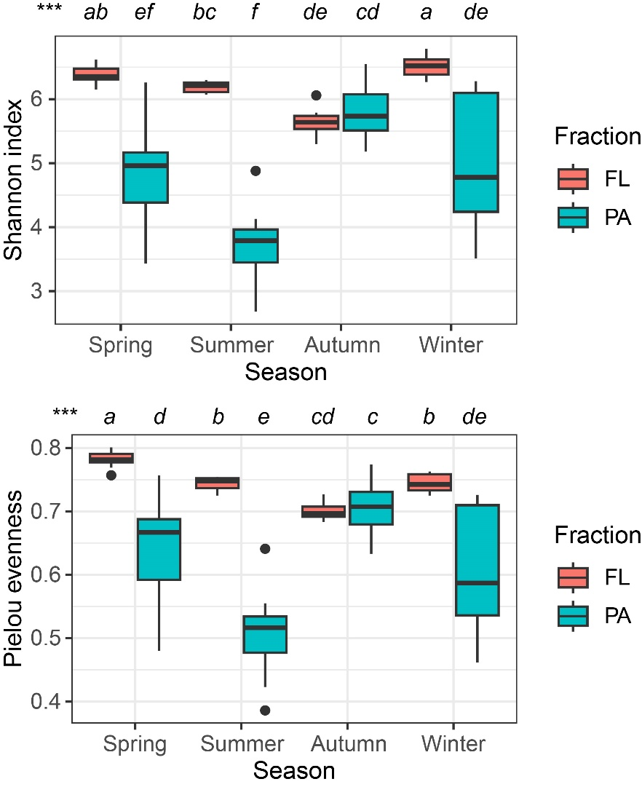
Fig. S4. Boxplots illustrating the α-diversity indices (Shannon index and Pielou evenness) across seasons for (a) free-living (FL) and (b) particle-attached (PA) bacterial communities in Lake Xingyun. Diversity indices were computed using a subset of 33,669 sequences per sample.

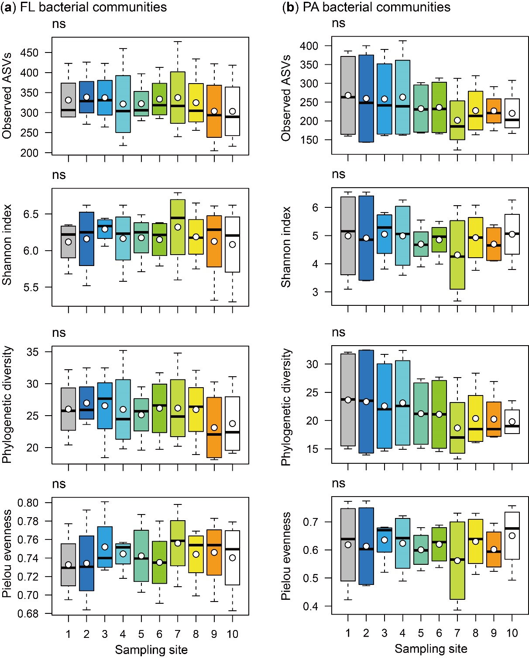
Fig. S5. Boxplots of the α-diversity indices among sampling sites for (a) free-living (FL) and (b) particle-attached (PA) bacterial assemblages in Lake Xingyun. Diversity indices were calculated using subset of 33,669 sequences per sample.

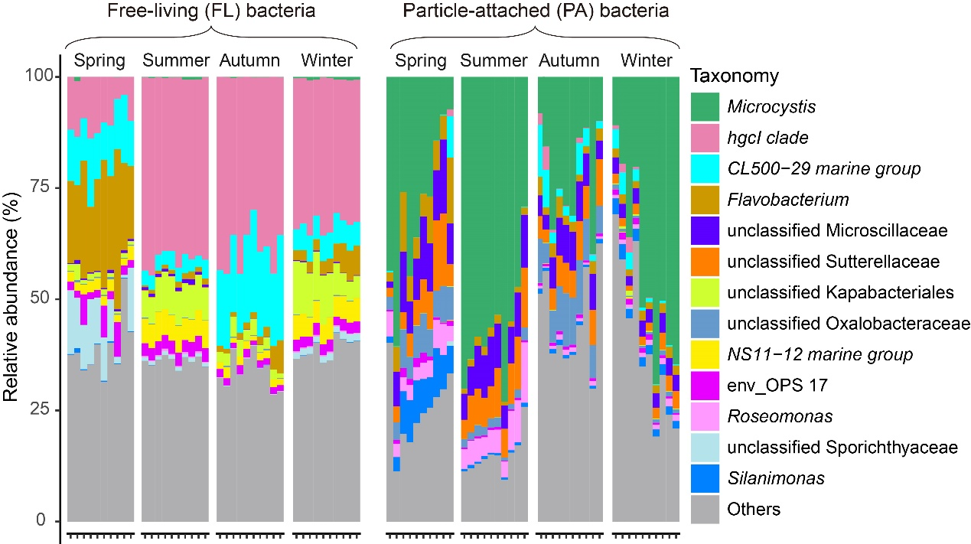
Fig. S6. The relative abundance of dominant genera detected in free-living (FL) and particle-attached (PA) bacterial communities at each sampling site across seasons in Lake Xingyun. In each panel, x-axis represents samples from Site 1 to Site 10.

Table S1 Summary of the numbers of reads for each sample in this study. PA: particle-attached; FL: free-living; QC: quality control.
SampleID | Fraction | Sampling site | Raw Reads | Post-QC | Final reads
XY01A01 | PA | 1 | 68738 | 48937 | 44230
XY01A04 | PA | 1 | 69469 | 47501 | 40603
XY01A07 | PA | 1 | 69114 | 53048 | 49729
XY01A11 | PA | 1 | 68171 | 47259 | 37637
XY01F01 | FL | 1 | 68461 | 38382 | 37276
XY01F04 | FL | 1 | 68446 | 35723 | 35710
XY01F07 | FL | 1 | 69279 | 38524 | 38489
XY01F11 | FL | 1 | 69141 | 35711 | 35567
XY02A01 | PA | 2 | 68897 | 49146 | 44592
XY02A04 | PA | 2 | 69538 | 52235 | 50845
XY02A07 | PA | 2 | 69256 | 52594 | 51398
XY02A11 | PA | 2 | 68523 | 46274 | 34989
XY02F01 | FL | 2 | 68683 | 40220 | 39199
XY02F04 | FL | 2 | 68562 | 35240 | 35153
XY02F07 | FL | 2 | 68355 | 37757 | 37696
XY02F11 | FL | 3 | 69276 | 34244 | 34154
XY03A01 | PA | 3 | 69136 | 48224 | 44082
XY03A04 | PA | 3 | 69669 | 48608 | 46488
XY03A07 | PA | 3 | 69396 | 50619 | 49022
XY03A11 | PA | 3 | 68619 | 46915 | 34171
XY03F01 | FL | 3 | 68905 | 41392 | 40717
XY03F04 | FL | 3 | 68683 | 33711 | 33669
XY03F07 | FL | 3 | 68656 | 37621 | 37520
XY03F11 | FL | 3 | 69501 | 36126 | 35768
XY04A01 | PA | 4 | 69211 | 49216 | 43209
XY04A04 | PA | 4 | 69974 | 51441 | 48925
XY04A07 | PA | 4 | 69590 | 51939 | 50563
XY04A11 | PA | 4 | 68650 | 47858 | 36810
XY04F01 | FL | 4 | 68930 | 40919 | 39728
XY04F04 | FL | 4 | 68942 | 35622 | 35571
XY04F07 | FL | 4 | 68791 | 37362 | 37267
XY04F11 | FL | 4 | 70324 | 34274 | 34153
XY05A01 | PA | 5 | 69361 | 51395 | 47745
XY05A04 | PA | 5 | 69045 | 49224 | 46813
XY05A07 | PA | 5 | 69661 | 50114 | 48605
XY05A11 | PA | 5 | 68882 | 47728 | 33755
XY05F01 | FL | 5 | 68206 | 39521 | 37876
XY05F04 | FL | 5 | 69041 | 36203 | 36164
XY05F07 | FL | 5 | 68923 | 36663 | 36531
XY05F11 | FL | 5 | 69581 | 37527 | 37376
XY06A01 | PA | 6 | 68558 | 49906 | 45635
XY06A04 | PA | 6 | 70314 | 48579 | 46578
XY06A07 | PA | 6 | 68782 | 50061 | 48543
XY06A11 | PA | 6 | 69008 | 46070 | 34944
XY06F01 | FL | 6 | 68229 | 40071 | 38007
XY06F04 | FL | 6 | 69175 | 34906 | 34860
XY06F07 | FL | 6 | 69081 | 36361 | 36289
XY06F11 | FL | 6 | 68831 | 38956 | 38457
XY07A01 | PA | 7 | 68748 | 53274 | 51360
XY07A04 | PA | 7 | 68221 | 42970 | 41644
XY07A07 | PA | 7 | 68863 | 53448 | 53325
XY07A11 | PA | 7 | 69182 | 46377 | 35732
XY07F01 | FL | 7 | 68283 | 42532 | 40478
XY07F04 | FL | 7 | 68281 | 34419 | 34390
XY07F07 | FL | 7 | 69145 | 37641 | 37427
XY07F11 | FL | 7 | 69899 | 35129 | 34875
XY08A01 | PA | 8 | 68798 | 49329 | 46738
XY08A04 | PA | 8 | 68311 | 43049 | 41700
XY08A07 | PA | 8 | 68129 | 50568 | 49409
XY08A11 | PA | 8 | 68206 | 46638 | 35508
XY08F01 | FL | 8 | 68451 | 39713 | 36482
XY08F04 | FL | 8 | 68292 | 36212 | 36194
XY08F07 | FL | 8 | 69360 | 37504 | 37177
XY08F11 | FL | 8 | 69113 | 38765 | 37635
XY09A01 | PA | 9 | 68850 | 53076 | 51095
XY09A04 | PA | 9 | 68438 | 42056 | 41552
XY09A07 | PA | 9 | 68281 | 48292 | 46953
XY09A11 | PA | 9 | 68369 | 47990 | 41947
XY09F01 | FL | 9 | 68489 | 39790 | 36945
XY09F04 | FL | 9 | 68463 | 37189 | 37132
XY09F07 | FL | 9 | 69486 | 37799 | 37117
XY09F11 | FL | 9 | 70314 | 35657 | 35621
XY10A01 | PA | 10 | 68989 | 53747 | 50028
XY10A04 | PA | 10 | 68488 | 40413 | 39433
XY10A07 | PA | 10 | 68350 | 45421 | 43854
XY10A11 | PA | 10 | 70794 | 45530 | 39495
XY10F01 | FL | 10 | 68750 | 39426 | 35624
XY10F04 | FL | 10 | 68622 | 35579 | 35543
XY10F07 | FL | 10 | 68584 | 36635 | 36493
XY10F11 | FL | 10 | 70371 | 37213 | 37093
Sum |  |  | 5516484 | 3441308 | 3239107

