Host Species and Environment Shape the Skin Microbiota of Mexican Axolotls.

Enrique Soto-Cortés¹, Montserrat Marroquín-Rodríguez², Maria Delia Basanta^{3,4}, Yurixhi Maldonado-López⁵, Gabriela Parra-Olea⁶, Eria A. Rebollar¹.

1. Centro de Ciencias Genómicas, Universidad Nacional Autónoma de México, Cuernavaca, Mexico.

2. Facultad de Medicina, Universidad Nacional Autónoma de México, Mexico City, Mexico.

3. Department of Biology, University of Nevada Reno, Reno, NV, USA.

4. Facultad de Ciencias, Universidad Nacional Autónoma de México, Mexico City, Mexico.
5. Cátedras CONAHCYT - Instituto de Investigaciones sobre los Recursos Naturales, Universidad Michoacana de San Nicolás de Hidalgo, Morelia, Michoacán, Mexico.
6. Instituto de Biología, Universidad Nacional Autónoma de México, Mexico City, Mexico.

SUPPLEMENTARY FILE 1
- SUPPLEMENTARY METHODS
Amphibian sampling
Processing and sequencing of the skin bacterial and fungal microbial communities
- SUPPLEMENTARY FIGURES
Figure S1. Venn diagrams showing unique and shared bacterial ASVs between axolotl skin and water microbiota for each host species.
Figure S2. Venn diagrams showing unique and shared fungal ASVs between axolotl skin and water microbiota for each host species.
Figure S3. Beta diversity of axolotl skin and water microbiota for all hosts.

Figure S4. Venn diagrams for each host species showing the skin-associated ASVs.
Figure S5. Principal Component Analysis of the environmental matrix data associated to four habitats where axolotls were sampled.
- SUPPLEMENTARY TABLES

Table S1. Environmental and bioclimatic variables name and definition used in the study.

Table S2. Final bacterial and fungal sample size after the rarefaction process.

Table S3 . PERMANOVA and PERMUTEST comparisons between skin and water samples for each species based on Bray-Curtis dissimilarity distances.

Table S4. PERMANOVA and PERMUTEST comparisons between skin and water samples for each species based on Jaccard similarity distances.

Table S5. PERMANOVA and PERMUTEST comparisons among host species using Bray-Curtis and Jaccard similarity distances for bacteria and fungi
Table S6. Lineal mixed models of alpha diversity, showing the effect of selected environmental predictors on observed ASVs in skin bacterial and fungal communities in axolotls.
Table S7. Permutational multivariate analysis of variance (PERMANOVA) models, showing the effect of predictors introduced on the dbRDA model regression based on Bray-Curtis dissimilarity distances for skin bacterial and fungal communities.

SUPPLEMENTARY FILE 2
Table S8. Metadata associated to each locality and host species.
Table S9. Taxonomy of microbial ASVs shared across host species.
- Table S9A. Taxonomy of the bacterial ASVs shared across host species.
- Table S9B. Taxonomy of the fungal ASVs shared across host species.
Table S10. Taxonomy of ASVs that are significantly enriched on each host species according to LEFSE analysis
- Table S10A. Taxonomy of bacterial ASVs that are significantly enriched on each host species according to LEFSE analysis
- Table S10B. Taxonomy of fungal ASVs that are significantly enriched on each host species according to LEFSE analysis

- SUPPLEMENTARY METHODS
Amphibian sampling
To capture individuals, we used different techniques according to each species and habitat. To collect A. andersoni individuals, we used fish nets of 1.5 m wide per 50m long at 2-5 m from the lake shore for 12hs (19:00 – 07:00hs) and collected them the day after. We repeated this procedure 3 times across 2 months. For A. dumerilii, we used 180 metallic cylinder traps with a conical inlet, set at the bottom of the lake. The traps were kept at the bottom of the lake (20 m of depth) by the weight of it, for 12hs (19:00 – 07:00hs). To identify the organism collected in the lake, we use a microchip marking system, to avoid resampling. Traps were collected the day after, and this procedure was repeated 4 times across 6 months. For A. mexicanum, we sampled individuals from four different mesocosms for 4 hrs (11:30-15:30 hrs) using hand nets in one single day. For A. taylori, we dove for two consecutive nights at a depth of 12 m and captured them with a hand net. Once the individuals were captured, they were placed in individual containers with water from their habitat. Each individual was manipulated using a new pair of nitrile gloves to swab and then released at the end of sampling. All equipment (nets, traps, containers) were cleaned and disinfected before their use.
Processing and sequencing of the skin bacterial and fungal microbial communities
The DNA from all swabs was extracted with the Qiagen DNeasy Blood and Tissue Kit (Qiagen, Valencia, CA, USA). A pre-treatment with lysozyme was included as a first step with a lysis buffer (0.315% Tris-HCl, 0.074% EDTA, 0.12% Triton-x-100) with 20 mg lysozyme per 1 ml of lysis buffer added immediately before use.
For 16S library preparation, we used the barcoded primers (F515/R806) to amplify the V4 region of the 16S rRNA gene according to Caporaso et al., (2011). PCR reactions per sample were run in triplicate with one negative control (water instead of DNA as template). PCR products and negative controls were verified in 1% agarose gels and only triplicate amplicons, with negative controls without amplification, were combined and quantified using the Qubit 2.0 Fluorometer using the dsDNA HS Assay Kit (Life Technologies). When constructing the 16S amplicon libraries, all field control samples were included but none of them amplified and thus, they were not included for sequencing. The final pool of samples was created by combining equimolar ratios of amplicons (200 ng/sample) from each sample and was cleaned with the QIAquick Qiagen PCR clean-up kit. The barcoded composite PCR products were sent to the Molecular Biology Core Facilities at Dana-Farber Cancer Institute (Boston, MA, USA) for 250PE MiSeq Illumina sequencing.
For the skin fungal microbiome, we sent 23 uL of DNA extractions to Minnesota Genomics Center (MN, USA) for ITS1 library construction using the primers ITS1F_Nextera (TCGTCGGCAGCGTCAGATGTGTATAAGAGACAGCTTGGTCATTTAGAGGAAG*TAA) and ITS1R_Nextera (GTCTCGTGGGCTCGGAGATGTGTATAAGAGACAGGCTGCGTTCTTCATCGA*TGC) and followed by 300PE MiSeq Illumina sequencing.

- SUPPLEMENTARY FIGURES

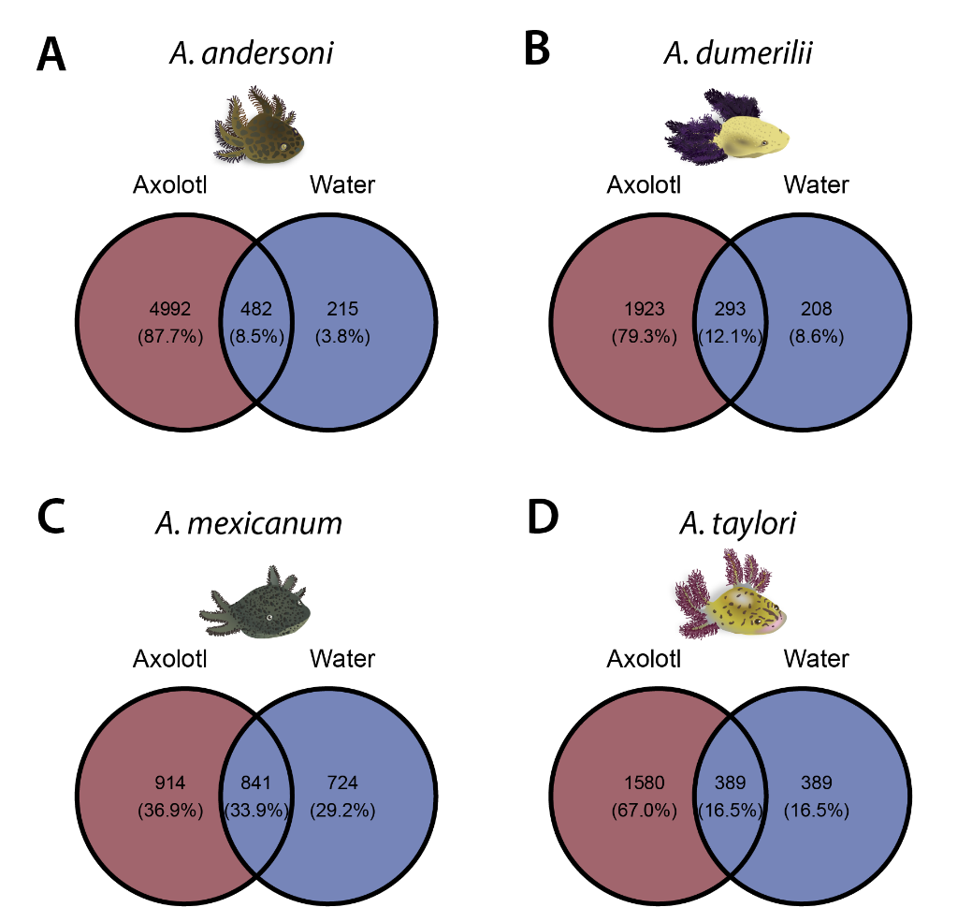
Figure S1. Venn diagrams showing unique and shared bacterial ASVs between axolotl skin and water microbiota for each host species: (A) A. andersoni, (B) A. dumerilii, (C) A. mexicanum and (D) A. taylori. Parenthesis indicate the percentage of unique and shared ASVs between sample types.
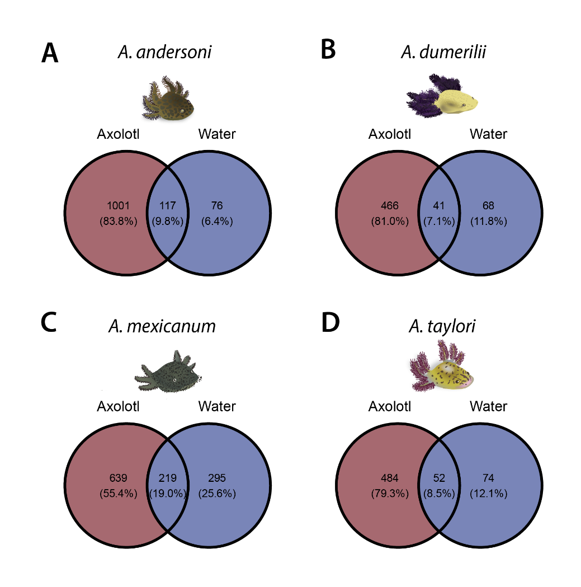

Figure S2 Venn diagrams showing unique and shared fungal ASVs between axolotl skin and water microbiota for each host species: (A) A. andersoni, (B) A. dumerilii, (C) A. mexicanum and (D) A. taylori. Parenthesis indicate the percentage of unique and shared ASVs between sample types.
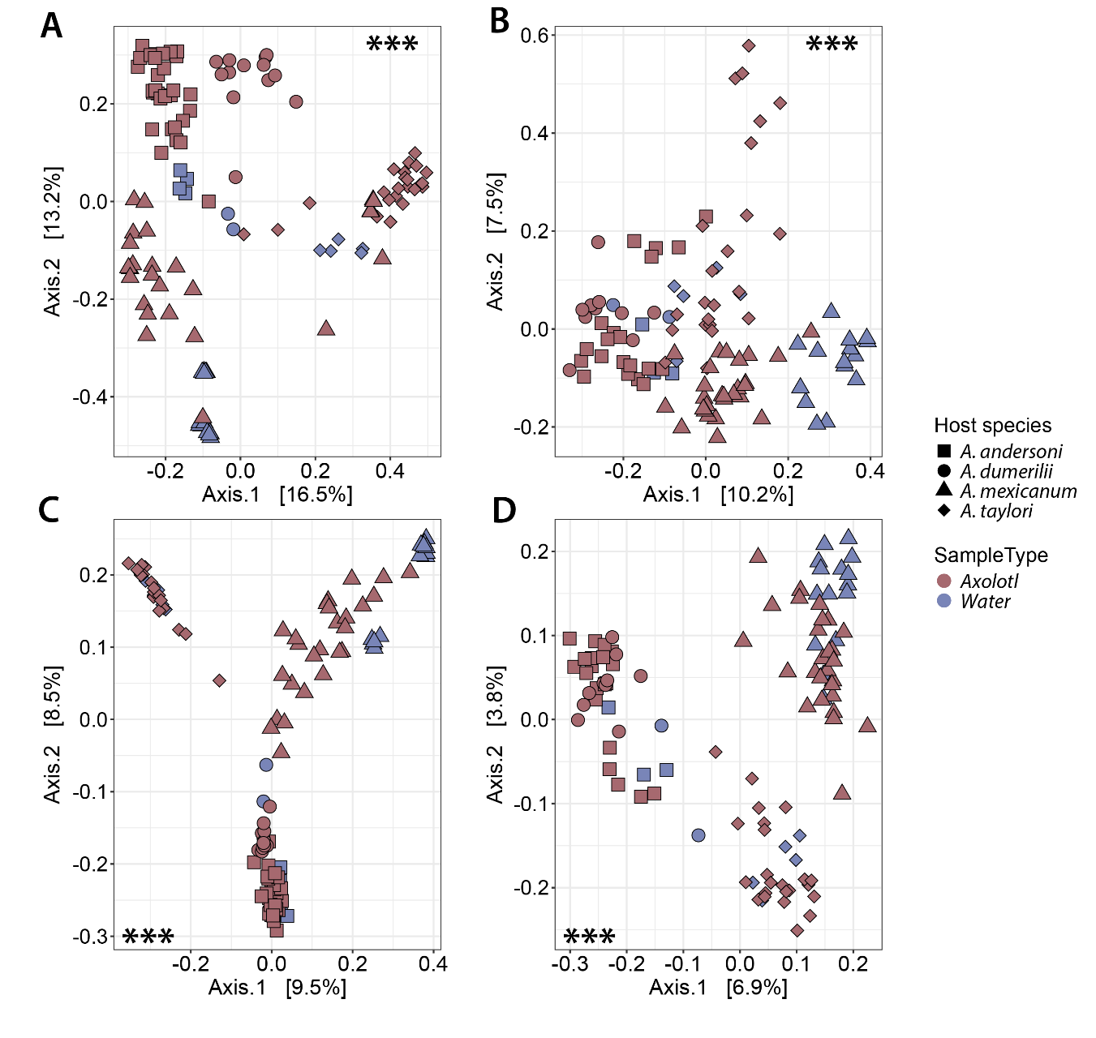

Figure S3 . Beta diversity of axolotl skin and water microbiota for all hosts. Principal Coordinates Analysis (PCoAs) of (A) bacterial and (B) fungal communities using Bray-Curtis and Jaccard distances, respectively (C and D). Shapes in legends denote host species origin. Colors in legend denote the sample type. Asterisks indicate statistically significant differences between sample types: *** = p-value < 0.001.

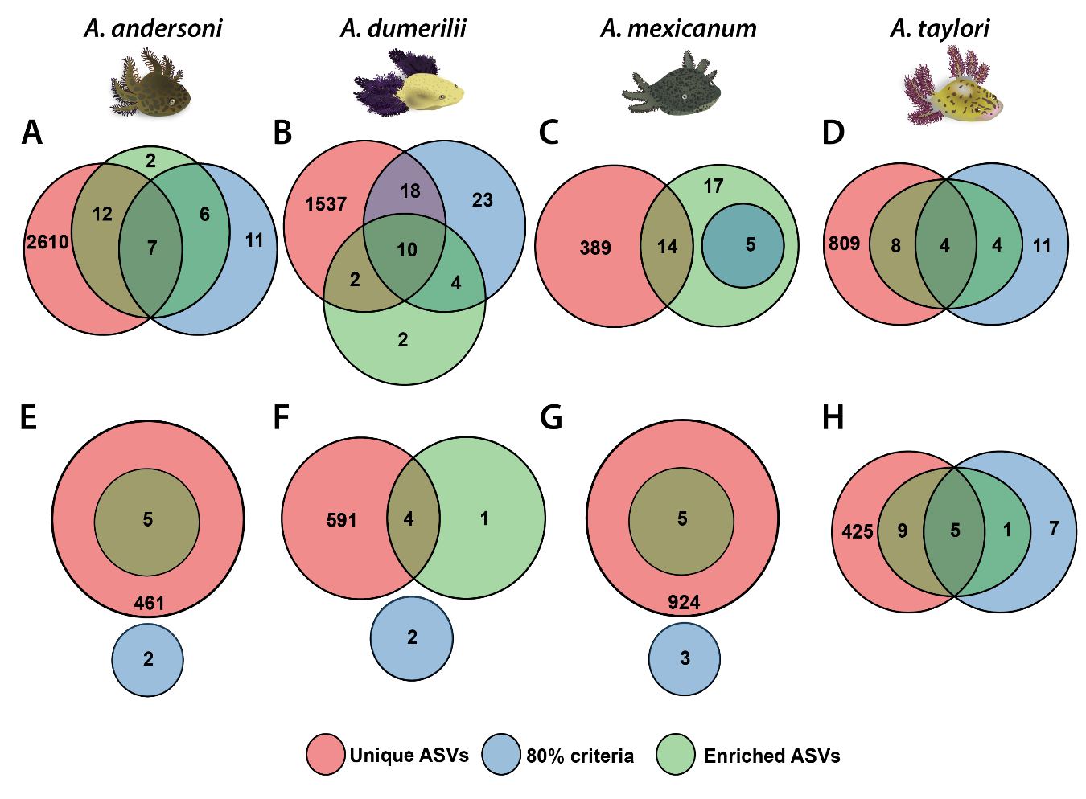

Figure S4. Venn diagrams for each host species showing the skin-associated ASVs using three different criteria: 1) ASVs that were unique only to the skin samples (“Unique ASVs”), 2) ASVs present in at least 80% of skin samples, excluding ASVs that were highly prevalent in water samples (“80% criteria”), 3) ASVs significantly enriched on the skin in contrast with water samples (“Enriched ASVs”). A-D represent bacterial ASVs and E-H represent fungal ASVs for A. andersoni, A. dumerilii, A. mexicanum and A. taylori, respectively.

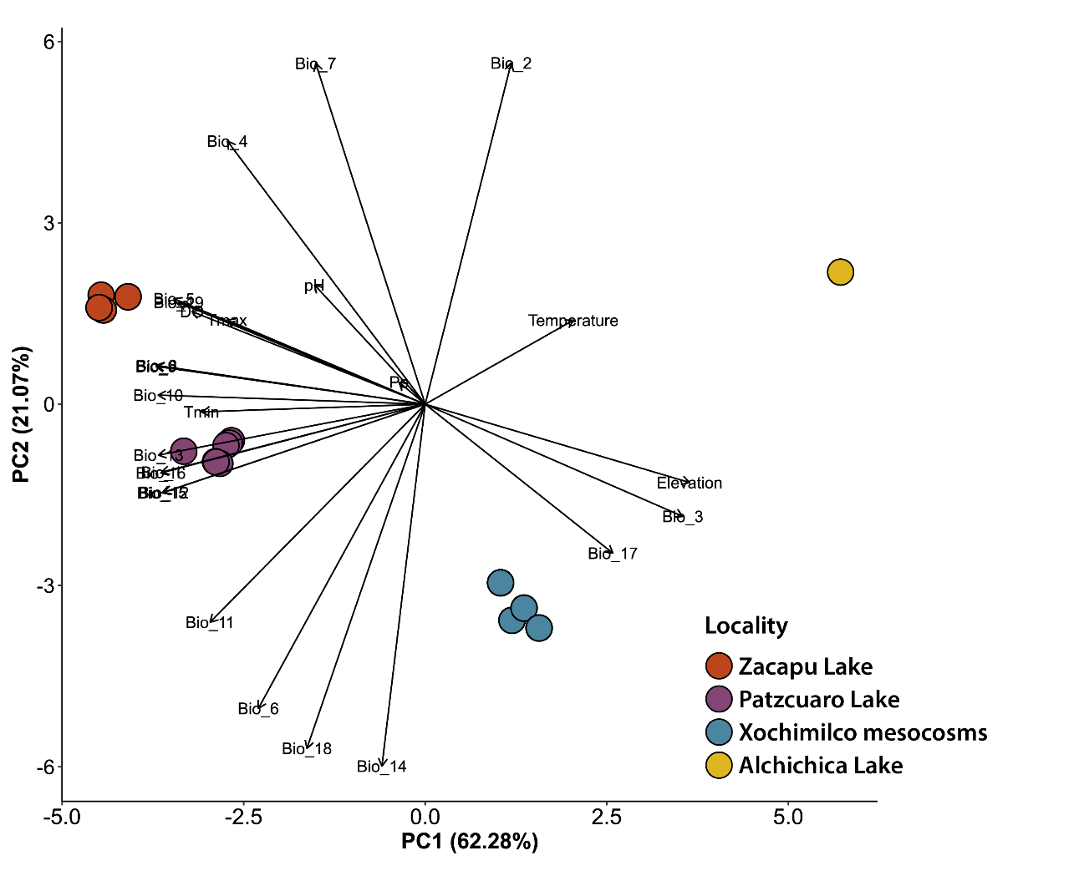

Figure S5. Principal Component Analysis of the environmental matrix data associated to four habitats where axolotls were sampled: Zacapu Lake, Michoacán (red, A. andersoni habitat), Pátzcuaro Lake, Michoacán (yellow, A. dumerilii habitat), Mexico City, CDMX (green, A. mexicanum habitat), Alchichica Lake, Puebla (blue, A. taylori). Vector directions indicate the type of correlation of each predictor variable. See supporting table 1 for variable names.

- SUPPLEMENTARY TABLES

Table S1. Environmental and bioclimatic variables name and definition used in the study.
Variable name | Variable definition
SVL | Snout vent length (cm) of each individual
Weight | Weight (g) of each individual
Elevation | The height of a geographic location above mean sea level
Water temperature | Mean water temperature of the lake where the axolotls were sampled
Water pH | Mean water pH of the lake where the axolotls were sampled
Pp | Mean value of monthly precipitation across 2018
Tmin | Mean value of monthly minimum temperature across 2018
Tmax | Mean value of monthly maximum temperature across 2018
DO | Mean dissolved oxygen values in the lake water where the axolotls were sampled
BIO_1 | Annual Mean Temperature
BIO_2 | Mean Diurnal Range (Mean of monthly (max temp - min temp))
BIO_3 | Isothermality (BIO2/BIO7) (×100)
BIO_4 | Temperature Seasonality (standard deviation ×100)
BIO_5 | Max Temperature of Warmest Month
BIO_6 | Min Temperature of Coldest Month
BIO_7 | Temperature Annual Range (BIO5-BIO6)
BIO_8 | Mean Temperature of Wettest Quarter
BIO_9 | Mean Temperature of Driest Quarter
BIO_10 | Mean Temperature of Warmest Quarter
BIO_11 | Mean Temperature of Coldest Quarter
BIO_12 | Annual Precipitation
BIO_13 | Precipitation of Wettest Month
BIO_14 | Precipitation of Driest Month
BIO_15 | Precipitation Seasonality (Coefficient of Variation)
BIO_16 | Precipitation of Wettest Quarter
BIO_17 | Precipitation of Driest Quarter
BIO_18 | Precipitation of Warmest Quarter
BIO_19 | Precipitation of Coldest Quarter

Table S2. Final bacterial and fungal sample size after the rarefaction process.
Kingdom | Host species | Samples
 |  | Skin | Water | Total
BACTERIA | A. andersoni | 30 | 4 | 34
BACTERIA | A. dumerilii | 13 | 2 | 15
BACTERIA | A. mexicanum | 26 | 15 | 41
BACTERIA | A. taylori | 23 | 5 | 28
BACTERIA | Total samples | 92 | 26 | 118
FUNGI | A. andersoni | 20 | 3 | 23
FUNGI | A. dumerilii | 10 | 2 | 12
FUNGI | A. mexicanum | 27 | 15 | 42
FUNGI | A. taylori | 23 | 5 | 28
FUNGI | Total samples | 80 | 25 | 105

Table S3 . PERMANOVA and PERMUTEST comparisons between skin and water samples for each species based on Bray-Curtis dissimilarity distances. Numbers in bold indicate statistically significant p-values of each comparison.
Kingdom | Sample type comparison (axolotl skin vs water) |  |  | PERMANOVA |  |  |  | PERMUTEST
Kingdom | Sample type comparison (axolotl skin vs water) | DF | Residuals |  | Pseudo-F | R2 | p-value | F | p-value
 | All samples | 1 | 117 |  | 10.32 | 0.0817 | < 0.001 | 1.49 | 0.214
BACTERIA | A. andersoni | 1 | 31 |  | 4.51 | 0.1236 | < 0.001 | 8.281 | < 0.001
BACTERIA | A. dumerilii | 1 | 13 |  | 6.85 | 0.34523 | < 0.01 | 3.73 | 0.128
BACTERIA | A. mexicanum | 1 | 39 |  | 14.9 | 0.2765 | < 0.001 | 5.9 | 0.022
BACTERIA | A. taylori | 1 | 26 |  | 7.28 | 0.2186 | < 0.001 | 4.13 | 0.052
 | All samples | 1 | 103 |  | 4.69 | 0.0435 | < 0.001 | 0.11 | 0.729
FUNGI | A. andersoni | 1 | 21 |  | 1.48 | 0.0658 | 0.095 | 1.23 | 0.219
FUNGI | A. dumerilii | 1 | 10 |  | 1.85 | 0.15672 | 0.024 | 0.012 | 0.871
FUNGI | A. mexicanum | 1 | 40 |  | 7.48 | 0.15752 | < 0.001 | 2.335 | 0.145
FUNGI | A. taylori | 1 | 26 |  | 1.54 | 0.05613 | 0.031 | 4.52 | 0.039

Table S4. PERMANOVA and PERMUTEST comparisons between skin and water samples for each species based on Jaccard similarity distances.
Kingdom | Sample type comparison (axolotl skin vs water) |  |  | PERMANOVA |  |  |  | PERMUTEST
Kingdom | Sample type comparison (axolotl skin vs water) | DF | Residuals |  | Pseudo-F | R2 | p-value | F | p-value
 | All samples | 1 | 117 |  | 4.37 | 0.0363 | < 0.001 | 27.39 | < 0.001
BACTERIA | A. andersoni | 1 | 31 |  | 1.87 | 0.057 | < 0.001 | 118.9 | < 0.001
BACTERIA | A. dumerilii | 1 | 13 |  | 1.91 | 0.128 | 0.01 | 54.3 | < 0.001
BACTERIA | A. mexicanum | 1 | 39 |  | 5.37 | 0.121 | < 0.001 | 69.6 | < 0.001
BACTERIA | A. taylori | 1 | 26 |  | 2.42 | 0.085 | < 0.001 | 20 | 0.002
 | All samples | 1 | 103 |  | 1.95 | 0.018 | < 0.001 | 12.7 | < 0.001
FUNGI | A. andersoni | 1 | 21 |  | 1.24 | 0.056 | 0.026 | 46.8 | < 0.001
FUNGI | A. dumerilii | 1 | 10 |  | 1.51 | 0.131 | 0.018 | 82.2 | < 0.001
FUNGI | A. mexicanum | 1 | 40 |  | 1.82 | 0.043 | < 0.001 | 19.5 | < 0.001
FUNGI | A. taylori | 1 | 26 |  | 1.16 | 0.042 | 0.014 | 24.8 | < 0.001

Table S5. PERMANOVA and PERMUTEST comparisons among host species using Bray-Curtis and Jaccard similarity distances for bacteria and fungi. Numbers in bold indicate statistically significant p-values of each comparison.
Kingdom | Matrix distance |  |  |  | PERMANOVA |  |  | PERMUTEST
Kingdom | Matrix distance | DF | Residuals | Pseudo-F |  | R2 | p-value | F | p-value
BACTERIA | Bray-Curtis | 3 | 87 | 16.9 |  | 0.3683 | < 0.001 | 4.68 | 0.006
BACTERIA | Jaccard | 3 | 87 | 9.2 |  | 0.242 | < 0.001 | 10.17 | < 0.001
FUNGI | Bray-Curtis | 3 | 76 | 5.3 |  | 0.1731 | < 0.001 | 15.75 | < 0.001
FUNGI | Jaccard | 3 | 76 | 3.3 |  | 0.116 | < 0.001 | 29.28 | < 0.001

Table S6. Lineal mixed models of alpha diversity, showing the effect of selected environmental predictors on observed ASVs in skin bacterial and fungal communities in axolotls. See Table S1 for variable names definition. Numbers in bold indicate statistically significant p-values.

Kingdom | Variables | Estimate | Std.Error | t-value | p-value
BACTERIA | (Intercept) | 189.32967 | 6.72708819 | 28.1443717 | < 0.001
BACTERIA | Bio_7 | 38.0695418 | 7.16094693 | 5.31627202 | < 0.001
BACTERIA | Pp | 25.4145776 | 8.26344003 | 3.07554451 | < 0.01
BACTERIA | Tmin | 69.5098657 | 8.46520941 | 8.21123995 | < 0.001
FUNGI | (Intercept) | 66.175 | 3.68017837 | 17.9814654 | < 0.001
FUNGI | Water temperature | 7.59086839 | 4.53417233 | 1.67414642 | 0.09
FUNGI | Bio_6 | 33.6138531 | 5.28807528 | 6.35653831 | < 0.001
FUNGI | Bio_7 | 31.4595823 | 4.70065294 | 6.69259839 | < 0.001
FUNGI | Pp | 6.99521 | 3.74554585 | 1.86760916 | 0.06

Table S7. Permutational multivariate analysis of variance (PERMANOVA) models, showing the effect of predictors introduced on the dbRDA model regression based on Bray-Curtis dissimilarity distances for skin bacterial and fungal communities. Numbers in bold indicate statistically significant p-values. See Table S1 for variable names definition.
Kingdom | Variables | Df | Residuals | Pseudo-F | p-value
BACTERIA | Host species | 3 | 83 | 18.4 | < 0.001
BACTERIA | Water pH | 1 | 83 | 4.05 | < 0.001
BACTERIA | Water temperature | 1 | 83 | 3 | < 0.01
BACTERIA | Pp | 1 | 83 | 3.2 | < 0.01
BACTERIA | Tmin | 1 | 83 | 4.5 | < 0.001
FUNGI | Host species | 3 | 74 | 5.2 | < 0.001
FUNGI | Water temperature | 1 | 74 | 1.1 | < 0.25
FUNGI | Water pH | 1 | 74 | 0.76 | 0.9
FUNGI | Pp | 1 | 74 | 1.05 | 0.34

