Supplementary information
Glacier retreat induces contrasting shifts in bacterial biodiversity patterns in glacial lake water and sediment
Keshao Liu^{1^}, Qi Yan^{2^}, Xuezi Guo^{1, 3}, Wenqiang Wang^{2, 4}, Zhihao Zhang^{1, 3}, Mukan Ji², Feng Wang¹, and Yongqin Liu^{1, 2}*

¹ State Key Laboratory of Tibetan Plateau Earth System, Environment and Resources (TPESER), Institute of Tibetan Plateau Research, Chinese Academy of Sciences, Beijing 100101, China
² Center for the Pan-Third Pole Environment, Lanzhou University, Lanzhou, 730000, China
³ University of Chinese Academy of Sciences, Beijing, 100101, China
⁴ College of ecology, Lanzhou University, Lanzhou, 730000, China
^ Keshao Liu and Qi Yan contributed equally to this study.

* Corresponding author:
Yongqin Liu,
E-mail: yqliu@itpcas.ac.cn
State Key Laboratory of Tibetan Plateau Earth System, Environment and Resources (TPESER), Institute of Tibetan Plateau Research, Chinese Academy of Sciences, Beijing 100101, China.

Running title: Bacterial communities in glacial lakes

Table S2 Relationships of the bacterial communities (at the genera level) and GI in water and sediment samples as indicated by spearman correlation analysis.
Genera | phylum | Water | Sediment
g__Longivirga | Actinobacteriota | -0.22** | -0.32*
g__Tetrasphaera | Actinobacteriota | -0.46** | -0.45**
g__Edaphobaculum | Bacteroidota | -0.34** | -0.69*
g__Arcicella | Bacteroidota | 0.67** | 0.67**
g__RBG-13-54-9 | Chloroflexota | -0.33* | -0.51**
g__Syntrophorhabdus | Desulfobacterota | -0.35* | -0.31***
g__Gemmatimonas | Gemmatimonadota | 0.60* | -0.32**
g__Schlesneria | Planctomycetota | -0.41** | -0.61*
g__Roseococcus | Pseudomonadota | -0.58*** | -0.37***
g__Roseomonas | Pseudomonadota | 0.58* | 0.73**
g__Phenylobacterium | Pseudomonadota | 0.58* | -0.35**
g__UKL13-1 | Pseudomonadota | -0.29* | -0.32*
g__Pseudolabrys | Pseudomonadota | -0.35* | -0.57***
g__Delftia | Pseudomonadota | -0.35* | 0.46*
g__Rhizobacter | Pseudomonadota | 0.70* | -0.60***
g__Ellin6067 | Pseudomonadota | 0.69** | -0.69*
g__Undibacterium | Pseudomonadota | 0.64* | -0.33*
g__Terrimicrobium | Verrucomicrobiota | -0.57*** | -0.48***
Asterisks indicate significant correlation in Spearman’s rank correlation test (*P < 0.05, **P < 0.01, ***P < 0.001)

Table S3 Summary of alpha diversity indices of bacterial community across water and sediment.
Alpha diversity | Lakes | Water |  |  | Sediment
Alpha diversity | Lakes | Mean | SE |  | Mean | SE
Chao1 | Lake 1 | 364 | 18 |  | 575 | 54
Chao1 | Lake 2 | 251 | 7 |  | 664 | 46
Chao1 | Lake 3 | 429 | 36 |  | 730 | 12
Chao1 | Lake 4 | 440 | 10 |  | 1045 | 62
Chao1 | Lake 5 | 228 | 16 |  | 1144 | 15
Chao1 | Lake 6 | 220 | 16 |  | 1123 | 49
Chao1 | Lake 7 | 323 | 19 |  | 910 | 38
Shannon | Lake 1 | 6.00 | 0.18 |  | 7.08 | 0.22
Shannon | Lake 2 | 5.16 | 0.18 |  | 6.88 | 0.45
Shannon | Lake 3 | 5.69 | 0.14 |  | 7.38 | 0.44
Shannon | Lake 4 | 5.51 | 0.61 |  | 8.74 | 0.26
Shannon | Lake 5 | 3.67 | 0.42 |  | 9.06 | 0.30
Shannon | Lake 6 | 5.00 | 0.12 |  | 8.80 | 0.27
Shannon | Lake 7 | 4.46 | 0.17 |  | 8.59 | 0.15

Table S4 The topological features of co-occurrence networks for water and sediment.
 |  |  | Water |  |  | Sediment
 |  |  | HGL | LGL |  | HGL | LGL
Empirical  networks | Nodes |  | 166 | 84 |  | 309 | 555
Empirical  networks | Edges |  | 1052 | 180 |  | 884 | 2419
Empirical  networks | Average degree |  | 14.5 | 5.96 |  | 8.4 | 12.5
Empirical  networks | Modularity |  | 0.47 | 0.64 |  | 0.79 | 0.63
Empirical  networks | Density |  | 0.08 | 0.05 |  | 0.02 | 0.02
Empirical  networks | Clustering coefficient |  | 0.607 | 0.606 |  | 0.57 | 0.44
Empirical  networks | Average path length |  | 2.96 | 1.97 |  | 5.90 | 4.59
Empirical  networks | Power-law model |  | 0.87 | 0.95 |  | 0.95 | 0.90
Empirical  networks | Log (Betweenness centrality+1) |  | 1.12±1.01 | 0.41±0.55 |  | 1.35±1.32 | 1.89±1.30
Empirical  networks | Log (Eigenvector centrality+1) |  | 0.08±0.10 | 0.06±0.09 |  | 0.03±0.07 | 0.05±0.07
Random  networks |  | Average clustering coefficient | 0.08±0.004 | 0.05±0.01 |  | 0.02±0.006 | 0.02±0.01
 |  | Average path length | 2.27±0.004 | 3.14±0.05 |  | 3.47±0.013 | 3.15±0.004
 |  | Modularity | 0.13±0.004 | 0.43±0.015 |  | 0.39±0.006 | 0.30±0.004

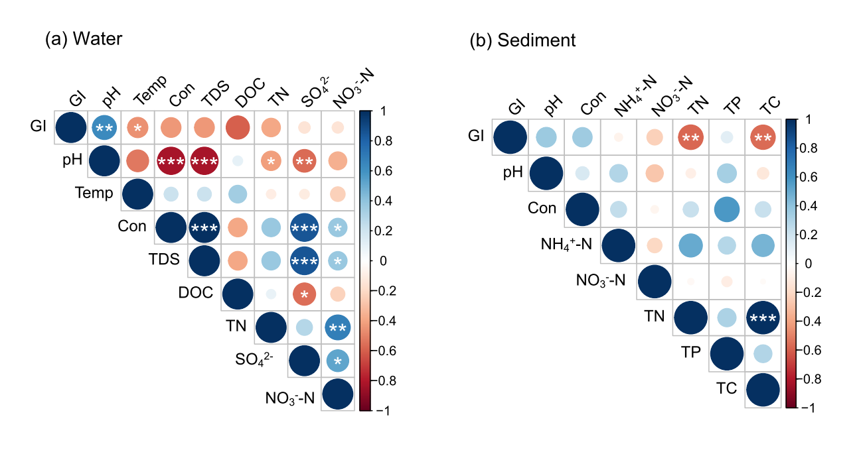
Figure S1. Spearman correlations between the glacier index (GI) and environmental factors in water (a) and sediment (b) of studying glacial lakes. Temp: temperature; Con: conductivity; TDS: total dissolved solids; DOC: dissolved organic carbon; TN: total nitrogen; TP: total phosphorus; TC: total carbon. *P < 0.05, **P < 0.01, ***P < 0.001.

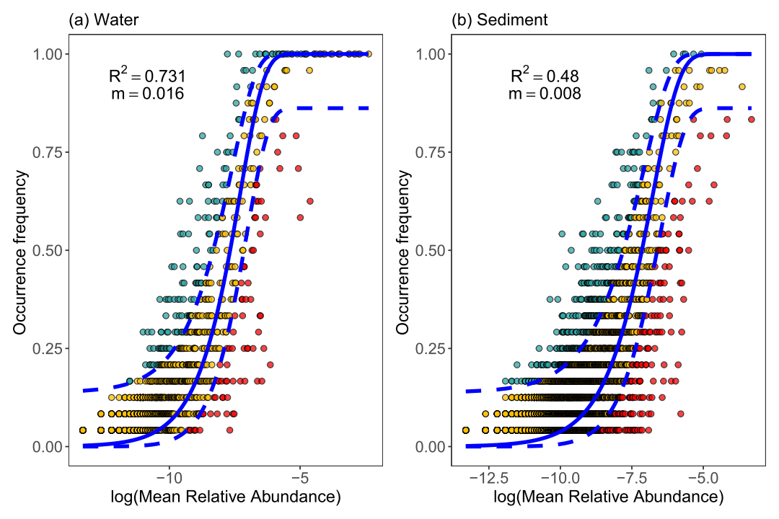
Figure S2. The neutral community model (NCM) applied to assess the assembly of water (a) and sediment (b) bacterial communities. The solid blue lines indicate the best-ﬁt to the neutral model, and dashed blue lines represent 95% conﬁdence intervals around the model prediction. OTUs that occur more or less frequently than predicted by the NCM are shown in green and red, respectively. m, migration rate; R² indicates the goodness of the overall ﬁt of the model.

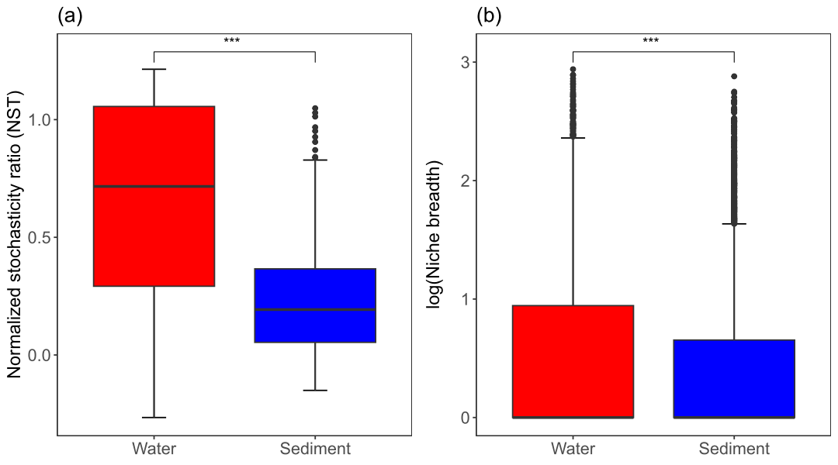
Figure S3. Ecological processes shaping the bacterial community assembly in water and sediment of glacial lakes. (a) The ecological stochasticity in bacterial community assembly estimated by normalized stochasticity ratio. (b) Mean habitat niche breadth from all taxa in each sample (Bcom) of bacterial communities in water and sediment of glacial lakes. Asterisks represent significance (∗∗∗, P < 0.001).

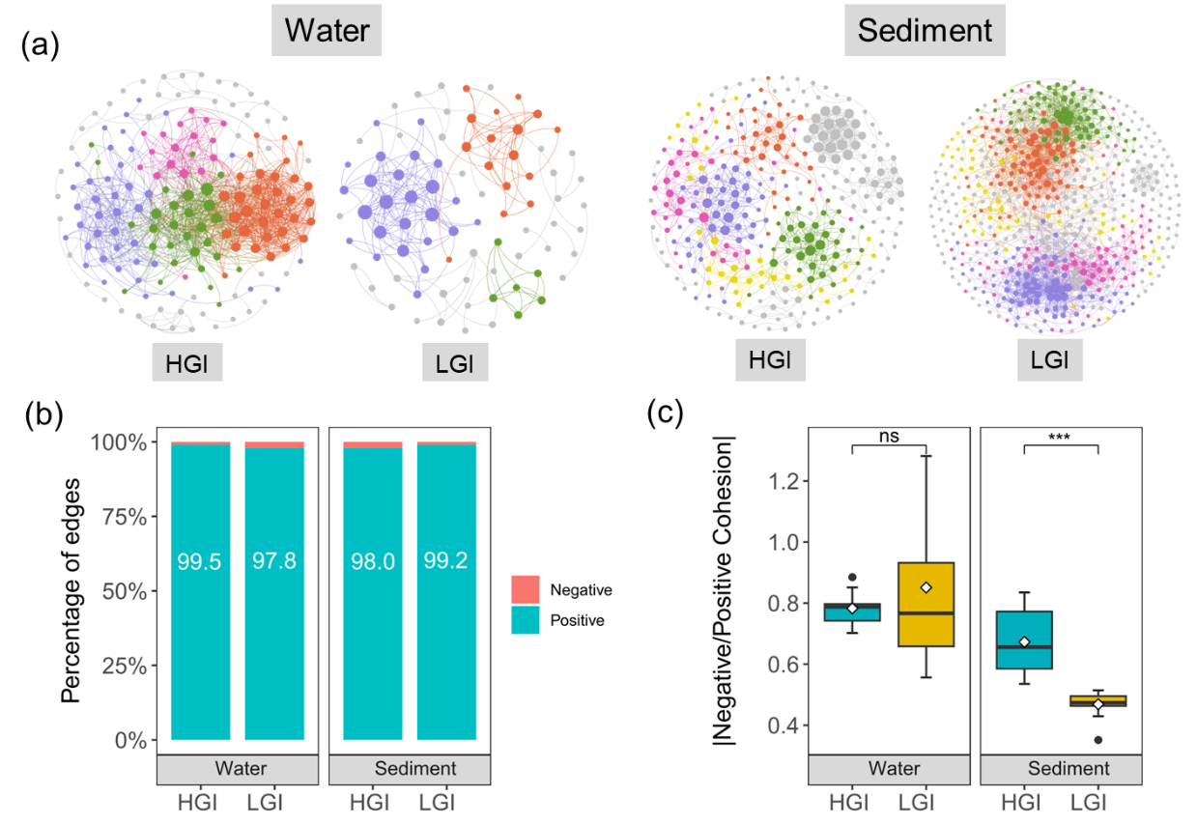
Figure S4. Co-occurrence networks for bacterial communities in water and sediments of glacial lakes. (a) Bacterial co-occurrence networks of water and sediments in HGI and LGI lakes. The modules are randomly colored and the size of each node is proportional to the degree. A connection indicates a strong (Spearman’s ρ > 0.8) and significant (P < 0.01) correlation. (b) Percentage of negative and positive edges in bacterial co-occurrence networks of water and sediments in HGI and LGI lakes. (c) Comparison of negative:positive cohesion in water and sediments of HGI and LGI lakes. ns, P > 0.05; ***, P < 0.001.

