Influence of growth support on the diversity, composition and functionality of microbial communities associated with Tillandsia recurvata

Josiane Soares Siqueira¹, Lucas Amoroso Lopes de Carvalho¹, Carlos Henrique Barbosa Santos², Edvan Teciano Frezarin¹, Daniel Guariz Pinheiro¹, Daniel Nicodemo³, Nicolas Desoignies⁴, Everlon Cid Rigobelo^{1*}
¹ Agricultural and Livestock Microbiology Postgraduate Program, São Paulo State University (UNESP), School of Agricultural and Veterinarian Sciences, Jaboticabal, 14884-900, São Paulo, Brazil
² São Paulo State University (UNESP), School of Agricultural and Veterinarian Sciences, Jaboticabal, 14884-900, São Paulo, Brazil
³ Department of Animal Science, School of Agricultural and Veterinarian Sciences, São Paulo State University (UNESP), Jaboticabal, 14884-900, São Paulo, Brazil
⁴ Phytopathology, Microbial and Molecular Farming Lab, Center D' Etudes et Recherche Appliquée-Haute Ecole Provinciale du Hainaut Condorcet, Ath, Belgium.

* Correspondence:everlon.cid@unesp.br; ORCID: 0000-0002-9734-3338

Supplementary Material

Table S1. Counts of sequence reads before and after bioinformatics processing. The table includes the number of raw 16S rRNA and ITS sequence reads ("Raw") and the reads retained after identifying and filtering Amplicon Sequence Variants ("ASVs"). The "ASVs (Filtered)" column shows the total number of reads remaining after the removal of contaminant sequences, including those from mitochondria and chloroplasts, with the corresponding ASV richness indicated in parentheses. LT = Leaves of Tillandsia recurvata obtained from trees, RT = Roots of T. recurvata obtained from trees, LF = Leaves of T. recurvata obtained from fences, RF = Roots of T. recurvata obtained from fences.

 | Sample | Raw | ASVs | ASVs (Filtered)
16S rRNA (Bacteria) | LT.1 | 406,432 | 375,019 (415) | 33,436 (373)
16S rRNA (Bacteria) | LT.2 | 224,541 | 206,498 (922) | 171,766 (906)
16S rRNA (Bacteria) | LT.3 | 415,891 | 381,873 (492) | 40,291 (449)
16S rRNA (Bacteria) | LT.4 | 237,420 | 218,639 (330) | 6,887 (295)
16S rRNA (Bacteria) | LT.5 | 193,545 | 178,374 (1,205) | 95,369 (1,182)
16S rRNA (Bacteria) | RT.P | 391,499 | 347,050 (3,723) | 336,515 (3,668)
16S rRNA (Bacteria) | LF.1 | 471,047 | 443,018 (213) | 15,720 (157)
16S rRNA (Bacteria) | LF.2 | 252,606 | 234,383 (443) | 18,424 (413)
16S rRNA (Bacteria) | LF.3 | 194,735 | 179,460 (150) | 4,215 (120)
16S rRNA (Bacteria) | LF.4 | 339,536 | 316,138 (477) | 64,380 (451)
16S rRNA (Bacteria) | LF.5 | 491,355 | 461,958 (139) | 2,171 (100)
16S rRNA (Bacteria) | RF.P | 108,360 | 94,254 (703) | 68,909 (680)
ITS (Fungi) | LT.1 | 299,204 | 236,768 (297) | 236,701 (294)
ITS (Fungi) | LT.2 | 246,970 | 195,853 (306) | 195,764 (303)
ITS (Fungi) | LT.3 | 181,486 | 149,790 (311) | 149,023 (304)
ITS (Fungi) | LT.4 | 230,528 | 207,994 (367) | 207,962 (365)
ITS (Fungi) | LT.5 | 202,849 | 158,850 (175) | 158,776 (173)
ITS (Fungi) | RT.P | 334,619 | 232,876 (423) | 231,766 (409)
ITS (Fungi) | LF.1 | 331,889 | 291,841 (203) | 291,841 (203)
ITS (Fungi) | LF.2 | 184,620 | 157,479 (255) | 157,470 (253)
ITS (Fungi) | LF.3 | 146,585 | 130,244 (286) | 130,235 (285)
ITS (Fungi) | LF.4 | 465,055 | 408,946 (336) | 408,853 (330)
ITS (Fungi) | LF.5 | 199,495 | 177,231 (284) | 177,154 (279)
ITS (Fungi) | RF.P | 337,914 | 282,024 (331) | 281,795 (325)

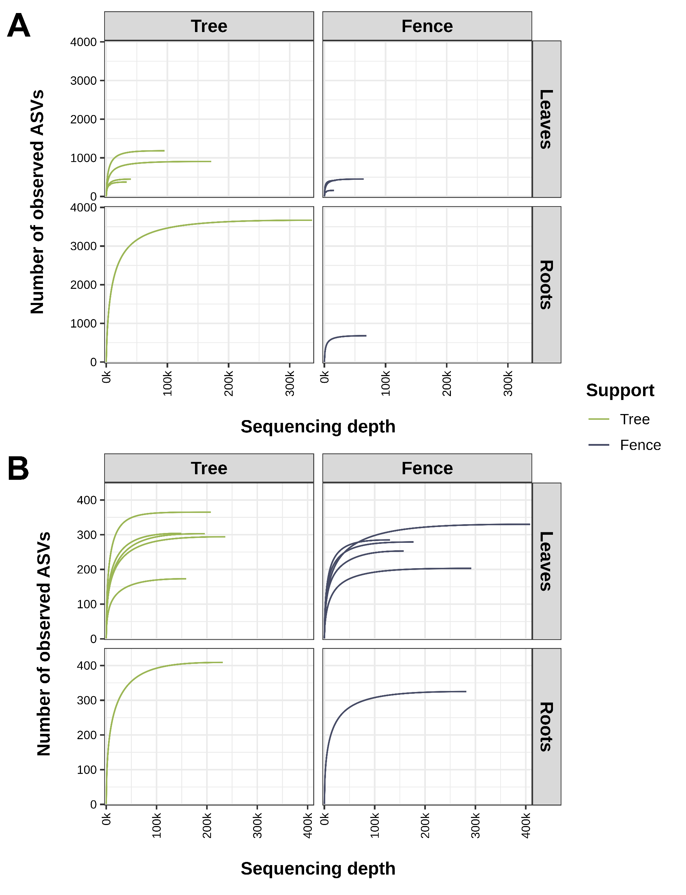
Figure S1. Rarefaction curves illustrating the observed Amplicon Sequence Variants (ASVs) of bacterial (A) and fungal (B) communities associated with Tillandsia recurvata growing on trees and fences, separated by organ system (leaves and roots). The y-axis represents the number of observed ASVs, while the x-axis denotes sequencing depth. The curves show the stabilization into a plateau, indicating sufficient sequencing coverage to capture the microbial diversity within each sample.

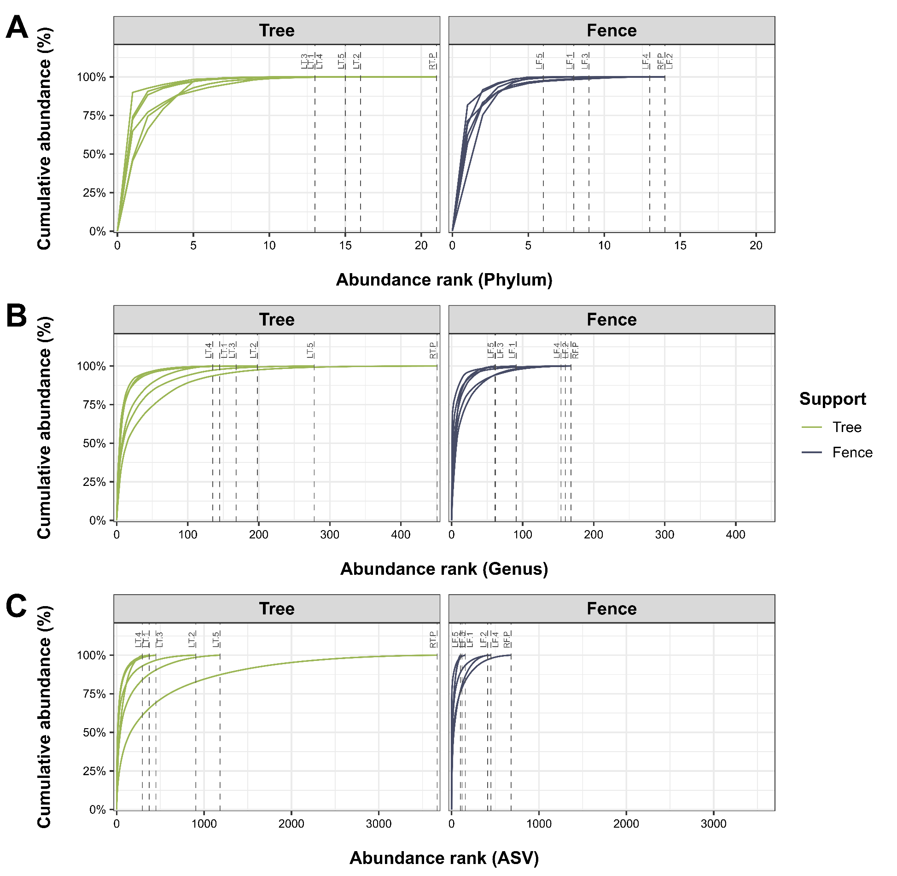
Figure S2. Cumulative relative abundance curves displaying the bacterial community distribution at the Phylum (A), Genus (B), and Amplicon Sequence Variant (ASV) (C) ranks in Tillandsia recurvata samples collected from trees and fences. The y-axis represents cumulative abundance (%), while the x-axis shows the taxa rank. Dashed lines indicate the point at which each sample reaches 100% of its relative abundance.

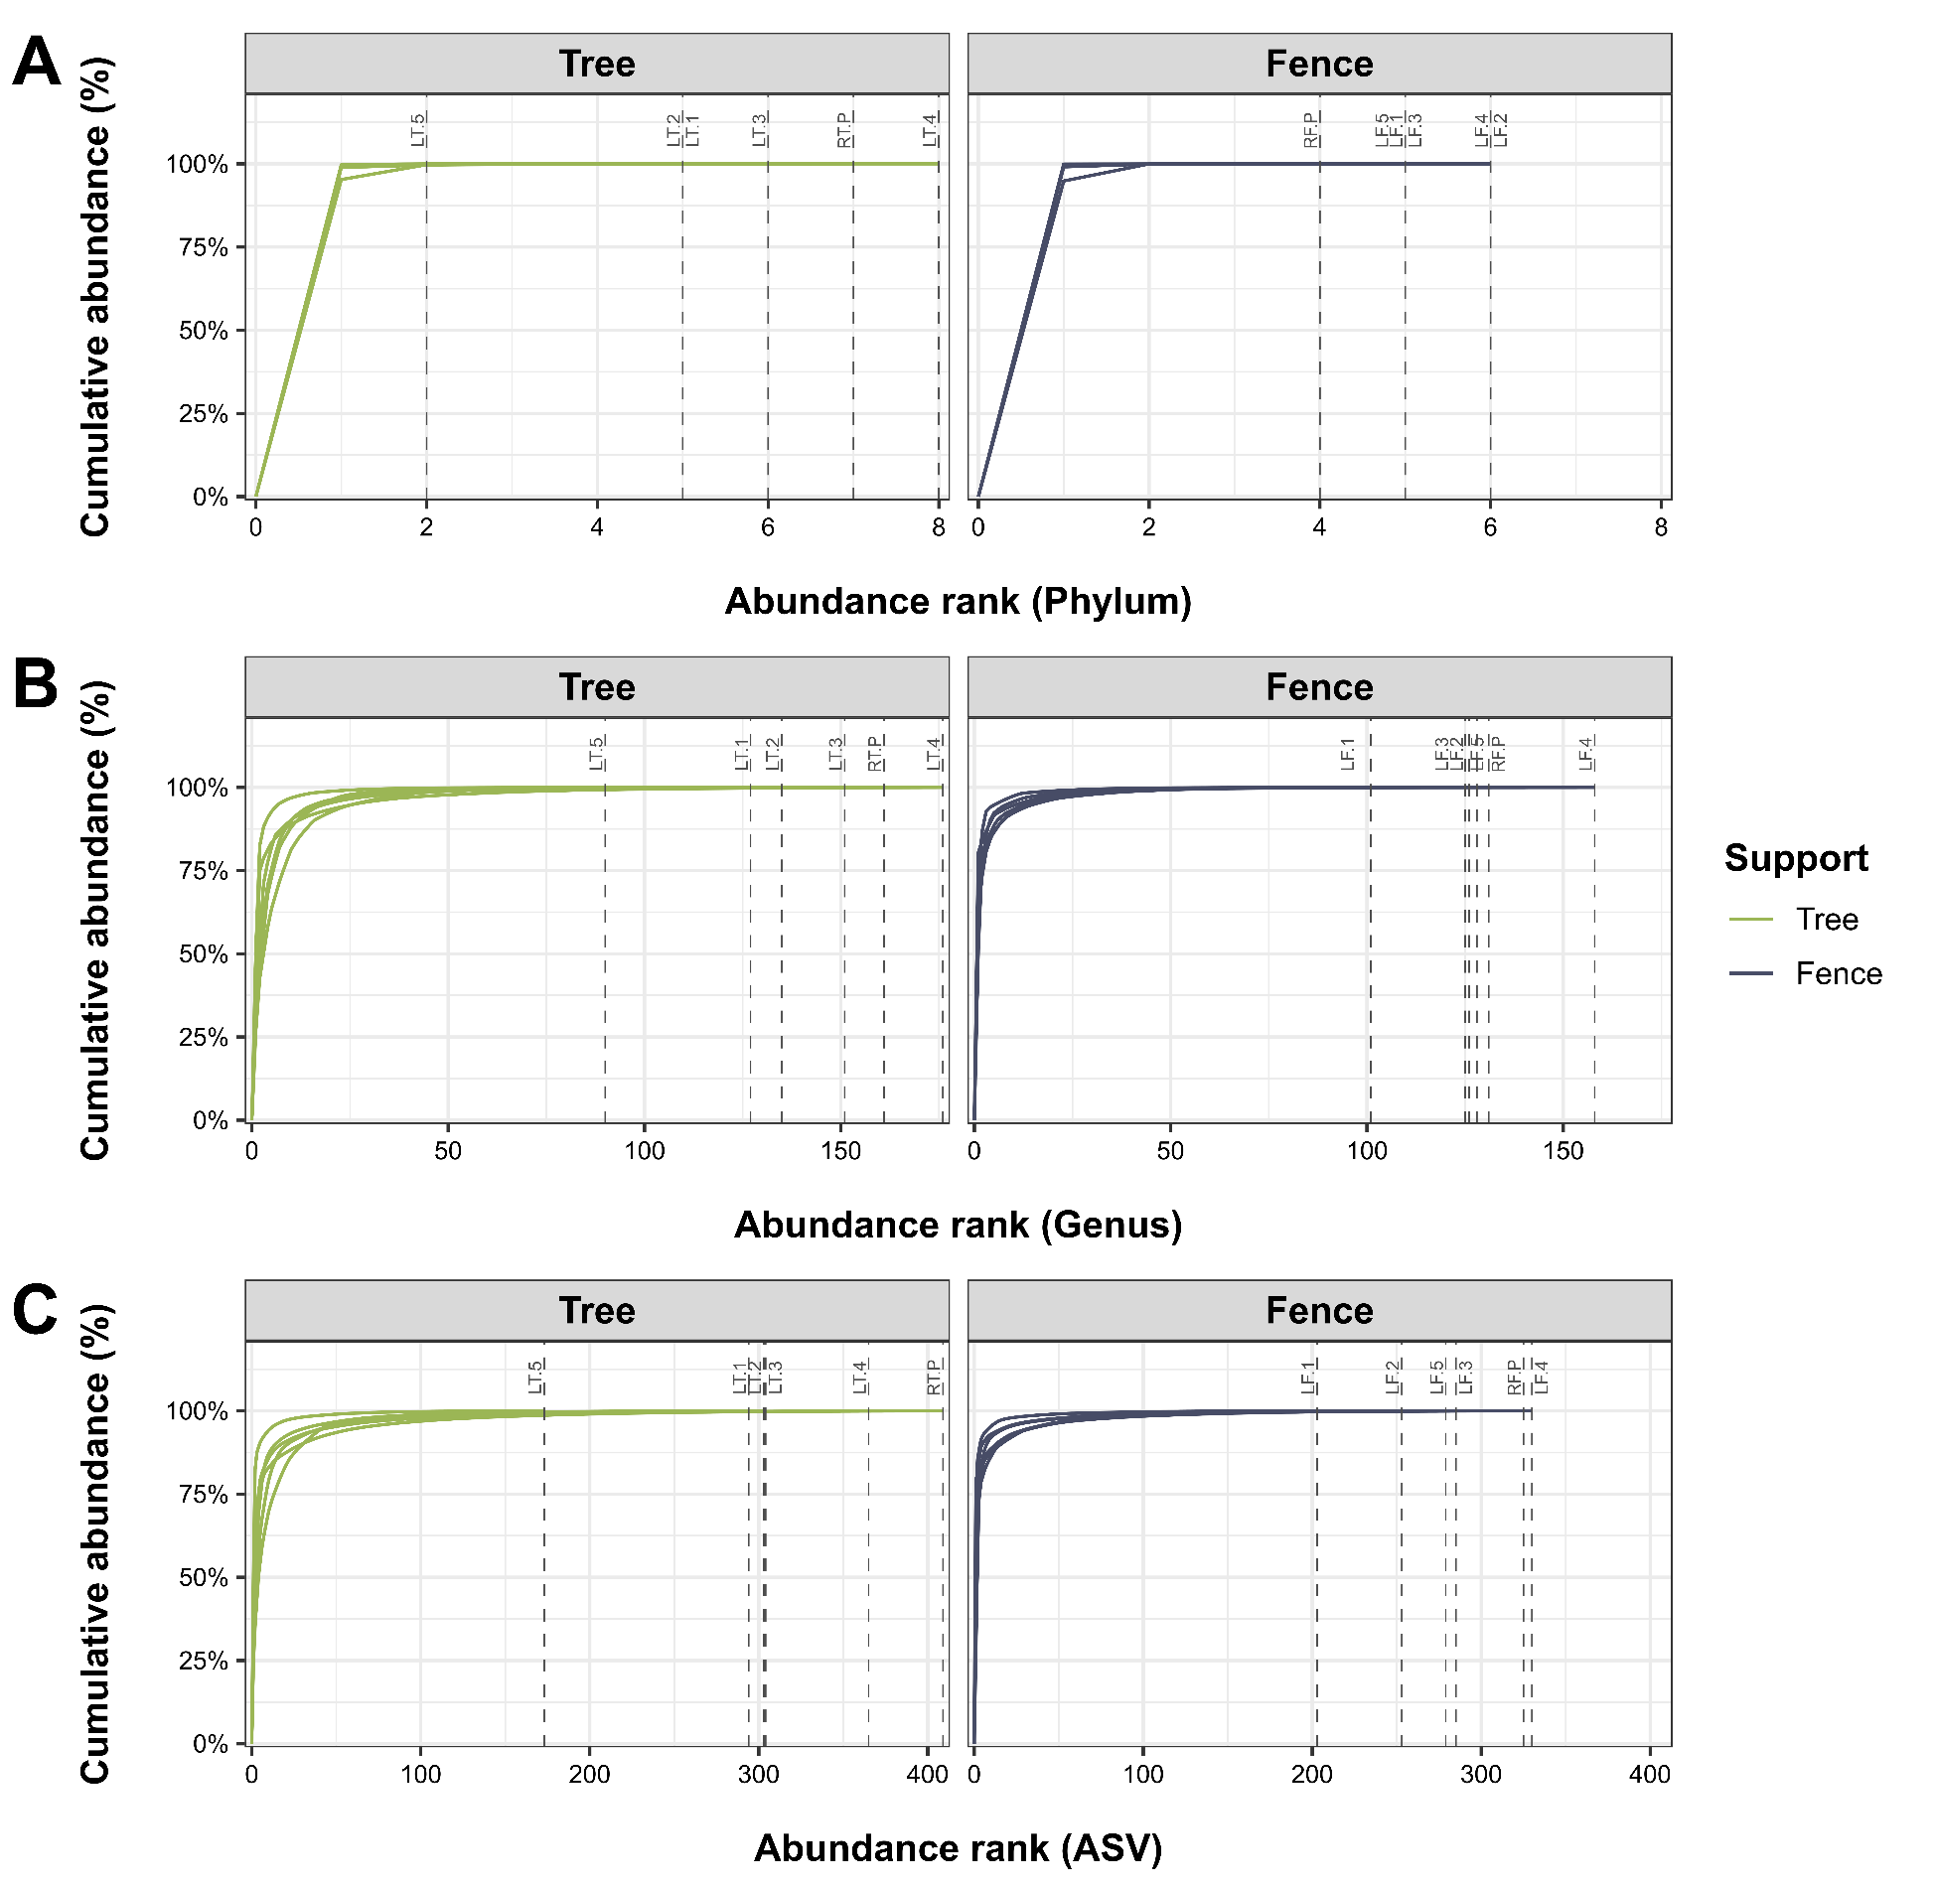
Figure S3. Cumulative relative abundance curves displaying the fungal community distribution at the Phylum (A), Genus (B), and Amplicon Sequence Variant (ASV) (C) ranks in Tillandsia recurvata samples collected from trees and fences. The y-axis represents cumulative abundance (%), while the x-axis shows the taxa rank. Dashed lines indicate the point at which each sample reaches 100% of its relative abundance.

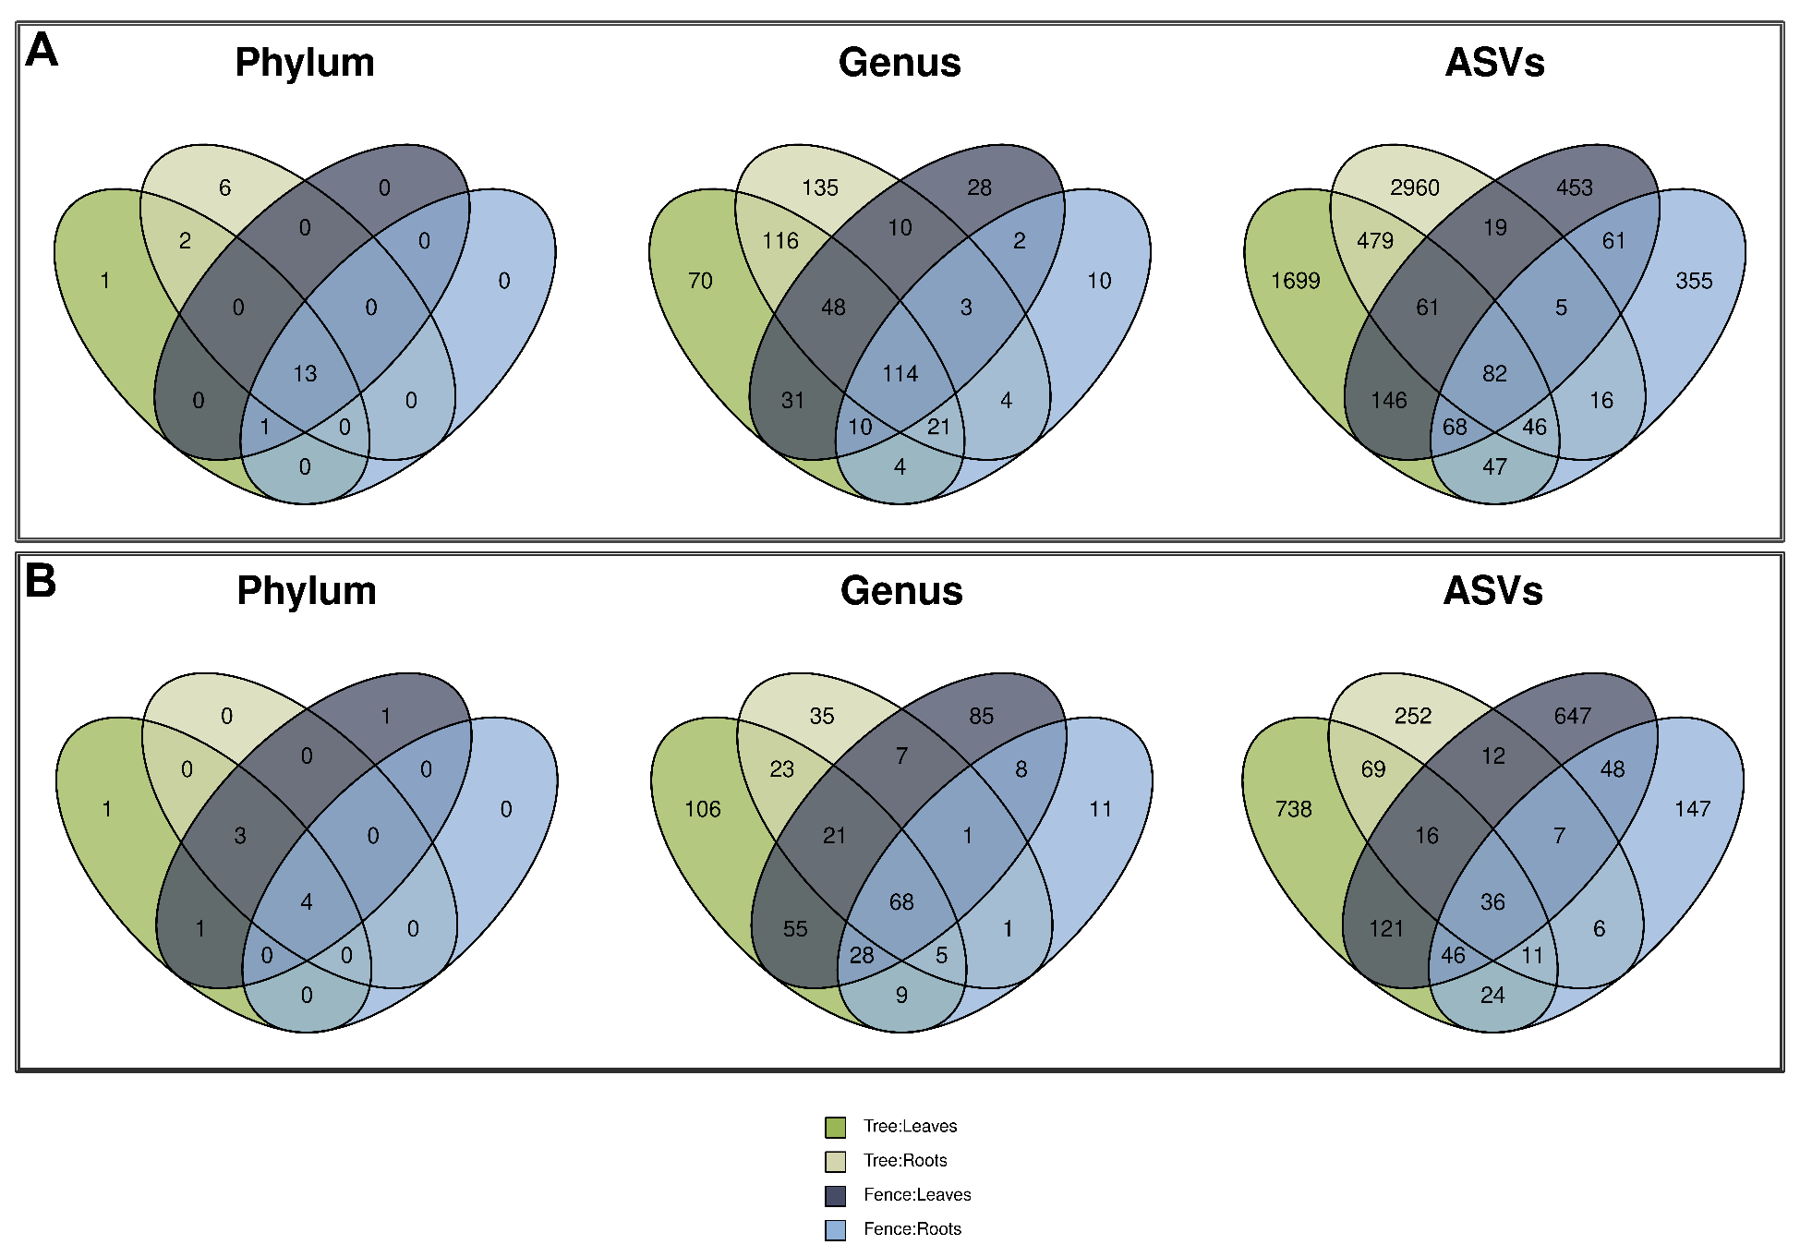
Figure S4. Venn diagrams depicting the shared and unique bacterial (A) and fungal (B) across taxonomic ranks (Phyla, Genera, and ASVs) among Tillandsia recurvata samples collected from two different locations (trees and fences) and two plant tissues (leaves and roots). Each diagram represents the overlap and exclusivity of microbial diversity across the specified groups, illustrating the extent of taxonomic sharing among the samples.

Table S2. Alpha diversity metrics—Richness, Shannon, and Gini-Simpson Index— of microbial (bacterial and fungal) communities across leaves and roots samples of Tillandsia recurvata collected from trees and fences. LT = Leaves of T. recurvata obtained from trees, RT = Roots of T. recurvata obtained from trees, LF = Leaves of T. recurvata obtained from fences, RF = Roots of T. recurvata obtained from fences.

 | Sample | Richness | Shannon | Gini-Simpson
16S rRNA | LT.1 | 373 | 4.22 | 0.962
16S rRNA | LT.2 | 906 | 4.79 | 0.975
16S rRNA | LT.3 | 449 | 4.38 | 0.970
16S rRNA | LT.4 | 295 | 5.02 | 0.990
16S rRNA | LT.5 | 1182 | 5.50 | 0.982
16S rRNA | RT.P | 3668 | 6.82 | 0.996
16S rRNA | LF.1 | 157 | 1.90 | 0.522
16S rRNA | LF.2 | 413 | 4.94 | 0.982
16S rRNA | LF.3 | 120 | 3.89 | 0.964
16S rRNA | LF.4 | 451 | 4.14 | 0.944
16S rRNA | LF.5 | 100 | 3.64 | 0.925
16S rRNA | RF.P | 680 | 4.81 | 0.968
ITS | LT.1 | 294 | 3.20 | 0.908
ITS | LT.2 | 303 | 2.56 | 0.842
ITS | LT.3 | 304 | 2.93 | 0.883
ITS | LT.4 | 365 | 2.42 | 0.753
ITS | LT.5 | 173 | 1.56 | 0.637
ITS | RT.P | 409 | 2.49 | 0.814
ITS | LF.1 | 203 | 1.23 | 0.451
ITS | LF.2 | 253 | 1.66 | 0.623
ITS | LF.3 | 285 | 1.90 | 0.599
ITS | LF.4 | 330 | 2.12 | 0.791
ITS | LF.5 | 279 | 2.13 | 0.689
ITS | RF.P | 325 | 1.37 | 0.372

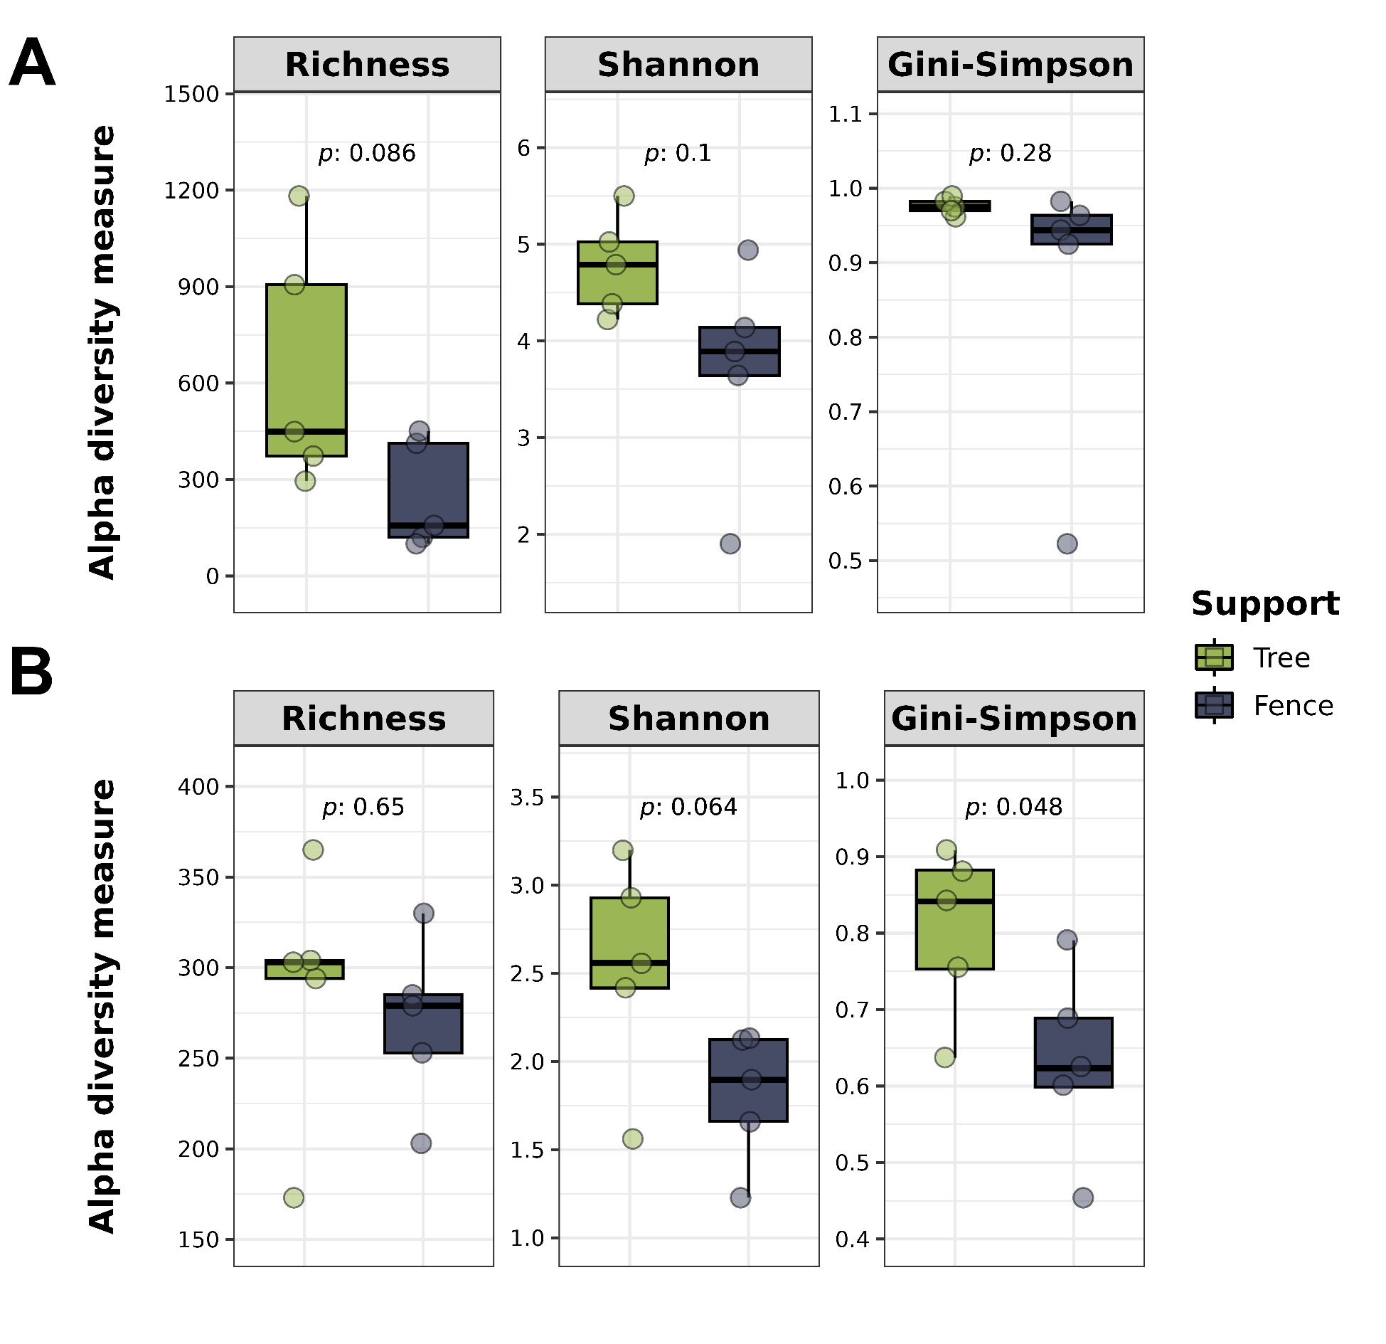
Figure S5. Box plots displaying alpha diversity metrics—Richness, Shannon, and Gini-Simpson Index— of bacterial (A) and fungal (B) communities across leaves' samples of Tillandsia recurvata collected from trees and fences. The box plots illustrate the variation in diversity within these samples. Statistical comparisons were performed using Student’s t-test to identify significant differences (p ≤ 0.05) between the two groups.

Table S3. Alpha diversity metrics—Richness, Shannon, and Gini-Simpson Index— of rare microorganisms (bacterial and fungal) across leaves and roots samples of Tillandsia recurvata collected from trees and fences. LT = Leaves of T. recurvata obtained from trees, RT = Roots of T. recurvata obtained from trees, LF = Leaves of T. recurvata obtained from fences, RF = Roots of T. recurvata obtained from fences.

 | Sample | Richness | Shannon | Gini-Simpson
16S rRNA | LT.1 | 235 | 4.17 | 0.962
16S rRNA | LT.2 | 542 | 5.17 | 0.984
16S rRNA | LT.3 | 216 | 4.06 | 0.958
16S rRNA | LT.4 | 158 | 4.35 | 0.977
16S rRNA | LT.5 | 938 | 5.67 | 0.992
16S rRNA | RT.P | 467 | 4.93 | 0.980
16S rRNA | LF.1 | 49 | 2.24 | 0.739
16S rRNA | LF.2 | 187 | 4.64 | 0.984
16S rRNA | LF.3 | 34 | 2.44 | 0.828
16S rRNA | LF.4 | 184 | 3.57 | 0.922
16S rRNA | LF.5 | 28 | 3.07 | 0.940
16S rRNA | RF.P | 116 | 3.96 | 0.964
ITS | LT.1 | 163 | 2.50 | 0.830
ITS | LT.2 | 136 | 3.41 | 0.923
ITS | LT.3 | 141 | 3.21 | 0.885
ITS | LT.4 | 208 | 4.19 | 0.966
ITS | LT.5 | 94 | 3.65 | 0.960
ITS | RT.P | 61 | 2.78 | 0.870
ITS | LF.1 | 89 | 2.78 | 0.761
ITS | LF.2 | 107 | 3.92 | 0.968
ITS | LF.3 | 131 | 3.22 | 0.886
ITS | LF.4 | 172 | 3.76 | 0.942
ITS | LF.5 | 124 | 2.70 | 0.816
ITS | RF.P | 40 | 2.79 | 0.905

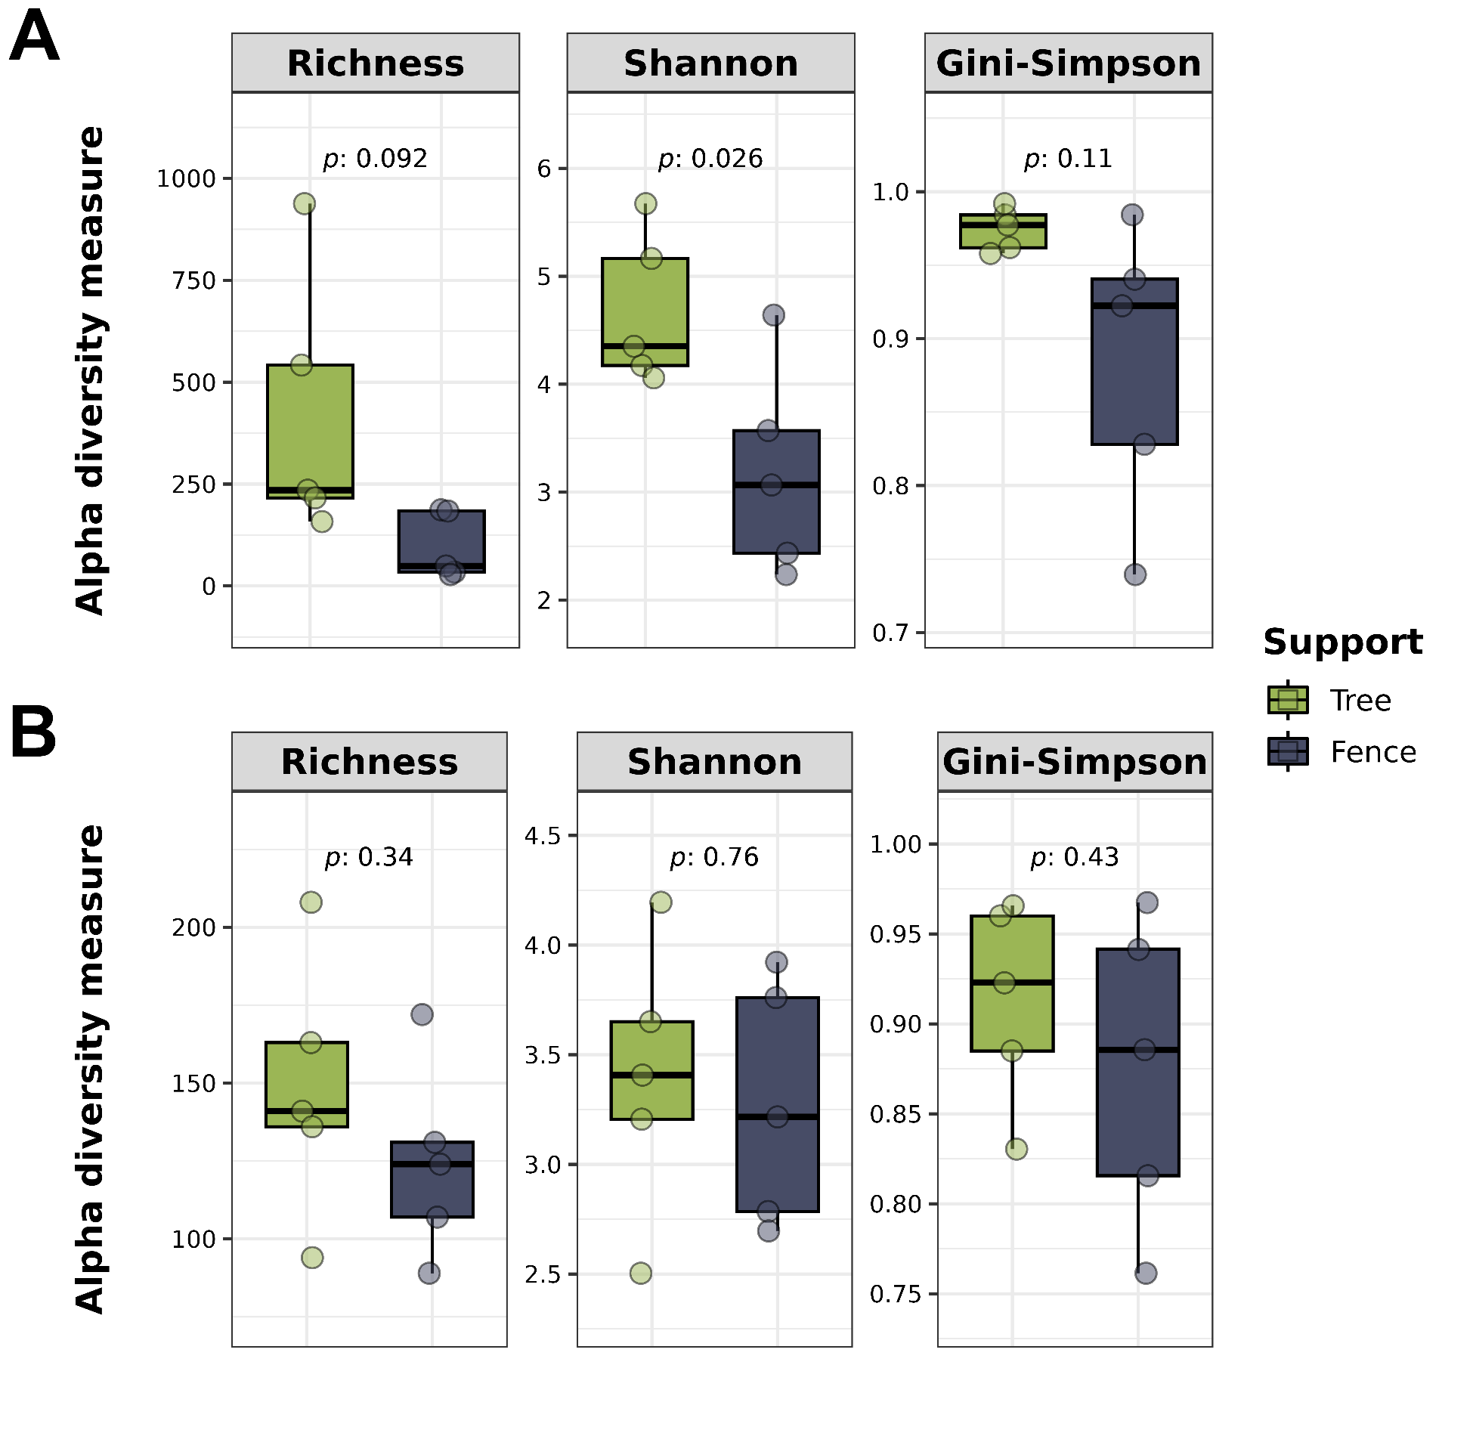
Figure S6. Box plots displaying the alpha diversity of rare Amplicon Sequence Variants (ASVs) in leaf samples of Tillandsia recurvata collected from trees and fences. The diversity metrics shown include Richness, Shannon, and Gini-Simpson Index. Rare ASVs were defined as those with an average relative abundance of less than 0.001% in the groups or those present in only one sample. Statistical comparisons between the two groups were performed using Student’s t-test to identify significant differences (p ≤ 0.05).

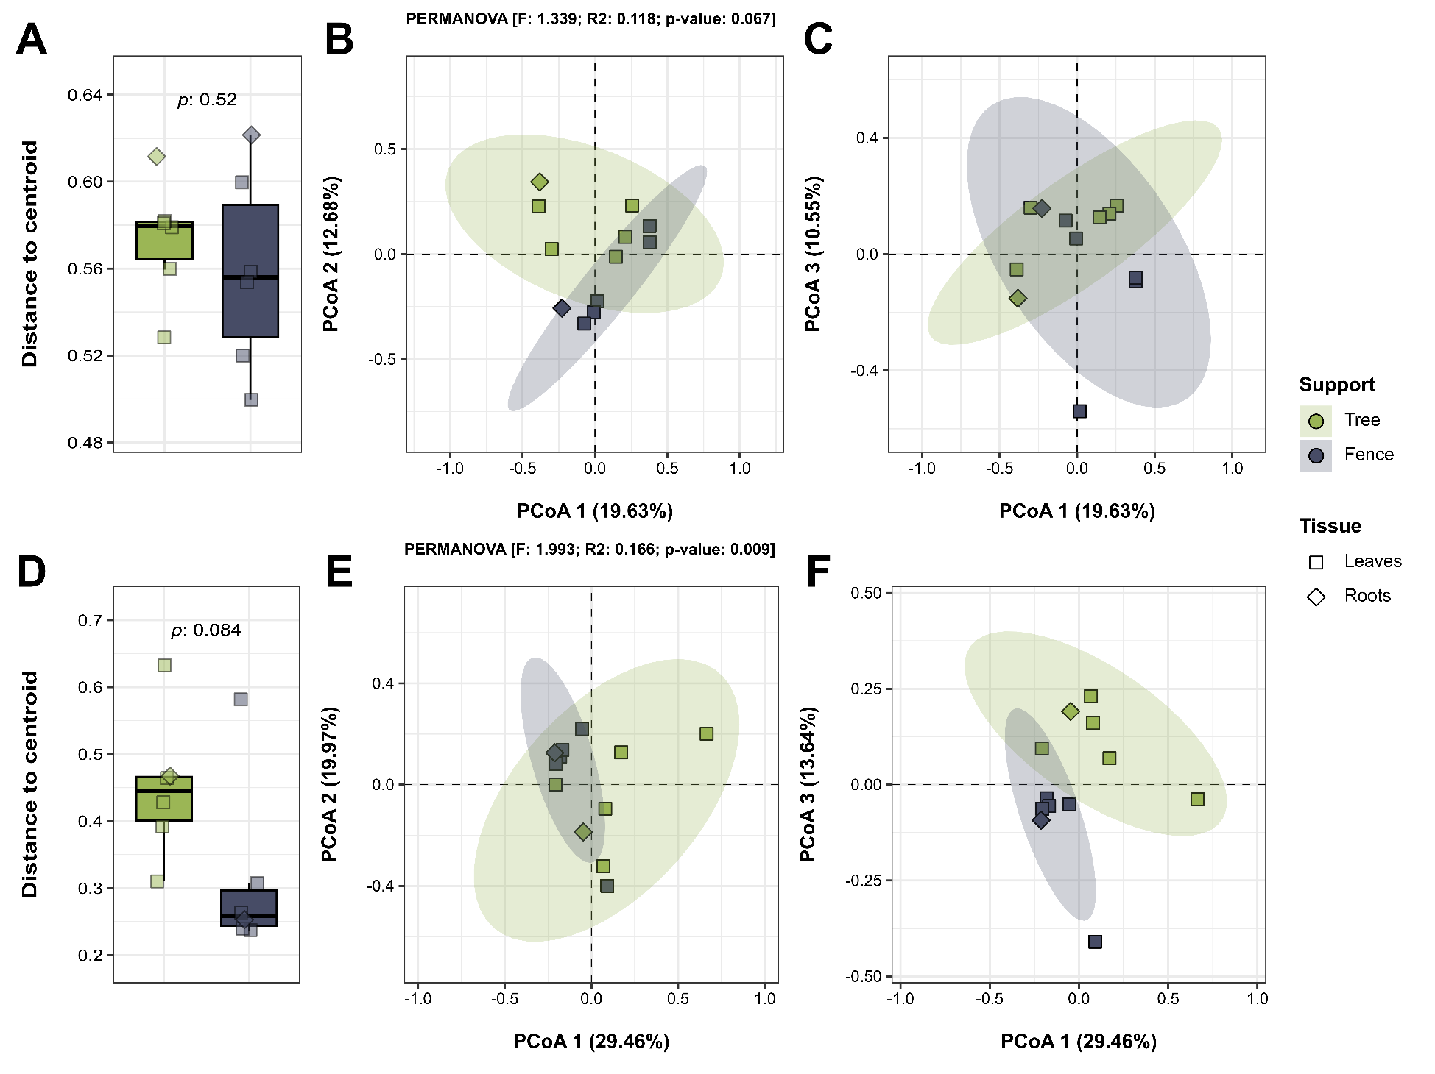
Figure S7. Beta diversity analysis of Bacteria (A, B, C) and Fungi (D, E, F) associated with Tillandsia recurvata growing on trees versus fences. The panel includes (A, D) box plots showing the distribution of centroid distances based on Bray-Curtis dissimilarities, with statistical comparisons performed using Student’s t-test (p ≤ 0.05), and Principal Coordinate Analysis (PCoA) plots displaying the dispersion of leaves and roots samples across combinations of axes 1 and 2 (B, E), and axes 1 and 3 (C, F). The influence of growth support on community composition was assessed using permutational multivariate analysis of variance (PERMANOVA) (p ≤ 0.05).

