Within-site variations in soil physicochemical properties explained the spatiality and cohabitation of arbuscular mycorrhizal fungi in the roots of Cryptomeria japonica
Akotchiffor Kevin Geoffroy Djotan ^{* 1, 2, 3}, Norihisa Matsushita ^{1, 4}, Kenji Fukuda ^{1, 5}
¹University of Tokyo, Graduate School of Agricultural and Life Sciences, Laboratory of Forest Botany, Japan
² Mie University, Graduate School of Bioresources, Laboratory of Forest Mycology, Mie, Japan
ORCID: ³https://orcid.org/0000-0002-3726-9826; ⁴https://orcid.org/0000-0003-3281-8846, ⁵https://orcid.org/0000-0002-9980-3107
*Corresponding author, E-mail: geoffroydjotan@yahoo.fr

Electronic Supplementary Materials
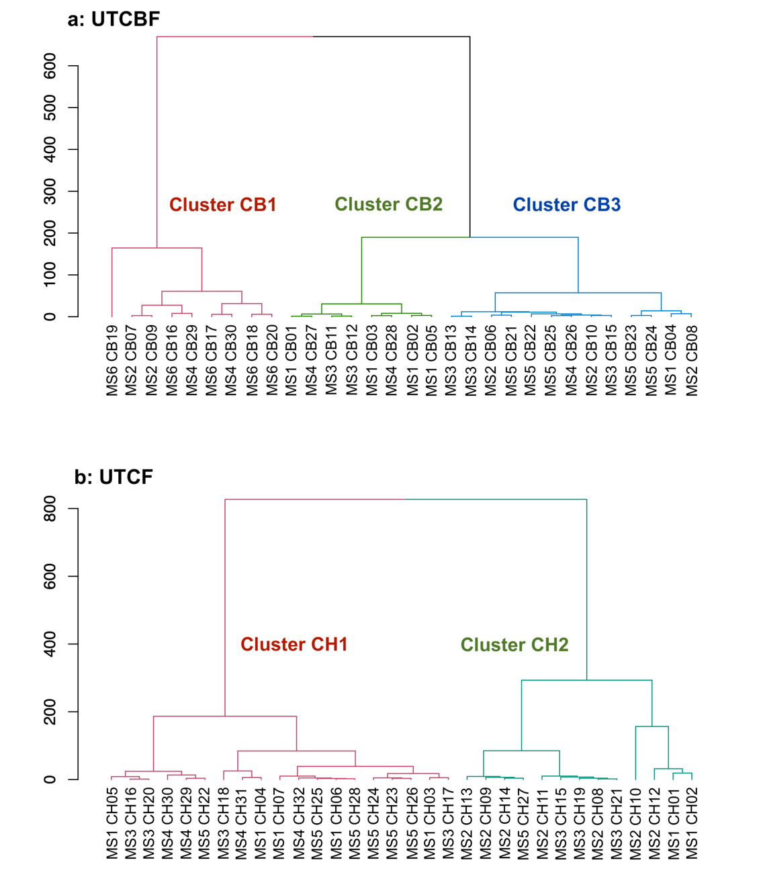
Online Resource 1 Soil clusters based on physicochemical properties at the two study sites
a, University of Tokyo Chiba Forest (UTCBF, CB); b, University of Tokyo Chichibu Forest (UTCF, CH). Surrounding soil samples are labeled based on the trees corresponding to the root community of arbuscular mycorrhizal fungi investigated. The sample labels consist of the name of the microsite it was collected from (MSX) followed by the tree label (CBXX or CHXX)

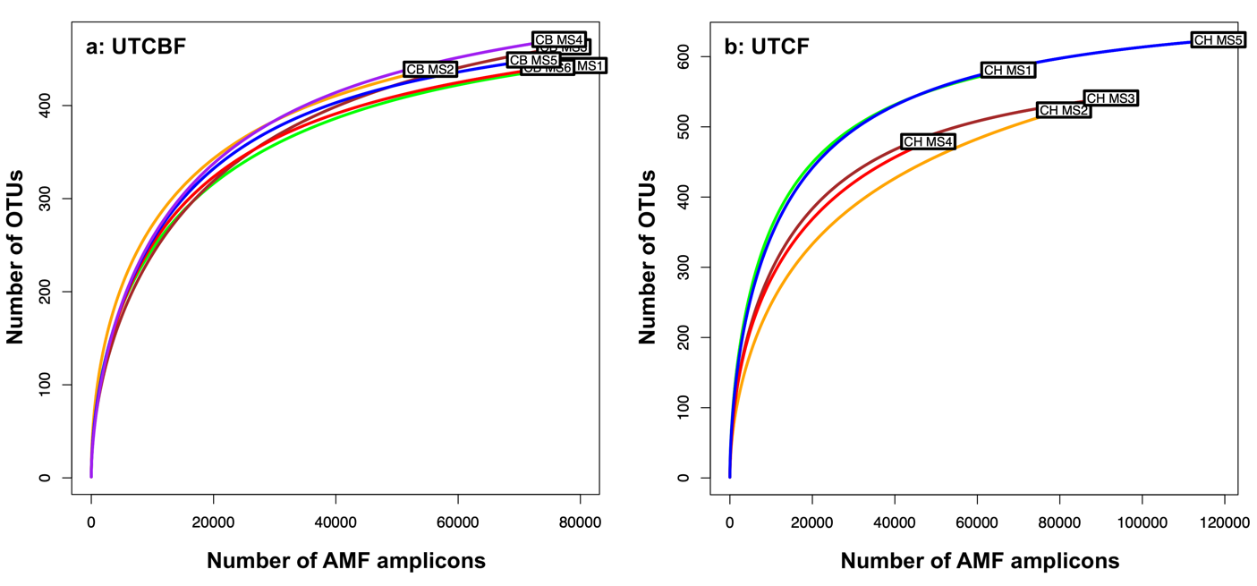
Online Resource 2 Rarefaction curves of the communities of arbuscular mycorrhizal fungi in the roots of Cryptomeria japonica by site and microsite
AMF, arbuscular mycorrhizal fungi; CB, University of Tokyo Chiba Forest (UTCBF); CH, University of Tokyo Chichibu Forest (UTCF); MS, Microsite
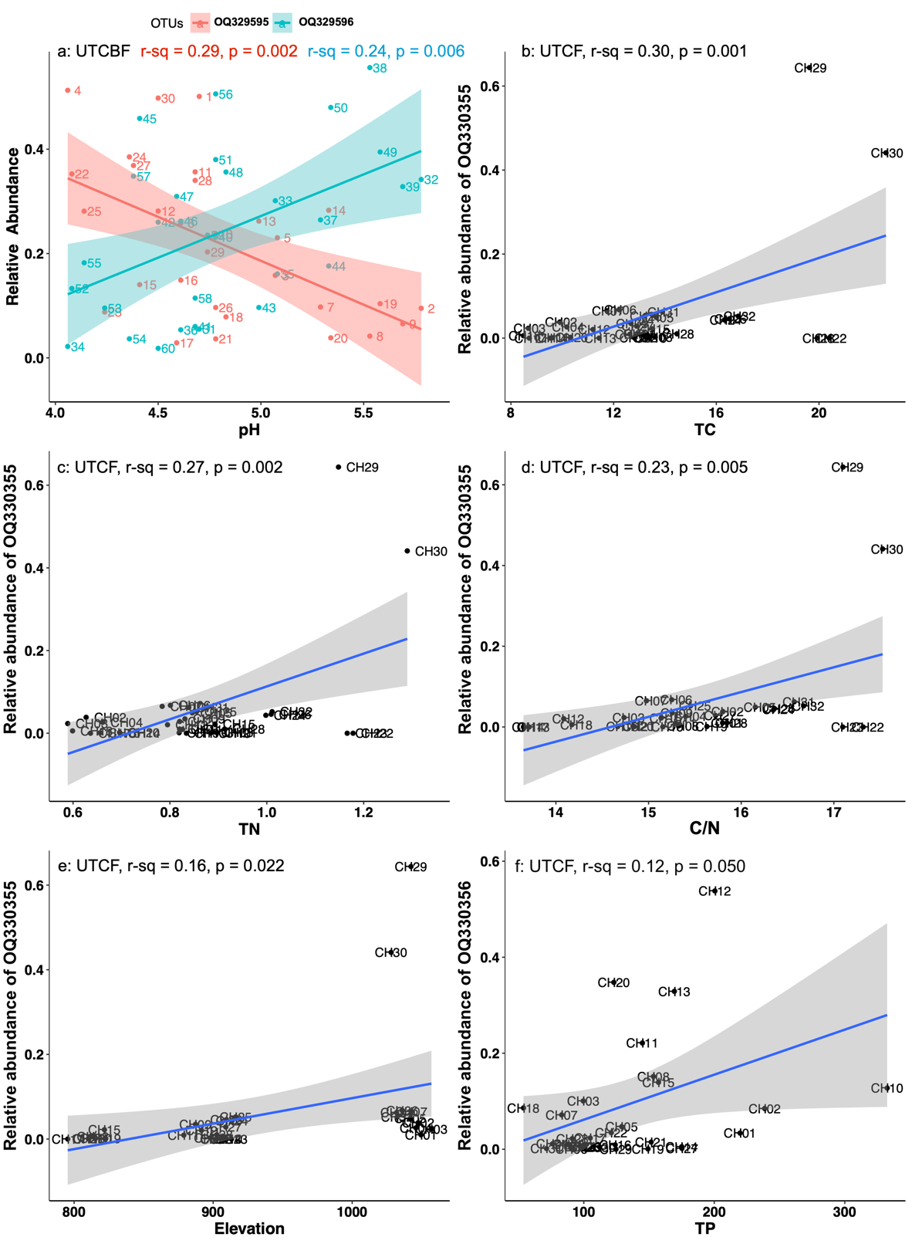
Online Resource 3 Linear regression analysis between the relative abundances of dominant operational taxonomic units (OTU) of arbuscular mycorrhizal fungi (AMF) at each site and soil physicochemical properties showing significant correlations
Sites are University of Tokyo Chiba Forest (UTCBF) and Chichibu Forest (UTCF). Soil physicochemical properties are pH (a); TC, total carbon (b); TN, total nitrogen (c); C/N, carbon-to-nitrogen ratio (d); elevation (e); and TP, total phosphorus (f)

Table S1 Comparison of environmental variables and tree diameter at breast height (DBH) between study sites
Variables | Comparison test | Probability value
Elevation | Kruskal-Wallis rank sum test | 0.00
pH | One-way ANOVA | 0.00
Total Carbon (TC) | Kruskal-Wallis rank sum test | 0.00
Total Nitrogen (TN) | Kruskal-Wallis rank sum test | 0.00
Total C/N | Kruskal-Wallis rank sum test | 0.05
Total Phosphorus (TP) | Kruskal-Wallis rank sum test | 0.00
Diameter at breast height (DBH | Kruskal-Wallis rank sum test | 0.00
^{a)} Significant variations reflected by p-value < 0.05
Table S2 Comparison of the diameter at breast height, elevation, and soil physicochemical properties among microsites at the study sites
A: Probabilities obtained through analysis of variance
Variables ^{i)} | University of Tokyo Chiba Forest (UTCBF) | University of Tokyo Chichibu Forest (UTCF)
Elevation | 0.00 | 0.00
pH | 0.05 | 0.03
Total carbon (TC) | 0.07 | 0.00
Total nitrogen (TN) | 0.08 | 0.00
Carbon to nitrogen ratio (C/N) | 0.04 | 0.00
Total phosphorus (TP) | 0.00 | 0.02
Diameter at breast height (DBH) | 0.04 ^{ii} | 0.01
B: Average values of the diameter at breast height (DBH) compared between MSs at each site
University of Tokyo Chiba Forest (UTCBF) |  |  | University of Tokyo Chichibu Forest (UTCF)
Microsites | DBH (Average ± SD, cm) ^{iii)} |  | Microsites | DBH (Average ± SD, cm) ^{iii)}
MS1 | 49.4 ± 2.6 a |  | MS1 | 29.0 ± 4.5 ab
MS2 | 53.8 ± 5.9 a |  | MS2 | 27.1 ± 1.9 b
MS3 | 65.2 ± 15.6 a |  | MS3 | 27.0 ± 3.9 b
MS4 | 52.6 ± 11.9 a |  | MS4 | 34.5 ± 3.3 a
MS5 | 54.2 ± 3.3 a |  | MS5 | 26.4 ± 3.3 b
MS6 | 65.0 ± 5.8 a |  | - | -
^{i)} Six microsite plots (MSs) at UTCBF and five at UTCF were used for analysis of within-site spatial variations in soil physicochemical properties. ^{ii)} ANOVA showed significant effect of microsite (MS) on DBH but Tukey’s honestly significant difference test did not show any significant difference in its mean values among MSs at a 95% confidence level. ^{iii)} Within a site, groups with the same letter are not significantly different
Table S3 Probabilities obtained through analysis of variance of the number of operational taxonomic units (OTU) and Shannon index values of the root AMF communities of Cryptomeria japonica among microsite plots (MSs)
Variables ^{a)} | University of Tokyo Chiba Forest (UTCBF) | University of Tokyo Chichibu Forest (UTCF)
Number of OTUs | 1.00 | 0.01
Shannon index | 0.38 | 0.04
^{a)} Six MSs at UTCBF and five at UTCF were used for analysis of within-site spatial variations in root AMF communities. Significant variations reflected by p-value < 0.05
Table S4 Permutational analysis of variance of arbuscular mycorrhizal fungal (AMF) communities in the roots of Cryptomeria japonica investigated spatially at two sites
A: Spatial variation at University of Tokyo Chiba Forest (UTCBF)
Factor ^{a)} | Df | SumOfSqs | R² | F | Pr(>F) ^{b)}
Microsite plot (MS) | 5 | 1.018 | 0.238 | 1.502 | 0.10
Residual | 24 | 3.256 | 0.762
Total | 29 | 4.274 | 1.000

B: Spatial variation at University of Tokyo Chichibu Forest (UTCF)
Factor ^{a)} | Df | SumOfSqs | R² | F | Pr(>F) ^{b)}
Microsite plot (MS) | 4 | 1.604 | 0.238 | 2.112 | 0.00
Residual | 27 | 5.125 | 0.762
Total | 31 | 6.729 | 1.000
^{a)} The effect of the cultivar of C. japonica (which was an additional factor at UTCBF) on the composition of the root AMF community was not significant. b) Significant variations reflected by p-value < 0.05

Table S5 Composition of arbuscular mycorrhizal fungal (AMF) communities in the roots of Cryptomeria japonica in various microsite plots (MSs) at the University of Tokyo Chiba (UTCBF) and Chichibu (UTCF) Forests
AMF genus | MS at UTCBF |  |  |  |  |  |  | MS at UTCF
AMF genus | MS1 | MS2 | MS3 | MS4 | MS5 | MS6 |  | MS1 | MS2 | MS3 | MS4 | MS5
Acaulospora | 0.006 | 0.003 | 0.001 | 0.001 | 0.001 | 0.001 |  | 0.005 | 0.001 | 0.001 | 0.002 | 0.003
Archaeospora | 0.000 | 0.000 | 0.000 | 0.000 | 0.000 | 0.000 |  | 0.015 | 0.002 | 0.003 | 0.005 | 0.010
Claroideoglomus | 0.000 | 0.000 | 0.000 | 0.000 | 0.000 | 0.000 |  | 0.000 | 0.000 | 0.000 | 0.000 | 0.000
Diversispora | 0.048 | 0.047 | 0.020 | 0.015 | 0.030 | 0.006 |  | 0.002 | 0.106 | 0.009 | 0.002 | 0.006
Funneliformis | 0.000 | 0.000 | 0.000 | 0.000 | 0.000 | 0.000 |  | 0.000 | 0.000 | 0.000 | 0.000 | 0.000
Glomus | 0.347 | 0.394 | 0.391 | 0.341 | 0.445 | 0.452 |  | 0.752 | 0.695 | 0.818 | 0.553 | 0.756
Rhizophagus | 0.560 | 0.517 | 0.567 | 0.617 | 0.495 | 0.501 |  | 0.171 | 0.166 | 0.152 | 0.074 | 0.171
Scutellospora | 0.000 | 0.000 | 0.000 | 0.000 | 0.000 | 0.000 |  | 0.003 | 0.013 | 0.002 | 0.002 | 0.002
Septoglomus | 0.037 | 0.033 | 0.019 | 0.020 | 0.023 | 0.039 |  | 0.009 | 0.010 | 0.010 | 0.021 | 0.023
Unclassified |  |  |  |  |  |  |  | 0.042 | 0.007 | 0.005 | 0.342 | 0.028
Uncultured | 0.002 | 0.004 | 0.002 | 0.005 | 0.006 | 0.002
Two cultivars of C. japonica are planted in the University of Tokyo Chiba Forest (Sanbu-sugi in MS 1–3 and, Kuro-sugi in MS 4–6), but cultivar information was not available for the University of Tokyo Chichibu Forest
Table S6 Operational taxonomic units (OTUs) making significant contributions to the variations in arbuscular mycorrhizal fungi (AMF) communities in the roots of Cryptomeria japonica among microsite plots (MSs)
A: University of Tokyo Chiba Forest (UTCBF)
OTUs | r² | Pr(>r)
OQ329595 | 0.987 | 0.001
OQ329596 | 0.969 | 0.001
OQ329603 | 0.662 | 0.001
OQ329619 | 0.646 | 0.001
OQ329611 | 0.635 | 0.001
OQ329451 | 0.616 | 0.001
OQ329670 | 0.454 | 0.005
OQ329899 | 0.442 | 0.015
OQ329895 | 0.437 | 0.012
OQ329634 | 0.422 | 0.002
OQ329663 | 0.421 | 0.001
OQ329698 | 0.397 | 0.002
OQ329890 | 0.393 | 0.002
OQ329693 | 0.393 | 0.002
OQ329736 | 0.390 | 0.003
OQ329858 | 0.388 | 0.006
OQ329717 | 0.368 | 0.003
OQ329704 | 0.366 | 0.003
OQ329484 | 0.337 | 0.008
OQ329669 | 0.334 | 0.008
OQ329713 | 0.333 | 0.009
OQ329909 | 0.331 | 0.005
OQ329874 | 0.323 | 0.015
OQ329633 | 0.321 | 0.011
OQ329889 | 0.313 | 0.007
OQ329750 | 0.312 | 0.013
OQ329729 | 0.310 | 0.013
OQ329538 | 0.308 | 0.015
OQ329700 | 0.300 | 0.005
OQ329795 | 0.300 | 0.026
OQ329692 | 0.296 | 0.011
OQ329902 | 0.294 | 0.019
OQ329767 | 0.284 | 0.024
OQ329711 | 0.282 | 0.014
OQ329745 | 0.280 | 0.013
OQ329805 | 0.279 | 0.025
OQ329601 | 0.277 | 0.028
OQ329880 | 0.276 | 0.014
OQ329510 | 0.268 | 0.017
OQ329605 | 0.267 | 0.012
OQ329967 | 0.265 | 0.024
OQ329770 | 0.264 | 0.016
OQ329674 | 0.262 | 0.018
OQ329940 | 0.262 | 0.027
OQ329653 | 0.261 | 0.016
OQ329784 | 0.260 | 0.021
OQ329910 | 0.259 | 0.037
OQ329661 | 0.259 | 0.022
OQ329870 | 0.256 | 0.023
OQ329706 | 0.255 | 0.020
OQ329479 | 0.253 | 0.028
OQ329606 | 0.252 | 0.022
OQ329465 | 0.252 | 0.021
OQ329798 | 0.241 | 0.029
OQ329781 | 0.240 | 0.034
OQ329632 | 0.236 | 0.033
OQ329743 | 0.235 | 0.047
OQ329620 | 0.227 | 0.038
OQ329879 | 0.227 | 0.032
OQ329680 | 0.221 | 0.037
OQ329866 | 0.214 | 0.041
OQ329960 | 0.213 | 0.047
OQ329468 | 0.207 | 0.047
OQ329641 | 0.206 | 0.030
OQ329642 | 0.206 | 0.048
OQ329733 | 0.206 | 0.049
OQ329739 | 0.201 | 0.039
OQ329648 | 0.199 | 0.028
OQ329626 | 0.184 | 0.029
OQ329628 | 0.178 | 0.032

B: University of Tokyo Chichibu Forest (UTCF)
OTUs | r² | Pr(>r)
OQ330355 | 0.861 | 0.001
OQ330356 | 0.837 | 0.001
OQ330479 | 0.816 | 0.003
OQ330311 | 0.755 | 0.002
OQ330661 | 0.753 | 0.001
OQ330531 | 0.746 | 0.001
OQ330448 | 0.743 | 0.002
OQ330614 | 0.696 | 0.003
OQ330314 | 0.682 | 0.004
OQ330649 | 0.640 | 0.001
OQ330530 | 0.635 | 0.001
OQ330408 | 0.630 | 0.001
OQ330432 | 0.550 | 0.001
OQ330551 | 0.541 | 0.002
OQ330643 | 0.515 | 0.005
OQ330418 | 0.507 | 0.006
OQ330472 | 0.506 | 0.005
OQ330573 | 0.493 | 0.004
OQ330618 | 0.449 | 0.016
OQ330091 | 0.436 | 0.003
OQ330086 | 0.435 | 0.006
OQ330202 | 0.429 | 0.009
OQ330323 | 0.410 | 0.008
OQ330380 | 0.405 | 0.016
OQ330231 | 0.397 | 0.007
OQ330568 | 0.395 | 0.006
OQ330134 | 0.372 | 0.013
OQ330517 | 0.368 | 0.02
OQ330313 | 0.367 | 0.008
OQ330245 | 0.363 | 0.007
OQ330047 | 0.361 | 0.001
OQ330366 | 0.350 | 0.015
OQ330088 | 0.350 | 0.014
OQ330228 | 0.350 | 0.019
OQ330482 | 0.326 | 0.007
OQ330151 | 0.323 | 0.018
OQ330079 | 0.314 | 0.023
OQ330164 | 0.313 | 0.006
OQ330701 | 0.306 | 0.023
OQ330672 | 0.301 | 0.02
OQ330670 | 0.294 | 0.014
OQ330226 | 0.293 | 0.024
OQ330488 | 0.289 | 0.018
OQ330334 | 0.271 | 0.019
OQ330279 | 0.257 | 0.03
OQ330172 | 0.256 | 0.025
OQ330310 | 0.246 | 0.021
OQ330526 | 0.240 | 0.043
OQ330702 | 0.239 | 0.025
OQ330510 | 0.233 | 0.048
OQ330374 | 0.228 | 0.048
OQ330316 | 0.219 | 0.049
OQ330123 | 0.211 | 0.041
OQ330087 | 0.191 | 0.044
OQ330100 | 0.184 | 0.048
In total, 70 and 55 OTUs made significant contributions (p-value associated with RDA test less than 0.05) to the observed variations in AMF communities in the roots of C. japonica

