Supplementary material to

Seasonal changes in the gut microbiota of Halyomorpha halys
Maja Fluch¹, Erika Corretto², Heike Feldhaar³, Hannes Schuler^{1,2}*
¹ Faculty of Agricultural, Environmental and Food Sciences, Free University of Bozen-Bolzano, Bolzano, Italy
² Competence Centre for Plant Health, Free University of Bozen-Bolzano, Bolzano, Italy
³ Animal Population Ecology, Bayreuth Center for Ecology and Environmental Research (BayCEER), University of Bayreuth, 95440, Bayreuth, Germany
*corresponding author; e-mail: hannes.schuler@unibz.it
Orcids:
- Maja Fluch: 0009-0007-0162-3401
- Erika Corretto: 0000-0002-7767-5191
- Heike Feldhaar: 0000-0001-6797-5126
- Hannes Schuler: 0000-0001-8307-9831

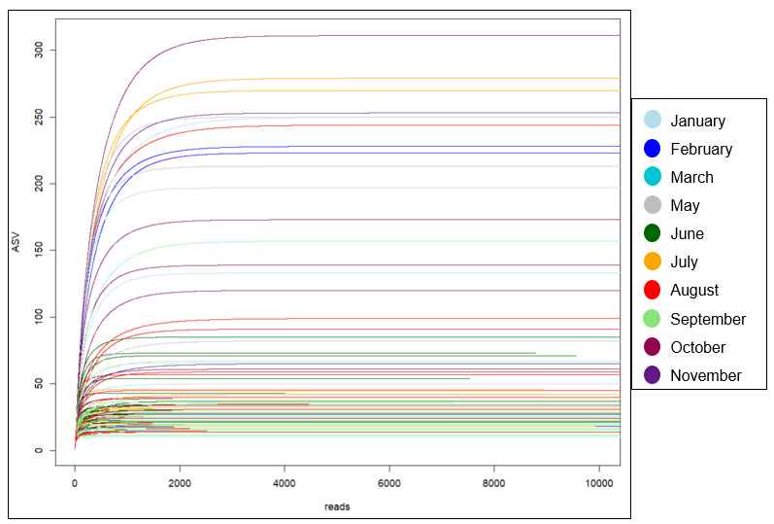
Fig S1 Rarefaction curves showing the number of reads and observed ASVs for the sequenced samples. The different colors indicate the different months of collection

Fig S2 The percentage of reads assigned to the different bacterial genera and families. Pantoea accounts for 45.6% of all reads, Commensalibacter for 35.0%, followed by Lactococcus with 1.24%, and unclassified Enterobacteriaceae with 1.22%. Other refers to ASVs with less than 1,000 reads and accounts for 13.8%

Fig S3 Two models of the relationship between the number of Commensalibacter and Pantoea reads. Both models show a decrease of Pantoea with an increase in Commensalibacter. (a) The linear model reveals a significant (p < 0.05) correlation. (b) The non-linear model decreases faster up to around 25,000 reads of Commensalibacter and has an asymptotic trend that is slightly higher than 0

Fig S4 NMDS based on Jaccard distances. Each dot represents a single individual: the blue dotted lines indicates individuals sampled in the winter months (November, January), yellow spring (February, March), gray early summer (May, June), pink late summer (July, August), and green fall (September, October)

