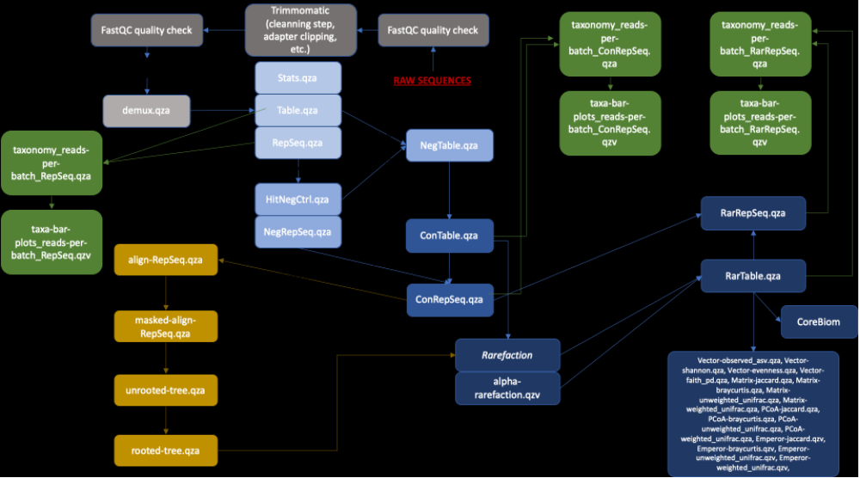
Fig. S1 Simplified tailored bioinformatic workflow pipeline used for each marker. All scripts created and used for this pipeline can be found at https://github.com/PLStenger/BioIndic_La_Reunion_Island_Lagoon

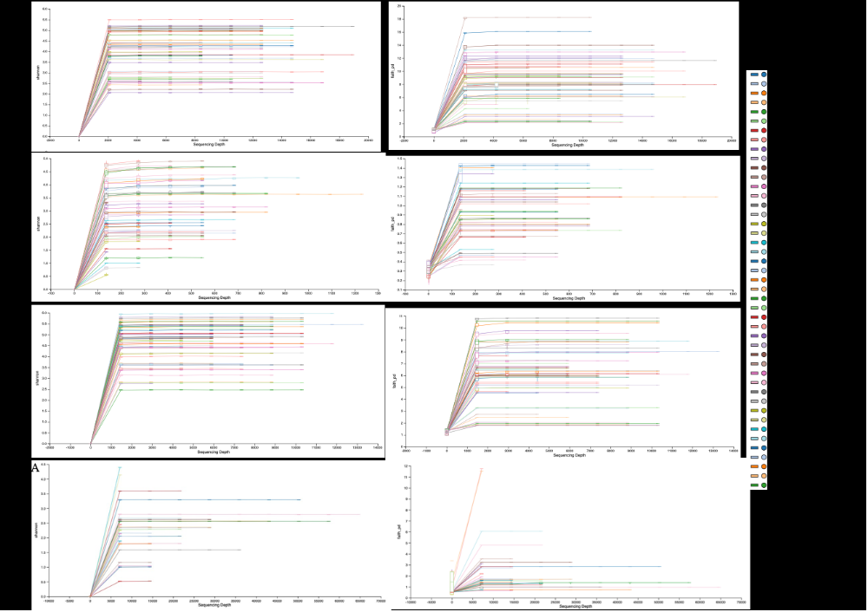
Fig. S2 Alpha-rarefaction curves from the QIIME2 tool with a maximum depth of 16,70; 18,908; 64,625 and 13,250 respectively for V4 (16S), ITS2 (18S), TufA (chloroplast), and V1/V3 (18S) datasets, for the Shannon entropy (a measure of richness and diversity that accounts for both the abundance and evenness of taxa) and Faith PD (a measure of biodiversity that incorporates phylogenetic differences between species using the sum of the lengths of branches)

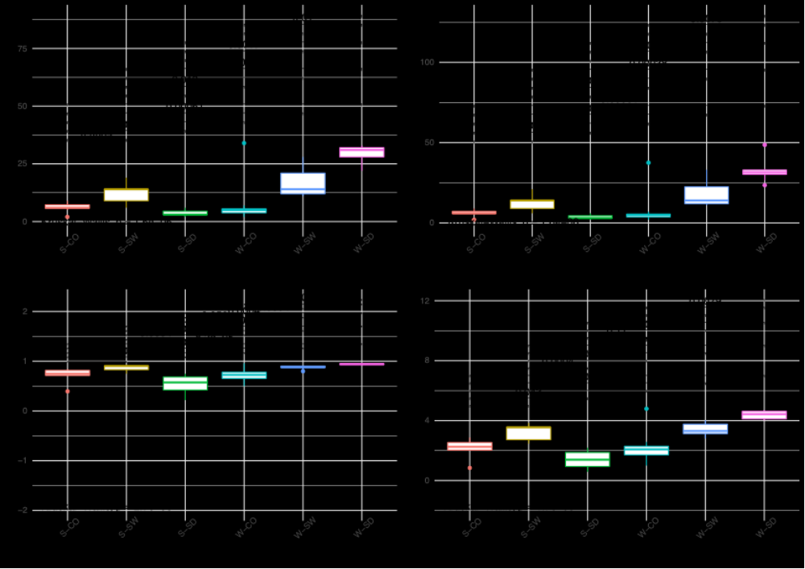
Fig. S3A Bacterial microbial diversity was assessed with indexes on substrates (coral rubble (CO), seawater (SW), and sediment (SD)) and seasonal (austral summer (S) and winter (W)) data. Bray-Curtis dissimilarity (Sorensen, 1948) and Jaccard similarity index (Jaccard, 1908) matrices were also calculated with the q2-diversity tool. The observed number of ASVs (DeSantis et al., 2006), Chao1 (expected richness) (Chao, Anne, 1984), Simpson evenness (a measure of diversity that accounts for the number of organisms and the number of species) (Simpson, 1949), Pielou evenness (a measure of the relative evenness of species richness) (Pielou, 1966), Shannon entropy (Shannon and Weaver, 1949), and Faith PD (Faith, 1992) (Tables 1, 2, 3, and 4), were performed using Kruskal-Wallis test after checking the normal law by Shapiro test. Boxplots were realized with ggplot2 R package V. 3.3.5 (Wickham and Chang, 2019)

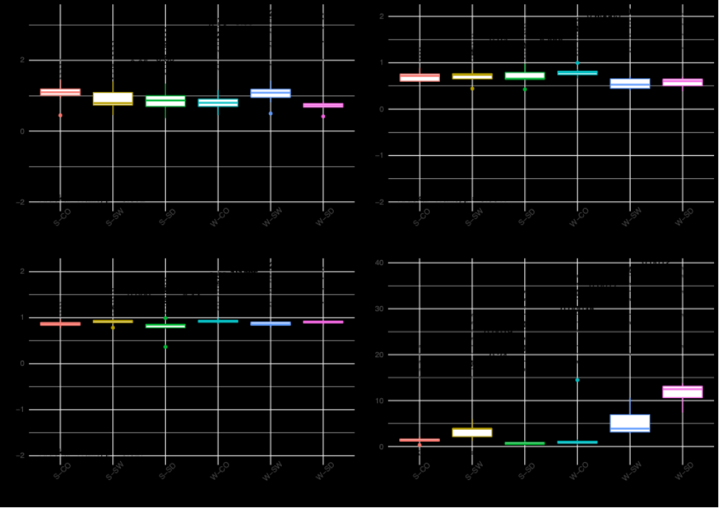
Fig. S3B Bacterial microbial diversity was assessed with indexes on substrates (coral rubble (CO), seawater (SW), and sediment (SD)) and seasonal (austral summer (S) and winter (W)) data. Bray-Curtis dissimilarity (Sorensen, 1948) and Jaccard similarity index (Jaccard, 1908) matrices were also calculated with the q2-diversity tool. The observed number of ASVs (DeSantis et al., 2006), Chao1 (expected richness) (Chao, Anne, 1984), Simpson evenness (a measure of diversity that accounts for the number of organisms and the number of species) (Simpson, 1949), Pielou evenness (a measure of the relative evenness of species richness) (Pielou, 1966), Shannon entropy (Shannon and Weaver, 1949), and Faith PD (Faith, 1992) (Tables 1, 2, 3, and 4), were performed using Kruskal-Wallis test after checking the normal law by Shapiro test. Boxplots were realized with ggplot2 R package V. 3.3.5 (Wickham and Chang, 2019)

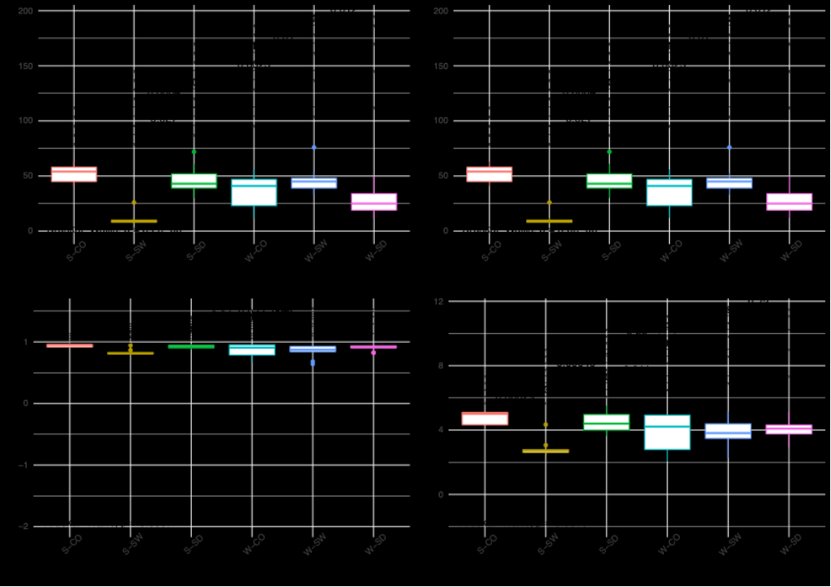
Fig. S4A Fungal microbial diversity was assessed with indexes on substrates (coral rubble (CO), seawater (SW), and sediment (SD)) and seasonal (austral summer (S) and winter (W)) data. Bray-Curtis dissimilarity (Sorensen, 1948) and Jaccard similarity index (Jaccard, 1908) matrices were also calculated with the q2-diversity tool. The observed number of ASVs (DeSantis et al., 2006), Chao1 (expected richness) (Chao, Anne, 1984), Simpson evenness (a measure of diversity that accounts for the number of organisms and the number of species) (Simpson, 1949), Pielou evenness (a measure of the relative evenness of species richness) (Pielou, 1966), Shannon entropy (Shannon and Weaver, 1949), and Faith PD (Faith, 1992) (Tables 1, 2, 3, and 4), were performed using Kruskal-Wallis test after checking the normal law by Shapiro test. Boxplots were realized with ggplot2 R package V. 3.3.5 (Wickham and Chang, 2019)

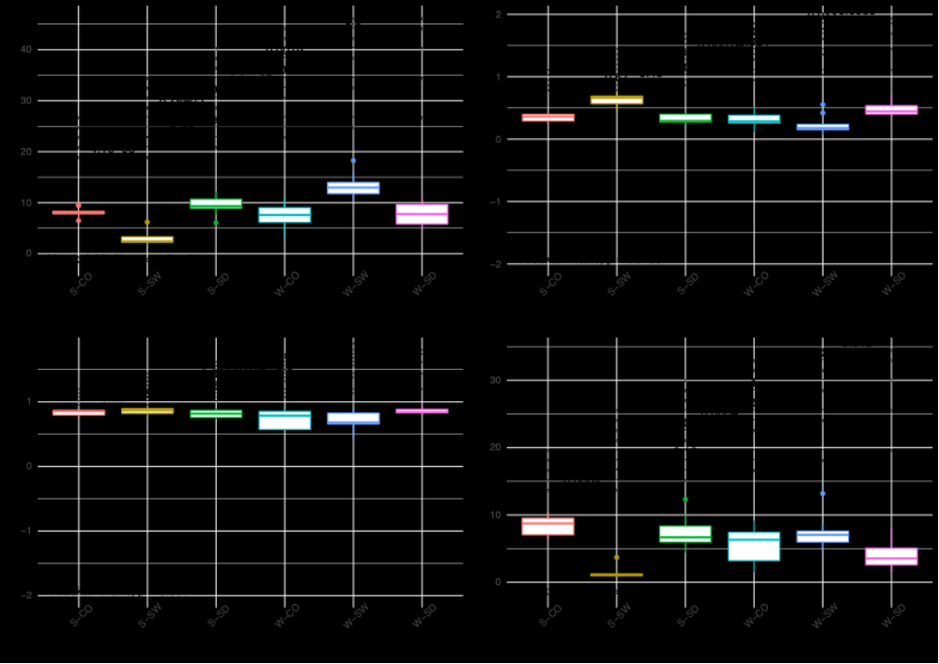
Fig. S4B Fungal microbial diversity was assessed with indexes on substrates (coral rubble (CO), seawater (SW), and sediment (SD)) and seasonal (austral summer (S) and winter (W)) data. Bray-Curtis dissimilarity (Sorensen, 1948) and Jaccard similarity index (Jaccard, 1908) matrices were also calculated with the q2-diversity tool. The observed number of ASVs (DeSantis et al., 2006), Chao1 (expected richness) (Chao, Anne, 1984), Simpson evenness (a measure of diversity that accounts for the number of organisms and the number of species) (Simpson, 1949), Pielou evenness (a measure of the relative evenness of species richness) (Pielou, 1966), Shannon entropy (Shannon and Weaver, 1949), and Faith PD (Faith, 1992) (Tables 1, 2, 3, and 4), were performed using Kruskal-Wallis test after checking the normal law by Shapiro test. Boxplots were realized with ggplot2 R package V. 3.3.5 (Wickham and Chang, 2019)

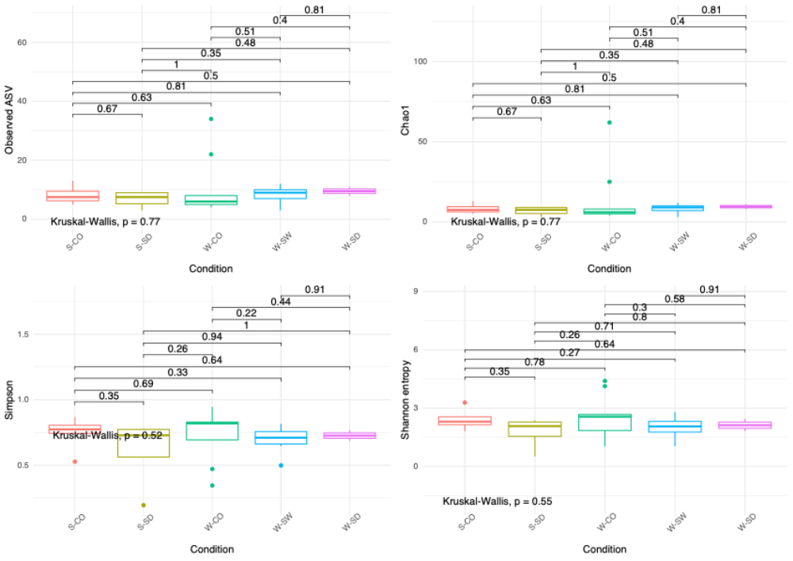
Fig. S5A Microalagae microbial diversity was assessed with indexes on substrates (coral rubble (CO), seawater (SW), and sediment (SD)) and seasonal (austral summer (S) and winter (W)) data. Bray-Curtis dissimilarity (Sorensen, 1948) and Jaccard similarity index (Jaccard, 1908) matrices were also calculated with the q2-diversity tool. The observed number of ASVs (DeSantis et al., 2006), Chao1 (expected richness) (Chao, Anne, 1984), Simpson evenness (a measure of diversity that accounts for the number of organisms and the number of species) (Simpson, 1949), Pielou evenness (a measure of the relative evenness of species richness) (Pielou, 1966), Shannon entropy (Shannon and Weaver, 1949), and Faith PD (Faith, 1992) (Tables 1, 2, 3, and 4), were performed using Kruskal-Wallis test after checking the normal law by Shapiro test. Boxplots were realized with ggplot2 R package V. 3.3.5 (Wickham and Chang, 2019)

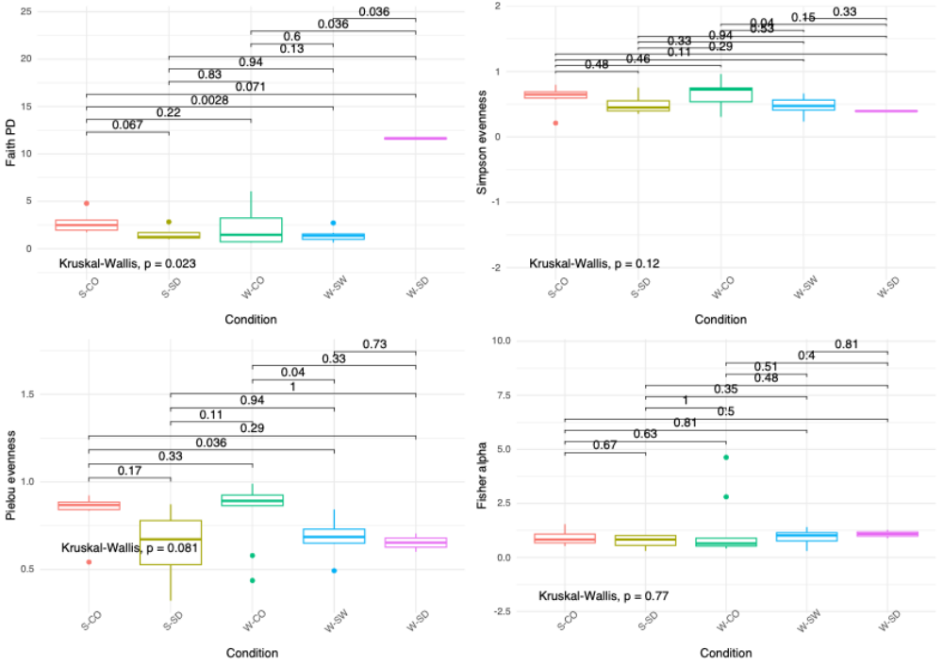
Fig. S5B Microalgae microbial diversity was assessed with indexes on substrates (coral rubble (CO), seawater (SW), and sediment (SD)) and seasonal (austral summer (S) and winter (W)) data. Bray-Curtis dissimilarity (Sorensen, 1948) and Jaccard similarity index (Jaccard, 1908) matrices were also calculated with the q2-diversity tool. The observed number of ASVs (DeSantis et al., 2006), Chao1 (expected richness) (Chao, Anne, 1984), Simpson evenness (a measure of diversity that accounts for the number of organisms and the number of species) (Simpson, 1949), Pielou evenness (a measure of the relative evenness of species richness) (Pielou, 1966), Shannon entropy (Shannon and Weaver, 1949), and Faith PD (Faith, 1992) (Tables 1, 2, 3, and 4), were performed using Kruskal-Wallis test after checking the normal law by Shapiro test. Boxplots were realized with ggplot2 R package V. 3.3.5 (Wickham and Chang, 2019)

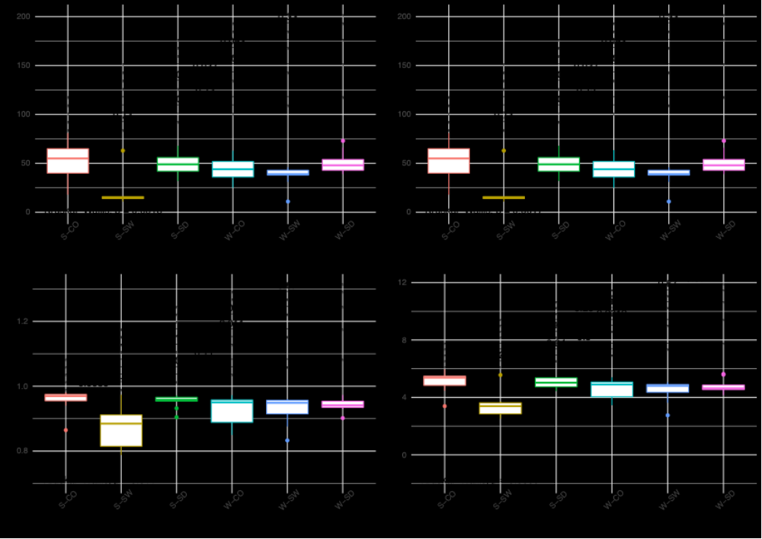
Fig. S6A Protista microbial diversity was assessed with indexes on substrates (coral rubble (CO), seawater (SW), and sediment (SD)) and seasonal (austral summer (S) and winter (W)) data. Bray-Curtis dissimilarity (Sorensen, 1948) and Jaccard similarity index (Jaccard, 1908) matrices were also calculated with the q2-diversity tool. The observed number of ASVs (DeSantis et al., 2006), Chao1 (expected richness) (Chao, Anne, 1984), Simpson evenness (a measure of diversity that accounts for the number of organisms and the number of species) (Simpson, 1949), Pielou evenness (a measure of the relative evenness of species richness) (Pielou, 1966), Shannon entropy (Shannon and Weaver, 1949), and Faith PD (Faith, 1992) (Tables 1, 2, 3, and 4), were performed using Kruskal-Wallis test after checking the normal law by Shapiro test. Boxplots were realized with ggplot2 R package V. 3.3.5 (Wickham and Chang, 2019)

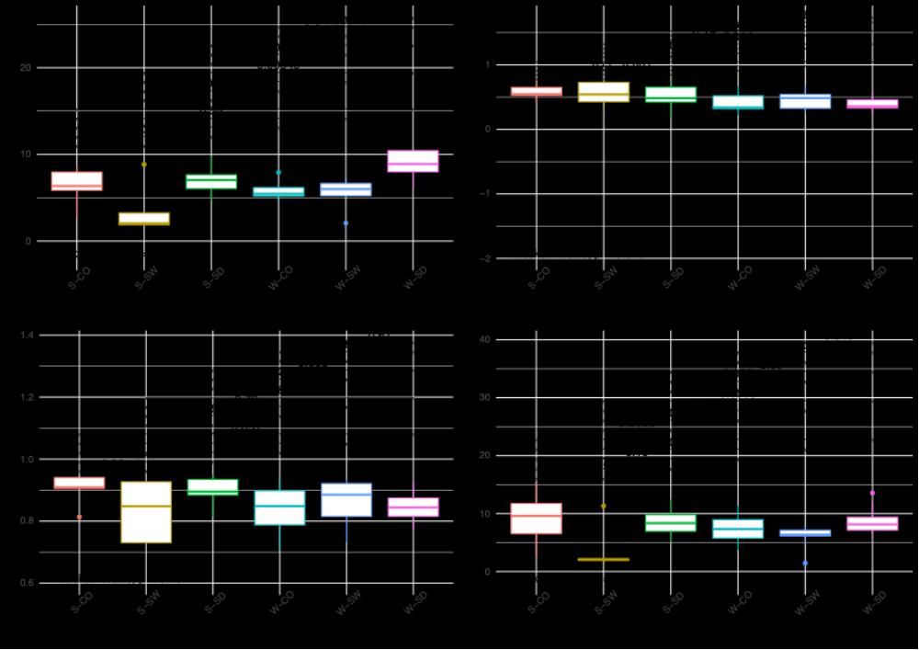
Fig. S6B Protista microbial diversity was assessed with indexes on substrates (coral rubble (CO), seawater (SW), and sediment (SD)) and seasonal (austral summer (S) and winter (W)) data. Bray-Curtis dissimilarity (Sorensen, 1948) and Jaccard similarity index (Jaccard, 1908) matrices were also calculated with the q2-diversity tool. The observed number of ASVs (DeSantis et al., 2006), Chao1 (expected richness) (Chao, Anne, 1984), Simpson evenness (a measure of diversity that accounts for the number of organisms and the number of species) (Simpson, 1949), Pielou evenness (a measure of the relative evenness of species richness) (Pielou, 1966), Shannon entropy (Shannon and Weaver, 1949), and Faith PD (Faith, 1992) (Tables 1, 2, 3, and 4), were performed using Kruskal-Wallis test after checking the normal law by Shapiro test. Boxplots were realized with ggplot2 R package V. 3.3.5 (Wickham and Chang, 2019)

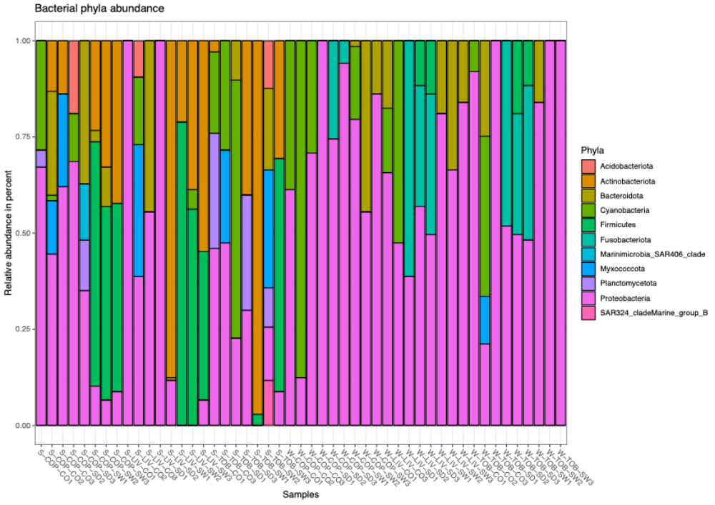
Fig. S7 Bar plot for bacterial communities’ phyla relative abundance

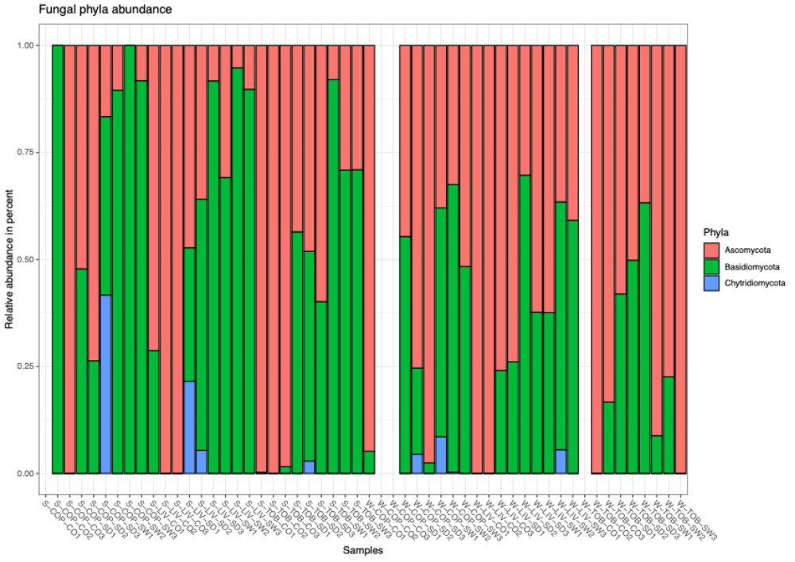
Fig. S8 Bar plot for fungal communities’ phyla relative abundance

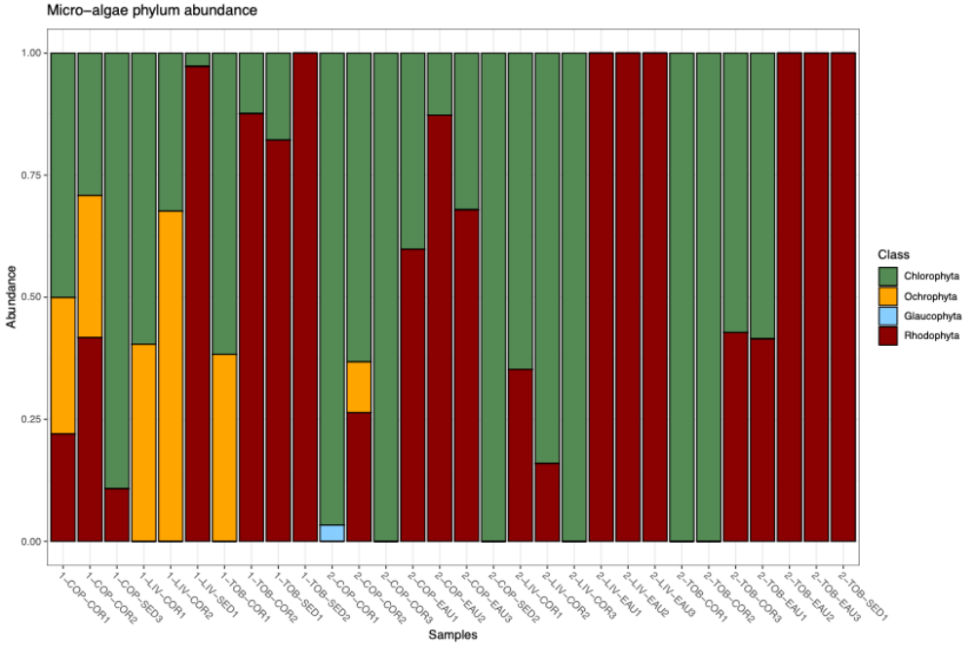
Fig. S9 Bar plot for micro-algae communities’ phyla relative abundance

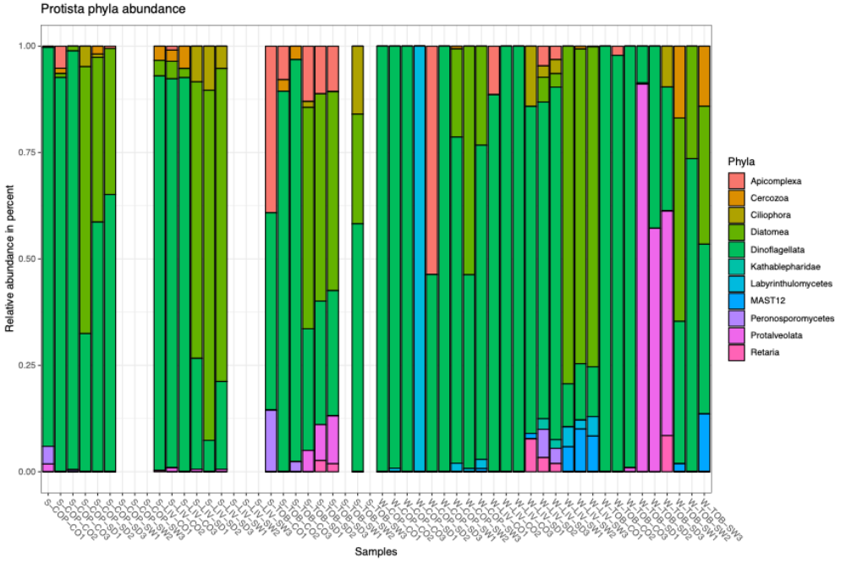
Fig. S10 Bar plot for protists communities’ phyla relative abundance

Supplemental Table 1a, b, c, d, e, f, g, h, I, j, k, l. NGS full data: number of total reads and ASVs per sample including means and standard deviation calculations for bacteria (a, b, c), fungi (d, e, f), protista (g, h, i), microalgae (j, k, l), and all (m). Two-way Anovas were carried out to compare ASVs abundance data by site (a, d, g, j) or substrate (b, e, h, k) or season (c, f, i, l) or sample (m) and letters indicate significantly different means according to a test of Duncan (at P < 0.05). Abbreviations: COP: Copacabana, LIV: Livingstone, TOB: Toboggan, CO: Corals, SD: Sediments, SW: Seawater.

a
Sites | Total reads | Mean total reads /sample ± stdv | Total ASVs | Mean total ASVs / sample ± stdv
COP | 379,126 | 21,063 ± 4,516 | 88,301 | 4,906 ± 2,329a
LIV | 388,579 | 21,588 ± 4,706 | 82,987 | 4,610 ± 2,060a
TOB | 376,285 | 20,905 ± 3,699 | 91,096 | 5,061 ± 2,274a

b
Substrates | Total reads | Mean total reads /sample ± stdv | Total ASVs | Mean total ASVs / sample ± stdv
Corals | 405,849 | 22,547 ± 3,992 | 106,450 | 5,913 ± 2,161ab
Sediment | 392,924 | 21,829 ± 4,630 | 76,420 | 4,245 ± 2,648ab
Seawater | 345,217 | 19,179 ± 3,529 | 79,514 | 4,417 ± 1,217a

c
Season | Total reads | Mean total reads /sample ± stdv | Total ASVs | Mean total ASVs / sample ± stdv
Summer | 594,130 | 22,005 ± 4,951 | 157,308 | 5,826 ± 2,075a
Winter | 549,860 | 20,365 ± 3,321 | 105,076 | 3,892 ± 1,878b

d
Sites | Total reads | Mean total reads /sample ± stdv | Total ASVs | Mean total ASVs / sample ± stdv
COP | 395,955 | 21,998 ± 4,940 | 290,900 | 16,161 ± 3,351a
LIV | 410,903 | 22,828 ± 4,690 | 277,680 | 15,427 ± 3,176a
TOB | 415,710 | 23,095 ± 5,476 | 280,342 | 15,575 ± 3,846a

e
Substrates | Total reads | Mean total reads /sample ± stdv | Total ASVs | Mean total ASVs / sample ± stdv
Corals | 389,063 | 21,615 ± 3,370 | 259,500 | 14,417 ± 2,332ab
Sediment | 478,871 | 26,604 ± 5,061 | 323,564 | 17,976 ± 3,862c
Seawater | 354,634 | 19,702 ± 3,637 | 265,858 | 14,770 ± 2,816ad

f
Season | Total reads | Mean total reads /sample ± stdv | Total ASVs | Mean total ASVs / sample ± stdv
Summer | 605,891 | 22,440 ± 4,442 | 416,321 | 15,419 ± 2,558a
Winter | 616,677 | 22,840 ± 5,530 | 432,601 | 16,022 ± 4,133a

g
Sites | Total reads | Mean total reads /sample ± stdv | Total ASVs | Mean total ASVs / sample ± stdv
COP | 362,794 | 20,155 ± 5,461 | 201,038 | 11,169 ± 2926a
LIV | 339,963 | 18,887 ± 3,885 | 184,923 | 10,274 ± 1,935a
TOB | 387,728 | 21,540 ± 5,945 | 192,550 | 10,697 ± 3,272a

h
Substrates | Total reads | Mean total reads /sample ± stdv | Total ASVs | Mean total ASVs / sample ± stdv
Corals | 349,859 | 19,437 ± 4,614 | 190,006 | 10,556 ± 2,783a
Sediment | 417,170 | 23,176 ± 5,877 | 207,800 | 11,544 ± 2,994a
Seawater | 323,456 | 17,970 ± 3,592 | 180,705 | 10,039 ± 2,342a

i
Season | Total reads | Mean total reads /sample ± stdv | Total ASVs | Mean total ASVs / sample ± stdv
Summer | 511,093 | 18,929 ± 5,903 | 283,216 | 10,489 ± 2,860a
Winter | 579,392 | 21,459 ± 4,091 | 295,295 | 10,937 ± 2,654a

j
Sites | Total reads | Mean total reads /sample ± stdv | Total ASVs | Mean total ASVs / sample ± stdv
COP | 825,971 | 45,887 ± 31,689 | 326,747 | 18,153 ± 20,046a
LIV | 727,874 | 40,437 ± 32,182 | 235,311 | 13,073 ± 16,778a
TOB | 881,586 | 48,977 ± 32,529 | 169,199 | 9,400 ± 8,796a

k
Substrates | Total reads | Mean total reads /sample ± stdv | Total ASVs | Mean total ASVs / sample ± stdv
Corals | 809,130 | 44,952 ± 22,266 | 323,594 | 17,977 ± 1,5454a
Sediment | 949,771 | 52,765 ± 28,033 | 106,680 | 5,927 ± 5,399b
Seawater | 676,530 | 37,585 ± 41,640 | 300,983 | 16,721 ± 20,993ab

l
Season | Total reads | Mean total reads /sample ± stdv | Total ASVs | Mean total ASVs / sample ± stdv
Summer | 1,005,692 | 37,248 ± 35,056 | 201,269 | 7,454 ± 12,033a
Winter | 1,429,739 | 52,953 ± 26,353 | 529,988 | 19,629 ± 17,389b

m
 |  |  |  | bacteria |  | fungi |  | protista |  | microalgae
Sample ID | Season | Site | Substrat | Reads | ASV | Reads | ASV | Reads | ASV | Reads | ASV
Summer-COP-CO-replica_1 | Summer | COP | CO | 26,093 | 9,239 | 24,910 | 15,810 | 19,596 | 11,489 | 91,546 | 55,260
Summer-COP-CO-replica_2 | Summer | COP | CO | 24,852 | 7,945 | 25,236 | 16,016 | 27,272 | 15,206 | 39,409 | 16,950
Summer-COP-CO-replica_3 | Summer | COP | CO | 26,189 | 7,555 | 18,878 | 12,725 | 21,970 | 12,738 | 12,790 | 0
Summer-COP-SW-replica_1 | Summer | COP | SW | 14,260 | 4,160 | 20,389 | 15,776 | 14,143 | 10,180 | 117 | 0
Summer-COP-SW-replica_2 | Summer | COP | SW | 17,194 | 3,281 | 16,122 | 13,695 | 15,072 | 10,959 | 569 | 10
Summer-COP-SW-replica_3 | Summer | COP | SW | 17,258 | 2,540 | 19,215 | 16,115 | 17,090 | 12,130 | 142 | 15
Summer-COP-SD-replica_1 | Summer | COP | SD | 23,488 | 5,865 | 29,924 | 21,310 | 20,054 | 10,513 | 53,835 | 1,625
Summer-COP-SD-replica_2 | Summer | COP | SD | 23,822 | 5,800 | 26,281 | 16,884 | 7,283 | 3,956 | 56,668 | 941
Summer-COP-SD-replica_3 | Summer | COP | SD | 29,603 | 8,051 | 21,161 | 14,722 | 18,081 | 10,082 | 59,285 | 20,123
Summer-LIV-CO-replica_1 | Summer | LIV | CO | 18,013 | 4,666 | 23,549 | 15,426 | 19,002 | 11,061 | 41,969 | 11,512
Summer-LIV-CO-replica_2 | Summer | LIV | CO | 20,796 | 5,423 | 20,154 | 14,301 | 15,392 | 9,108 | 48,187 | 13,808
Summer-LIV-CO-replica_3 | Summer | LIV | CO | 26,358 | 6,836 | 22,576 | 14,130 | 11,371 | 7,191 | 288 | 0
Summer-LIV-SW-replica_1 | Summer | LIV | SW | 16,676 | 2,757 | 13,848 | 10,153 | 17,233 | 12,092 | 35 | 0
Summer-LIV-SW-replica_2 | Summer | LIV | SW | 15,945 | 3,410 | 17,904 | 14,393 | 16,573 | 10,483 | 58 | 0
Summer-LIV-SW-replica_3 | Summer | LIV | SW | 15,615 | 2,518 | 18,374 | 14,130 | 17,607 | 11,456 | 373 | 0
Summer-LIV-SD-replica_1 | Summer | LIV | SD | 23,992 | 6,307 | 27,020 | 16,853 | 18,197 | 8,612 | 108,218 | 16,774
Summer-LIV-SD-replica_2 | Summer | LIV | SD | 31,218 | 8,407 | 19,855 | 13,131 | 13,349 | 6,370 | 53,517 | 3,693
Summer-LIV-SD-replica_3 | Summer | LIV | SD | 28,156 | 7,986 | 30,044 | 20,258 | 24,214 | 10,758 | 45,229 | 5,155
Summer-TOB-CO-replica_1 | Summer | TOB | CO | 27,789 | 8,635 | 25,357 | 15,843 | 14,925 | 6,696 | 48,598 | 7,220
Summer-TOB-CO-replica_2 | Summer | TOB | CO | 25,926 | 8,470 | 23,929 | 15,432 | 25,744 | 16,051 | 63,795 | 25,772
Summer-TOB-CO-replica_3 | Summer | TOB | CO | 25,575 | 7,255 | 24,904 | 14,165 | 11,033 | 6,208 | 12,669 | 85
Summer-TOB-SW-replica_1 | Summer | TOB | SW | 15,484 | 3,199 | 18,530 | 13,754 | 23,547 | 12,777 | 120 | 8
Summer-TOB-SW-replica_2 | Summer | TOB | SW | 15,744 | 4,479 | 18,459 | 15,071 | 24,295 | 14,278 | 11,176 | 974
Summer-TOB-SW-replica_3 | Summer | TOB | SW | 19,370 | 4,846 | 19,818 | 12,405 | 12,000 | 7,631 | 232 | 0
Summer-TOB-SD-replica_1 | Summer | TOB | SD | 22,175 | 6,682 | 26,332 | 17,087 | 29,063 | 13,571 | 78,779 | 7,659
Summer-TOB-SD-replica_2 | Summer | TOB | SD | 22,994 | 5,538 | 31,698 | 21,795 | 28,559 | 10,526 | 78,905 | 7,657
Summer-TOB-SD-replica_3 | Summer | TOB | SD | 19,545 | 5,458 | 21,424 | 14,941 | 28,428 | 11,094 | 99,183 | 6,028
Winter-COP-CO-replica_1 | Winter | COP | CO | 20,026 | 4,666 | 19,507 | 13,096 | 19,587 | 9,515 | 45,172 | 18,280
Winter-COP-CO-replica_2 | Winter | COP | CO | 21,050 | 4,594 | 18,467 | 15,097 | 19,958 | 8,139 | 49,654 | 29,719
Winter-COP-CO-replica_3 | Winter | COP | CO | 24,511 | 5,194 | 20,855 | 16,767 | 26,770 | 12,982 | 64,546 | 46,654
Winter-COP-SW-replica_1 | Winter | COP | SW | 19,875 | 4,471 | 19,324 | 17,442 | 18,386 | 8,758 | 69,508 | 34,376
Winter-COP-SW-replica_2 | Winter | COP | SW | 21,194 | 4,921 | 20,388 | 13,988 | 15,170 | 7,967 | 108,774 | 59,945
Winter-COP-SW-replica_3 | Winter | COP | SW | 23,453 | 5,648 | 20,432 | 18,386 | 22,616 | 12,310 | 59,404 | 26,904
Winter-COP-SD-replica_1 | Winter | COP | SD | 16,442 | 1,667 | 27,940 | 20,345 | 25,972 | 14,807 | 5,645 | 511
Winter-COP-SD-replica_2 | Winter | COP | SD | 15,757 | 1,509 | 13,775 | 9,157 | 28,977 | 15,362 | 69,014 | 8,315
Winter-COP-SD-replica_3 | Winter | COP | SD | 14,059 | 1,195 | 33,151 | 23,569 | 24,797 | 13,945 | 39,893 | 7,119
Winter-LIV-CO-replica_1 | Winter | LIV | CO | 20,634 | 4,177 | 21,116 | 13,387 | 16,835 | 10,314 | 28,200 | 7,287
Winter-LIV-CO-replica_2 | Winter | LIV | CO | 24,873 | 5,501 | 23,394 | 14,423 | 19,983 | 9,374 | 73,331 | 33,193
Winter-LIV-CO-replica_3 | Winter | LIV | CO | 15,323 | 2,863 | 21,006 | 12,239 | 22,064 | 11,286 | 37,173 | 16,537
Winter-LIV-SW-replica_1 | Winter | LIV | SW | 28,069 | 5,768 | 27,126 | 19,868 | 14,828 | 8,986 | 33,780 | 15,615
Winter-LIV-SW-replica_2 | Winter | LIV | SW | 22,663 | 5,635 | 17,217 | 12,063 | 21,778 | 9,220 | 97,634 | 64,625
Winter-LIV-SW-replica_3 | Winter | LIV | SW | 19,647 | 4,994 | 24,214 | 17,567 | 20,182 | 9,484 | 59,031 | 36,148
Winter-LIV-SD-replica_1 | Winter | LIV | SD | 21,712 | 2,223 | 25,978 | 17,590 | 22,828 | 12,644 | 47,013 | 4,651
Winter-LIV-SD-replica_2 | Winter | LIV | SD | 19,422 | 1,891 | 32,243 | 22,612 | 25,532 | 13,849 | 48,866 | 6,313
Winter-LIV-SD-replica_3 | Winter | LIV | SD | 19,467 | 1,625 | 25,285 | 15,156 | 22,995 | 12,635 | 4,972 | 0
Winter-TOB-CO-replica_1 | Winter | TOB | CO | 19,182 | 4,755 | 11,393 | 7,370 | 21,619 | 11,541 | 42,107 | 9,683
Winter-TOB-CO-replica_2 | Winter | TOB | CO | 24,222 | 7,545 | 21,144 | 14,664 | 20,182 | 12,897 | 52,547 | 9,476
Winter-TOB-CO-replica_3 | Winter | TOB | CO | 14,437 | 1,131 | 22,688 | 18,609 | 16,556 | 8,210 | 57,149 | 22,158
Winter-TOB-SW-replica_1 | Winter | TOB | SW | 21,914 | 6,499 | 20,692 | 15,452 | 18,405 | 6,943 | 72,301 | 21,755
Winter-TOB-SW-replica_2 | Winter | TOB | SW | 20,685 | 4,807 | 27,629 | 16,804 | 13,655 | 4,791 | 51,050 | 20,086
Winter-TOB-SW-replica_3 | Winter | TOB | SW | 20,171 | 5,581 | 14,953 | 8,796 | 20,876 | 10,260 | 112,226 | 20522
Winter-TOB-SD-replica_1 | Winter | TOB | SD | 18,393 | 1,487 | 27,313 | 17,489 | 26,720 | 11,397 | 52,939 | 7532
Winter-TOB-SD-replica_2 | Winter | TOB | SD | 19,353 | 1,893 | 32,977 | 23,538 | 27,813 | 14,561 | 22,242 | 187
Winter-TOB-SD-replica_3 | Winter | TOB | SD | 23,326 | 2,836 | 26,470 | 17,127 | 24,308 | 13,118 | 25,568 | 2397

Supplemental Table 2. Abundance and richness counts calculated values for bacteria phylum and bacterial traits.

Relative abundance | Phylum | Summer-Coral | Summer-SeaWater | Summer-Sediment | Winter-Coral | Winter-SeaWater | Winter-Sediment
Relative abundance | Acidobacteriota | 13 | 17 | 26 | 0 | 0 | 0
Relative abundance | Actinobacteriota | 41 | 467 | 175 | 0 | 0 | 0
Relative abundance | Bacteroidota | 98 | 47 | 66 | 58 | 198 | 0
Relative abundance | Cyanobacteria | 133 | 7 | 109 | 376 | 26 | 0
Relative abundance | Firmicutes | 0 | 548 | 0 | 0 | 0 | 77
Relative abundance | Fusobacteriota | 0 | 0 | 0 | 0 | 0 | 384
Relative abundance | Marinimicrobia_SAR406_clade | 0 | 0 | 20 | 0 | 0 | 0
Relative abundance | Myxococcota | 132 | 42 | 0 | 17 | 0 | 0
Relative abundance | Planctomycetota | 47 | 14 | 59 | 0 | 0 | 0
Relative abundance | Proteobacteria | 632 | 75 | 367 | 645 | 1009 | 772
Relative abundance | SAR324_cladeMarine_group_B | 0 | 16 | 0 | 0 | 0 | 0
Relative richness | Acidobacteriota | 1 | 1 | 1 | 0 | 0 | 0
Relative richness | Actinobacteriota | 3 | 11 | 2 | 0 | 0 | 0
Relative richness | Bacteroidota | 3 | 4 | 4 | 3 | 10 | 0
Relative richness | Cyanobacteria | 8 | 1 | 2 | 11 | 1 | 0
Relative richness | Firmicutes | 0 | 15 | 0 | 0 | 0 | 4
Relative richness | Fusobacteriota | 0 | 0 | 0 | 0 | 0 | 8
Relative richness | Marinimicrobia_SAR406_clade | 0 | 0 | 1 | 0 | 0 | 0
Relative richness | Myxococcota | 4 | 1 | 0 | 1 | 0 | 0
Relative richness | Planctomycetota | 3 | 1 | 2 | 0 | 0 | 0
Relative richness | Proteobacteria | 25 | 7 | 10 | 20 | 64 | 41
Relative richness | SAR324_cladeMarine_group_B | 0 | 1 | 0 | 0 | 0 | 0
 | Trait
Relative abundance | Autotroph Lithotroph Chemotroph | 186 | 0 | 0 | 224 | 493 | 0
Relative abundance | Heterotroph | 860 | 219 | 264 | 135 | 1292 | 0
Relative abundance | Heterotroph Autotroph Lithotroph Chemotroph | 1 | 0 | 0 | 112 | 0 | 0
Relative abundance | Heterotroph Chemotroph | 1608 | 431 | 585 | 544 | 1727 | 0
Relative abundance | Heterotroph Organotroph Chemotroph | 297 | 109 | 132 | 131 | 142 | 77
Relative abundance | Heterotroph Organotroph Phototroph | 184 | 0 | 0 | 0 | 493 | 0
Relative abundance | Organotroph | 0 | 16 | 0 | 0 | 0 | 0
Relative abundance | Organotroph Chemotroph | 1885 | 564 | 584 | 1297 | 2981 | 1516
Relative richness | Autotroph Lithotroph Chemotroph | 8 | 0 | 0 | 6 | 25 | 0
Relative richness | Heterotroph | 28 | 18 | 16 | 7 | 64 | 0
Relative richness | Heterotroph Autotroph Lithotroph Chemotroph | 1 | 0 | 0 | 3 | 0 | 0
Relative richness | Heterotroph Chemotroph | 67 | 29 | 35 | 20 | 90 | 0
Relative richness | Heterotroph Organotroph Chemotroph | 11 | 7 | 8 | 4 | 6 | 4
Relative richness | Heterotroph Organotroph Phototroph | 6 | 0 | 0 | 0 | 25 | 0
Relative richness | Organotroph | 0 | 3 | 0 | 0 | 0 | 0
Relative richness | Organotroph Chemotroph | 67 | 65 | 29 | 37 | 178 | 76

Supplemental Table 3. Abundance and richness counts calculated values for bacteria genera.

Relative abundance | genera | Summer-Coral | Summer-SeaWater | Summer-Sediment | Winter-Coral | Winter-SeaWater | Winter-Sediment
Relative abundance | Actibacterium | 44 | 0 | 0 | 0 | 0 | 0
Relative abundance | Aestuariibacter | 0 | 0 | 0 | 0 | 97 | 0
Relative abundance | Ahrensia | 47 | 0 | 0 | 0 | 0 | 0
Relative abundance | Aliiglaciecola | 0 | 0 | 0 | 0 | 24 | 0
Relative abundance | Aliikangiella | 0 | 0 | 0 | 0 | 19 | 0
Relative abundance | Alteromonas | 0 | 0 | 0 | 0 | 81 | 0
Relative abundance | Cognatishimia | 0 | 0 | 0 | 0 | 197 | 0
Relative abundance | Ferrimonas | 0 | 0 | 0 | 0 | 0 | 14
Relative abundance | Filomicrobium | 41 | 0 | 0 | 0 | 0 | 0
Relative abundance | KI89A_clade | 0 | 0 | 38 | 0 | 0 | 0
Relative abundance | Kiloniella | 0 | 14 | 0 | 0 | 1 | 0
Relative abundance | Nautella | 0 | 0 | 0 | 0 | 36 | 0
Relative abundance | Parasphingopyxis | 21 | 0 | 0 | 0 | 0 | 0
Relative abundance | Pelagibius | 5 | 0 | 0 | 67 | 0 | 0
Relative abundance | Photobacterium | 0 | 3 | 0 | 49 | 0 | 468
Relative abundance | Shimia | 0 | 0 | 0 | 0 | 188 | 0
Relative abundance | Sphingorhabdus | 9 | 0 | 0 | 0 | 0 | 0
Relative abundance | Thalassotalea | 0 | 0 | 0 | 0 | 61 | 0
Relative abundance | Thiohalophilus | 0 | 0 | 16 | 0 | 0 | 0
Relative abundance | Tistlia | 6 | 12 | 0 | 66 | 0 | 0
Relative abundance | uncultured | 298 | 0 | 71 | 311 | 191 | 0
Relative abundance | Vibrio | 0 | 27 | 0 | 85 | 42 | 270
Relative abundance | Woeseia | 0 | 0 | 242 | 64 | 0 | 0
Relative richness | genera
Relative richness | Actibacterium | 2 | 0 | 0 | 0 | 0 | 0
Relative richness | Aestuariibacter | 0 | 0 | 0 | 0 | 7 | 0
Relative richness | Ahrensia | 2 | 0 | 0 | 0 | 0 | 0
Relative richness | Aliiglaciecola | 0 | 0 | 0 | 0 | 2 | 0
Relative richness | Aliikangiella | 0 | 0 | 0 | 0 | 2 | 0
Relative richness | Alteromonas | 0 | 0 | 0 | 0 | 3 | 0
Relative richness | Cognatishimia | 0 | 0 | 0 | 0 | 10 | 0
Relative richness | Ferrimonas | 0 | 0 | 0 | 0 | 0 | 3
Relative richness | Filomicrobium | 2 | 0 | 0 | 0 | 0 | 0
Relative richness | KI89A_clade | 0 | 0 | 1 | 0 | 0 | 0
Relative richness | Kiloniella | 0 | 1 | 0 | 0 | 1 | 0
Relative richness | Nautella | 0 | 0 | 0 | 0 | 4 | 0
Relative richness | Parasphingopyxis | 2 | 0 | 0 | 0 | 0 | 0
Relative richness | Pelagibius | 1 | 0 | 0 | 2 | 0 | 0
Relative richness | Photobacterium | 0 | 1 | 0 | 2 | 0 | 21
Relative richness | Shimia | 0 | 0 | 0 | 0 | 8 | 0
Relative richness | Sphingorhabdus | 1 | 0 | 0 | 0 | 0 | 0
Relative richness | Thalassotalea | 0 | 0 | 0 | 0 | 6 | 0
Relative richness | Thiohalophilus | 0 | 0 | 1 | 0 | 0 | 0
Relative richness | Tistlia | 1 | 1 | 0 | 4 | 0 | 0
Relative richness | uncultured | 9 | 0 | 3 | 9 | 16 | 0
Relative richness | Vibrio | 0 | 3 | 0 | 1 | 2 | 11
Relative richness | Woeseia | 0 | 0 | 5 | 1 | 0 | 0

Supplemental Table 4a. PERMANOVA (nPerm=9999) results for the bacterial phyla

16S - all Phyla
 | Df | SumOfSqs | R2 | F | Pr(>F)
sites | 5 | 8.7883 | 0.39811 | 5.6884 | 0.001 | ***
Residual | 43 | 13.2867 | 0.60189
Total | 48 | 22.0750 | 1.00000

Supplemental Table 4b. Pairwise Adonis test of the PERMANOVA (nPerm=9999) for the bacterial phyla structure of substrates and seasonal data analysis. S: austral summer; W: austral winter; CO: coral rubble substrate; SW: seawater substrate; SD: sediment substrate; vs: versus.

comparison | R2 | Pvalue
S_CO vs. S_SW | 0.30232 | 0.001
S_CO vs. S_SD | 0.12695 | 0.007
S_CO vs. W_CO | 0.09913 | 0.012
S_CO vs. W_SW | 0.19897 | 0.001
S_CO vs. W_SD | 0.32547 | 0.001
S_SW vs. S_SD | 0.32649 | 0.002
S_SW vs. W_CO | 0.30082 | 0.001
S_SW vs. W_SW | 0.41708 | 0.001
S_SW vs. W_SD | 0.55708 | 0.001
S_SD vs. W_CO | 0.12649 | 0.011
S_SD vs. W_SW | 0.21967 | 0.001
S_SD vs. W_SD | 0.34829 | 0.001
W_CO vs. W_SW | 0.19519 | 0.001
W_CO vs. W_SD | 0.27353 | 0.001
W_SW vs. W_SD | 0.42969 | 0.001

Supplemental Table 4c. PERMANOVA (nPerm=9999) results for the Proteobacteria phylum

16S - Proteobacteria
 | Df | SumOfSqs | R2 | F | Pr(>F)
sites | 5 | 6.3924 | 0.30479 | 3.5073 | 0.001 | ***
Residual | 40 | 14.5805 | 0.69521
Total | 45 | 20.9729 | 1.00000

Supplemental Table 4d. Pairwise Adonis test of the PERMANOVA (nPerm=9999) for the Proteobacteria phylum structure of substrates and seasonal data analysis. S: austral summer; W: austral winter; CO: coral rubble substrate; SW: seawater substrate; SD: sediment substrate; vs: versus.

comparison | R2 | Pvalue
S_CO vs S_SW | 0.09859 | 0.091
S_CO vs S_SD | 0.13434 | 0.009
S_CO vs W_CO | 0.08407 | 0.144
S_CO vs W_SW | 0.19623 | 0.001
S_CO vs W_SD | 0.31515 | 0.001
S_SW vs S_SD | 0.1254 | 0.187
S_SW vs W_CO | 0.08085 | 0.387
S_SW vs W_SW | 0.19744 | 0.001
S_SW vs W_SD | 0.26938 | 0.001
S_SD vs W_CO | 0.11665 | 0.04
S_SD vs W_SW | 0.23347 | 0.001
S_SD vs W_SD | 0.34757 | 0.001
W_CO vs W_SW | 0.18887 | 0.001
W_CO vs W_SD | 0.2515 | 0.001
W_SW vs W_SD | 0.4375 | 0.001

Supplemental Table 5a. ASVs FoldChange according to the corresponding comparisons for the 16S S CO_condition, with the ASVs codes and their taxonomy assignation
ASVs | S SW | S SD | W CO | W SW | W SD | taxonomy
5ecd24f7ec3c0af926e4d8faf3d19c15 | 3.96 | 3.95 | 3.96 | 3.96 | 3.97 | d__Bacteria; p__Proteobacteria; c__Alphaproteobacteria; o__Rhodobacterales; f__Rhodobacteraceae
dcc8e79dabc76e6d2c43800811423785 | 3.22 | 3.21 | 3.21 | 3.22 | 3.23 | d__Bacteria; p__Myxococcota; c__Polyangia; o__Polyangiales; f__Sandaracinaceae; g__uncultured
739b77ab2a0dfe54e04dc993c9b83f5d | 2.50 | 2.49 | 2.49 | 2.50 | 2.51 | d__Bacteria; p__Actinobacteriota; c__Acidimicrobiia; o__Microtrichales; f__Ilumatobacteraceae; g__Ilumatobacter
fbf594bc0d9a3bcc70cf33ce06cb1e7b | 2.62 | 2.61 | 2.62 | 2.62 | 2.63 | d__Bacteria; p__Proteobacteria; c__Alphaproteobacteria; o__Rhizobiales; f__Hyphomicrobiaceae; g__Filomicrobium
6271d830634965b1d10941dcbd0e6c96 | 2.79 | 2.78 | 2.78 | 2.79 | 2.80 | d__Bacteria; p__Proteobacteria; c__Alphaproteobacteria; o__Rhizobiales; f__Rhizobiaceae; g__Ahrensia; S _uncultured_bacterium
784b6a2f5d2abbfe5aefeb6dec1e7010 | 2.47 | 2.46 | 2.46 | 2.47 | 2.48 | d__Bacteria; p__Cyanobacteria; c__Cyanobacteriia; o__Cyanobacteriales; f__Xenococcaceae; g__ChroococcidiopsiS PCC-6712; S _uncultured_cyanobacterium

Supplemental Table 5b. ASVs FoldChange according to the corresponding comparisons for the 16S S SD_condition, with the ASVs codes and their taxonomy assignation
ASVs | S CO | S SW | W CO | W SW | W SD | taxonomy
5dea35a3ae5a7e3586e41bfb15332dc8 | 4.92 | 4.92 | 4.92 | 4.92 | 4.93 | d__Bacteria; p__Actinobacteriota; c__Acidimicrobiia; o__Actinomarinales; f__uncultured; g__uncultured
15c24998b9ff78eed263fdfe80afcd47 | 3.79 | 3.80 | 3.79 | 3.80 | 3.81 | d__Bacteria; p__Proteobacteria; c__Gammaproteobacteria; o__Steroidobacterales; f__Woeseiaceae; g__Woeseia

Supplemental Table 5c. ASVs FoldChange according to the corresponding comparisons for the 16S S SW condition, with the ASVs codes and their taxonomy assignation
ASVs | S CO | S SD | W CO | W SW | W SD | taxonomy
22b15c3f34f229f5bb514ec7af2def79 | 3.95 | 3.95 | 3.95 | 3.96 | 3.97 | d__Bacteria; p__Firmicutes; c__Bacilli; o__Caldalkalibacillales; f__Caldalkalibacillaceae; g__Caldalkalibacillus; S _CaldalkalibacilluS thermarum
6d614ecd9b649f6e4adb4470e5e44640 | 3.94 | 3.94 | 3.94 | 3.95 | 3.96 | d__Bacteria; p__Firmicutes; c__Bacilli; o__Caldalkalibacillales; f__Caldalkalibacillaceae; g__Caldalkalibacillus; S _CaldalkalibacilluS thermarum
584fc51c3941f1ca4fc6c482fc88bed0 | 3.63 | 3.63 | 3.63 | 3.64 | 3.65 | d__Bacteria; p__Firmicutes; c__Bacilli; o__Caldalkalibacillales; f__Caldalkalibacillaceae; g__Caldalkalibacillus; S _CaldalkalibacilluS thermarum
2d3fbd2720c0ded9a182db73d79b2a03 | 3.63 | 3.63 | 3.63 | 3.64 | 3.65 | d__Bacteria; p__Firmicutes; c__Bacilli; o__Caldalkalibacillales; f__Caldalkalibacillaceae; g__Caldalkalibacillus; S _CaldalkalibacilluS thermarum
23b6b5375c6305cfa4aed24e2e2d3dc1 | 3.11 | 3.11 | 3.11 | 3.12 | 3.12 | d__Bacteria; p__Actinobacteriota; c__Actinobacteria; o__Micrococcales; f__Micrococcaceae
044dcc73d98cb674e75744e55f53794a | 2.32 | 2.91 | 2.91 | 2.92 | 2.93 | d__Bacteria; p__Actinobacteriota; c__Actinobacteria; o__Micrococcales; f__Micrococcaceae
7c845c135e99fe8c6cb88645666b4d5a | 3.09 | 3.09 | 3.09 | 3.10 | 3.10 | d__Bacteria; p__Actinobacteriota; c__Actinobacteria; o__Micrococcales; f__Micrococcaceae
718b712d92b29b40f5b067f893b8b29f | 3.11 | 3.11 | 3.11 | 3.12 | 3.12 | d__Bacteria; p__Actinobacteriota; c__Actinobacteria; o__Micrococcales; f__Micrococcaceae
e6f8f637bb56d931c7e27e516e4b8fa1 | 2.80 | 2.80 | 2.80 | 2.81 | 2.82 | d__Bacteria; p__Actinobacteriota; c__Actinobacteria; o__Micrococcales; f__Micrococcaceae
7f58ebadc55ee51866b22757e7a8a45d | 2.93 | 2.93 | 2.93 | 2.94 | 2.95 | d__Bacteria; p__Actinobacteriota; c__Actinobacteria; o__Micrococcales; f__Micrococcaceae
77c1cf98af6f8ae07b588f85e92c3f23 | 2.28 | 2.28 | 2.28 | 2.29 | 2.30 | d__Bacteria; p__Firmicutes; c__Bacilli; o__Caldalkalibacillales; f__Caldalkalibacillaceae; g__Caldalkalibacillus; S _uncultured_bacterium

Supplemental Table 5d. ASVs FoldChange according to the corresponding comparisons for the 16S W CO_condition, with the ASVs codes and their taxonomy assignation
ASVs | S CO | S SW | S SD | W SW | W SD | taxonomy
438a19c8781a13dd92c0510c9523d027 | 2.53 | 3.24 | 3.23 | 3.24 | 3.24 | d__Bacteria; p__Proteobacteria; c__Alphaproteobacteria; o__Kiloniellales; f__Kiloniellaceae; g__Pelagibius; S _uncultured_bacterium
7f740deb75c7446c701e8131ea8c9f95 | 3.28 | 3.29 | 3.28 | 3.29 | 3.30 | d__Bacteria; p__Cyanobacteria; c__Cyanobacteriia; o__Cyanobacteriales; f__Nostocaceae; g__MastigocoleuS BC008; S _uncultured_bacterium
1c8e5b006ac7a8693a125e021e261e4b | 3.17 | 3.18 | 3.17 | 3.18 | 3.19 | d__Bacteria; p__Cyanobacteria; c__Cyanobacteriia; o__Cyanobacteriales; f__Xenococcaceae; g__uncultured; S _uncultured_bacterium

Supplemental Table 5e. ASVs FoldChange according to the corresponding comparisons for the 16S W SD_condition, with the ASVs codes and their taxonomy assignation
ASVs | S CO | S SW | S SD | W CO | W SW | taxonomy
e7a0eae2c500491686b33ccffb86c9a5 | 3.27 | 3.28 | 3.27 | 3.27 | 3.28 | d__Bacteria; p__Fusobacteriota; c__Fusobacteriia; o__Fusobacteriales; f__Fusobacteriaceae; g__Propionigenium; S _uncultured_bacterium
ab5729658ef5decee3d43a80b446cb37 | 2.90 | 2.91 | 2.90 | 2.90 | 2.91 | d__Bacteria; p__Fusobacteriota; c__Fusobacteriia; o__Fusobacteriales; f__Fusobacteriaceae; g__Propionigenium; S _uncultured_bacterium
151d5bb32489badedbd5c9da8152d48c | 3.19 | 3.20 | 3.19 | 3.19 | 3.20 | d__Bacteria; p__Fusobacteriota; c__Fusobacteriia; o__Fusobacteriales; f__Fusobacteriaceae; g__Propionigenium; S _uncultured_bacterium
b8a92756bd697fe1de9baa9af32beaf4 | 3.00 | 3.01 | 3.00 | 3.00 | 3.01 | d__Bacteria; p__Fusobacteriota; c__Fusobacteriia; o__Fusobacteriales; f__Fusobacteriaceae; g__Propionigenium; S _uncultured_bacterium
f6096e420b13aa67176cf5e039632d2b | 2.70 | 2.70 | 2.70 | 2.70 | 2.70 | d__Bacteria; p__Fusobacteriota; c__Fusobacteriia; o__Fusobacteriales; f__Fusobacteriaceae; g__Propionigenium; S _uncultured_bacterium
a2e37928904fa9464e641e9f106f086f | 2.81 | 2.82 | 2.81 | 2.23 | 2.82 | d__Bacteria; p__Proteobacteria; c__Gammaproteobacteria; o__Vibrionales; f__Vibrionaceae; g__Photobacterium; S _Photobacterium_rosenbergii
0f37674a56682b9f7ad5add911b7e920 | 2.37 | 2.38 | 2.37 | 2.37 | 2.38 | d__Bacteria; p__Fusobacteriota; c__Fusobacteriia; o__Fusobacteriales; f__Fusobacteriaceae; g__Propionigenium; S _uncultured_bacterium
4fe53ac6c50ea34d8839a296a3e33b93 | 2.49 | 2.49 | 2.49 | 2.49 | 2.49 | d__Bacteria; p__Firmicutes; c__Clostridia; o__Peptostreptococcales-Tissierellales; f__Peptostreptococcaceae; g__Tepidibacter; S _Tepidibacter_mesophilus
631f2f346f9bb03f7462bfa1ec92e4cd | 2.27 | 2.28 | 2.27 | 2.28 | 2.28 | d__Bacteria; p__Firmicutes; c__Clostridia; o__Peptostreptococcales-Tissierellales; f__Peptostreptococcaceae; g__Tepidibacter; S _Tepidibacter_mesophilus

Table: ASVs FoldChange according to the corresponding comparisons for the 16S W SW condition, with the ASVs codes and their taxonomy assignation
ASVs | S CO | S SW | S SD | W CO | W SD | taxonomy
8dd289831b1317e84d0d8d63de011137 | 3.16 | 3.17 | 3.16 | 3.17 | 3.18 | d__Bacteria; p__Proteobacteria; c__Alphaproteobacteria; o__Rhodobacterales; f__Rhodobacteraceae
615a9288eb80826a369bc68694214c2a | 2.68 | 2.68 | 2.68 | 2.68 | 2.69 | d__Bacteria; p__Bacteroidota; c__Bacteroidia; o__Flavobacteriales; f__Flavobacteriaceae; g__Winogradskyella; S _uncultured_bacterium
c9dd9804db88ed2418bab8525fd82672 | 2.73 | 2.74 | 2.73 | 2.73 | 2.74 | d__Bacteria; p__Proteobacteria; c__Alphaproteobacteria; o__Rhodobacterales; f__Rhodobacteraceae; g__Cognatishimia; S _uncultured_bacterium
8b3b43e6f70c8048a82f480941bc8da5 | 2.63 | 2.64 | 2.63 | 2.63 | 2.65 | d__Bacteria; p__Proteobacteria; c__Alphaproteobacteria; o__Rhodobacterales; f__Rhodobacteraceae; g__Cognatishimia; S _uncultured_bacterium
aaae489635d8dbc2209e903311a7d3d5 | 2.49 | 2.50 | 2.49 | 2.49 | 2.51 | d__Bacteria; p__Proteobacteria; c__Gammaproteobacteria; o__Vibrionales; f__Vibrionaceae; g__Vibrio
2cd19dd447d5f763a88aa0be6d786568 | 2.71 | 2.71 | 2.70 | 2.71 | 2.72 | d__Bacteria; p__Proteobacteria; c__Gammaproteobacteria; o__Alteromonadales; f__Alteromonadaceae; g__Aestuariibacter
3b50437a4eaab693bc6dcf6ca479ddef | 2.49 | 2.50 | 2.49 | 2.50 | 2.51 | d__Bacteria; p__Proteobacteria; c__Gammaproteobacteria; o__Alteromonadales; f__Colwelliaceae; g__Thalassotalea; S _Thalassotalea_loyana
ac9f043f14e9125dae4ba938b108a113 | 2.55 | 2.56 | 2.55 | 2.55 | 2.57 | d__Bacteria; p__Bacteroidota; c__Bacteroidia; o__Flavobacteriales; f__Cryomorphaceae; g__uncultured; S _uncultured_Flavobacteriia
1ad0fb1b2dc4d0bc690abbf991253041 | 2.52 | 2.53 | 2.52 | 2.53 | 2.54 | d__Bacteria; p__Proteobacteria; c__Alphaproteobacteria; o__Rhodobacterales; f__Rhodobacteraceae; g__Cognatishimia; S _ThalassobiuS sp.
0061feefe77c41702d777216044feee2 | 2.34 | 2.35 | 2.34 | 2.35 | 2.36 | d__Bacteria; p__Proteobacteria; c__Alphaproteobacteria; o__Rhodobacterales; f__Rhodobacteraceae; g__Cognatishimia; S _uncultured_bacterium
36205a3cbee913cddbcc2bd2542e9826 | 2.49 | 2.50 | 2.49 | 2.49 | 2.51 | d__Bacteria; p__Bacteroidota; c__Bacteroidia; o__Flavobacteriales; f__Cryomorphaceae; g__uncultured; S _uncultured_Flavobacteriia
fbf72d775c7d500a30ff1c73c1d5245e | 2.63 | 2.64 | 2.63 | 2.63 | 2.65 | d__Bacteria; p__Proteobacteria; c__Gammaproteobacteria; o__Alteromonadales; f__Alteromonadaceae; g__Aestuariibacter

Supplemental Table 6. Abundance and richness counts calculated values for fungal phylum and fungi guilds.

 | Phylum | Summer-Coral | Summer-SeaWater | Summer-Sediment | Winter-Coral | Winter-SeaWater | Winter-Sediment
Relative abundance | Ascomycota | 1760 | 4847 | 1046 | 592 | 5932 | 10952
Relative abundance | Basidiomycota | 54 | 29007 | 994 | 41 | 3453 | 6691
Relative abundance | Chytridiomycota | 0 | 0 | 84 | 0 | 45 | 79
Relative richness | Ascomycota | 1 | 1 | 1 | 1 | 1 | 1
Relative richness | Basidiomycota | 1 | 1 | 1 | 1 | 1 | 1
Relative richness | Chytridiomycota | 0 | 0 | 1 | 0 | 1 | 1
 | Guilds
Relative abundance | Animal Pathogen | 0 | 128 | 14 | 5 | 205 | 152
Relative abundance | Plant Pathogen | 0 | 1 | 23 | 8 | 163 | 459
Relative abundance | Wood Saprotroph | 1 | 0 | 0 | 0 | 22 | 13
Relative abundance | Undefined Saprotroph | 3 | 150 | 4 | 2 | 127 | 139
Relative abundance | Composite guilds | 0 | 101 | 2 | 0 | 6 | 3
Relative richness | Animal Pathogen | 0 | 4 | 7 | 4 | 17 | 11
Relative richness | Plant Pathogen | 0 | 1 | 9 | 6 | 17 | 9
Relative richness | Wood Saprotroph | 1 | 0 | 1 | 1 | 3 | 4
Relative richness | Undefined Saprotroph | 4 | 2 | 3 | 3 | 17 | 9
Relative richness | Composite guilds | 0 | 2 | 2 | 0 | 2 | 1

Supplemental Table 7. Abundance and richness counts calculated values for fungal genera.

 | genera | Summer-Coral | Summer-SeaWater | Summer-Sediment | Winter-Coral | Winter-SeaWater | Winter-Sediment
Relative abundance | Aspergillus | 28 | 2842 | 222 | 34 | 2009 | 1542
Relative abundance | Candida | 0 | 46 | 0 | 0 | 0 | 0
Relative abundance | Chaetomium | 0 | 0 | 122 | 0 | 0 | 0
Relative abundance | Cladosporium | 0 | 775 | 113 | 0 | 892 | 4389
Relative abundance | Diaporthe | 0 | 0 | 0 | 11 | 0 | 0
Relative abundance | Leptospora | 0 | 0 | 0 | 28 | 0 | 0
Relative abundance | Mycosphaerella | 0 | 0 | 0 | 23 | 0 | 1014
Relative abundance | Other | 0 | 51 | 140 | 24 | 1089 | 1686
Relative abundance | Penicillium | 0 | 906 | 0 | 0 | 0 | 0
Relative abundance | Periconia | 0 | 0 | 0 | 0 | 971 | 0
Relative abundance | Rhinocladiella | 13 | 0 | 0 | 0 | 0 | 713
Relative abundance | Simplicillium | 0 | 0 | 54 | 0 | 532 | 0
Relative richness | Aspergillus | 3 | 7 | 8 | 0 | 23 | 9
Relative richness | Aureobasidium | 0 | 0 | 0 | 0 | 6 | 0
Relative richness | Chaetomium | 0 | 0 | 4 | 0 | 0 | 0
Relative richness | Cladosporium | 0 | 2 | 4 | 0 | 12 | 9
Relative richness | Mycosphaerella | 0 | 0 | 0 | 0 | 0 | 6
Relative richness | Penicillium | 0 | 3 | 0 | 0 | 0 | 0
Relative richness | Rhinocladiella | 2 | 0 | 0 | 0 | 0 | 5
Relative richness | Simplicillium | 0 | 0 | 5 | 0 | 9 | 0
Relative richness | Other | 0 | 3 | 8 | 8 | 40 | 13

Supplemental Table 8a. PERMANOVA (nPerm=9999) results for the fungal phyla

ITS - all Phyla
 | Df | SumOfSqs | R2 | F | Pr(>F)
sites | 5 | 7.2423 | 0.35514 | 4.8464 | 0.001 | ***
Residual | 44 | 13.1505 | 0.64486
Total | 49 | 20.3928 | 1.00000

Supplemental Table 8b. Pairwise Adonis test of the PERMANOVA (nPerm=9999) for the fungal phyla structure of substrates and seasonal data analysis. S: austral summer; W: austral winter; CO: coral rubble substrate; SW: seawater substrate; SD: sediment substrate; vs: versus.

comparison | R2 | Pvalue
S_CO vs. S_SW | 0.44678 | 0.001
S_CO vs. S_SD | 0.2111 | 0.001
S_CO vs. W_SW | 0.28671 | 0.001
S_CO vs. W_SD | 0.26784 | 0.001
S_SW vs. S_SD | 0.30255 | 0.001
S_SW vs. W_CO | 0.36243 | 0.003
S_SW vs. W_SW | 0.40135 | 0.001
S_SW vs. W_SD | 0.33106 | 0.001
S_SD vs. W_CO | 0.13324 | 0.001
S_SD vs. W_SW | 0.16429 | 0.001
S_SD vs. W_SD | 0.16322 | 0.001
W_CO vs. W_SW | 0.21599 | 0.002
W_CO vs. W_SD | 0.18546 | 0.002
W_SW vs. W_SD | 0.16443 | 0.001
S_CO vs. W_CO | 0.0858 | 0.325

Supplemental Table 8c. PERMANOVA (nPerm=9999) results for the Proteobacteria phylum

ITS - Ascomycota
 | Df | SumOfSqs | R2 | F | Pr(>F)
sites | 5 | 5.824 | 0.28262 | 3.3093 | 0.001 | ***
Residual | 42 | 14.783 | 0.71738
Total | 47 | 20.607 | 1.00000

Supplemental Table 8d. Pairwise Adonis test of the PERMANOVA (nPerm=9999) for the Ascomycota phylum structure of substrates and seasonal data analysis. S: austral summer; W: austral winter; CO: coral rubble substrate; SW: seawater substrate; SD: sediment substrate; vs: versus.

comparison | R2 | Pvalue
S_CO vs. S_SW | 0.27654 | 0.001
S_CO vs. S_SD | 0.22807 | 0.002
S_CO vs. W_CO | 0.11401 | 0.128
S_CO vs. W_SW | 0.35801 | 0.001
S_CO vs. W_SD | 0.30119 | 0.001
S_SW vs. S_SD | 0.12468 | 0.011
S_SW vs. W_CO | 0.14683 | 0.013
S_SW vs. W_SW | 0.2135 | 0.001
S_SW vs. W_SD | 0.12255 | 0.039
S_SD vs. W_CO | 0.09891 | 0.096
S_SD vs. W_SW | 0.17446 | 0.001
S_SD vs. W_SD | 0.14623 | 0.001
W_CO vs. W_SW | 0.21905 | 0.001
W_CO vs. W_SD | 0.16498 | 0.001
W_SW vs. W_SD | 0.17266 | 0.001

Supplemental Table 9a. ASVs FoldChange according to the corresponding comparisons for the ITS S CO_condition, with the ASVs codes and their taxonomy assignation
ASVs | S SW | S SD | W CO | W SW | W SD | taxonomy
69cc5aafdbd1e6fb3d371c90309a083e | 2.87 | 3.87 | 3.17 | 5.08 | 5.06 | k__Fungi;p__unidentified;c__unidentified;o__unidentified;f__unidentified;g__unidentified;S _unidentified
3e5aae3f0b270c7641ab31eb26ff0ff4 | 4.93 | 2.99 | 4.97 | 4.97 | 4.80 | k__Fungi;p__unidentified;c__unidentified;o__unidentified;f__unidentified;g__unidentified;S _unidentified
7ba839d903e9ba5dfb46c66414ce926f | 4.79 | 4.31 | 4.83 | 4.83 | 4.81 | k__Fungi
e0179270541998e497ce0924f6a7bd9a | 4.49 | 4.54 | 4.53 | 4.53 | 4.51 | k__Fungi;p__Ascomycota
a8f3b0205a43f9fdc20aa3eb63e2e209 | 3.25 | 3.30 | 3.29 | 3.30 | 3.28 | k__Fungi
7a7e2c9d19a19a3bfd5907e2fb948534 | 4.20 | 4.25 | 3.16 | 4.24 | 4.22 | k__Fungi;p__unidentified;c__unidentified;o__unidentified;f__unidentified;g__unidentified;S _unidentified
3a6eaa1a14b60a83e997ce7ab31586eb | 4.36 | 4.42 | 4.40 | 4.41 | 4.39 | k__Fungi
c4edbfc0c190a9665f7825986ed129f3 | 3.89 | 2.17 | 3.93 | 3.93 | 3.91 | k__Fungi
5ba3510abf887f481d5ba6463ab334c0 | 2.74 | 2.79 | 2.78 | 2.78 | 2.76 | k__Fungi
6615cfb3cde948d25a4711f5dc8e767a | 3.80 | 3.85 | 3.84 | 3.84 | 3.82 | k__Fungi
1d2d45c555046f5013e2d7356b1e4aa3 | 3.70 | 3.75 | 3.73 | 3.74 | 3.72 | k__Fungi;p__unidentified;c__unidentified;o__unidentified;f__unidentified;g__unidentified;S _unidentified
ef59cf45d38811dca6bdbc99496fc8fc | 3.35 | 3.40 | 3.39 | 3.39 | 3.37 | k__Fungi
f9831cc81915cee198bf8241ce1cfddb | 3.46 | 3.52 | 3.50 | 2.59 | 3.49 | k__Fungi
f480e2b14aa57f5b6ae383b4343377b9 | 2.71 | 2.77 | 2.75 | 2.76 | 2.74 | k__Fungi
fcbb29ba6fe7bdb1f23dc91b3ed9ab54 | 3.07 | 3.12 | 3.11 | 3.11 | 3.09 | k__Fungi
38d7bb847804680591572e1386691988 | 2.81 | 2.86 | 2.85 | 2.85 | 2.83 | k__Fungi;p__unidentified;c__unidentified;o__unidentified;f__unidentified;g__unidentified;S _unidentified
b2bb8c2e67da81aebf88130459d84da1 | 2.46 | 2.52 | 2.50 | 2.51 | 2.49 | k__Fungi
00ed0814b243aa2ee83f5465bc3055f0 | 2.01 | 2.07 | 2.05 | 2.06 | 2.04 | k__Fungi
7b5aa800f506626a1e40dd99835bdb52 | 2.01 | 2.07 | 2.05 | 2.06 | 2.04 | k__Fungi;p__unidentified;c__unidentified;o__unidentified;f__unidentified;g__unidentified;S _unidentified

Supplemental Table 9b. ASVs FoldChange according to the corresponding comparisons for the ITS S SD_condition, with the ASVs codes and their taxonomy assignation
ASVs | S CO | S SW | W CO | W SW | W SD | taxonomy
fd4324f1aae1a17c21b227ac1d0fc806 | 6.71 | 6.64 | 6.68 | 6.69 | 6.67 | k__Fungi
18a282ef1fe1170a8ca4210663212cea | 6.37 | 6.30 | 6.34 | 6.35 | 6.33 | k__Fungi
dbf2b94b1f185085650ae9c05e19d91d | 6.15 | 6.09 | 6.13 | 6.13 | 6.11 | k__Fungi
a6df5eda569177b3ff2d273b37ac5e11 | 4.30 | 4.41 | 4.28 | 4.28 | 4.43 | k__Fungi;p__Ascomycota
9d842065985daed5811e7b55533578fe | 4.08 | 4.01 | 4.05 | 3.42 | 4.04 | k__Fungi;p__unidentified;c__unidentified;o__unidentified;f__unidentified;g__unidentified;S _unidentified
3137d89b6126594c57d240bc98264b90 | 3.16 | 3.09 | 3.13 | 3.13 | 3.12 | k__Fungi
8d6b9aceb454e0e39e24c53a4480608f | 2.48 | 2.42 | 2.46 | 2.46 | 2.44 | k__Fungi
8fc922b98429c50ac3877cef9b9eee87 | 4.40 | 4.33 | 4.37 | 4.37 | 4.36 | k__Fungi
082a5b566e19ff77939349f131ab0ccb | 3.17 | 3.11 | 3.15 | 3.15 | 3.13 | k__Fungi
cca39b5b34492916d3fa511a7bc7c769 | 3.98 | 3.91 | 3.95 | 3.96 | 3.94 | k__Fungi
ce0081e9b6f0ef69d3acebb1944ed069 | 3.77 | 3.71 | 3.74 | 3.75 | 3.73 | k__Fungi;p__unidentified;c__unidentified;o__unidentified;f__unidentified;g__unidentified;S _unidentified
45409634159cdc7f7c0d05504b83c583 | 4.16 | 4.09 | 4.13 | 4.14 | 4.12 | k__Fungi;p__unidentified;c__unidentified;o__unidentified;f__unidentified;g__unidentified;S _unidentified
7edfaa89623ed513c5f79b0adde82da6 | 3.63 | 3.57 | 3.61 | 3.61 | 3.59 | k__Fungi
42f043e1b1bdda1c85b3bb1490e9c665 | 3.28 | 3.21 | 3.25 | 3.26 | 3.24 | k__Fungi
964ba37312ed3c7ede5cbe039bf21f9c | 2.63 | 3.09 | 2.31 | 3.14 | 3.12 | k__Fungi
8ba0ba980f57660c2dd488231cea4ca1 | 2.37 | 2.30 | 2.34 | 2.35 | 2.33 | k__Fungi
72191a7f48cd1df35fd38db34c683da3 | 2.48 | 2.42 | 2.46 | 2.46 | 2.45 | k__Fungi;p__unidentified;c__unidentified;o__unidentified;f__unidentified;g__unidentified;S _unidentified
4edfcb827b5bd53758960228845c1b30 | 2.60 | 2.53 | 2.57 | 2.58 | 2.56 | k__Fungi
24c97ce81e91a83aaa74fd90dec9b036 | 2.13 | 2.07 | 2.11 | 2.11 | 2.09 | k__Fungi;p__unidentified;c__unidentified;o__unidentified;f__unidentified;g__unidentified;S _unidentified

Supplemental Table 9c. ASVs FoldChange according to the corresponding comparisons for the ITS S SW condition, with the ASVs codes and their taxonomy assignation
ASVs | S CO | S SD | W CO | W SW | W SD | taxonomy
e640793a641a8cb7dc36af589bcf9fa8 | 6.65 | 5.16 | 6.62 | 6.63 | 6.61 | k__Fungi;p__Ascomycota;c__Eurotiomycetes;o__Eurotiales;f__Aspergillaceae;g__Penicillium
4abdf4bb28f79f03652b744af0aa5c89 | 6.43 | 6.41 | 6.40 | 6.40 | 6.39 | k__Fungi;p__Basidiomycota;c__Malasseziomycetes;o__Malasseziales;f__Malasseziaceae;g__Malassezia;S _Malassezia_arunalokei
fe06a0666f132c2105dc66c397249698 | 2.60 | 2.59 | 2.57 | 2.58 | 2.56 | k__Fungi;p__Basidiomycota;c__Malasseziomycetes;o__Malasseziales;f__Malasseziaceae;g__Malassezia;S _Malassezia_arunalokei

Table: ASVs FoldChange according to the corresponding comparisons for the ITS W CO_condition, with the ASVs codes and their taxonomy assignation
ASVs | S CO | S SW | S SD | W SW | W SD | taxonomy
25d05f1098902179b4cedcebbf5bcbd3 | 3.34 | 5.84 | 3.64 | 4.66 | 3.99 | k__Fungi;p__unidentified;c__unidentified;o__unidentified;f__unidentified;g__unidentified;S _unidentified
463f036fa93cc1b793957e623fda2c3c | 6.09 | 6.03 | 6.08 | 6.07 | 6.05 | k__Fungi
897c5e8b561a7b2374c0a626245041d9 | 3.92 | 4.02 | 3.91 | 3.90 | 4.05 | k__Fungi;p__unidentified;c__unidentified;o__unidentified;f__unidentified;g__unidentified;S _unidentified
8e869ee3c7bfbce4e1c226d80fa6964f | 3.66 | 3.59 | 3.65 | 3.64 | 3.62 | k__Fungi
5be210e7f2d48a0342f7483ba8741325 | 3.36 | 3.30 | 3.35 | 3.34 | 2.91 | k__Fungi
09d0a2eaf89ec42d4d23fafd2435f0c8 | 3.86 | 4.95 | 3.32 | 4.99 | 4.97 | k__Fungi;p__unidentified;c__unidentified;o__unidentified;f__unidentified;g__unidentified;S _unidentified
1a08aeb23cfc47fb8e40fc3c7ebe91d0 | 2.78 | 2.71 | 2.77 | 2.76 | 2.74 | k__Fungi
977cfce10d93a00b5bad104cc233d228 | 2.64 | 2.58 | 2.63 | 2.62 | 2.60 | k__Fungi;p__unidentified;c__unidentified;o__unidentified;f__unidentified;g__unidentified;S _unidentified
37f1b94da95e62571dc5ea7855b318ef | 2.91 | 2.84 | 2.90 | 2.89 | 2.87 | k__Fungi
7de5ae90c5225e9d7ac281d9e6e9cf62 | 2.13 | 2.07 | 2.12 | 2.11 | 2.09 | k__Fungi

Supplemental Table 9d. ASVs FoldChange according to the corresponding comparisons for the ITS W SD_condition, with the ASVs codes and their taxonomy assignation
ASVs | S CO | S SW | S SD | W CO | W SW | taxonomy
58fe30097b9079281f74f7dcf6dd11c9 | 6.87 | 6.07 | 4.74 | 5.02 | 5.37 | k__Fungi;p__Ascomycota;c__Dothideomycetes;o__Capnodiales;f__Mycosphaerellaceae;g__Mycosphaerella;S _Mycosphaerella_tassiana
93beffee3c8b39b41d0bff86d1c3148f | 6.70 | 6.63 | 6.69 | 6.26 | 6.68 | k__Fungi;p__Basidiomycota;c__Agaricomycetes;o__Polyporales;f__Fomitopsidaceae;g__Fomitopsis;S _FomitopsiS pinicola
0a8905a9bbb491027f305beb0ff827c7 | 2.77 | 2.71 | 2.76 | 2.75 | 2.75 | k__Fungi;p__Basidiomycota;c__Microbotryomycetes;o__Sporidiobolales;f__Sporidiobolaceae;g__Sporobolomyces;S _SporobolomyceS roseus
e0c2f7010d7d603ba61e16b1365ad277 | 2.30 | 2.23 | 2.29 | 2.27 | 2.28 | k__Fungi;p__Ascomycota;c__Dothideomycetes;o__Capnodiales;f__Mycosphaerellaceae;g__Zymoseptoria;S _Zymoseptoria_brevis
746ca59654d6e25bdcf4ae72cb3bfcce | 3.41 | 3.34 | 3.40 | 3.38 | 3.39 | k__Fungi;p__Ascomycota;c__Dothideomycetes;o__Pleosporales;f__Pleosporaceae;g__Alternaria

Supplemental Table 9e. ASVs FoldChange according to the corresponding comparisons for the ITS W SW condition, with the ASVs codes and their taxonomy assignation
ASVs | S CO | S SW | S SD | W CO | W SD | taxonomy
77c200433f4160dc2871b768a64707a2 | 7.98 | 7.92 | 7.97 | 7.04 | 7.94 | k__Fungi;p__unidentified;c__unidentified;o__unidentified;f__unidentified;g__unidentified;S _unidentified
c699838a46579430c872bdec9b85abc8 | 7.46 | 7.40 | 7.45 | 7.44 | 7.42 | k__Fungi
5e121ffcb86d7aae03b24874a3aab388 | 6.79 | 6.72 | 6.78 | 6.76 | 6.75 | k__Fungi;p__Ascomycota;c__Dothideomycetes;o__Pleosporales;f__Periconiaceae;g__Periconia;S _Periconia_byssoides
fcebe89997be3f9d2468a24b7cab01da | 6.77 | 6.71 | 6.76 | 6.75 | 6.73 | k__Fungi
c8d6524cd25e998736d6ee5627f74397 | 5.93 | 5.86 | 5.92 | 5.90 | 5.89 | k__Fungi;p__unidentified;c__unidentified;o__unidentified;f__unidentified;g__unidentified;S _unidentified
4b0e945f9405b4c52b82bd641bd8208e | 5.90 | 5.83 | 5.89 | 5.87 | 5.86 | k__Fungi;p__Ascomycota;c__Eurotiomycetes;o__Eurotiales;f__Aspergillaceae;g__Aspergillus
679bc27d903170f56933996e7d7c6ead | 5.81 | 5.74 | 5.80 | 5.78 | 5.77 | k__Fungi
7d107bae0d633f0a737c3f545ea874e3 | 3.78 | 4.45 | 4.51 | 4.49 | 4.48 | k__Fungi;p__Basidiomycota;c__Wallemiomycetes;o__Wallemiales;f__Wallemiaceae;g__Wallemia;S _Wallemia_canadensis
b27c2a98cb19c29f6bd4803392585bd9 | 5.58 | 5.52 | 5.57 | 5.56 | 5.54 | k__Fungi
a1d664f5c79033133ded6f36900ada22 | 5.87 | 5.81 | 5.86 | 5.85 | 5.83 | k__Fungi
31c23802c119b4aa1add205d83211285 | 2.52 | 2.45 | 2.51 | 2.49 | 2.65 | k__Fungi;p__Basidiomycota;c__Malasseziomycetes;o__Malasseziales
661590b56190c0ddb217923ce8938d81 | 5.37 | 5.30 | 3.42 | 5.34 | 5.33 | k__Fungi;p__Ascomycota;c__Dothideomycetes;o__Pleosporales;f__Didymellaceae
040c678048cba04966e32b027507aa08 | 5.13 | 5.07 | 5.12 | 5.11 | 5.09 | k__Fungi
58c2789f49ca5d8cff457a26c5a086a1 | 5.69 | 5.63 | 5.68 | 5.67 | 5.65 | k__Fungi
e473da7da651bd60da8f8645b1e9b8f0 | 4.46 | 4.39 | 4.03 | 4.43 | 2.73 | k__Fungi;p__Ascomycota;c__Sordariomycetes;o__Hypocreales;f__Cordycipitaceae;g__Simplicillium;S _Simplicillium_lanosoniveum
4a886fcd641b79735b2ac053e47853a8 | 4.40 | 4.33 | 4.39 | 4.37 | 4.36 | k__Fungi
d0658f6abb2f307fcfbe686b4f3c5867 | 3.97 | 3.91 | 3.96 | 3.95 | 4.10 | k__Fungi;p__Ascomycota;c__Eurotiomycetes;o__Eurotiales;f__Aspergillaceae;g__Aspergillus;S _AspergilluS clavatophorus
dd1b5f10be02c2115a6c86e8bd0859d2 | 4.72 | 4.65 | 4.71 | 4.69 | 4.68 | k__Fungi
3c5cffab3a96c6f5ac727d529713af58 | 2.46 | 2.39 | 2.45 | 2.43 | 2.42 | k__Fungi;p__Ascomycota;c__Eurotiomycetes;o__Eurotiales;f__Aspergillaceae;g__Aspergillus;S _AspergilluS glabripes
b4be9109c8728d7beb1c2c2f58a6f9a3 | 4.52 | 4.46 | 4.51 | 4.50 | 4.48 | k__Fungi
85387bfb2c1b31ad76e49253735418bb | 3.92 | 3.86 | 3.76 | 3.90 | 4.05 | k__Fungi;p__Basidiomycota;c__Malasseziomycetes;o__Malasseziales;f__Malasseziaceae;g__Malassezia;S _Malassezia_sympodialis
5b13b3c452a5a6ac23f53cb60f3e96ea | 3.71 | 3.64 | 3.70 | 3.68 | 2.15 | k__Fungi;p__Basidiomycota;c__Agaricomycetes;o__Polyporales;f__Polyporaceae;g__Trametes;S _TrameteS hirsuta
f309d882d9ed9c9c01a3bbf2a28edcae | 3.94 | 3.87 | 2.45 | 3.91 | 3.90 | k__Fungi;p__Basidiomycota;c__Agaricostilbomycetes;o__Agaricostilbales;f__Agaricostilbaceae;g__Sterigmatomyces;S _SterigmatomyceS halophilus
9966a24cc74658b979bed374ca253dca | 3.81 | 3.75 | 3.80 | 3.79 | 3.78 | k__Fungi
a4426d0080885de13b3bedc175f31af9 | 2.88 | 2.82 | 2.87 | 2.86 | 2.84 | k__Fungi
3193bd248ffbe22c55debfb14fc53c6c | 2.97 | 2.91 | 2.96 | 2.95 | 2.93 | k__Fungi
96b88fb051e8c2cadf5e34ab102f8740 | 3.88 | 3.81 | 3.87 | 3.85 | 3.84 | k__Fungi
b294891a088704dddd57ef49e12ede8d | 2.47 | 2.41 | 2.46 | 2.45 | 2.43 | k__Fungi
116026400579e2d56f6c7dc8fde839d4 | 3.96 | 3.90 | 3.95 | 3.93 | 3.92 | k__Fungi;p__Ascomycota;c__Eurotiomycetes;o__Chaetothyriales;f__Herpotrichiellaceae;g__Exophiala;S _Exophiala_xenobiotica
d8d886124a0b02ece3f443ee9b724286 | 3.42 | 3.36 | 3.41 | 3.40 | 3.38 | k__Fungi
8a1173206bb7603ff5d0c7852b26ce96 | 3.63 | 3.57 | 3.62 | 3.61 | 3.60 | k__Fungi;p__Ascomycota;c__Dothideomycetes;o__Pleosporales;f__Didymellaceae;g__Stagonosporopsis
e36aecaf06bb3db9e0ab4950c371c438 | 3.65 | 3.59 | 3.64 | 3.63 | 3.61 | k__Fungi;p__Basidiomycota;c__Wallemiomycetes;o__Wallemiales;f__Wallemiaceae;g__Wallemia
9487df50d555a66ebe4f9fe5a52beb47 | 3.24 | 3.17 | 3.23 | 3.21 | 3.20 | k__Fungi;p__unidentified;c__unidentified;o__unidentified;f__unidentified;g__unidentified;S _unidentified
13ec90dbb84c53e39b5380b2937c989a | 3.70 | 3.64 | 3.69 | 3.68 | 3.66 | k__Fungi
914f662b1954067d953cab4bfb63052f | 2.76 | 2.69 | 2.75 | 2.73 | 2.72 | k__Fungi
5d5f532bc234a361ddae1fd333311447 | 3.04 | 2.98 | 3.03 | 3.02 | 3.00 | k__Fungi
fbeb5d8fb6f194715c51cd4e4cc6e9f4 | 3.20 | 3.14 | 3.19 | 3.18 | 3.16 | k__Fungi;p__unidentified;c__unidentified;o__unidentified;f__unidentified;g__unidentified;S _unidentified
ed3d4c8bfc0aa655f97aab74b8508d4d | 2.64 | 2.58 | 2.63 | 2.62 | 2.61 | k__Fungi;p__Basidiomycota;c__Agaricomycetes;o__Hymenochaetales;f__HymenochaetaleS fam_Incertae_sedis;g__Resinicium;S _Resinicium_saccharicola
37e10df84291226bba50ec1be562e32c | 2.70 | 2.63 | 2.69 | 2.67 | 2.66 | k__Fungi;p__Ascomycota;c__Dothideomycetes;o__Pleosporales;f__Didymosphaeriaceae;g__Pseudopithomyces;S _PseudopithomyceS rosae
8105b11bb38fe4ff4406ad354dacc42f | 2.31 | 2.24 | 2.30 | 2.28 | 2.27 | k__Fungi;p__Ascomycota;c__Dothideomycetes;o__Pleosporales;f__Phaeosphaeriaceae
2ee475a84b435dc133cbf79aa7ab36ac | 2.41 | 2.34 | 2.40 | 2.38 | 2.37 | k__Fungi
55f7d02288da80df8f04a042dee49c73 | 2.34 | 2.28 | 2.33 | 2.32 | 2.30 | k__Fungi
31b5c1340a14a8689628434d827c1375 | 2.13 | 2.07 | 2.12 | 2.11 | 2.09 | k__Fungi
2643ed7dcf0f950c77293380f0782b8c | 2.62 | 2.55 | 2.61 | 2.59 | 2.58 | k__Fungi

Supplemental Table 10. Abundance and richness counts calculated values for microalgae phylum and microalgae genera (for both Rhodophyta and Chlorophyta).

 | Phylum | Summer-Coral | Summer-Sediment | Winter-Coral | Winter-SeaWater | Winter-Sediment
Relative abundance | Chlorophyta | 9958 | 7144 | 47486 | 3034 | 2570
Relative abundance | Ochrophyta | 7485 | 0 | 663 | 0 | 0
Relative abundance | Glaucophyta | 0 | 0 | 216 | 0 | 0
Relative abundance | Rhodophyta | 9126 | 13528 | 5727 | 37381 | 2661
Relative richness | Chlorophyta | 12 | 3 | 13 | 7 | 1
Relative richness | Ochrophyta | 8 | 0 | 1 | 0 | 0
Relative richness | Glaucophyta | 0 | 0 | 1 | 0 | 0
Relative richness | Rhodophyta | 3 | 4 | 5 | 12 | 1
 | Genera from Rhodophyta
Relative abundance | Compsothamnion | 0 | 0 | 0 | 561 | 2661
Relative abundance | Neogoniolithon | 0 | 0 | 422 | 0 | 0
Relative abundance | uncultured | 0 | 0 | 1256 | 0 | 0
Relative abundance | Wrangelia | 9126 | 13528 | 4049 | 36820 | 0
Relative richness | Compsothamnion | 0 | 0 | 0 | 1 | 1
Relative richness | Neogoniolithon | 0 | 0 | 1 | 0 | 0
Relative richness | uncultured | 0 | 0 | 1 | 0 | 0
Relative richness | Wrangelia | 1 | 1 | 1 | 1 | 0
 | Genera from Chlorophyta
Relative abundance | Acetabularia | 102 | 0 | 0 | 0 | 0
Relative abundance | Blastophysa | 0 | 0 | 0 | 1 | 0
Relative abundance | Bryopsis | 964 | 0 | 0 | 0 | 0
Relative abundance | Chlorella | 2075 | 0 | 0 | 0 | 0
Relative abundance | Dichotomosiphon | 0 | 0 | 0 | 835 | 0
Relative abundance | Ostreobium | 5545 | 6397 | 43856 | 959 | 2570
Relative abundance | Phaeophila | 352 | 0 | 0 | 0 | 0
Relative abundance | Ulva | 508 | 0 | 0 | 0 | 0
Relative abundance | Ulvella | 412 | 0 | 0 | 0 | 0
Relative abundance | Ventalia | 0 | 119 | 0 | 0 | 0
Relative richness | Acetabularia | 1 | 0 | 0 | 0 | 0
Relative richness | Blastophysa | 0 | 0 | 0 | 1 | 0
Relative richness | Bryopsis | 1 | 0 | 0 | 0 | 0
Relative richness | Chlorella | 2 | 0 | 0 | 0 | 0
Relative richness | Dichotomosiphon | 0 | 0 | 0 | 1 | 0
Relative richness | Ostreobium | 4 | 1 | 10 | 1 | 1
Relative richness | Phaeophila | 2 | 0 | 0 | 0 | 0
Relative richness | Ulva | 1 | 0 | 0 | 0 | 0
Relative richness | Ulvella | 1 | 0 | 0 | 0 | 0
Relative richness | Ventalia | 0 | 1 | 0 | 0 | 0

Supplemental Table 11a. PERMANOVA (nPerm=9999) results for the microalgae phyla

TUFA - all Phyla
 | Df | SumOfSqs | R2 | F | Pr(>F)
sites | 4 | 2.0 | 0.13793 | 1 | 1
Residual | 25 | 12.5 | 0.86207
Total | 29 | 14.5 | 1.00000

Supplemental Table 11c. PERMANOVA (nPerm=9999) results for the Chlorophyta phylum

TUFA - Chlorophyta
 | Df | SumOfSqs | R2 | F | Pr(>F)
sites | 4 | 1.9833 | 0.16602 | 0.9953 | 0.605
Residual | 20 | 9.9630 | 0.83398
Total | 24 | 11.9463 | 1.00000

Supplemental Table 12. Abundance and richness counts calculated values for protista phylum and protista genera for Dinoflagellata.

 | Phylum | Summer-Coral | Summer-SeaWater | Summer-Sediment | Winter-Coral | Winter-SeaWater | Winter-Sediment
Relative abundance | Apicomplexa | 208 | 0 | 371 | 11 | 0 | 73
Relative abundance | Cercozoa | 139 | 0 | 32 | 0 | 360 | 0
Relative abundance | Ciliophora | 0 | 57 | 219 | 0 | 0 | 99
Relative abundance | Diatomea | 116 | 92 | 4520 | 0 | 6020 | 58
Relative abundance | Dinoflagellata | 6384 | 208 | 3002 | 2466 | 4068 | 1508
Relative abundance | Kathablepharidae | 0 | 0 | 0 | 0 | 0 | 30
Relative abundance | Labyrinthulomycetes | 0 | 0 | 0 | 3 | 272 | 21
Relative abundance | MAST12 | 0 | 0 | 0 | 0 | 692 | 3
Relative abundance | Peronosporomycetes | 91 | 0 | 0 | 0 | 0 | 66
Relative abundance | Protalveolata | 29 | 0 | 268 | 5 | 0 | 594
Relative abundance | Retaria | 3 | 0 | 52 | 0 | 0 | 75
Relative richness | Apicomplexa | 4 | 0 | 9 | 2 | 0 | 3
Relative richness | Cercozoa | 8 | 0 | 1 | 0 | 9 | 0
Relative richness | Ciliophora | 0 | 1 | 8 | 0 | 0 | 5
Relative richness | Diatomea | 5 | 1 | 27 | 0 | 38 | 3
Relative richness | Dinoflagellata | 44 | 4 | 38 | 25 | 19 | 25
Relative richness | Kathablepharidae | 0 | 0 | 0 | 0 | 0 | 2
Relative richness | Labyrinthulomycetes | 0 | 0 | 0 | 1 | 9 | 2
Relative richness | MAST12 | 0 | 0 | 0 | 0 | 13 | 1
Relative richness | Peronosporomycetes | 4 | 0 | 0 | 0 | 0 | 2
Relative richness | Protalveolata | 2 | 0 | 5 | 1 | 0 | 3
Relative richness | Retaria | 1 | 0 | 2 | 0 | 0 | 4
 | Dinoflagellata genera
Relative abundance | Alexandrium | 67 | 0 | 20 | 2 | 0 | 0
Relative abundance | Cochlodinium | 24 | 0 | 234 | 0 | 1687 | 377
Relative abundance | Pelagodinium | 1058 | 0 | 478 | 590 | 0 | 694
Relative abundance | Peridiniales | 38 | 0 | 54 | 0 | 1 | 12
Relative abundance | Prorocentrum | 0 | 0 | 56 | 0 | 0 | 0
Relative abundance | Pyramidodinium | 56 | 8 | 37 | 3 | 0 | 123
Relative abundance | Symbiodinium | 1020 | 55 | 554 | 1315 | 130 | 42
Relative richness | Alexandrium | 4 | 0 | 2 | 1 | 0 | 0
Relative richness | Cochlodinium | 1 | 0 | 3 | 0 | 3 | 3
Relative richness | Pelagodinium | 7 | 0 | 5 | 4 | 0 | 6
Relative richness | Peridiniales | 2 | 0 | 2 | 0 | 1 | 1
Relative richness | Prorocentrum | 0 | 0 | 2 | 0 | 0 | 0
Relative richness | Pyramidodinium | 3 | 1 | 2 | 1 | 0 | 5
Relative richness | Symbiodinium | 8 | 1 | 4 | 9 | 3 | 3

Supplemental Table 13a. PERMANOVA (nPerm=9999) results for the protista phyla

18S - all Phyla
 | Df | SumOfSqs | R2 | F | Pr(>F)
sites | 5 | 9.964 | 0.43375 | 7.3538 | 0.001 | ***
Residual | 48 | 13.008 | 0.56625
Total | 53 | 22.972 | 1.00000

Supplemental Table 13b. Pairwise Adonis test of the PERMANOVA (nPerm=9999) for the protista phyla structure of substrates and seasonal data analysis. S: austral summer; W: austral winter; CO: coral rubble substrate; SW: seawater substrate; SD: sediment substrate; vs: versus.

comparison | R2 | Pvalue
S_CO vs. S_SW | 0.42702 | 0.001
S_CO vs. S_SD | 0.26008 | 0.001
S_CO vs. W_CO | 0.17412 | 0.001
S_CO vs. W_SW | 0.36639 | 0.001
S_CO vs. W_SD | 0.37238 | 0.001
S_SW vs. S_SD | 0.34342 | 0.001
S_SW vs. W_CO | 0.33664 | 0.001
S_SW vs. W_SW | 0.41452 | 0.001
S_SW vs. W_SD | 0.41924 | 0.001
S_SD vs. W_CO | 0.20638 | 0.001
S_SD vs. W_SW | 0.23994 | 0.001
S_SD vs. W_SD | 0.25931 | 0.001
W_CO vs. W_SW | 0.27990 | 0.001
W_CO vs. W_SD | 0.27891 | 0.001
W_SW vs. W_SD | 0.36142 | 0.002

Supplemental Table 13c. PERMANOVA (nPerm=9999) results for the Dinoflagellata phylum

18S - Dinoflagellata
 | Df | SumOfSqs | R2 | F | Pr(>F)
sites | 5 | 6.3657 | 0.35421 | 4.2783 | 0.001 | ***
Residual | 39 | 11.6058 | 0.64579
Total | 44 | 17.9716 | 1.00000

Supplemental Table 13d. Pairwise Adonis test of the PERMANOVA (nPerm=9999) for the Dinoflagellata phyla structure of substrates and seasonal data analysis. S: austral summer; W: austral winter; CO: coral rubble substrate; SW: seawater substrate; SD: sediment substrate; vs: versus.

comparison | R2 | Pvalue
S_CO vs. S_SD | 1.1984 | 0.001
S_CO vs. S_SW | 0.3776 | 0.211
S_CO vs. W_CO | 0.8358 | 0.011
S_CO vs. W_SW | 2.8752 | 0.001
S_CO vs. W_SD | 1.3745 | 0.001
S_SD vs. S_SW | 0.4270 | 0.532
S_SD vs. W_CO | 0.8733 | 0.009
S_SD vs. W_SW | 1.8448 | 0.001
S_SD vs. W_SD | 0.7717 | 0.014
S_SW vs. W_CO | 0.3836 | 0.285
S_SW vs. W_SW | 0.74369 | 0.104
S_SW vs. W_SD | 0.52584 | 0.319
W_CO vs. W_SW | 2.1461 | 0.001
W_CO vs. W_SD | 0.9039 | 0.006
W_SW vs. W_SD | 2.0371 | 0.001

Supplemental Table 14a. ASVs FoldChange according to the corresponding comparisons for the 18S S CO_condition, with the ASVs codes and their taxonomy assignation
ASVs | S SW | S SD | W CO | W SW | W SD | taxonomy
a715f5ef63662364ff0fc61dd52f059a | 4.91 | 2.97 | 4.93 | 4.97 | 3.36 | d__Eukaryota; p__Dinoflagellata; c__Dinophyceae; o__Gymnodiniphycidae; f__Suessiaceae
ccfbafae530a10602004bf42fd409b64 | 4.41 | 4.48 | 4.43 | 4.48 | 4.43 | d__Eukaryota; p__Dinoflagellata; c__Dinophyceae; o__Gymnodiniphycidae; f__Suessiaceae; g__Symbiodinium; S _uncultured_zooxanthellae
37c7fc4b4654d6151a8db4488750474b | 3.86 | 3.92 | 3.88 | 3.92 | 3.88 | d__Eukaryota; p__Dinoflagellata; c__Dinophyceae; o__Gymnodiniphycidae; f__Suessiaceae
4e4f657b5b120b999408f780549c43d8 | 2.20 | 2.26 | 2.22 | 2.26 | 2.22 | d__Eukaryota; p__Cercozoa; c__Chlorarachniophyta; o__Chlorarachniophyta; f__Chlorarachniophyta; g__Lotharella; S _Lotharella_globosa
d8c6f92ed74425fe2c0eb5f091e7549d | 2.58 | 2.64 | 2.60 | 2.65 | 2.60 | d__Eukaryota; p__Peronosporomycetes; c__Peronosporomycetes; o__Peronosporomycetes; f__Peronosporomycetes; g__Olpidiopsis; S _OlpidiopsiS sp.

Supplemental Table 14b. ASVs FoldChange according to the corresponding comparisons for the 18S W SD_condition, with the ASVs codes and their taxonomy assignation
ASVs | S CO | S SW | S SD | W CO | W SW | taxonomy
e3847540a1c68808e59048a54d22536f | 6.11 | 6.06 | 6.12 | 6.08 | 6.12 | d__Eukaryota; p__Protalveolata; c__Perkinsidae; o__Perkinsidae; f__Perkinsidae; g__Parvilucifera; S _Dinovorax_pyriformis
3dee003a0fb06fc55dbfed09cf0e4f55 | 3.23 | 3.18 | 3.24 | 3.20 | 3.24 | d__Eukaryota; p__Dinoflagellata; c__Dinophyceae; o__Gymnodiniphycidae; f__Suessiaceae; g__Pelagodinium
4e345709fea7f72d41a41d295ebbd953 | 3.07 | 3.02 | 3.08 | 3.03 | 3.08 | d__Eukaryota; p__Peronosporomycetes; c__Peronosporomycetes; o__Peronosporomycetes; f__Peronosporomycetes
93c61f8dee5f2f05fdf3305089f8eee8 | 2.73 | 2.67 | 2.73 | 2.69 | 2.74 | d__Eukaryota; p__Diatomea; c__Bacillariophyceae; o__Bacillariophyceae; f__Bacillariophyceae; g__Nitzschia
75fb725ae1624697608b36f19d03cc3a | 2.75 | 2.70 | 2.76 | 2.72 | 2.76 | d__Eukaryota; p__Dinoflagellata; c__Dinophyceae
fa48b2dc8db5c7232cd7ff3d654564f1 | 2.75 | 2.70 | 2.76 | 2.72 | 2.76 | d__Eukaryota; p__Apicomplexa; c__Conoidasida; o__Gregarinasina; f__Archigregarinorida; g__Selenidium; S _Selenidium_sp.
7a537c98b1de12c5bcd6bbde73ae050e | 2.46 | 2.41 | 2.47 | 2.43 | 2.47 | d__Eukaryota; p__Ciliophora; c__Intramacronucleata; o__Conthreep; f__IN2411; g__IN2411; S _uncultured_ciliate
f40e11315a77d825cad4f2a53a821edd | 2.28 | 2.22 | 2.28 | 2.24 | 2.29 | d__Eukaryota; p__Retaria
b00e2a50a09c1ff86d3539922da421f8 | 2.14 | 2.08 | 2.14 | 2.10 | 2.15 | d__Eukaryota; p__Kathablepharidae; c__Kathablepharidae; o__Kathablepharidae; f__Kathablepharidae

Supplemental Table 14c. ASVs FoldChange according to the corresponding comparisons for the 18S W SW condition, with the ASVs codes and their taxonomy assignation
ASVs | S CO | S SW | S SD | W CO | W SD | taxonomy
3172df48e36399aa3c09363792028df9 | 4.48 | 4.43 | 4.49 | 4.45 | 4.45 | d__Eukaryota; p__Dinoflagellata; c__Dinophyceae; o__Gymnodiniphycidae; f__Incertae_Sedis; g__Cochlodinium; S _Margalefidinium_polykrikoides
720b2ee9aaa59c7c7f182e16810bb05a | 6.00 | 5.94 | 6.00 | 5.96 | 5.96 | d__Eukaryota; p__Diatomea; c__Bacillariophyceae; o__Bacillariophyceae; f__Bacillariophyceae
5708f5c3b97028c4ad30ecc0cfb79be5 | 5.99 | 5.94 | 5.18 | 5.96 | 5.96 | d__Eukaryota; p__Diatomea; c__Bacillariophyceae; o__Bacillariophyceae; f__Bacillariophyceae; g__Bacillariophyceae
55d1c8f9660bb9644af0316986a15d05 | 5.92 | 5.86 | 5.92 | 5.88 | 5.88 | d__Eukaryota; p__Diatomea; c__Bacillariophyceae; o__Bacillariophyceae; f__Bacillariophyceae; g__Nitzschia
2f577fe6ba1d4d1264995ba099ad8fe6 | 5.81 | 5.76 | 4.91 | 5.78 | 5.78 | d__Eukaryota; p__Diatomea; c__Bacillariophyceae; o__Bacillariophyceae; f__Bacillariophyceae; g__Navicula
cc12cde4f1b6f2fde1ee5404e2992f52 | 5.66 | 5.60 | 5.66 | 5.62 | 5.62 | d__Eukaryota; p__Dinoflagellata; c__Dinophyceae
26e0a731910c34d8187177039ce431cf | 5.50 | 5.45 | 5.51 | 5.47 | 5.47 | d__Eukaryota; p__Dinoflagellata; c__Dinophyceae
37d81902f438c022dbb9f713bd855aea | 5.55 | 5.50 | 5.56 | 5.52 | 5.52 | d__Eukaryota; p__Dinoflagellata; c__Dinophyceae
d27532581bb6773cb738815a7afcce28 | 5.17 | 5.12 | 4.11 | 5.13 | 5.13 | d__Eukaryota; p__Dinoflagellata; c__Dinophyceae
efcd9ad895f1d4fa3753d31ce074b2ac | 4.66 | 4.60 | 3.30 | 4.62 | 4.62 | d__Eukaryota; p__Dinoflagellata; c__Dinophyceae
2fb7c9c771fd44d3af7b57065e0b2ae3 | 4.60 | 4.55 | 4.61 | 4.57 | 4.57 | d__Eukaryota; p__Dinoflagellata; c__Dinophyceae
59f33e8fa1fc97f365a58e417bdaf0c6 | 3.05 | 2.99 | 3.05 | 3.01 | 3.01 | d__Eukaryota; p__Cercozoa; c__Imbricatea; o__Imbricatea; f__Thaumatomonadida; g__D2P04A09
2583e4f3a532c1e289a6077b57e67be3 | 4.35 | 4.30 | 4.36 | 4.31 | 3.90 | d__Eukaryota; p__MAST-12; c__MAST-12A; o__MAST-12A; f__MAST-12A; g__MAST-12A; S _uncultured_stramenopile
3d51307508e507bb5aca4b3c112319e5 | 4.27 | 4.22 | 4.28 | 4.24 | 4.24 | d__Eukaryota; p__MAST-12; c__MAST-12A; o__MAST-12A; f__MAST-12A; g__MAST-12A
4f712ec370d780b7238a3685fde88116 | 2.44 | 2.39 | 2.45 | 2.41 | 2.41 | d__Eukaryota; p__Diatomea; c__Bacillariophyceae; o__Bacillariophyceae; f__Bacillariophyceae; g__Cylindrotheca; S _Cylindrotheca_closterium
ff0c36e5c260b6333c6133bdce9072be | 4.27 | 4.22 | 4.28 | 4.24 | 4.24 | d__Eukaryota; p__MAST-12; c__MAST-12A; o__MAST-12A; f__MAST-12A; g__MAST-12A
0d5bd450b2e2dfa5f53c7e16eef0ff90 | 4.32 | 4.27 | 4.33 | 4.29 | 4.29 | d__Eukaryota; p__Cercozoa; c__Imbricatea; o__Imbricatea; f__Thaumatomonadida; g__D2P04A09; S _uncultured_marine
830baa356750316a83d2a18f9620538c | 4.16 | 4.10 | 4.16 | 4.12 | 4.12 | d__Eukaryota; p__MAST-12; c__MAST-12A; o__MAST-12A; f__MAST-12A; g__MAST-12A
3761b41ff6d338012078ce15e99e92d9 | 2.54 | 2.49 | 2.55 | 2.51 | 2.51 | d__Eukaryota; p__Labyrinthulomycetes; c__Labyrinthulomycetes; o__Labyrinthulomycetes; f__Thraustochytriaceae; g__Thraustochytrium; S _Thraustochytrium_sp.
b3e06f46b1372648ed62a9fc454e7877 | 3.45 | 3.40 | 3.46 | 3.41 | 3.42 | d__Eukaryota; p__Diatomea; c__Bacillariophyceae; o__Bacillariophyceae; f__Bacillariophyceae; g__Bacillariophyceae
263ea89d7d80d337a29c87b439dee288 | 3.58 | 3.53 | 3.59 | 3.55 | 3.55 | d__Eukaryota; p__Diatomea; c__Bacillariophyceae; o__Bacillariophyceae; f__Bacillariophyceae; g__Nitzschia
5554f9515d094f708dc92757ef7d85a4 | 3.44 | 3.39 | 3.45 | 3.41 | 3.41 | d__Eukaryota; p__Diatomea; c__Bacillariophyceae; o__Bacillariophyceae; f__Bacillariophyceae; g__Bacillariophyceae
d88cd9a5ff105e8e69f82ad95ccbd961 | 3.29 | 3.23 | 3.29 | 3.25 | 3.25 | d__Eukaryota; p__Diatomea; c__Bacillariophyceae; o__Bacillariophyceae; f__Bacillariophyceae; g__Cocconeis; S _Cocconeidaceae_sp.
1ffdd1de927fa1db7700b5eb076146d2 | 3.05 | 2.99 | 3.05 | 3.01 | 3.01 | d__Eukaryota; p__Diatomea; c__Bacillariophyceae; o__Bacillariophyceae; f__Bacillariophyceae; g__Bacillariophyceae; S _Nitzschia_sp.
aa61740a71cac201f96e466e7292544f | 3.11 | 3.05 | 3.11 | 3.07 | 3.07 | d__Eukaryota; p__Labyrinthulomycetes; c__Labyrinthulomycetes; o__Labyrinthulomycetes; f__Thraustochytriaceae; g__Thraustochytrium; S _Thraustochytrium_sp.
bfd7798b4eab50de571b0a274e2e278b | 3.01 | 2.95 | 3.01 | 2.97 | 2.97 | d__Eukaryota; p__Diatomea; c__Diatomea; o__Fragilariales; f__Fragilariales; g__Licmophora; S _Amphora_sp.
57e6313cc3947c4df02d08205c79dcb5 | 3.32 | 3.27 | 3.33 | 3.28 | 3.28 | d__Eukaryota; p__Diatomea; c__Bacillariophyceae; o__Bacillariophyceae; f__Bacillariophyceae
de3c53ff7cafe7bd5d8d0d28c374d53b | 2.78 | 2.72 | 2.78 | 2.74 | 2.74 | d__Eukaryota; p__Diatomea; c__Bacillariophyceae; o__Bacillariophyceae; f__Bacillariophyceae; g__Cylindrotheca; S _Cylindrotheca_closterium
614ad3899288ad2a5b15f7e009591562 | 2.89 | 2.84 | 2.90 | 2.86 | 2.86 | d__Eukaryota; p__Labyrinthulomycetes; c__Labyrinthulomycetes; o__Labyrinthulomycetes; f__Thraustochytriaceae; g__Thraustochytrium; S _Thraustochytrium_sp.
b4d05f7a7a3eeaab78d0fb9f90679312 | 2.56 | 2.51 | 2.57 | 2.52 | 2.52 | d__Eukaryota; p__Diatomea; c__Bacillariophyceae; o__Bacillariophyceae; f__Bacillariophyceae; g__Navicula
5f81f3bc16e268b3985ac6ead08bde7a | 2.36 | 2.31 | 2.37 | 2.33 | 2.33 | d__Eukaryota; p__Diatomea; c__Bacillariophyceae; o__Bacillariophyceae; f__Bacillariophyceae; g__Navicula
ba35b4a7f221639db4a423ec4e0fbeb7 | 2.30 | 2.24 | 2.31 | 2.26 | 2.26 | d__Eukaryota; p__Dinoflagellata; c__Dinophyceae
6c9bcbcd24fb782d493684b06cbe9adc | 2.27 | 2.22 | 2.28 | 2.24 | 2.24 | d__Eukaryota; p__Dinoflagellata; c__Dinophyceae; o__Gymnodiniphycidae

