Supplementary Materials for
Land use types drive the distinct patterns of bacterial and fungal communities in soils from the semi-arid area
Wanqiang Qiª, Wenjuan Song ^{b, c*}, Ran Qi ^{d}, Ye Liª, Hongkui Yangª, Yousan Liª, Zhide Changª
ª Xining Center of Integrated Survey of Natural Resources, China Geological Survey, Xining 810000, Qinhai, China
^{b}School of Water Resources and Environment, China University of Geosciences (Beijing), Beijing, 100083, China
^{c} MOE Key Laboratory of Groundwater Circulation and Environmental Evolution, China University of Geosciences, Beijing, 100083, China
^{d} Command Center of Integrated Survey of Natural Resources, China Geological Survey, Beijing,100055, China
*Corresponding author
Wenjuan Song, School of Water Resources and Environment, China University of Geosciences (Beijing), Beijing, 100083, China, Email: songwj@cugb.edu.cn

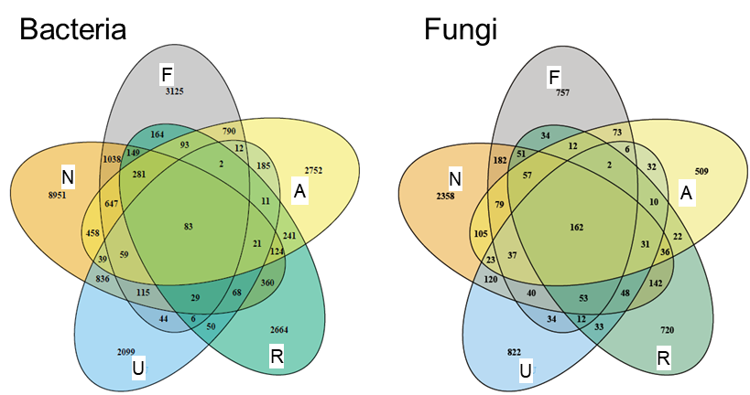
Fig. S1 The unique and shared number of ASVs in soil bacterial and fungal communities across five land use types (F: farmland; N: natural grassland; U: uncultivated land; R: riverbed; A: artificial grassland).

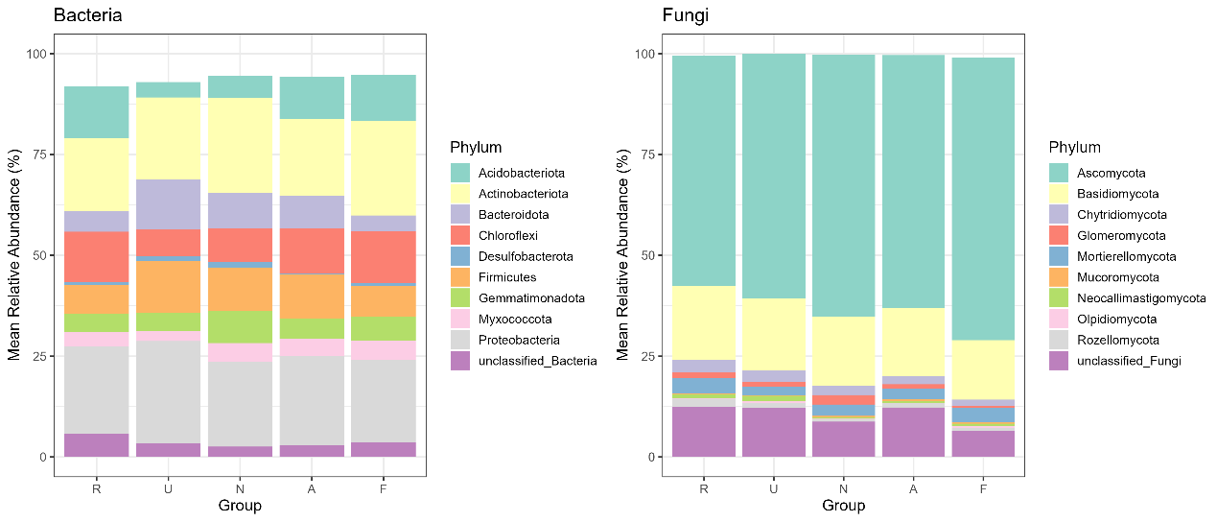
Fig. S2 The relative abundances of bacterial and fungal communities at the phylum level.

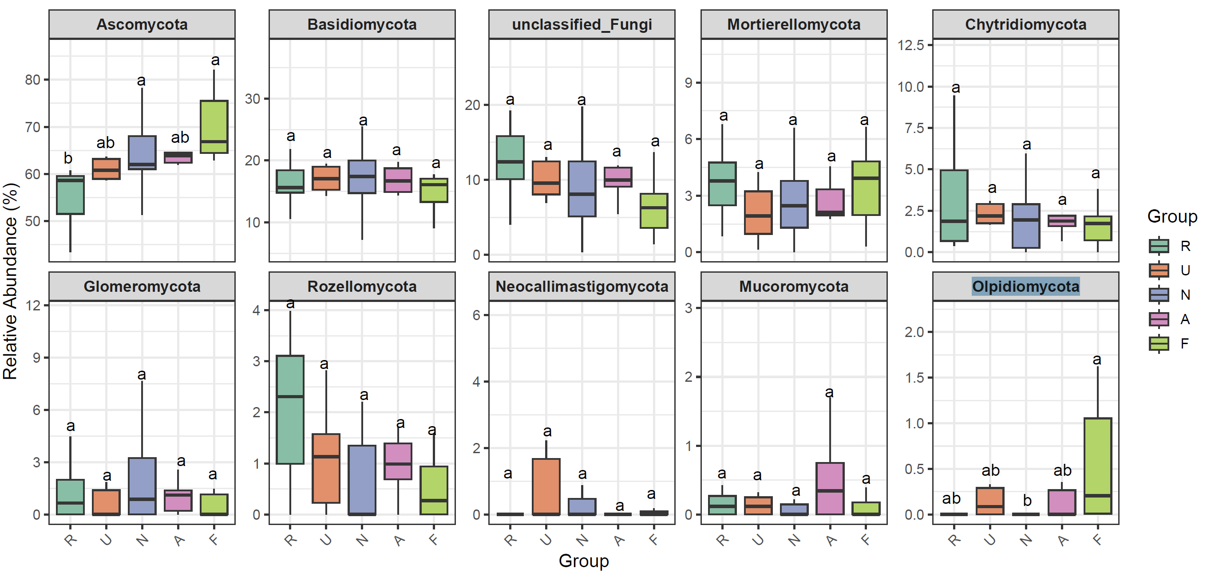
Fig. S3 Differential composition of the soil fungal community at the phylum level across five land use types via Wilcoxon tests (R: riverbed; U: uncultivated land; N: natural grassland; A: artificial grassland; F: farmland; different letters indicate significance between land use types via Wilcoxon tests for pairwise comparisons).

Fig. S4 Mantel test between the microbial communities and physiochemical parameters in farmland and natural grassland soils.

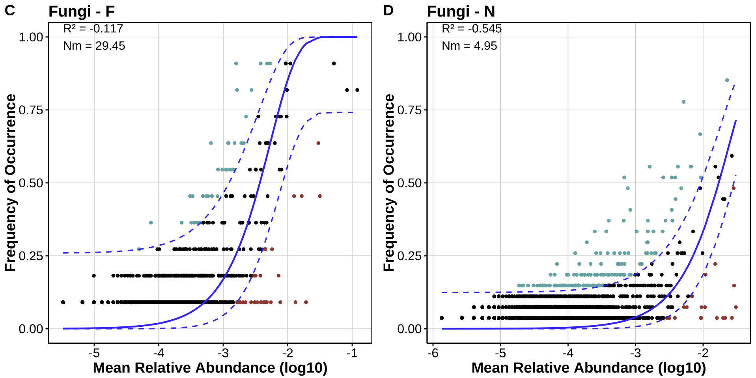
Fig. S5 Fitted neutral model of soil fungal communities (ASVs) in farmland (A) and natural grassland (B).
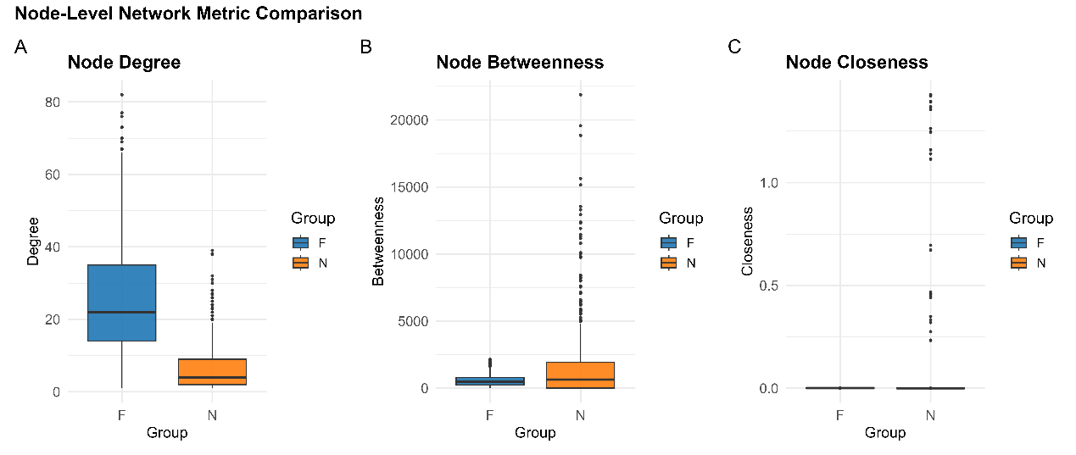
Fig. S6 The difference in the node degree, node betweenness and node closeness of the co-occurrence network of microbial communities from two main land use types (F: Farmland; N: Natural grassland).

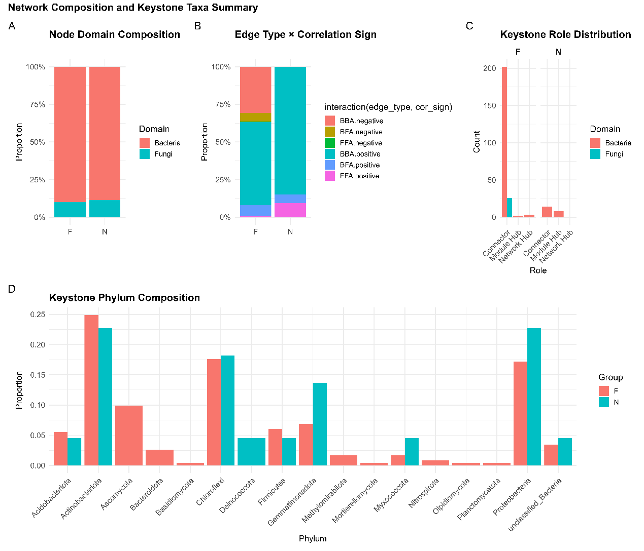
Fig. S7 The proportion of bacterial and fungal nodes (A), proportion of negative and positive edges (B), and count of bacterial and fungal key stones (C), and proportion of keystone species at phylum level (D) in soils from farmland (F) and natural grassland (N). (BBA: Bacteria-bacteria association, FFA: Fungi-fungi association; BFA: Bacteria-fungi association)
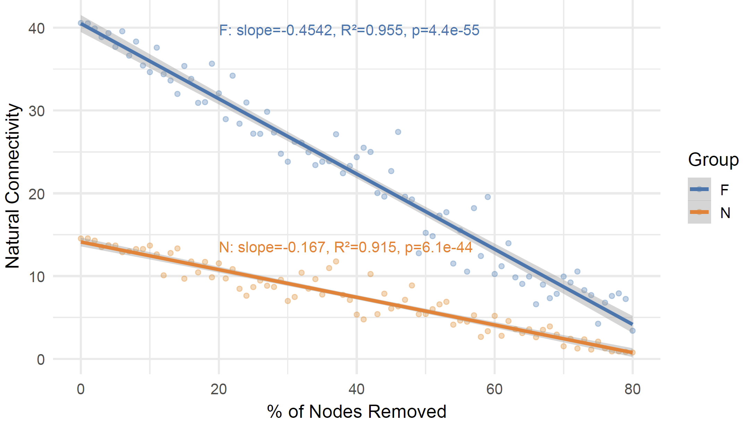
Fig. S8 The network stability of co-occurrence network of microbial communities in soils from farmland (F) and natural grassland (N).

