Supplementary Materials

Table S1 Oomycete isolates recovered from declining alder (Alnus glutinosa and A. incana) stands in Switzerland with their respective substrate of origin and sequence GenBank accession numbers.
Isolate No. | Species | Isolation source | Accession No.
GN513 | P. bilorbang | Soil | PV082471
GN516 | P. chlamydospora | Soil | PV082472
GN518 | P. chlamydospora | Soil | PV082473
GN509 | P. citrophthora | Water | PV082474
GN519 | P. citrophthora | Water | PV082475
GN520 | P. citrophthora | Water | PV082476
GN131 | P. pseudocryptogea | Soil | PV082477
GN515 | P. gallica | Soil | PV082478
GN531 | P. gallica | Soil | PV082479
GN536 | P. gallica | Soil | PV082480
GN88 | P. gonapodyides | Water | PV082481
GN152 | P. gonapodyides | Soil | PV082482
GN244 | P. gonapodyides | Soil | PV082483
GN507 | P. heteromorpha | Soil | PV082484
GN485 | P. honggalleglyana | Soil | PV082485
GN491 | P. honggalleglyana | Soil | PV082486
GN496 | P. honggalleglyana | Soil | PV082487
GN95 | P. lacustris | Soil | PV082488
GN229 | P. lacustris | Soil | PV082489
GN236 | P. lacustris | Soil | PV082490
GN10 | P. niederhauseri | Soil | PV082491
GN11 | P. niederhauseri | Soil | PV082492
GN5 | P. plurivora | Soil | PV082493
GN376 | P. plurivora | Soil | PV082494
GN484 | P. plurivora | Water | PV082495
GN482 | P. pseudosyringae | Soil | PV082496
GN528 | P. bilorbang | Soil | PV082497
GN531 | P. bilorbang | Soil | PV082498
GN19 | P. × alni | Soil | PV082499
GN210 | P. × alni | Bark | PV082500
GN211 | P. × alni | Bark | PV082501
GN20 | Py. aquatile | Soil | PV082502
GN57 | Py. aquatile | Soil | PV082503
GN106 | Py. aquatile | Soil | PV082504
GN59 | Py. lutarium | Soil | PV082505
GN73 | Pp. chamaehyphon | Water | PV082506
GN171 | Pp. chamaehyphon | Soil | PV082507
GN200 | Pp. chamaehyphon | Soil | PV082508
GN43 | Pp. citrinum | Soil | PV082509
GN405 | Pp. citrinum | Soil | PV082510
GN474 | Pp. citrinum | Soil | PV082511
GN71 | Pp. litorale | Water | PV082512
GN488 | Pp. litorale | Soil | PV082513
GN526 | Pp. litorale | Soil | PV082514
GN7 | Pp. montanum | Soil | PV082515
GN352 | Pp. paucipapillatum | Soil | PV082516
GN468 | Pp. paucipapillatum | Soil | PV082517
GN476 | Pp. paucipapillatum | Soil | PV082518
GN389 | Pp. vexans | Soil | PV082519
GN532 | Pp. vexans | Soil | PV082520
GN533 | Pp. vexans | Soil | PV082521
GN45 | G. heterothallicum | Soil | PV082522
GN16 | G. intermedium | Soil | PV082523
GN26 | G. intermedium | Soil | PV082524

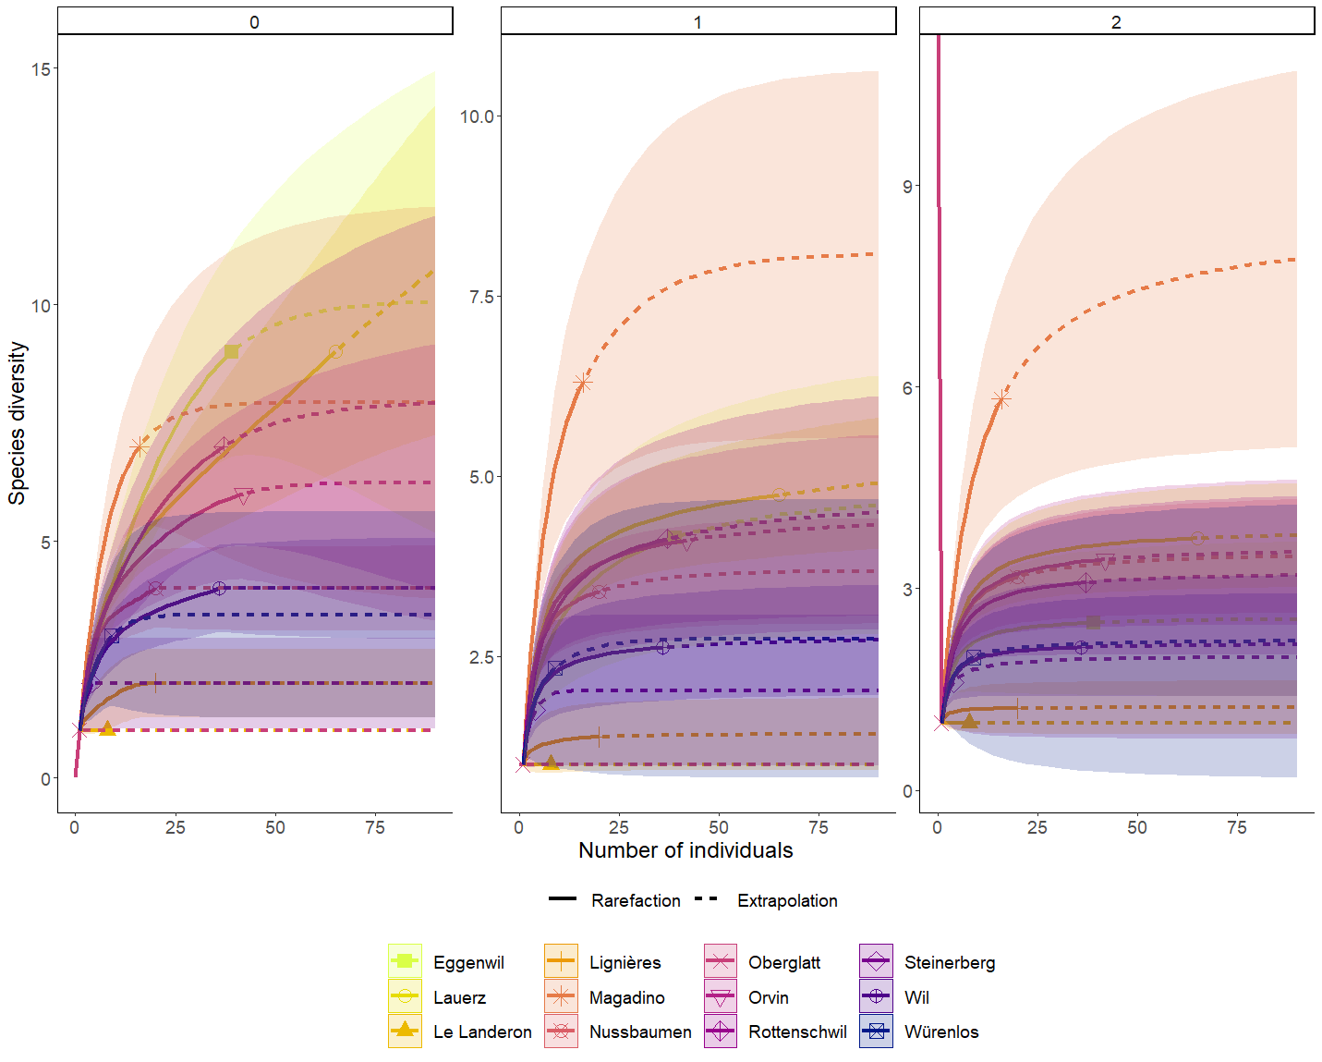

Fig. S1 Oomycete diversity in the rhizosphere soil of symptomatic alder trees at 12 different sites sampled during the present study (for more information see Tables 1 and 3) in Switzerland. The comparison is shown by individual abundance-based rarefaction (solid lines) and extrapolation curves (dashed lines). Each panel is based on the first three Hill numbers [32, 33]: ⁰D (left panel), ¹D (middle panel) and ²D (right panel). The color-shaded regions show the 95% confidence intervals.

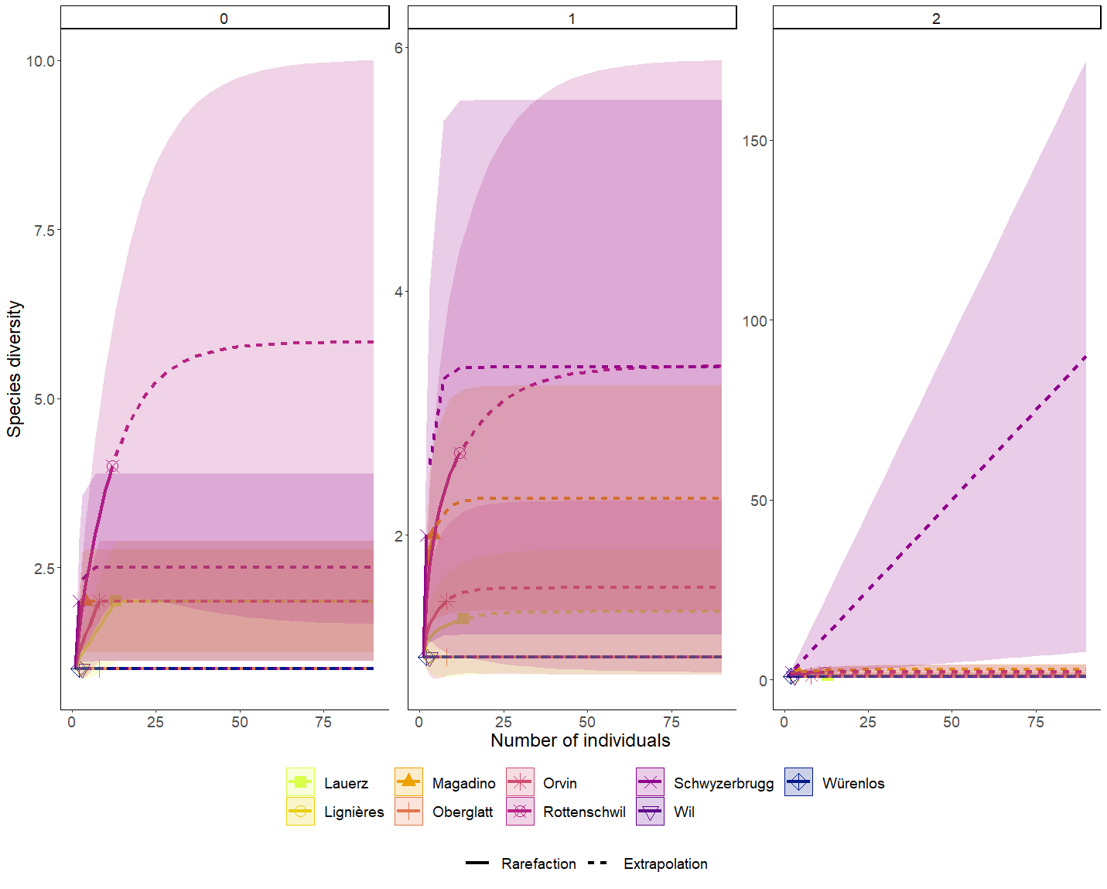
Fig. S2 Oomycete diversity in water samples taken in the declining alder stands at 9 different sites in Switzerland (for more information see Tables 1 and 3). The comparison is shown by individual abundance-based rarefaction (solid lines) and extrapolation curves (dashed lines). Each panel is based on the first three Hill numbers [32, 33]: ⁰D (left panel), ¹D (middle panel) and ²D (right panel). The color-shaded regions show the 95% confidence intervals.

