Supplemental File 1. Abundance counts of taxa (identified at the species level where possible) found in the cultivated communities and fecal samples.
Supplemental Table 1. Average read counts before and after filtering steps.
 | Before filtering | After DADA2 filtering step | After DADA2 denoising and merging | After DADA2 chimera removal | After removal of mitochondrial and chloroplast sequences and low abundance ASVs
Mojave Dilution 1 | 529306 | 265378 | 241629 | 24125 | 23835
Mojave Dilution 2 | 537373 | 276528 | 256364 | 24532 | 24267
Mojave Feces | 550816 | 254716 | 206530 | 34577 | 33498
Pancake Dilution 1 | 549198 | 293585 | 279728 | 23008 | 22882
Pancake Dilution 2 | 570214 | 306675 | 294095 | 25655 | 25534
Pancake Feces | 566370 | 280498 | 240896 | 37775 | 36728

Supplemental Table 2. Standard deviation of read counts before and after filtering steps.
 | Before filtering | After DADA2 filtering step | After DADA2 denoising and merging | After DADA2 chimera removal | After removal of mitochondrial and chloroplast sequences and low abundance ASVs
Mojave Dilution 1 | 71457 | 27749 | 23316 | 2657 | 2581
Mojave Dilution 2 | 48289 | 22177 | 19826 | 2139 | 2055
Mojave Feces | 21577 | 12330 | 10012 | 5189 | 5157
Pancake Dilution 1 | 49699 | 28689 | 27422 | 2724 | 2717
Pancake Dilution 2 | 114233 | 63903 | 61208 | 4421 | 4388
Pancake Feces | 44446 | 26372 | 24746 | 4302 | 4235

Supplemental Figure 1. Microbial communities cluster in PCoA plots largely based on cultivation (or lack thereof) and incubation temperature (or tortoise sampled from) for the enrichments. PCoA analysis was performed using the unweighted Jaccard distance metric. Enrichments from feces of a male desert tortoise (Mojave) were incubated at 30°C, and enrichments from a female desert tortoise (Pancake) were incubated at 39°C. (Fecal samples were not incubated.)
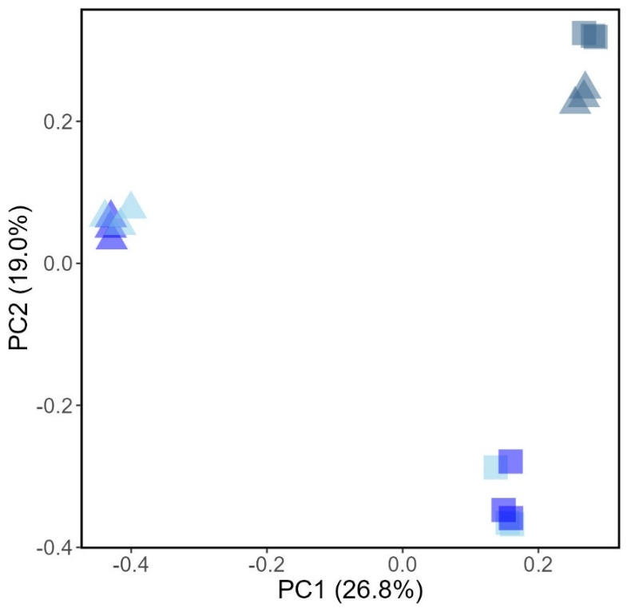
Mojave (30°C)
Pancake (39°C)
Tortoise
Dilution
Feces
Dilution 1
Dilution 2

Supplemental Figure 2. Alpha diversity is significant based on the tortoise sampled from when using a p-value cutoff of 0.05 but not a cutoff of 0.01 (p = 0.047). The p-value was calculated using the Kruskal-Wallis test with Faith’s phylogenetic diversity.

Supplemental Figure 3. Cellulose-degrading classes are abundant in fecal samples and cultivated communities.
Mojave
Pancake
Feces
Dilution 1
Dilution 2
Feces
Dilution 1
Dilution 2

