Supplementary Material
Insights into proliferation effects of low-dose glyphosate on phytoplankton communities

Jinzhu Su^{1,2}, YuPing Su ^{2,3*}, Yuxin weng^{2,3}, Gohar Ayub^{2,3}, Chenxing She², Yumei Xiao²

¹ Fujian Provincial Key Lab of Coastal Basin Environment, Fujian Polytechnic Normal University, Fuqing 350300, P.R. China
² College of Environmental and Resource Science, Fujian Normal University, Fuzhou 350007, P. R. China
³ Fujian Province Research Centre for River and Lake Happy Assessment, Fuzhou 350007, P. R. China

Correspondence: *Professor Yuping Su, College of Environmental and Resource Science, Fujian Normal University, Fuzhou 350007, PR China.
Email: ypsu@fjnu.edu.cn

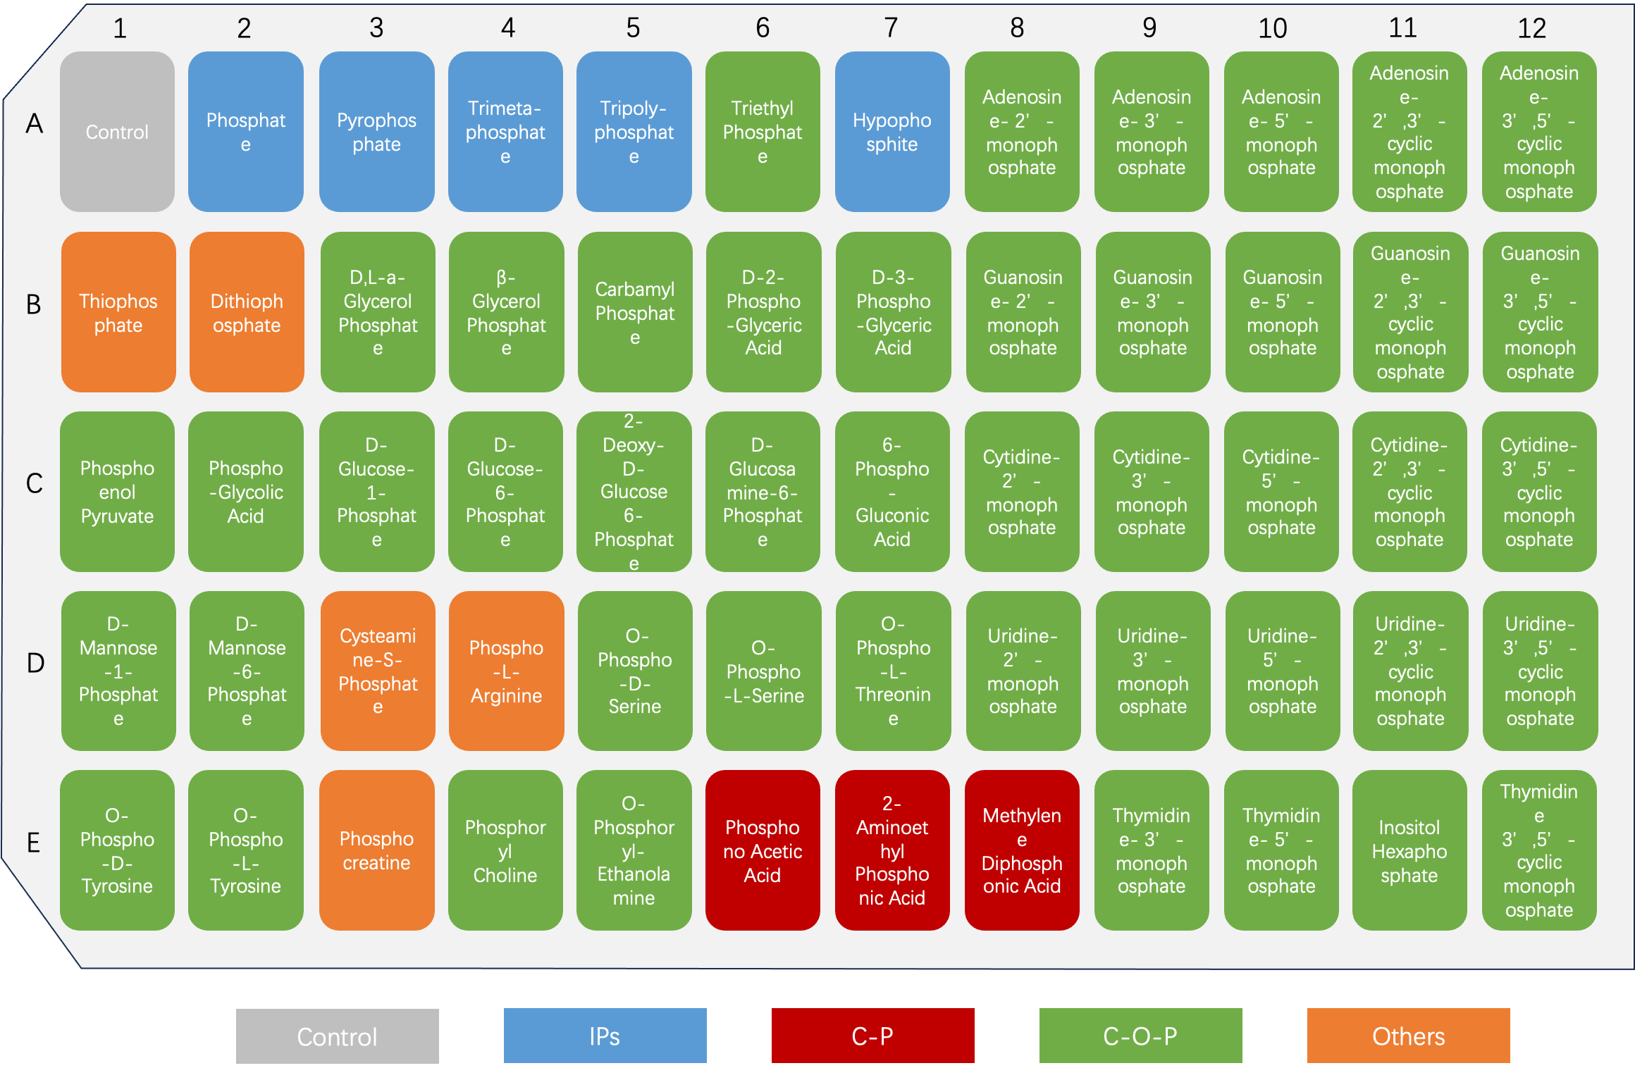
Figure S1 Map of BIOLOG PM4 microplate. Different colours represent a group of phosphorus sources. Grey cells represent negative control (no phosphorus source); blue cells represent IPs; red cells represent C-P bond phosphorus; green cells represent C-O-P bond phosphorus; orange cells represent other chemical bonds phosphorus. For example, B1 and B2 represent S=P bond phosphorus; D3 represents S-P bond phosphorus, D4 and E3 both represent N-P bond phosphorus, which did not analysis in this study.

Figure S2 Experimental design. A, three algae were cultured with different phosphorus sources in PM4A Microplate. B, mono and co-culture of M.aeruginosa and P. umbonatum var. inaequale with 0.05 mg/L glyphosate. C, the effect of glyphosate on algal communities of sediment-water interface.

Figure S3 Pearson correlations between biomass, growth rate, soluble protein and APA. MB indicated M. aeruginosa biomass, PB indicated P. umbonatum var. inaequale biomass, MGR indicated growth rate of M. aeruginosa, PGR indicated growth rate of P. umbonatum var. inaequale, SP indicated soluble protein, APA indicated alkaline phosphatase activity. The data were analyzed by Pearson correlations using RStudio software and the p values are represented as follows: *p < 0.05, **p < 0.01, N=16.

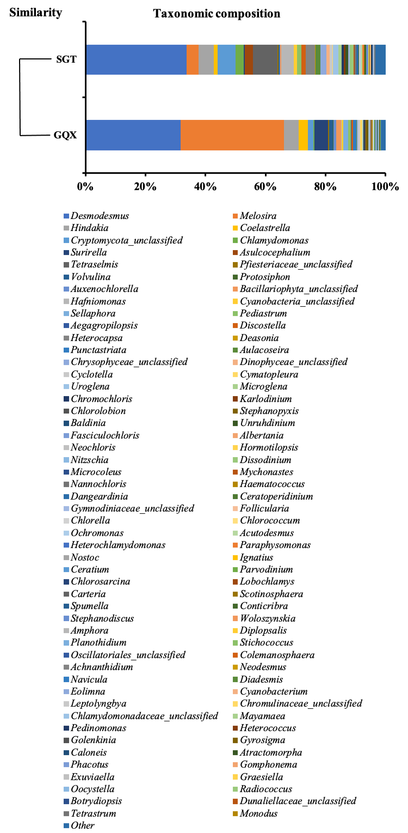
Figure S4 The in situ taxonomic composition of Gongqiaoxi station and Shiguitou station at Jiulong River (species at the genus level).

Table S1 The cell densities and experimental medium of mono and co-culture
 | Control | Treatment | Species | Phosphorus-free standard base medium | Initial cell density  (cells/L) | Initial biomass  (mg/L)
 | P-free | Glyphosate  (mg/L)
Mono-culture | - | 0.05 | M.aeruginosa | BG11 | 5.12×10⁷ | 1.89
Mono-culture | - | 0.05 | P. umbonatum var. inaequale | 119 | 8.18×10⁵ | 1.92
Co-culture | - | 0.05 | M.aeruginosa | 119 | 8.56×10⁷ | 3.15
Co-culture | - | 0.05 | P. umbonatum var. inaequale | 119 | 1.32×10⁶ | 3.11

Standard BG11 medium
NaNO₃, 15 mg/L; K₂HPO₄, 0.4 mg/L; MgSO₄·7H₂O, 0.75 mg/L; CaCl₂·2H₂O 0.36 mg/L; Citric acid, 0.06 mg/L; Ammonium ferric citrate, 0.06 mg/L; Na₂CO₃ 0.2 mg/L; Trace element 1ml/L (H₃BO₃, 2.86 g/L; MnCl₂·4H₂O, 1.86 g/L; ZnSO₄·7H₂O, 0.22 g/L; Na₂MoO₄·2H₂O, 0.39 g/L; CuSO₄·5H₂O, 0.08 g/L; Co(NO₃)₂·6H₂O 0.05 g/L)
Standard 119 medium: NaNO3, 0.05 g/L; MgSO4·7H2O, 0.015 g/L; CaCl2·2H2O 0.01 g/L; Na2CO3, 0.005 g/L; KHCO3, 0.01 g/L; KH2PO4, 0.007 g/L; Na2SiO3·9H2O, 0.10 g/L; MnSO4·4H2O, 0.002 g/L; Soil extract, 30mL; EDTA-Fe, 1 mL; PIV stock solution, 1 mL; Vit8 solution, 0.3 mL.
(1) Soil extract: Weigh 0.5 kg of unfertilized garden soil and place it in a beaker or flask. Add 1000 mL of distilled water to the soil. Seal the beaker or flask with a breathable stopper to allow air exchange while preventing contamination. Heat the beaker or flask in a boiling water bath for 2 hours. After heating, allow the mixture to cool to room temperature. Under sterile conditions, carefully decant the supernatant. Add sterilized distilled water to the supernatant to adjust the total volume to 1000 mL. Store the soil extract at 4°C for future use.
(2) EDTA-Fe:
A solution：Na₂EDTA, 1 g; distilled water, 50ml;
B solution: FeCl₃·6H₂O, 81 mg; HCl (0.1N) (0.1 mol/L), 50 ml.
(3) PIV stock solution: Na₂EDTA, 0.75g /L; FeCl₃·6H₂O, 97 mg/L; ZnCl₂ mg/L; Na₂MoO₄·2H₂O, 4mg/L; MnCl₂·4H₂O, 41 mg/L; CoCl₂·6H₂O, 2 mg/L
(4) Vit8 solution (per (mg/100mL)): Thiamine HCl(VB1-HCl), 20; Capantothenic, 10; Vitaming B₆(2HCl), 4; Vitamin H, 0.05; Choline crtric, 50; Orotic acid, 26; Folacin, 0.02; Nicotinic acid, 10; Vitaming B₂, 0.5; Vitaming B₆, 2; Inositol, 100; Thymine, 80; Vitaming B₁₂, 0.005; Folinic acid, 0.25.
Standard SE medium: NaNO₃, 0.25 g/L; K₂HPO₄·3H₂O, 0.075 g/L; MgSO₄·7H₂O, 0.075 g/L; CaCl₂·2H₂O, 0.025 g/L; KH₂PO₄, 0.175 g/L; NaCl, 0.025 g/L; Soil extract, 40 ml/L; FeCl₃·6H₂O, 0.005 g/L; Fe-EDTA, 1 ml/L; A5 solution, 1 ml/L; distilled water, 958 ml/L.
(1) A5 solution (per (mg/100mL))：H₃BO₃, 286; ZnSO₄·7H₂O, 22; MnCl₂·4H₂O, 181; CuSO₄·5H₂O, 7.9; (NH₄) ₆Mo₇O₂₄·4H2O, 3.9.
(2) EDTA-Fe：The procedure is the same as described in the Standard 119 medium.

