Supplementary Information
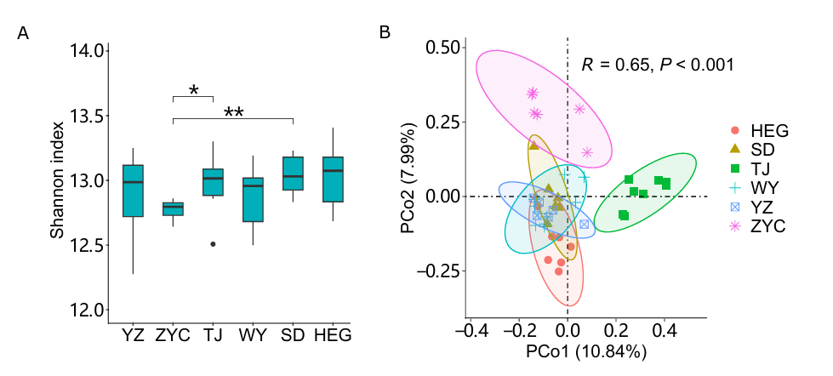
Figure S1 The α-diversity (A) and β-diversity (B) of gut phage community across all populations.

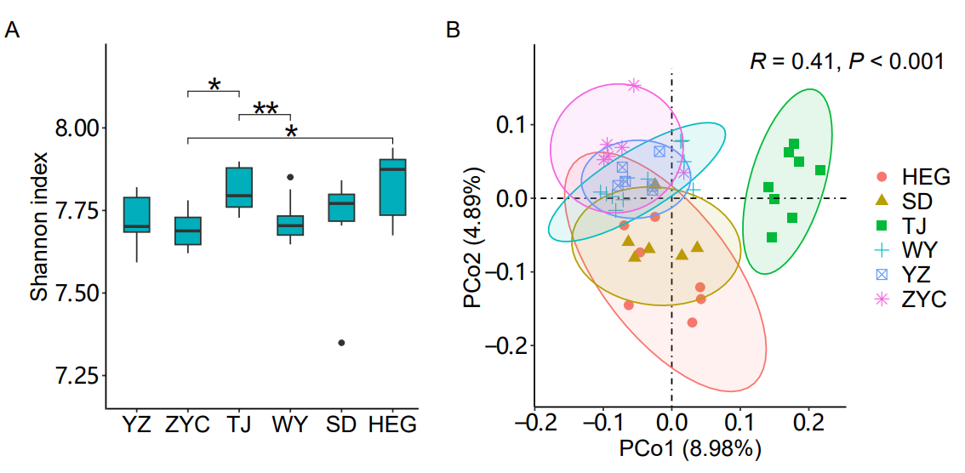
Figure S2 The α-diversity (A) and β-diversity (B) of gut bacteriome community across all populations.

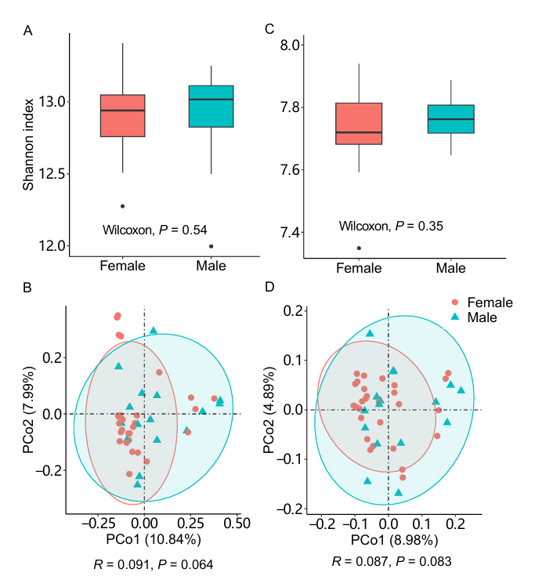
Figure S3 The α-diversity (A) and β-diversity (B) of fecal phage community across gender and α-diversity (C) and β-diversity (D) of fecal bacteriome community across gender.

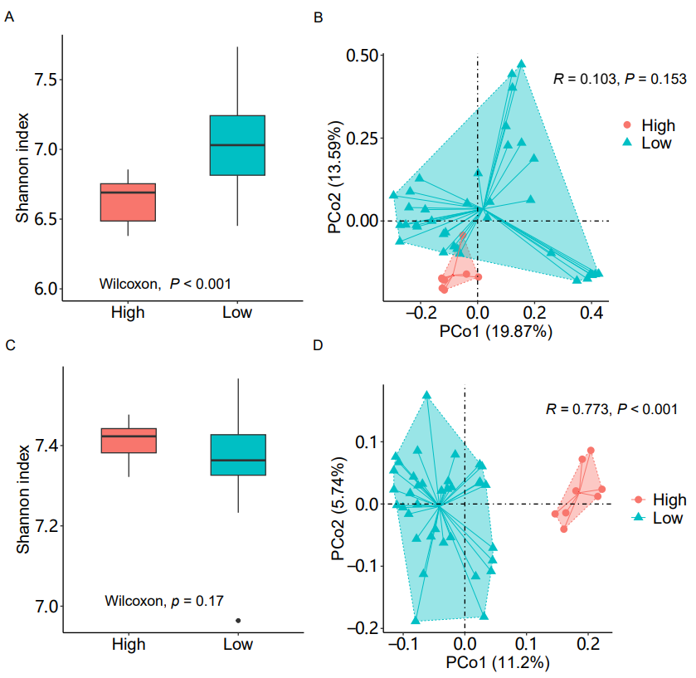
Figure S4 The α-diversity (A, C) and β-diversity (B, D) of gut phage and bacteriome community associated with altitude.

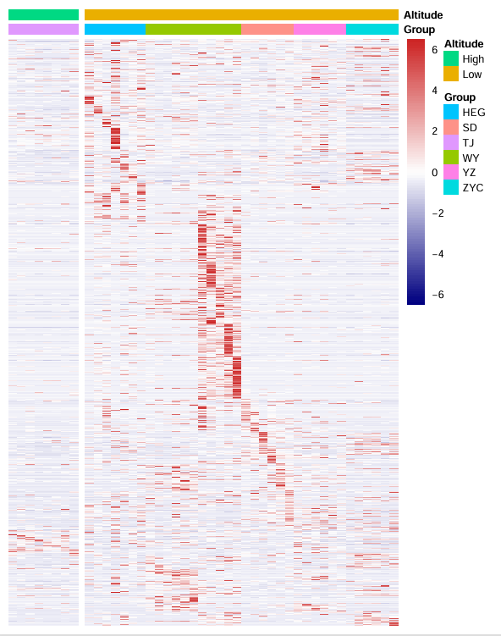
Figure S5 The RPKM abundance of fecal phage community associated with altitude.

Table S1 Primer information for Przewalski’s gazelle individual identification

Primer information  5，-3， |  |  | Amplified  fragment size（bp）
AC91-F | TTGGTCGTACTGACTGGTA |  | 176-200
AC91-R | GGAGTGACTGAGGACAGA
HDZ8 -F | GACAAACACTCAGAAGGCAAAG |  | 132-166
HDZ8 -R | GGTGGCAGGACTGAGCAAG
MAF23-F | GTGGAGGAATCTTGACTTGTGATAG |  | 124-160
MAF23-R | GGCTATAGTCCATGGAGTCGCAG
AC1-F | TTGGCAGGTGGATTATTTAC |  | 171-199
AC1-R | TGGTTGTCAATGGAAGGAA
AC29-F | AGGACGGCACTTAAACTTATG |  | 169-198
AC29-R | TATCATTGTCAGGCTTCTCT
HDZ496-F | GTTTTTCCAGATGGTATTTTCCTC |  | 228-250
HDZ496-R | GTATTCGGCTGAAGGGACC
AC299-F | CGGTGTTCATATAACAGATTCC |  | 159-189
AC299-R | GGTTGCTCAGTGGTCTCA

Table S2 Information of Przewalski’s gazelle gut virome sequencing data.

 | Sample |  | Clean reads  number |  | GC（%） | Contigs number | Contigs number  >1000
 | HEG10 |  | 26729359 |  | 46.1 | 767401 | 113124
 | HEG119 |  | 68910651 |  | 44.94 | 2362105 | 383464
 | HEG126 |  | 57000104 |  | 47.49 | 1804193 | 287375
 | HEG179 |  | 26201258 |  | 46.34 | 821358 | 130790
 | HEG215 |  | 55026670 |  | 46.38 | 1815461 | 308635
 | HEG32 |  | 55463935 |  | 45.66 | 2159349 | 375556
 | HEG59 |  | 35710005 |  | 43.55 | 1363239 | 187183
 | QJ106 |  | 64661844 |  | 48.64 | 2374388 | 398246
 | QJ107 |  | 64426935 |  | 47.65 | 2085620 | 403010
 | QJ108 |  | 71142231 |  | 46.66 | 1792496 | 355181
 | QJ63 |  | 66963318 |  | 47.84 | 2636748 | 451972
 | QJA |  | 43712310 |  | 47.23 | 1437518 | 245340
SD133 |  |  | 101432182 |  | 46.74 | 2690930 | 525133
SD137 |  |  | 29115465 |  | 44.28 | 1125277 | 187573
SD140 |  |  | 29261195 |  | 48.52 | 1215489 | 220595
SD142 |  |  | 38155255 |  | 44.56 | 1572027 | 277932
SD19 |  |  | 94112095 |  | 45.11 | 2489636 | 580184
SD20 |  |  | 120774899 |  | 45.15 | 2977021 | 687880
 | TJ103 |  | 105985333 |  | 45.26 | 2605543 | 594578
 | TJ77 |  | 46016971 |  | 45.53 | 1644600 | 306141
 | TJ84 |  | 44646296 |  | 44.46 | 1855182 | 312291
 | TJ87 |  | 34553090 |  | 45.07 | 1509367 | 254676
 | TJ88 |  | 34837082 |  | 43.32 | 1190452 | 210798
 | TJ91 |  | 39509374 |  | 44.02 | 1472712 | 254348
 | TJ93 |  | 34188349 |  | 43.63 | 1316224 | 213791
 | TJ97 |  | 36596038 |  | 45.21 | 1250432 | 219749
WY200 |  |  | 53312051 |  | 46.76 | 1640251 | 279810
WY201 |  |  | 47201925 |  | 43.84 | 1240373 | 254179
WY204 |  |  | 40864046 |  | 45.42 | 1176054 | 218660
WY47 |  |  | 52758862 |  | 45.89 | 1613223 | 286099
WY48 |  |  | 36896092 |  | 46.02 | 960671 | 175035
WY49 |  |  | 51809455 |  | 46.51 | 1467208 | 279396
YZ193 |  | 27485004 |  | 45.4 |  | 982863 | 174760
YZ194 |  | 33306473 |  | 45.31 |  | 1418847 | 224332
YZ196 |  | 56400377 |  | 44.06 |  | 1960635 | 424307
YZ197 |  | 28956912 |  | 45.13 |  | 814845 | 139554
YZ42 |  | 35234424 |  | 47.06 |  | 1114372 | 184947
YZ45 |  | 40696123 |  | 46.74 |  | 1438299 | 250678
 | ZYC64 |  | 31759717 |  | 45.85 | 1014088 | 203460
ZYC66 |  | 35982191 |  | 47.3 |  | 1028143 | 195894
ZYC68 |  | 88116591 |  | 47.1 |  | 1985422 | 483725
ZYC71 |  | 74702210 |  | 47.69 |  | 1772385 | 421263
ZYC72 |  | 34151785 |  | 47.61 |  | 689039 | 162427
ZYC73 |  | 44539929 |  | 46.91 |  | 1316819 | 269578

Table S3 Statistical outputs for db-RDA analyses of phage and microbiome composition

 | bacteriome |  |  |  | phage
 | Df | SumOfSqs | F | P | Df | SumOfSqs | F | P
Longitude | 1 | 0.22 | 2.65 | <0.001 | 1 | 0.81 | 4.13 | <0.001
Latitude | 1 | 0.20 | 2.32 | <0.001 | 1 | 0.67 | 3.41 | <0.001
Altitude | 1 | 0.13 | 1.54 | 0.02 | 1 | 0.56 | 2.87 | <0.001
Sex | 1 | 0.09 | 1.10 | 1.00 | 1 | 0.26 | 1.34 | 0.35
Vegetation type | 2 | 0.22 | 1.27 | 0.06 | 2 | 0.71 | 1.82 | <0.01
Population size | 1 | 0.10 | 1.24 | 0.31 | 1 | 0.48 | 2.43 | <0.01
Longitude:Altitude | 1 | 0.12 | 1.37 | 0.10 | 1 | 0.34 | 1.72 | 0.03
Residual | 35 | 2.96 |  |  | 35 | 6.84
Corrected model R2 | 0.10 |  |  | <0.001 | 0.21 |  |  | <0.001

Table S4 Statistical outputs for PERMANOVA of phage and microbiome composition

 | bacteriome |  |  |  |  | phage
 | Df | SumOfSqs | R² | F | P | Df | SumOfSqs | R² | F | P
Longitude | 1 | 0.10 | 0.0240 | 1.13 | 0.67 | 1 | 0.38 | 0.0355 | 1.90 | <0.01
Latitude | 1 | 0.10 | 0.0237 | 1.12 | 0.77 | 1 | 0.39 | 0.0369 | 1.97 | <0.01
Altitude | 1 | 0.10 | 0.0256 | 1.21 | 0.33 | 1 | 0.41 | 0.0388 | 2.07 | <0.01
Sex | 1 | 0.09 | 0.0228 | 1.08 | 1.00 | 1 | 0.26 | 0.0241 | 1.29 | 0.44
Vegetation type | 2 | 0.21 | 0.0524 | 1.24 | 0.08 | 2 | 0.77 | 0.0720 | 1.93 | <0.001
Population size | 1 | 0.10 | 0.0259 | 1.23 | 0.28 | 1 | 0.48 | 0.0446 | 2.38 | <0.01
Residual | 36 | 3.08 | 0.7615 |  |  | 36 | 7.18 | 0.6732

