Supplementary Materials
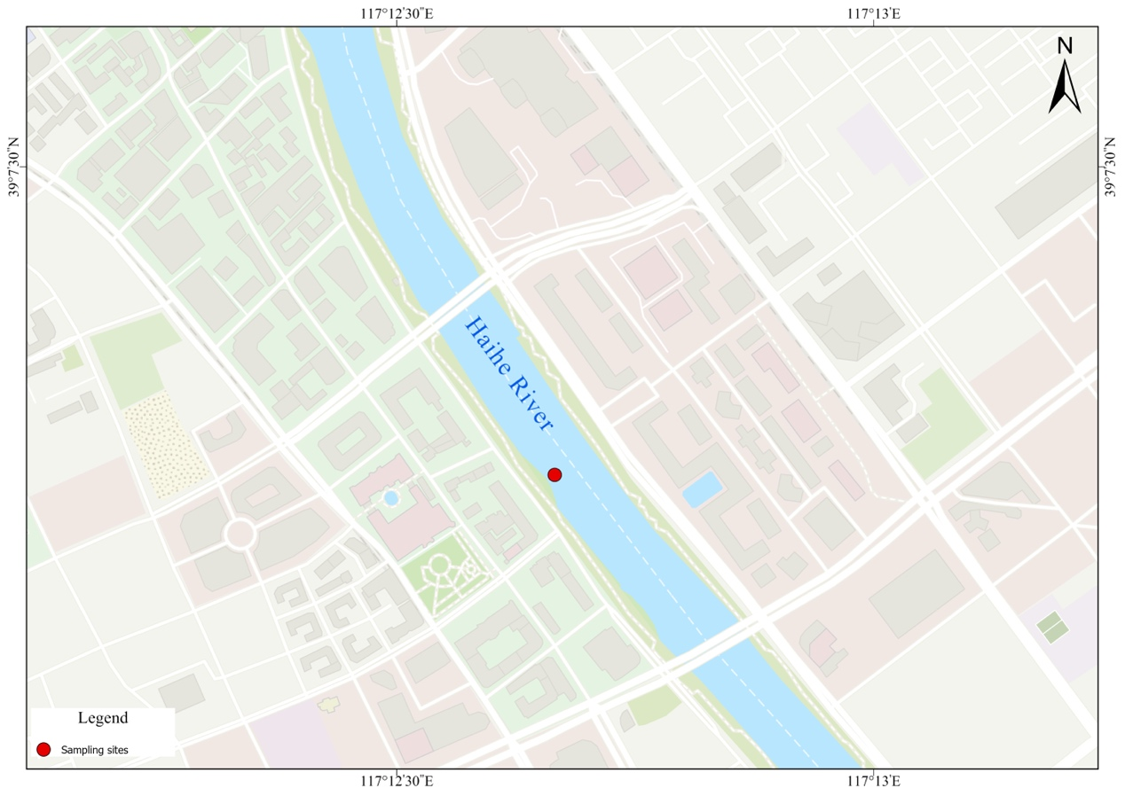
Fig. S1. Geographic location of the sampling site in the Haihe River, Tianjin, China. The red dot indicates the specific sampling location.
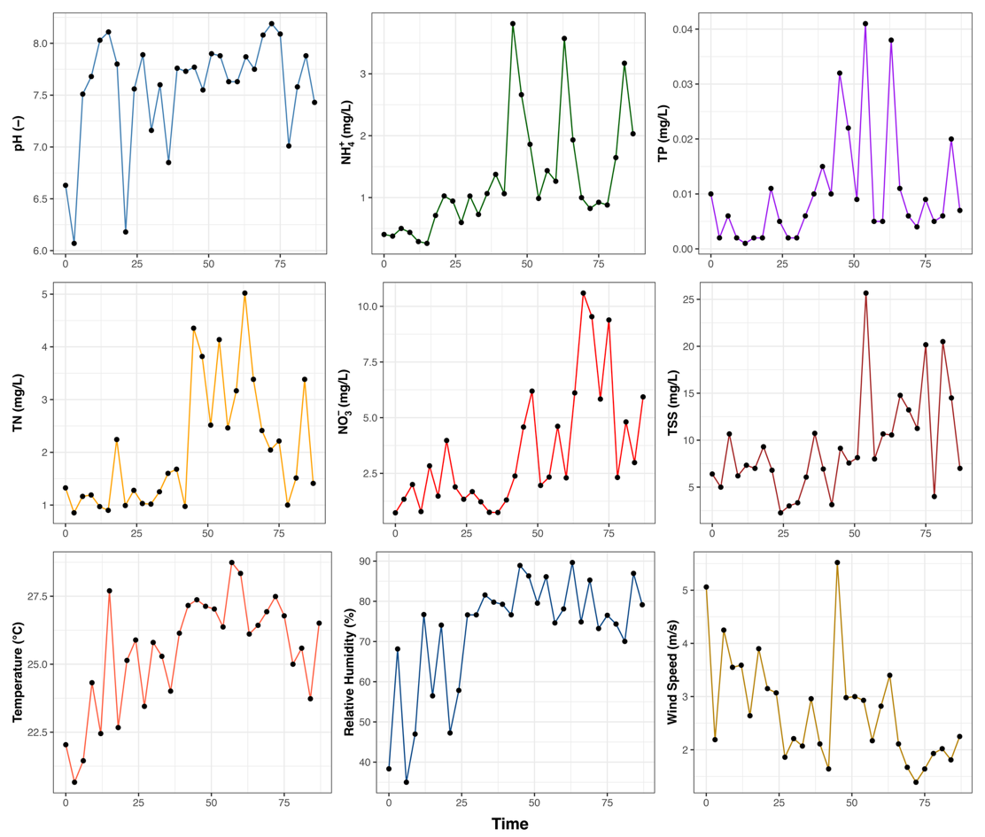
Fig. S2 Temporal variation of environmental factors during the study period, including water quality parameters (TN, TP, NH₄-N, NO₃-N, TSS, and pH) and meteorological variables (temperature, relative humidity, and wind speed).
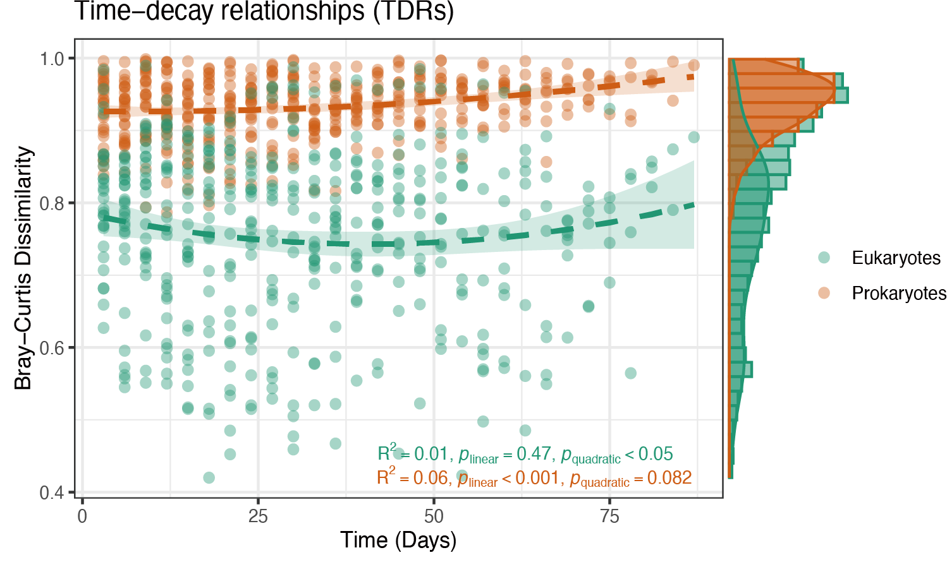
Fig. S1 Time-decay relationships (TDRs) for prokaryotic and eukaryotic communities, showing Bray-Curtis dissimilarity over time.

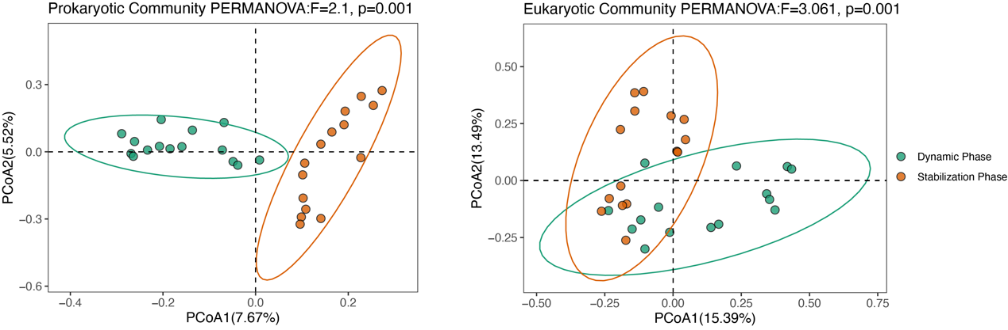
Fig. S2 Principal Coordinates Analysis (PCoA) plots showing community structure for prokaryotic (left) and eukaryotic (right) communities based on Bray-Curtis dissimilarity.
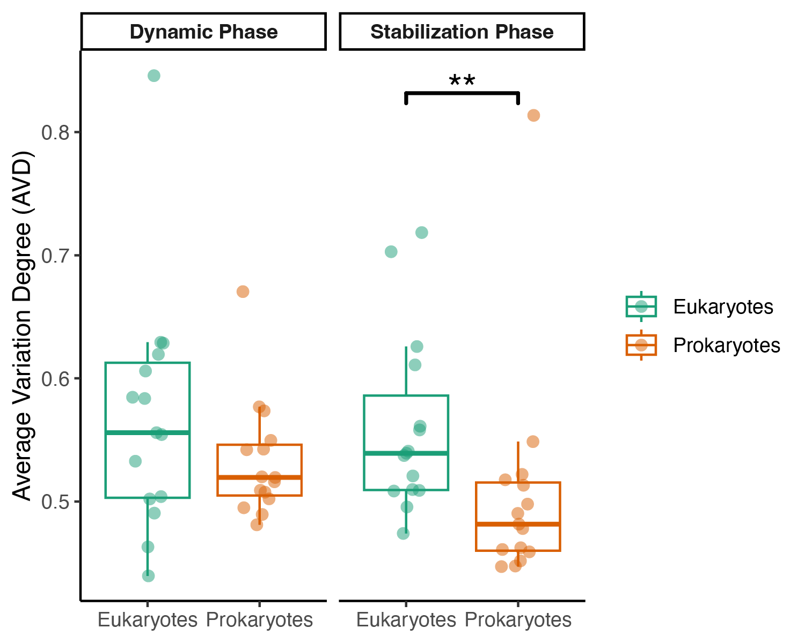
Fig. S3 Average Variation Degree (AVD) for eukaryotic and prokaryotic communities during the Dynamic and Stabilization Phases. The significant difference in AVD between the Stabilization Phase for eukaryotic and prokaryotic communities is marked with ** (p < 0.01).
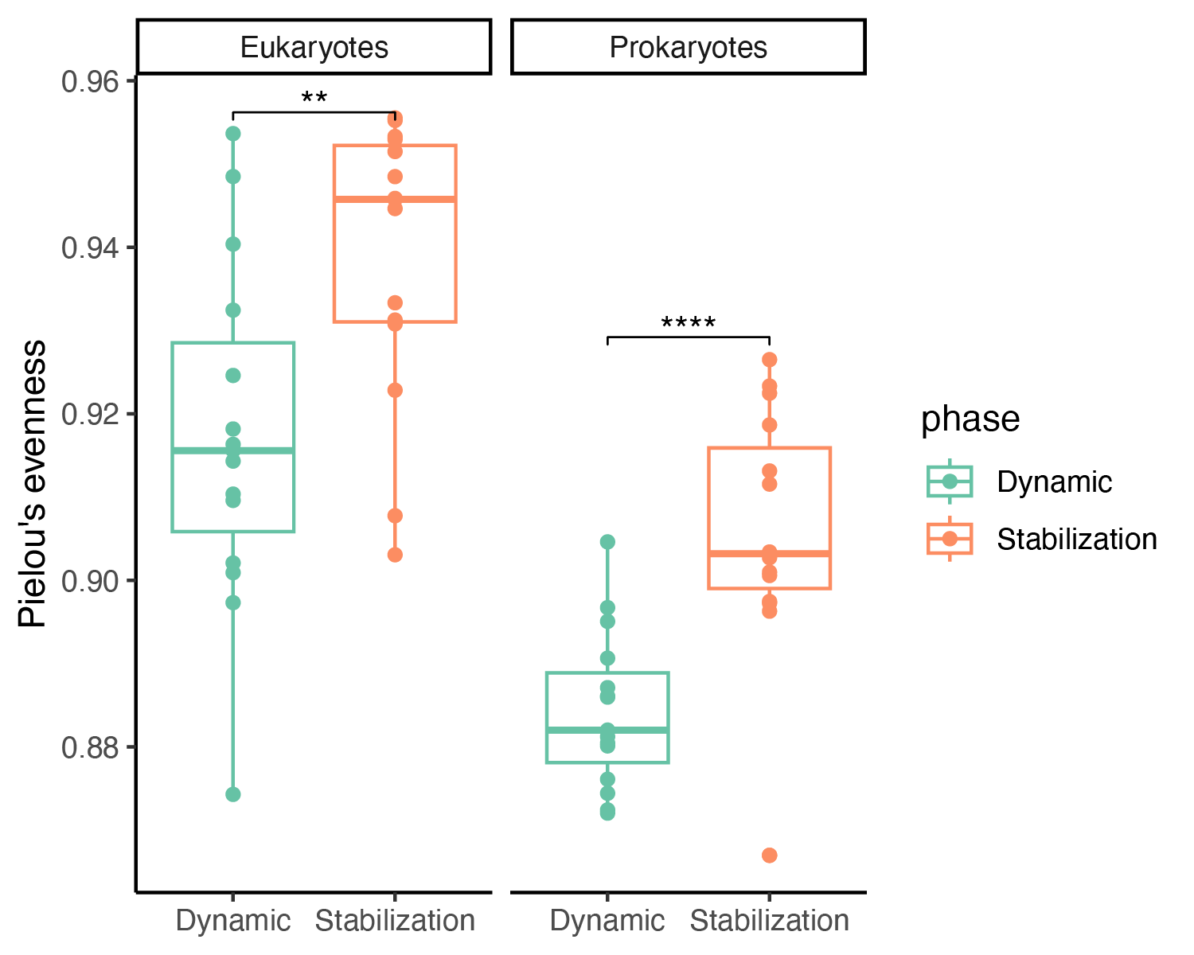
Fig. S4 Pielou’s evenness index for eukaryotic and prokaryotic communities during the Dynamic and Stabilization Phases. Green boxplots represent the Dynamic Phase, and orange boxplots represent the Stabilization Phase. Significant differences between phases are indicated for both eukaryotes (** p < 0.01) and prokaryotes (**** p < 0.0001).

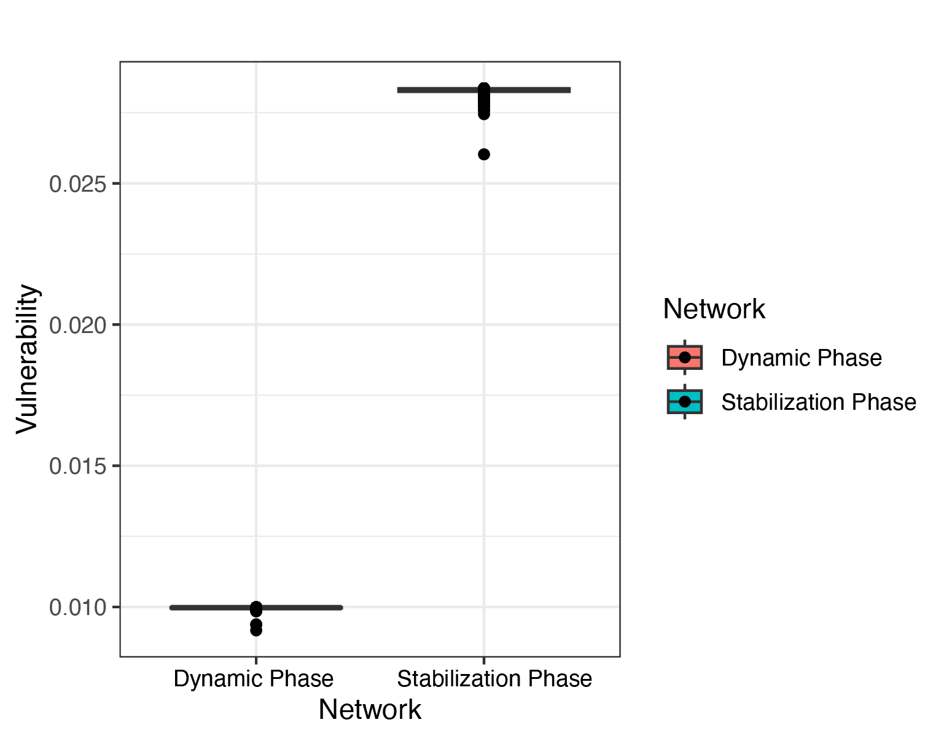
Fig. S5 Vulnerability of microbial co-occurrence networks during the Dynamic Phase and Stabilization Phase. Networks are categorized into Homogenization (Dynamic Phase) and Heterogenization (Stabilization Phase).

Table S1 Network properties comparison between the Dynamic Phase and Stabilization Phase for microbial co-occurrence networks.
Property | Dynamic Phase | Stabilization Phase
Vertex | 722 | 742
Edge | 3209 | 6429
Average Degree | 8.89 | 17.33
Average Path Length | 2.54 | 3.50
Network Diameter | 7 | 14
Clustering Coefficient | 0.89 | 0.89
Density | 0.01 | 0.02
Heterogeneity | 0.98 | 1.23
Centralization | 0.04 | 0.10
Modularity | 0.92 | 0.75

