Supplementary Material
Physicochemical, structural, and proteomic insights into drinking water-isolated Acinetobacter calcoaceticus aggregation and biofilm dynamics

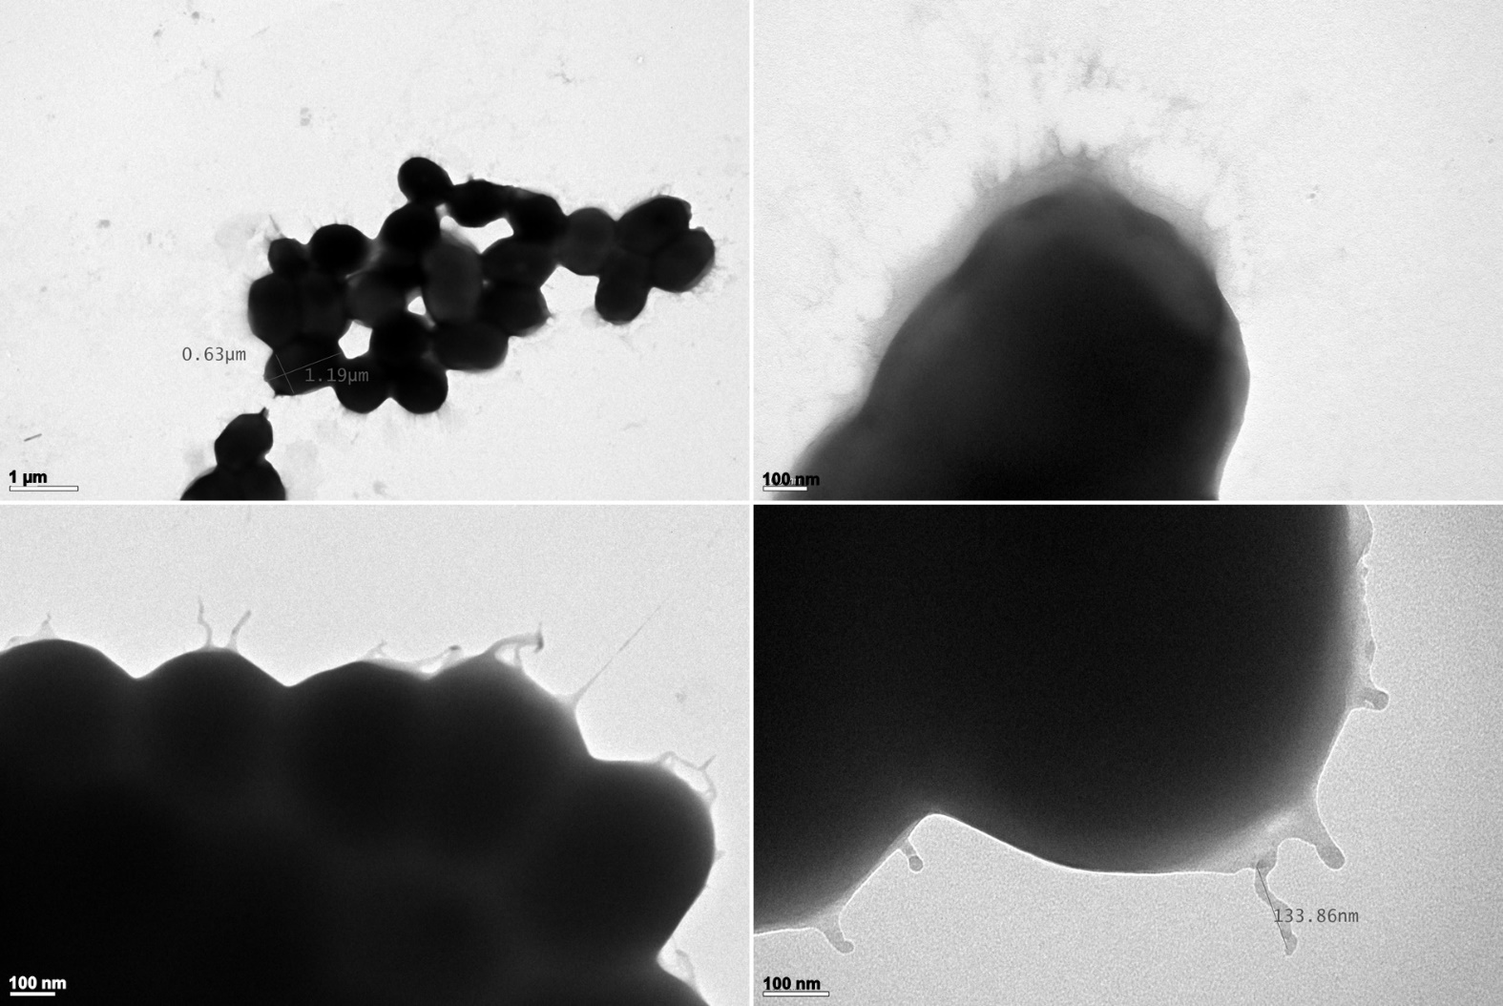
Figure S1. Transmission electron micrographs of Acinetobacter calcoaceticus negatively stained. The image shows multiple aggregated A. calcoaceticus cells, with clear visualization of amorphous extracellular material, as well as filamentous structures emerging from the cell surface.

