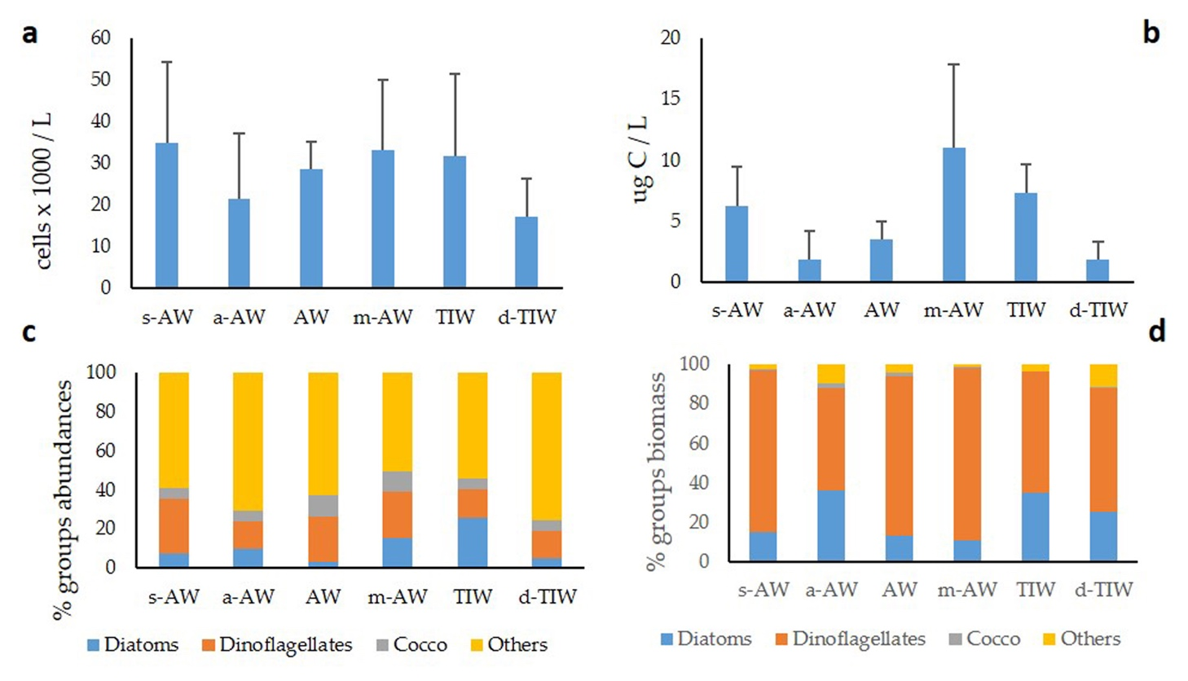

Fig. S1. Phytoplankton averaged distribution in the six water masses. Total abundance (cells x 10³ L⁻¹) (a) and biomass (µg C L⁻¹) (b); percentages of the main taxonomic groups (diatoms, dinoflagellates, coccolithophorids and other phytoflagellates) in terms of abundance (c) and biomass (d). Standard deviations are indicated.

