Supporting Information
Correction to: Hydro- and xerohalophyte species drive compositional and functional divergence in bacterial leaf endosphere
Beatriz Roncero-Ramos*^{1,} Elena Romano-Rodríguez¹, Enrique Mateos-Naranjo¹, Pedro Valle-Romero¹, Susana Redondo-Gómez¹
¹ Departamento de Biología Vegetal y Ecología, Facultad de Biología, Universidad de Sevilla, Avda. Reina Mercedes s/n, 41012 Seville, Spain.
Corresponding author: broncero@us.es
Journal: Microbial Ecology

Supplementary Tables
Table S1 Accumulated precipitation in 2022/2023, average monthly temperatures (Tm) and average monthly maximum (Tm-max) and minimum (Tm-min) temperatures for the autumn 2022 months. Source: AEMET.
 | Hydrohalophytes | Xerohalophytes
 | Huelva | Almería | Murcia
Precipitation (mm) | 300 | 50 | 200
Tm (ºC) | 17.9 | 20.6 | 18.8
Tm-max (ºC) | 23.3 | 24.9 | 25.1
Tm-min (ºC) | 12.4 | 16.3 | 12.5

Table S2 Average and standard deviation of electrical conductivity of the rhizosediment of all sampled populations.
Plant species | Average electrical conductivity (mS · cm⁻¹) ± SD
Atriplex portulacoides | 7.0 ± 3.8
Salicornia perennis | 14.2 ± 11.2
Suaeda vera | 0.7 ± 0.6
Halocnemum strobilaceum | 8.4 ± 4.7
Atriplex glauca | 1.3 ± 1.2
Anabasis articulata | 1.0 ± 0.2

Supplementary Figures
Fig. S1 Biogeographical map with locations of all sampled populations indicated by numbers as in Table 1. The three hydrohalophyte plant species were sampled in populations 1 (Duque), 2 (Estadio) and 3 (Terrón). The xerohalophytes were sampled on the mediterranean coast: Halocnemum strobilaceum in populations 10 (Guadalentín), 11 (Calarreona) and 12 (Ecoparque); Anabasis articulata in populations 7 (Fabriquilla), 8 (Faro) and 9 (Isleta); and Atriplex glauca in populations 4 (Ermita), 5 (Rambla) and 6 (Corralete).
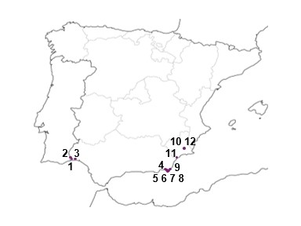

Fig. S2 Scheme of the leaf sample collection protocol. First, fully developed individuals were selected. Then, three fragments of 2-3 cm of length were cut from the centre of each plant. Finally, a composite sample of each individual was surface sterilized in the laboratory.
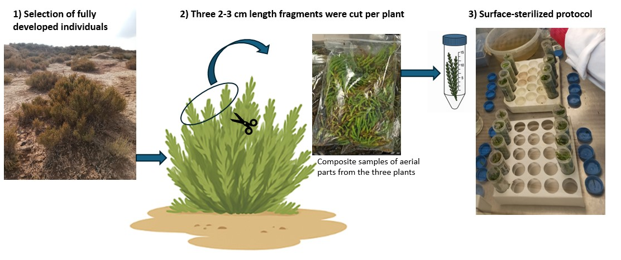

Fig. S3 Relative abundance of the 10 top bacterial phyla in the leaf endosphere of halophytes. Bars represent composite samples of each population.
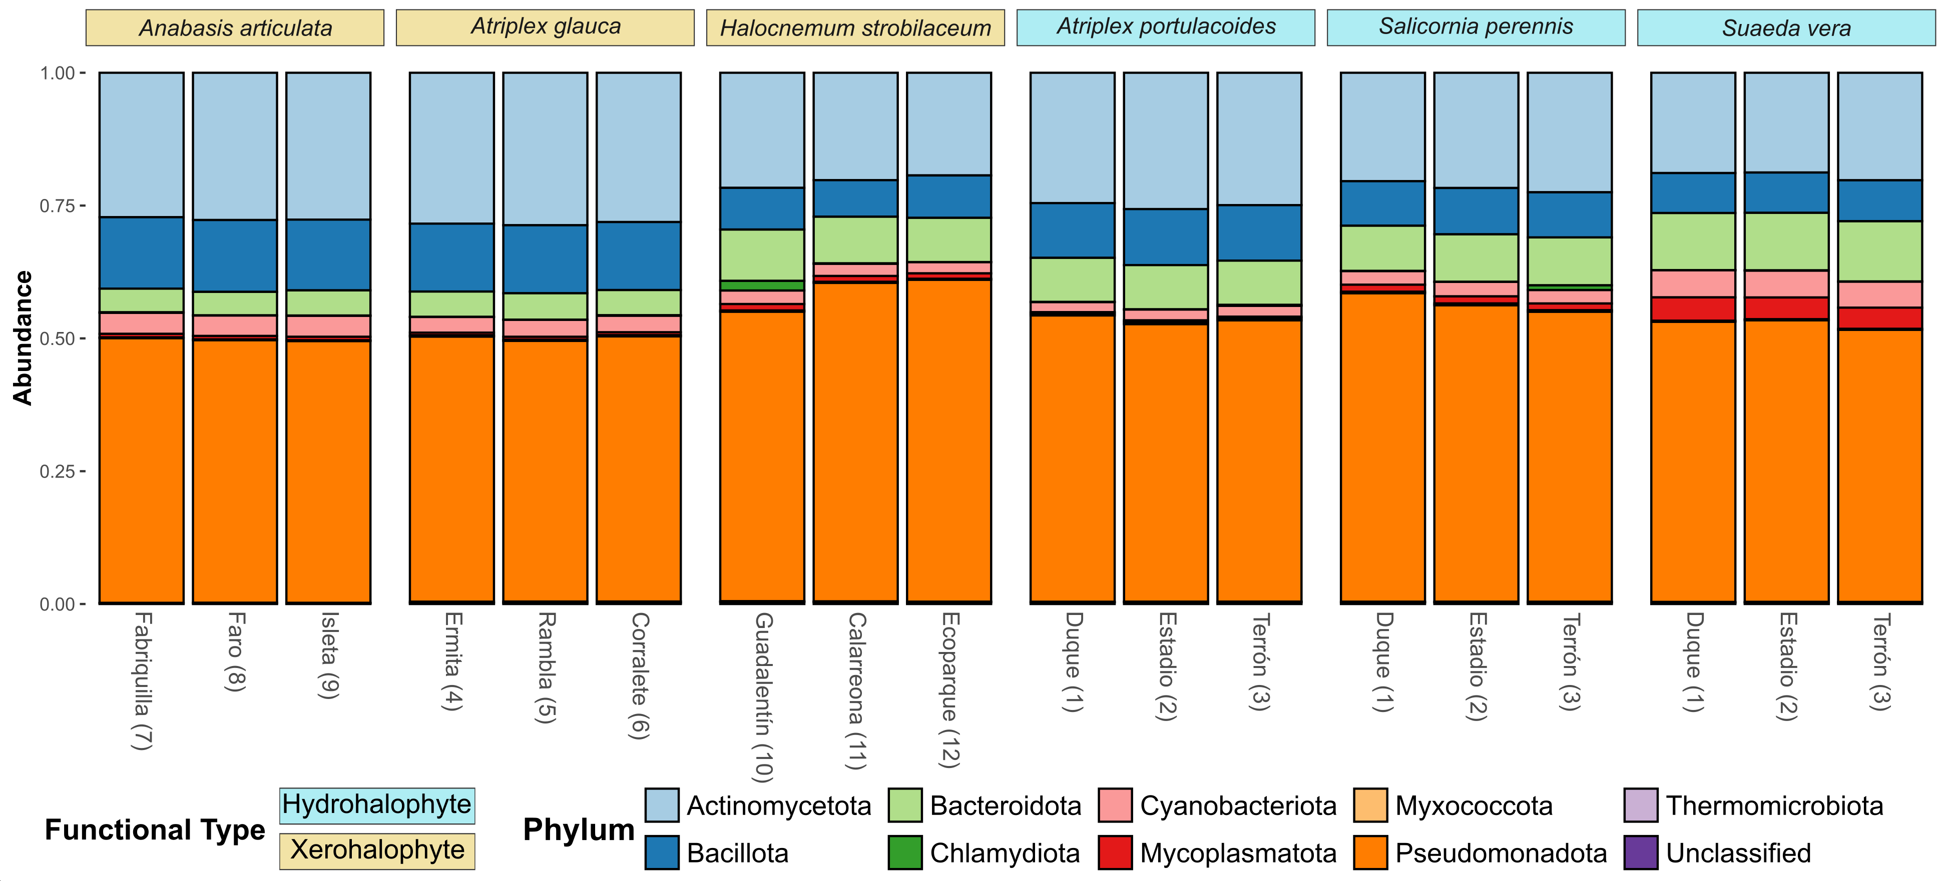
Fig. S4 PCoA ordination analysis based on a weighted unifrac distance matrix of PGP traits annotation of bacterial metagenomes. Each data point is a composite sample. Factors are represented by colour (plant species) and shape (functional type). Numbers represent populations in Table 1.
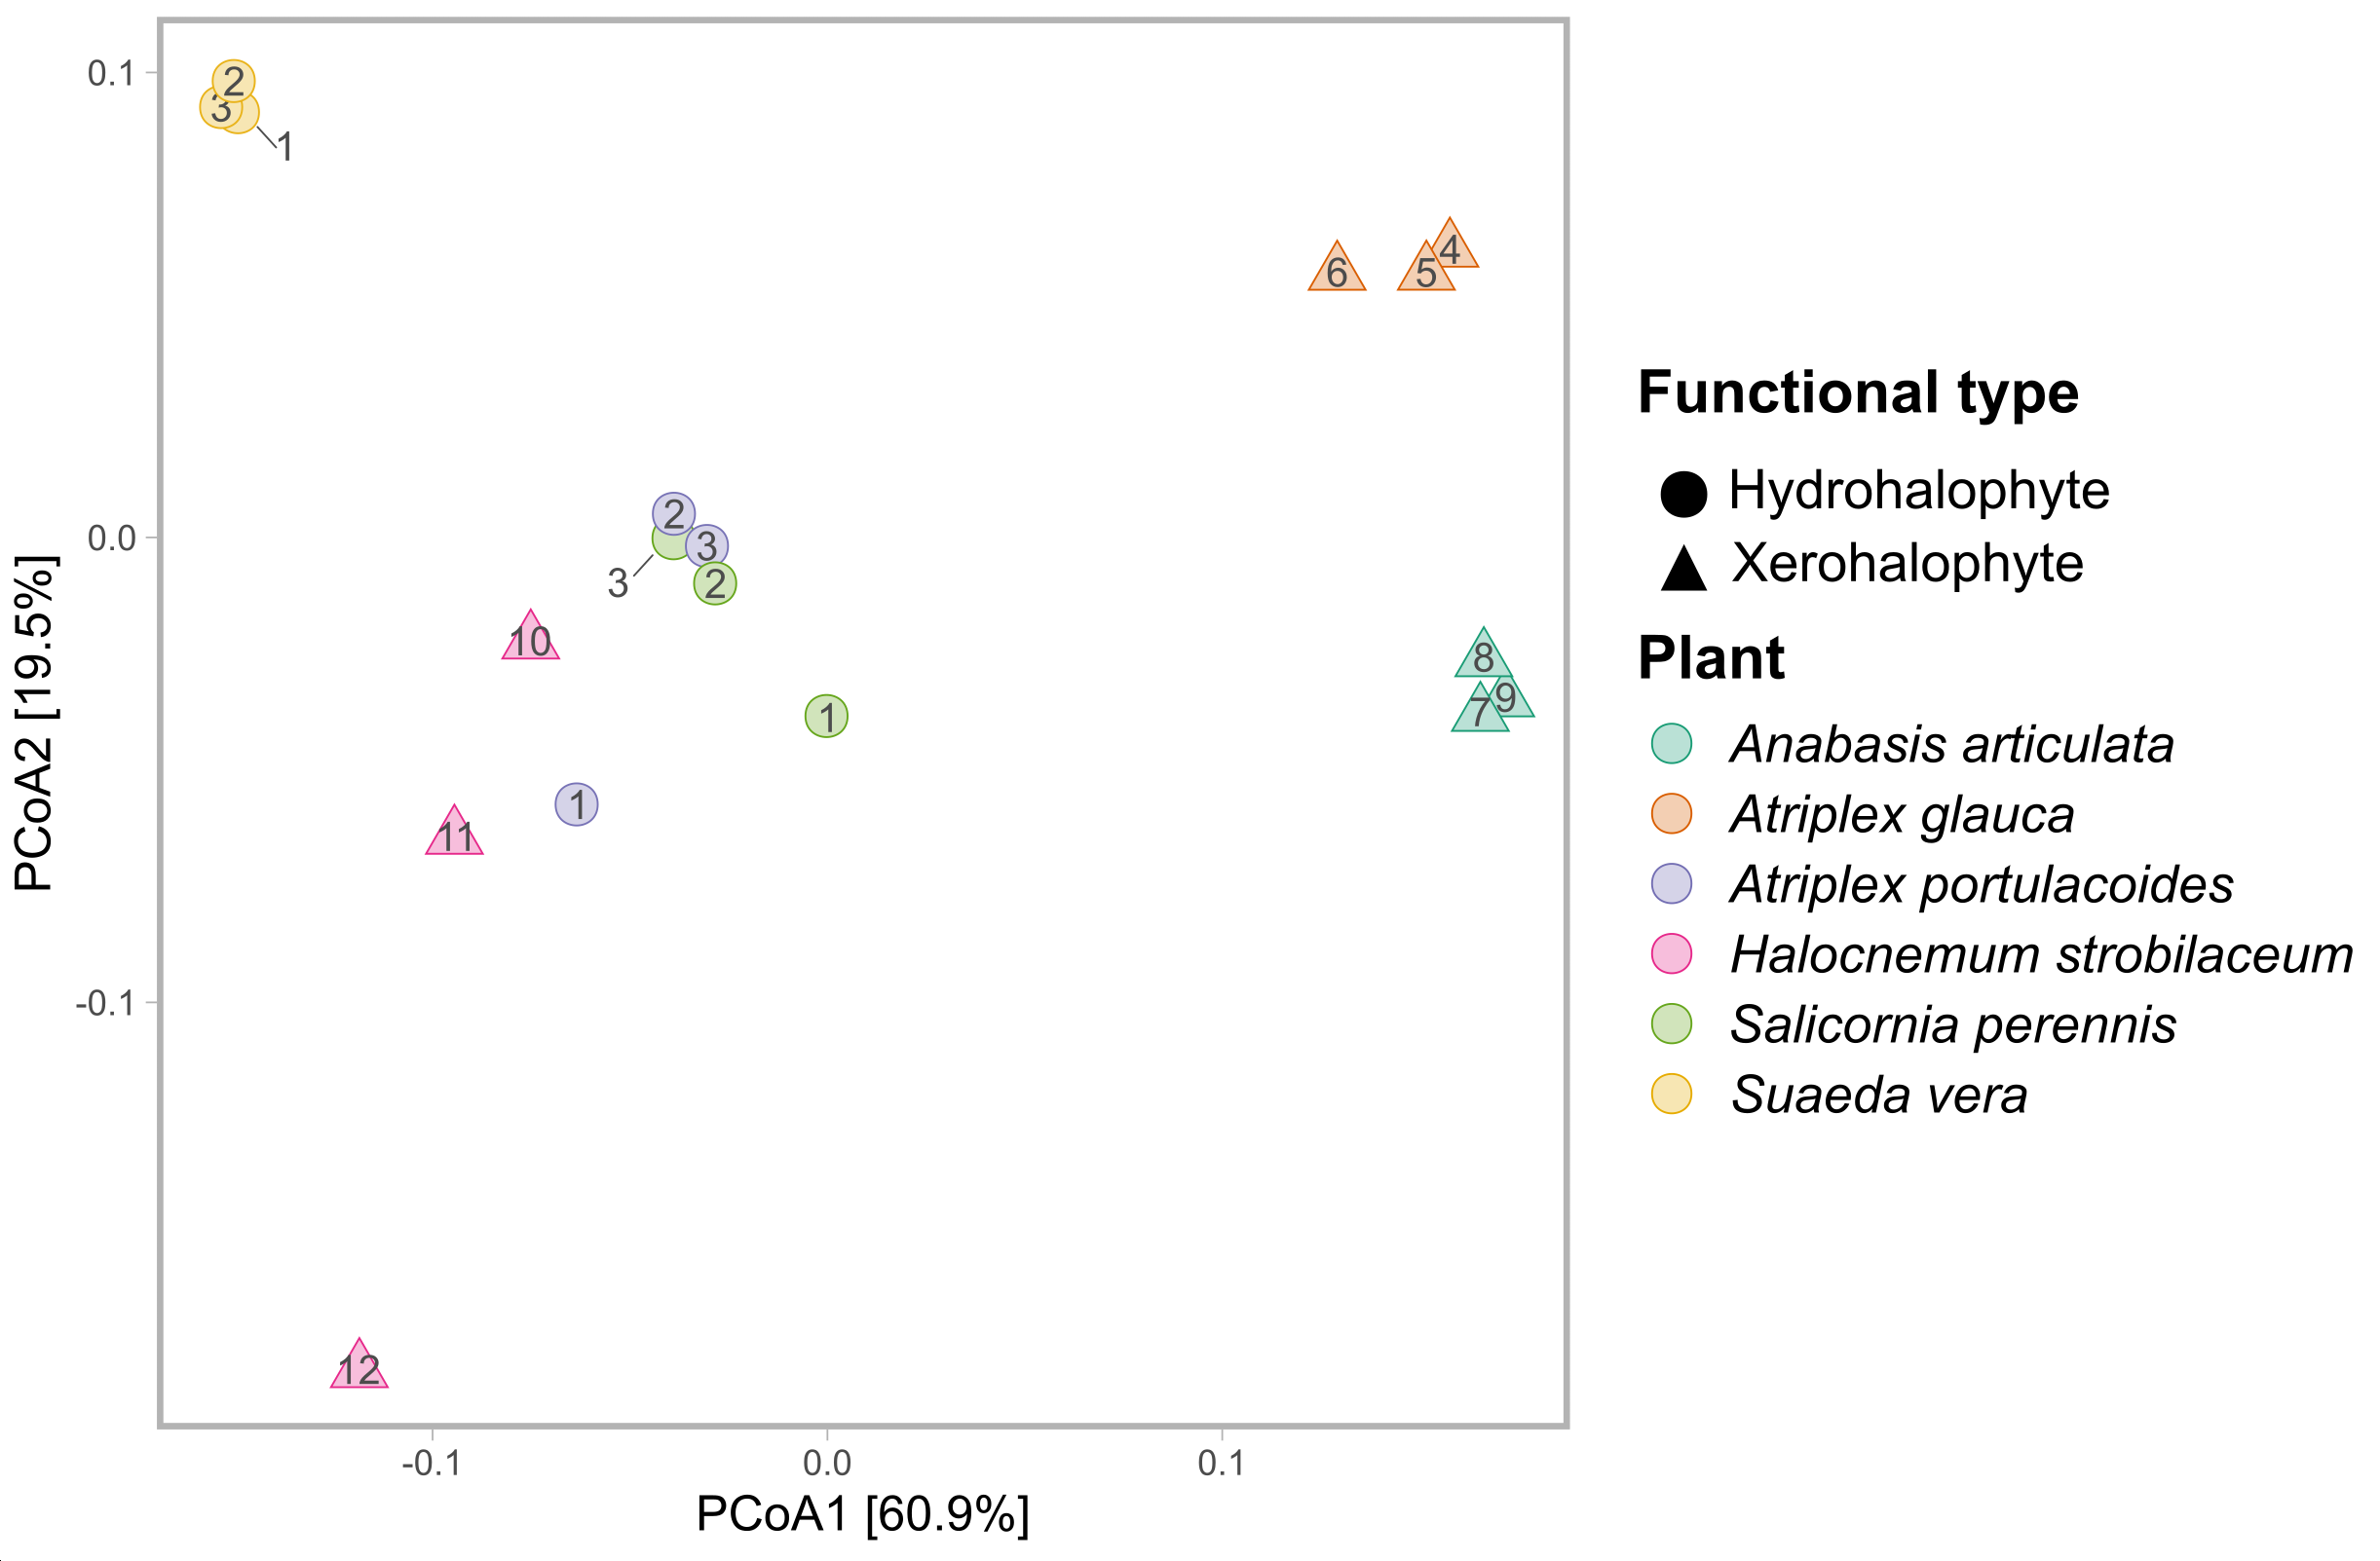

Fig. S5 Relative abundance of genes related to PGP properties classified by KEGG Orthology Level 2 of bacterial leaf endosphere of halophytes. Bars represent composite samples of each population

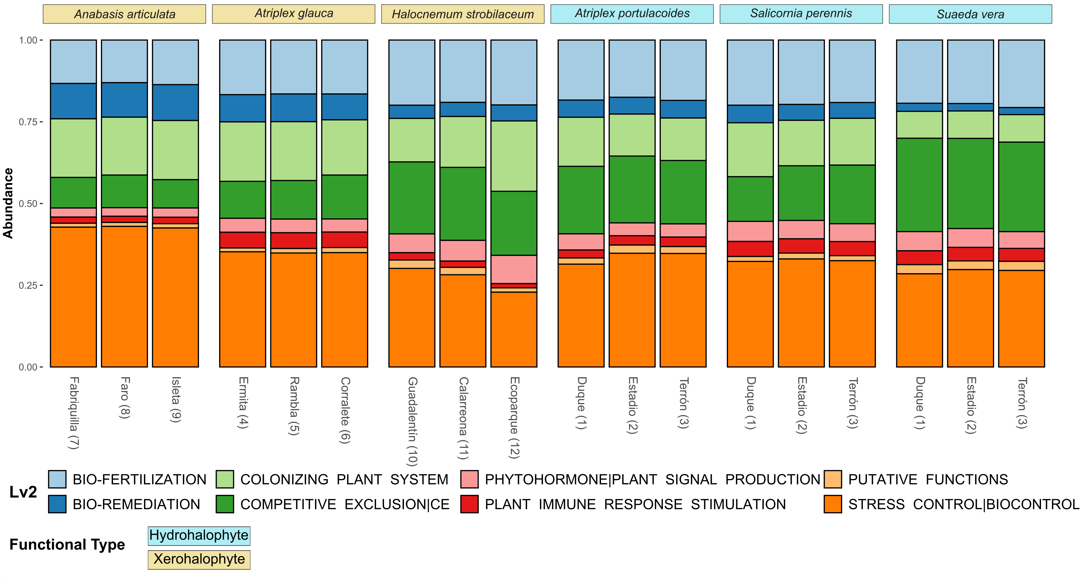
Fig. S6 Boxplot of the relative abundances of the abundances of the 6 PGP properties significantly different (q-value < 0.05; ANCOM-BC results) between xero and hydrohalophytes.
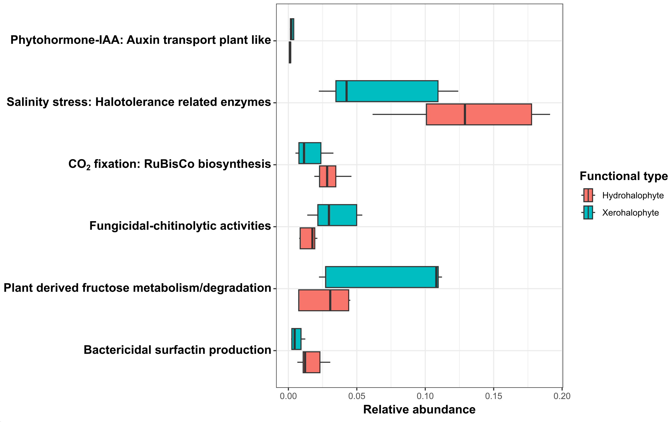

Fig. S7 Upset plot showing the numbers and interactions of differentially abundant PGP properties after ANCOMBC2 analyses. The horizontal bars show the number of PGP properties differentially abundant between each pair of plant species. Vertical bars represent the inclusive intersection size. Dark spheres indicate which sets are represented in the vertical bar.
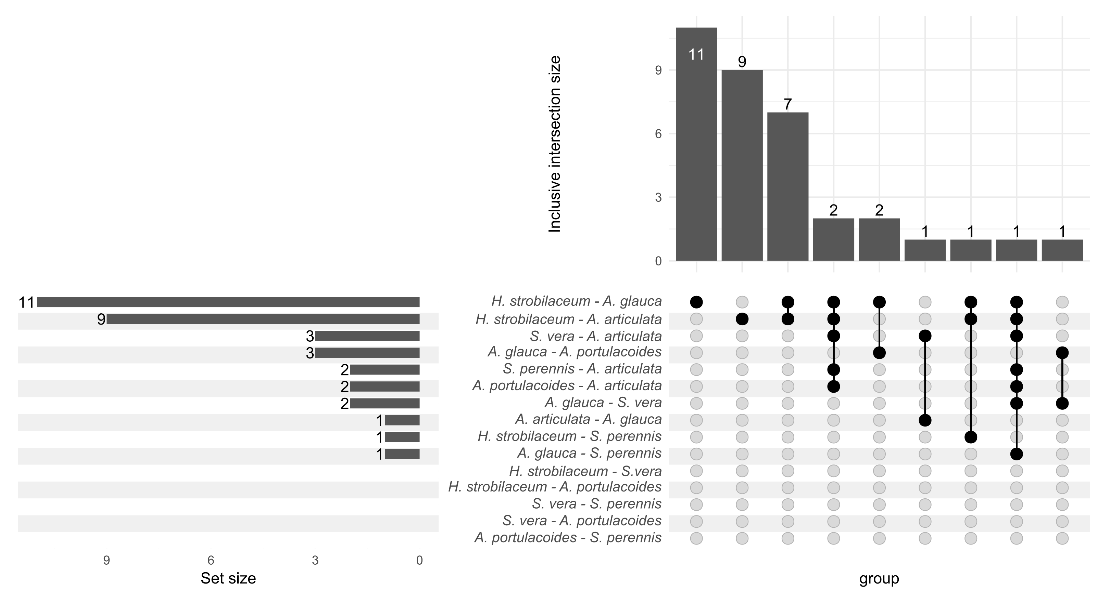

SI1. Protocol of samples surface sterilization
For surface disinfection, they were washed with 70 % (v/v) ethanol (1 min of shaking), afterwards with sodium hypochlorite 1:4 in sterile distilled water for 15 min and gently shaken and in sterile distilled water (four times) (Navarro-Torre et al. 2017). Disinfected samples were crushed separately with a sterile mortar in liquid nitrogen.
Negative controls (sterile and non-ground aerial parts, sterile saline solution, sterile distilled water. and air from the laminar flow hood) were performed to confirm the effective disinfection process. The inoculation for the controls was performed using a spatula, and the plates were incubated at 25 °C for 24-48 hours.

Navarro-Torre S. Barcia-Piedras JM. Mateos-Naranjo E. Redondo-Gómez S. Camacho M. Caviedes MA. Pajuelo E. Rodríguez-Llorente ID (2017) Assessing the role of endophytic bacteria in the halophyte Arthrocnemum macrostachyum salt tolerance. Plant Biology 19:249-256. https://doi.org/10.1111/plb.12521

SI2. Bioinformatic analyses
The following steps were done by Novogene (Cambridge, UK). First, reads were filtered by removing low-quality reads (threshold <= 38). Those with a certain proportion of N bases (length > 10 bp) and overlaps with adapters (threshold > 15 bp) using Readfq (https://github.com/lskatz/FqReader.go). Megahit (Li et al. 2015) was used to generate assemblies (parameter settings: --presets meta-large (--end-to-end. --sensitive. -I 200. -X 400) (Karlsson et al. 2013; Nielsen et al. 2014) and Scaftigs without N were obtained (Qin et al. 2010; Li et al. 2015). ORF prediction for Scaftigs (>= 500 bp) was done using MetaGeneMark and redundancy was eliminated using CD-HIT. Clean data was aligned using Bowtie2 to calculate number of reads of genes in each sample (--end-to-end. --sensitive. -I 200. -x 400). Genes with reads <= 2 in each sample were filtered out and relative abundances of genes were obtained. Annotation of all genes was done using command blastp (E-value 1e-5) DIAMOND software (Buchfink et al. 2015) against the NCBI database (https://www.ncbi.nlm.nih.gov/) and sequences with E-values <= 1e-10 were selected for taxonomy annotation using the LCA algorithm (MEGAN software; Huson et al. 2007). Therefore, the abundance of a species in a sample is equal to the sum of the abundance of all genes annotated as that species.
A second annotation on PGP traits was done by the authors using the tool PGPg Finder (Pellegrinetti et al. (2024) based on the PLaBAse (Patz et al. 2024). The workflow meta_wf was applied on raw reads, which were trimmed using Trimmomatic v. 0.39 (SLIDINGWINDOW:4:20 MINLEN:36; Bolger et al. 2014) and assembled with Megahit v. 1.2.9 (Li et al. 2015). Annotation against the PGPT database was done using DIAMOND v. 2.0.14 (default parameters; Buchfink B et al. 2015). Reads were mapped to assemblies using Bowtie2 v. 2.3.5.1 (Langmead & Salzberg. 2012) and gene abundances were calculated with BBMap v. 39.01 pileup (Bushnell. 2014).

Bolger AM. Lohse M. Usadel B. 2014. Trimmomatic: A flexible trimmer for Illumina Sequence Data. Bioinformatics btu170.
Bushnell. B. 2014. BBMap: A Fast. Accurate. Splice-Aware Aligner. Lawrence Berkeley National Laboratory. No. LBNL-7065E.
Huson DH. Auch AF. Qi J. Schuster SC. 2007. MEGAN analysis of metagenomic data. Genome Research 17: 377-86.
Karlsson FH. Tremaroli V. Nookaew I. Bergström G. Behre CJ. Fagerberg B. Nielsen J. Bäckhed F. 2013. Gut metagenome in European women with normal. impaired and diabetic glucose control. Nature 498: 99-103.
Langmead B. Salzberg S. 2012. Fast gapped-read alignment with Bowtie 2. Nature Methods 9: 357-359.
Li D. Liu CM. Luo R. Sadakane K. Lam TW. 2015. MEGAHIT: An ultra-fast single-node solution for large and complex metagenomics assembly via succinct de Bruijn graph. Bioinformatics 31:1674-6.
Nielsen HB. Almeida M. Juncker AS. et al. 2014. Identification and assembly of genomes and genetic elements in complex metagenomic samples without using reference genomes. Nature Biotechnology 32: 822-828.
Patz S. Rauh M. Gautam A. Huson DH. 2024. mgPGPT: Metagenomic analysis of plant growth-promoting traits. (submitted preprint)
Pellegrinetti TA. Monteiro G. Lemos LN. RAC Santos. Barros A. Mendes L. 2024. PGPg_finder: A Comprehensive and User-friendly Pipeline for Identifying Plant Growth-Promoting Genes in Genomic and Metagenomic Data. Rhizosphere 30: 100905.
Qin J. Li R. Raes J. et al. 2010. A human gut microbial gene catalogue established by metagenomic sequencing. Nature 464: 59-65.

