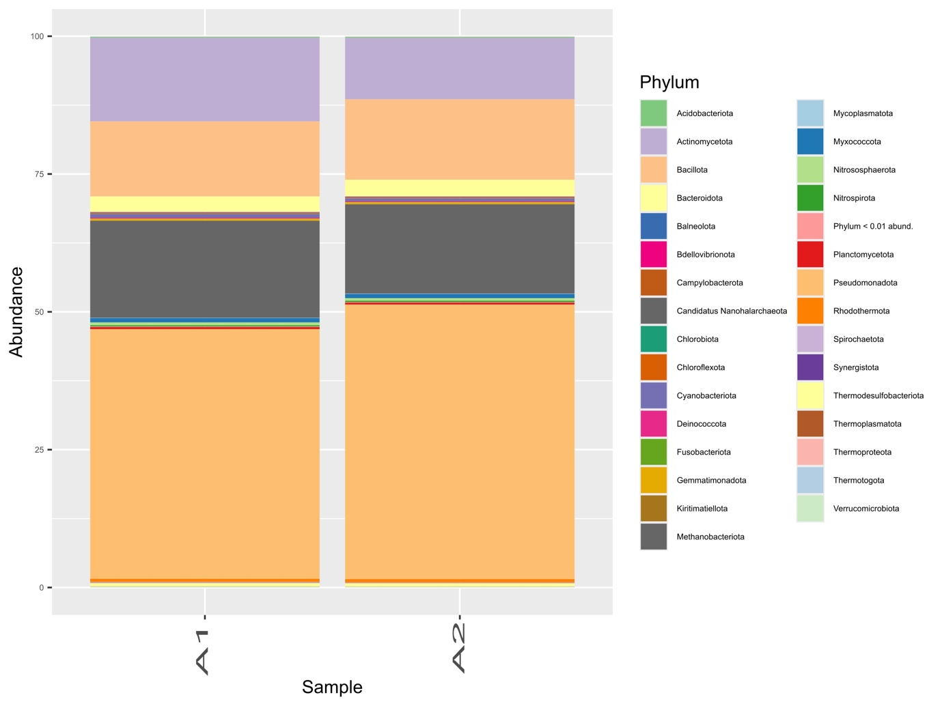
Supplementary Figure S1A. Relative abundance of prokaryotic phyla in samples A1 and A2. Both samples were dominated by Pseudomonadota followed by Methanobacteriota, Actinomycetota, and Bacillota, whereas the remaining phyla collectively represented less than 5% of the communities.
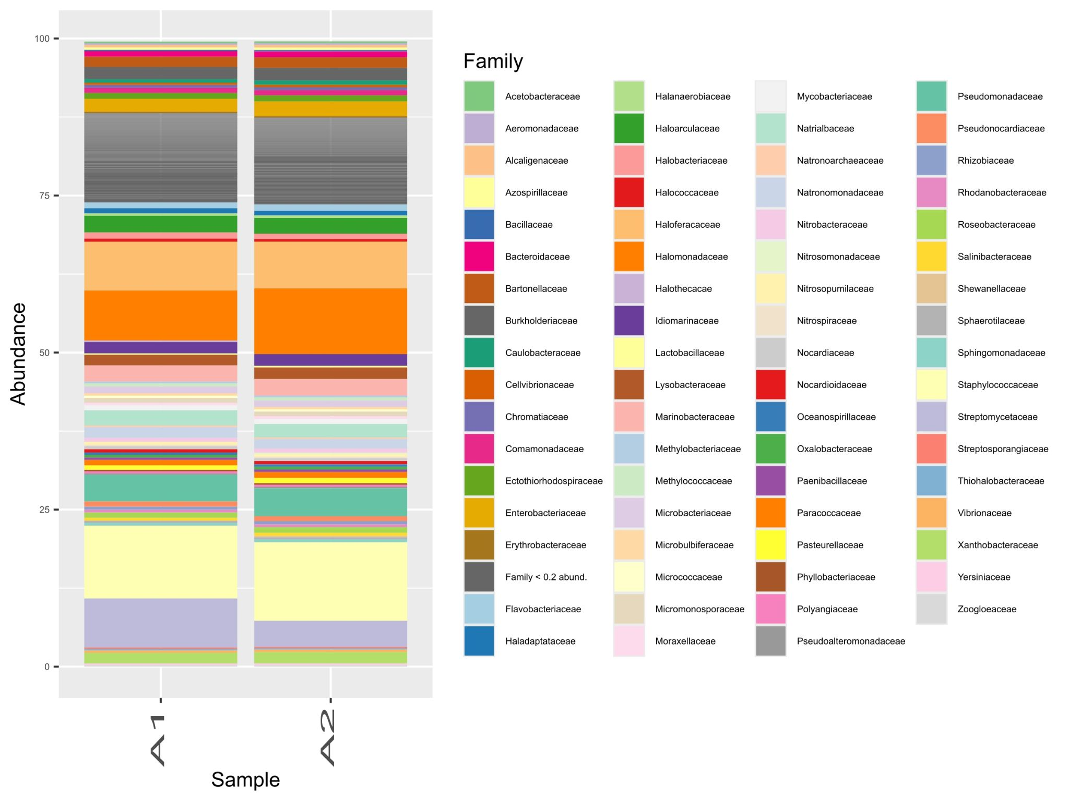
Supplementary Figure S1B. Relative abundance of microbial families in samples A1 and A2. Both communities were dominated by Staphylococcaceae, Halomonadaceae, Streptomycetaceae, and Haloferacaceae, with additional moderately abundant families including Pseudomonadaceae, Marinobacteraceae, Haloarculaceae, Natrialbaceae, and Enterobacteriaceae. Numerous other families were detected at lower relative abundances (<2%), reflecting substantial taxonomic diversity beyond the dominant lineages.
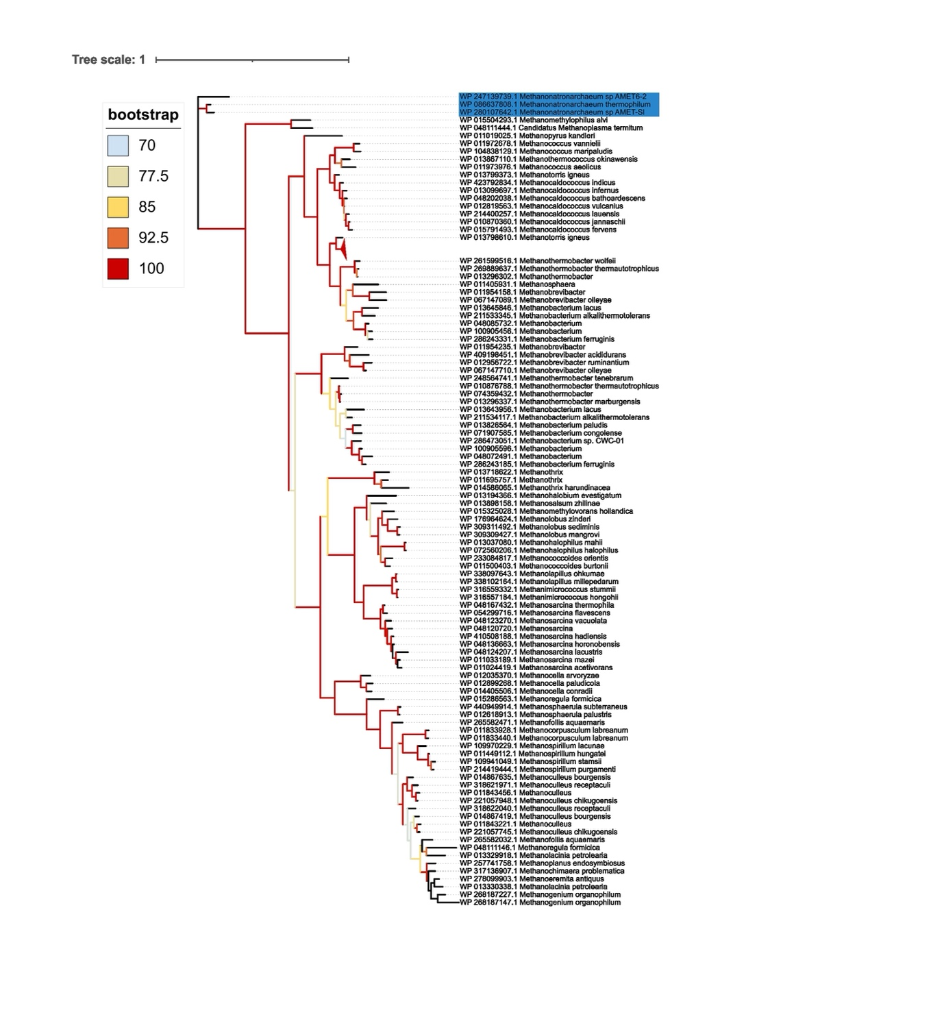
Supplementary Figure S2. Maximum-likelihood phylogeny of 105 reference mcrA sequences inferred with IQ-TREE using the LG+F+I+G4 model selected by BIC. Branch support was assessed with 1,000 ultrafast bootstrap replicates (UFBoot) and is indicated by branch color-coding. Leaves corresponding to Methanonatronarchaeum strains containing the mcrA gene are highlighted.

