Supplemental Table 1. Primers used to generate plasmid template for various amplicon sizes.

pCR4-amplicon size and gene target† | Primer | Sequence (5′–3′) | Reference
239 bp (Bacterial nitrite reductase, nirK)
 | nirK876 | ATYGGCGGVCAYGGCGA | [1, 2]
 | nirK1040 | GCCTCGATCAGRTTRTGGTT
265 bp (Archaeal 16S rRNA)
 | Arch 931F | AGGAAT TGG CGG GGG AGC A | [3]
 | Arch m1100r | BGG GTC TCG CTC GTT RCC | [4]
322 bp (Fungal nitrite reductase, nirK)
 | F-nirK715F | CCDCACAACATMGACTGYCA | This study
 | F-nirK931R | AACTCGCTYTGCATHACGTAGTATTC | This study
425 bp (Bacterial nitrogenase, nifH)
 | PolF | TGCGAYCCSAARGCBGACTC | [5]
 | PolR | ATSGCCATCATYTCRCCGGA | [5]
491 bp (bacterial nitrite reductase)
 | nirSCd3aF | GTSAACGTSAAGGARACSGG | [6]
 | nirSR3cd | GASTTCGGRTGSGTCTTGA | [6]
568 bp (Bacterial ammonia monooxygenase, amoA)
 | amoA-1F | GGGGTTTCTACTGGTGGT | [7]
 | amoA-2R | CCCCTCKGSAAAGCCTTCTTC | [7]
723 bp (Archaeal ammonia monooxygenase, amoA)
 | Arch-amoAF | STAATGGTCTGGCTTAGACG | [8]
 | Arch-amoAR | GCGGCCATCCATCTGTATGT | [8]
†Amplification performed with plasmid-specific primers pCR4-265F (5′–AGT CCT GCA GGT TTA AAC GAA–3′) and pCR4-312R (5’–ATA GGG CGA ATT GAA TTT AGC G–3′) that amplify the gene insert and a 69 bp portion of the plasmid.

References
1. Henry S, et al. (2004) Quantification of denitrifying bacteria in soils by nirK gene targeted real-time PCR. J Microbiol Methods 59: 327-335
2. Henry S, et al. (2005) Corrigendum to "Quantification of denitrifying bacteria in soils by nirK gene targeted real-time PCR" [J. Microbiol. Methods 59 (2004) 327-335]. J Microbiol Methods 61: 289-290
3. Amann RI, et al. (1995) Phylogenetic identification and in situ detection of individual microbial cells without cultivation. Microbiol Rev 59: 143-169
4. Einen J, et al. (2008) Enumeration of Archaea and Bacteria in seafloor basalt using real-time quantitative PCR and fluorescence microscopy. FEMS Microbiol Lett 282: 182-187
5. Poly F, et al. (2001) Improvement in the RFLP procedure for studying the diversity of nifH genes in communities of nitrogen fixers in soil. Res Microbiol 152: 95-103
6. Throbäck IN, et al. (2004) Reassessing PCR primers targeting nirS, nirK and nosZ genes for community surveys of denitrifying bacteria with DGGE. FEMS Microbiol Ecol 49: 401-417
7. Rotthauwe JH, et al. (1997) The ammonia monooxygenase structural gene amoA as a functional marker: Molecular fine-scale analysis of natural ammonia-oxidizing populations. Appl Environ Microbiol 63: 4704-4712
8. Francis CA, et al. (2005) Ubiquity and diversity of ammonia-oxidizing archaea in water columns and sediments of the ocean. Proc Natl Acad Sci USA 102: 14683-14688
Supplemental Figure 1.

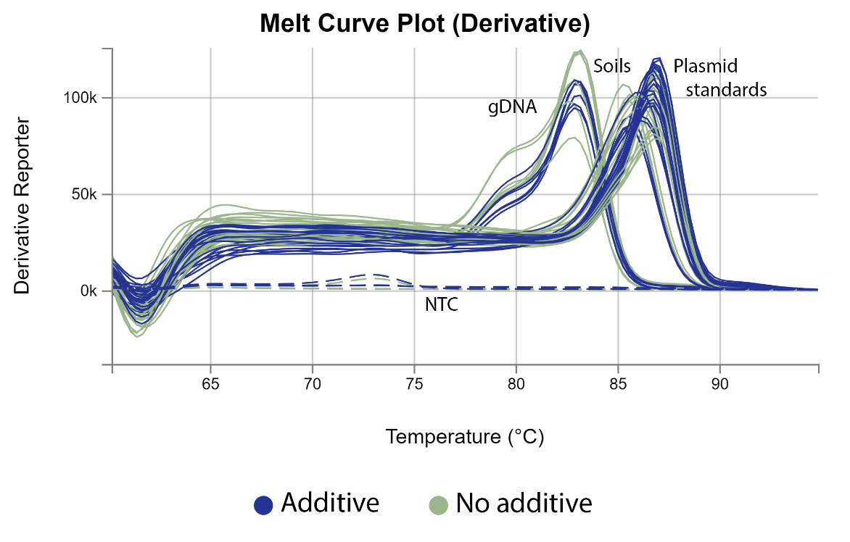

Supplemental Figure 1. Melt curve analysis of quantitative PCR reactions targeting the bacterial ammonia monooxygenase (amoA) gene from circular pCR4 plasmid, soil, and genomic DNA templates. Amplification was performed on the StepOnePlus platform with PowerSYBR Master Mix without (No additive, 0 ng μL⁻¹) or with pUC19 additive (Additive, 0.05 ng μL⁻¹). Lines show data from individual wells for triplicate reactions with circular plasmid standards encoding the amoA gene (Plasmid Standards, 1×10⁵ – 1×10¹ copies per μL⁻¹ reaction), genomic DNA from Nitrosomonas europaea ATCC 19718 (gDNA, 2.4×10² and 2.4×10⁴ amoA copies μL⁻¹ reaction), and soil DNA from two locations. The no template qPCR controls (NTC) are shown with dashed lines. Reactions with pUC19 additive are shown in blue and additive-free in green.

Supplemental Figure 2.
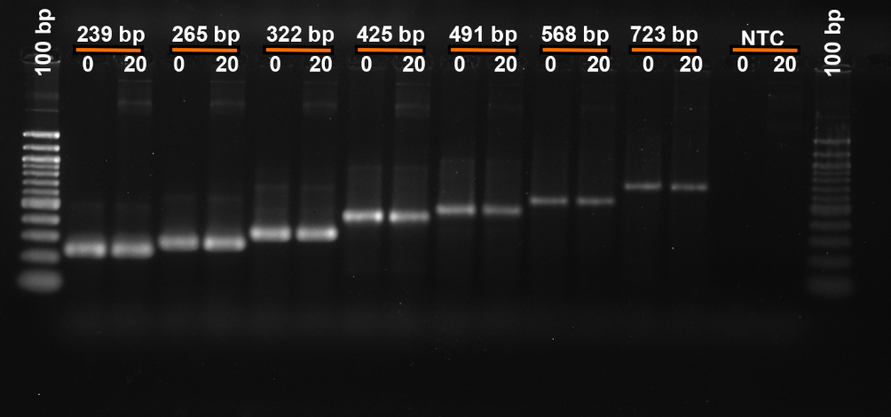

Supplemental Figure 2. Gel image of quantitative PCR reactions targeting uncut circular plasmid template with inserts of varying size. Reactions were performed on the StepOnePlus platform with PowerSYBR Master Mix containing 0 (no additive) or 2 ng μL⁻¹ pUC19 additive. Gel electrophoresis was performed with 1.8% agarose, 6 μL PCR product, and 0.5 μg 100 bp ladder (New England Biolabs). Additive concentration (0, 2 ng μL⁻¹) and amplicon size are shown above the wells. NTC is the qPCR no template control.

