Supplementary materials
Xinyi Zhai^{1†}, Jian Jin^{1†}, Min Yu^{1,2,3}, Ronghua Liu¹, Jiake Li¹, Yi Liu¹, Xiao-Hua Zhang^{1,2,3}, Jiwen Liu^{1,2,3*}

1 Frontiers Science Center for Deep Ocean Multispheres and Earth System, and College of Marine Life Sciences, Ocean University of China, Qingdao, China
2 Laboratory for Marine Ecology and Environmental Science, Qingdao Marine Science and Technology Center, Qingdao, China
3 Institute of Evolution & Marine Biodiversity, Ocean University of China, Qingdao, China

*Correspondence:
liujiwen@ouc.edu.cn
†These authors contributed equally to this work

This file includes:
Fig. S1 to Fig. S5
Tables S1 to S3

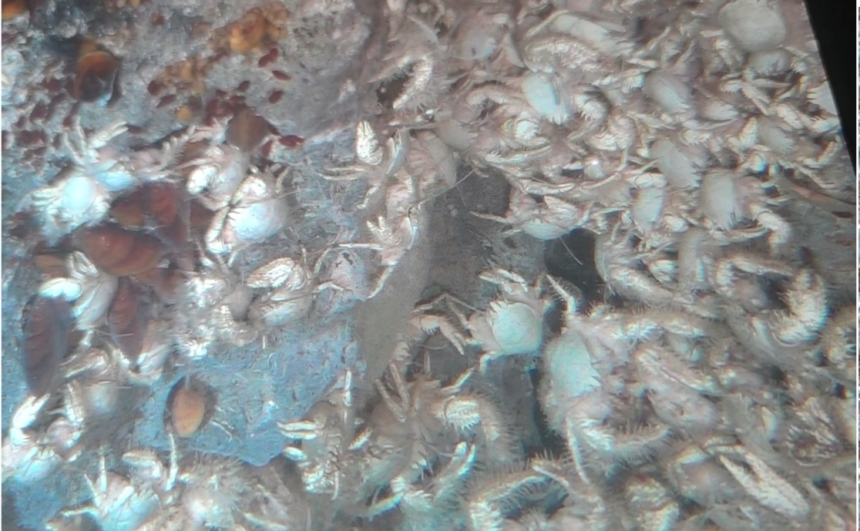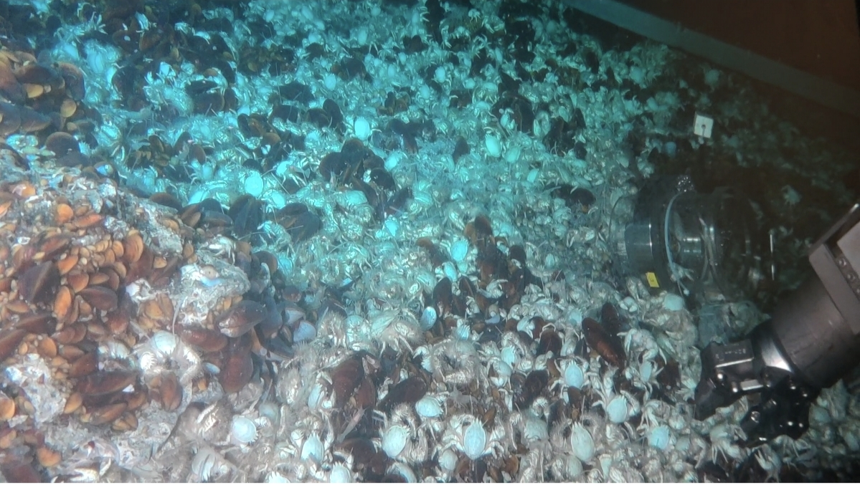
Fig. S1 ROV frame images showing methane bubble

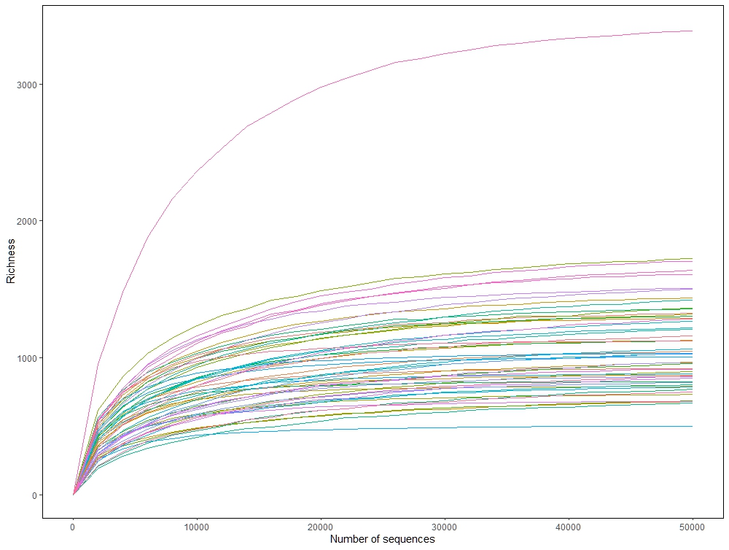

Fig. S2 The richness curves of 16S rRNA data in each sample

a
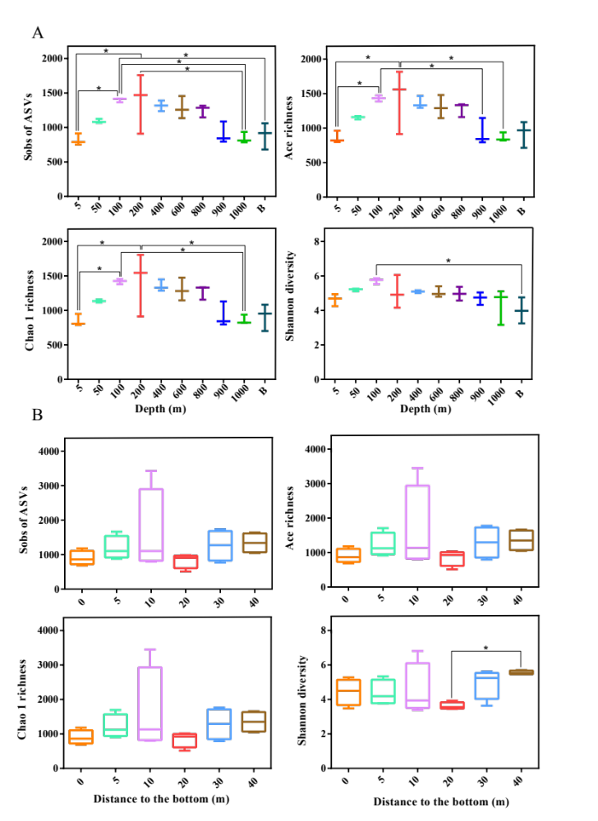
ACE richness

b
Depth(m)
Depth(m)

Distance to the bottom (m)
Distance to the bottom (m)
ACE richness

Fig. S3 The α-diversity index variation with depths. * 0.01 < P-value ≤ 0.05, ** 0.001 < P-value ≤ 0.01, *** P- value ≤ 0.001. (a) CTD samples. (b) ROV samples

Archaea
Bacteria
b
a
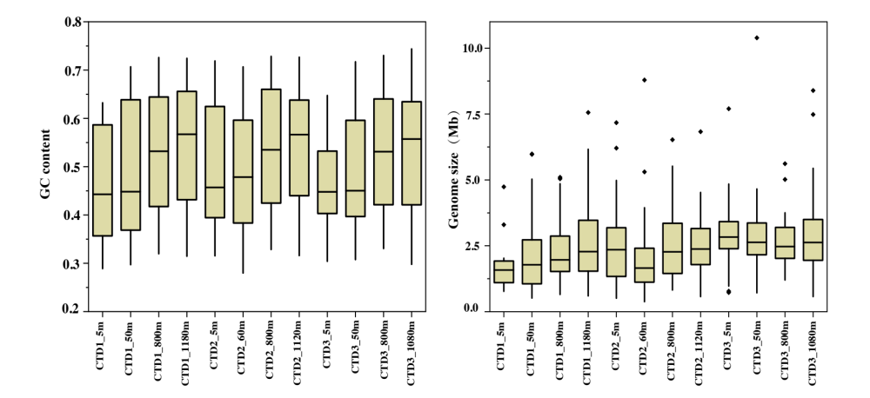
Fig. S4 General information of MAGs. (a) Numbers of MAGs assembled from each CTD metagenome sample. (b) MAGs genome size and GC content in each metagenome sample

b
a
Fig. S5 Maximum likelihood phylogenetic tree of 571 MAGs. (a) Phylogenetic tree of 539 bacterial MAGs based on 120 single- copy protein-coding sequences. (b) Phylogenetic tree of 32 archaeal MAGs based on 53 single-copy protein-coding sequences

Table S1 The taxonomy and abundance of ASV in all samples.
(Table shown in separate file “TableS1.xls”)

Table S2 Statistical difference analysis of major methane and sulfur metabolic genes relative abundance between depths by Mann-Whitney U test. * 0.01 < P-value ≤ 0.05, ** 0.001 < P-value ≤ 0.01, *** P-value ≤ 0.001.
(Table shown in separate file “TableS2.xls”)

Table S3 Information of all MAGs assembled from all metagenome.
(Table shown in separate file “TableS3.xls”)

