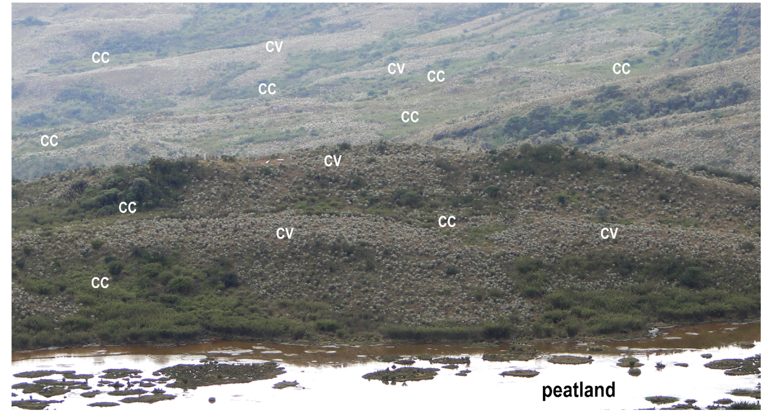
Figure S1: Landscape picture of the Laguna Seca hillside showing the peatland in the foreground and the alternance of CC (Concave) and CV (Convex) sites in the background.

