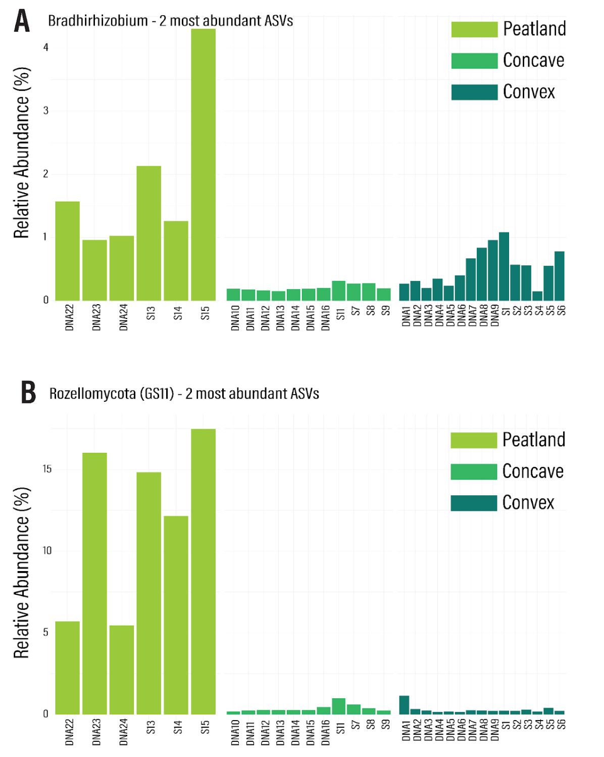
Figure S2: Highlight of abundant ASVs from the peatland.
(A) Combined abundance of 16S rRNA ASV 6472eb8b1e09f892aca2f23182962903 and d829bee4984f82ffc2453212157caf96 (d__Bacteria; p__Pseudomonadota; c__Alphaproteobacteria; o__Rhizobiales_505101; f__Xanthobacteraceae; g__Bradyrhizobium) (B) Combined abunance of ASV b114cf39a964dfcdc0fe29e0fdc91cc4 and ef8f737247f8ae533166865b2c81612c, the top 2 most abundant Rozellomycota ITS ASV (k__Fungi; p__Rozellomycota; c__Rozellomycotina_cls_Incertae_sedis; o__GS11; f__GS11_fam_Incertae_sedis; g__GS11_gen_Incertae_sedis)

