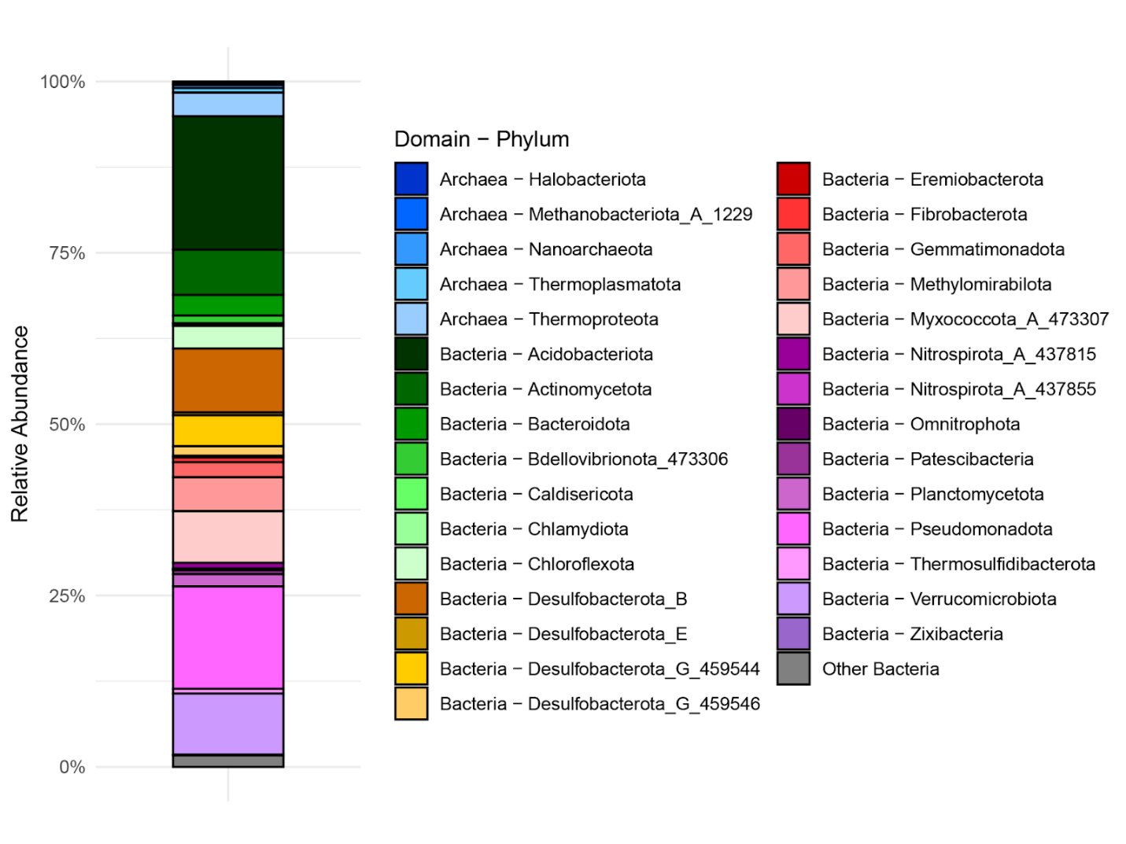Figure S3: Relative abundance of MAGs from MUCC 2.0 that have a BLAST match in the Páramos dataset. A total of 729 MAGs from MUCC 2.0 have a (dereplicated) blast match on the 16S rRNA gene gene with >97% identity over >250 bp. The relative abundance of these hits at the phylum level is presented in this figure.

