Supplementary Material

Deciphering the geochemical constrains influencing sediment microbiomes in gypsum caves

Pedro M. Martin-Sanchez¹, Angel Fernandez-Cortes², Jose Maria Calaforra², Sergio Sanchez-Moral³, Cesareo Saiz-Jimenez¹, Valme Jurado¹
¹Instituto de Recursos Naturales y Agrobiologia de Sevilla, IRNAS-CSIC, 41012 Sevilla, Spain
²Departamento de Biologia y Geologia, Universidad de Almeria, Almeria, Spain
³Museo Nacional de Ciencias Naturales, MNCN-CSIC, 28006 Madrid, Spain

Table S1 (separate Excel file). Metadata for the sediment samples included in this study (9 samples from the Sorbas karst and 9 samples from Italian caves), including 34 geochemical variables.

Table S2 (separate Excel file). Complete list of 6,291 bacterial amplicon sequence variants identified in the nine sediment samples from the Sorbas karst, detailing their abundances, distribution, taxonomic assignments and representative 16S rRNA gene sequences.

Table S3. Permutational multivariate analysis of variance (PERMANOVA) showing the significant explanatory variables for the observed variance between sediment samples from “Sorbas” and “Sorbas + Italy” datasets (R² values with p < 0.05).
 | Significant R² values (%, p < 0.05)
Variablesª | Sorbas (n = 9) | Sorbas + Italy (n = 18)
Cave | ns | 37
Origin | na | 9.2
Mg | 21.3 | 8.2
Ca | 20.9 | 8.8
pH | 18.5 | 7.4
Sr | 18.1 | ns
Carbonate | 17.3 | 9.2
Available Mg | 15.8 | 7.1
B | ns | 9.3
Li | ns | 9.3
K | ns | 9.2
Zn | ns | 9.2
Ni | ns | 9.0
Cr | ns | 8.9
Al | ns | 8.8
V | ns | 8.6
Fe | ns | 8.1
Co | ns | 8.0
Cation exchange capacity | ns | 7.9
Organic carbon | ns | 7.6
Organic matter | ns | 7.5
Pb | ns | 7.5
Cu | ns | 7.4
P | ns | 7.2
Olsen P | ns | 7.0
ª: Eleven geochemical variables were excluded because their R² values were not significant (p > 0.05) for both datasets.
na: not applicable; ns: not significant (p > 0.05).

Table S4. Data for the six geochemical variables that had a significant influence on the bacterial community composition of sediment samples from the Sorbas karst, according to PERMANOVA analysis.
Sample | Cave | pH | Carbonate  (%) | Ca  (mg/kg) | Mg  (mg/kg) | Plant-available Mg  (mg/kg) | Sr  (mg/kg)
AG-4 | Water | 7.78 | 56.40 | 236743.11 | 2449.21 | 54.40 | 230.14
AG-7 | Water | 7.83 | 56.70 | 230379.84 | 2756.35 | 32.78 | 209.55
C3-1 | C3 | 7.90 | 43.70 | 199927.35 | 4823.89 | 464.15 | 334.09
C3-5 | C3 | 7.74 | 42.10 | 186448.78 | 5430.13 | 106.94 | 199.99
YS-1 | Gypsum | 8.61 | 40.00 | 171219.91 | 19371.64 | 1262.21 | 640.66
YS-3 | Gypsum | 8.22 | 45.30 | 176575.55 | 12307.12 | 200.44 | 437.31
YS-5 | Gypsum | 8.04 | 39.10 | 161559.53 | 13691.74 | 232.76 | 464.89
YS-8 | Gypsum | 8.15 | 37.10 | 156576.41 | 15595.05 | 632.26 | 778.08
YS-12 | Gypsum | 8.53 | 15.20 | 173321.01 | 19458.18 | 7405.27 | 883.14

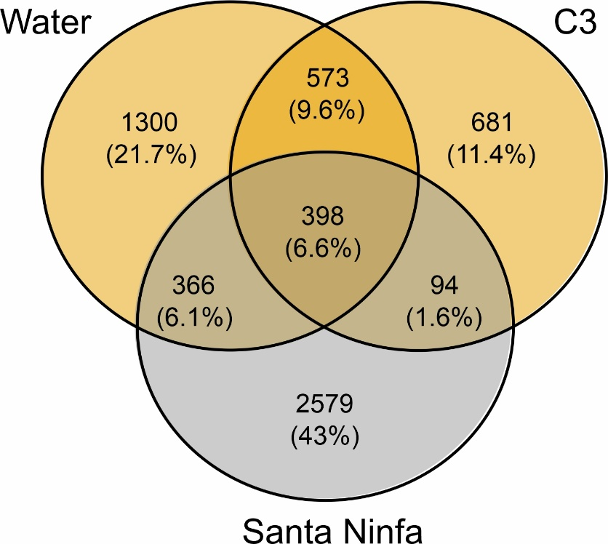
Figure S1. Venn diagram showing overlaps between the sediment bacterial communities from two caves from the Sorbas karst (Water and C3 caves in orange) and one cave from Italy (Santa Ninfa cave in grey), as numbers and percentages of ASVs. These three caves were selected for further comparison considering their similarities in bacterial community composition (see Figure 2c).

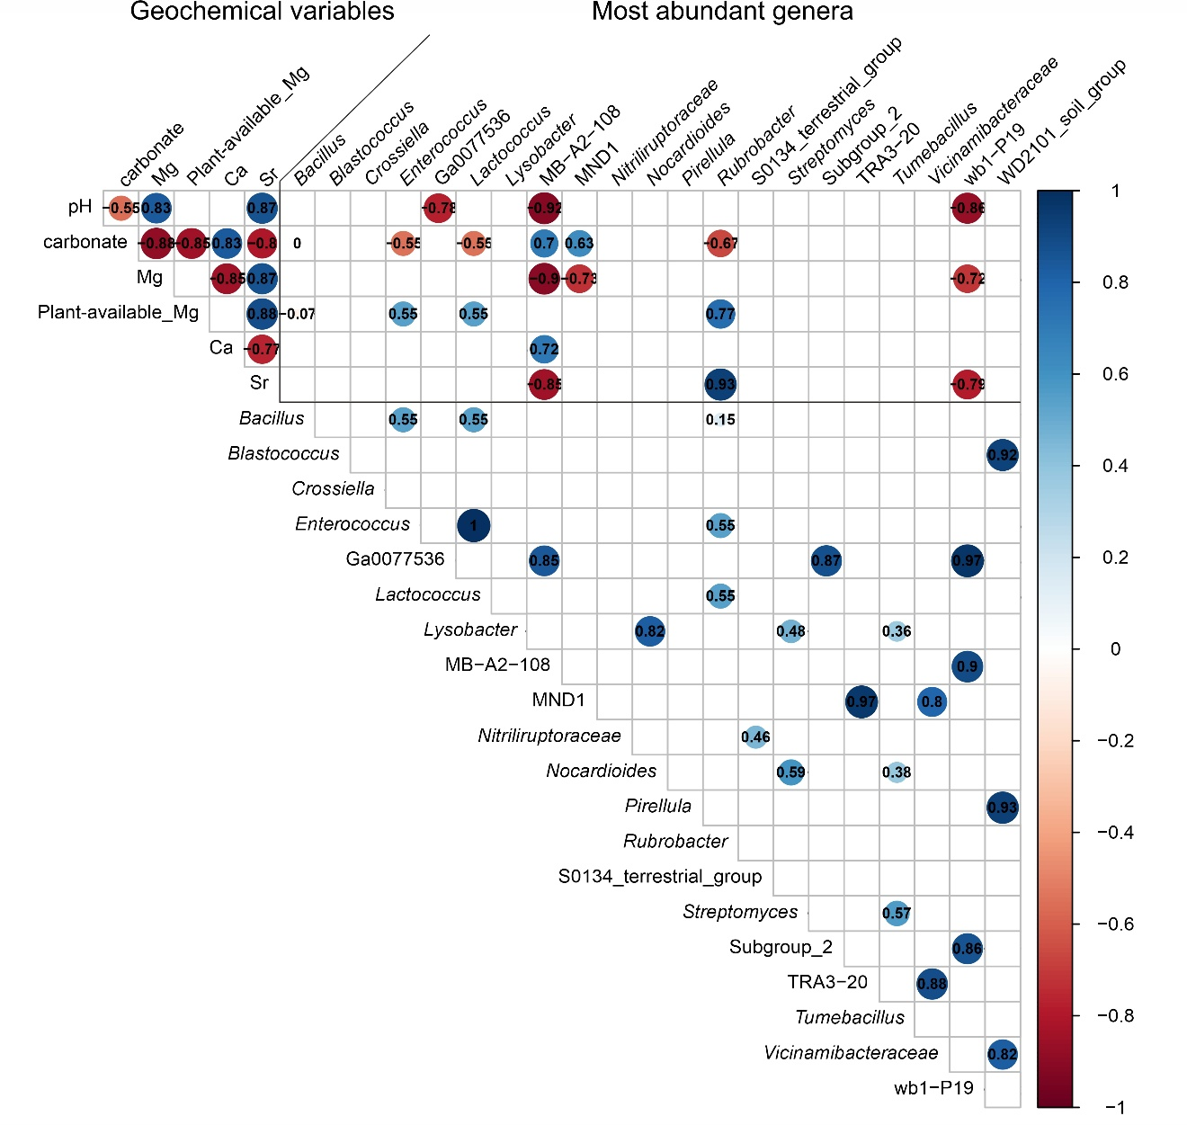
Figure S2. Spearman correlation matrix comparing the most relevant geochemical variables (those 6 with significant influence according to PERMANOVA – Table S4) and the most abundant genera (those with relative abundances >3% - Figure 3) for the Sorbas dataset (9 sediment samples from Water, C3 and Gypsum caves). Only significant (p < 0.05) correlation coefficients are shown in the plot by both colored circles and their specific values.

