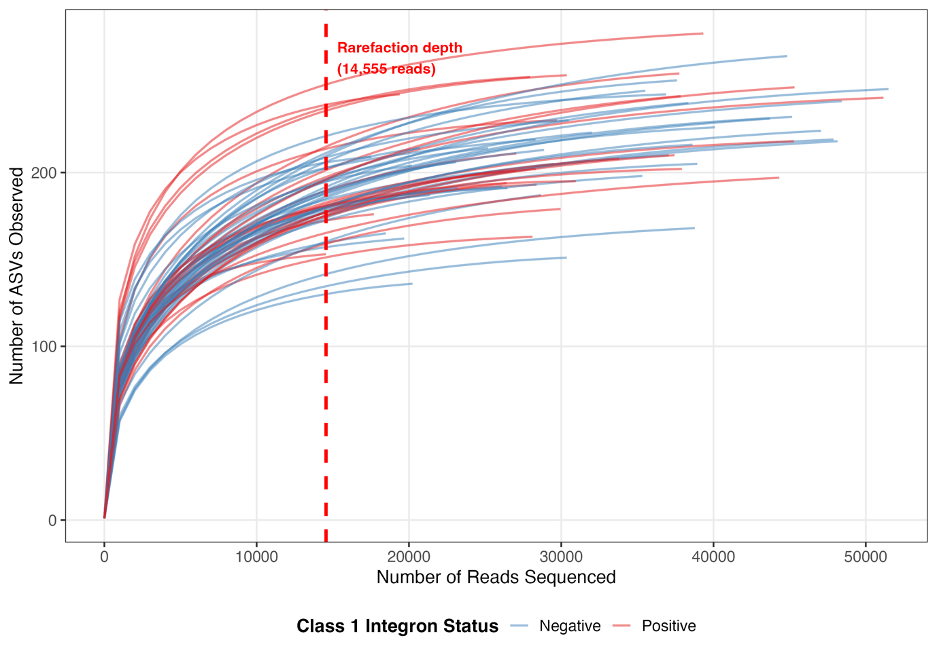Supplementary Figure 1. Rarefaction curves for koala faecal samples from Belair National Park (n = 62). Individual samples are coloured by class 1 integron status (red = positive, n = 24; blue = negative, n = 38). The dashed vertical line indicates the selected rarefaction depth (14,555 reads), corresponding to the minimum read count across all samples.

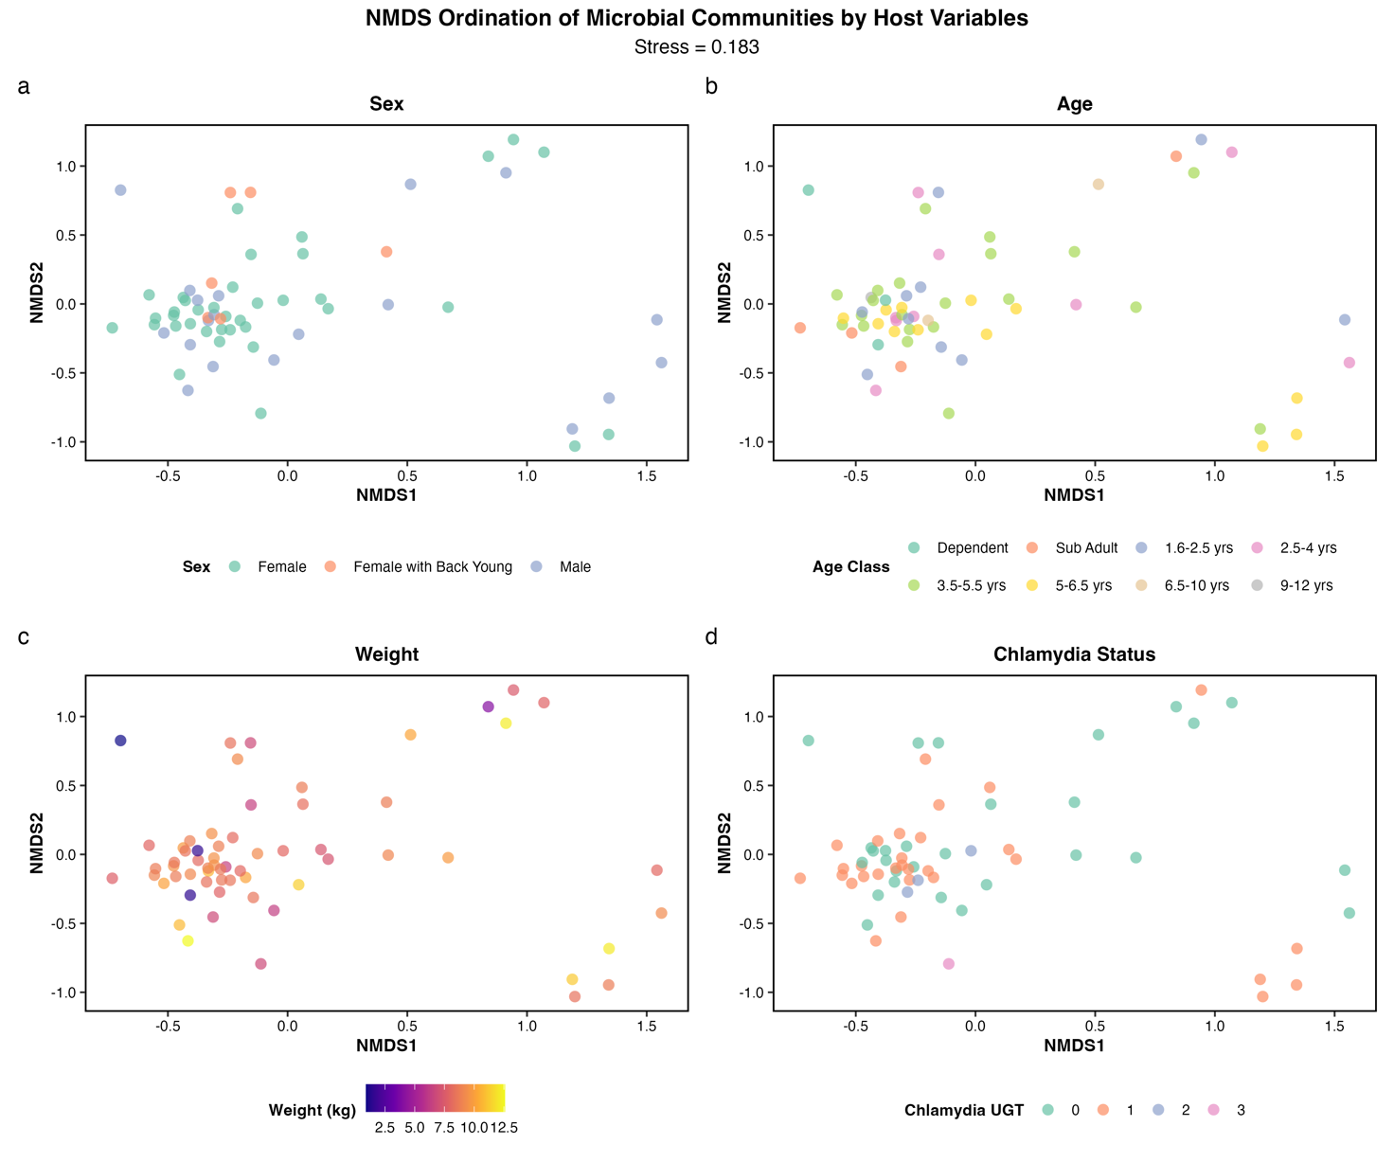
Supplementary Figure 2. Non-metric multidimensional scaling (NMDS) ordination of koala gut microbiome communities (n=62) based on Bray-Curtis dissimilarity, coloured by (a) sex, (b) age, (c) weight, (d) chlamydial disease status. No variables were significantly associated with microbiome composition (PERMANOVA p >0.05).

