Soil microbial diversity alters soil microhydrology through extracellular polymeric substance production

Authors: Yvonne Kan¹, Mariana Acevedo^{1,2}, Hailey Buell¹, Emily Herrera¹, Avery Swanton^{1,2}, Alonso Favela^{*1,2,3}
Affiliation:
¹School of Plant Sciences, University of Arizona, Tucson, AZ
²Ecosystem Genomics Graduate Interdisciplinary Program, University of Arizona, Tucson, AZ
³Center for Agroecosystem Research in the Desert (ARID), University of Arizona, Tucson, AZ

Table of Content
- Figure S1. Richness and Composition of Starting Inoculum
- Figure S2. Overview of Experimental Timeline
- Figure S3. Pre-experiment Dialysis Trial
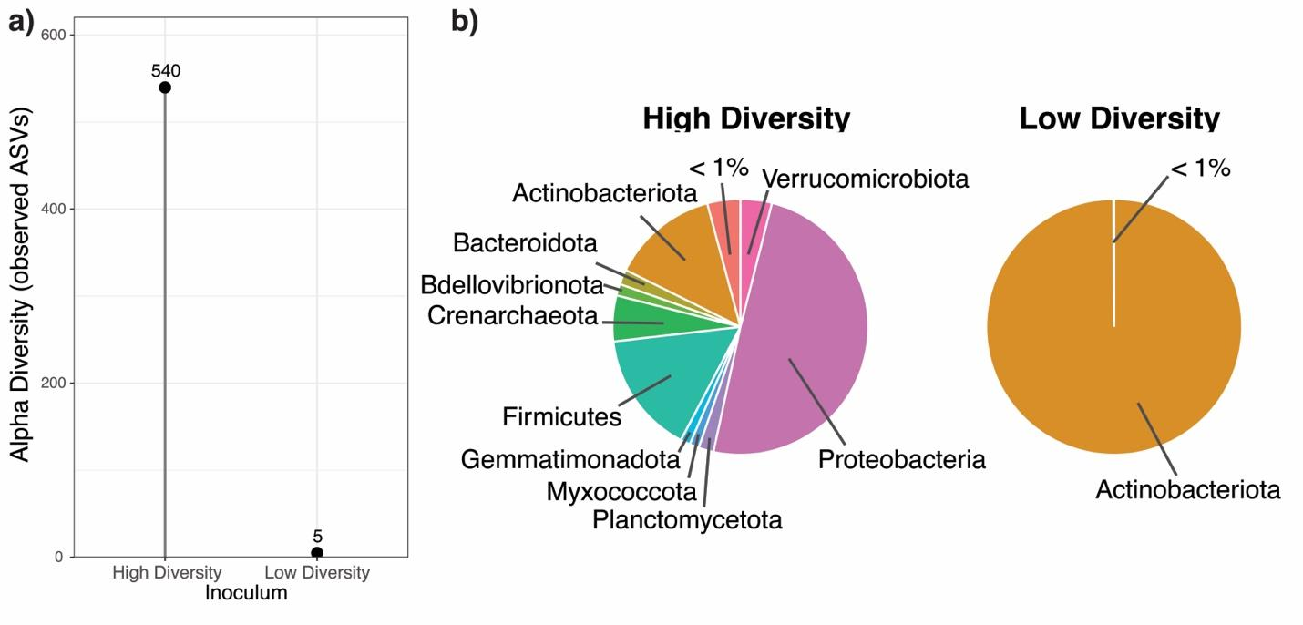
Figure S1. Overview of microbial diversity and compositional differences in the experimental inocula used in this study. High-diversity samples represent a 1 g soil to 10 mL nanopure water slurry that was then serially diluted (1:10), with the final (1:100,000) dilution used as the low-diversity treatment. (a) Displays the observed diversity from these dilutions for the high- and low-diversity inocula. Numbers represent the total number of unique ASVs observed using 16S rRNA sequencing. (b) Displays the compositional differences in taxonomy within these samples, labeled by phylum. Phyla that represented less than 1% of total sequenced reads were binned into the "<1%" category. Notably, this category includes Acidobacteriota, Chloroflexi, and Nitrospirota.
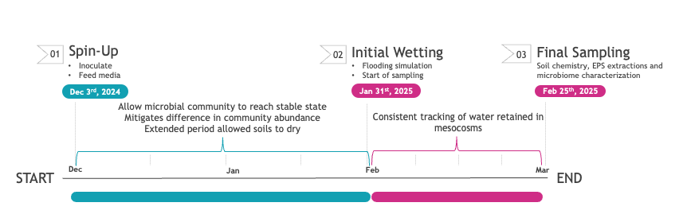
Figure S2. Overview of the experimental timeline. This overview highlights the spin-up period, the trial timeline within the samples, and the dry-down phase. Following the initial phase, a secondary wet phase was implemented, representing the primary dataset presented in this manuscript. During this secondary experimental phase, soil moisture was estimated via container mass differences across mesocosms. Soil chemistry, EPS extractions, and microbiome characterization were all performed at the end of the experiment, as these measurements were destructive.

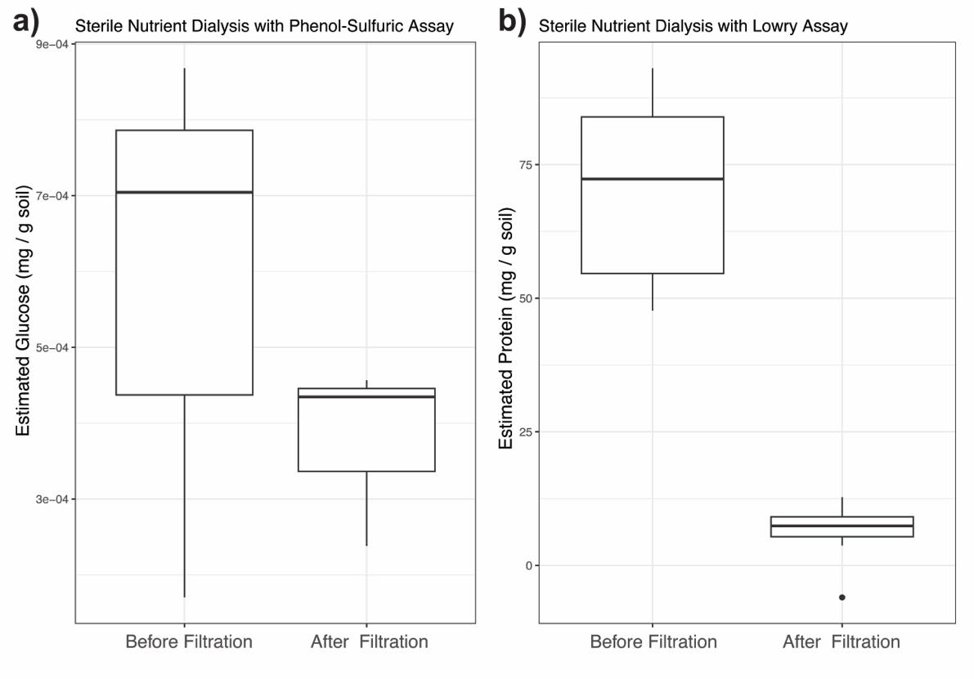
Figure S3. Pre-experimental results testing whether the nutrient solution used in the experiment interacts with assays used to characterize EPS fractions, and potential mitigation strategies. These pre-experimental trials informed the dialysis step in the soil EPS quantification protocol. Here we present results from several sterile mesocosms (no inoculum added; autoclaved) with nutrient solution added to the system, following the EPS extraction protocol outlined in the main text (minus the dialysis step). In these systems, we anticipated no EPS formation and expected values close to zero; however, this was not what we observed in the pre-dialysis filtrate. Post-dialysis, we observed a drop in estimated values to levels consistent with our expectations. We believe these results occur because both the phenol-sulfuric acid assay (a) and the Lowry assay (b) are sensitive to the potentially high ionic load present in nutrient-rich mesocosms.

