Supplementary Materials for

Extracellular ionic fluxes suggest the basis for cellular life at the 1/f ridge of extended criticality

Mariusz Pietruszka and Monika Olszewska

Table S1 Unpaired t-test results (conventional criteria) for the β exponent that were performed for multiple pollens of Hyacinthus orientalis L. G1 – group 1, G2 – group 2, SD – standard deviation, SEM – standard error of difference; n – number of experiments. “Normal” denotes the isotonic conditions at room temperature and atmospheric pressure. The row for IAA/2,4-D presents a result that was not “statistically significant” as was expected.

t-test | P value and statistical significance | mean of G1 – G2  95% confidence interval | mean of G1 | SD | SEM
t-test | P value and statistical significance | mean of G1 – G2  95% confidence interval | mean of G2 | SD | SEM
normal/hyper  n = 12 | The two-tailed P value 0.1205  not quite statistically significant | 0.0469  -0.0133 – 0.1071 | 0.9985 | 0.0769 | 0.0222
normal/hyper  n = 12 |  | 0.0469  -0.0133 – 0.1071 | 0.9517 | 0.0648 | 0.0187
normal/hypo  n = 12 | The two-tailed P value 0.0018  very statistically significant | 0.1239  0.0515 – 0.1963 | 0.9985 | 0.0769 | 0.0222
normal/hypo  n = 12 |  | 0.1239  0.0515 – 0.1963 | 0.8747 | 0.0932 | 0.0269
normal/2,4-D  n = 12 | The two-tailed P value 0.0001  extremely statistically significant | 0.1448  0.0891 – 0.2006 | 0.9985 | 0.0769 | 0.0222
normal/2,4-D  n = 12 |  | 0.1448  0.0891 – 0.2006 | 0.8537 | 0.0525 | 0.0152
normal/IAA  n = 12 | The two-tailed P value 0.0001  extremely statistically significant | 0.1463  0.0843 – 0.2084 | 0.9985 | 0.0769 | 0.0222
normal/IAA  n = 12 |  | 0.1463  0.0843 – 0.2084 | 0.8522 | 0.0693 | 0.0200
IAA/2,4-D  n = 12 | The two-tailed P value 0.9524  not statistically significant | -0.0015  -0.0536 – 0.0506 | 0.8522 | 0.0693 | 0.0200
IAA/2,4-D  n = 12 | The two-tailed P value 0.9524  not statistically significant | -0.0015  -0.0536 – 0.0506 | 0.8537 | 0.0525 | 0.0152
normal/cold  n = 12/n = 6 | The two-tailed P value 0.0001  extremely statistically significant | 0.1950  0.1242 – 0.2658 | 0.9985 | 0.0769 | 0.0222
normal/cold  n = 12/n = 6 |  | 0.1950  0.1242 – 0.2658 | 0.8035 | 0.0356 | 0.0146

Table S2 ANOVA Test. Input data on k = 6 independent treatments that were performed for multiple pollens of Hyacinthus orientalis L.

Treatment | normal | hyper | hypo | 2,4-D | IAA | cold
Treatment | A | B | C | D | E | F
Input Data | 1.1773  1.0736  1.0606  0.9368  0.9077  0.9130  1.0090  0.9976  0.9987  0.9559  0.9603  0.9987 | 0.7896  0.9025  0.9575  0.9631  0.9870  0.9471  1.0337  0.9297  0.9985  1.0252  0.9618  0.9238 | 0.7764  0.7567  0.9116  0.8194  0.8971  1.0239  0.9060  0.9874  0.9015  0.7336  0.9479  0.8584 | 0.8474  0.8579  0.8525  0.8354  0.8125  0.7943  0.7998  0.9813  0.8729  0.8428  0.8234  0.9176 | 0.9077  0.8496  0.8309  0.7366  0.7879  0.8012  0.8735  0.9892  0.8802  0.7757  0.9132  0.8738 | 0.8473  0.8140  0.7439  0.7972  0.7953  0.8165

Table S3 ANOVA Test. Descriptive statistics that were performed for multiple pollens of Hyacinthus orientalis L.

Treatment | normal | hyper | hypo | 2,4-D | IAA | cold | Pooled Total
Treatment | A | B | C | D | E | F | Pooled Total
observations (N) | 12 | 12 | 12 | 12 | 12 | 6 | 66
sum | 11.9892 | 11.4195 | 10.5199 | 10.2378 | 10.2195 | 4.8142 | 59.2001
mean | 0.9991 | 0.9516 | 0.8767 | 0.8531 | 0.8516 | 0.8024 | 0.8970
sum of squares | 12.0426 | 10.9129 | 9.3130 | 8.7647 | 8.7569 | 3.8686 | 53.6587
sample variance | 0.0058 | 0.0042 | 0.0082 | 0.0028 | 0.0049 | 0.0012 | 0.0086
sample std. dev. | 0.0764 | 0.0645 | 0.0908 | 0.0525 | 0.0699 | 0.0342 | 0.0926
std. dev. of mean | 0.0221 | 0.0186 | 0.0262 | 0.0151 | 0.0202 | 0.0140 | 0.0114

Table S4 ANOVA Test. One-way ANOVA of six independent treatments that were performed for multiple pollens of Hyacinthus orientalis L.

source | sum of  squares SS | degrees of  freedom | mean square  MS | F statistic | p-value
treatment | 0.2674 | 5 | 0.0535 | 11.0451 | 1.4461e-07
error | 0.2905 | 60 | 0.0048
total | 0.5579 | 65

Table S5 ANOVA Test. Tukey HSD results. Multiple pollens of Hyacinthus orientalis L.

treatments  pair | Tukey HSD  Q statistic | Tukey HSD  p-value | Tukey HSD  inference
A vs B  normal/hyper | 2.3635 | 0.5485053 | insignificant
A vs C  normal/hypo | 6.0957 | 0.0010053 | ** p<0.01
A vs D  normal/2,4-D | 7.2661 | 0.0010053 | ** p<0.01
A vs E  normal/IAA | 7.3420 | 0.0010053 | ** p<0.01
A vs F  normal/cold | 7.9970 | 0.0010053 | ** p<0.01
D vs E  2,4-D/IAA | 0.0759 | 0.8999947 | insignificant

Table S6 ANOVA Test. Scheffé results. Multiple pollens of Hyacinthus orientalis L.

treatments  pair | Scheffé  TT-statistic | Scheffé  p-value | Scheffé  inference
A vs B  normal/hyper | 1.6713 | 0.7311819 | insignificant
A vs C  normal/hypo | 4.3103 | 0.0053753 | ** p<0.01
A vs D  normal/2,4-D | 5.1379 | 0.0004390 | ** p<0.01
A vs E  normal/IAA | 5.1916 | 0.0003694 | ** p<0.01
A vs F  normal/cold | 5.6548 | 8.0051e-05 | ** p<0.01
D vs E  2,4-D/IAA | 0.0537 | 1.0000000 | insignificant

Table S7 ANOVA Test that was performed for multiple pollens of Hyacinthus orientalis L. Bonferroni and Holm results: pairs were compared simultaneously.

treatments  pair | Bonferroni  and Holm  TT-statistic | Bonferroni  p-value | Bonferroni  inference | Holm  p-value | Holm  inference
A vs B  normal/hyper | 1.6713 | 1.4981500 | insignificant | 0.5992600 | insignificant
A vs C  normal/hypo | 4.3103 | 0.0009233 | ** p<0.01 | 0.0007386 | ** p<0.01
A vs D  normal/2,4-D | 5.1379 | 4.7788e-05 | ** p<0.01 | 4.1417e-05 | ** p<0.01
A vs E  normal/IAA | 5.1916 | 3.9185e-05 | ** p<0.01 | 3.6573e-05 | ** p<0.01
A vs F  normal/cold | 5.6548 | 6.8950e-06 | ** p<0.01 | 6.8950e-06 | ** p<0.01
D vs E  2,4-D/IAA | 0.0537 | 14.3604693 | insignificant | 0.9573646 | insignificant

Table S8 ANOVA Test. Bonferroni and Holm results: only pairs relative to A (normal) were compared simultaneously. Multiple pollens of Hyacinthus orientalis L.
Calculated using https://astatsa.com/OneWay_ANOVA_with_TukeyHSD/
Accessed 4 October 2019.

treatments  pair | Bonferroni  and Holm  TT-statistic | Bonferroni  p-value | Bonferroni  inference | Holm  p-value | Holm  inference
A vs B  normal/hyper | 1.6713 | 0.4993833 | insignificant | 0.0998767 | insignificant
A vs C  normal/hypo | 4.3103 | 0.0003078 | ** p<0.01 | 0.0001231 | ** p<0.01
A vs D  normal/2,4-D | 5.1379 | 1.5929e-05 | ** p<0.01 | 9.5577e-06 | ** p<0.01
A vs E  normal/IAA | 5.1916 | 1.3062e-05 | ** p<0.01 | 1.0449e-05 | ** p<0.01
A vs F  normal/cold | 5.6548 | 2.2983e-06 | ** p<0.01 | 2.2983e-06 | ** p<0.01

Table S9 The average value (mean) of the spectral exponent (β) for different plant species (normal state). PSD ~ 1/f ^{β}, where f stands for the frequency; mean β = <β> and SD – standard deviation; n – number of experiments.

Species (n = 6) | Mean β | SD β | Temperature [○C]
Hyacinthus orientalis L. | 0.9985 | ± 0.08 | 25.12 ± 1.10
Nicotiana tabacum L. | 0.9837 | ± 0.16 | 24.85 ± 0.98

Table S10 The largest Lyapunov exponent (LLE) and EZ entropy. LLE calculated (number of iterations = 20) with the use of Lyarosenstein Matlab code [ML], while the fuzzy entropy calculated with the use of EZ entropy software [EZentropy].

Treatment |  | Temperature [○C] | Spectral exponent β | LLE | Normalised  LLE | Fuzzy Entropy
Hyacinthus orientalis L.
Multi-pollens | Normal | 25.3 ± 0.5 | 1.074 ± 0.024 | -15.95 | -0.9851 | 0.1743
Multi-pollens | Hyper | 24.7 ± 0.5 | 0.958 ± 0.025 | -15.98 | -0.9870 | 0.2358
Multi-pollens | Hypo | 24.5 ± 0.5 | 0.887 ± 0.025 | -15.99 | -0.9876 | 0.1624
Multi-pollens | 2,4D | 24.3 ± 0.5 | 0.853 ± 0.024 | -16.17 | -0.9987 | 0.5631
Multi-pollens | IAA | 25.5 ± 0.5 | 0.850 ± 0.026 | -16.19 | -1 | 0.1274
Multi-pollens | Cold | 15.8 ± 0.5 | 0.814 ± 0.024 | -16.11 | -0.9951 | 0.5923

[ML] https://www.mathworks.com/matlabcentral/fileexchange/38424-largest-lyapunov-exponent-with-rosenstein-s-algorithm. Accessed 17.01.2020 by M. Lipowczan.

[EZentropy] Peng Li: EZ Entropy: a software application for the entropy analysis of physiological time series, Li ﻿BioMed Eng OnLine (2019) 18:30. Courtesy of the author. https://doi.org/10.1186/s12938-019-0650-5

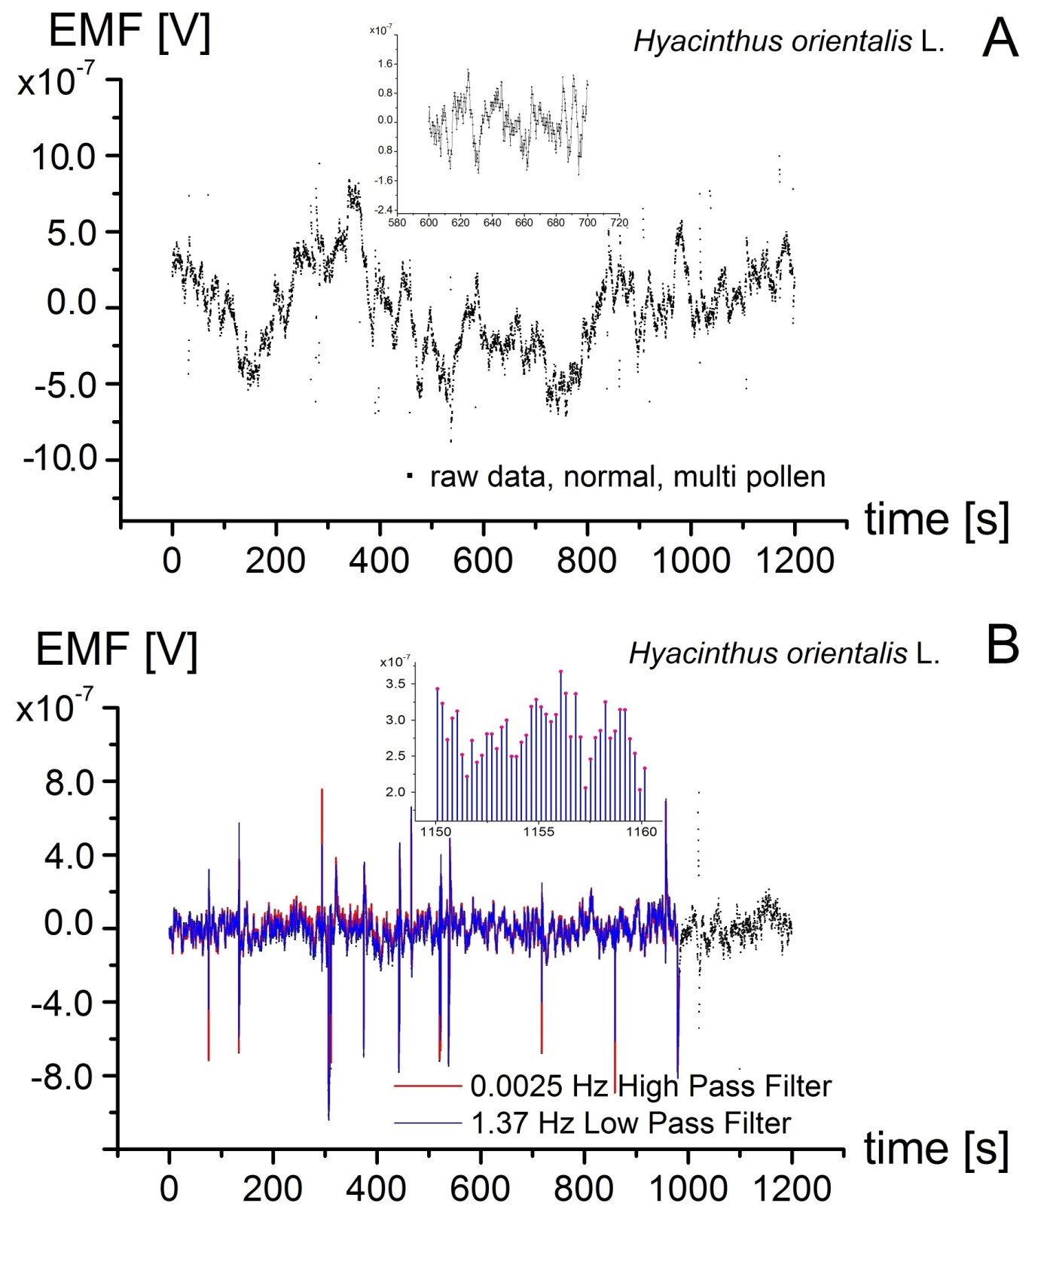
Figure S1 Representative time series of the electromotive force (EMF). A Raw data (5000 points) amplitude registered by the ELoPvC in the experiment on an intact Hyacinthus orientalis L. pollen (24.5 ± 0.5°C) at a μV level (Inset A one-hundred-second fragment showing dense sampling 4.1 Hz of the voltage). The linear base line was subtracted (detrended) and B the low-pass 1.37 Hz and high-pass 0.0025 Hz filter were applied. Inset Stable fluctuations in the 10 s envelope of oscillations.

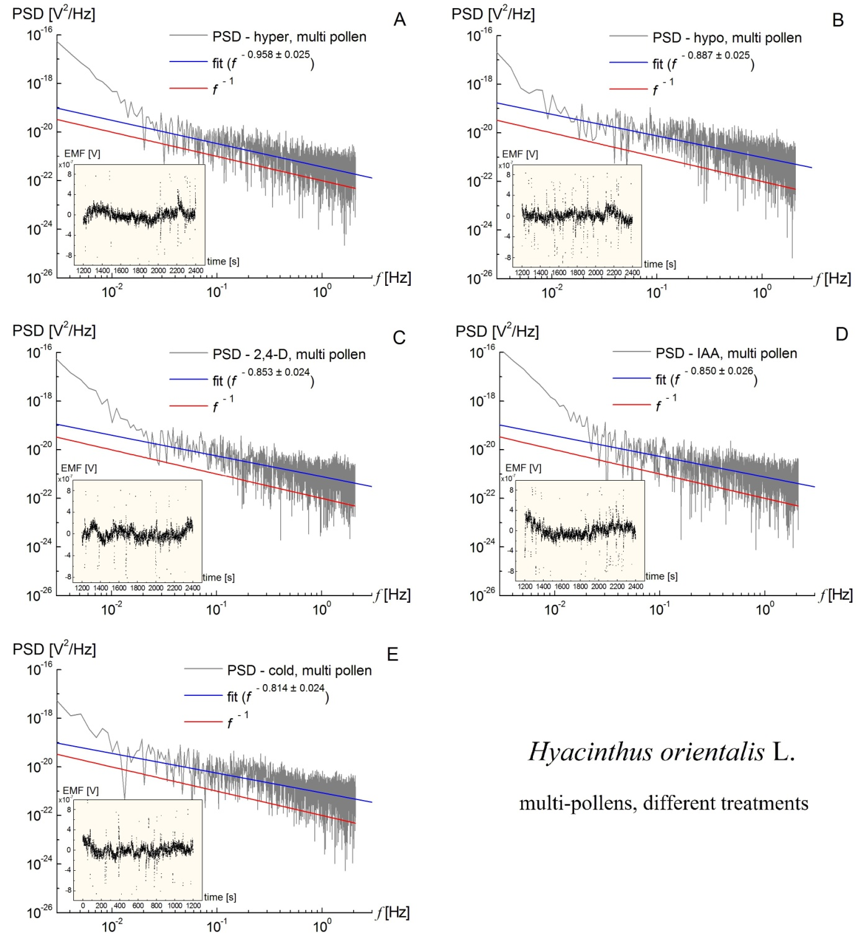

Figure S2 Representative power spectral density as a function of the frequency that was calculated for the EMF that was induced by the ionic fluxes of a group of pollens of Hyacinthus orientalis L. A Hypertonic treatment at ~24.7 ± 0.5°C; the actual fit β = 0.958 ± 0.025 is indicated by the blue line. B Hypotonic treatment at ~24.5 ± 0.5°C; β = 0.887 ± 0.025. C 2,4-D ~24.3 ± 0.5°C; β = 0.853 ± 0.024. D IAA ~25.5 ± 0.5°C; β = 0.850 ± 0.026. E Cold ~15.8 ± 0.5°C; β = 0.814 ± 0.024. The insets represent the signal that was obtained. The precise 1/f behaviour is indicated by the straight red line for comparison (the irrelevant intercept was neglected).

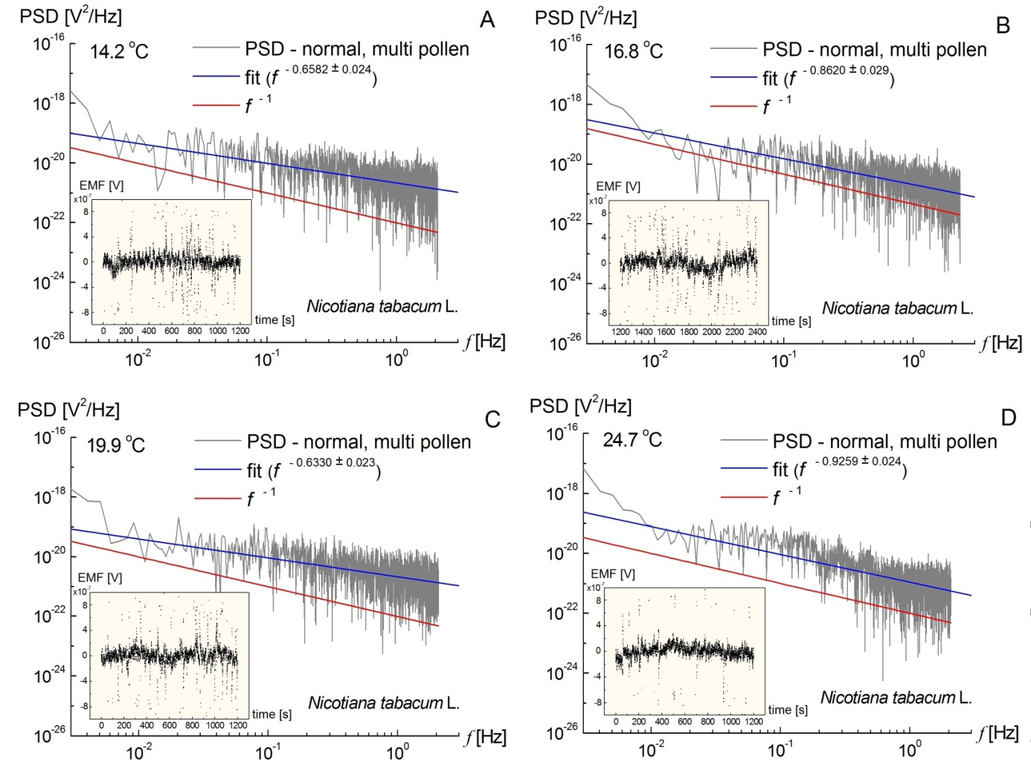

Figure S3 Representative flicker noise spectrum as a function of the frequency that was calculated for the EMF that was induced by the extracellular ionic fluxes of a group of pollens of Nicotiana tabacum L. parameterised by temperature: A 12.2 ± 0.5°C, B 16.8 ± 0.5°C, C 19.9 ± 0.5°C and D 24.7 ± 0.5°C. The actual fits are indicated by the blue line.

T-test for the normal state mean of the β exponent for Hyacinthus orientalis L.

We conducted a t-test for one population mean with an unknown population standard deviation, which is why the sample standard deviation (s) was used instead. The provided sample mean was <β> = 0.9985, the sample standard deviation was s = 0.08 and the sample size was n = 12.
The following null and alternative hypotheses needed to be tested:
H₀: <β>_{pop} = 1
H_{a}: <β>_{pop} ≠ 1
This corresponded to a two-tailed test for which a t-test for one mean with unknown population standard deviation was used.
Based on the information provided, the significance level was α = 0.001 and the critical value for a two-tailed test was t_{c} = 4.437. The rejection region for this two-tailed test was R = {t: ∣t∣ > 4.437}.
The t-statistic was computed as follows:
$$t=\frac{<β>-μ_{0}}{s\sqrt{n}}=-0.065$$
Since it was observed that ∣t∣ = 0.065 ≤ t_{c} = 4.437, it was then concluded that the null hypothesis was not rejected. Therefore, there was not enough evidence to claim that the population mean <β>_{pop} was different than 1 at the 0.001 significance level. The 99.9% confidence interval was 0.896 < <β>_{pop} < 1.101.

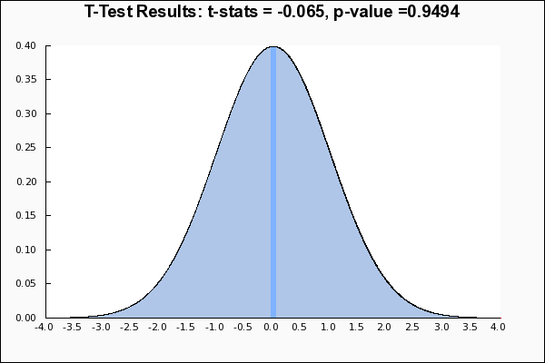

Figure S4 T-test results for the mean of the β exponent of Hyacinthus orientalis L. (normal state). Calculated using https://mathcracker.com/t-test-for-one-mean.php#results
Accessed 10 October 2019.

T-test for the normal state mean of the β exponent for Nicotiana tabacum L.

We conducted a t-test for one population mean with an unknown population standard deviation, which is why the sample standard deviation (s) was used instead. The provided sample mean was <β> = 0.9837, the sample standard deviation was s = 0.16 and the sample size was n = 12.
The following null and alternative hypotheses needed to be tested:
H₀: <β>_{pop} = 1
H_{a}: <β>_{pop} ≠ 1
This corresponded to a two-tailed test for which a t-test for one mean with an unknown population standard deviation was used.
Based on the information provided, the significance level was α = 0.001 and the critical value for a two-tailed test was t_{c} = 4.437. The rejection region for this two-tailed test was R = {t: ∣t∣ > 4.437}.
The t-statistic was computed as follows:
$$t=\frac{<β>-μ_{0}}{s\sqrt{n}}=-0.353$$
Since it was observed that ∣t∣ = 0.353 ≤ t_{c} = 4.437, it was then concluded that the null hypothesis was not rejected. Therefore, there was not enough evidence to claim that the population mean <β>_{pop} was different than 1 at the 0.001 significance level. The 99.9% confidence interval was 0.779 < <β>_{pop} < 1.189.

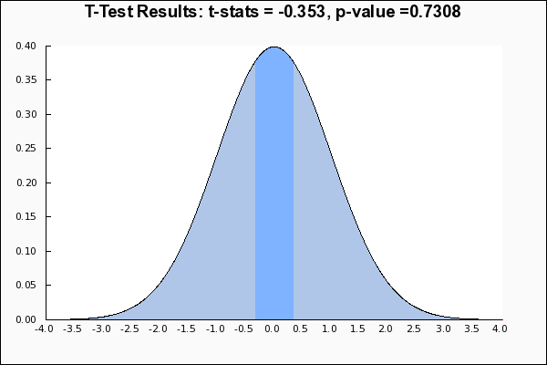

Figure S5 T-test results for the mean of the β exponent of Nicotiana tabacum L. (normal state). Calculated using https://mathcracker.com/t-test-for-one-mean.php#results
Accessed 10 October 2019.
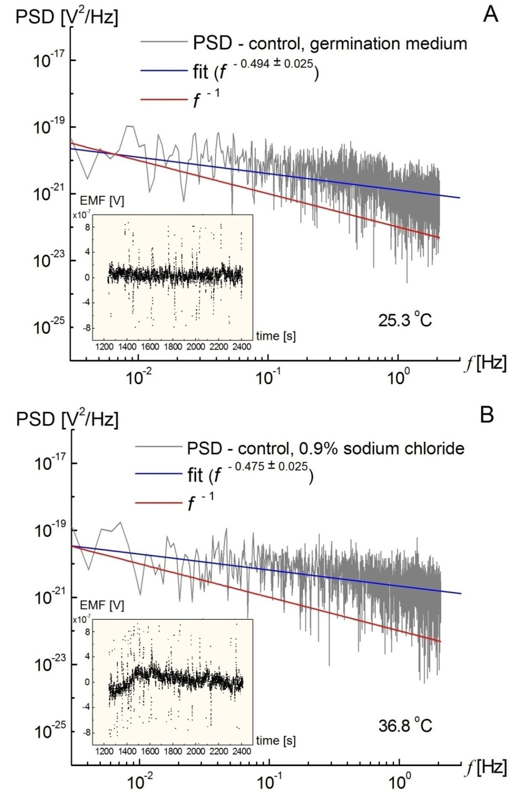
Figure S6 Power spectral density as a function of the frequency at control conditions. A Germination medium at 25.3 ± 0.5°C: f ^{-0.494 ± 0.025}. B 0.9% sodium chloride at 36.8 ± 0.5°C:
f ^{-0.475 ± 0.024}. The insets represent the signal that was obtained.
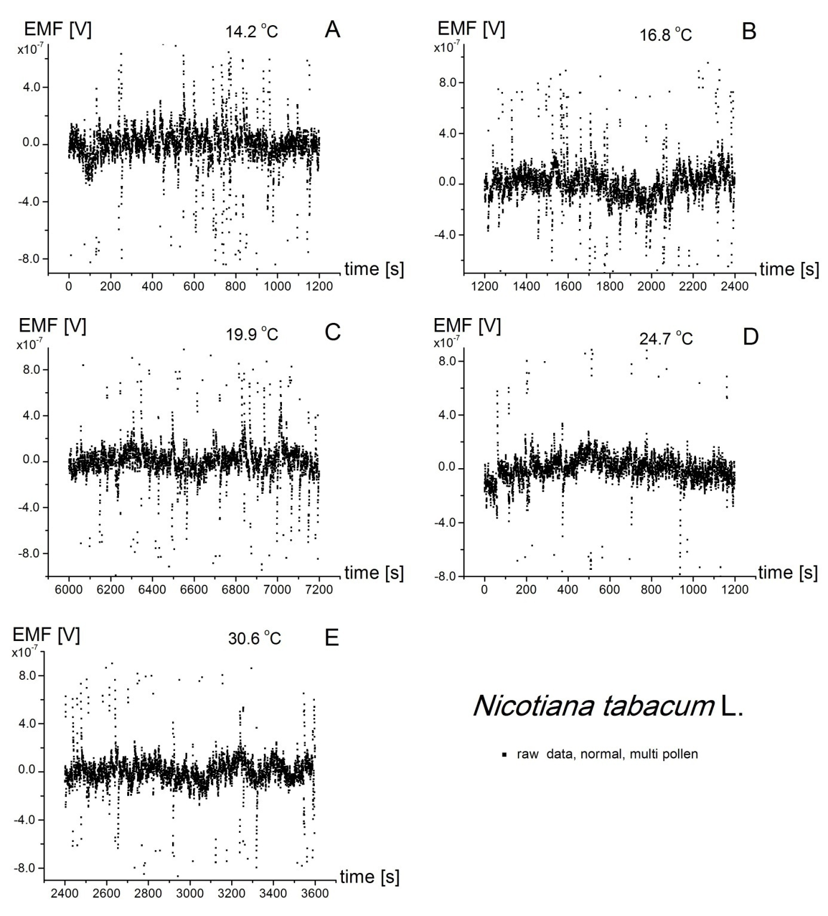
Figure S7 Representative time series of the electromotive force (EMF) parameterised by temperature. Raw data (total 5000 points for each 20 min. phase, sampling at 4.1 Hz). The amplitude was registered by an ELoPvC in the experiment on intact Nicotiana tabacum L. pollen tubes. The linear base line was subtracted (detrended).
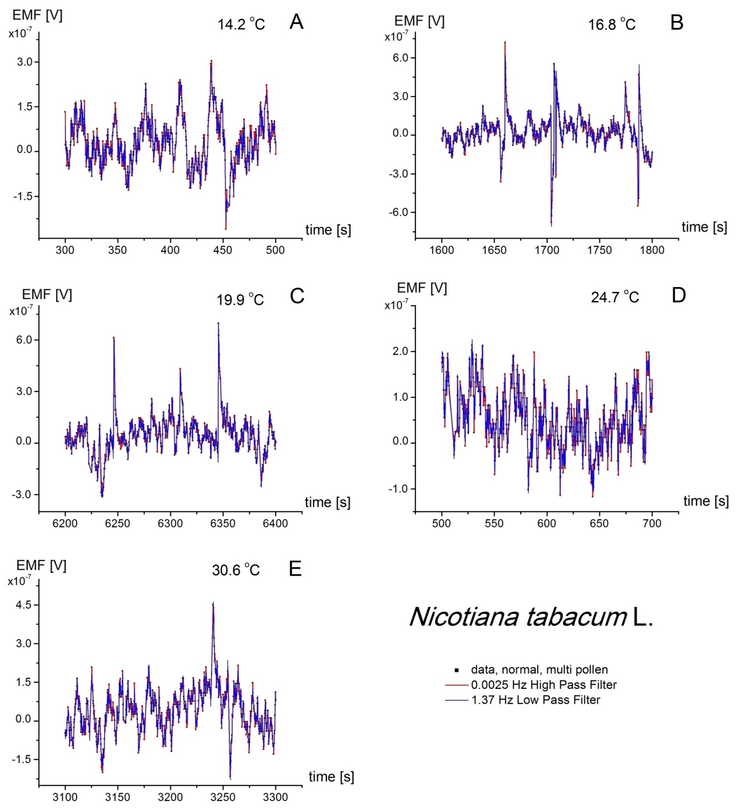

Figure S8 Representative fragments (zoomed in 200 s) time series of the electromotive force (EMF) parameterised by temperature. The raw data that were sampled at 4.1 Hz were registered by an ELoPvC in the experiment on intact Nicotiana tabacum L. pollen tubes on μV level. The linear base line was subtracted (detrended) and the low-pass 1.37 Hz and high-pass filter 0.0025 Hz were applied. See also Figure S7 for the whole range.

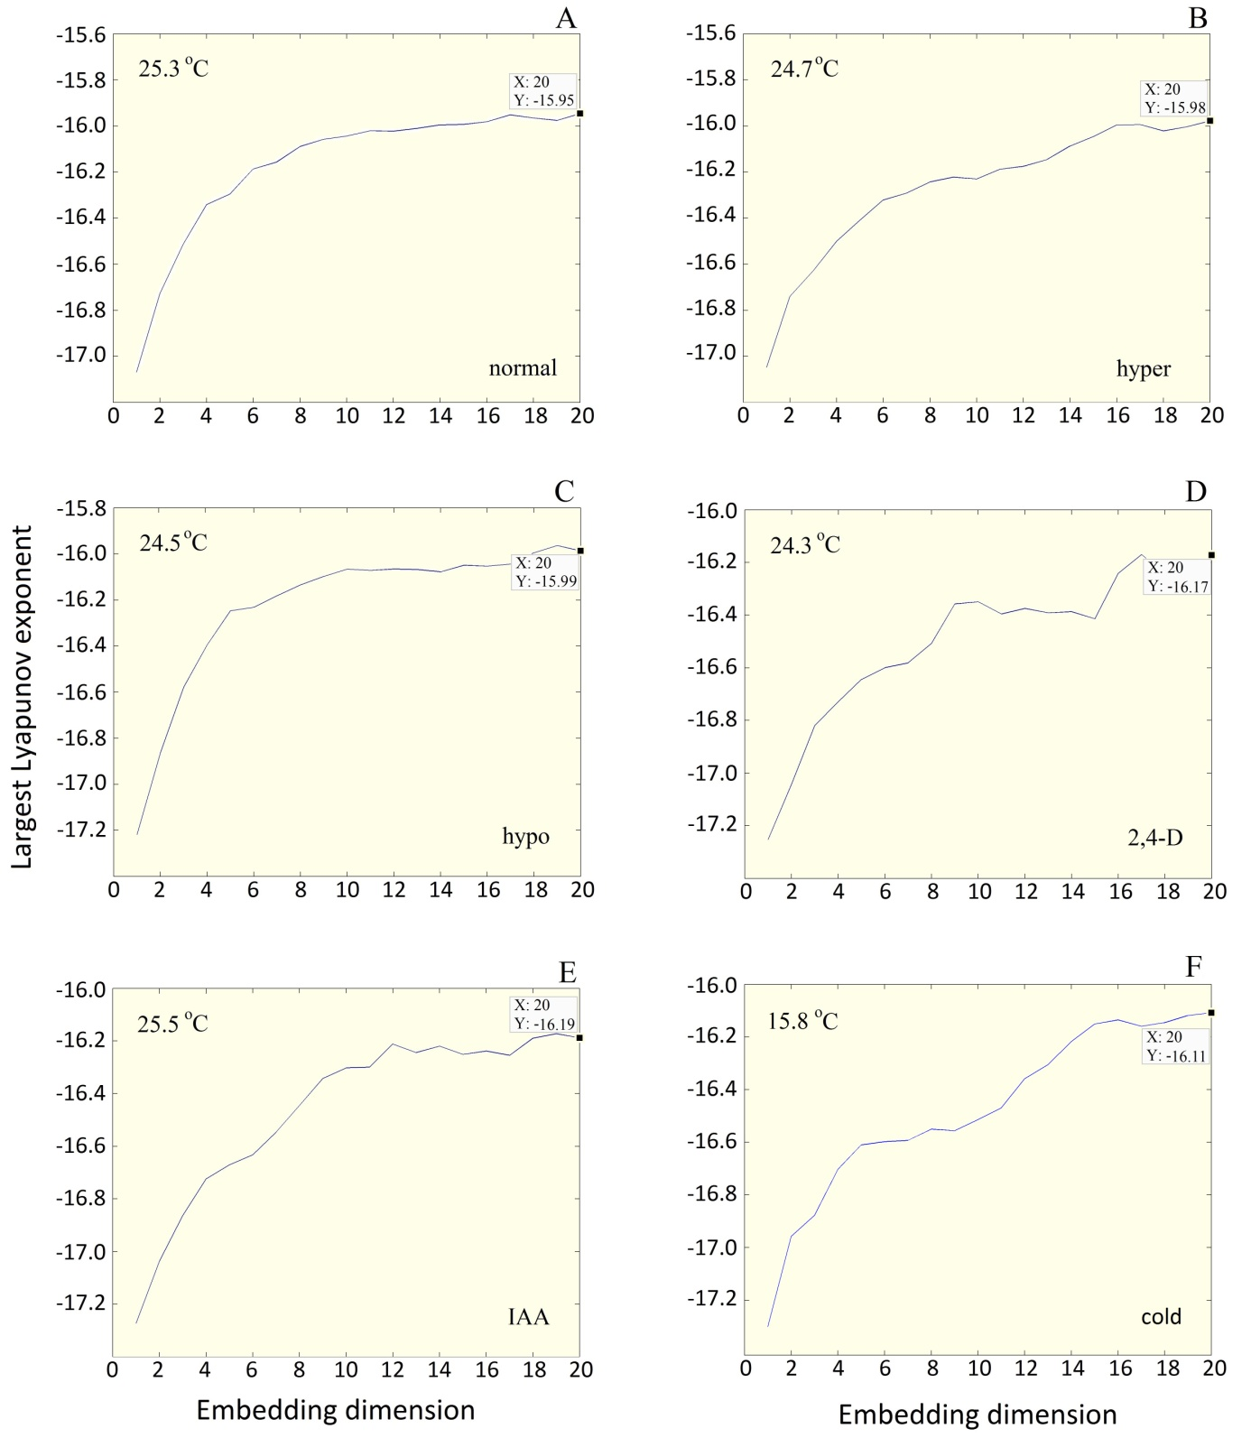

Figure S9 Largest Lyapunov exponent as a function of embedding dimension for multi-pollens of Hyacinthus orientalis L. for different treatments.

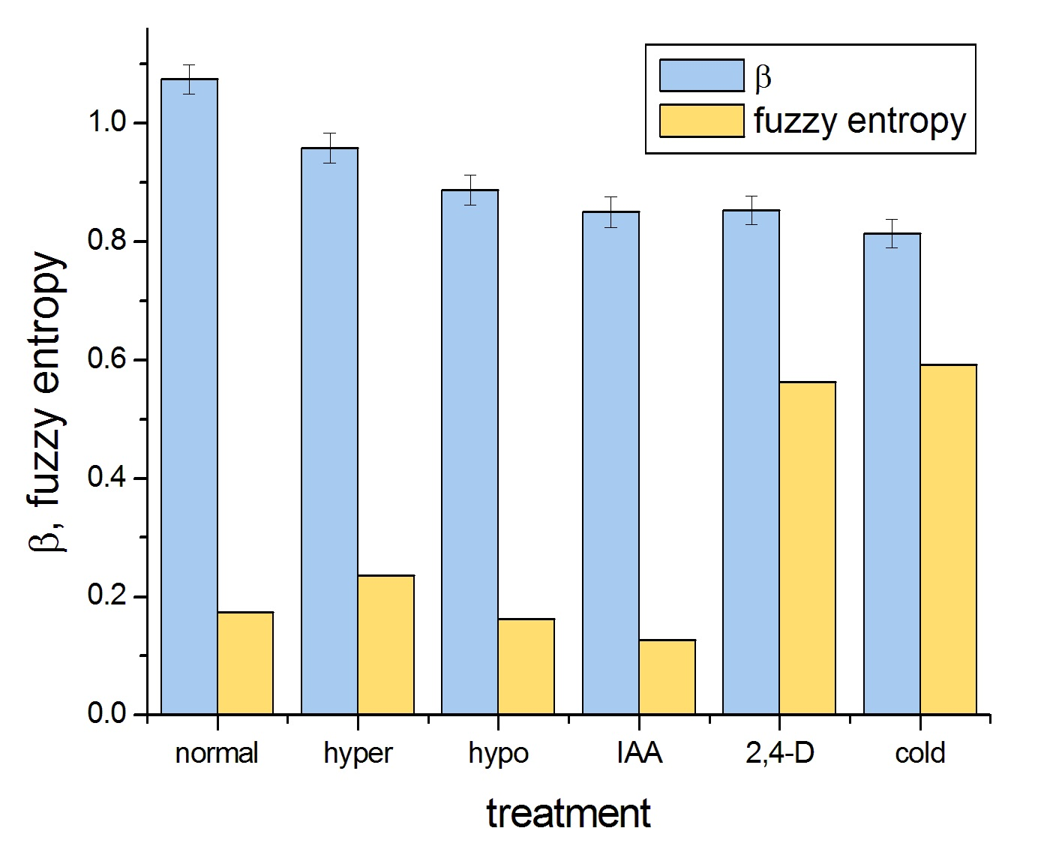
Figure S10 EZ entropy and the spectral exponent β calculated for different treatments of Hyacinthus orientalis L. multi-pollens (Table S10).
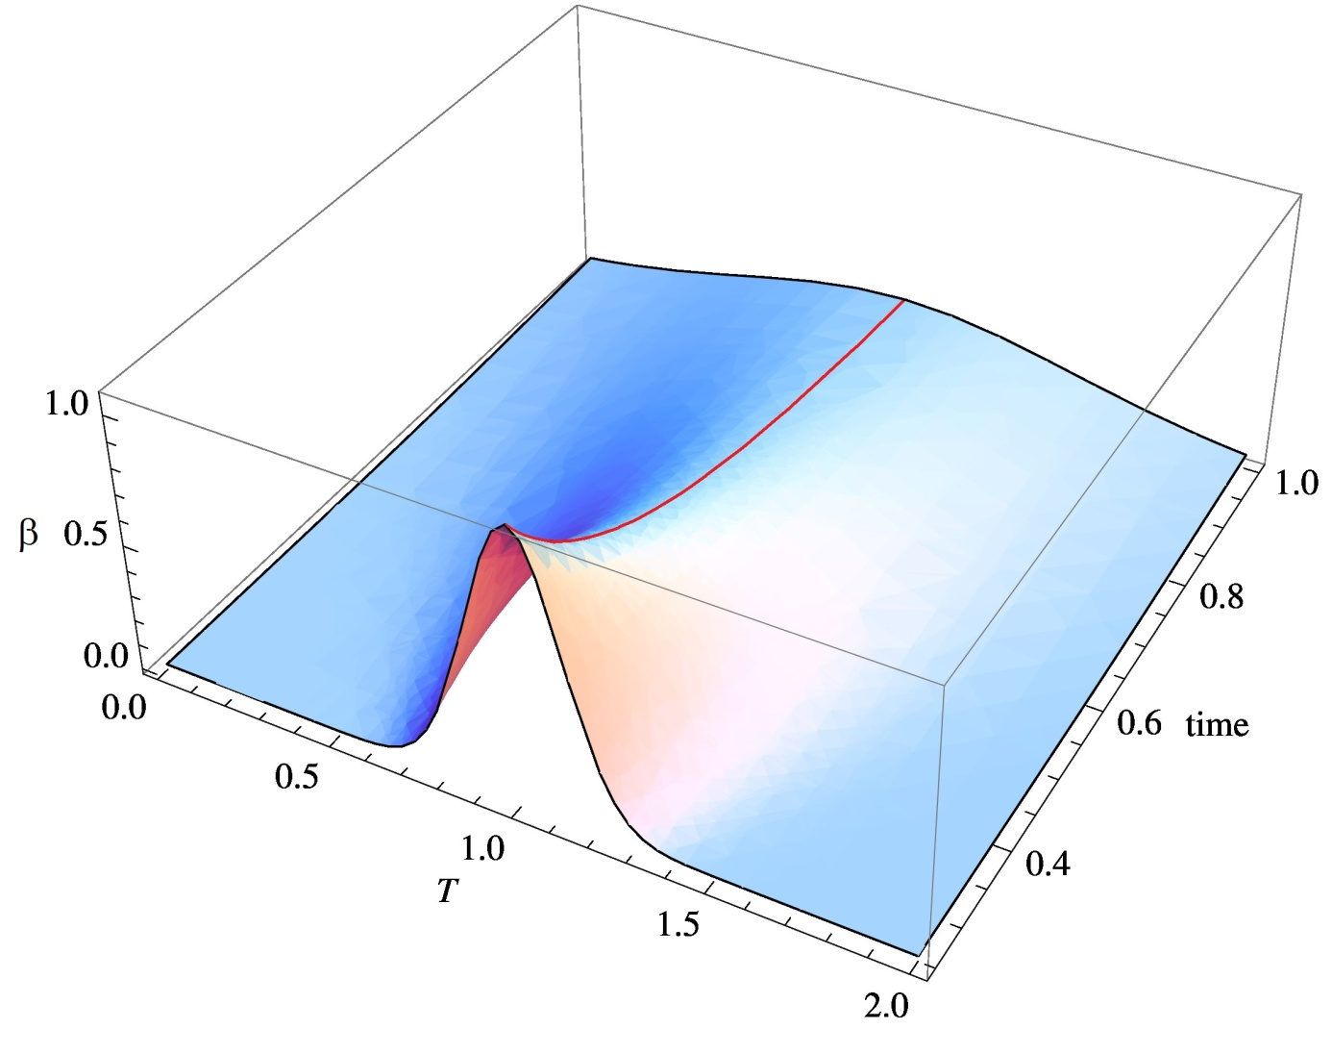
Figure S11 Critical exponent β as a function of temperature (T) and time (both in a.u.). An illustration for the ridge (red line) of extended criticality.

