Supplementary materials
The law of mass action allows to derive the following relationship between the fraction of bound complex, $X=\frac{c_{AB}}{c_{A, total}}$, for a given K_{D} with $c_{A, total}$ being the total molar target concentration, $c_{B, total}$ the total ligand concentration and $c_{AB}$ the concentration of the complex.
Supplementary equation (i)
$$X=\frac{c_{B,total}+c_{A,total}+K_{D}-\sqrt{{\left(c_{B,total}+c_{A,total}+K_{D}\right)}^{2}-4(c_{A,total}+c_{B,total})}}{2c_{A,total}}$$
Assuming the measured F_{norm} values correspond to a linear superposition of the signals for unbound ($F_{norm}(0))$ and bound $(F_{norm}(1)$) fractions respectively, F_{norm} values were fitted using supplementary equation (i) and (ii).
Supplementary equation (ii)
$$F_{norm}\left(X\right)=F_{norm}(0)+X∙\left(F_{norm}(1)-F_{norm}(0)\right)$$

dye | buffer | K_{D} [µM] | σ [µM] | Fluorescence change upon binding
No dye (LabelFree) | sodium acetate+ ^{a)} | 4.1 | 1.1 | NO
Blue-NHS (Dylight 488) | sodium acetate+ ^{a)} | 10.0 | 1.8 | YES
Blue-NHS  (Dylight 488) | PBS+ | 17.8 | 2.2 | YES
NT-RED-NHS | PBS+ | 97.6 | 18.4 | NO
NT-RED-NHS 2nd gen. | PBS+ | 25.5-43.2 ^{b)} | ~5 | NO
NT-RED-NHS 2nd gen. | TRIS+ | 47.9 | 2.7 | NO
Supplementary table 1: list of labeling strategies and buffers tested for the lysozyme–NAG3 interaction prior to the 40-instrument benchmark. ^{a)} Sodium acetate + buffer: 100mM sodium acetate pH5.0, 0.1% Tween-20. ^{b)} Different labeling replicates with different labeling efficiencies.
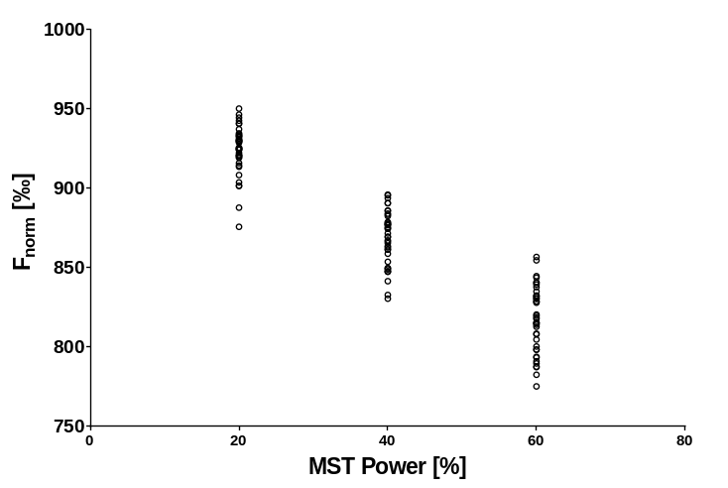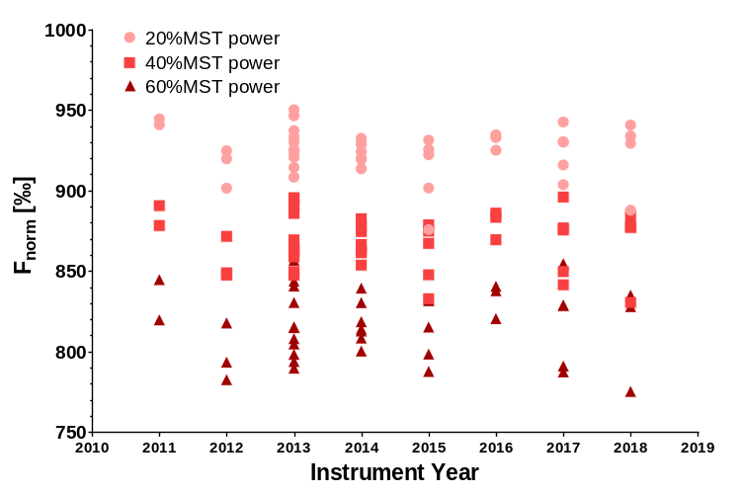
b)
a)
Supplementary figure 1: a) F_{norm} values derived in MOAA for 25 nM RED-NHS 2nd generation dye of each individual instrument for 20, 40 and 60% MST power respectively. b) Values from a) plotted as function of instrument manufacturing year.
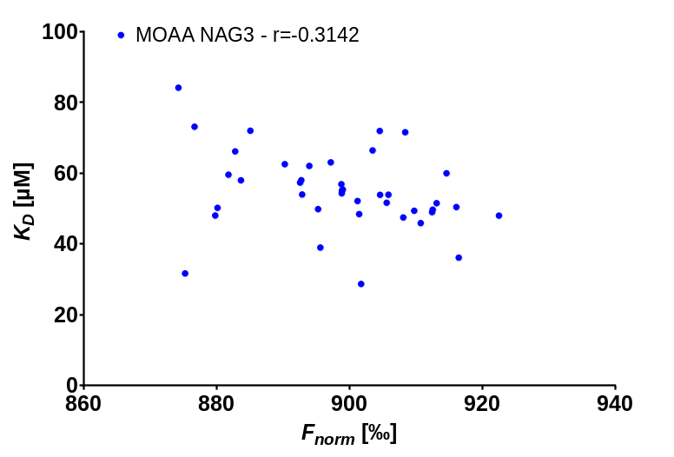
Supplementary figure 2: K_{D} versus F_{norm} values of the unbound state ($F_{norm}(0)$) derived in MOAA for Lysozyme–NAG3 interaction.

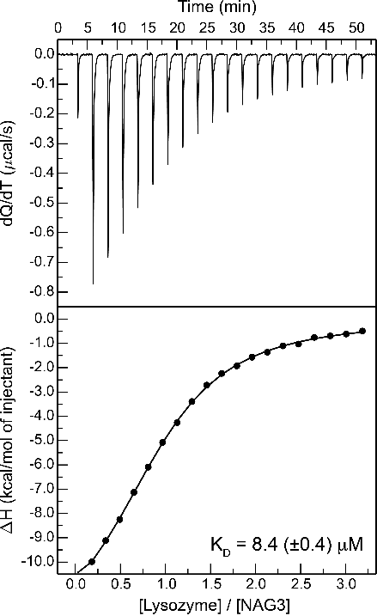
Supplementary figure 3: Exemplary ITC measurement for the lysozyme–NAG3 interaction in 20 mM Tris pH 7.8, 150 mM NaCl, 0.005% Tween-20 at 25°C. 29 µM Lysozyme in the cell and 450 µM NAG3 in the syringe measured with a MicroCal Auto-iTC200, analyzed with the MicroCal PEAQ-ITC analysis software.
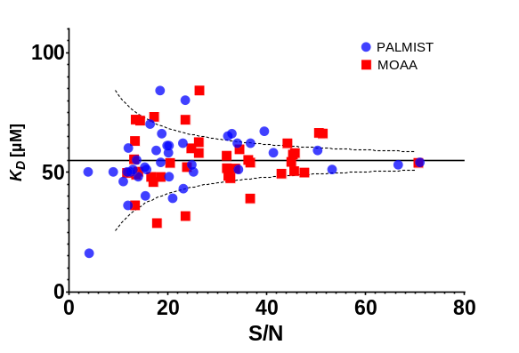
Supplementary figure 4: Distribution of extracted K_{D} values for the Lysozyme–NAG3 interaction regarding the S/N ratio of the replicates for all measurements. The horizontal line corresponds to the average K_{D} of 54.8µM while the dashed lines correspond to the S/N dependent relative standard deviation of triplicates as estimated in equation (8).

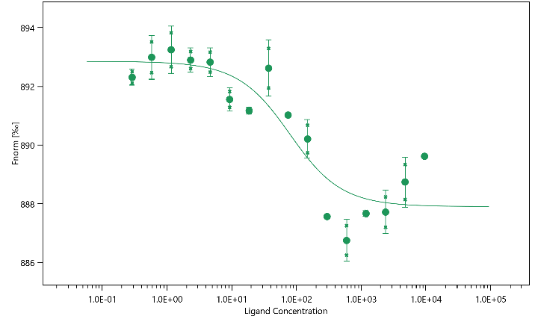
Supplementary figure 5: Exemplary TRIC binding curve for the lysozyme–NB interaction in PBS+, data from instrument N20. For high ligand concentration non-ideal behavior can be seen with the upper baseline deviation from the expected 1:1 binding model. Graph exported from MOAA.
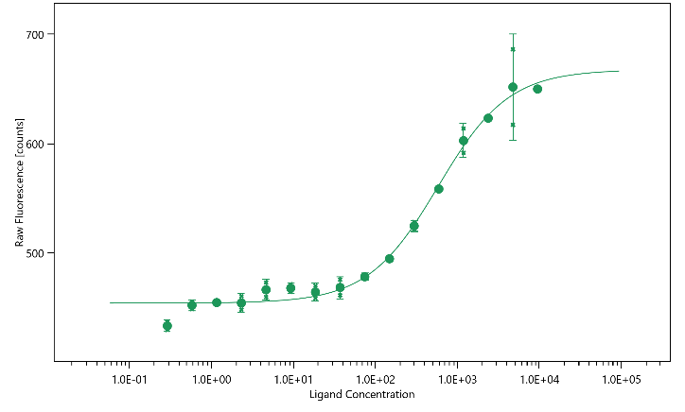
Supplementary figure 6: Exemplary binding curve from the fluorescence analysis for the lysozyme–NB interaction in PBS+, data from instrument N20. Curve nicely resembles a 1:1 binding model. Graph exported from MOAA.

