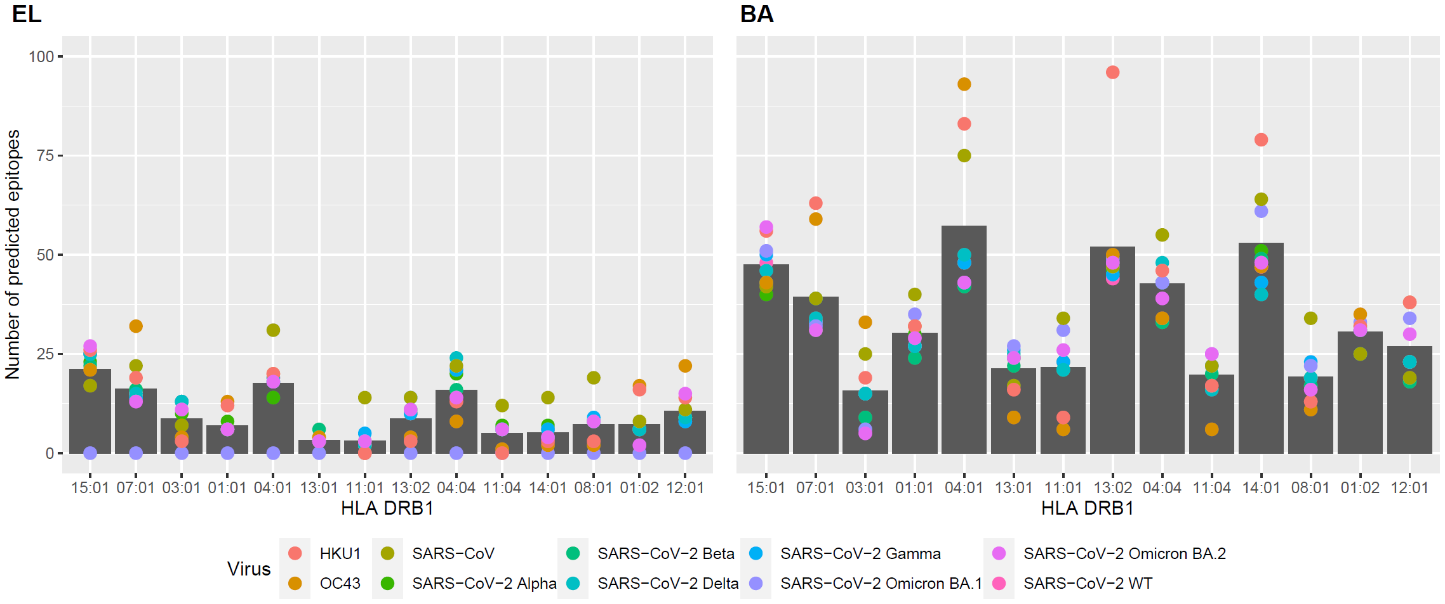
S1. Eluted Ligand versus Binding Affinity-based HLA-DRB1 epitope prediction
S1. Eluted Ligand versus Binding Affinity-based HLA-DRB1 epitope predictions. The number of predicted epitopes is shown per HLA-DRB1. HLA-DRB1 molecules are sorted based on their allele frequencies in the population.

S2. Number of predicted epitopes in the SARS-CoV-2 spike protein plotted against HLA frequency.

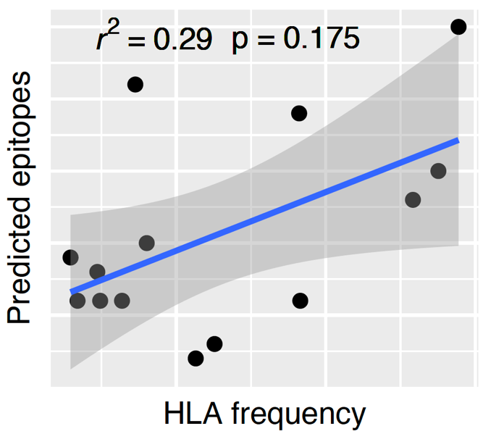
S2. Number of predicted epitopes in the SARS-CoV-2 spike protein plotted against HLA frequency. Trend line (blue) with 95% confidence interval. P-value was calculated with spearman correlation test in R.

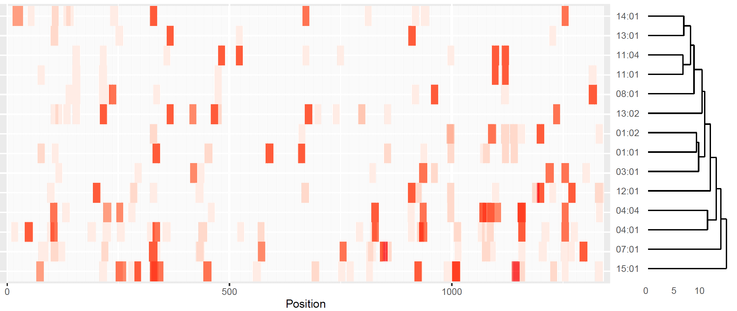
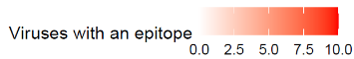
S3. Number of coronavirus epitopes per HLA-DRB1 molecule for each position in the spike protein. Number of coronaviruses (SARS-CoV, SARS-CoV-2 WT, Alpha, Beta, Gamma, Delta, Omicron BA.1, Omicron BA.2, HKU1, and OC43) with a predicted epitope per HLA-DRB1 molecule in the spike protein (red scale). Positions on the x-axis indicate the position on the multiple sequence alignment made with the spike proteins from the viruses. The number and position of epitopes for the HLA-DRB1 molecules were hierarchically clustered using complete linkage.

