Supplementary Information for:
Allele co-segregation and haplotype diversity of MHC IIβ genes in the small-spotted catshark Scyliorhinus canicula

Alessia Rota^{1,2,3,4}, Ana Veríssimo^{3,4}*, Arnaud Gaigher^{3,5}*

¹ Department of Earth and Environmental Sciences, University of Milano-Bicocca, Milan, Italy
² National Biodiversity Future Centre (NBFC), Palermo, 90133, Italy
³ CIBIO‐InBIO, Research Center in Biodiversity and Genetic Resources, University of Porto, 4485-661 Vairão, Portugal
⁴ BIOPOLIS Program in Genomics, Biodiversity and Land Planning, CIBIO, Campus de Vairão, 4485-661 Vairão, Portugal
⁵ Research Unit for Evolutionary Immunogenomics, Department of Biology, University of Hamburg, Hamburg, Germany

*Co-corresponding authors: averissimo@cibio.up.pt; arnaud.gaigher@gmail.com

Table S1: Composition of the optimised primer mix of the forward and reverse primers used for the co-amplification of 11 microsatellites in Scyliorhinus canicula (Griffiths et al. 2011). All primers are labelled using fluorescent dyes as indicated.

 |  | Quantity (µl)
Type | Name | Forward (10 µM) | Reverse (10 µM)
Marker | Scan02 | 2.4 | 2.4
 | Scan05 | 2.4 | 2.4
 | Scan10 | 3.0 | 3.0
 | Scan12 | 2.4 | 2.4
 | Scan03 | 3.6 | 3.6
 | Scan15 | 2.4 | 2.4
 | Scan06 | 6.0 | 6.0
 | Scan09 | 2.4 | 2.4
 | Scan13 | 2.4 | 2.4
 | Scan04 | 2.4 | 2.4
 | Scan16 | 3.0 | 3.0
Dye | NED | 7.8
 | FAM | 14.4
 | VIC | 10.2
H20 |  | 202.8
 | Final volume (µl) | 300

Table S2: Nucleotide sequence, annealing temperature and fragment length of the primer combinations used for the amplification of MHC IIβ1 (exon 2) and β2 (exon 3) lineages in Scyliorhinus canicula. To amplify the MHC IIβ2 B lineage, an equal ratio of the two forward primers β2_B03F and β2_B52F has been used.
Target lineage | Forward primer ID | Forward sequence | Reverse primer ID | Reverse sequence | Ta | Amplicon size
β1 A/B | NF2 | TCTCACAGGGGCTCACA | NR2 | CCGCTCTCACCTYTCCGG | 58° | 279 bp
β1 C | DF2 | CTCTTCTAGGGGCTCATACC | DR2 | CCGCTCTCACCTTTCCTGG | 60° | 277 bp
β1 A | NF2 | TCTCACAGGGGCTCACA | β1_AR3 | GACAGCGCCGACTGTTCCATGA | 65° | 261 bp
β1 B | NF2 | TCTCACAGGGGCTCACA | β1_NR2B_11R | ATGCCAATGTTAGTCTGACA | 60° | 246 bp
β2 A | β2_AintF2 | GGAGGAGAGTTAGAAATGATG | β2_AintR1 | GATTTTGACAGACCTGCTCAG | 59° | 452 bp
β2 B | β2_B03F | ACTGGATTTTACCCTGCAA | classIIDBB_β2R | CAGGCTGMTGTGWKYCAC | 60° | 162 bp
β2 B | β2_B52F | ACTGGATTTTACCCTCCAG | classIIDBB_β2R | CAGGCTGMTGTGWKYCAC | 60° | 162 bp
β2 C | β2_CF | GAAACCAACAGTCACTATCCGC | β2_CR2 | CGACAGGTATATTTATCACCAG | 58.5° | 237 bp

Table S3: Multilocus genotypes for 76 individuals of Scyliorhinus canicula at 11 microsatellite loci. Cells coded with “0” refer to loci with no data.

Sample ID | Scan02 |  | Scan03 |  | Scan04 |  | Scan05 |  | Scan06_2 |  | Scan09 |  | Scan10 |  | Scan12 |  | Scan13 |  | Scan15 |  | Scan16_2
Group1_F1 | 134 | 138 | 186 | 192 | 255 | 255 | 198 | 200 | 229 | 229 | 132 | 132 | 270 | 276 | 119 | 119 | 203 | 203 | 254 | 254 | 283 | 283
Group1_F10 | 136 | 138 | 188 | 192 | 255 | 255 | 198 | 200 | 229 | 229 | 132 | 132 | 270 | 276 | 119 | 127 | 203 | 205 | 254 | 254 | 283 | 283
Group1_F11 | 0 | 0 | 0 | 0 | 0 | 0 | 0 | 0 | 0 | 0 | 0 | 0 | 0 | 0 | 0 | 0 | 0 | 0 | 0 | 0 | 0 | 0
Group1_F13 | 138 | 138 | 188 | 188 | 255 | 255 | 198 | 200 | 229 | 233 | 132 | 132 | 270 | 276 | 119 | 127 | 203 | 203 | 254 | 256 | 283 | 283
Group1_F15 | 138 | 140 | 188 | 188 | 255 | 255 | 198 | 200 | 229 | 239 | 132 | 132 | 266 | 270 | 117 | 119 | 203 | 205 | 252 | 256 | 283 | 283
Group1_F16 | 138 | 138 | 186 | 192 | 255 | 255 | 198 | 200 | 229 | 233 | 132 | 132 | 270 | 276 | 119 | 127 | 203 | 203 | 252 | 254 | 283 | 283
Group1_F17 | 134 | 136 | 188 | 192 | 255 | 255 | 198 | 200 | 229 | 229 | 132 | 132 | 270 | 276 | 119 | 127 | 203 | 203 | 252 | 256 | 283 | 283
Group1_F18 | 134 | 136 | 188 | 192 | 255 | 255 | 198 | 200 | 229 | 233 | 132 | 132 | 270 | 276 | 119 | 127 | 203 | 205 | 254 | 256 | 283 | 283
Group1_F19 | 134 | 138 | 188 | 192 | 255 | 255 | 198 | 200 | 229 | 229 | 132 | 132 | 270 | 276 | 119 | 119 | 203 | 205 | 252 | 256 | 283 | 283
Group1_F2 | 134 | 138 | 188 | 188 | 255 | 255 | 198 | 200 | 229 | 229 | 132 | 132 | 270 | 276 | 119 | 127 | 203 | 203 | 254 | 256 | 283 | 283
Group1_F20 | 134 | 138 | 186 | 188 | 255 | 263 | 198 | 200 | 229 | 235 | 132 | 134 | 270 | 270 | 117 | 119 | 203 | 203 | 254 | 254 | 275 | 283
Group1_F21 | 134 | 138 | 188 | 188 | 255 | 255 | 198 | 200 | 229 | 229 | 132 | 132 | 266 | 270 | 117 | 119 | 203 | 203 | 252 | 254 | 283 | 283
Group1_F22 | 134 | 136 | 186 | 186 | 255 | 255 | 198 | 200 | 229 | 229 | 132 | 132 | 270 | 270 | 117 | 119 | 203 | 203 | 252 | 256 | 283 | 283
Group1_F23 | 136 | 136 | 186 | 186 | 255 | 255 | 198 | 200 | 229 | 237 | 132 | 132 | 270 | 270 | 119 | 119 | 203 | 205 | 256 | 256 | 275 | 283
Group1_F3 | 136 | 138 | 186 | 188 | 255 | 255 | 198 | 200 | 229 | 229 | 132 | 132 | 270 | 276 | 119 | 119 | 203 | 205 | 254 | 254 | 283 | 283
Group1_F4 | 136 | 140 | 186 | 188 | 255 | 255 | 198 | 200 | 229 | 241 | 132 | 132 | 270 | 270 | 115 | 119 | 203 | 205 | 254 | 258 | 283 | 283
Group1_F5 | 138 | 140 | 186 | 188 | 255 | 255 | 198 | 200 | 229 | 237 | 132 | 132 | 270 | 270 | 119 | 119 | 203 | 205 | 254 | 256 | 275 | 283
Group1_F6 | 134 | 136 | 186 | 192 | 255 | 255 | 198 | 200 | 229 | 233 | 132 | 132 | 270 | 276 | 119 | 127 | 203 | 203 | 252 | 254 | 283 | 283
Group1_F7 | 136 | 138 | 186 | 188 | 255 | 265 | 198 | 200 | 229 | 241 | 132 | 132 | 270 | 270 | 115 | 119 | 203 | 203 | 254 | 258 | 283 | 283
Group1_F8 | 136 | 138 | 186 | 192 | 255 | 255 | 198 | 200 | 229 | 229 | 132 | 132 | 270 | 276 | 119 | 119 | 203 | 203 | 254 | 254 | 283 | 283
Group1_F9 | 136 | 136 | 186 | 186 | 255 | 265 | 198 | 200 | 229 | 237 | 132 | 132 | 270 | 270 | 115 | 119 | 203 | 205 | 256 | 258 | 283 | 283
Group1_mother1 | 136 | 138 | 186 | 188 | 255 | 255 | 200 | 200 | 229 | 229 | 132 | 132 | 270 | 270 | 119 | 119 | 203 | 203 | 254 | 256 | 283 | 283
Group2_father1 | 134 | 140 | 186 | 192 | 263 | 265 | 198 | 198 | 233 | 235 | 132 | 132 | 274 | 274 | 119 | 121 | 203 | 203 | 254 | 254 | 285 | 285
Group2_father2 | 134 | 134 | 194 | 194 | 255 | 255 | 198 | 198 | 229 | 233 | 132 | 132 | 270 | 276 | 119 | 121 | 203 | 203 | 252 | 258 | 283 | 283
Group2_father3 | 132 | 142 | 186 | 194 | 255 | 255 | 198 | 200 | 229 | 241 | 132 | 132 | 270 | 274 | 117 | 119 | 195 | 203 | 256 | 258 | 279 | 283
Group2_mother1 | 134 | 134 | 186 | 186 | 255 | 263 | 198 | 200 | 229 | 229 | 132 | 132 | 270 | 274 | 117 | 121 | 203 | 203 | 256 | 258 | 283 | 285
Group2_mother2 | 132 | 134 | 186 | 194 | 263 | 263 | 198 | 198 | 233 | 235 | 132 | 132 | 274 | 274 | 121 | 121 | 203 | 203 | 254 | 256 | 285 | 285
Group2_mother3 | 134 | 140 | 192 | 194 | 255 | 263 | 198 | 198 | 233 | 237 | 134 | 134 | 274 | 274 | 121 | 123 | 203 | 203 | 254 | 256 | 283 | 285
Group2_mother4 | 136 | 144 | 186 | 194 | 255 | 255 | 198 | 200 | 229 | 239 | 132 | 132 | 270 | 274 | 119 | 121 | 203 | 205 | 252 | 256 | 279 | 283
Group2_pup1A2 | 134 | 142 | 186 | 186 | 255 | 255 | 198 | 198 | 229 | 229 | 132 | 132 | 270 | 270 | 117 | 117 | 195 | 203 | 256 | 258 | 283 | 285
Group2_pup1A3 | 132 | 136 | 186 | 186 | 255 | 255 | 198 | 198 | 229 | 229 | 132 | 132 | 270 | 274 | 119 | 121 | 195 | 203 | 256 | 258 | 279 | 283
Group2_pup1A4 | 134 | 142 | 186 | 186 | 255 | 255 | 198 | 200 | 229 | 229 | 132 | 132 | 270 | 274 | 119 | 121 | 203 | 203 | 258 | 258 | 283 | 285
Group2_pup1A6 | 134 | 138 | 192 | 194 | 255 | 265 | 198 | 198 | 233 | 237 | 132 | 132 | 274 | 274 | 121 | 121 | 203 | 203 | 254 | 254 | 283 | 285
Group2_pup1B2 | 136 | 140 | 186 | 194 | 255 | 265 | 198 | 198 | 229 | 235 | 132 | 132 | 274 | 274 | 119 | 119 | 203 | 203 | 254 | 256 | 283 | 285
Group2_pup1B4 | 132 | 134 | 186 | 186 | 255 | 263 | 198 | 198 | 229 | 241 | 132 | 132 | 270 | 274 | 119 | 121 | 203 | 203 | 256 | 256 | 279 | 283
Sample ID | Scan02 |  | Scan03 |  | Scan04 |  | Scan05 |  | Scan06_2 |  | Scan09 |  | Scan10 |  | Scan12 |  | Scan13 |  | Scan15 |  | Scan16_2
Group2_pup1B6 | 132 | 144 | 186 | 194 | 255 | 255 | 198 | 198 | 239 | 241 | 132 | 132 | 270 | 270 | 117 | 119 | 203 | 203 | 252 | 256 | 279 | 279
Group2_pup1C3 | 134 | 144 | 194 | 194 | 255 | 255 | 198 | 198 | 233 | 239 | 132 | 132 | 270 | 274 | 121 | 121 | 203 | 203 | 252 | 258 | 279 | 283
Group2_pup1C4 | 134 | 144 | 186 | 186 | 255 | 265 | 198 | 198 | 229 | 233 | 132 | 132 | 270 | 274 | 119 | 119 | 203 | 205 | 254 | 256 | 283 | 285
Group2_pup1C6 | 134 | 138 | 192 | 192 | 263 | 263 | 198 | 198 | 233 | 233 | 132 | 132 | 274 | 274 | 119 | 119 | 203 | 203 | 254 | 256 | 285 | 285
Group2_pup1D2 | 134 | 140 | 186 | 192 | 263 | 265 | 198 | 200 | 229 | 235 | 132 | 132 | 270 | 274 | 119 | 121 | 203 | 203 | 254 | 258 | 283 | 285
Group2_pup1D6 | 134 | 140 | 186 | 186 | 255 | 265 | 198 | 200 | 229 | 233 | 132 | 132 | 274 | 274 | 119 | 121 | 203 | 203 | 254 | 258 | 283 | 285
Group2_pup1E2 | 134 | 134 | 186 | 186 | 255 | 263 | 198 | 198 | 229 | 233 | 132 | 132 | 274 | 274 | 117 | 121 | 203 | 203 | 254 | 256 | 285 | 285
Group2_pup1E3 | 134 | 142 | 194 | 194 | 255 | 255 | 198 | 200 | 229 | 229 | 132 | 132 | 274 | 274 | 117 | 119 | 203 | 203 | 258 | 258 | 283 | 283
Group2_pup1E5 | 134 | 142 | 186 | 186 | 255 | 263 | 200 | 200 | 229 | 241 | 132 | 132 | 274 | 274 | 117 | 119 | 195 | 203 | 258 | 258 | 279 | 285
Group2_pup1E6 | 132 | 140 | 186 | 194 | 255 | 265 | 198 | 198 | 235 | 237 | 132 | 132 | 274 | 274 | 119 | 121 | 203 | 203 | 254 | 254 | 283 | 285
Group2_pup1F3 | 134 | 134 | 192 | 192 | 255 | 265 | 198 | 198 | 229 | 233 | 132 | 132 | 274 | 274 | 117 | 121 | 203 | 203 | 254 | 258 | 283 | 285
Group2_pup1F5 | 134 | 134 | 192 | 192 | 255 | 265 | 198 | 198 | 229 | 233 | 132 | 132 | 274 | 274 | 117 | 121 | 203 | 203 | 254 | 258 | 283 | 285
Group2_pup1G10 | 132 | 140 | 186 | 194 | 255 | 265 | 198 | 198 | 235 | 237 | 132 | 132 | 274 | 274 | 119 | 121 | 203 | 203 | 254 | 254 | 283 | 285
Group2_pup1G2 | 134 | 144 | 186 | 194 | 255 | 263 | 198 | 200 | 229 | 235 | 132 | 132 | 270 | 274 | 119 | 121 | 203 | 205 | 252 | 254 | 279 | 285
Group2_pup1G5 | 134 | 142 | 186 | 186 | 255 | 255 | 200 | 200 | 229 | 241 | 132 | 132 | 270 | 274 | 117 | 117 | 195 | 203 | 256 | 258 | 283 | 283
Group2_pup1H1 | 134 | 142 | 186 | 186 | 255 | 263 | 198 | 200 | 229 | 229 | 132 | 132 | 274 | 274 | 117 | 121 | 203 | 203 | 256 | 258 | 283 | 283
Group2_pup1H10 | 138 | 140 | 186 | 186 | 255 | 263 | 198 | 198 | 233 | 237 | 132 | 132 | 274 | 274 | 121 | 121 | 203 | 203 | 254 | 254 | 283 | 285
Group2_pup1H5 | 134 | 144 | 186 | 192 | 255 | 263 | 198 | 198 | 233 | 239 | 132 | 132 | 270 | 274 | 119 | 119 | 203 | 205 | 252 | 254 | 283 | 285
Group2_pup1I1 | 134 | 142 | 186 | 186 | 255 | 263 | 198 | 200 | 229 | 229 | 132 | 132 | 270 | 270 | 117 | 121 | 203 | 203 | 258 | 258 | 279 | 283
Group2_pup1I10 | 132 | 144 | 186 | 186 | 255 | 255 | 198 | 200 | 229 | 239 | 132 | 132 | 270 | 274 | 119 | 119 | 203 | 205 | 252 | 258 | 279 | 283
Group2_pup1I3 | 134 | 140 | 186 | 186 | 263 | 265 | 198 | 198 | 229 | 233 | 132 | 132 | 274 | 274 | 119 | 121 | 203 | 203 | 254 | 258 | 283 | 285
Group2_pup1I5 | 134 | 140 | 186 | 186 | 263 | 265 | 198 | 200 | 229 | 233 | 132 | 132 | 274 | 274 | 117 | 121 | 203 | 203 | 254 | 256 | 283 | 285
Group2_pup1I6 | 134 | 140 | 186 | 192 | 263 | 265 | 198 | 200 | 229 | 233 | 132 | 132 | 274 | 274 | 117 | 119 | 203 | 203 | 254 | 258 | 285 | 285
Group2_pup1J1 | 136 | 142 | 194 | 194 | 255 | 255 | 200 | 200 | 229 | 239 | 132 | 132 | 270 | 270 | 119 | 121 | 203 | 205 | 252 | 258 | 279 | 283
Group2_pup1J10 | 134 | 142 | 186 | 186 | 255 | 255 | 198 | 200 | 229 | 241 | 132 | 132 | 274 | 274 | 117 | 121 | 203 | 203 | 256 | 256 | 279 | 285
Group2_pup1J3 | 134 | 136 | 186 | 192 | 255 | 265 | 198 | 198 | 229 | 235 | 132 | 132 | 270 | 274 | 121 | 121 | 203 | 205 | 254 | 256 | 283 | 285
Group2_pup1J5 | 138 | 140 | 192 | 192 | 255 | 265 | 198 | 198 | 235 | 237 | 132 | 132 | 274 | 274 | 121 | 121 | 203 | 203 | 254 | 254 | 283 | 285
Group2_pup2A6 | 134 | 134 | 194 | 194 | 255 | 263 | 198 | 200 | 229 | 229 | 132 | 132 | 270 | 276 | 117 | 121 | 203 | 203 | 258 | 258 | 283 | 285
Group2_pup2A9 | 134 | 144 | 186 | 194 | 255 | 263 | 198 | 200 | 229 | 235 | 132 | 132 | 270 | 274 | 119 | 121 | 203 | 205 | 254 | 256 | 279 | 285
Group2_pup2B1 | 132 | 140 | 192 | 192 | 255 | 265 | 198 | 198 | 235 | 237 | 132 | 132 | 274 | 274 | 119 | 121 | 203 | 203 | 254 | 254 | 283 | 285
Group2_pup2B2 | 134 | 134 | 0 | 0 | 265 | 265 | 198 | 198 | 229 | 233 | 132 | 134 | 274 | 274 | 117 | 121 | 203 | 203 | 254 | 254 | 0 | 0
Group2_pup2B9 | 134 | 134 | 0 | 0 | 255 | 263 | 198 | 200 | 229 | 229 | 132 | 132 | 270 | 270 | 121 | 121 | 203 | 203 | 258 | 258 | 283 | 285
Group2_pup2C1 | 132 | 136 | 186 | 186 | 255 | 255 | 200 | 200 | 229 | 239 | 132 | 132 | 270 | 274 | 117 | 119 | 195 | 203 | 256 | 256 | 279 | 279
Group2_pup2C2 | 134 | 134 | 192 | 192 | 263 | 265 | 198 | 198 | 229 | 233 | 132 | 132 | 274 | 274 | 119 | 121 | 203 | 203 | 256 | 256 | 283 | 285
Group2_pup2C9 | 134 | 134 | 186 | 194 | 255 | 263 | 198 | 198 | 229 | 233 | 132 | 132 | 274 | 276 | 117 | 121 | 203 | 203 | 258 | 258 | 283 | 285
Group2_pup2D1 | 134 | 134 | 194 | 194 | 255 | 255 | 198 | 200 | 229 | 229 | 132 | 132 | 270 | 274 | 121 | 121 | 203 | 203 | 252 | 258 | 283 | 283
Group2_pup2D2 | 134 | 134 | 186 | 186 | 255 | 263 | 198 | 200 | 229 | 233 | 132 | 132 | 270 | 276 | 117 | 119 | 203 | 203 | 252 | 256 | 283 | 283
Group2_pup2D9 | 136 | 140 | 186 | 186 | 255 | 265 | 198 | 198 | 229 | 233 | 132 | 132 | 270 | 274 | 119 | 119 | 203 | 205 | 254 | 256 | 283 | 285
Group2_pup2E1 | 134 | 134 | 194 | 194 | 255 | 255 | 198 | 200 | 229 | 233 | 132 | 132 | 274 | 276 | 119 | 121 | 203 | 203 | 256 | 258 | 283 | 283
Group2_pup2G1 | 134 | 144 | 192 | 194 | 255 | 265 | 198 | 200 | 235 | 239 | 132 | 132 | 270 | 274 | 119 | 121 | 203 | 205 | 254 | 256 | 283 | 285
Group2_pup2I1 | 134 | 134 | 192 | 192 | 255 | 265 | 198 | 200 | 229 | 235 | 132 | 132 | 270 | 274 | 119 | 121 | 203 | 203 | 254 | 258 | 285 | 285

Table S4: Results of the Cervus reconstruction showing the most likely mother and father for each offspring in group 2. Mother (M) or Father (F) are highlighted red in cases where the respective LOD score is < 0.
Offspring ID | Candidate mother | Candidate father
1A2 | M1 | F3
1A3 | M4, M1 | F3
1A4 | M1 | F3, F2
1A6
1B2 | M4 | F1
1B4 | M1, M2 | F3
1B6 | M4 | F3
1C3 | M4 | F2
1C4 | M4
1C6 |  | F1
1D2 | M1 | F1
1D6 | M1 | F1
1E2 | M1, M2 | F1
1E3 | M1, M4 | F3, F2
1E5 | M1 | F3
1E6 |  | F1
1F3 | M1 | F1
1F5 | M1 | F1
1G10 |  | F1
1G2 | M4 | F2
1G5 | M1, M4 | F3
1H1 | M1, M2 | F3
1H10 |  | F1
1H5 | M4 | F2
1I1 | M1 | F3, F2
1I10 | M4 | F3
1I3 | M2, M1 | F1
1I5 | M1 | F1
1I6 | M1 | F1
1J1 | M4 | F3
1J10 | M1, M2, M4 | F3
1J3 | M4
1J5 | M3 | F1
2A6 | M1 | F2, F3
2A9 | M4, M2
2B1 |  | F1
2B2
2B9 | M1 | F2
2C1 | M4 | F3
2C2 | M1 | F1
2C9 | M1, M2 | F2, F1
2D1 | M1, M4 | F2
2D2 | M1 | F2
2D9 | M4
2E1 | M4, M1, M3 | F2
2G1 | M4
2I1 | M1 | F1

Table S5: Inference of genetic linkage between MHC IIβ lineages of the small-spotted catshark using family data. (a) Family #1, (b) Family #2, (c) Family #3, (d) Family #4, and (e) Family #5. Only Family #1 is part of Group 1. Family #1 includes several putative fathers. Haplotypes with * indicate that they were not considered for detecting recombination events (see Table 3).

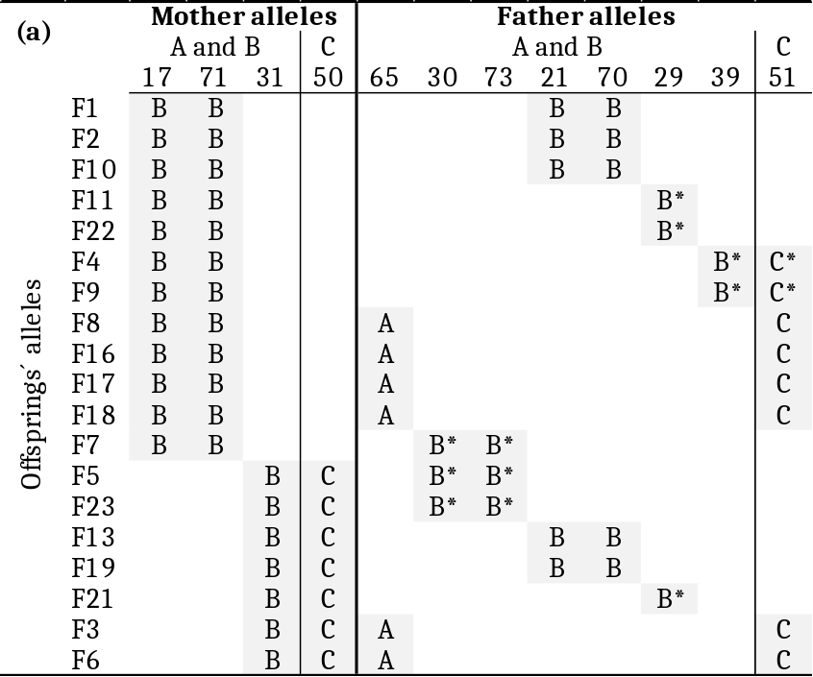

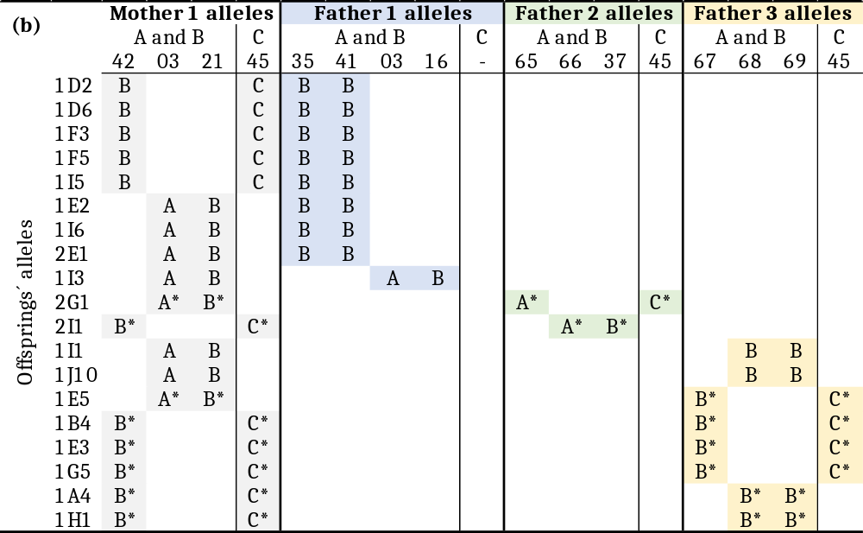

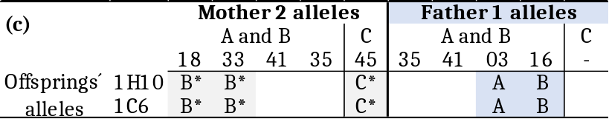

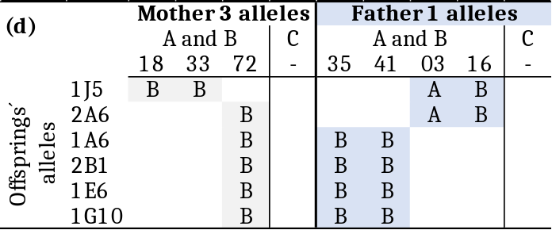

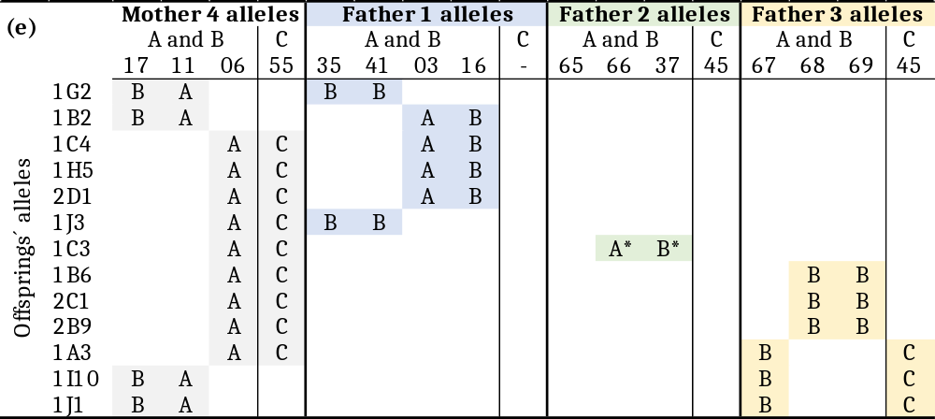

Table S6: Number of alleles from lineages A, B and C, and number of lineages present per individual of S. canicula sampled from the same population, taken from Gaigher et al. (2023).

Individual Ref. | No. of A alleles | No. of B alleles | No. of C alleles | No. of lineages
ALG_709 | 1 | 2 | 1 | 3
ALG_710 | 0 | 2 | 1 | 2
ALG_712 | 0 | 3 | 2 | 2
ALG_714 | 0 | 3 | 1 | 2
ALG_718 | 0 | 2 | 2 | 2
ALG_719 | 1 | 3 | 2 | 3
ALG_722 | 1 | 2 | 1 | 3
ALG_723 | 0 | 3 | 2 | 2
ALG_725 | 2 | 1 | 1 | 3
ALG_726 | 0 | 3 | 1 | 2
ALG_727 | 0 | 2 | 2 | 2
ALG_728 | 1 | 2 | 1 | 3
ALG_732 | 1 | 1 | 2 | 3
ALG_733 | 0 | 2 | 2 | 2
ALG_740 | 0 | 4 | 2 | 2
ALG_741 | 0 | 3 | 1 | 2
ALG_744 | 0 | 2 | 1 | 2
ALG_745 | 1 | 1 | 2 | 3
ALG_749 | 0 | 2 | 2 | 2
ALG_750 | 0 | 2 | 1 | 2
ALG_751 | 1 | 2 | 1 | 3
ALG_757 | 0 | 3 | 1 | 2
PTM734 | 0 | 2 | 1 | 2
PTM735 | 1 | 2 | 1 | 3
PTM746 | 1 | 1 | 1 | 3

Figure S1: Graphic illustration of the primers' location for the amplification of MHC IIβ1 (exon 2) and β2 (exon 3) in Scyliorhinus canicula. The different colours identify the primer pair combinations (see details in Table S2). Primers placed above the exon amplify for gene C, while primers below the exon amplify for lineage A and/or lineage B.
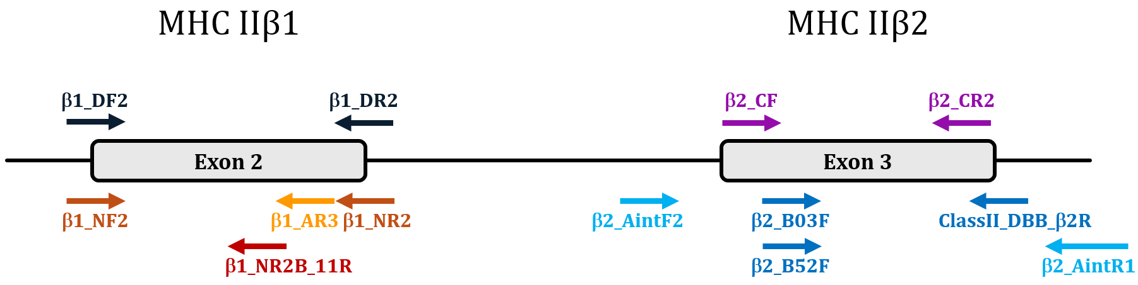

Figure S2: Phylogenetic network of small-spotted catshark MHC IIβ exon 2 alleles. Black dots represent the sequences extracted from the S. canicula reference genome sScyCan1.1 (BioProject PRJEB35945). Grey dots represent the new sequences detected in this study (GenBank accession numbers: PP982215-PP982223). Other exon 2 allele sequences were obtained from Gaigher et al. (2023).
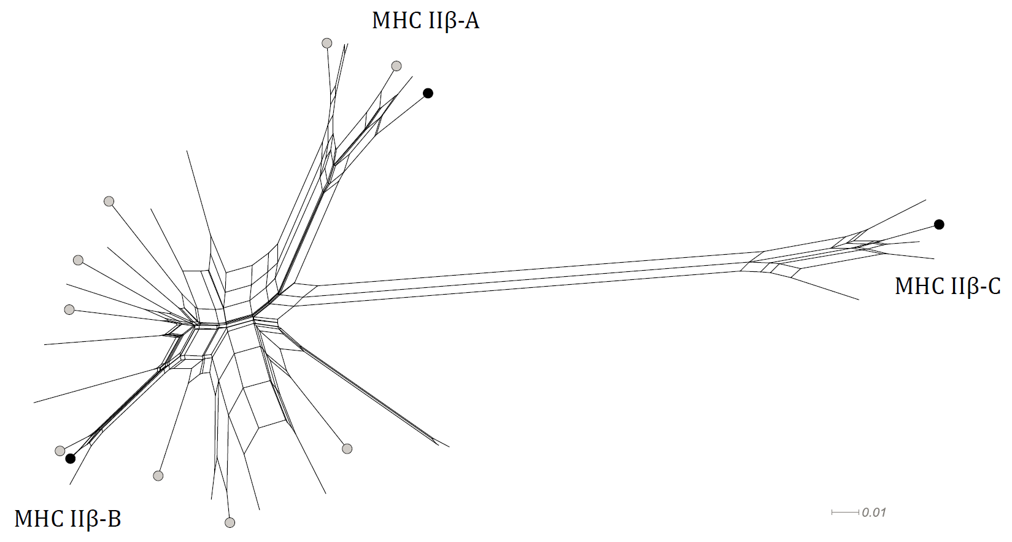

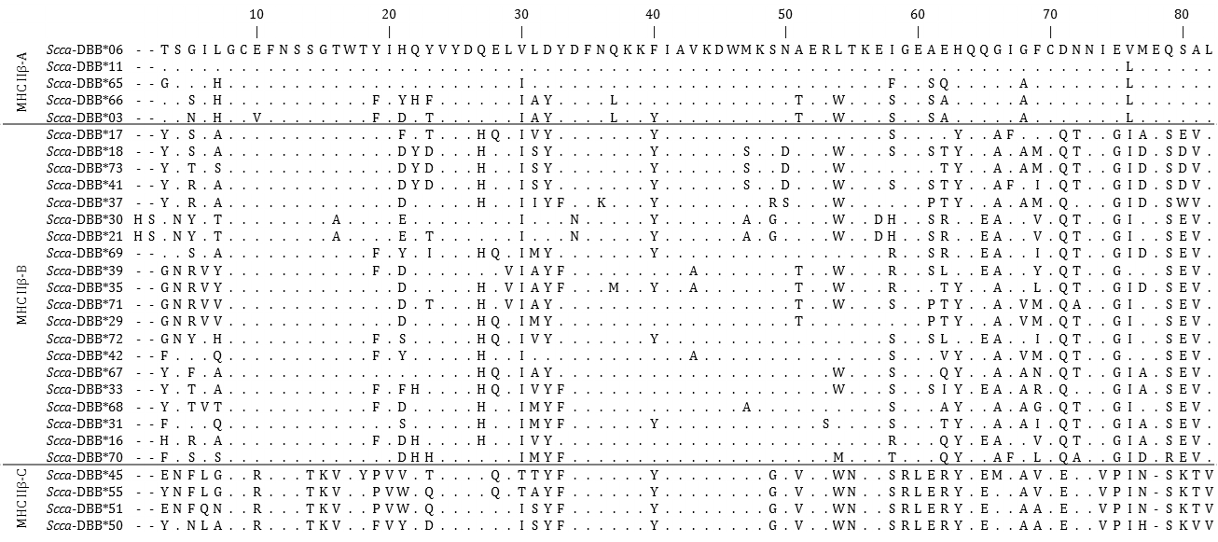
Figure S3: Amino acid sequences of MHC IIβ exon 2 alleles detected in this study.

Figure S4: Alignment of transcripts referring to loci representing MHC IIβ lineages A, B and C in Scyliorhinus canicula (from the gene annotation of the sScyCan1.1 genome assembly). Untranslanted regions in the 5´and 3´ends of the coding sequence are highlighted in dark grey and light grey, respectively. Dots refer to nucleotide agreements to the reference sequence on top; dashes refer to alignment gaps.
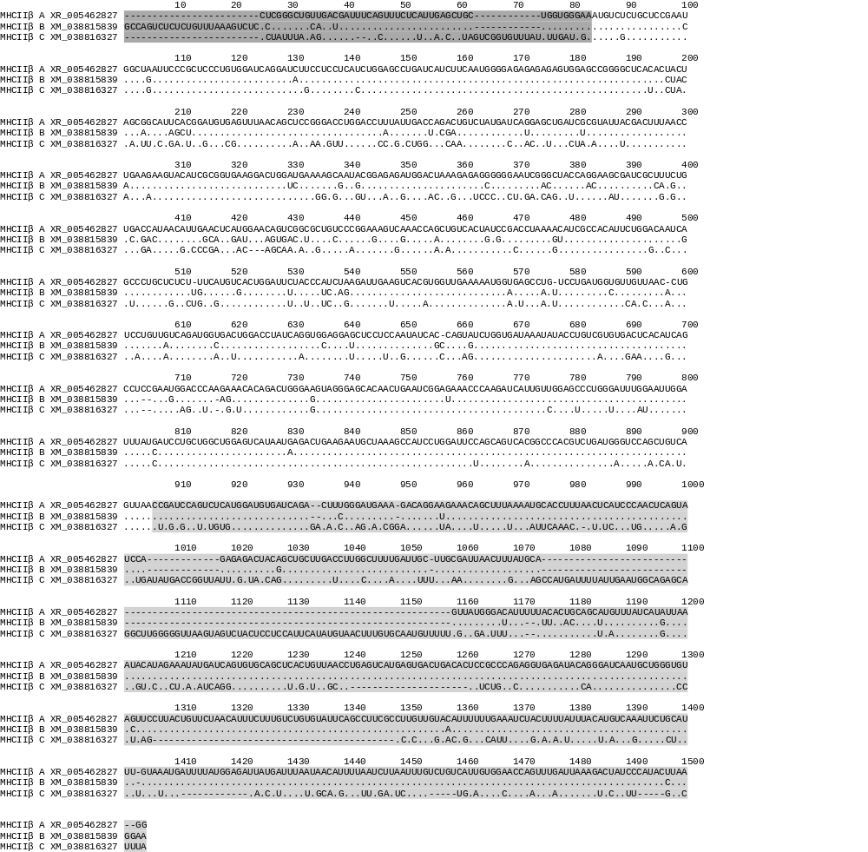

Figure S5: Comparison of the number of alleles per lineage per individual in a sample of 25 unrelated individuals of S. canicula from Gaigher et al. (2023). Number of alleles for a) lineages A and C, b) lineages B and C, and c) lineages A and B. Size of circles is proportional to number of individuals with the combination of allele numbers per lineage.

