Supplementary figures

Naïve adaptive immune receptor repertoires in celiac disease assessed by machine learning; Impact of the HLA-DQ2.5 allotype on the TCR repertoire

Aengus Officer, Ida Lindeman, Milena Pavlovic, Christin Lund-Andersen, Eivind Ness-Jensen, Geir Kjetil Sandve, Ludvig M. Sollid

##

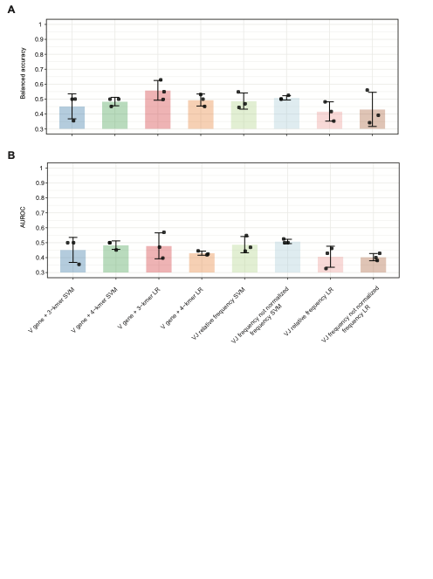
Supplementary figure 1. Diagnosis classification using BCR dataset 2b. (A) Balanced accuracy and (B) AUROC diagnosis classification performance using the raw subset of BCR dataset 2b for the three assessment test sets. VJ frequency-based models were either normalized to a relative frequency or measured as absolute counts. Individual datapoints represent the respective scores for each assessment split, bars represent the mean of the three splits ± one standard deviation.

A
Distribution of CeD individuals in TCR analysis (1) by HLA label
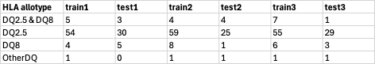

B
Distribution of HC individuals in TCR analysis (1) by HLA label
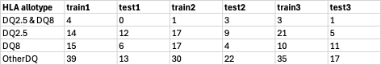

C
Distribution of individuals in TCR analysis (2) by diagnosis label
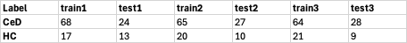

D
Distribution of CeD individuals in TCR analysis (3) by HLA label
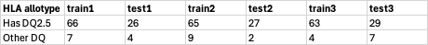

E
Distribution of HC individuals in TCR analysis (3) by HLA label
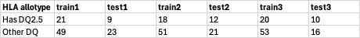

Supplementary figure 2. Distribution of individuals by primary label across TCR repertoire analyses. The numbers of individuals used in each of the three training and three test sets for each of the TCR analyses are shown.

