Optimization of methods for isolation and purification of outer membrane vesicles (OMVs) from Neisseria lactamica
Ronaldo Moraes Preto^{1,2}, Vithória Carolyna Trindade dos Santos^{1,2}, Marcos Vinicius Santos Lordelo^{1,2}, Getúlio Henrique Ferreira Pereira^{1,2}, Luciana Cezar de Cerqueira Leite¹, Viviane Maimoni Gonçalves¹, Giovana Cappio Barazzone^{1*}
¹Laboratório de Desenvolvimento de Vacinas, Instituto Butantan, São Paulo, Brazil; ²Programa de Pós-Graduação Interunidades em Biotecnologia, Universidade de São Paulo, São Paulo, Brazil

* Corresponding author
e-mail: giovana.barazzone@butantan.gov.br

Supplementary information: full uncropped Gels

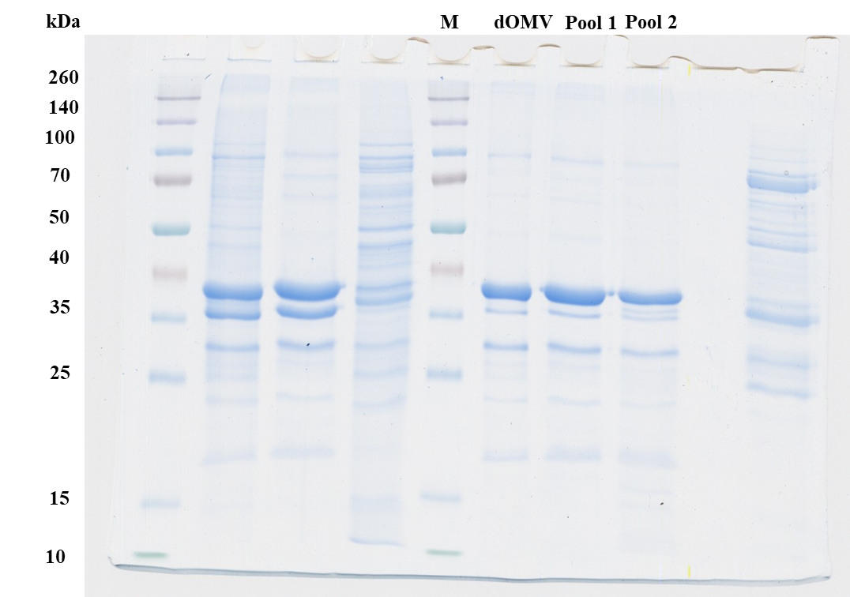
Figure 1A - SDS-PAGE of the eluted fractions (Gels 12%, 5 μg/lane). M: Spectra™ Multicolor Broad Range Protein Ladder.

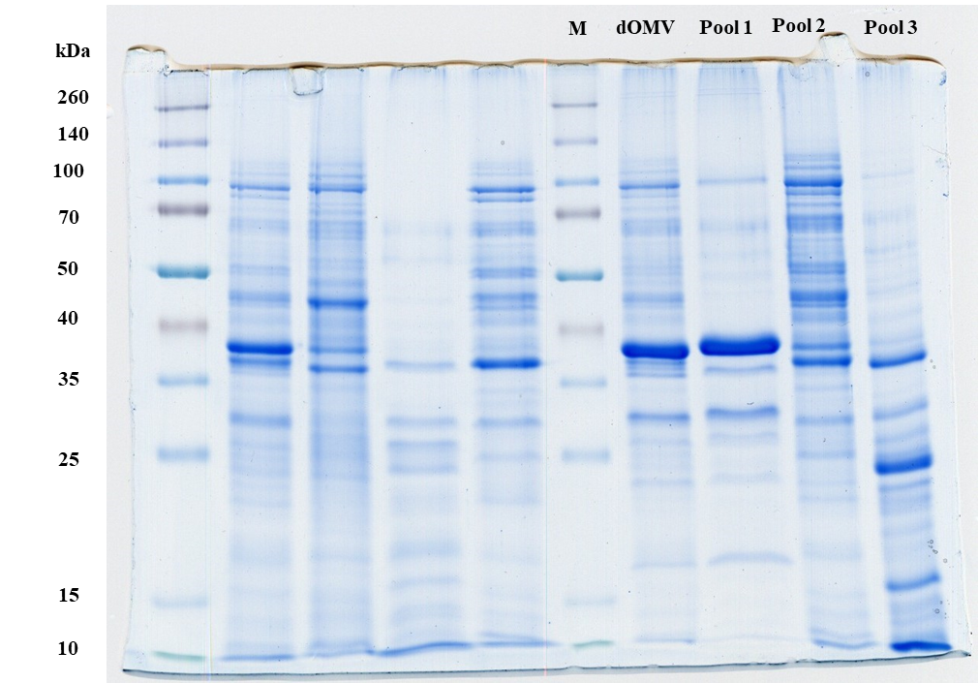
Figure 1B - SDS-PAGE of the eluted fractions (Gels 12%, 5 μg/lane). M: Spectra™ Multicolor Broad Range Protein Ladder.

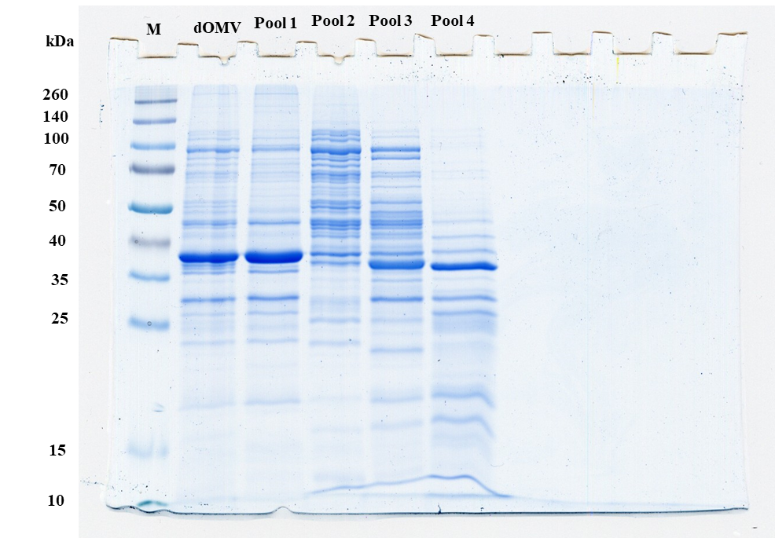
Figure 1C - SDS-PAGE of the eluted fractions (Gels 12%, 5 μg/lane). M: Spectra™ Multicolor Broad Range Protein Ladder.

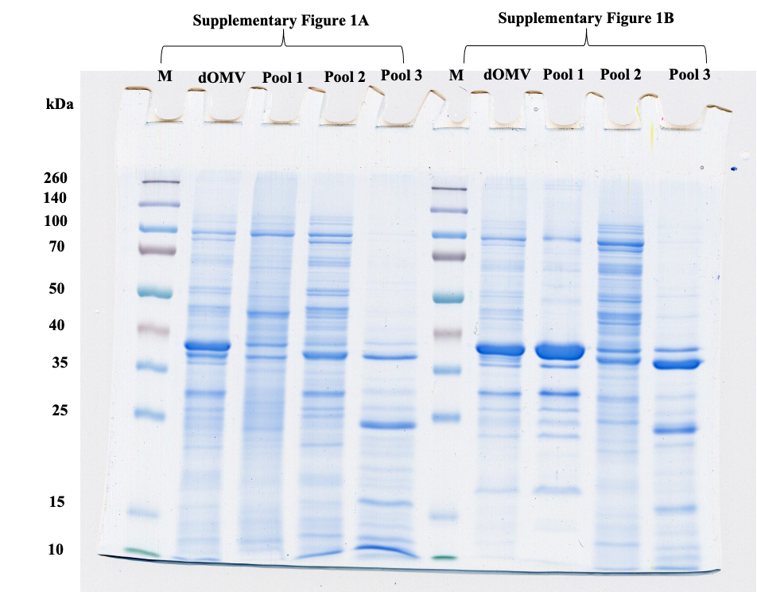
Supplementary Figures 1A and 1B - SDS-PAGE of the eluted fractions (Gels 12%, 5 μg/lane). M: Spectra™ Multicolor Broad Range Protein Ladder.

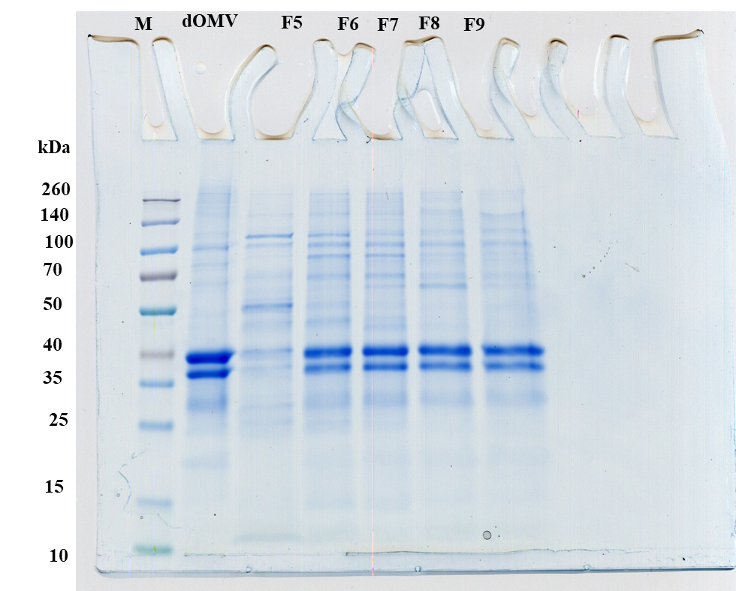
Figure 2B - SDS-PAGE (Gel 12%, 5μg/lane). M: Spectra™ Multicolor Broad Range Protein Ladder, dOMV: detoxified OMV. F5-F9: fractions of the elution.
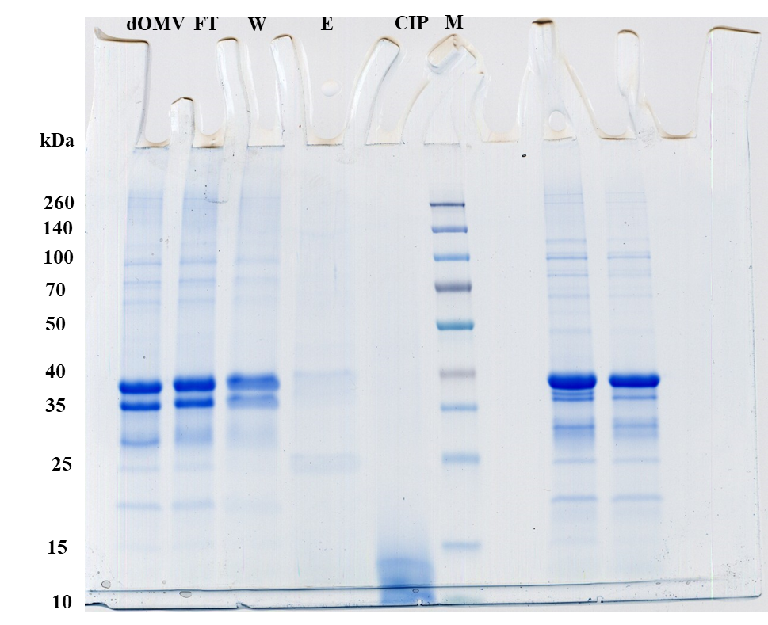
Figure 3A - SDS-PAGE (Gels 12%, 5μg/lane), M: Spectra™ Multicolor Broad Range Protein Ladder. FT: flow-through, W: washing, E: elution with 1 M NaCl and CIP: cleaning-in-place with 1 M NaOH and 20% isopropanol.

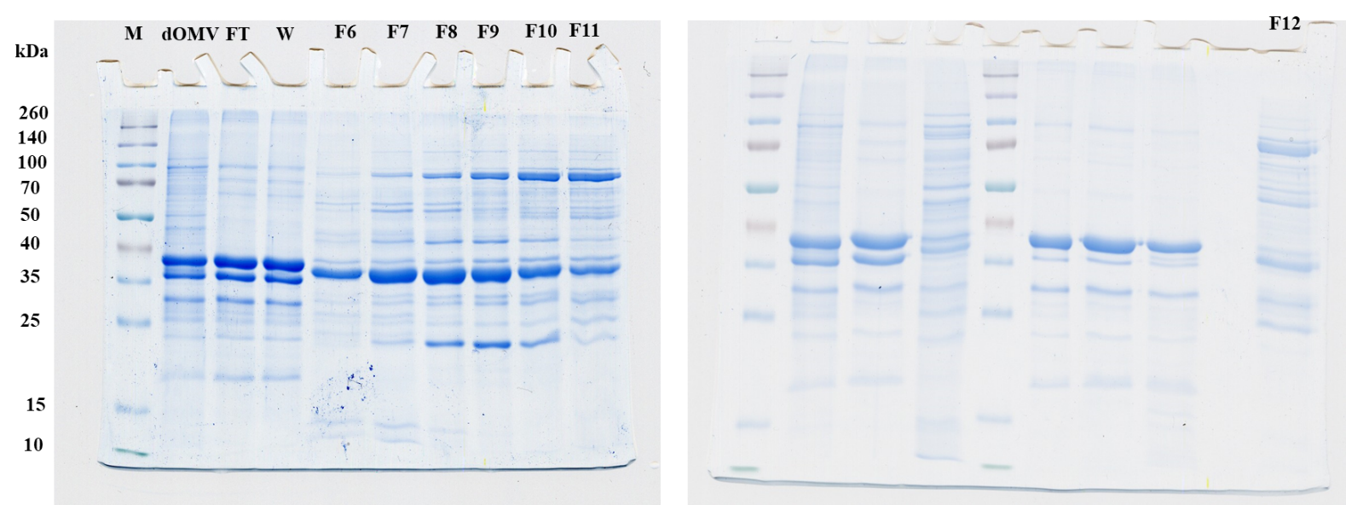
Figure 3 B - SDS-PAGE (Gels 12%, 5μg/lane), M: Spectra™ Multicolor Broad Range Protein Ladder. FT: flow-through, W: washing and F: collected fractions.

