Optimization of methods for isolation and purification of outer membrane vesicles (OMVs) from Neisseria lactamica.
Ronaldo Moraes Preto^{1,2}, Vithória Carolyna Trindade dos Santos^{1,2}, Marcos Vinicius Santos Lordelo^{1,2}, Getúlio Henrique Ferreira Pereira^{1,2}, Luciana Cezar de Cerqueira Leite¹, Viviane Maimoni Gonçalves¹, Giovana Cappio Barazzone¹
¹Laboratório de Desenvolvimento de Vacinas, Instituto Butantan, São Paulo, Brazil; ²Programa de Pós-Graduação Interunidades em Biotecnologia, Universidade de São Paulo, São Paulo, Brazil
* Corresponding author
e-mail: giovana.barazzone@butantan.gov.br

Supplementary information

Supplementary Table 1- Modified Catlin’s MC2LAA-YE Medium Composition
Reagent | Concentration (g/L)
Sodium chloride | 5.800
Ammonium chloride | 0.400
Potassium chloride | 0.186
Calcium chloride dihydrate | 0.037
Sodium citrate | 0.647
Magnesium sulfate heptahydrate | 0.616
Hydrated manganese sulphate | 0.001
L-glutamic acid | 2.360
L-arginine.HCl | 0.210
Glycine | 0.302
L-serine | 0.042
L-cysteine.HCl.H₂O | 0.022
Glycerol (mL / L) | 5.000
Sodium lactate (mL / L) | 15.020
Bibasic sodium phosphate | 1.062
Monobasic potassium phosphate | 0.171
Ultrafiltered yeast ext  ract | 2.000

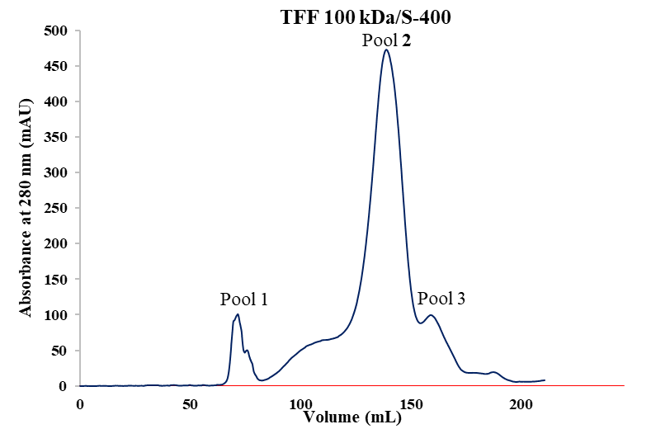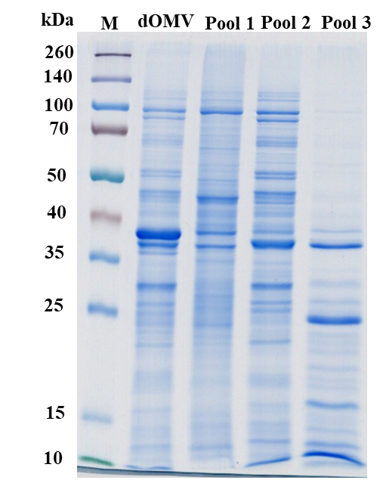
A

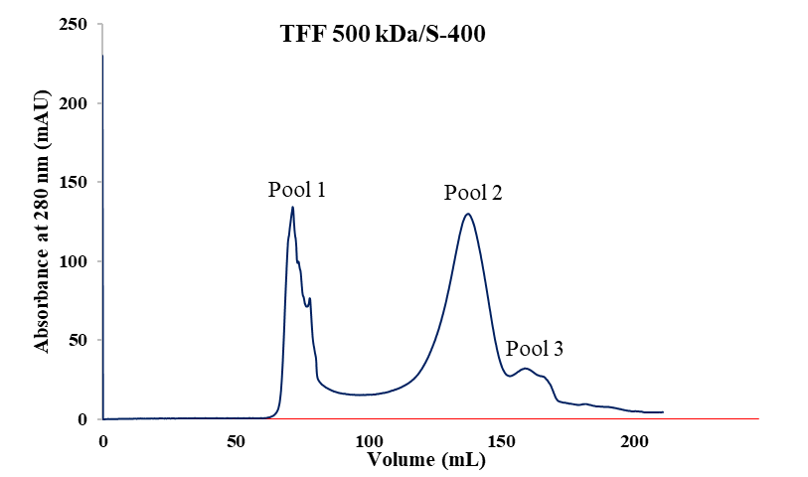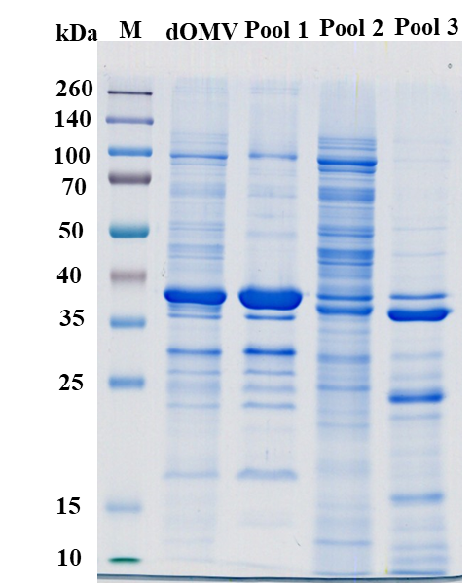Supplementary Figure 1- Purification of detoxified OMV (dOMV) isolated by TFF 100 kDa and TFF 500 kDa in Size-exclusion chromatography – A) SephacrylTM S-400 chromatogram of TFF 100 kDa (TFF 100 kDa/S-400). B) SephacrylTM S-400 chromatogram of TFF 500 kDa (TFF 500 kDa/S-400). Blue line: absorbance at 280 nm. In the right panel: SDS-PAGE (Gels 12%, 5μg/lane). M: Spectra™ Multicolor Broad Range Protein Ladder.
B

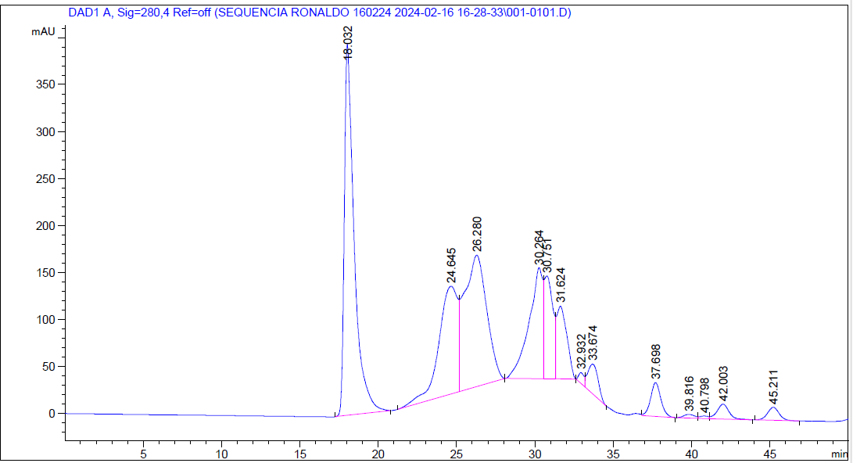
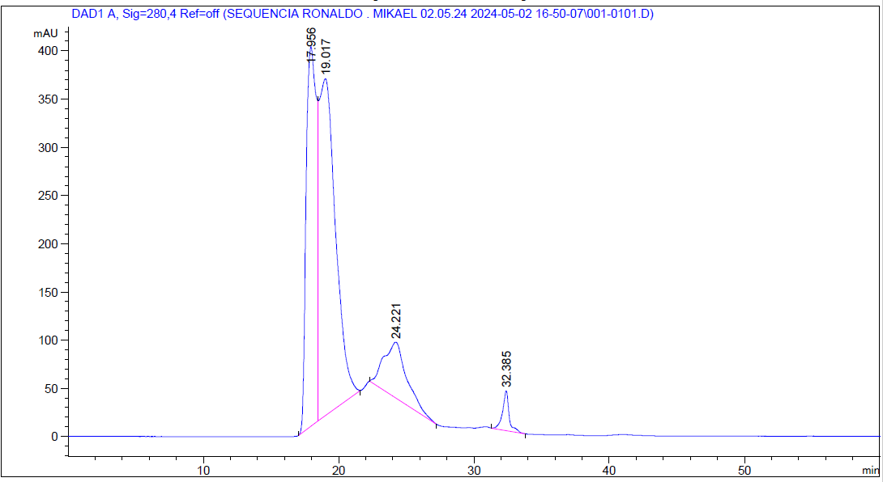
Supplementary Figure 2- HPLC evaluation of the purifications using TFF 300 kDa under different transmembrane pressures. A) TFF 300 kDa with transmembrane pressure of 20-25 psi B) TFF 300 kDa with transmembrane pressure of 10-15 psi.
A
B

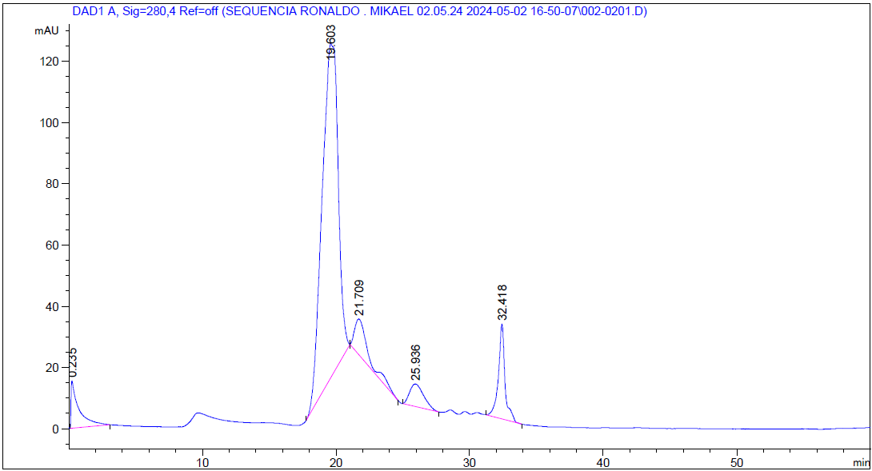
B
A
Supplementary Figure 3- HPLC evaluation of the purification using membrane chromatography in Sartobind® Q A) TFF 300 kDa (input sample) B) Fraction 08 from membrane chromatography in Sartobind® Q.

