Supporting Information to: “Application of a replicative targetable vector system for difficult-to-manipulate streptomycetes”

Table of Contents
Table S1. Plasmids used in this study 2
Table S2. Strains used in this study 2
Table S3. Oligonucleotides used in this study 3
Assessment of the pIJ101 replication region present in pIJ86 and pDS0007 4
Figure S1. Genetic map of pIJ86 5
Figure S2. Genetic map of pHZ1358 6
Figure S3. Genetic map of pIJ101 7
Figure S4. Pairwise alignment of pIJ86, pHZ1358, and pIJ101 8
Figure S5. Representation of the linearized molecules of pIJ86, pHZ1358, and pIJ101 9
Figure S6. Representation of the GAP4 alignment 10
Figure S7. Analysis of BamHI-free rep of pDS0007 11
Figure S8. Assessment of the rep region from pIJ86 sequence 12
Figure S9. Comparison of new and in-silico pIJ86 sequences 13
Figure S10. Alignment of the pIJ86 sequence reported in this study with JIC’s in-silico sequence 14
Figure S11. Study on segregational stability 16
Figure S12. Test of pDS0007 segregation stability 17
Figure S13. Comparative segregation stability test of pGM1190, and pDS0007 18
Figure S14. Segregation stability test of pDS0007 in S. coelicolor M512 19
Figure S15. Genetic map of pDS0201 20
Figure S16. Assessment of S. iranensis ΔpepM::neo candidate mutants by PCR 21
Figure S17. Extended PCR assessment of candidate mutants 22
References 24

Table S1. Plasmids used in this study
Name | Description | Source
pIJ86 | Escherichia coli-Streptomyces bifunctional expression vector, pIJ101 derived, apramycin resistance aac(3)IV, ermE*p promoter | John Innes Centre, Norwich, United Kingdom
pGM1190 | tipAp, tsr, aac(3)IV, rep, sso, dso | (Muth, 2018)
pGus21 | Cloning vector, aac(3)IV, ermE*p gusA, I-SceI-site | (Ladwig et al., 2015)
pTC192-km | Source of kanamycin resistance gene neo | University of Leon, Spain (Rodríguez-García et al., 2006)
pRM4 | aac(3)IV, ermE*p, attP_{phiC31}, int_{phiC31}, oriC_{pUC18}, oriT_{RP4} | (Menges et al., 2007)
pSET152 | aac(3)IV, attP_{phiC31}, int_{phiC31}, oriC_{pUC18}, oriT_{RP4} | (Bierman et al., 1992)
pBluescript II KS(+) | Cloning vector, bla, oriC_{pUC18}, lacZ’ | (Alting-Mees and Short, 1989)
pDS0007 | pIJ86 derivative with ermE*p gusA, I-SceI-site region from pGus21 | This work
pDS0201 | pGus21 derivative with homologous recombination cassette for pepM gene replacement | This work
pDS0202 | pDS0007 derivative with pDS0201 cassette | This work
pDS0204 | pRM4-derivative with ermE*p::pepM | This work

Table S2. Strains used in this study
Name | Description | Source
Escherichia coli DH5α | General cloning host  Δ(argF-lac)169 φ80dlacZ58(M15) ΔphoA8 glnX44(AS) λ⁻ deoR481 rfbC1 gyrA96(NalR) recA1 endA1 thiE1 hsdR17 | DSMZ; (Bethesda Research Laboratories, 1986; Grant et al., 1990)
Escherichia coli NEB 5-alpha | General cloning host  fhuA2Δ(argF-lacZ)U169 phoA glnV44 Φ80Δ(lacZ)M15 gyrA96 recA1 relA1 endA1 thi-1 hsdR17 | New England Biolabs, catalogue number C2987
Escherichia coli ET12567/pHZ8002 | Conjugation donor strain  F- dam-13::Tn9 dcm-6 hsdM hsdR zjj-202::Tn10 recF143 galK2 galT22 ara-14 lacY1 xyl-5 leuB6 thi-1 tonA31 rpsL136 hisG4 tsx-78 mtl-1 gln | John Innes Centre, Norwich, United Kingdom; (MacNeil et al., 1992; Paget et al., 1999)
Streptomyces coelicolor M145 | Prototrophic plasmid free derivative of S. coelicolor A3(2) strain | John Innes Centre, Norwich, United Kingdom; (Kieser et al., 2000)
Streptomyces coelicolor M512 | S. coelicolor M145 ΔactII-ORF4 ΔredD  Double deleted mutant derivative of S. coelicolor M145 | John Innes Centre, Norwich, United Kingdom; (Floriano and Bibb, 1996)
Streptomyces iranensis DSM 41954 | Type strain | DSMZ; (Hamedi et al., 2010)
Streptomyces iranensis YM1001 | DSM 41954 ΔpepM::neo | This work
Streptomyces iranensis YM1003 | DSM 41954 ΔpepM::neo attB_{phiC31}::pDS0204 | This work
Table S3. Oligonucleotides used in this study
Name | Sequence | Description
pIJ10257_Nde_1 | CGAGTGTCCGTTCGAGTG | Sequencing of ermE*p driven gene
pIJ10257_Hind_1 | GTGTTGCCCCAGCAATCAG | Sequencing of ermE*p driven gene
M13F - 24mer | CGCCAGGGTTTTCCCAGTCACGAC | Universal primer for sequencing of insert in many lacZ-containing vectors
M13R - 22mer | TCACACAGGAAACAGCTATGAC | Universal primer for sequencing of insert in many lacZ-containing vectors
AZ029 | CTGACCCGTGAAGGGATCTA | Cloning of homologous region downstream of pepM
AZ030 | CGTGGTACTCAACGGCATTA | Cloning of homologous region downstream of pepM
AZ031 | CTTAGAATTCGCCCTGCGCCTGATAGGAG | EcoRI site; cloning of homologous region upstream of pepM
AZ033 | GAATAAGCTTCGCCCAGACGGCTTGGAAC | HindIII site; cloning of homologous region upstream of pepM
AZ044 | AAGGCCGCTCAACAAGAC | PCR test for pepM complementation screening
AZ045 | GCGTAGATCACCATGGATACC | PCR test for pepM complementation screening
AZ066 | TGCTCGACGTTGTCACTG | PCR test for pepM mutant screening
AZ067 | AGCGGCGATACCGTAAAG | PCR test for pepM mutant screening
AZ072 | TCGGGAGGAGTACACCTTG | PCR test for pepM mutant screening and cloning of pepM for complementation
AZ073 | CGCCATGCAGAAGTTGTCG | PCR test for pepM mutant screening and cloning of pepM for complementation
AZ074 | TACGGCTGTCGGCATAGAAC | PCR test for pepM mutant screening
AZ075 | AACTCCGGTGCTTCTCGATG | PCR test for pepM mutant screening
AZ078 | GGAATCCATATGGCTCATGGCAAACGGGAACC | NdeI site; cloning of pepM for complementation
AZ079 | CCCAAGCTTCCCGCCATGCAGAAGTTGTC | HindIII site; cloning of pepM for complementation
AZ084 | GCTCGCCGAGCAAATCTTGG | PCR test for pepM mutant screening
AZ085 | CCCGAGCAAGATCGTGAGACTG | PCR test for pepM mutant screening
JP719 | GGAGCGAGTTAGTGCGAAGT | Sanger sequencing of pDS0007 rep region
JP720 | GTGAGCACCACCACTGTGTC | Sanger sequencing of pDS0007 rep region
JP721 | CTACCTGCGGCAGATGCT | Sanger sequencing of pDS0007 rep region
JP722 | CTCGCCAGCCGTCAAGAT | Sanger sequencing of pDS0007 rep region
JP723 | CGAACACCTTGGGAAAGAAA | Sanger sequencing of pDS0007 rep region
JP724 | AACTCCTCGGACGGATCG | Sanger sequencing of pDS0007 rep region
JP725 | CAGGACGACGACCAGGAC | Sanger sequencing of pDS0007 rep region
JP726 | AGCTCACTCAAAGGCGGTAA | Sanger sequencing of pDS0007 rep region
JP727 | GGCGGTGCTACAGAGTTCTT | Sanger sequencing of pDS0007 rep region
JP728 | ACGAGCAACGTTCCTGTCTC | Sanger sequencing of pDS0007 rep region
JP729 | GTCTCCAGCCGCTTGAAGT | Sanger sequencing of pDS0007 rep region
JP730 | AGTGAGCGCAACGCAATTA | Sanger sequencing of pDS0007 rep region
JP731 | CCAAGGTTGAGAAGCTGACC | Sanger sequencing of pDS0007 rep region

Assessment of the pIJ101 replication region present in pIJ86 and pDS0007
To identify the actual replication functions from pIJ101 present in pIJ86 we performed a comparative analysis of the available nucleotide sequences. While the sequence and functional annotation of pIJ101 has been available since 1988 (Kendall and Cohen, 1988), the best studied sequence is that of the pIJ101-derived vector pHZ1358 (Sun et al., 2009) (GenBank AY667410). The published sequence for pIJ101 (GenBank M21778; Figure S1) starts within the replication protein encoding gene rep, making it more difficult to obtain and study an alignment of the linear sequences. The sequence was rotated to start at the single NcoI site, so that position 5759 becomes the new position 1.

The sequence for pIJ86 (map in Figure S1) obtained from JIC StrepStrains (jic.strepstrains@jic.ac.uk, John Innes Centre, Norwich Research Park, Norwich, NR4 7UH, United Kingdom) contains the replication protein encoding gene rep in opposite orientation to the pIJ101 and pHZ1358 sequence. Thus, the reverse-complementary sequence was analyzed.

The linearized sequences of pIJ101, pHZ1358, and pIJ86 were aligned in pairs with Clone Manager 11, for local alignment (regions of local similarity) with the Needleman-Wunsch algorithm for most optimal alignment, with parameters Match score=1, Mismatch penalty=5, Gap penalty=5 (both changed from the default value of 1, to avoid extension of matching region beyond the high similarity sequence). The results revealed both, a deletion in pHZ1358 (as reported in (Sun et al., 2009)) and that pIJ86 carries a smaller region from the pIJ101 replication region, which does not include the sti locus (Figures S4 and S5).

pDS0007 was sequenced with primers JP719, JP720, JP721, JP722, JP723, JP724, JP725, JP726, JP727, JP728, JP729, JP730, JP731, M13rev, pIJ10257_Nde1, pIJ10257_Hind1 (Table S1). Reads from successful sequencing reactions were automatically assembled with GAP4 of Staden Package (Staden et al., 1999; Bonfield and Whitwham, 2010) with default parameters. Afterwards, the in-silico compiled sequence for pDS0007 (linearized at the restored HindIII site) was added as reference and the all Sanger reads could be matched to the in-silico sequence. Then, linearized sequences of pIJ101 (at position 7209) and pHZ1358 (at position 4336), and pIJ86 (at the unique HindIII site) were added and manually aligned to identify the regions of each vector as present in pHZ1358 and pIJ101. Figure S6 shows the arrangement of all Sanger reads and vector sequences.

pIJ86
5788 bps
1000
2000
3000
4000
5000
XbaI 265
Acc65I 292
KpnI 292
BamHI 562
XbaI 568
SphI 582
HindIII 588
BglII 600
NcoI 1669
BbsI 1723
FspI 2052
XhoI 2537
EcoRV 2934
MluI 4711
XhoI 4724
NruI 5296
oriT RK2
ermE*p*
ori pIJ101
pIJ101 rep
pUC18
ColE1 origin
aac(3)IV
Figure S1. Genetic map of pIJ86
Genetic map of pIJ86 based on the in-silico sequence provided by JIC StrepStrains. Note the BamHI site located inside the gene rep encoding the replication protein in pIJ101 (Fig. S1) does not exist in pIJ86, making the BamHI site at position 562 a unique site for cloning.

Figure S2. Genetic map of pHZ1358
pHZ1358_AY667410
10848 bps
2000
4000
6000
8000
10000
SpeI 4299
XhoI 5234
BamHI 10848
T7
bla
ColE1
repeat_region
neo
pIJ101_sti
pIJ101_rep
tsr
repeat_region
traJ
bacteriophage lambda COS site
T3
Genetic map of pHZ1358 based on the published sequence GenBank AY667410. Note the BamHI site located inside the gene rep encoding the replication protein in pIJ101 (Fig. S3) does not exist in pHZ1358, making the BamHI site at position 10848 a unique site for cloning.
pIJ101_M21778
8830 bps
2000
4000
6000
8000
BamHI 1
XhoI 42
FspI 527
NcoI 910
NcoI 2038
FspI 2495
NcoI 2693
NcoI 3550
FspI 3891
NcoI 4454
NcoI 4598
NcoI 5759
FspI 7237
SpeI 7243
unknown
kilB
unknown
spdB
spdA
unknown
tra
korA
korA
unknown
unknown
rep
Figure S3. Genetic map of pIJ101
Genetic map of pIJ101 based on the published sequence GenBank M21778. Note the BamHI site at position 1 (highlighted in red) is located inside the gene rep, encoding the replication protein, and the NcoI site at position 5759 (highlighted in green) used for rotation and linearization previous the analyses of similarity.

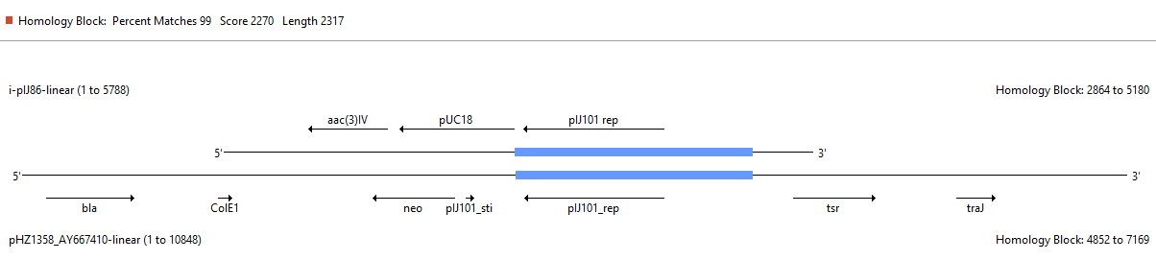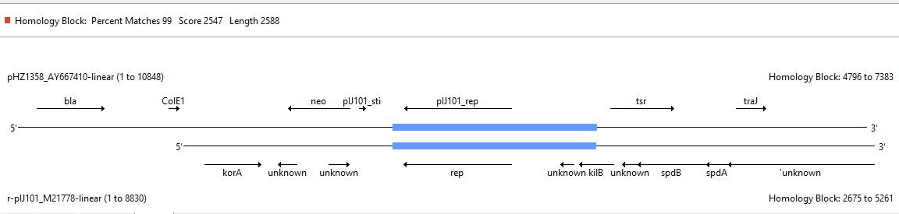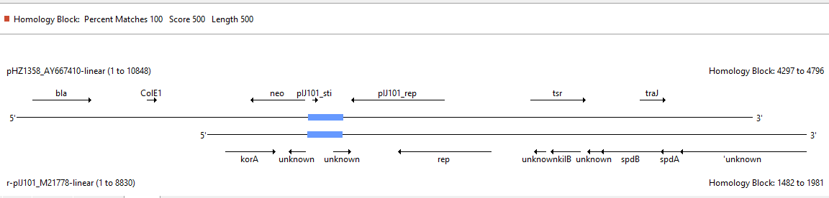
Figure S4. Pairwise alignment of pIJ86, pHZ1358, and pIJ101
Screenshots from the Clone Manager pairwise alignment analysis showing the regions of high similarity. The coloured frame relates to the colour used in Fig. S5 to represent the regions of similarity. This analysis focuses on the regions originating on pIJ101 present in the other two vectors. There are more regions of similarity between pIJ86 and pHZ1358, which are not shown because they are not relevant to this analysis since they originate from functions needed for replication in E. coli (pUC18 ori) or conjugation (RK2 conjugation origin).
Figure S5. Representation of the linearized molecules of pIJ86, pHZ1358, and pIJ101
pHZ1358
(10848 bps)
2000
4000
6000
8000
10000
BamHI 1
SpeI 4300
XhoI 5235
'T3
T7
bla
ColE1
repeat
neo
pIJ101_sti
pIJ101_rep
tsr
repeat
traJ
COS
T3'
pIJ86
(5788 bps)
1000
2000
3000
4000
5000
XhoI 1060
EcoRV 2850
XhoI 3247
FspI 3732
BglII 5184
HindIII 5196
SphI 5202
XbaI 5216
BamHI 5222
KpnI 5492
XbaI 5519
aac(3)IV
pUC18-ori
pIJ101 rep
ori pIJ101
ermE*p*
oriT RK2
2000
4000
6000
8000
BglII 397
SpeI 1485
BamHI 3073
XhoI 3114
unknown'
tra
kiorA
unknown
unknown
rep
unknown
kilB
unknown
spdB
spdA
'unknown
pIJ101
(8830 bps)
Representation of the linearized molecules of pIJ86, pHZ1358, and pIJ101 as used for the similarity analysis, highlighting the stretches of molecule of high similarity indicating the sequence from pIJ101 present in pHZ1358 and pIJ86 (100% identity or nearly; regions boxed with same colour; note that the segments span the same length, but the scale of each DNA molecule is different).

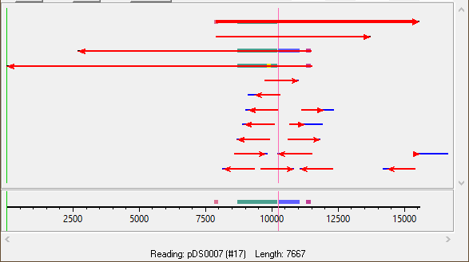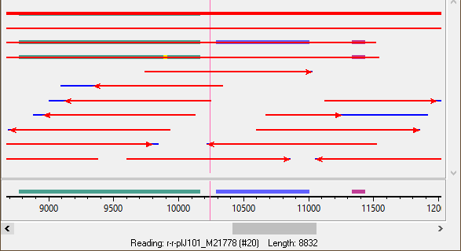
Figure S6. Representation of the GAP4 alignment
Representation of the GAP4 alignment (full view on top, zoomed-in at pIJ101-rep at the bottom) of vector sequences pDS0007 (top, thicker line), pIJ86 (second from top, as linearized at HindIII site), pIJ101 (third from top, M21778 linearized at position 7209), pHZ1358 (AY667410 linearized at position 4336) and Sanger reads (bottom short arrows). The gene rep encoding pIJ101 replication protein is marked in green. The replication region of pIJ101 present in pDS0007 (and therefore also in pIJ86) ends at position 2338 (red vertical line), therefore missing the sti region (purple block at the top right of both pIJ101 and pHZ1358 lines). The blue block on the pHZ1358 line represents the 694 bp deletion previously reported (Sun et al., 2009). The yellow block on pIJ101 rep gene represents the BamHI site missing in pH1358, pIJ86, and pDS0007.
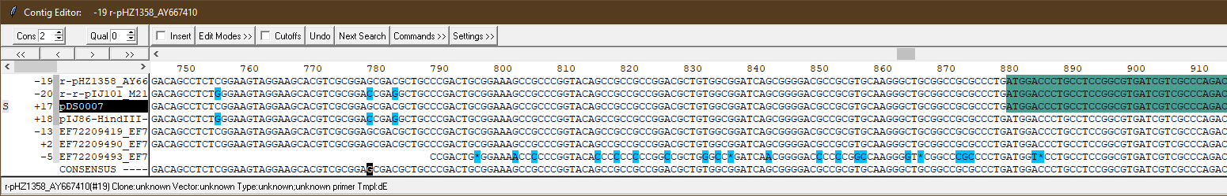
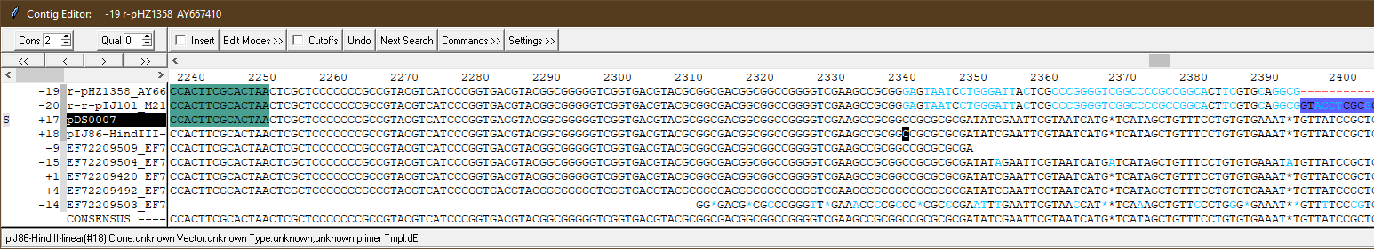
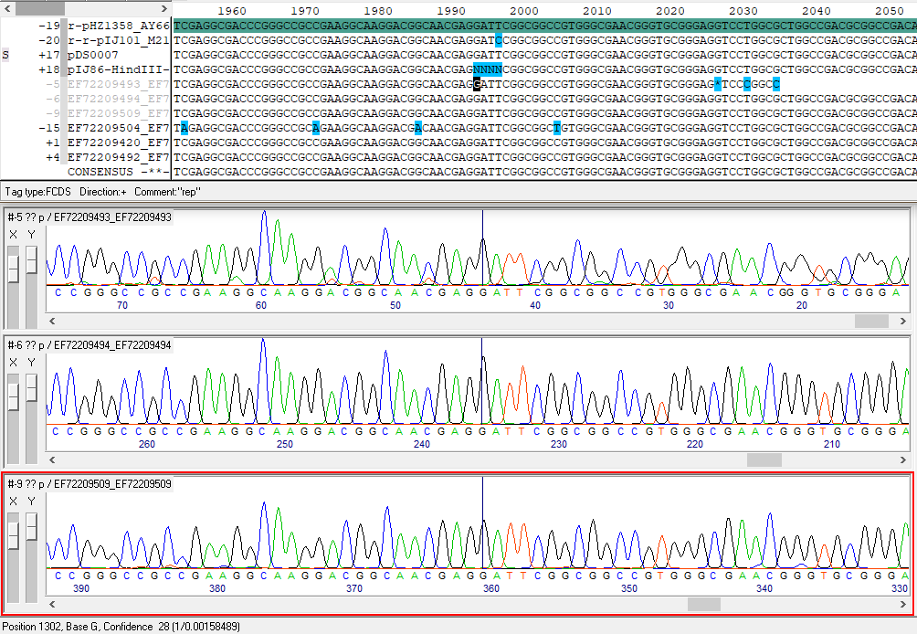
Figure S7. Analysis of BamHI-free rep of pDS0007
Nucleotide alignment of assembled Sanger reads and vector sequences. The numbering of nucleotides assumes the start of pDS0007 as position 1). Top, start of rep (green shading) and the three single nucleotide differences (positions 754, 778, and 782) between the published pIJ101 sequence, matching the in-silico pIJ86, and published pHZ138 that matches the de-novo sequence of pDS0007. Middle, end of rep and of the pIJ101 replication region present in pDS0007 (and pIJ86). Bottom, the BamHI site present in pIJ101 but missing in all others is confirmed by electropherograms.
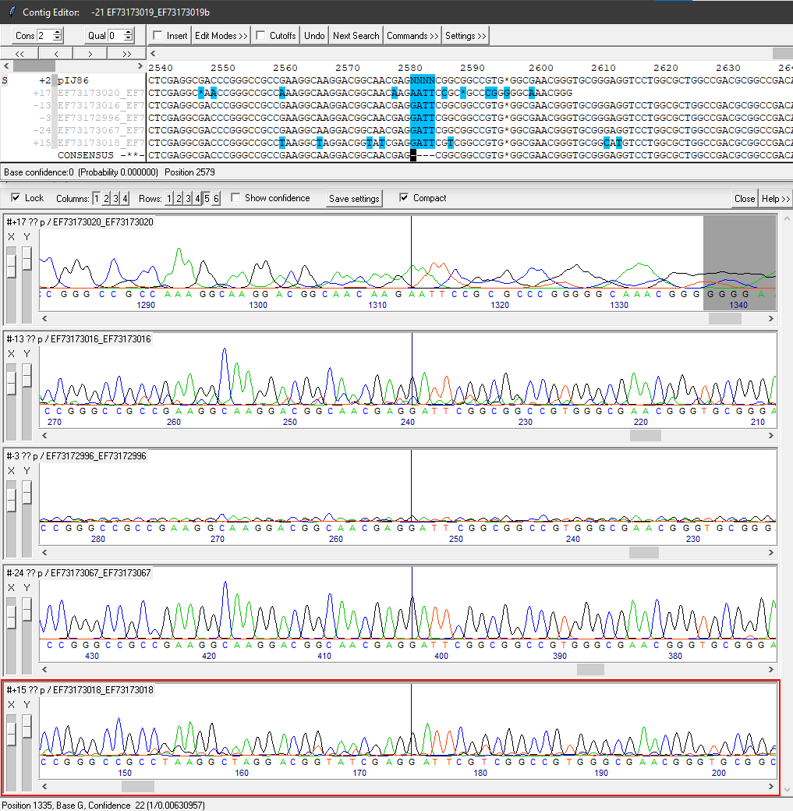
Figure S8. Assessment of the rep region from pIJ86 sequence
pIJ101 rep contains a BamHI site that is not present in pHZ1358 or pIJ86, but the sequence in the last case was not known. Here, it is confirmed that pIJ86 sequence is the same as pHZ1358, the previously observed mutation inside pIJ101 rep 2582C>T that results in the loss of the BamHI site (GGATCC>GGATTC)is confirmed in the original pIJ86 vector, as it was found during the assessment of pDS0007 (Figure S7)

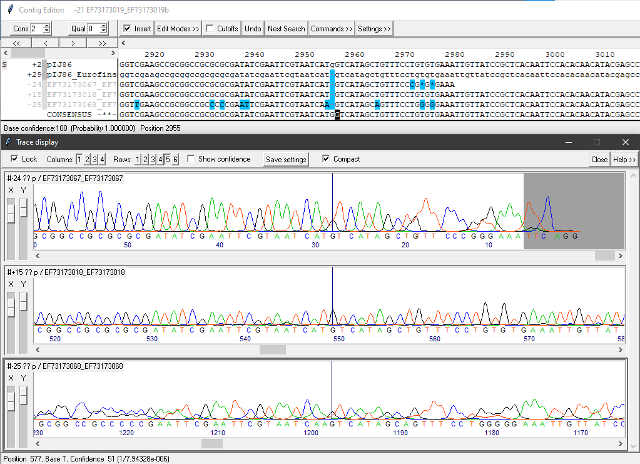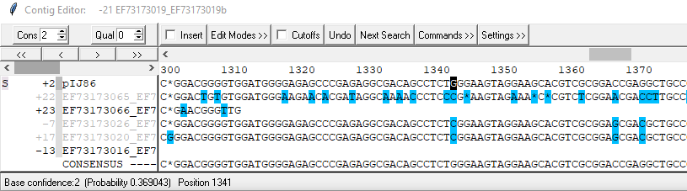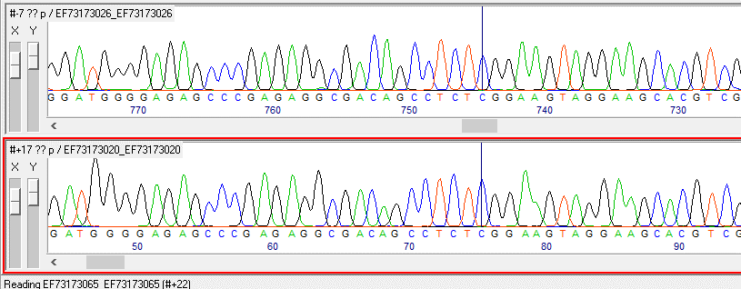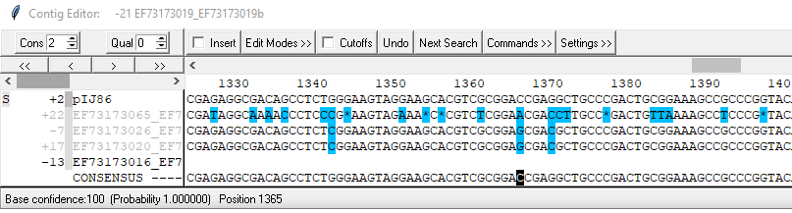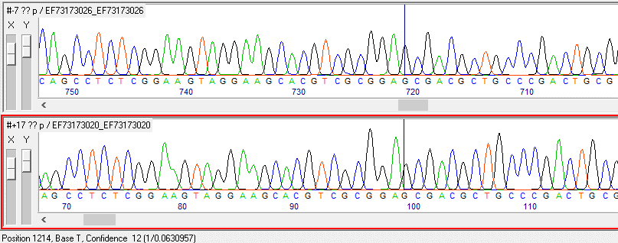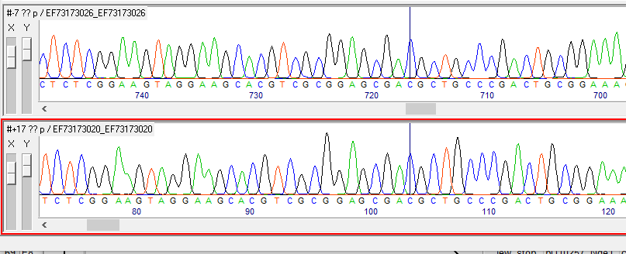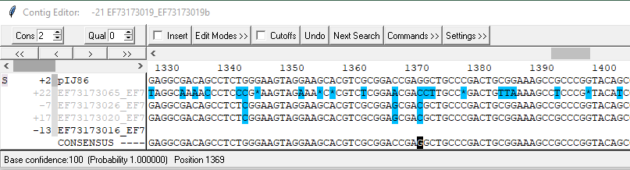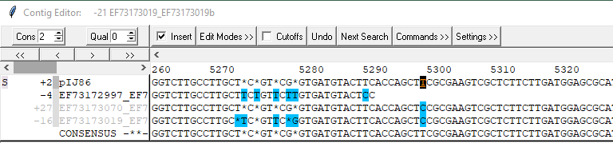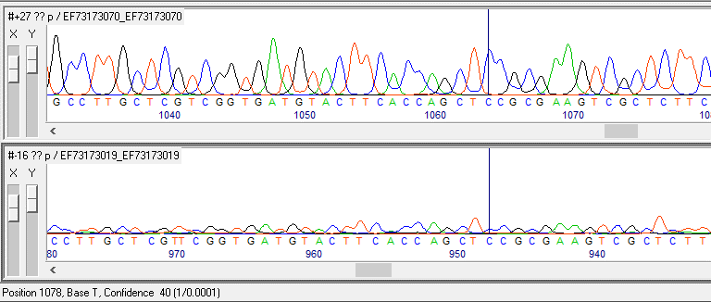
Figure S9. Comparison of new and in-silico pIJ86 sequences
Alignment of Sanger sequencing electropherograms showing the differences found between the pIJ86 sequence reported here and the original in-silico pIJ86 sequence provided by JIC StrepStrains:
1341G>C; 1365C>G; 1369G>C; 2579N>G; 2580N>A; 2581N>T; 2582N>T; 5296T>C
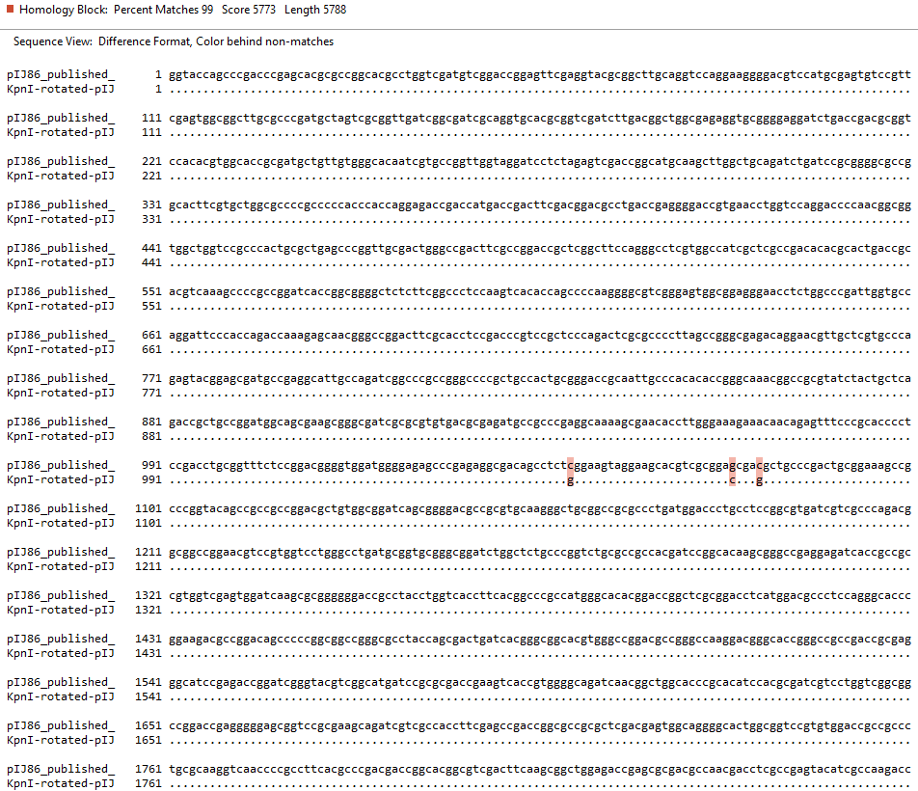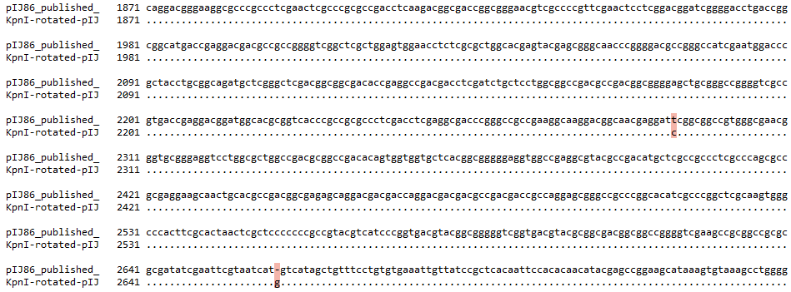
Figure S10. Alignment of the pIJ86 sequence reported in this study with JIC’s in-silico sequence
Alignment of the published pIJ86 sequence (GenBank accession PQ361717) and the original in-silico sequence from JIC StrepStrains after rotation to match the start position with the KpnI site (continues on next page).
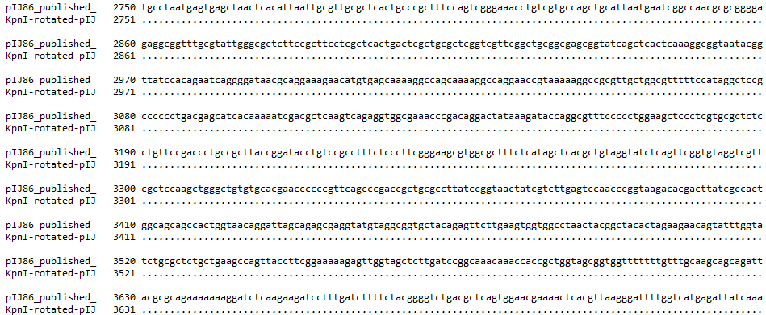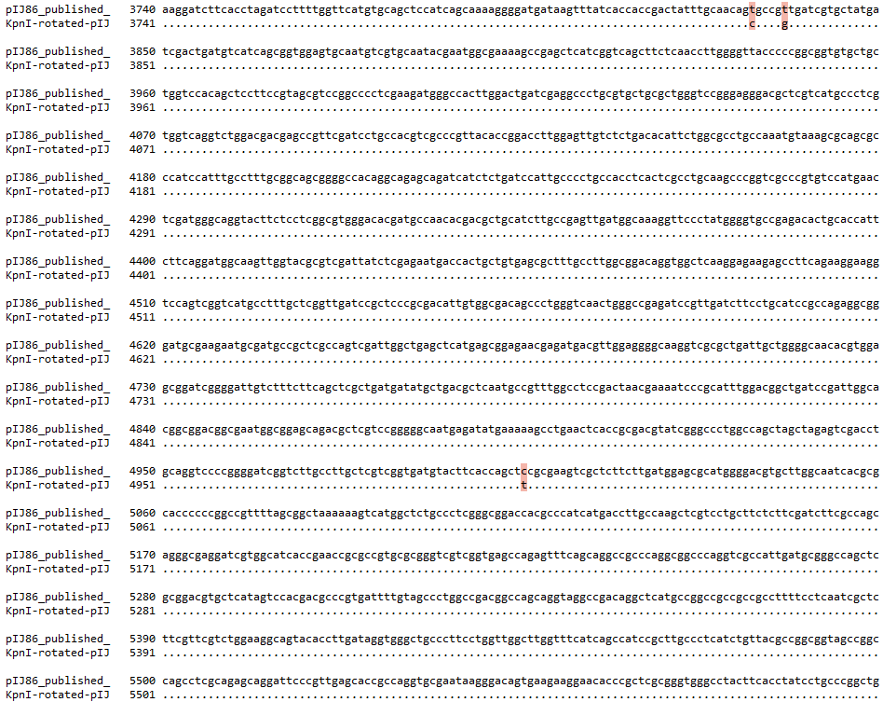

SFM/Apra plate with replicated exconjugants
SFM/Apra plate with one exconjugant (selection to maintain vector) (SP+)
SFM no-antibiotic plate with one exconjugant (no selection pressure to maintain vector) (SP-)
Spore stock with selection for vector (SP+)
Spore stock without selection for vector (SP-)
SFM/Apra
(Test Plate TP+)
SFM no-antibiotic (Test Plate TP-)
Expected a much lower number of colonies than without Apra, since lack of selection for vector maintenance would have allowed its loss during development.
SFM no-antibiotic (Test Plate TP-)
Expected a similar number of colonies as without Apra, since maintenance of the vector was selected during development.
SFM/Apra
(Test Plate TP+)

Figure S11. Study on segregational stability
Schematic representation of the study on segregational stability of pGM1190 and pDS0007. The same volume of spore stock dilution was plated on SFM with or without apramycin (Apra). The ratio given is the percentage of colonies on plates with apramycin with respect to the number of colonies appeared without apramycin, i.e. the percentage of colonies that have maintained the plasmid after one sporulation round with or without antibiotic selection. SP, Sporulation Plate; TP, Test Plate; +, supplemented with apramycin; -, without apramycin supplementation.
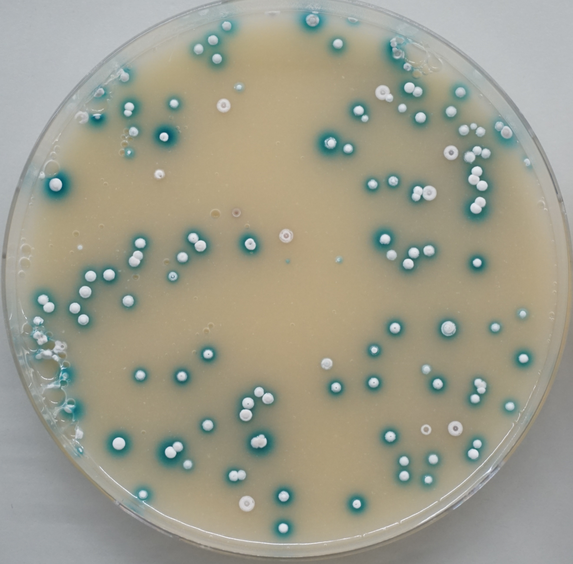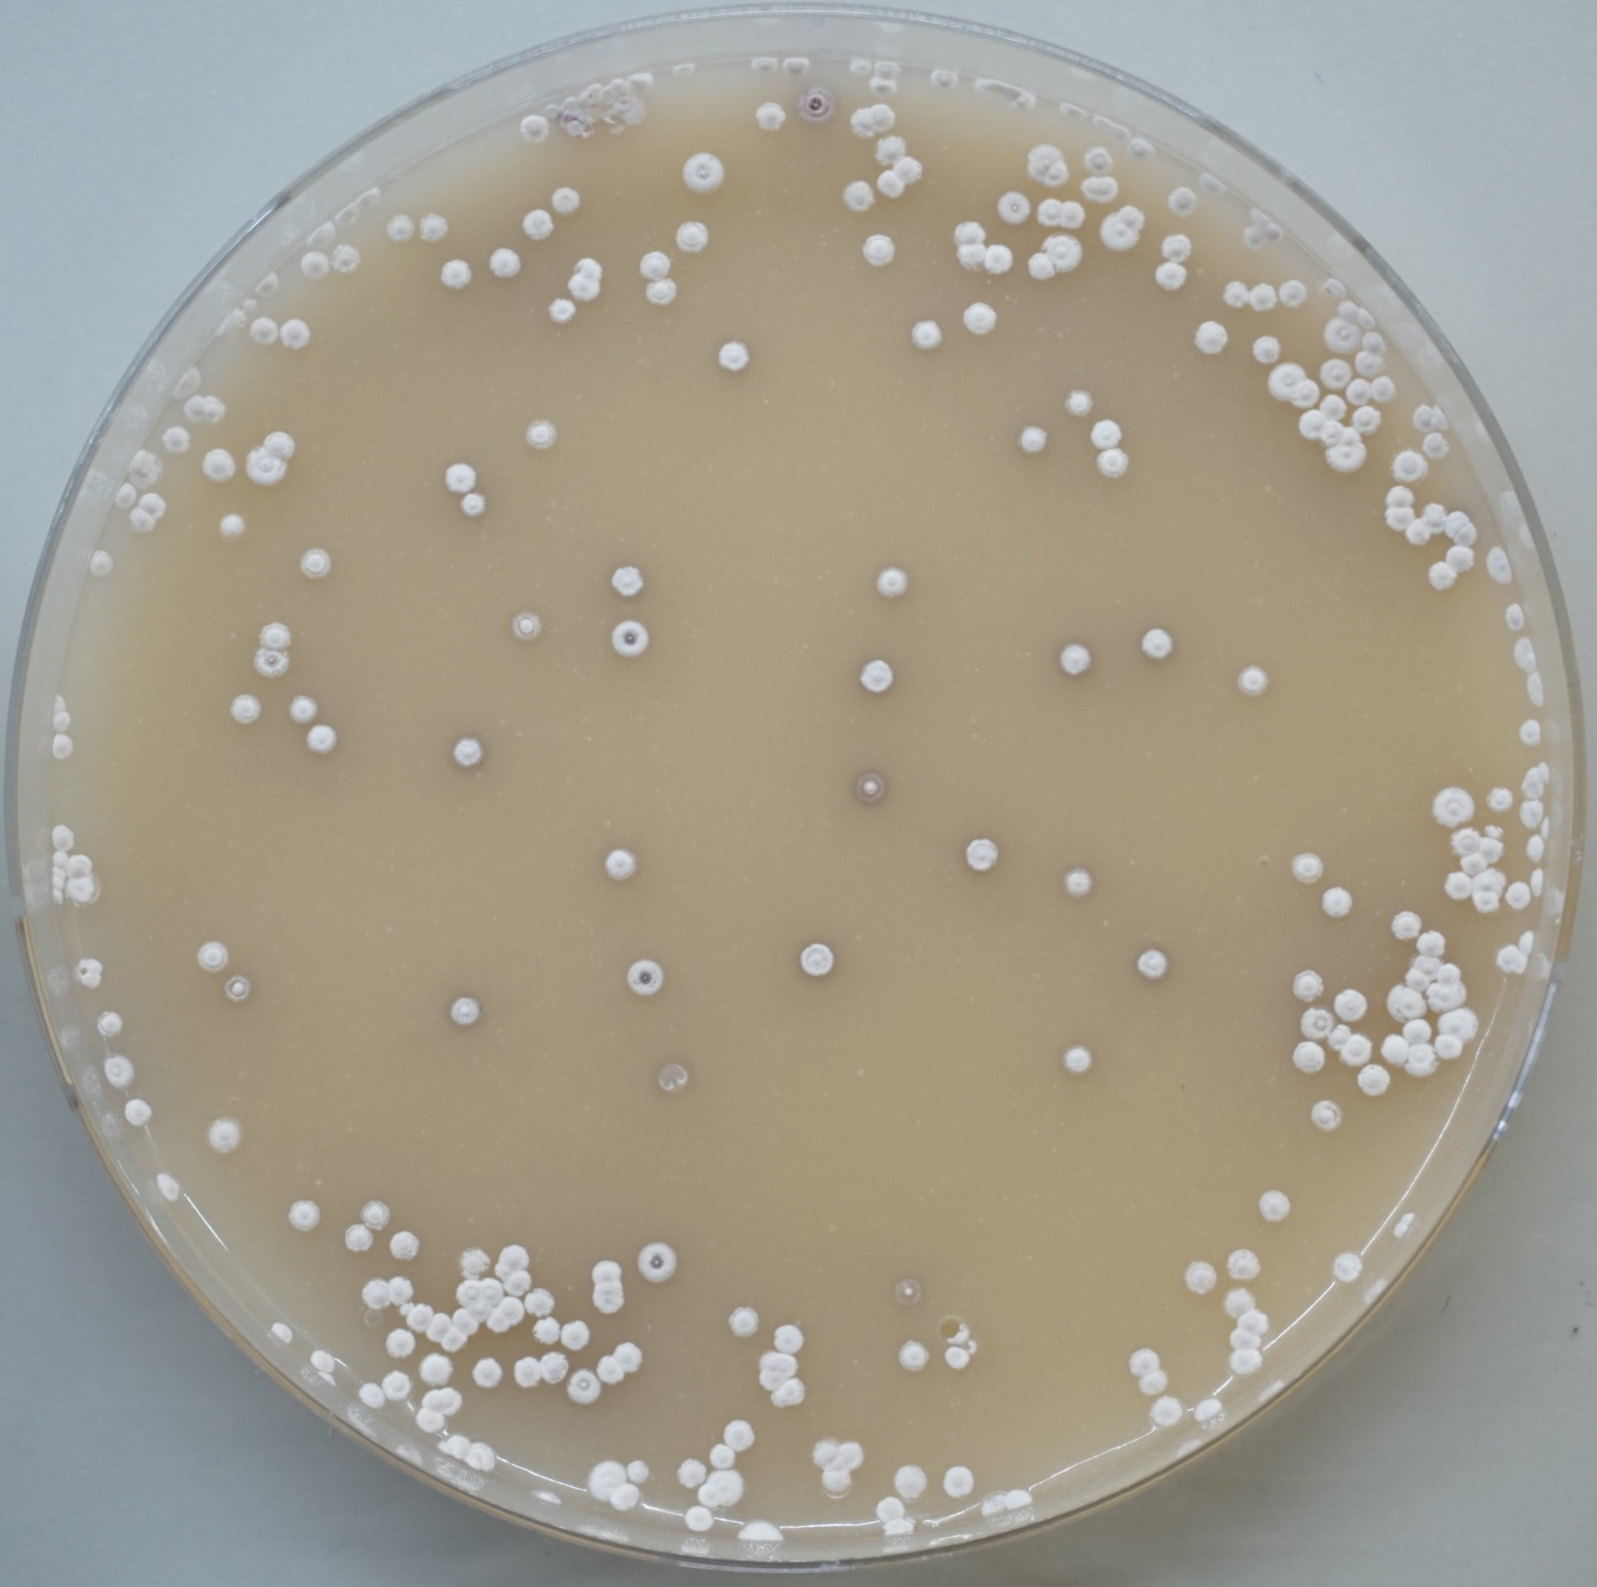
Figure S12. Test of pDS0007 segregation stability
SFM plates supplemented with X-Gluc were inoculated with spores of S. coelicolor M145 with pDS0007 obtained from SFM supplemented with apramycin (selection for pDS0007 maintenance, left plate) or without selection (right plate). Most of the colonies (92%) from spores obtained with antibiotic selection show β-glucuronidase activity (blue pigment) indicative of the presence of the vector, while none of the colonies from the spores obtained without antibiotic pressure show any β-glucuronidase activity. This shows that the vector is completely lost without antibiotic selection, and it is lost at low frequency (8%) even with antibiotic selection. Note that the slight purple diffusible pigment observed on the right plate originates from actinorhodin production and not from X-Gluc enzymatic reaction.

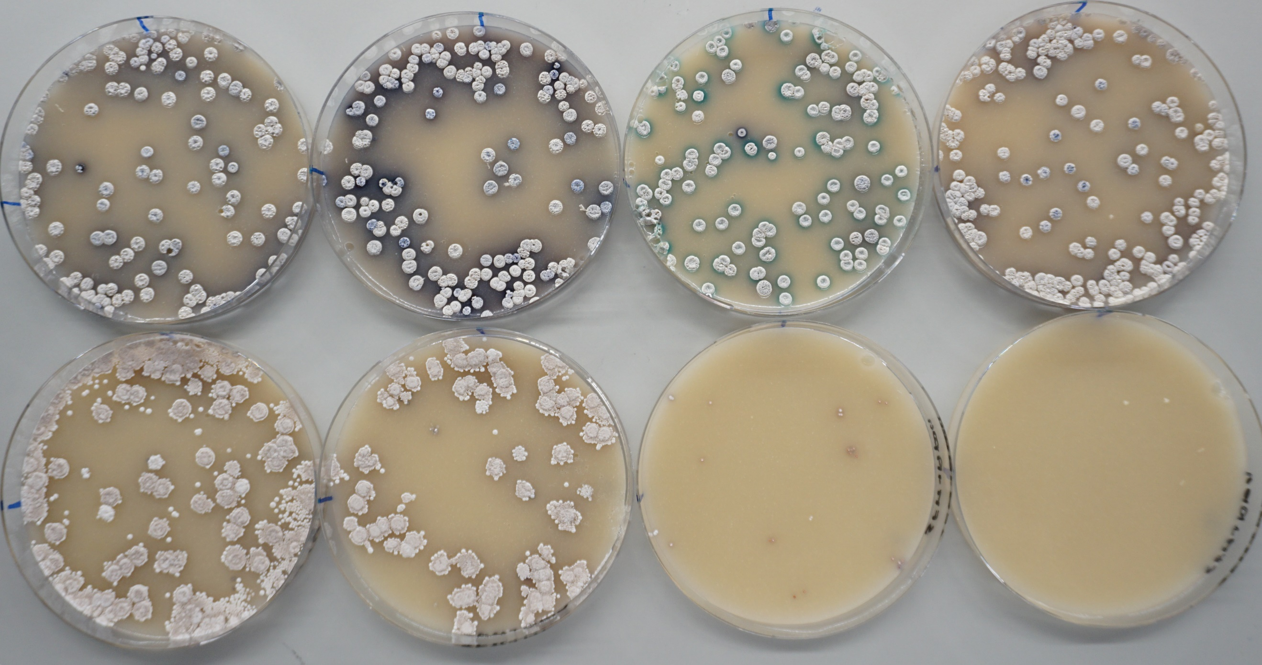
A2
B2
C2
D2
C1
D1
B1
A1
Figure S13. Comparative segregation stability test of pGM1190, and pDS0007
Comparative segregation stability test of pGM1190 (A and B) and pDS0007 (C and D) in S. coelicolor M145.
Top row (plates numbered with 1) are SFM plates without antibiotic (supplemented with X-Gluc in C1 and D1). Bottom row (plates numbered with 2) are SFM plates supplemented with apramycin to which the colonies of the top plates were replica-plated.
A1, spores of S. coelicolor M145 carrying pGM1190 obtained under selection with apramycin (SP+ in Figure S11, selection for plasmid maintenance)
B1, spores of S. coelicolor M145 carrying pGM1190 obtained without selection with apramycin (SP- in Figure S11)
C1, spores of S. coelicolor M145 carrying pDS0007 obtained under selection with apramycin (SP+ in Figure S11, selection for plasmid maintenance)
D1, spores of S. coelicolor M145 carrying pDS0007 obtained without selection with apramycin (SP- in Figure S11)
C1 and D1 plates are the same as shown in Figure S12 but three days older.

Most of the colonies with pGM1190 vector grew upon selection with apramycin, indicating that pGM1190 is a very stable vector even without selection. However, colonies with pDS0007 showed only some minor growth and from few colonies upon replica-plating with antibiotic selection, even when the original spore stock had been obtained with antibiotic selection, what indicates that pDS0007 is readily lost even during the growth and sporulation occurred on the top plates (C1 and D1) before replica-plating to the bottom plates (C2 and D2). Note that the purple diffusible pigment observed on top plates, mostly A1 and B1, originates from actinorhodin production and not from X-Gluc enzymatic transformation (seen on top plate C1)
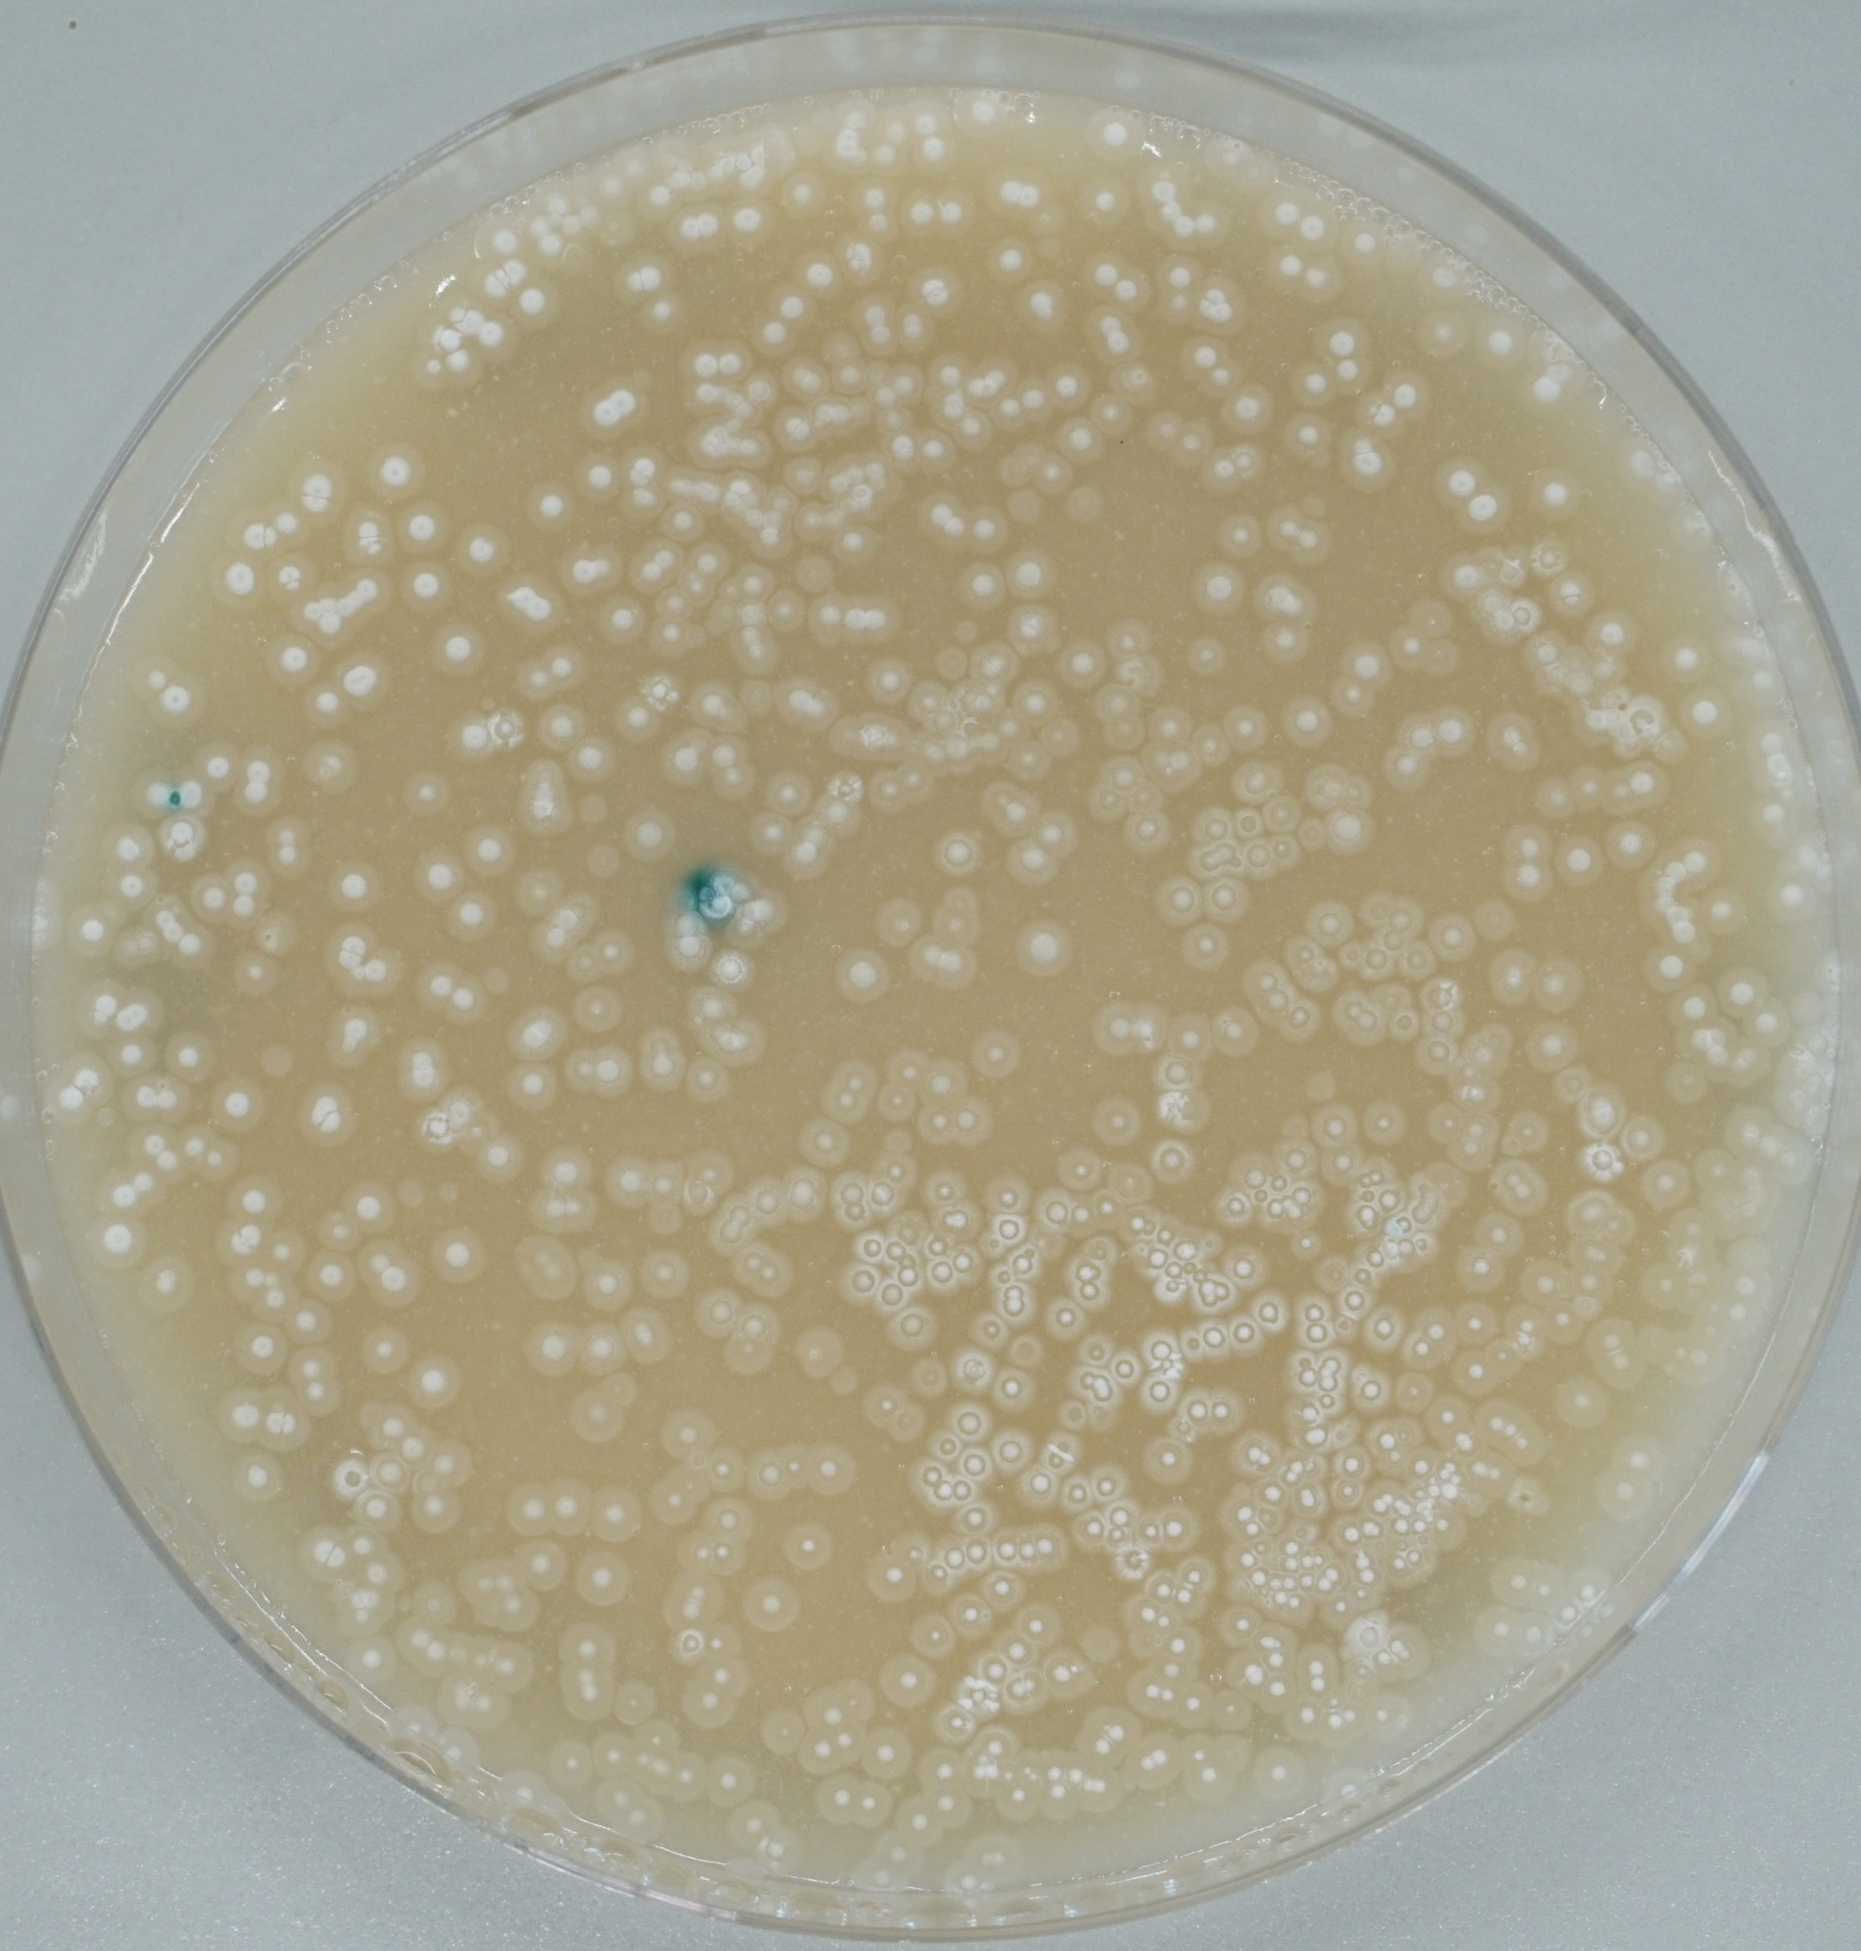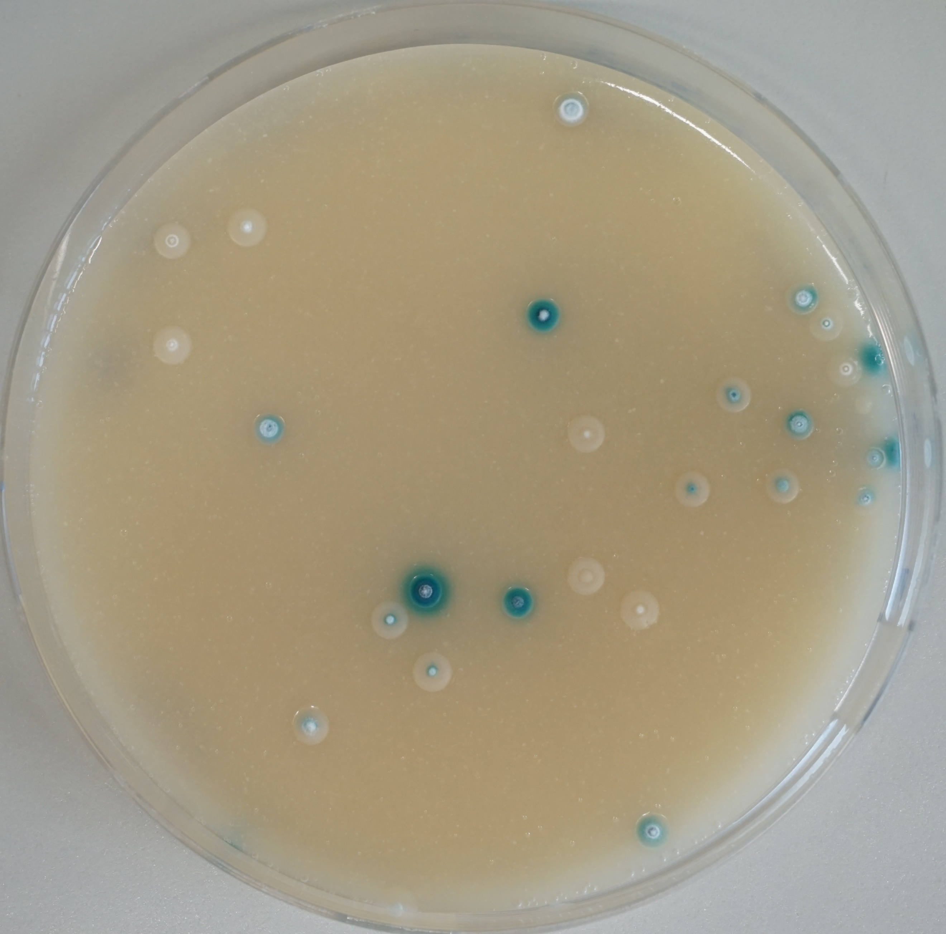
Single spore clone, carrying the vector, growing on SFM without-antibiotic (SP-)
(no selection pressure to maintain vector)
Spore stock without selection for vector
SFM no-antibiotic
+X-Gluc (TP-)
SFM+Apra
+X-Gluc (TP+)
Figure S14. Segregation stability test of pDS0007 in S. coelicolor M512
S. coelicolor M512 is a double ΔactII-ORF4 ΔredD null mutant [9] that does not produce actinorhodin or prodigiosin, respectively, as to avoid the problem of the blue-purple pigment production that might be mistaken for X-Gluc enzymatic transformation seen in Figure S12 and S13. The same volume of a spore preparation obtained from a plate without apramycin selection (i.e. an SP- plate in Figure S11) was used to inoculate two SFM plates supplemented with either only X-Gluc (TP-, left) or X-Gluc and apramycin (TP+, right). The plate at the left shows abundant number of colonies but very few show conversion of X-Gluc to blue pigment, indicating the very low proportion of spores that have maintained the plasmid. The plate at the right only allows the growth of spores that maintain the plasmid (apramycin selection) and shows a number of individual colonies nearly all of them showing conversion of X-Gluc to blue pigment (which is a second control assay for plasmid backbone maintenance, although in some colonies is not clearly visible in the image).

pDS0201
10877 bps
2000
4000
6000
8000
10000
AZ031 5306
AZ074 6494
AZ028 7265
AZ033 7372
AZ066 7971
AZ067 8476
AZ029 8743
AZ075 9148
AZ030 10800
I-SceI_site
gusA
ermEp*-RBS
lacO
ColE1_ori
aac (3) IV
RP4 ori
J2Z30_008146
J2Z30_008147
neo
ppd_J2Z30_008149
J2Z30_008150

Figure S15. Genetic map of pDS0201
Genetic map of pDS0201 construct, based on pDS0007 and used to replace pepM with neo. Features belonging to the vector are located on the map line, features belonging to the homologous recombination cassette are located inside the map line and coloured in green. The location of relevant oligonucleotides used for cloning of homologous regions and PCR testing of candidate mutants are given outside the map line (AZ0nn).

A
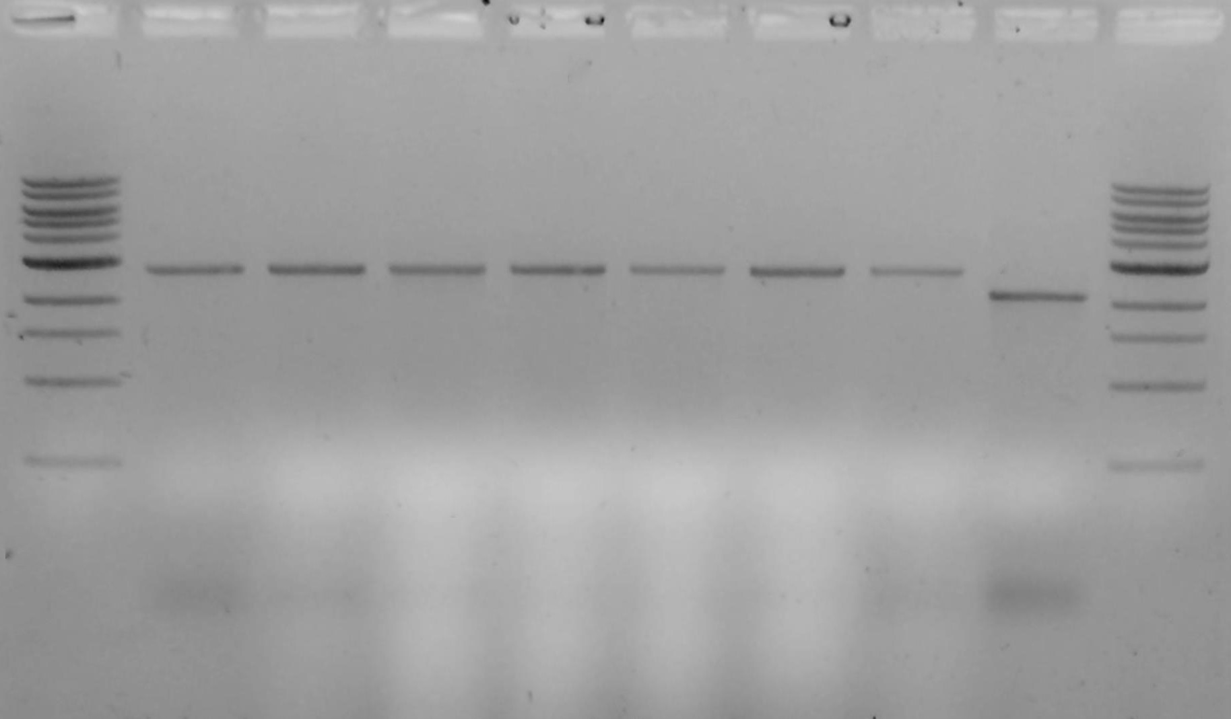
B
WT 2106 bp
ΔpepM::neo
2655 bp
AZ074
AZ075
147
neo
ppd
150
AZ074
AZ075
147
pepM
ppd
150
M 2 3 4 5 8 9 10 WT M
Kilobases

3 -
2 -
Kilobases

- 3
- 2
Figure S16. Assessment of S. iranensis ΔpepM::neo candidate mutants by PCR
Assessment of S. iranensis candidate double crossover clones, i.e. kanamycin resistant and vector-free (apramycin sensitive, β-glucuronidase negative) by PCR. Oligonucleotides AZ068 and AZ069 anneal either side of the deleted region and generate a PCR product 550 bp larger if the targeted gene pepM has been replaced with the kanamycin resistance gene neo. A, agarose gel electrophoresis of PCR reactions. The only observable amplicon for clones 2 to 10 corresponds to the expected size for the S. iranensis ΔpepM::neo genotype (2655 bp), while the S. iranensis parental control (WT) produced only the amplicon with the expected size for the wild-type genotype (2106 bp). DNA size marker is NEB’s 1 kb ladder (from top, 10, 8, 6, 5, 4, 3, 2, 1.5, 1, 0.5 kb; thicker band is 3 kb). B, scheme of the genetic region for both expected mutant and parental strain. The genes pepM, encoding the phosphoenolpyruvate mutase, and ppd, encoding the phosphonopyruvate decarboxylase, are shown. The nomenclature used for neighbouring genes corresponds to the last three digits of the locus_tag of the GenBank entry (e.g. “147” corresponds to gene J2Z30_008147 of accession JAGGLR010000028; pepM is J2Z30_008148, ppd is J2Z30_008149)

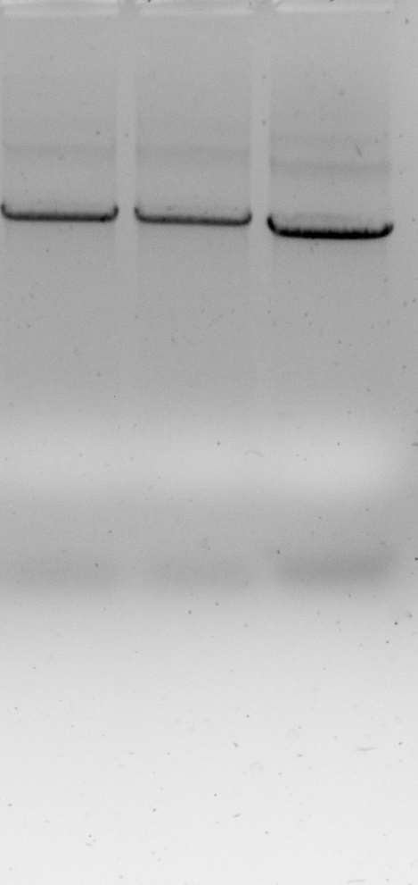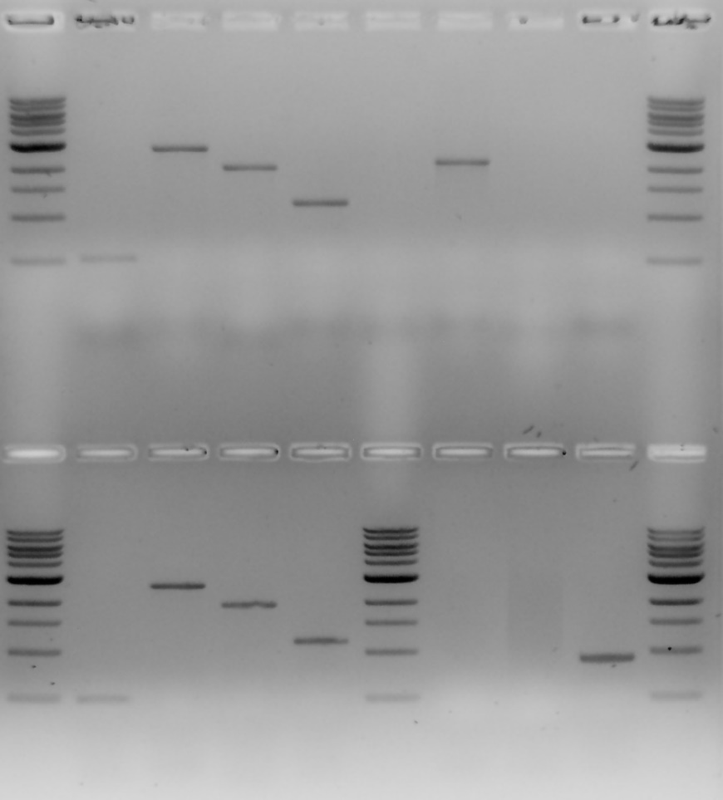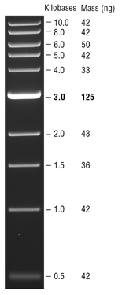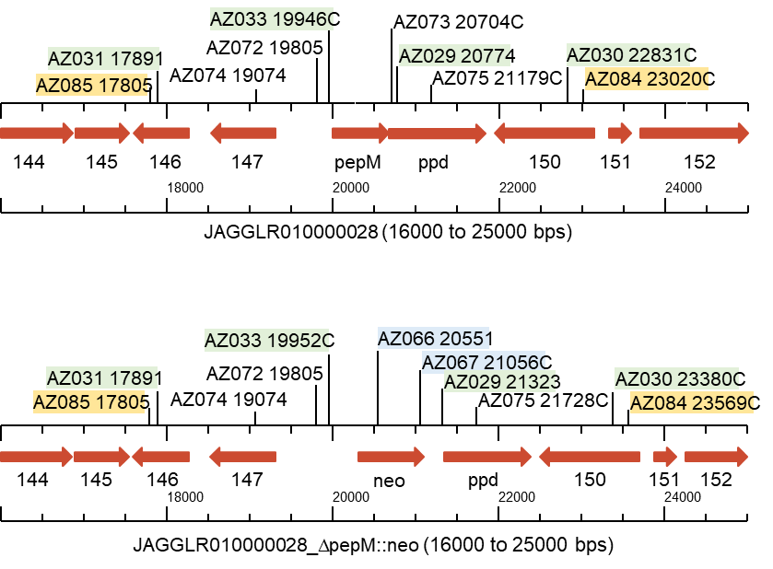
Primer pair | ΔpepM::neo  [gel line clone 3; clone 9] | WT  [gel line]
AZ066-AZ067 | 506 bp [1;9] | - [5]
AZ074-AZ075 | 2655 bp [2;10] | 2106 bp [6]
AZ074-AZ067 | 1983 bp [3;11] | - [7]
AZ066-AZ075 | 1178 bp [4;12] | - [8]
AZ072-AZ073 | - [13;14] | 900 bp [15]
AZ084-AZ085 | 5765 bp [16; 17] | 5216 bp [18]

S. iranensis ΔpepM #3
S. iranensis WT
S. iranensis ΔpepM #9
#3 #9 WT
1
2
3
4
5
6
7
8
9
10
11
12
13
14
15
#3 #9 WT
16
17
18
A
B
C
D
Figure S17. Extended PCR assessment of candidate mutants
Assessment of S. iranensis candidate double crossover clones by PCR with an extended number of primer pairs, including two primers that anneal outside of the regions used for homologous recombination. A, table of primer pairs, expected amplicon size, and location of sample in the respective gel. B, genetic arrangement of the region surrounding pepM and location of annealing sites for oligonucleotides in Figure S15-A. Highlighted in green are the oligonucleotides used for amplification of the homologous regions; in blue, oligonucleotides that anneal within the neo marker; in orange, oligonucleotides that anneal outside of the homologous regions (and therefore would not anneal on the construct used for production of the mutant). C and D, images of gels with the results from the test PCR reactions; DNA size marker is NEB’s 1 kb ladder (from top, 10, 8, 6, 5, 4, 3, 2, 1.5, 1, 0.5 kb; thicker band is 3 kb).

References
Alting-Mees, M.A. and Short, J.M. (1989) pBluescript II: gene mapping vectors. Nucleic Acids Res 17: 9494–9494.
Bethesda Research Laboratories (1986) BRL pUC Host: E. coli DH5alpha Competent Cells. Focus 8: 9.
Bierman, M., Logan, R., O’Brien, K., Seno, E.T., Nagaraja Rao, R., and Schoner, B.E. (1992) Plasmid cloning vectors for the conjugal transfer of DNA from Escherichia coli to Streptomyces spp. Gene 116: 43–49.
Bonfield, J.K. and Whitwham, A. (2010) Gap5—editing the billion fragment sequence assembly. Bioinformatics 26: 1699–1703.
Floriano, B. and Bibb, M. (1996) afsR is a pleiotropic but conditionally required regulatory gene for antibiotic production in Streptomyces coelicolor A3(2). Molecular Microbiology 21: 385–396.
Grant, S.G., Jessee, J., Bloom, F.R., and Hanahan, D. (1990) Differential plasmid rescue from transgenic mouse DNAs into Escherichia coli methylation-restriction mutants. PNAS 87: 4645–4649.
Hamedi, J., Mohammadipanah, F., Klenk, H.-P., Pötter, G., Schumann, P., Spröer, C., et al. (2010) Streptomyces iranensis sp. nov., isolated from soil. Int J Syst Evol Microbiol 60: 1504–1509.
Kendall, K.J. and Cohen, S.N. (1988) Complete nucleotide sequence of the Streptomyces lividans plasmid pIJ101 and correlation of the sequence with genetic properties. J Bacteriol 170: 4634–4651.
Kieser, T., Bibb, M.J., Buttner, M.J., Chater, K.F., and Hopwood, D.A. (2000) Practical Streptomyces Genetics, Kieser, T., Bibb, M.J., Buttner, M.J., Chater, K.F., and Hopwood, D.A. (eds) John Innes Centre, Norwich Research Park, Colney, Norwich NR4 7UH, England: John Innes Foundation.
Ladwig, N., Franz-Wachtel, M., Hezel, F., Soufi, B., Macek, B., Wohlleben, W., and Muth, G. (2015) Control of Morphological Differentiation of Streptomyces coelicolor A3(2) by Phosphorylation of MreC and PBP2. PLOS ONE 10: e0125425.
MacNeil, D.J., Gewain, K.M., Ruby, C.L., Dezeny, G., Gibbons, P.H., and MacNeil, T. (1992) Analysis of Streptomyces avermitilis genes required for avermectin biosynthesis utilizing a novel integration vector. Gene 111: 61–68.
Menges, R., Muth, G., Wohlleben, W., and Stegmann, E. (2007) The ABC transporter Tba of Amycolatopsis balhimycina is required for efficient export of the glycopeptide antibiotic balhimycin. Appl Microbiol Biotechnol 77: 125–134.
Muth, G. (2018) The pSG5-based thermosensitive vector family for genome editing and gene expression in actinomycetes. Appl Microbiol Biotechnol 102: 9067–9080.
Paget, M.S.B., Chamberlin, L., Atrih, A., Foster, S.J., and Buttner, M.J. (1999) Evidence that the Extracytoplasmic Function Sigma Factor ςE Is Required for Normal Cell Wall Structure in Streptomyces coelicolor A3(2). J Bacteriol 181: 204–211.
Rodríguez-García, A., Santamarta, I., Pérez-Redondo, R., Martín, J.F., and Liras, P. (2006) Characterization of a two-gene operon epeRA involved in multidrug resistance in Streptomyces clavuligerus. Res Microbiol 157: 559–568.
Staden, R., Beal, K.F., and Bonfield, J.K. (1999) The Staden Package, 1998. In Bioinformatics Methods and Protocols. Methods in Molecular BiologyTM. Misener, S. and Krawetz, S.A. (eds). Totowa, NJ: Humana Press, pp. 115–130.
Sun, Y., He, X., Liang, J., Zhou, X., and Deng, Z. (2009) Analysis of functions in plasmid pHZ1358 influencing its genetic and structural stability in Streptomyces lividans 1326. Appl Microbiol Biotechnol 82: 303–310.

