Multi-walled carbon nanotubes as reusable boosters of pyocyanin production for anticancer research
Joanna Honselmann genannt Humme^{1*}, Kamila Dubrowska¹, Magdalena Perużyńska², Marek Droździk², Radosław Birger², Martyna Jurkiewicz³, Tomasz Kędzierski⁴, Ewa Mijowska⁴, Tomasz Idzik⁵, Jacek G. Sośnicki⁵, Elżbieta Filipek⁶, Mateusz Piz⁶, Rafał Rakoczy^{1,7}, Adrian Augustyniak^{1,7}
¹ Department of Chemical and Process Engineering, Faculty of Chemical Technology and Engineering, West Pomeranian University of Technology in Szczecin, Szczecin, Poland
² Department of Experimental & Clinical Pharmacology, Pomeranian Medical University in Szczecin, Szczecin, Poland
³ Department of Chemical Organic Technology and Polymeric Materials, Faculty of Chemical Technology and Engineering, West Pomeranian University of Technology in Szczecin, Szczecin, Poland
⁴ Department of Nanomaterials Physicochemistry, Faculty of Chemical Technology and Engineering, West Pomeranian University of Technology in Szczecin, Szczecin, Poland
⁵ Department of Organic and Physical Chemistry, Faculty of Chemical Technology and Engineering, West Pomeranian University of Technology in Szczecin, Szczecin, Poland
⁶ Department of Inorganic and Analytical Chemistry, Faculty of Chemical Technology and Engineering, West Pomeranian University of Technology in Szczecin, Szczecin, Poland
⁷ Center for Advanced Materials and Manufacturing Process Engineering (CAMMPE), Szczecin, Poland

Corresponding author: Joanna Honselmann genannt Humme, joanna_jablonska@zut.edu.pl

Results
Figure S1 The influence of different commercial MWCNTs on optical density and viability of P. aeruginosa in microplate cultures

Figure S2 The influence of different commercial MWCNTs on optical density and viability of P. aeruginosa in Petri dish cultures (37℃, 48h)

Figure S3 The characterization of the optimized and control culture: a) biomass to substrate, product to biomass and product to substrate yield and b) pyoverdine production

Figure S4 A fragment of ¹H,¹H NOESY spectrum of a Pyocyanin sample in CD3OD. (The spectrum has been cropped for clarity)
Figure S5 A fragment of ¹H,¹H DQFCOSY spectrum of a Pyocyanin sample in CD₃OD. (The spectrum has been cropped for clarity)
Figure S6 A fragment of ¹³C,¹H COSY spectrum of a Pyocyanin sample in CD₃OD. (The spectrum has been cropped for clarity)

Figure. S7 FTIR-ATR analyses of the purified pyocyanin (400-4000 cm⁻¹)

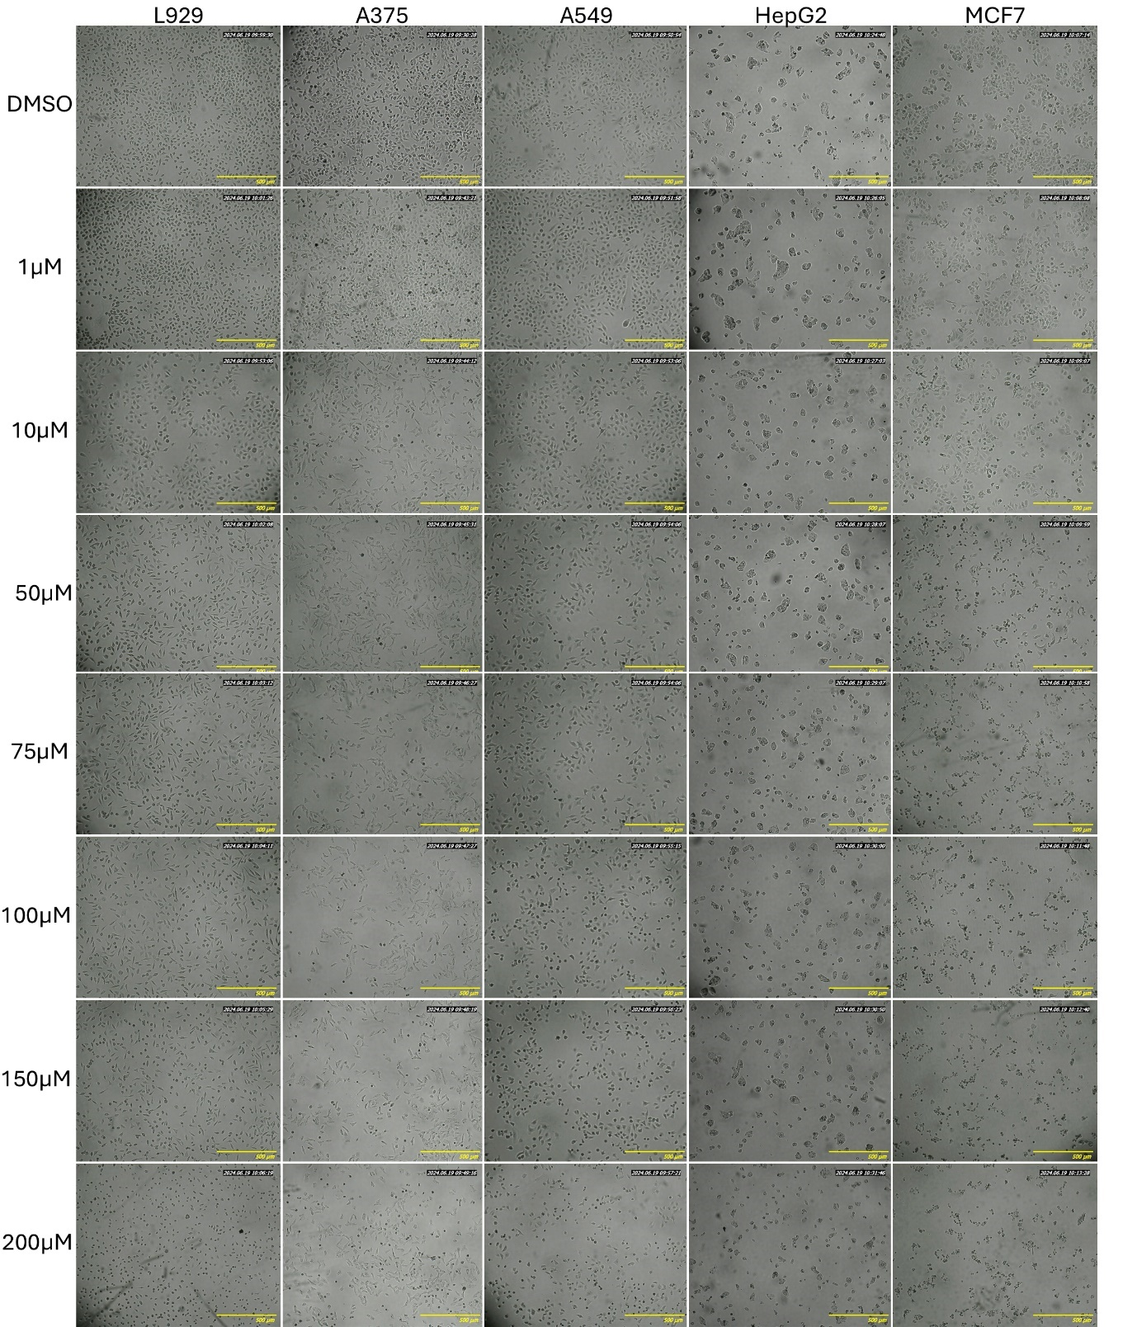
Figure S8 Representative optical microscopy images of normal (L929) and cancer cells after 24 h incubation with indicated concentrations of PYO

Figure S9 SEM-EDX analysis of the pristine and reused MWCNTs: a) Sigma Aldrich, b) Sigma Aldrich 1st reuse, c) Sigma Aldrich 2nd reuse

