Supplemental Materials

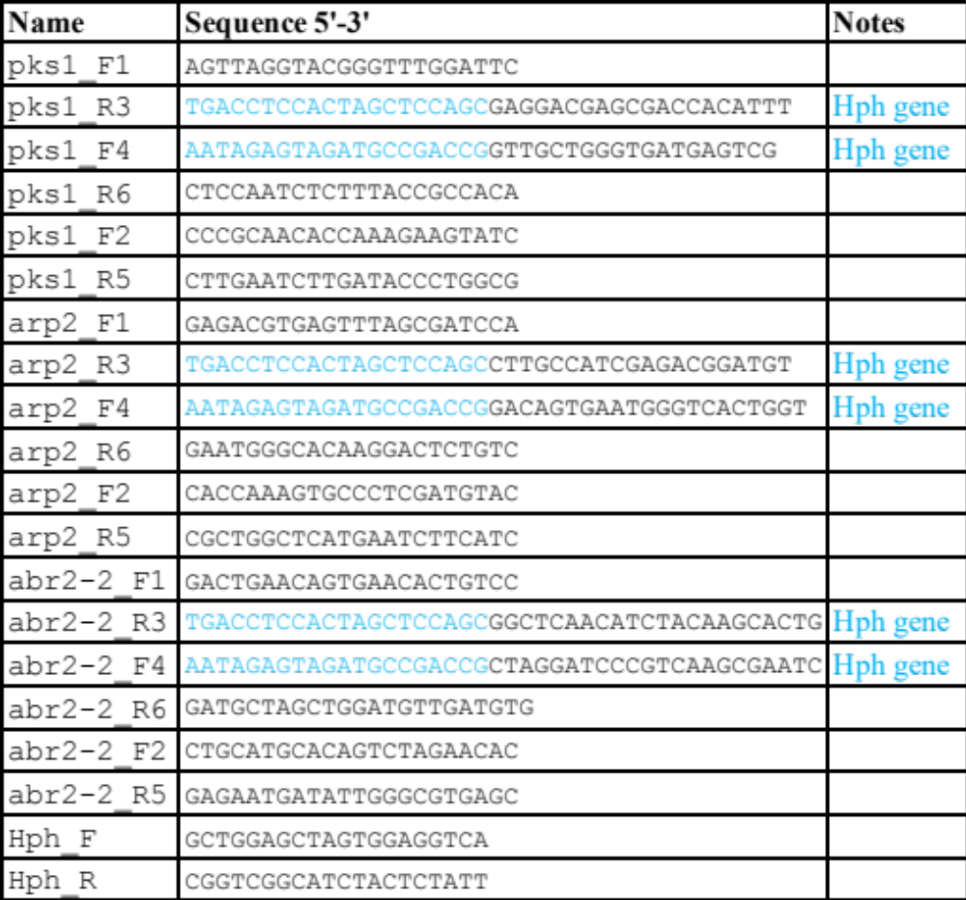
Table S1 Primers for gene deletions

1 2 3 4 5 6
Figure S1. PCR confirmation of gene deletion mutants Evpks1Δ, Evabr2Δ and Evarp2Δ. Top gel: Lane 1: wild type, pks1_F2/hph_R; Lane 2: Evpks1, pks1_F2/hph_R; Lane 3: wild type, arp2_F2/hph_R; Lane 4: Evarp2, arp2_F2/hph_R; Lane 5, wild type, abr2_F2/hph_R4, Lane 6: Evabr2, abr2_F2/hph_R.
Bottom gel: Lane 1: wild type, hph_F/pks1_R5, Evpks1, hph_F/pks1_R5; Lane 3: wild type, hph_F/arp2_R5; Lane 4: Evarp2, hph_F/arp2_R5; Lane 5, wild type, hph_F/abr2_R5, Lane 6: Evabr2, hph_F/abr2_R5.
Bands consistent with amplicon sizes confirmed replacement of the targeted gene with the selectable marker, hph. Wild type was not amplified by any pair of primers.

