Inventory of Supplementary Information

Increased L-glutamate production from gaseous nitrogen using Klebsiella pasteurii NG13 with modified citrate synthase

Daisuke Yoshidome, Keitaro Kuze, Atsushi Ichiyanagi, Ayako Yoshida, Saori Kosono, and Makoto Nishiyama

Supplementary Fig. 1. Comparison of culture profiles of CgCS+CitS and KpCS+CitS strains of K. pasteurii in ϕ25 test tubes and ϕ90 plates.
Supplementary Fig. 2. Extracellular L-glutamate production by KpCS* strains with their genomic KpCS deleted.
Supplementary Fig. 3. Extracellular L-glutamate production using KpCS variants modified at both of H227 and V362.
Supplementary Fig. 4. SDS-PAGE for purified KpCS.
Supplementary Fig. 5. Fitting the Michaelis-Menten equation.
Supplementary Fig. 6. Determining IC₅₀ of 2-OG.
Supplementary Fig. 7. Model structures of KpCS* variants binding OAA and 2-OG.
Supplementary Table 1. Plasmids used in this study.
Supplementary Table 2. Oligonucleotide primers used in this study.

Supplementary References

a
b

CgCS+CitS (test tube)

KpCS+CitS (test tube)

CgCS+CitS (plate)

KpCS+CitS (plate)

Supplementary Fig. 1. Comparison of culture profiles of CgCS+CitS and KpCS+CitS strains of K. pasteurii in ϕ25 test tubes and ϕ90 plates.
K. pasteurii strain (CgCS+CitS strain, black lines) overproducing CgCS and citrate transporter CitS or K. pasteurii strain (KpCS+CitS strain, red lines) overproducing KpCS and CitS was cultured statically under air in ϕ25 test tubes containing 5 mL of KDC medium (solid lines) or ϕ90 plates containing 25 mL of KDC medium (dotted lines). The height of the medium was set to 0.6 cm from the bottom of the vessel in both conditions. Nitrogenase activity (a) and extracellular L-Glu production (b) were measured at each time point using independent triple biological replicates. Data are shown as the mean of three biological replicates with standard deviation.
a
b

KpCS strains
Wild-type KpCS
KpCS*(H227Q)
KpCS*(H227L)
KpCS*(V362L)
KpCS*(H227W)

Supplementary Fig. 2. Extracellular L-glutamate production by KpCS* strains with their genomic KpCS deleted.
Extracellular L-Glu production of KpCS* strains with their genomic KpCS alive (a) and deleted (b). These strains were cultured in KDC medium was measured using independent triple biological replicates. Data are shown as the mean of three biological replicates with standard deviation.

KpCS* strains
a

b
KpCS*+CitS strains

Supplementary Fig. 3. Extracellular L-glutamate production using KpCS variants modified at both of H227 and V362.
Extracellular L-Glu production of KpCS* strains with the double replacements at H227 and V362 at day 4 (a) and KpCS*+CitS strains with the same double replacements at H227 and V362 at day 6 (b). These strains were cultured in KDC medium was measured using independent triple biological replicates. Data are shown as the mean of three biological replicates with standard deviation.

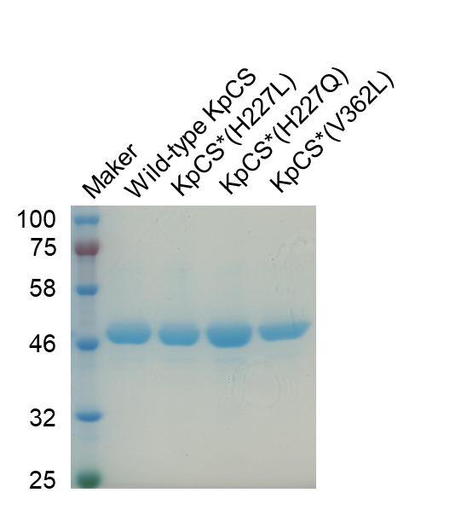
Supplementary Fig. 4. SDS-PAGE for purified KpCS.
The production of the wild-type KpCS and KpCS variants (47.9 kDa) was confirmed.

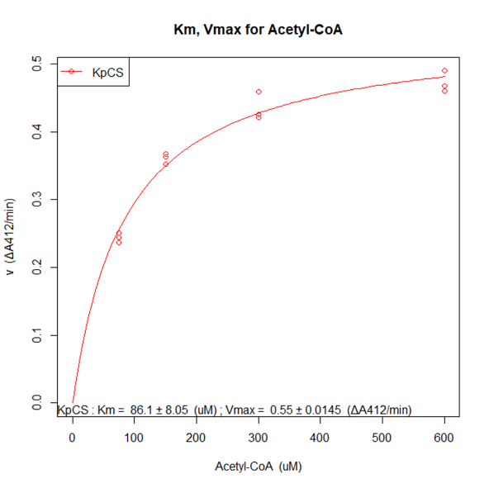
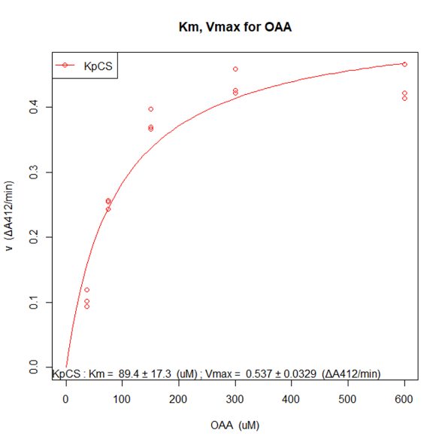
b
a

c
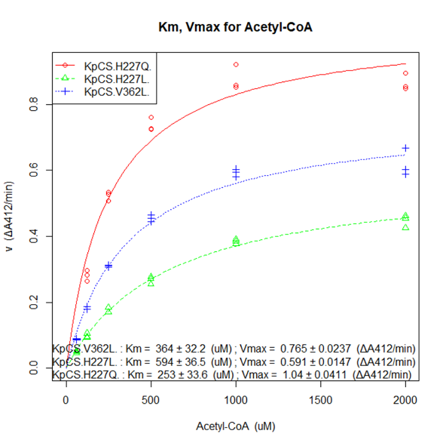
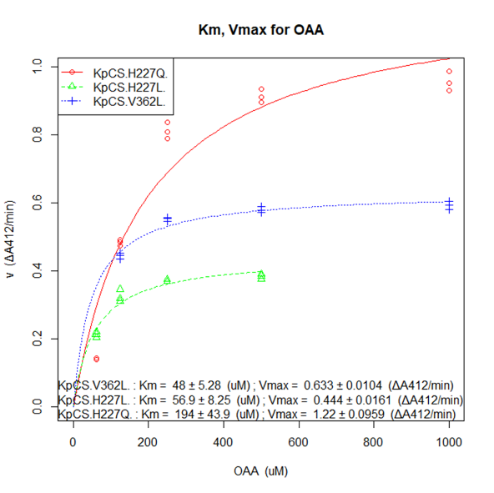
d

Supplementary Fig. 5. Fitting the Michaelis-Menten equation.
Increase in absorbance at 412 nm in 1 min. of each purified KpCSs was measured and plotted (a, b, c, d). For analysis of the apparent K_{m} and k_{cat} values of wild-type KpCS, KpCS*(H227Q), KpCS*(H227L), and KpCS*(V362L) for acetyl-CoA, OAA was constant at 300, 2000, 500, 1000 µM, respectively (a, c). For analysis of the apparent K_{m} and k_{cat} values of wild-type KpCS, KpCS*(H227Q), KpCS*(H227L), and KpCS*(V362L) for OAA, acetyl-CoA was constant at 300, 2000, 1000, 1000 µM, respectively (b, d). Fitting the Michaelis-Menten equation was conducted by the methods of Huitema and Horsman (2018) using the statistical program R.

KpCS(H227Q)
(IC₅₀: 1.14 ± 0.07 mM)
KpCS
(IC₅₀: 0.77 ± 0.03 mM)
a
b

d
c
KpCS(H227L)
(IC₅₀: 13.9 ± 0.6 mM)
KpCS(V362L)
(IC₅₀: 10.7 ± 0.36 mM)

Supplementary Fig. 6. Determining IC₅₀ of 2-OG.
Increase in absorbance at 412 nm in 1 min. of each purified KpCSs was measured and plotted (a~d). OAA and acetyl-CoA were constant at 300 µM and various concentration of 2-OG was added to the reaction culture. Calculation of IC₅₀ of 2-OG was conducted by the methods of Huitema and Horsman (2018) using the statistical program R.

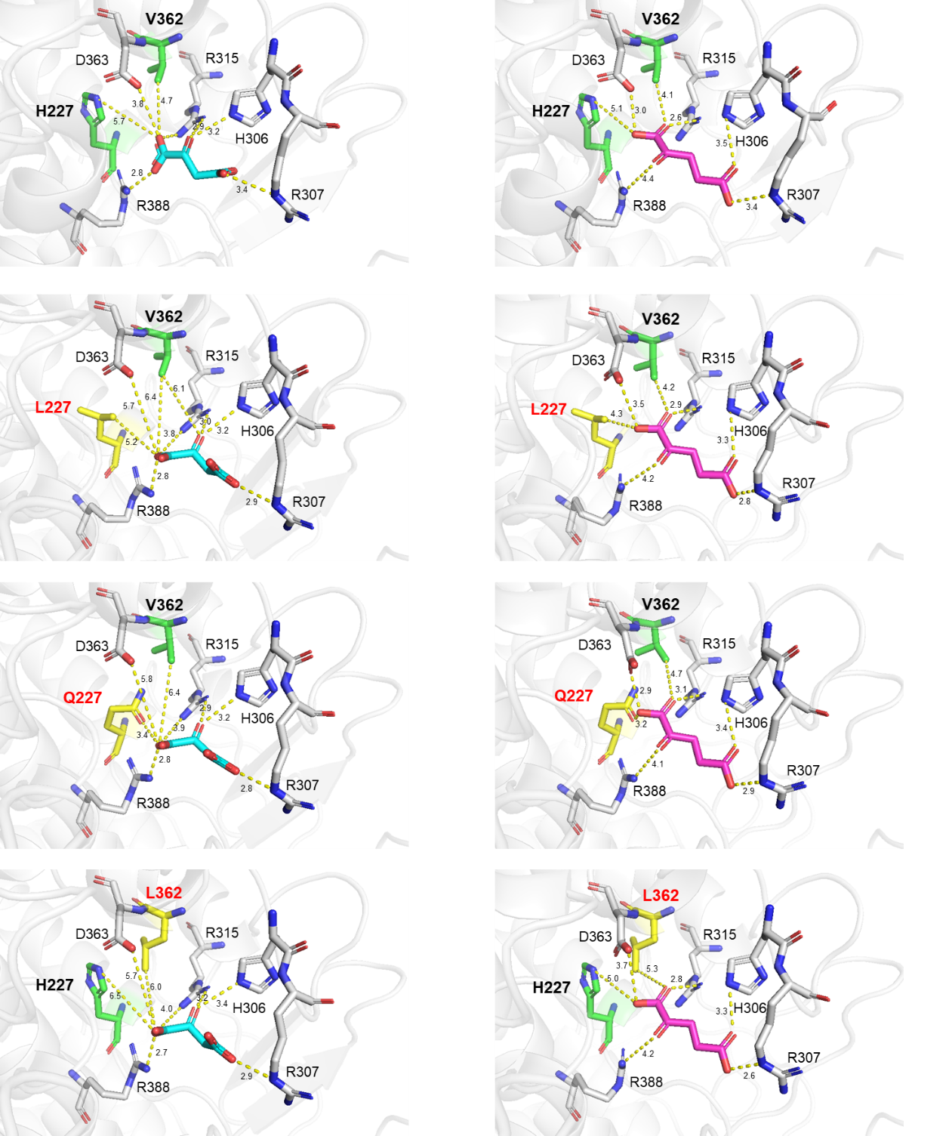
4b
4a
3a
3b
2a
2b
1b
1a
Supplementary Fig. 7. Model structures of KpCS* variants binding OAA and 2-OG.
Model structures of KpCS binding OAA (a, blue) and 2-OG (b, pink) were constructed based on CS from Escherichia coli binding OAA using SWISS-MODEL followed by energy minimization using Discovery Studio. H227 and V362 of wild-type KpCS (1), highlighted in green, were replaced with L227 (2), Q227 (3), and L362 (4), highlighted in yellow. Dotted lines represent the distances (Å) between two atoms.

Supplementary Table 1. Plasmids used in this study.
Name | Description |  | Primers (Template)
pKCT | Expression of CitS gene under the trc promoter, pCDF ori, Spc^{R} | Yoshidome et al. 2024b | -
pCCS | Expression of CgCS gene under the trc promoter, pSC101 ori, Tet^{R} | Yoshidome et al. 2024b | -
pKCS | Expression of wild-type KpCS gene under the trc promoter, pSC101 ori, Tet^{R} | Yoshidome et al. 2024b | -
pKCS(H227K) | Expression of KpCS(H227K) gene under the trc promoter, pSC101 ori, Tet^{R} | this study | 1-2 (pKCS)
pKCS(H227R) | Expression of KpCS(H227R) gene under the trc promoter, pSC101 ori, Tet^{R} | this study | 3-4 (pKCS)
pKCS(H227E) | Expression of KpCS(H227E) gene under the trc promoter, pSC101 ori, Tet^{R} | this study | 5-6 (pKCS)
pKCS(H227D) | Expression of KpCS(H227D) gene under the trc promoter, pSC101 ori, Tet^{R} | this study | 7-8 (pKCS)
pKCS(H227Q) | Expression of KpCS(H227Q) gene under the trc promoter, pSC101 ori, Tet^{R} | this study | 9-10 (pKCS)
pKCS(H227N) | Expression of KpCS(H227N) gene under the trc promoter, pSC101 ori, Tet^{R} | this study | 11-12 (pKCS)
pKCS(H227L) | Expression of KpCS(H227L) gene under the trc promoter, pSC101 ori, Tet^{R} | this study | 13-14 (pKCS)
pKCS(H227W) | Expression of KpCS(H227W) gene under the trc promoter, pSC101 ori, Tet^{R} | this study | 15-16 (pKCS)
pKCS(V362K) | Expression of KpCS(V362K) gene under the trc promoter, pSC101 ori, Tet^{R} | this study | 17-18 (pKCS)
pKCS(V362R) | Expression of KpCS(V362R) gene under the trc promoter, pSC101 ori, Tet^{R} | this study | 19-20 (pKCS)
pKCS(V362E) | Expression of KpCS(V362E) gene under the trc promoter, pSC101 ori, Tet^{R} | this study | 21-22 (pKCS)
pKCS(V362D) | Expression of KpCS(V362D) gene under the trc promoter, pSC101 ori, Tet^{R} | this study | 23-24 (pKCS)
pKCS(V362Q) | Expression of KpCS(V362Q) gene under the trc promoter, pSC101 ori, Tet^{R} | this study | 25-26 (pKCS)
pKCS(V362N) | Expression of KpCS(V362N) gene under the trc promoter, pSC101 ori, Tet^{R} | this study | 27-28 (pKCS)
pKCS(V362L) | Expression of KpCS(V362L) gene under the trc promoter, pSC101 ori, Tet^{R} | this study | 29-30 (pKCS)
pKCS(V362W) | Expression of KpCS(V362W) gene under the trc promoter, pSC101 ori, Tet^{R} | this study | 31-32 (pKCS)
pKCS(H227Q-Cstrep) | Expression of KpCS(H227Q-Cstrep) gene under the trc promoter, pSC101 ori, Tet^{R} | this study | 33-34 (pKCS(H227Q))
pKCS(H227L-Cstrep) | Expression of KpCS(H227L-Cstrep) gene under the trc promoter, pSC101 ori, Tet^{R} | this study | 33-34 (pKCS(H227L))
pKCS(V362L-Cstrep) | Expression of KpCS(V362L-Cstrep) gene under the trc promoter, pSC101 ori, Tet^{R} | this study | 33-34 (pKCS(V362L))

Supplementary Table 2. Oligonucleotide primers used in this study.
No. | Name | Sequence (5’ to 3’)
1 | KpCS(H227K)-F | ATCCTGAAAGCCGACCACGAACAAAACG
2 | KpCS(H227K)-R | GTCGGCTTTCAGGATCAGGATACGGTC
3 | KpCS(H227R)-F | ATCCTGCGCGCCGACCACGAACAAAACG
4 | KpCS(H227R)-R | GTCGGCGCGCAGGATCAGGATACGGTC
5 | KpCS(H227E)-F | ATCCTGGAAGCCGACCACGAACAAAACG
6 | KpCS(H227E)-R | GTCGGCTTCCAGGATCAGGATACGGTC
7 | KpCS(H227D)-F | ATCCTGGATGCCGACCACGAACAAAACG
8 | KpCS(H227D)-R | GTCGGCATCCAGGATCAGGATACGGTC
9 | KpCS(H227Q)-F | TCCTGCAAGCCGACCACGAACAAAACGCTTCGACC
10 | KpCS(H227Q)-R | GGTCGGCTTGCAGGATCAGGATACGGTCCATCG
11 | KpCS(H227N)-F | ATCCTGAACGCCGACCACGAACAAAACG
12 | KpCS(H227N)-R | GTCGGCGTTCAGGATCAGGATACGGTC
13 | KpCS(H227L)-F | ATCCTGCTGGCCGACCACGAACAAAACG
14 | KpCS(H227L)-R | GTCGGCCAGCAGGATCAGGATACGGTC
15 | KpCS(H227W)-F | ATCCTGTGGGCCGACCACGAACAAAACG
16 | KpCS(H227W)-R | GTCGGCCCACAGGATCAGGATACGGTC
17 | KpCS(V362K)-F | CCTAACAAAGATTTCTACTCCGGTATC
18 | KpCS(V362K)-R | GAAATCTTTGTTAGGGTAAAGTTTCTTC
19 | KpCS(V362R)-F | CCTAACCGCGATTTCTACTCCGGTATC
20 | KpCS(V362R)-R | GAAATCGCGGTTAGGGTAAAGTTTCTTC
21 | KpCS(V362E)-F | CCTAACGAAGATTTCTACTCCGGTATC
22 | KpCS(V362E)-R | GAAATCTTCGTTAGGGTAAAGTTTCTTC
23 | KpCS(V362D)-F | CCTAACGATGATTTCTACTCCGGTATC
24 | KpCS(V362D)-R | GAAATCATCGTTAGGGTAAAGTTTCTTC
25 | KpCS(V362Q)-F | CCTAACCAGGATTTCTACTCCGGTATC
26 | KpCS(V362Q)-F | GAAATCCTGGTTAGGGTAAAGTTTCTTC
27 | KpCS(V362N)-F | CCTAACAACGATTTCTACTCCGGTATC
28 | KpCS(V362N)-R | GAAATCGTTGTTAGGGTAAAGTTTCTTC
29 | KpCS(V362L)-F | CCTAACCTGGATTTCTACTCCGGTATC
30 | KpCS(V362L)-R | GAAATCCAGGTTAGGGTAAAGTTTCTTC
31 | KpCS(V362W)-F | CCTAACTGGGATTTCTACTCCGGTATC
32 | KpCS(V362W)-R | GAAATCCCAGTTAGGGTAAAGTTTCTTC
33 | KpCS-Cstrep-F | GAGCCATCCGCAGTTTGAAAAGTAAGAATTCGAGCTCGGTACC
34 | KpCS-Cstrep-R | CTTTTCAAACTGCGGATGGCTCCAACCACCGCGGGCGATATCGTTTTTGAAATCG

Supplementary References
Huitema C, Horsman G (2018) Analyzing enzyme kinetic data using the powerful statistical capabilities of R. bioRxiv:316588
Yoshidome D, Hidaka M, Miyanaga T, Ito Y, Kosono S, Nishiyama M (2024b) Glutamate production from aerial nitrogen using the nitrogen-fixing bacterium Klebsiella oxytoca. Commun Biol 7:443

