Supporting information for:

Applied Microbiology and Biotechnology

An integrated cell and medium engineering approach for production of a nanobody fusion in Saccharomyces cerevisiae

Laura R. K. Niemelä, Lotta-Mari Kirjavainen, Hendrikje C. J. Kozlowski, Heidi Salminen and Alexander D. Frey

Aalto University, Department of Bioproducts and Biosystems, Espoo, Finland

Supplementary tables
Supplemental Table S1. Oligonucleotides used in this study
Name | Target gene | DNA sequence 5´-3´
OAF55 |  | aaACTAGTATGAGGCAGGTTTGGTTCTCTTGGATTGTGGGATTGTTCCTATGTTTTTTCAACGTGTCTTCTGCTGATATCGTTTTGACTCAATCTCC
OAF56 |  | aaCTCGAGTTATTACTTACCTGGAGAC
EK003 | YPS1 | ATGAAACTGAAAACTGTAAGATCTGCGGTCCTTTCGTCACTCTTTGCATCGTACGCTGCAGGTCGACAAC
EK004 | YPS1 | TCAGATGAATGCAAAAAGAAGAGAAATTAATGTGAGGGGTAAAGATGGAACCACTAGTGGATCTGATATC
EK005 | PRB1 | ATGAAGTTAGAAAATACTCTATTTACACTCGGTGCCCTAGGGAGCATCTCGTACGCTGCAGGTCGACAAC
EK006 | PRB1 | TTAAATAATATTCAATTTATCAAGAATATCTCTCACTTGATCAAAGATTACCACTAGTGGATCTGATATC
OAF104 | PEP1 | ATGATATTACTTCATTTTGTCTATTCTCTTTGGGCCTTACTTCTCATTCCGTACGCTGCAGGTCGACAAC
OAF105 | PEP1 | CTACTGGTTTTCGTTAGATGGCGCTGTAGAATCAGGCCTGTCGATGTTTTGCATAGGCCACTAGTGGATCTG
OAF106 | MON2 | ATGGCCATGAACACTGGAGGGTTTGACTCCATGCAAAGGCAACTTGAAGCGTACGCTGCAGGTCGACAAC
OAF107 | MON2 | CTAGTCTAGTTTCGTAAATCCAAGTGATAATTCCAAAACTTTATCTTGGAGCATAGGCCACTAGTGGATCTG
OAF108 | ALG3 | ATGGAAGGTGAACAGTCTCCGCAAGGTGAAAAGTCTCTGCAAAGGAAGCAGTACGCTGCAGGTCGACAAC
OAF109 | ALG3 | TCAGTTGAGCTTTTTTTCCATAGAGCTGGTGGTACGAAGATGGCTTTTGGGCATAGGCCACTAGTGGATCTG
OJR38 | PEP4 | ATGTTCAGCTTGAAAGCATTATTGCCATTGGCCTTGTTGTTGGTCAGCGCGAGGCCCAGAATACCCTCC
OJR39 | PEP4 | TCAAATTGCTTTGGCCAAACCAACCGCATTGTTGCCCAAATCGTAAATAGCACTGGATGGCGGCGTTAG
OJR72 | VPS30 | ATGAAGTGCCAAACATGTCACTTACCCCTGCAACTAGACCCATCTTTAGACAGCTGAAGCTTCGTACGC
OJR73 | VPS30 | TTAGTTTCCGCTGATGGTCTTATCATTGTAATTCACTGTAGGGCTTAAGGGCATAGGCCACTAGTGGATCTG
OMP42 | PEP4 | GTGACCTAGTATTTAATCCAAATAAAATTCAAACAAAAACCAAAACTAACGTACGCTGCAGGTCGACAAC
OMP43 | PEP4 | CTCTCTAGATGGCAGAAAAGGATAGGGCGGAGAAGTAAGAAAAGTTTAGCGCATAGGCCACTAGTGGATCTG
EK158 | PRB1con | CTCAGTAATGCCACTGCAG
OJR29 | PEP1con | CCTCTCCCAGTAACGACTTC
OJR30 | CYM1con | GCCATGAACAACCTTCT
OJR31 | MON2con | CACGGTATTACGGGTTTACG
OJR32 | ALG3con | GACCAGCTTGGTTATGTG
OJR40 | PEP4con | AATGCGAATACGGGGAAC
OJR78 | VPS30con | TCTGGTTCGTAGGCTTCTTC
OJR95 | KanMxfor | TTGATGACGAGCGTAATGGC
OJR96 | KanMxrev | AAGATCCTGGTATCGGTCTG
OJR61 | incasrev | GGATGTATGGGCTAAATG
Supplemental Table S2. Screening of chemical chaperones and osmolytes
Compounds | Concentration range tested | Effects^{a)} on growth | Effects on titer | Reference
Arginine | 1 mM - 25 mM | +/- | ++ | Kang et al. 2000; Sharma et al. 2013
Tween-20 | 0.001% - 0.005% | +/- | + | Baumann et al. 2011
Sodium 4-phenylbutyrate (4-PBA) | 0.1 mM - 5.0 mM | +/- | ++ | Johari et al. 2015
Dithiotreitol (DTT) | 0.5 mM - 2.0 mM | - | - | Frand and Kaiser 1998
Glycerol | 1.0% - 8% | -- | -- | Figler et al. 2000; Street et al. 2006; Johari et al. 2015
CaCl₂ | 0.0025 mM - 0. 25 mM | - | + | Dulary et al. 2018
MnCl₂ | 0.01 mM - 1.0 mM | - | + | Dulary et al. 2018
CuSO₄ | 0.001 - 0.25 mM | - | + | Frand and Kaiser 1998
Glucose-6-phosphate | 0.1 - 10 mM | +/- | + | This study
Adenosine triphosphate (ATP) | 0.02 - 5.0 mM | - | + | This study
Dimethylsulfoxide (DMSO) | 0.1% - 1.0% | - | - | Sadowska-Bartosz et al. 2013; Johari et al. 2015
Triton X-100 | 0.01% - 0.1% | -- | -- | Baumann et al. 2011
Alanine | 5 mM - 25 mM | -- | +/- | Dandage et al. 2015
Proline | 5 mM - 25 mM | +/- | +/- | Street et al. 2006; Dandage et al. 2015
Glutamic acid | 0.5 mM - 5 mM | +/- | + | Wu et al. 2013
Glycine | 5 mM - 150 mM | - | +/- | Dandage et al. 2015
Betaine | 10 - 150 mM | +/- | +/- | Street et al. 2006; Johari et al. 2015
Taurine | 10 mM - 150 mM | - | - | Abe et al. 2015
Diamide (tetramethylazodicarboxamide, TMAD) | 0.2 mM - 50 mM | -- | -- | Frand and Kaiser 1998
Trimethylamine N-oxide (TMAO) | 2 mM - 100 mM | -- | - | Street et al. 2006; Johari et al. 2015
Dimethylethylammoniumpropane sulfonate (NDSB 195) | 1 mM - 100 mM | +/- | +/- | Mizukoshi et al. 2015
1-(3-sulfopropyl)pyridinium betaine (NDSB 201) | 2 - 10 mM | +/- | +/- | Willis et al. 2005
^{a)} Effect: increase/decrease < 10%: + or -; increase/decrease 10 - 30%: ++ or --; increase/decrease > 30%: +++ or ---; no change: +/-

Supplemental figures
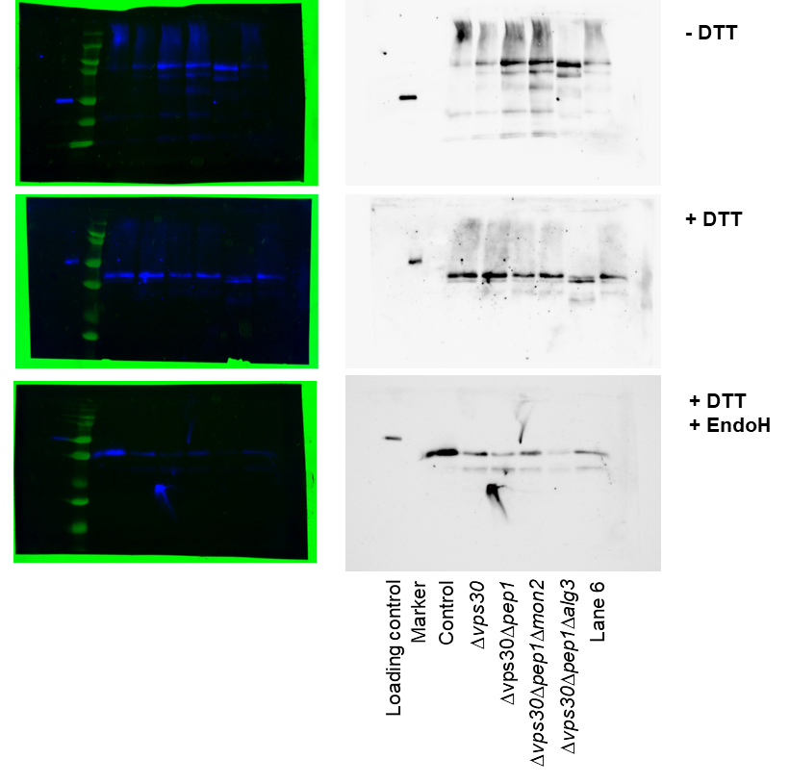
Supplemental Fig S1 Original, non-cropped images of the immunoblot analysis of chimeric nanobody-Fc fusion proteins expressed in control and deletion yeast strains. Non-reduced (- DTT), reduced (+ DTT), and reduced deglycosylated (+ DTT, + EndoH) samples are shown. Lane 6 contains the trace of an additional strain not included in the study. The loading control is the heavy chain of a reduced human IgG₁ antibody. Left side, overlay of immunoblot and true colour image of membrane to who; right side: immunoblot.

References
Abe Y, Ohkuri T, Yoshitomi S, Murakami S, Ueda T (2015) Role of the osmolyte taurine on the folding of a model protein, hen egg white lysozyme, under a crowding condition. Amino Acids 47:909–915. https://doi.org/10.1007/s00726-015-1918-0
Baumann K, Adelantado N, Lang C, Mattanovich D, Ferrer P (2011) Protein trafficking, ergosterol biosynthesis and membrane physics impact recombinant protein secretion in Pichia pastoris. Microb Cell Fact 10:93. https://doi.org/10.1186/1475-2859-10-93
Dandage R, Bandyopadhyay A, Jayaraj GG, Saxena K, Dalal V, Das A, Chakraborty K (2015) Classification of chemical chaperones based on their effect on protein folding landscapes. ACS Chem Biol 10:813–820. https://doi.org/10.1021/cb500798y
Dulary E, Yu SY, Houdou M, de Bettignies G, Decool V, Potelle S, Duvet S, Krzewinski-Recchi MA, Garat A, Matthijs G, Guerardel Y, Foulquier F (2018) Investigating the function of Gdt1p in yeast Golgi glycosylation. Biochim Biophys Acta Gen Subj 1862:394–402. https://doi.org/10.1016/j.bbagen.2017.11.006
Figler RA, Omote H, Nakamoto RK, Al-Shawi MK (2000) Use of chemical chaperones in the yeast Saccharomyces cerevisiae to enhance heterologous membrane protein expression: High-yield expression and purification of human P-glycoprotein. Arch Biochem Biophys 376:34–46. https://doi.org/10.1006/abbi.2000.1712
Frand AR, Kaiser CA (1998) The ERO1 gene of yeast is required for oxidation of protein dithiols in the endoplasmic reticulum. Mol Cell 1:161–170
Johari YB, Estes SD, Alves CS, Sinacore MS, James DC (2015) Integrated cell and process engineering for improved transient production of a “difficult-to-express” fusion protein by CHO cells. Biotechnol Bioeng 112:2527–2542. https://doi.org/10.1002/bit.25687
Kang HA, Choi E-S, Hong W-K, Kim J-Y, Ko S-M, Sohn J-H, Rhee SK (2000) Proteolytic stability of recombinant human serum albumin secreted in the yeast Saccharomyces cerevisiae. Appl Microbiol Biotechnol 53:575–582
Mizukoshi Y, Takeuchi K, Arutaki M, Takizawa T, Hanzawa H, Takahashi H, Shimada I (2015) Suppression of problematic compound oligomerization by cosolubilization of nondetergent sulfobetaines. Chem Med Chem 10:736–741. https://doi.org/10.1002/cmdc.201500057
Sadowska-Bartosz I, Paczka A, Moloń M, Bartosz G (2013) Dimethyl sulfoxide induces oxidative stress in the yeast Saccharomyces cerevisiae. FEMS Yeast Res 13:820–830. https://doi.org/10.1111/1567-1364.12091
Sharma S, Sarkar S, Paul SS, Roy S, Chattopadhyay K (2013) A small molecule chemical chaperone optimizes its unfolded state contraction and denaturant like properties. Sci Rep 3:3525 https://doi.org/10.1038/srep03525
Street TO, Wayne Bolen D, Rose GD, Jenkins TC (2006) A molecular mechanism for osmolyte-induced protein stability. Proc Natl Acad Sci 103:13997–14002
Willis MS, Hogan JK, Prabhakar P, Liu X, Tsai K, Wei Y, Fox T (2005) Investigation of protein refolding using a fractional factorial screen: A study of reagent effects and interactions. Protein Sci 14:1818–1826. https://doi.org/10.1110/ps.051433205
Wu Z, Song L, Liu SQ, Huang D (2013) Independent and additive effects of glutamic acid and methionine on yeast longevity. PLoS One 8. https://doi.org/10.1371/journal.pone.0079319

