Supplementary material

A Novel LED-Illuminated Bioreactor Strategy to Enhance Carotenoid Biosynthesis in the Newly Isolated Yeast Rhodotorula mucilaginosa LB-01

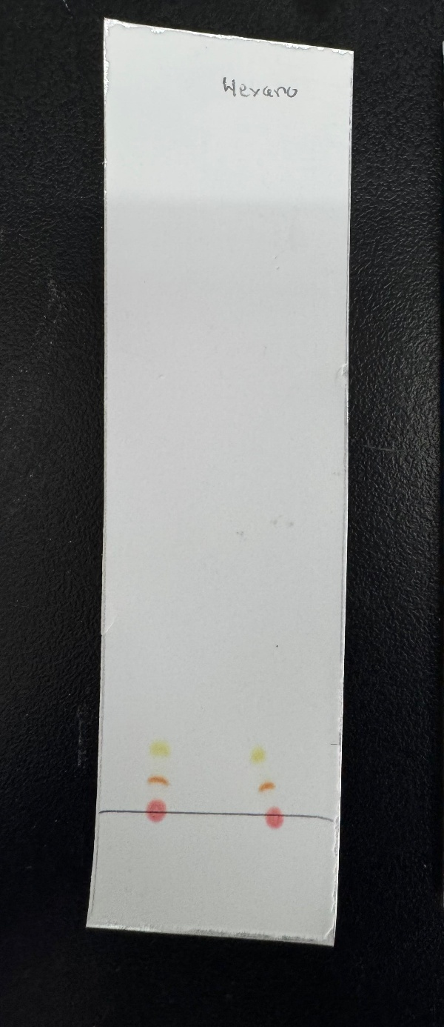
Figure S1. Separation of pigment fractions by thin-layer chromatography (TLC)

