Supporting information - Applied Microbiology and Biotechnology

Vibrio proteolyticus DCF12.2 postbiotic modulates gut metabolism without altering microbiota in zebrafish

Jorge García-Márquez^{1,2,3,}‡, Isabel Cerezo^{3,4,}‡, Rafaela Santos^{1,2}, Rui Magalhães^{1,2}, António Paulo Carvalho^{1,2}, Salvador Arijo³, Aires Oliva-Teles^{1,2}, Cláudia Serra^{1,2,}*, Miguel Ángel Moriñigo^{1,}*

¹ Centro Interdisciplinar de Investigação Marinha e Ambiental (CIIMAR), Universidade do Porto, Terminal de Cruzeiros do Porto de Leixões, Av, General Norton de Matos s/n, 4450-208 Matosinhos, Portugal; jgarcia@ciimar.up.pt (J.G.-M.); rafaela.santos@ciimar.up.pt (R.S.); rmagalhaes@ciimar.up.pt (R.M.); apcarval@fc.up.pt (A.P.C.); up201829@up.pt (A.O.-T.); cserra@ciimar.up.pt (C.S.)
² Departamento de Biologia, Faculdade de Ciências, University of Porto, Rua do Campo Alegre s/n, Ed. FC4,
4169-007 Porto, Portugal
³ Departamento de Microbiología, Facultad de Ciencias, Universidad de Málaga, Instituto Andaluz de Biotecnología y Desarrollo Azul (IBYDA), Campus Universitario de Teatinos s/n, 29071, Málaga, Spain; cerezoi@uma.es (I.C.); sarijo@uma.es (S.A.); morinigo@uma.es (M.A.M.)
⁴ Departamento de Biología y Geología, Ceimar-Universidad de Almería, 04120 La Cañada de San Urbano, Almería, Spain

*Correspondence: cserra@ciimar.up.pt (C.S.); morinigo@uma.es (M.A.M.)
‡These authors have contributed equally to this work.

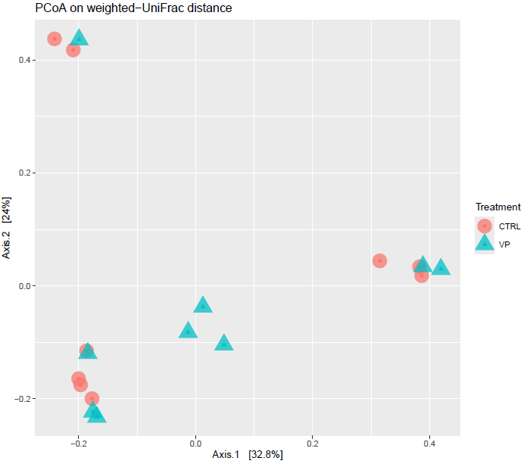
Fig. S1. Principal coordinate analysis (PCoA) of the bacterial communities of the microbiota of zebrafish fed the experimental diets, calculated from the weighted UniFrac distance matrix. Red circles and blue triangles represent the microbiota of each zebrafish individual fed the Control (CTRL) and V. proteolyticus DCF12.2 (VP) diets, respectively.

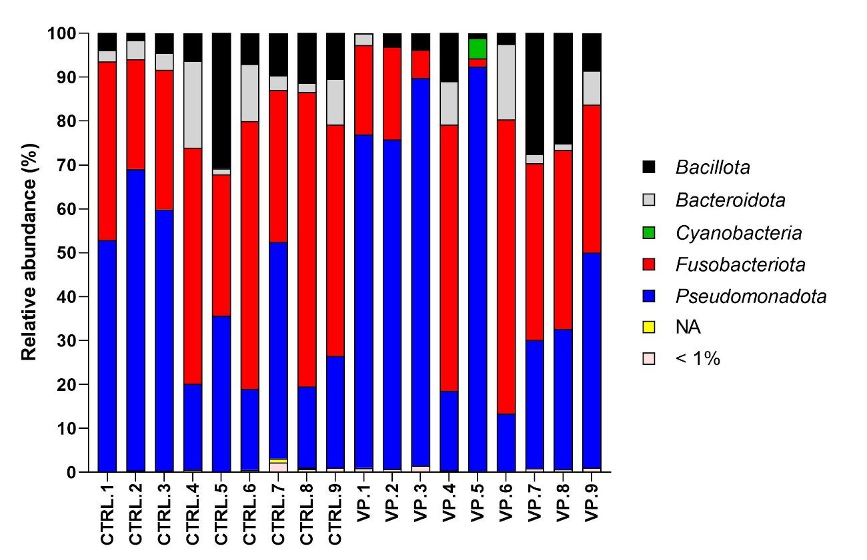
Fig. S2. Relative abundance (percentage) at phylum level for individual samples of intestinal microbiota of zebrafish fed Control (CTRL) and ethanol-inactivated V. proteolyticus DCF12.2 (VP) diets. < 1% indicates a mean relative abundance of less than 1%. NA represents unassigned taxa.

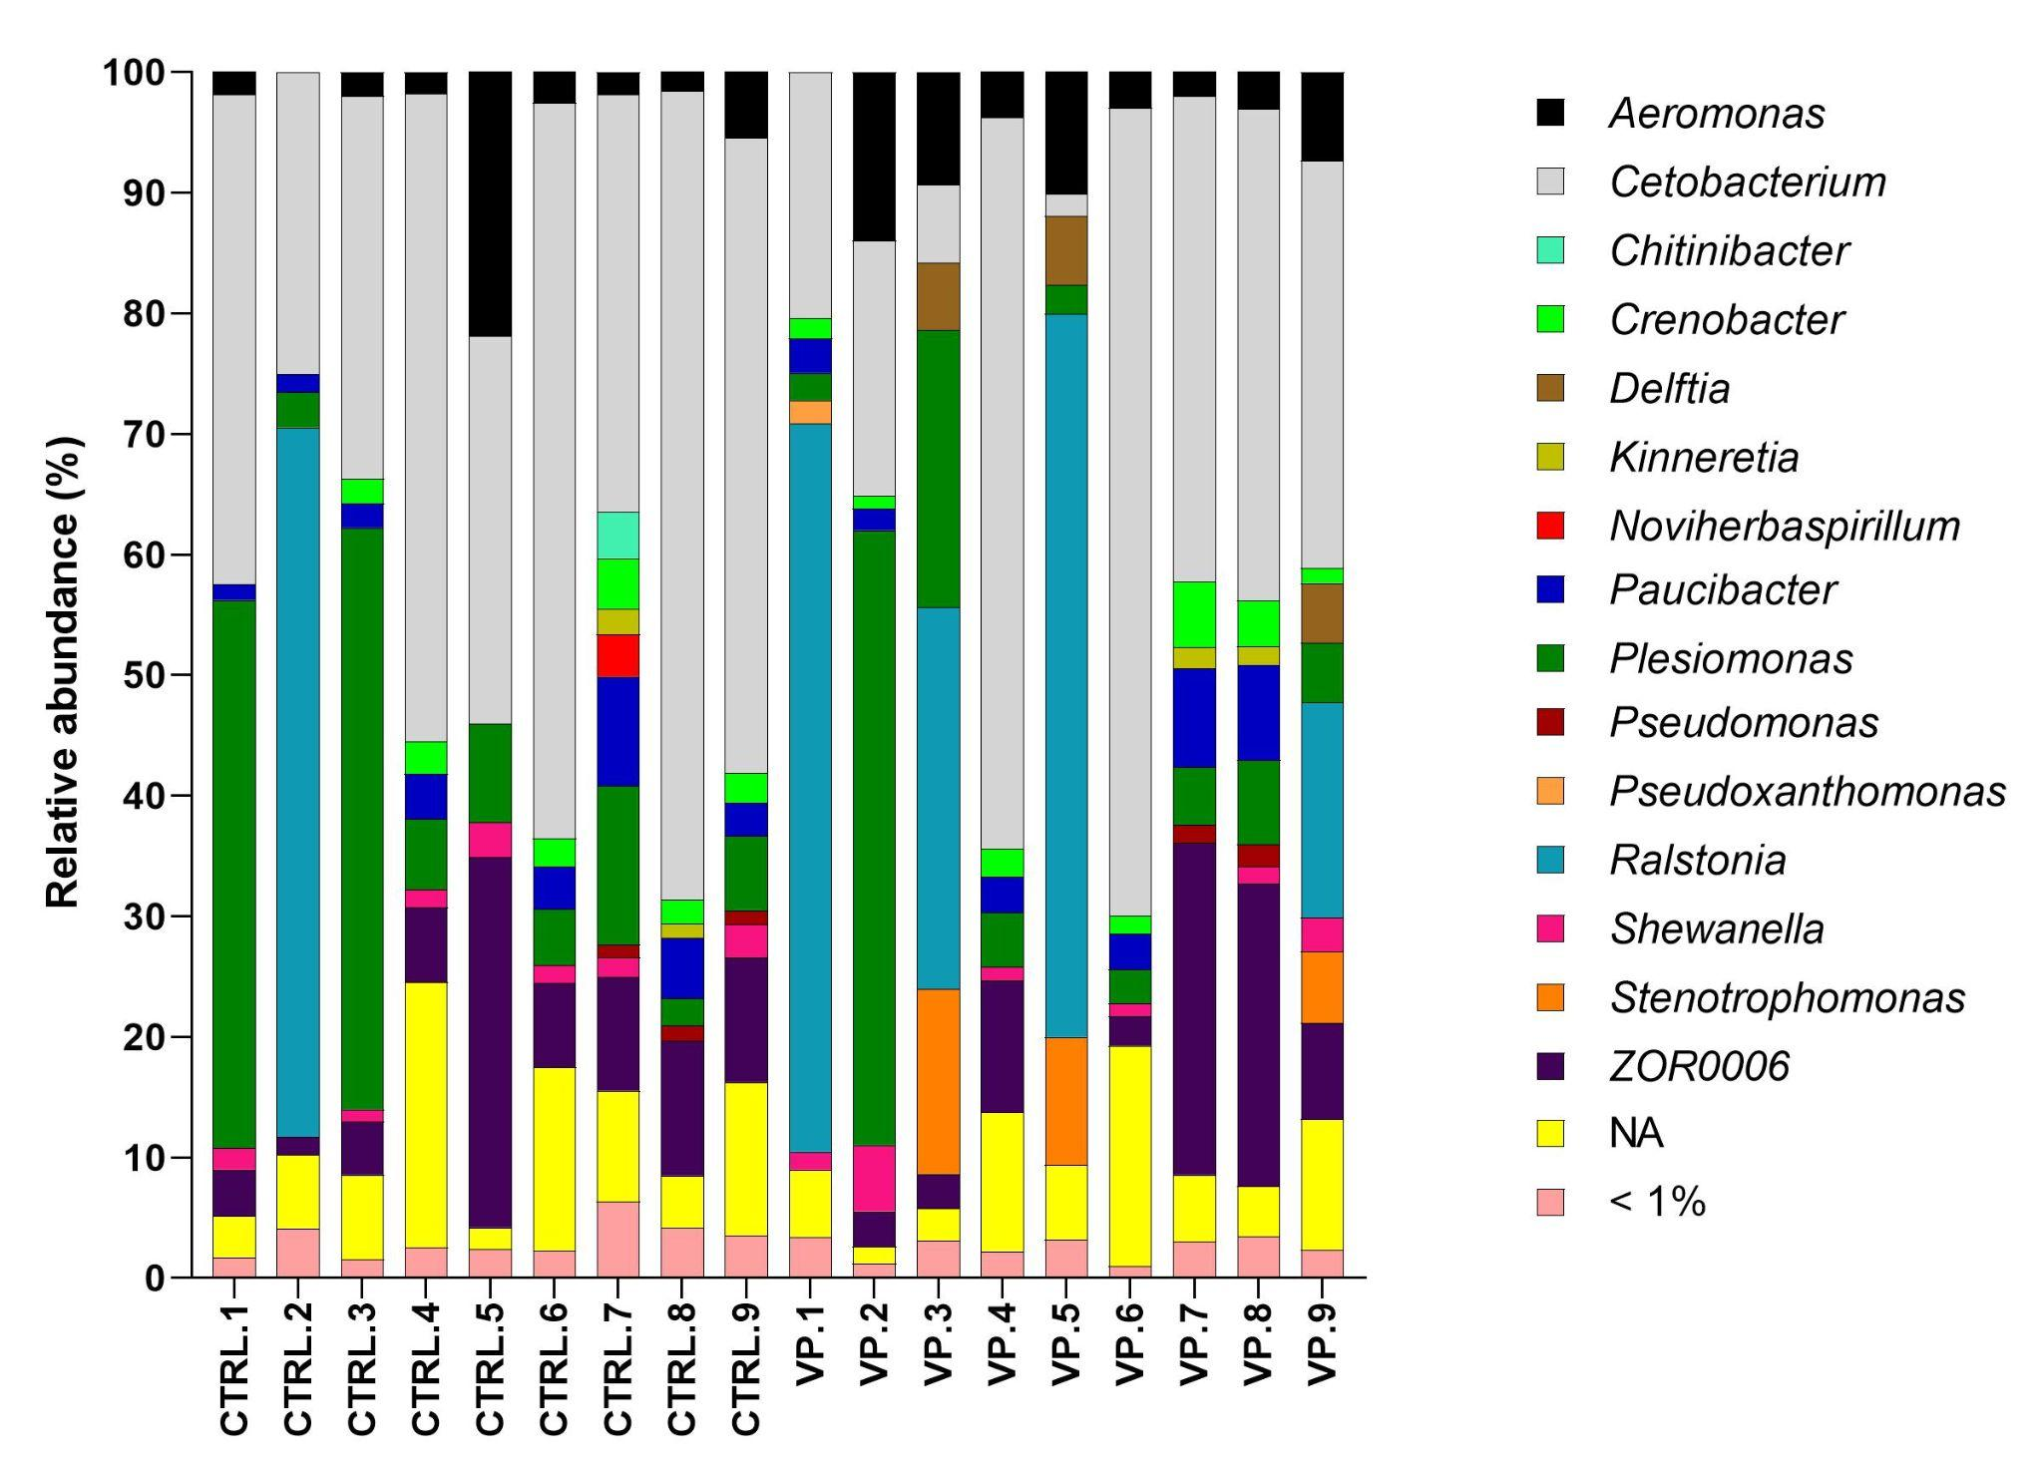
Fig. S3. Relative abundance (percentage) at the genus level for individual samples of intestinal microbiota of zebrafish fed Control (CTRL) and ethanol-inactivated V. proteolyticus DCF12.2 (VP) diets. < 1% indicates a mean relative abundance of less than 1%. NA represents unassigned taxa.

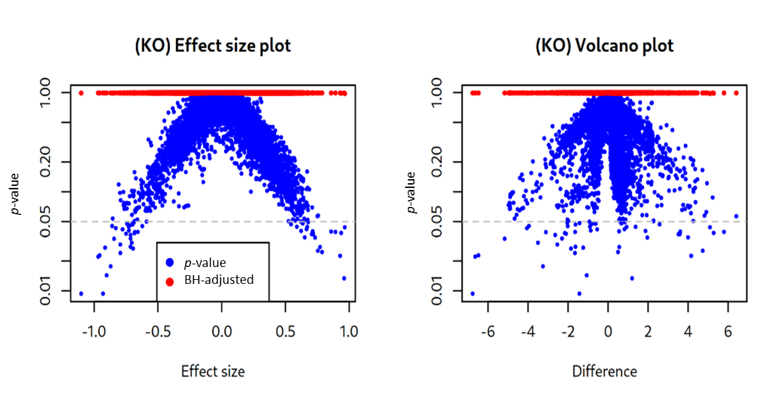
Fig. S4. Effect size and volcano plots for the differential abundance of functional predictions from PICRUSt2 using ALDEx2 in the intestine of zebrafish fed Control (CTRL) and ethanol-inactivated V. proteolyticus DCF12.2 (VP) diets. Blue dots indicate unadjusted p values, while red dots represent the Benjamini–Hochberg adjusted p values. The grey dashed horizontal line represents the threshold value of p = 0.05.

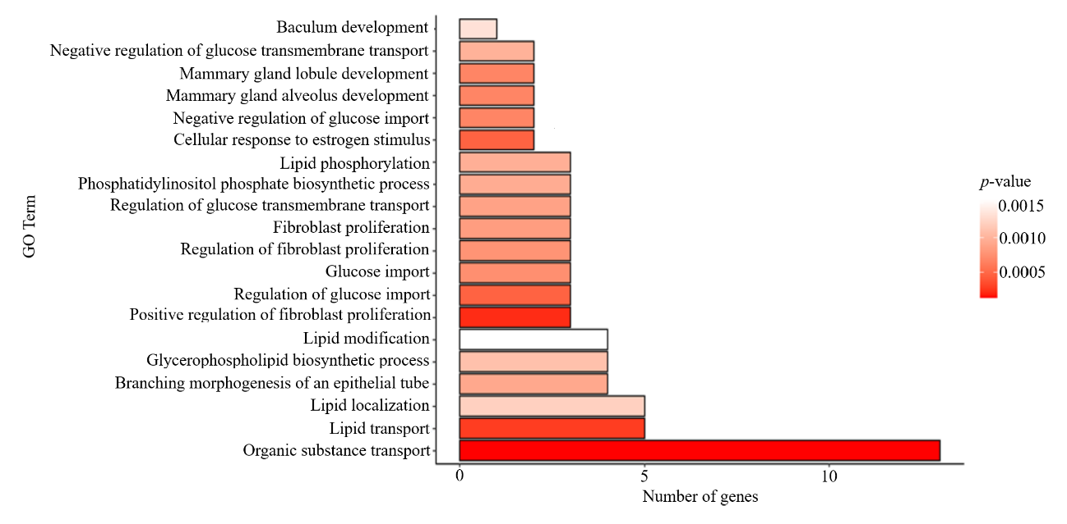Fig. S5. Top 20 of GO Biological process enrichment of upregulated Genes (ORA) in response to the dietary administration of V. proteolyticus DCF12.2.

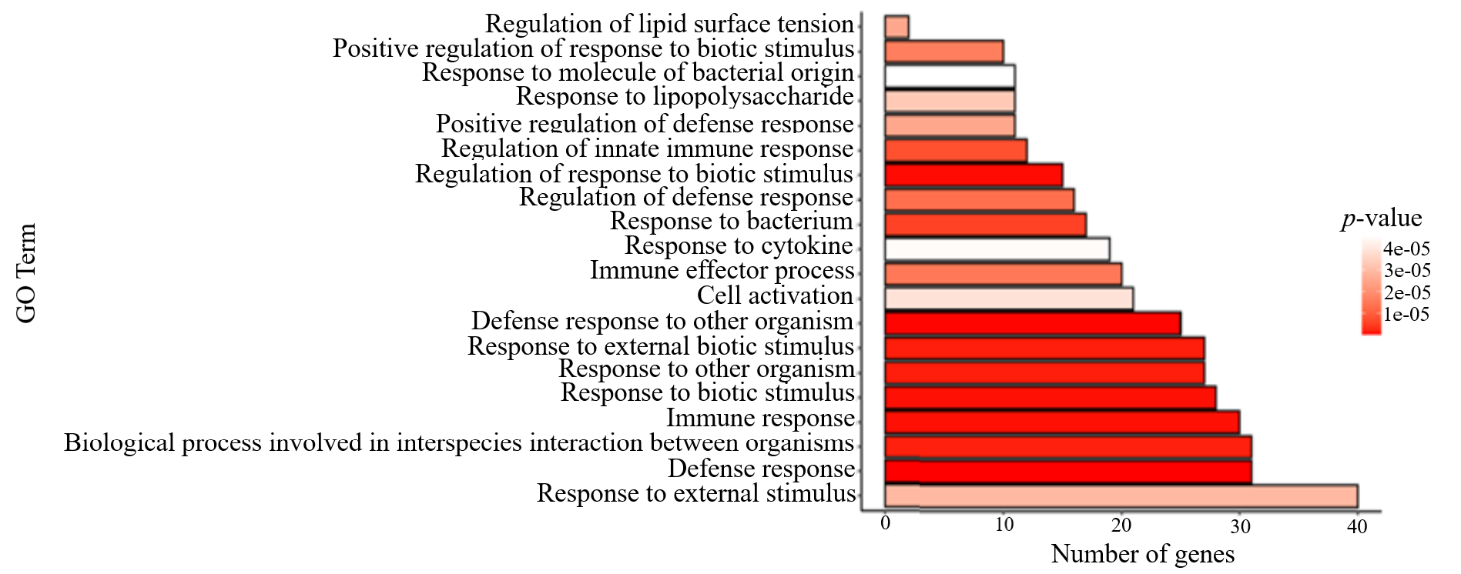Fig. S6. Top 20 of GO Biological process enrichment of downregulated Genes (ORA) in response to the dietary administration of V. proteolyticus DCF12.2.

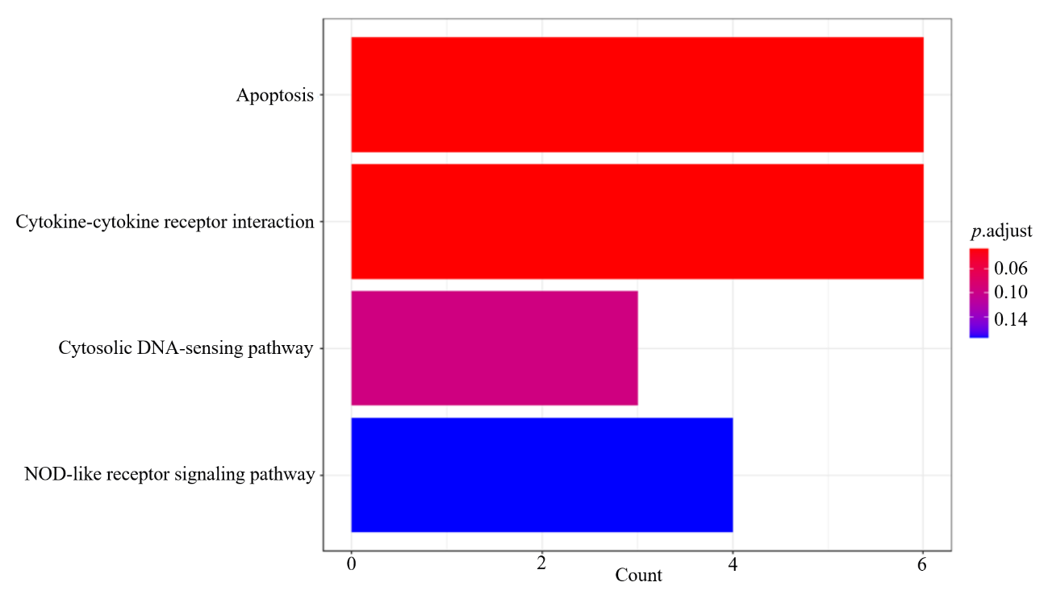
Fig. S7. KEGG enrichment of regulated Genes (ORA) in response to the dietary administration of V. proteolyticus DCF12.2.

Table S1. Assigned ASVs classified at the genus level in the gut microbiota of zebrafish fed the experimental diets. Only total relative abundance > 1% is considered. Different ASVs identified by DESeq2 analysis are highlighted in bold.
ASV assigned at genus level |  | CTRL |  | VP |  | p-value
ASV number | Genus | Mean | SD | Mean | SD | p-value
Seq_59 | Aeromonas | 0.21 | 0.42 | 0.75 | 2.25 | n.s.
Seq_60 | Aeromonas | 0.57 | 0.95 | 0.33 | 0.62 | n.s.
Seq_40 | Aeromonas | 1.45 | 3.54 | 0.37 | 0.74 | n.s.
Seq_129 | Aeromonas | 0.00 | 0.00 | 0.14 | 0.22 | <0.0001
Seq_48 | Aeromonas | 0.00 | 0.00 | 1.37 | 2.08 | <0.0001
Seq_58 | Aeromonas | 0.21 | 0.42 | 0.80 | 2.41 | n.s.
Seq_257 | Aeromonas | 0.03 | 0.08 | 0.01 | 0.03 | n.s.
Seq_65 | Aeromonas | 0.46 | 0.79 | 0.29 | 0.50 | n.s.
Seq_149 | Aeromonas | 0.05 | 0.16 | 0.01 | 0.04 | n.s.
Seq_136 | Aeromonas | 0.07 | 0.20 | 0.03 | 0.05 | n.s.
Seq_131 | Aeromonas | 0.00 | 0.00 | 0.13 | 0.20 | <0.0001
Seq_47 | Aeromonas | 0.00 | 0.00 | 1.34 | 2.03 | <0.0001
Seq_44 | Aeromonas | 1.35 | 3.28 | 0.34 | 0.67 | n.s.
Seq_3 | Cetobacterium | 5.98 | 9.16 | 4.92 | 9.77 | n.s.
Seq_10 | Cetobacterium | 0.00 | 0.00 | 1.82 | 4.63 | <0.0001
Seq_27 | Cetobacterium | 1.09 | 2.30 | 0.56 | 1.67 | n.s.
Seq_4 | Cetobacterium | 6.49 | 8.75 | 3.19 | 4.97 | n.s.
Seq_268 | Cetobacterium | 0.00 | 0.00 | 0.03 | 0.07 | n.s.
Seq_12 | Cetobacterium | 3.02 | 6.31 | 0.63 | 1.90 | <0.0001
Seq_1 | Cetobacterium | 6.44 | 9.90 | 5.31 | 10.56 | n.s.
Seq_37 | Cetobacterium | 0.00 | 0.00 | 0.39 | 0.82 | <0.0001
Seq_2 | Cetobacterium | 8.06 | 10.82 | 4.02 | 6.28 | n.s.
Seq_16 | Cetobacterium | 2.43 | 3.07 | 1.80 | 2.93 | n.s.
Seq_318 | Cetobacterium | 0.00 | 0.00 | 0.03 | 0.06 | n.s.
Seq_17 | Cetobacterium | 1.90 | 3.33 | 1.89 | 3.76 | n.s.
Seq_30 | Cetobacterium | 1.08 | 2.30 | 0.54 | 1.62 | n.s.
Seq_11 | Cetobacterium | 0.00 | 0.00 | 1.87 | 4.64 | <0.0001
Seq_9 | Cetobacterium | 2.96 | 3.72 | 2.26 | 3.75 | n.s.
Seq_15 | Cetobacterium | 2.85 | 5.96 | 0.62 | 1.86 | <0.0001
Seq_36 | Cetobacterium | 0.00 | 0.00 | 0.38 | 0.81 | <0.0001
Seq_133 | Cetobacterium | 0.00 | 0.00 | 0.08 | 0.17 | n.s.
Seq_13 | Cetobacterium | 2.01 | 3.54 | 2.06 | 4.11 | n.s.
Seq_127 | Cetobacterium | 0.00 | 0.00 | 0.07 | 0.15 | n.s.
Seq_88 | Crenobacter | 0.16 | 0.33 | 0.05 | 0.16 | n.s.
Seq_54 | Crenobacter | 0.59 | 0.83 | 0.67 | 1.14 | n.s.
Seq_66 | Crenobacter | 0.29 | 0.52 | 0.20 | 0.42 | n.s.
Seq_85 | Crenobacter | 0.00 | 0.00 | 0.10 | 0.20 | <0.0001
Seq_61 | Crenobacter | 0.46 | 0.67 | 0.54 | 0.91 | n.s.
Seq_80 | Crenobacter | 0.18 | 0.38 | 0.06 | 0.19 | n.s.
Seq_91 | Crenobacter | 0.00 | 0.00 | 0.10 | 0.22 | <0.0001
Seq_62 | Crenobacter | 0.32 | 0.57 | 0.22 | 0.45 | n.s.
Seq_41 | Delftia | 0.00 | 0.00 | 0.89 | 1.34 | <0.0001
Seq_43 | Delftia | 0.00 | 0.00 | 0.92 | 1.38 | <0.0001
Seq_55 | Paucibacter | 0.44 | 0.79 | 0.33 | 0.66 | n.s.
Seq_92 | Paucibacter | 0.00 | 0.00 | 0.07 | 0.13 | n.s.
Seq_56 | Paucibacter | 0.44 | 0.79 | 0.33 | 0.65 | n.s.
Seq_46 | Paucibacter | 0.92 | 1.42 | 0.92 | 1.54 | n.s.
Seq_95 | Paucibacter | 0.00 | 0.00 | 0.06 | 0.10 | n.s.
Seq_79 | Paucibacter | 0.19 | 0.39 | 0.10 | 0.30 | n.s.
Seq_78 | Paucibacter | 0.18 | 0.37 | 0.10 | 0.31 | n.s.
Seq_38 | Paucibacter | 1.12 | 1.75 | 1.19 | 1.96 | n.s.
Seq_7 | Plesiomonas | 5.40 | 10.72 | 2.94 | 8.81 | n.s.
Seq_33 | Plesiomonas | 1.49 | 2.41 | 0.82 | 1.40 | n.s.
Seq_42 | Plesiomonas | 1.07 | 1.69 | 0.41 | 0.84 | n.s.
Seq_45 | Plesiomonas | 0.99 | 1.54 | 0.40 | 0.83 | n.s.
Seq_20 | Plesiomonas | 0.00 | 0.00 | 1.70 | 3.83 | <0.0001
Seq_21 | Plesiomonas | 0.00 | 0.00 | 1.67 | 3.73 | <0.0001
Seq_8 | Plesiomonas | 5.01 | 9.95 | 2.73 | 8.18 | n.s.
Seq_39 | Plesiomonas | 1.24 | 2.03 | 0.73 | 1.22 | n.s.
Seq_6 | Ralstonia | 0.00 | 0.00 | 6.07 | 10.65 | <0.0001
Seq_366 | Ralstonia | 0.03 | 0.07 | 0.02 | 0.06 | n.s.
Seq_5 | Ralstonia | 0.00 | 0.00 | 6.09 | 10.54 | <0.0001
Seq_616 | Ralstonia | 0.01 | 0.02 | 0.01 | 0.01 | n.s.
Seq_31 | Ralstonia | 3.59 | 10.76 | 3.66 | 10.94 | n.s.
Seq_34 | Ralstonia | 2.96 | 8.84 | 3.07 | 9.18 | n.s.
Seq_77 | Shewanella | 0.19 | 0.29 | 0.12 | 0.23 | n.s.
Seq_87 | Shewanella | 0.14 | 0.29 | 0.28 | 0.84 | <0.0001
Seq_247 | Shewanella | 0.04 | 0.06 | 0.02 | 0.04 | n.s.
Seq_104 | Shewanella | 0.00 | 0.00 | 0.18 | 0.44 | <0.0001
Seq_123 | Shewanella | 0.14 | 0.35 | 0.01 | 0.02 | n.s.
Seq_76 | Shewanella | 0.17 | 0.36 | 0.33 | 0.99 | <0.0001
Seq_106 | Shewanella | 0.00 | 0.00 | 0.16 | 0.44 | n.s.
Seq_122 | Shewanella | 0.14 | 0.34 | 0.02 | 0.04 | n.s.
Seq_83 | Shewanella | 0.18 | 0.28 | 0.10 | 0.19 | n.s.
Seq_141 | Shewanella | 0.00 | 0.00 | 0.02 | 0.05 | n.s.
Seq_150 | Shewanella | 0.00 | 0.00 | 0.01 | 0.03 | n.s.
Seq_90 | Shewanella | 0.25 | 0.39 | 0.17 | 0.26 | n.s.
Seq_75 | Shewanella | 0.31 | 0.46 | 0.21 | 0.33 | n.s.
Seq_288 | Shewanella | 0.04 | 0.07 | 0.02 | 0.04 | n.s.
Seq_19 | Stenotrophomonas | 0.00 | 0.00 | 1.80 | 2.96 | <0.0001
Seq_18 | Stenotrophomonas | 0.00 | 0.00 | 1.73 | 2.84 | <0.0001
Seq_29 | ZOR0006 | 0.00 | 0.00 | 0.66 | 1.40 | <0.0001
Seq_52 | ZOR0006 | 0.46 | 0.91 | 0.16 | 0.49 | n.s.
Seq_53 | ZOR0006 | 0.46 | 0.91 | 0.16 | 0.49 | n.s.
Seq_22 | ZOR0006 | 1.64 | 2.29 | 2.65 | 5.22 | n.s.
Seq_24 | ZOR0006 | 2.39 | 4.92 | 0.74 | 1.82 | n.s.
Seq_32 | ZOR0006 | 0.00 | 0.00 | 0.61 | 1.29 | <0.0001
Seq_14 | ZOR0006 | 1.96 | 2.78 | 3.24 | 6.36 | n.s.
Seq_23 | ZOR0006 | 2.48 | 5.19 | 0.75 | 1.82 | n.s.
n.s., not significant (DESeq2, p ≥ 0.05)

Table S2. Differentially expressed genes significantly up- and down-regulated in the intestine of zebrafish fed V. proteolyticus DCF12.2 (VP) compared with Control (CTRL), including Gene ID, Gene name, Log2 fold change, p‑value, adjusted p‑value, and regulation tag.
Gene ID | Gene name | Log2 FC | p-value | p-adj | Regulation tag
797016 | si:dkeyp-110e4.11 | 6.032 | 0.000 | 0.030 | Up
559931 | vtg2 | 5.420 | 0.000 | 0.026 | Up
103911912 | LOC103911912 | 5.311 | 0.000 | 0.001 | Up
101884145 | LOC101884145 | 5.088 | 0.000 | 0.007 | Up
559475 | vtg1 | 4.995 | 0.001 | 0.034 | Up
64260 | vtg5 | 4.831 | 0.001 | 0.044 | Up
415248 | rcn3 | 4.517 | 0.000 | 0.000 | Up
100536928 | LOC100536928 | 4.051 | 0.001 | 0.038 | Up
103910098 | LOC103910098 | 3.799 | 0.000 | 0.000 | Up
101883185 | LOC101883185 | 3.686 | 0.000 | 0.002 | Up
403045 | egf | 3.604 | 0.001 | 0.049 | Up
108190615 | LOC108190615 | 3.367 | 0.000 | 0.013 | Up
259252 | esr1 | 2.963 | 0.000 | 0.015 | Up
100005373 | greb1l | 2.956 | 0.001 | 0.039 | Up
767641 | zgc:153219 | 2.504 | 0.001 | 0.047 | Up
792450 | LOC792450 | 2.498 | 0.001 | 0.048 | Up
110438982 | LOC110438982 | 2.454 | 0.001 | 0.038 | Up
325939 | si:dkey-286h2.7 | 1.768 | 0.000 | 0.002 | Up
393308 | riox2 | 1.757 | 0.000 | 0.010 | Up
100005033 | si:ch211-243a15.1 | 1.718 | 0.001 | 0.035 | Up
259306 | cyp2ad2 | 1.632 | 0.000 | 0.018 | Up
100006301 | si:dkey-204l11.1 | 1.575 | 0.000 | 0.027 | Up
100002095 | zgc:162707 | 1.448 | 0.000 | 0.031 | Up
556280 | cyp2u1 | 1.422 | 0.000 | 0.019 | Up
402954 | cbr4 | 1.363 | 0.001 | 0.037 | Up
393141 | mycb | 1.348 | 0.001 | 0.049 | Up
559775 | lman1 | 1.344 | 0.000 | 0.000 | Up
100536187 | LOC100536187 | 1.329 | 0.001 | 0.042 | Up
767678 | cish | 1.297 | 0.000 | 0.030 | Up
406541 | slc25a25a | 1.270 | 0.001 | 0.046 | Up
407663 | si:ch211-107o10.3 | 1.217 | 0.000 | 0.016 | Up
492560 | im:7141269 | 1.151 | 0.000 | 0.003 | Up
445176 | mfsd2ab | 1.145 | 0.000 | 0.023 | Up
606662 | plgrkt | 1.133 | 0.000 | 0.000 | Up
569104 | acoxl | 1.117 | 0.000 | 0.027 | Up
565337 | gltpd2 | 1.087 | 0.000 | 0.029 | Up
558617 | si:dkey-51e6.1 | 1.052 | 0.000 | 0.001 | Up
436772 | sec61g | 1.028 | 0.000 | 0.017 | Up
445059 | adprh | 1.016 | 0.001 | 0.035 | Up
406415 | tmem263 | 1.015 | 0.000 | 0.007 | Up
101883597 | xcr1b.2 | -1.004 | 0.001 | 0.044 | Down
561683 | nt5c1bb | -1.006 | 0.000 | 0.021 | Down
799279 | LOC799279 | -1.006 | 0.000 | 0.011 | Down
619272 | zgc:113314 | -1.010 | 0.000 | 0.030 | Down
101885260 | si:ch73-111e15.1 | -1.013 | 0.000 | 0.006 | Down
561574 | si:ch211-260b17.6 | -1.018 | 0.000 | 0.028 | Down
110439247 | LOC110439247 | -1.019 | 0.000 | 0.016 | Down
101885327 | cd180 | -1.033 | 0.000 | 0.016 | Down
337572 | ctss2.2 | -1.036 | 0.001 | 0.048 | Down
100148503 | traf1 | -1.040 | 0.000 | 0.011 | Down
101243556 | tmem173 | -1.042 | 0.000 | 0.031 | Down
100331104 | si:ch211-193e13.5 | -1.048 | 0.001 | 0.036 | Down
445212 | fam49al | -1.072 | 0.000 | 0.006 | Down
110439013 | LOC110439013 | -1.074 | 0.000 | 0.006 | Down
100005754 | ftr35 | -1.082 | 0.001 | 0.038 | Down
431720 | nr4a1 | -1.098 | 0.000 | 0.002 | Down
100536137 | si:ch211-241b2.5 | -1.101 | 0.000 | 0.009 | Down
436920 | egr3 | -1.117 | 0.000 | 0.006 | Down
100000151 | si:dkey-22o12.2 | -1.120 | 0.001 | 0.040 | Down
798168 | LOC798168 | -1.120 | 0.000 | 0.003 | Down
101885359 | si:cabz01030277.1 | -1.121 | 0.001 | 0.032 | Down
368241 | egr2a | -1.122 | 0.001 | 0.032 | Down
100331455 | adap2 | -1.123 | 0.000 | 0.009 | Down
100009643 | ms4a17a.6 | -1.125 | 0.000 | 0.004 | Down
100334535 | usp18 | -1.125 | 0.000 | 0.023 | Down
101886216 | LOC101886216 | -1.130 | 0.000 | 0.009 | Down
100151756 | fam117ab | -1.131 | 0.000 | 0.000 | Down
100000903 | prf1.1 | -1.134 | 0.000 | 0.012 | Down
100334819 | mcoln3a | -1.136 | 0.001 | 0.038 | Down
794166 | ccdc69 | -1.136 | 0.000 | 0.009 | Down
563803 | ccr12a | -1.137 | 0.000 | 0.023 | Down
560948 | zgc:174160 | -1.140 | 0.001 | 0.042 | Down
64603 | eomesa | -1.143 | 0.001 | 0.047 | Down
566726 | pctp | -1.145 | 0.000 | 0.029 | Down
402884 | tlr21 | -1.145 | 0.000 | 0.000 | Down
492336 | anxa3b | -1.150 | 0.000 | 0.011 | Down
405770 | il1b | -1.158 | 0.000 | 0.007 | Down
568267 | kctd17 | -1.174 | 0.000 | 0.024 | Down
569366 | tnfaip2b | -1.186 | 0.000 | 0.025 | Down
792926 | si:dkey-126g1.7 | -1.186 | 0.000 | 0.024 | Down
556950 | ppm1j | -1.189 | 0.000 | 0.031 | Down
795305 | irg1 | -1.190 | 0.001 | 0.038 | Down
799412 | trpm2 | -1.190 | 0.000 | 0.006 | Down
103908724 | LOC103908724 | -1.211 | 0.000 | 0.011 | Down
563836 | zgc:171566 | -1.215 | 0.000 | 0.022 | Down
795524 | nitr2a | -1.218 | 0.000 | 0.028 | Down
100000754 | ms4a17c.1 | -1.227 | 0.001 | 0.039 | Down
101886073 | LOC101886073 | -1.239 | 0.000 | 0.004 | Down
100005797 | slc38a5a | -1.249 | 0.001 | 0.037 | Down
567444 | irak3 | -1.259 | 0.000 | 0.000 | Down
100148868 | si:ch211-71m22.3 | -1.272 | 0.001 | 0.049 | Down
795188 | gpr25 | -1.275 | 0.001 | 0.036 | Down
555518 | si:dkey-68o6.6 | -1.275 | 0.000 | 0.003 | Down
321786 | pttg1ipa | -1.279 | 0.001 | 0.036 | Down
564030 | bik | -1.285 | 0.000 | 0.007 | Down
100535674 | LOC100535674 | -1.302 | 0.000 | 0.012 | Down
101886353 | fgfbp1b | -1.334 | 0.000 | 0.011 | Down
562630 | LOC562630 | -1.369 | 0.000 | 0.007 | Down
102659287 | trpm4b.1 | -1.381 | 0.000 | 0.018 | Down
100005849 | rhov | -1.402 | 0.000 | 0.017 | Down
570584 | moxd1 | -1.406 | 0.000 | 0.009 | Down
792519 | adrb3b | -1.418 | 0.001 | 0.035 | Down
110437762 |  | -1.431 | 0.001 | 0.048 | Down
100537501 | si:ch73-380l3.3 | -1.438 | 0.001 | 0.042 | Down
555812 | ucp2 | -1.440 | 0.000 | 0.023 | Down
100134935 | csf3r | -1.454 | 0.000 | 0.020 | Down
556374 | si:dkey-102c8.3 | -1.455 | 0.000 | 0.027 | Down
571165 | foxp3a | -1.468 | 0.000 | 0.003 | Down
566318 | si:ch211-239f4.1 | -1.477 | 0.000 | 0.025 | Down
101886000 | LOC101886000 | -1.504 | 0.000 | 0.017 | Down
564134 | arpp21 | -1.526 | 0.001 | 0.043 | Down
101883802 | LOC101883802 | -1.528 | 0.000 | 0.017 | Down
100001138 | si:ch211-165b19.8 | -1.531 | 0.001 | 0.043 | Down
100000938 | cass4 | -1.533 | 0.000 | 0.002 | Down
404039 | npsn | -1.549 | 0.000 | 0.022 | Down
103910580 |  | -1.567 | 0.001 | 0.047 | Down
108180146 | LOC108180146 | -1.568 | 0.001 | 0.036 | Down
565384 | snap91 | -1.580 | 0.000 | 0.019 | Down
571647 | mhc1zja | -1.580 | 0.000 | 0.008 | Down
100034480 | si:ch211-188c18.1 | -1.596 | 0.001 | 0.044 | Down
103910871 | LOC103910871 | -1.609 | 0.000 | 0.008 | Down
797322 | camta1a | -1.628 | 0.000 | 0.011 | Down
565910 | creb5b | -1.637 | 0.000 | 0.031 | Down
568750 | trim108 | -1.650 | 0.000 | 0.011 | Down
100331729 | tmem176l.4 | -1.650 | 0.000 | 0.011 | Down
565873 | cep152 | -1.650 | 0.001 | 0.044 | Down
794185 | sftpba | -1.700 | 0.000 | 0.018 | Down
557185 | slc25a35 | -1.722 | 0.000 | 0.013 | Down
570021 | LOC570021 | -1.734 | 0.000 | 0.007 | Down
553238 | esyt3 | -1.740 | 0.001 | 0.033 | Down
567257 | f3a | -1.740 | 0.000 | 0.020 | Down
100150280 | LOC100150280 | -1.745 | 0.000 | 0.010 | Down
393311 | plekhf1 | -1.764 | 0.000 | 0.015 | Down
100884133 | dicp1.5-6 | -1.770 | 0.000 | 0.006 | Down
100333959 | si:ch211-233g6.2 | -1.781 | 0.000 | 0.020 | Down
566550 | si:ch211-260p9.3 | -1.791 | 0.000 | 0.003 | Down
100534935 | si:ch211-197h24.8 | -1.793 | 0.000 | 0.002 | Down
100005096 | LOC100005096 | -1.826 | 0.000 | 0.025 | Down
394003 | cpne5b | -1.833 | 0.001 | 0.037 | Down
100000044 | si:dkey-100n10.2 | -1.887 | 0.000 | 0.012 | Down
100006896 | mmp13b | -1.890 | 0.000 | 0.004 | Down
100000986 | gzm3 | -1.920 | 0.000 | 0.013 | Down
100330638 | mslnb | -1.941 | 0.001 | 0.033 | Down
570251 | LOC570251 | -1.959 | 0.000 | 0.001 | Down
337514 | mpx | -1.973 | 0.001 | 0.040 | Down
81581 | cldnb | -2.028 | 0.000 | 0.030 | Down
100329848 | LOC100329848 | -2.029 | 0.000 | 0.001 | Down
393380 | tspan35 | -2.056 | 0.000 | 0.030 | Down
436948 | ccr10 | -2.083 | 0.000 | 0.005 | Down
110437969 | LOC110437969 | -2.091 | 0.000 | 0.024 | Down
559657 | fam129aa | -2.120 | 0.001 | 0.046 | Down
100000812 | si:dkey-172o19.2 | -2.165 | 0.000 | 0.013 | Down
100537421 | cxcr5 | -2.171 | 0.000 | 0.002 | Down
101883831 | rnf223 | -2.181 | 0.000 | 0.007 | Down
641321 | snap23.2 | -2.186 | 0.000 | 0.006 | Down
106144554 | nkl.2 | -2.225 | 0.001 | 0.034 | Down
108179235 | si:dkey-42l23.5 | -2.283 | 0.000 | 0.028 | Down
101885005 | si:ch73-380l3.4 | -2.284 | 0.000 | 0.000 | Down
561111 | si:dkey-78l4.2 | -2.422 | 0.001 | 0.037 | Down
100150269 | hecw2a | -2.478 | 0.001 | 0.039 | Down
793448 | tgm1l3 | -2.482 | 0.001 | 0.036 | Down
100002785 | ms4a17a.8 | -2.566 | 0.000 | 0.022 | Down
100536667 | LOC100536667 | -2.626 | 0.001 | 0.037 | Down
100331195 | il17rel | -2.741 | 0.001 | 0.039 | Down
101882982 | LOC101882982 | -2.759 | 0.000 | 0.023 | Down
100148735 | LOC100148735 | -2.791 | 0.001 | 0.039 | Down
100007383 | dicp1.1 | -2.800 | 0.001 | 0.039 | Down
100141339 | zgc:171509 | -2.823 | 0.000 | 0.009 | Down
555569 | otogl | -2.833 | 0.000 | 0.022 | Down
100034647 | krt17 | -2.835 | 0.001 | 0.038 | Down
100004287 | slc5a3a | -2.846 | 0.000 | 0.001 | Down
100330283 | LOC100330283 | -2.875 | 0.000 | 0.030 | Down
324942 | grhl1 | -2.922 | 0.000 | 0.008 | Down
100005948 | LOC100005948 | -3.055 | 0.000 | 0.025 | Down
100000389 | si:ch73-347e22.8 | -3.134 | 0.000 | 0.025 | Down
110439020 | LOC110439020 | -3.142 | 0.000 | 0.015 | Down
108182769 | LOC108182769 | -3.217 | 0.001 | 0.033 | Down
561765 | noxo1b | -3.319 | 0.000 | 0.011 | Down
564665 | crlf1b | -3.321 | 0.000 | 0.010 | Down
553296 | hrc | -3.436 | 0.001 | 0.047 | Down
101884914 | si:ch211-170a17.1 | -3.440 | 0.001 | 0.049 | Down
110439067 | LOC110439067 | -3.503 | 0.001 | 0.032 | Down
100333859 | si:dkey-162h11.3 | -3.841 | 0.000 | 0.013 | Down
101882922 | timp4.1 | -3.906 | 0.000 | 0.007 | Down
100004199 | LOC100004199 | -3.971 | 0.000 | 0.000 | Down
110437745 | LOC110437745 | -3.999 | 0.000 | 0.018 | Down
335563 | nkl.4 | -4.011 | 0.000 | 0.001 | Down
447832 | capn3a | -4.113 | 0.001 | 0.033 | Down
568018 | rpgrip1 | -4.307 | 0.000 | 0.018 | Down
553515 | si:ch211-95j8.2 | -4.351 | 0.000 | 0.031 | Down
100034650 | si:dkey-21e2.7 | -4.636 | 0.000 | 0.003 | Down
569718 | si:dkey-65b12.6 | -4.784 | 0.000 | 0.006 | Down
110438862 | LOC110438862 | -4.844 | 0.000 | 0.004 | Down
100884151 | dicp1.7 | -4.851 | 0.000 | 0.002 | Down
100147849 | LOC100147849 | -4.876 | 0.000 | 0.010 | Down
572528 | arid6 | -4.915 | 0.000 | 0.030 | Down
108190590 | LOC108190590 | -5.026 | 0.001 | 0.043 | Down
81584 | cldne | -5.033 | 0.000 | 0.008 | Down
393394 | btr30 | -5.723 | 0.000 | 0.022 | Down
100006550 | zgc:163079 | -6.415 | 0.001 | 0.031 | Down
553353 | si:ch211-202f3.3 | -6.751 | 0.000 | 0.004 | Down

