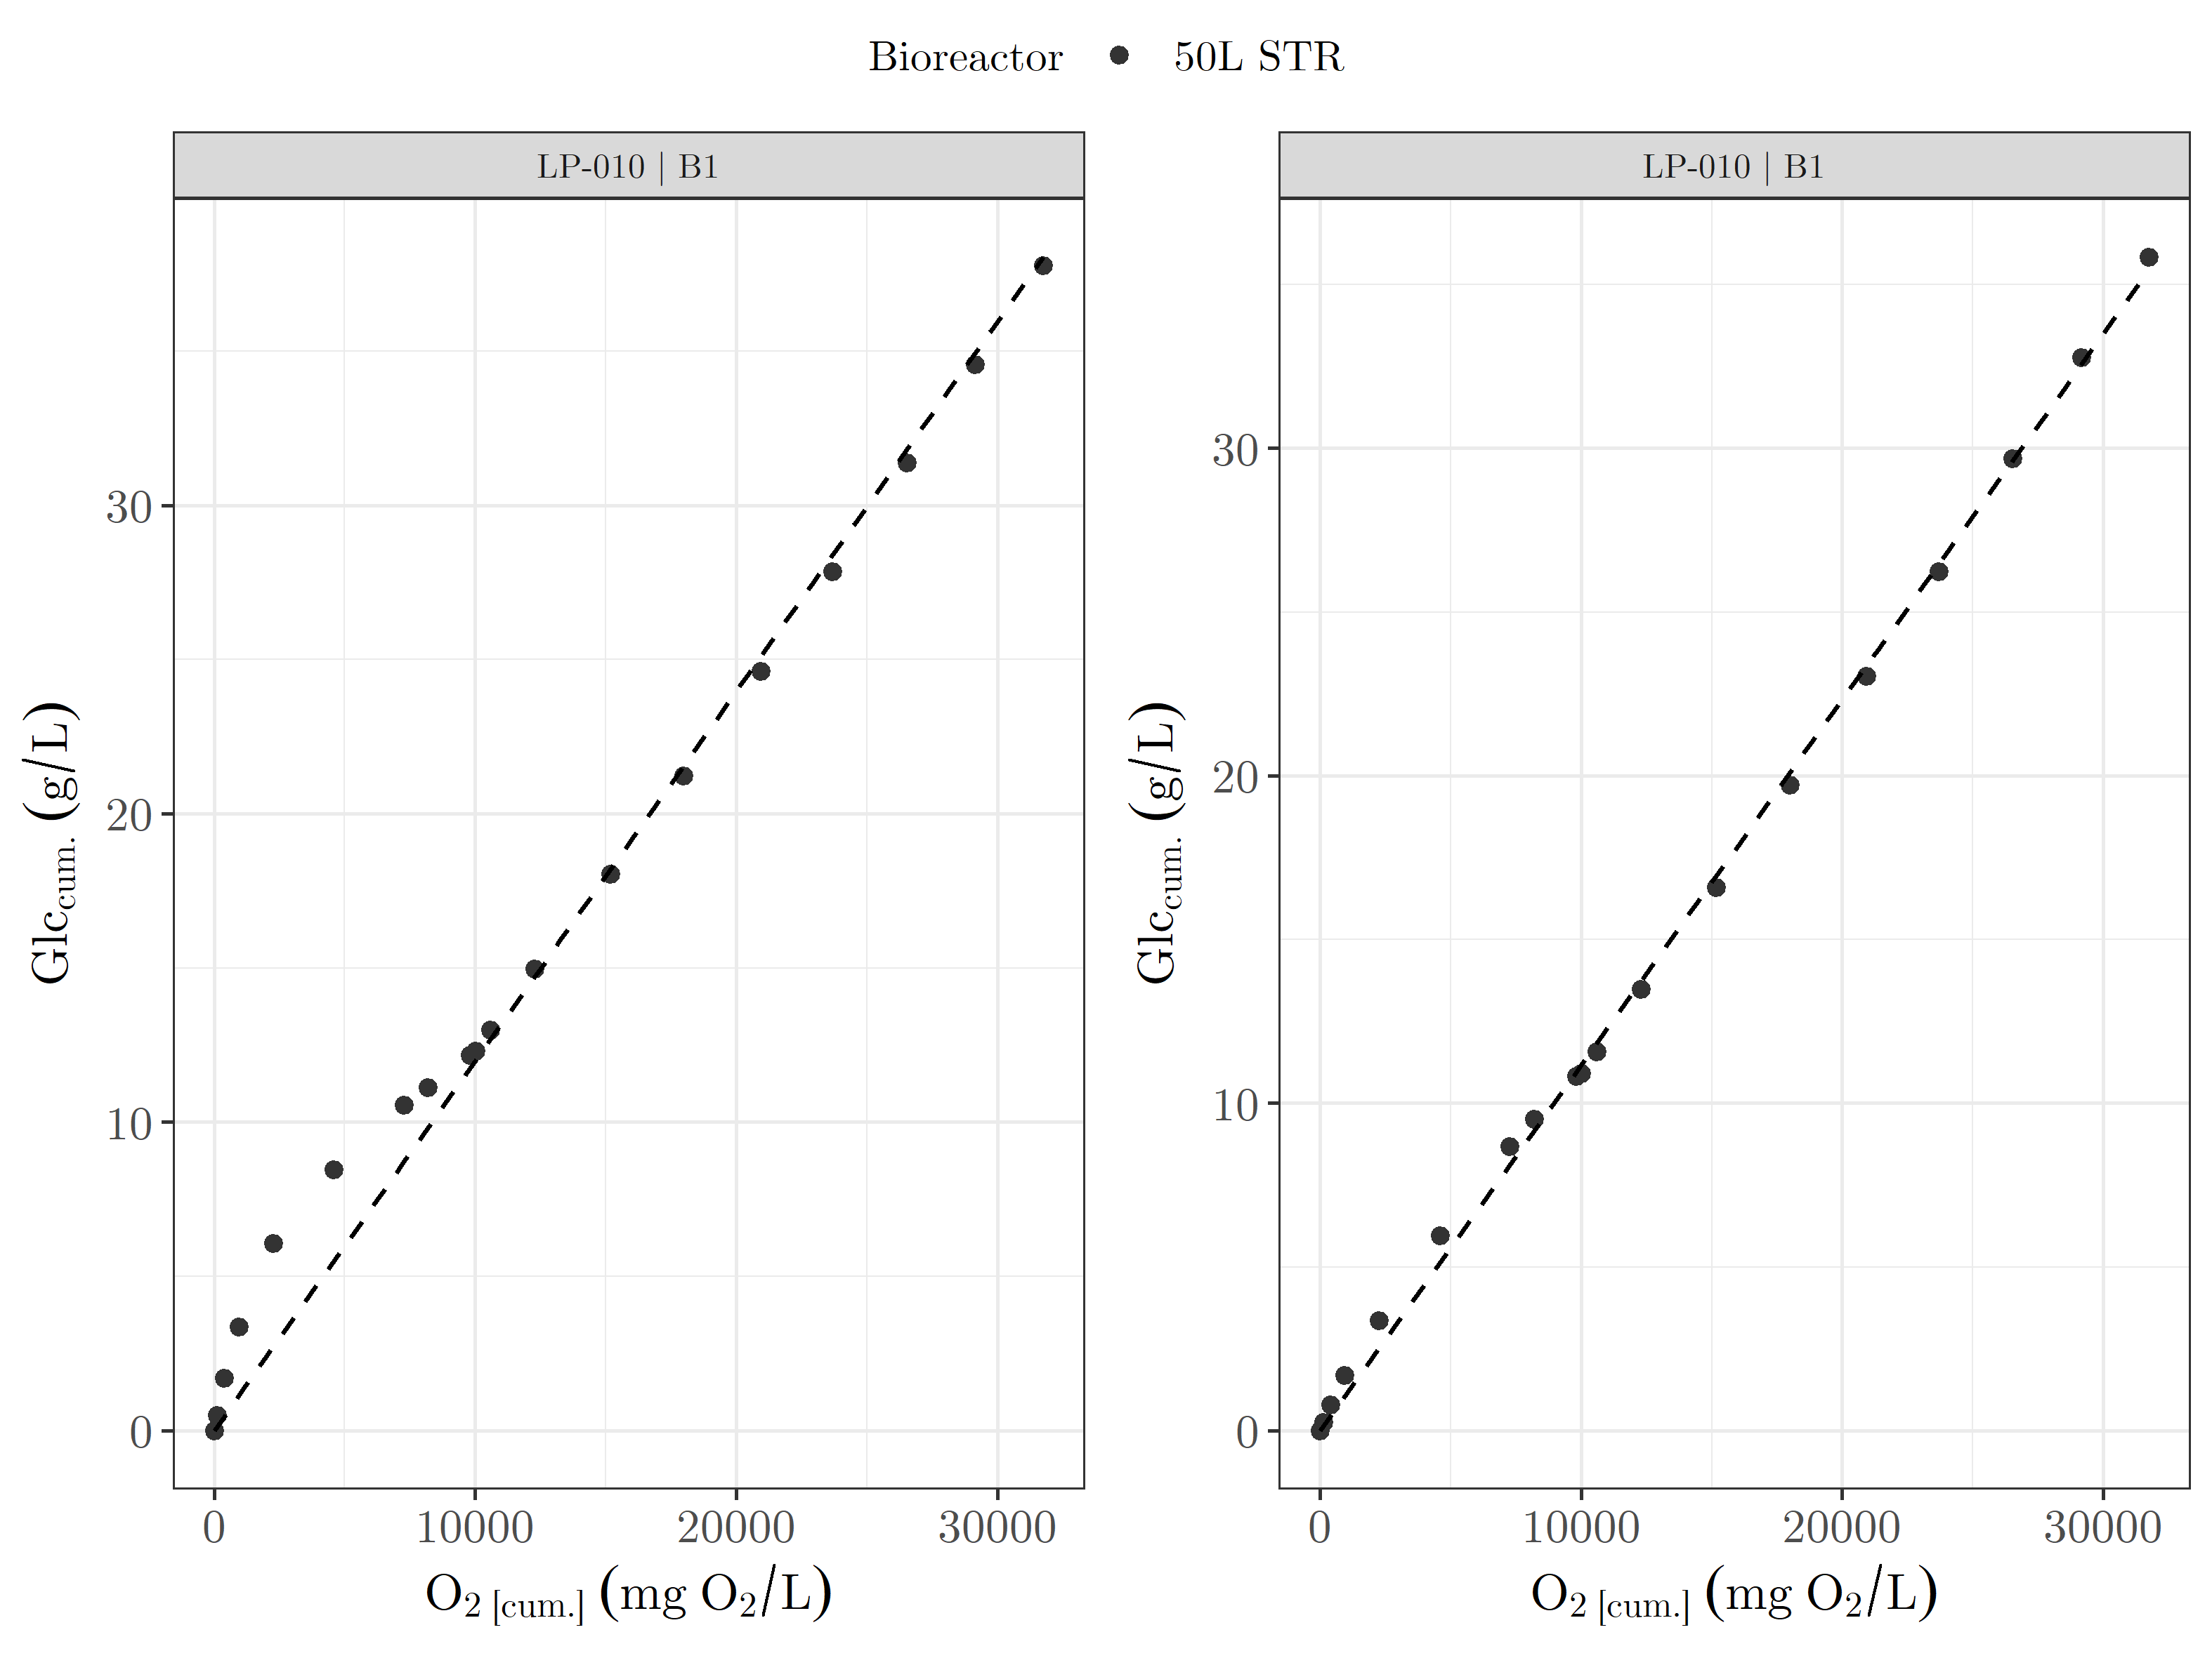 | 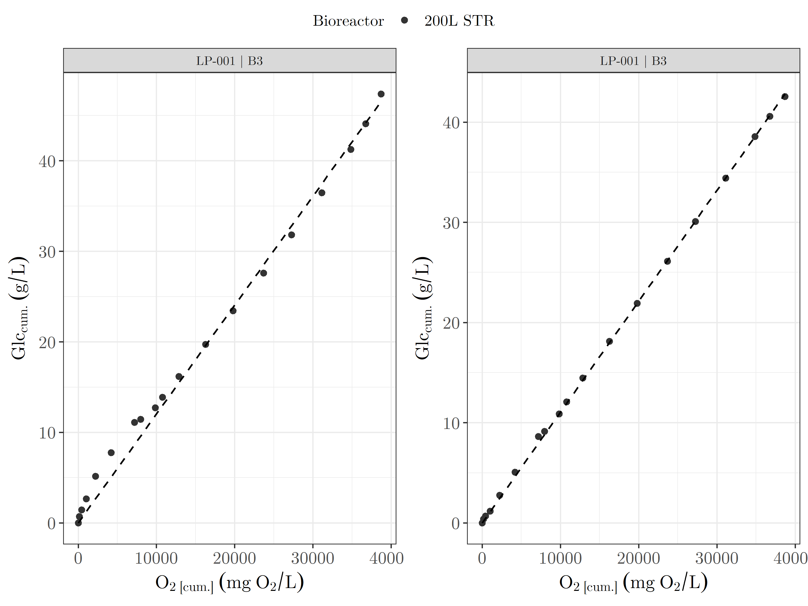
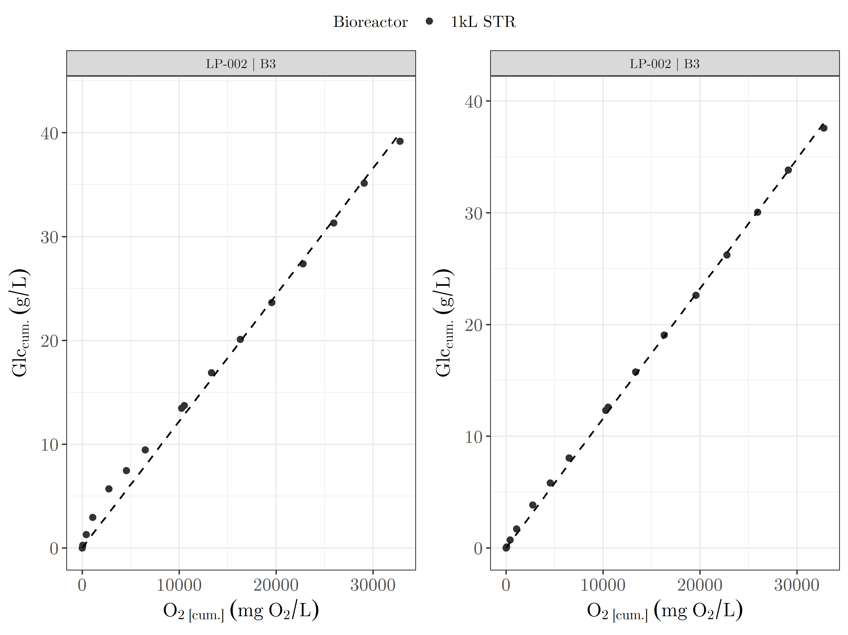 | 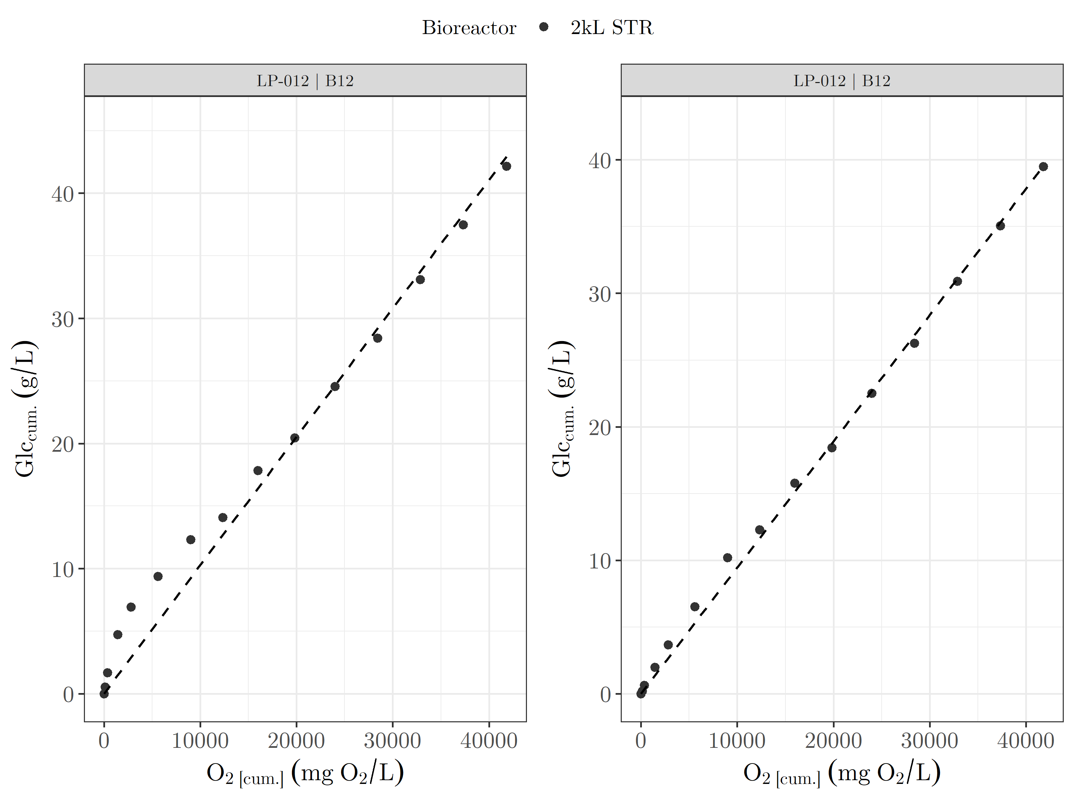

Figure S1 Effect of lactate metabolism on the correlation between cumulative oxygen consumption and cumulative glucose utilization for selected fed-batch runs across the different process scales. (left) Correlation obtained without considering lactate production and re-consumption. (right) Correlation obtained after incorporation of lactate production and re-consumption into glucose utilization calculation.

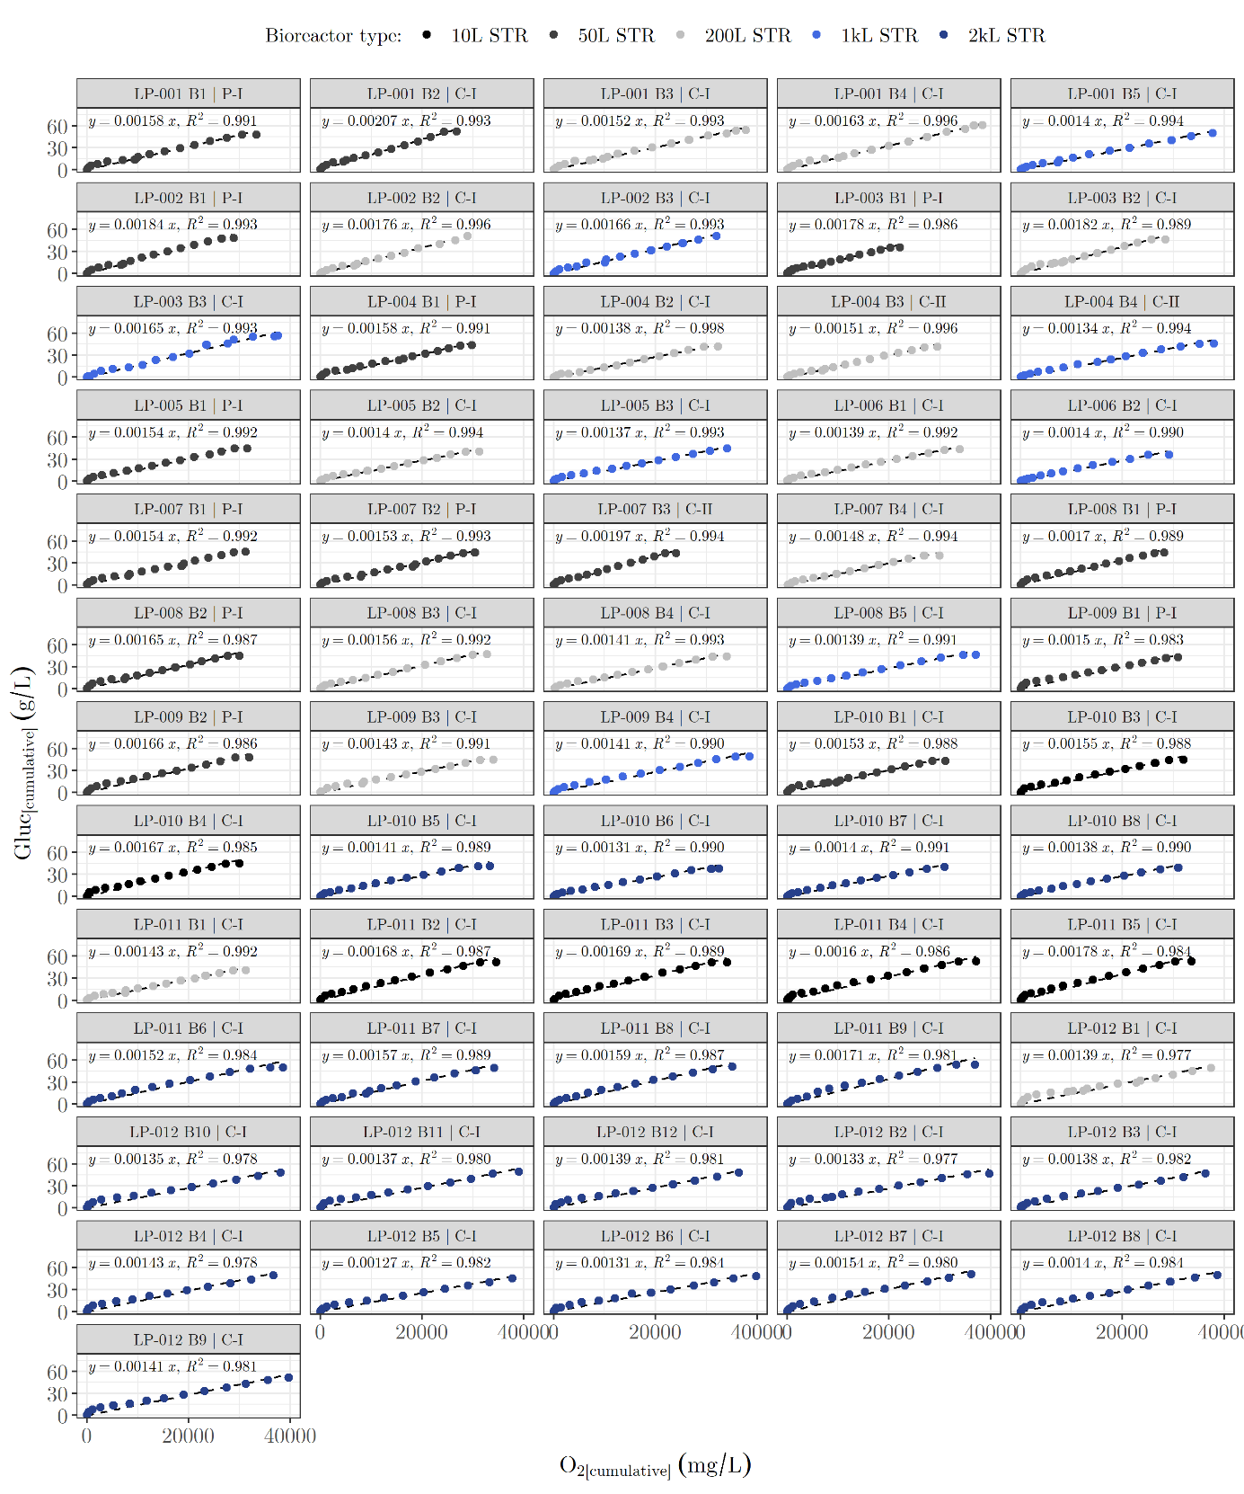
Figure S2 Correlation between cumulative oxygen consumption and cumulative glucose utilization calculated without considering lactate production and re-consumption. Exclusion of lactate metabolism resulted in overestimation of cumulative glucose utilization during process phases characterized by lactate production and subsequent re-consumption, leading to reduced correlation quality and lower R² values compared to the lactate-corrected correlations.

