Biomass and coccolith productions in Chrysotila carterae in high density cultivation system
Matteo Ferrariª, Veronica Busonª, Elisa Palandriª, Manuela Bordiga^{b}, Adriano Carrara ^{c}, Eleonora Sforzaª,

ªDepartment of Industrial Engineering DII, University of Padova, Via Marzolo 9, 35131 Padova, Italy
^{b} National Institute of Oceanography and Applied Geophysics (OGS), Borgo Grotta Gigante 42/C,
34010 Sgonico ( TS ), Italy
^{c} A2A S.p.A., Brescia, Italy

Supplementary Material

Submitted to Applied microbiology and biotechnology

April 2026

*Corresponding author: Eleonora Sforza
e-mail address: eleonora.sforza@unipd.it

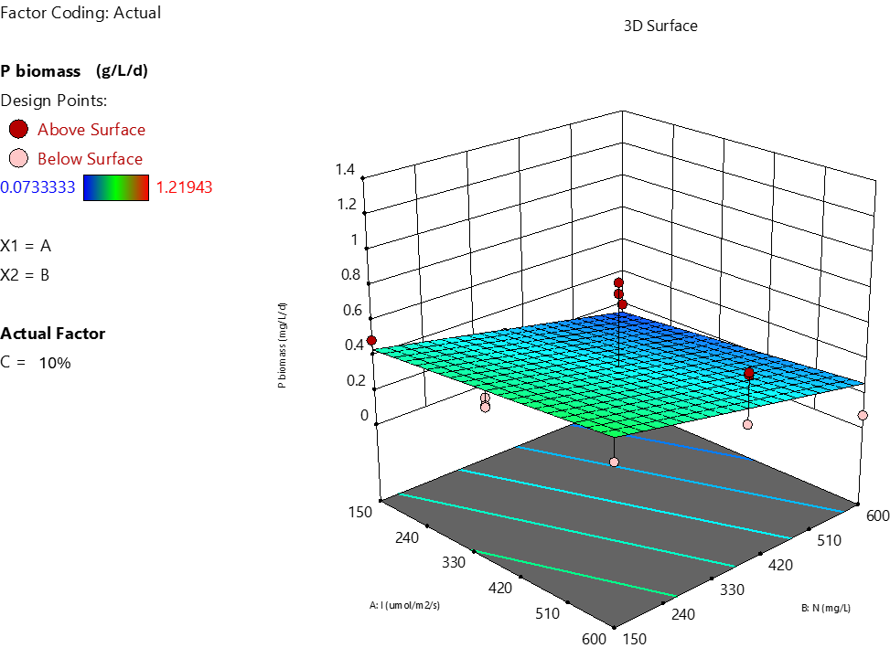
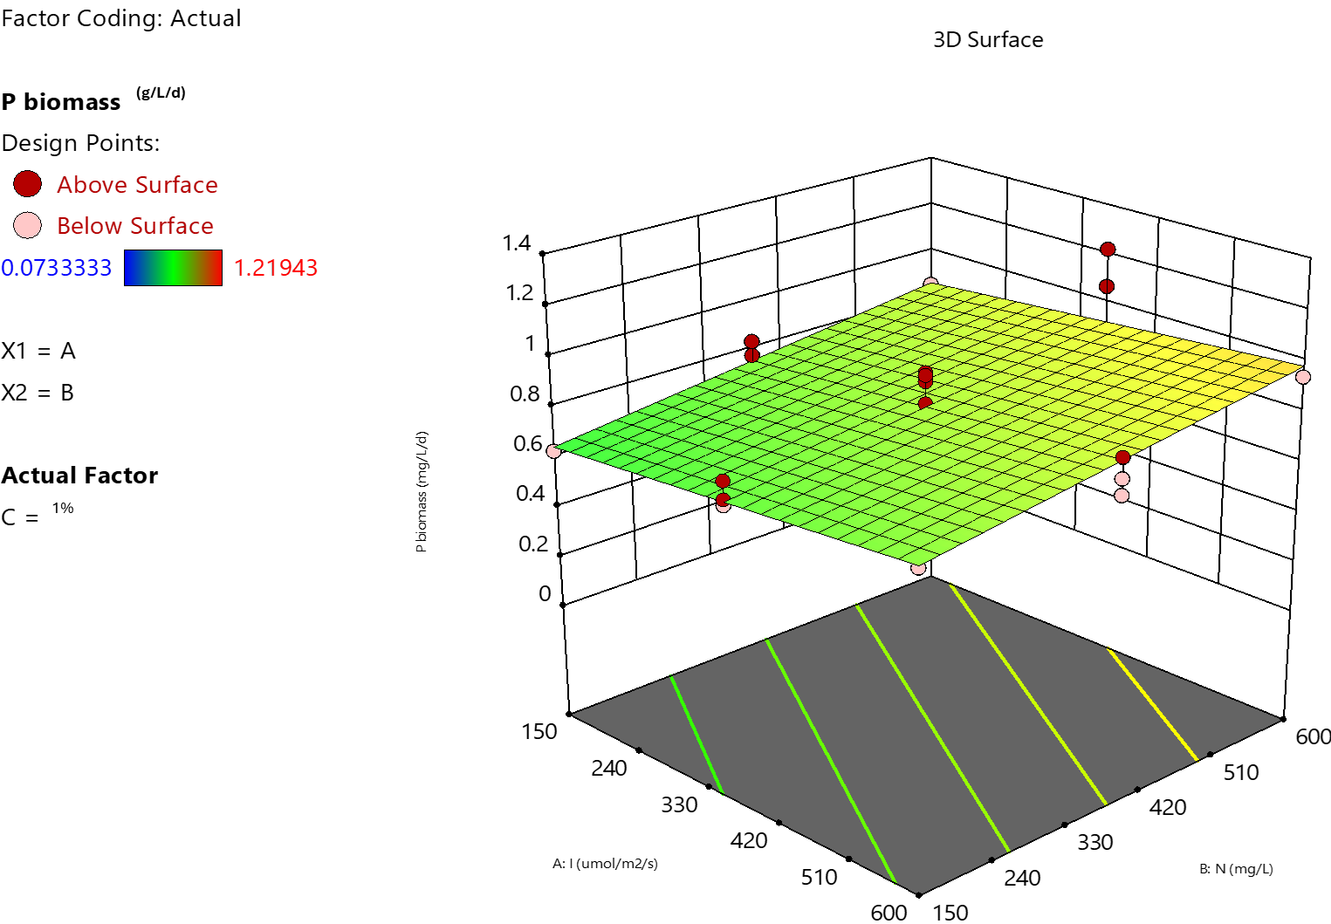 a)
B: Nitrogen (mg L⁻¹)
B: Nitrogen (mg L⁻¹)
Biomass productivity (g L⁻¹ d⁻¹)
A: Light intensity (µmol m⁻² s⁻¹)
A: Light intensity (µmol m⁻² s⁻¹)
Biomass productivity (g L⁻¹ d⁻¹)

b)
Figure S1: graphical representations of the biomass productivity models with the two CO₂ conditions: 1% (a) and 10% (b).

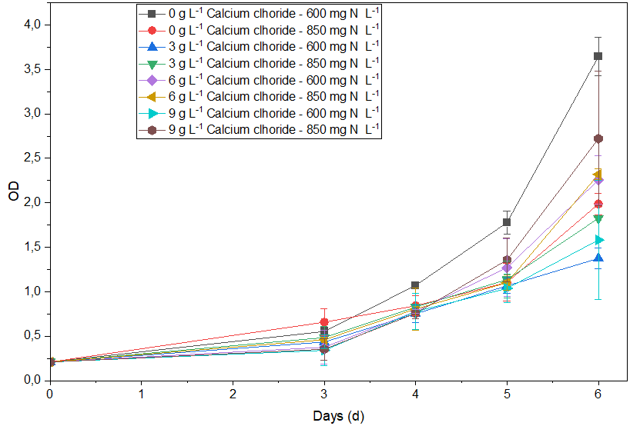
Figure S2: An example of the temporal trend of optical density (OD) observed during a CellDEG experiment with coccolithophores. In this case, daily OD measurements were collected for all tested conditions supplemented with different calcium concentrations.

