Escherichia coli DH5α-loaded fenugreek extract: an effective anticancer combination against human breast cancer cell lines

Hatim M. Hamadnalla¹, Hoda E. Mahmoud^{2*}, Omayma M. Sadek¹, Ahmed S. Sultan^{1*}
1 Department of Biochemistry, Faculty of Science, Alexandria University, Alexandria, Egypt.
2 Department of Biotechnology, Institute of Graduate Studies and Research, Alexandria University, Alexandria, Egypt.

*Corresponding authors:
Dr. Hoda E. Mahmoud, Ph.D.
Associate professor of Biotechnology, Department of Biotechnology, Institute of Graduate Studies and Research, Alexandria University, Alexandria, Egypt.
Tel: (+2) 01228058410
E-mail: hoda_eltalkhawy@alexu.edu.eg
ORCID ID: (https://orcid.org/0000-0003-4726-3281)
Professor Dr. Ahmed Sultan
Professor of Biochemistry and Molecular Therapeutics, Biochemistry Department, Faculty of Science, Alexandria University, Alexandria, Egypt
Tel: +201222267463 Email: dr_asultan@alexu.edu.edu.eg
ORCID ID: (https://orcid.org/0000-0001-6568-1757)

Supplementary Table S1: Phytochemical Screening of fenugreek seeds ethanolic extract
Phytochemical class | Phytochemical test | Result
Saponin | Foam test | positive
Flavonoid | KOH | positive
Tannin | Ferric chloride | positive
Anthraquinones | 10% Ammonia | positive
Alkaloid | Mayer and Wanger | positive

Supplementary Table S2: Quantitative determination and biological activity of Trigonella phytoconstituents
RT | Compound Name | M. formula | %in extract | Biological Activity
12.22 | Epicubenol | C15H26O | 1 | Antibacterial and antiproliferative (Sajjadi et al., 2015) (Benabdesslem, Ghomari, Adli, Mébarki, & Hachem, 2022).
17.51 | n-Hexadecanoic acid | C16H32O2 | 2.76 | antioxidant, antimicrobial, and anti-inflammatory activities, anticancer, Pesticide, Lubricant, Antiandrogenic, Antifungal, Antioxidant, Hypocholesterolemic, Nematicide, Anti-Androgenic, Flavor, Hemolytic, 5-Alphareductase Inhibitor, Potent Antimicrobial Agent, Antimalarial And Antifungal (Ravi & Krishnan, 2017; Siswadi & Saragih, 2021; Zito et al., 2010).
17.98 | Hexadecanoic acid, ethyl ester | C18H32O2 | 3.76 | Antioxidant activity and antimicrobial activity (Guerrero, Vargas, Petricevich, & Sciences, 2017).
19.72 | 9,12-Octadecadienoic acid | C18H32O2 | 13.49 | Anti-inflammatory, Hypocholesterolemic, Cancer Preventive, Hepatoprotective, Nematicide, Insectifuge, Antihistaminic, Antieczemic, Antiacne, 5-Alpha Reductase Inhibitor, Antiandrogenic, Antiarthritic, Anticoronary, Insectifuge (Sahaya Sathish, Vijayakanth, Palani, Thamizharasi, & Vimala).
19.81 | Oleic acid | C18H34O2 | 8.15 | Apoptotic activity, antimicrobial activity and  antioxidant activity (Alabi, Lajide, & Owolabi, 2018).
20.10 | Linoleic acid ethyl ester | C20H38O2 | 19.23 | Hypocholesterolemic, Nematicide, Antiarthritic, Hepatoprotective, Antiandrogenic , Hypocholesterolemic, 5-Alpha reductase inhibitor Antihistaminic, Anticoronary, Insectifuge ,Antieczemic, Antiacne (Sudha, Chidambarampillai, & Mohan, 2013).
20.21 | Ethyl Oleate | C20H38O2 | 7.42 | Antimicrobial, antioxidant (Saravanakumar et al., 2018).
20.59 | Octadecanoic acid, ethyl ester | C20H40O2 | 0.67 | Antioxidant, anti-inflammatory (Ganesh, Mohankumar, & technology, 2017).
21.83 | Pyrrolidine,1-(1-oxo-7,10-hexadecadienyl)- | C20H35NO | 4.37 | Anti-inflammatory effect, cytotoxic (Hussein & Sciences, 2016; Sahaya Sathish et al.).
21.83 | (2E,4E,10E)-N-Isobutylhexadeca-2,4,10-trienamide | C20H35NO | 4.37 | Antibacterial activity (Lalthanpuii et al., 2020).
21.87 | 9,12-Octadecadienoic acid (Z,Z)- | C21H38O4 | 2.63 | anti-inflammatory, antibacterial, antioxidant, antidiabetic activities, Anti-inflammatory, Hypocholesterolemic, Cancer Preventive, Hepatoprotective, Nematicide, Insectifuge, Antihistaminic, Antieczemic, Antiacne, 5-Alpha Reductase Inhibitor, Antiandrogenic, Antiarthritic, Anticoronary, Insectifuge (Manilal, Sujith, Kiran, Selvin, & Shakir, 2009; Sahaya Sathish et al.).
21.87 | Arachidonoyl ethanol amide | C22H37NO2 | 2.63 | Neurotransmitter (Verhoeckx et al., 2011).
24.59 | Diisooctyl phthalate | C24H38O4 | 5.11 | Antimicrobial (Ingole, 2016).
36.83 | Campesterol | C28H48O | 1.04 | cholesterol lowering and anticarcinogenic effects (Choi et al., 2007).
36.83 | Ergost-5-en-3-ol,(3a)-. | C28H48O | 1.04 | Anticancer, antimicrobial (Manjang, Dharma, Darwis, Munaf, & Sciences, 2015; Qais et al., 2021).
36.83 | 5-Cholestene-3-ol,24-methyl | C28H48O | 1.04 | Antiarthritic, Anticancer, Hepatoprotective, Antimicrobial, Antiasthma, Diuretic (Dhayabaran & Thangarathinam, 2016).
38.92 | ç-Sitosterol | C29H50O | 14.02 | Antimicrobial, Anticancer ,Antiarthritic, Antiasthma Diuretic, Anti-inflammatory(Sudha et al., 2013).
40.24 | Lupeol | C30H50O | 2.55 | Antimalarial , Antioxidant, Antiflue Antihyperglycemic, Antitumor Antiviral, Pesticide, Cytotoxic Anti-inflammatory(Sudha et al., 2013).
40.39 | 9,19-Cyclolanost-24-en-3-ol, (3a) | C30H50O | 3.63 | anti-inflammatory, anti-tumor, antioxidant, antibiosis, and anti-Alzheimer’s disease(Kim, Jun, Woo, Rhee, & Kim, 2006)
40.39 | 9,19-Cyclolanost-24-en-3-ol, acetate, (3a) | C32H52O2 | 3.63 | Anti-HIV(Hasan, Artika, & Kuswandi, 2014)
42.16 | Stigmastan-3,5-diene | C29H48 | 1.24 | Antibacterial activity, antioxidant activity and  anticancer activity (Mallu, Vemula, Kante, & Research, 2019).
42.16 | Stigmasta-3,5-diene | C29H48 | 1.24 | Antimicrobial activity, antiproliferative antioxidant, and anticancer activity (Abubakar & Majinda, 2016).

Supplementary Figures

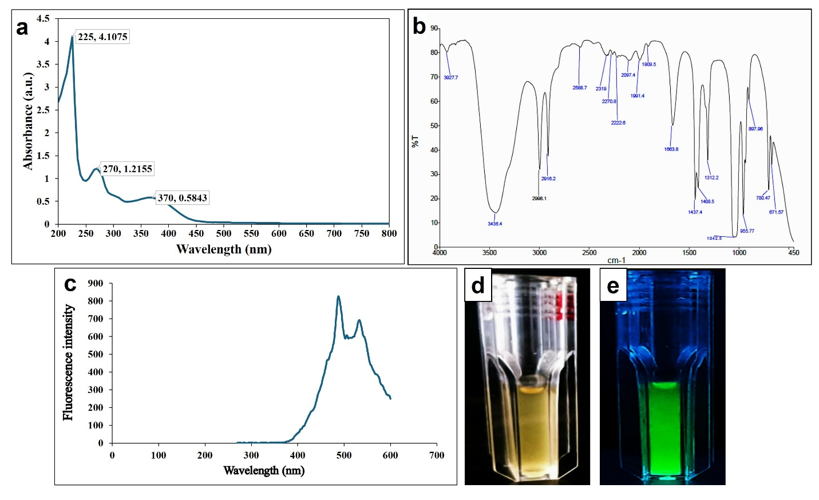

Fig. S1. Comprehensive characterization of Trigonella foenum-graecum ethanolic extract (FEE). (a) UV/visible spectroscopy reveals the absorbance profile of FEE. (b) FTIR spectrum identifies key functional groups present in the extract. (c) Photoluminescence (PL) spectrum illustrates the optical properties of FEE. (d) FEE under normal light shows a yellow color. (e) FEE under UV light (365 nm) exhibits strong green fluorescence.

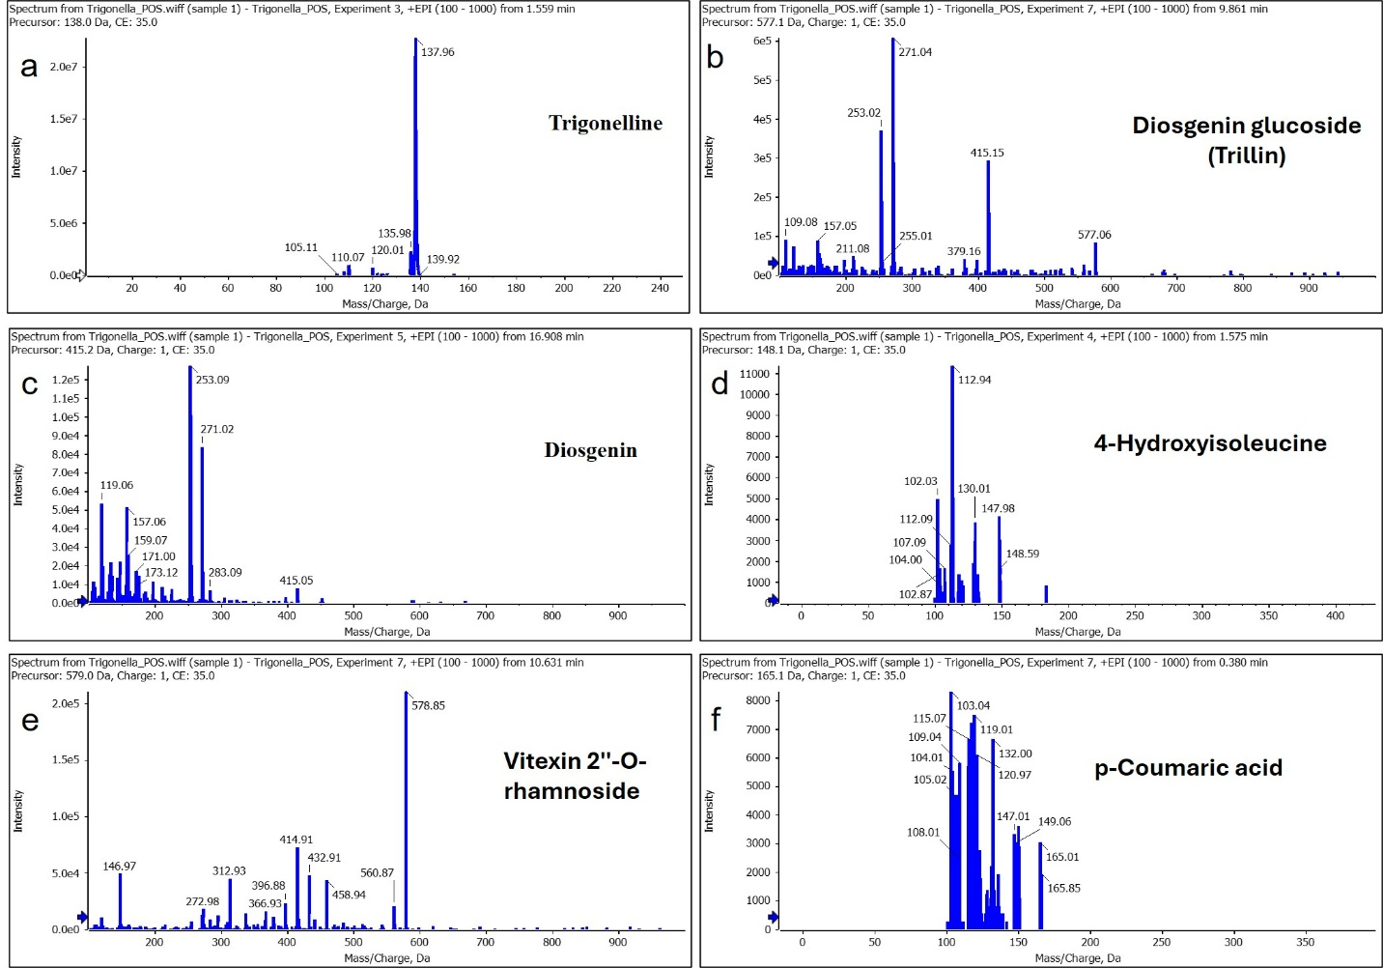

Supplementary Fig. S2. LC-MS chromatogram of FEE in positive (POS) ionization mode. Major compounds detected include trigonelline, diosgenin, trillin, 4-hydroxyisoleucine, vitexin 2''-O-rhamnoside, and p-coumaric acid.

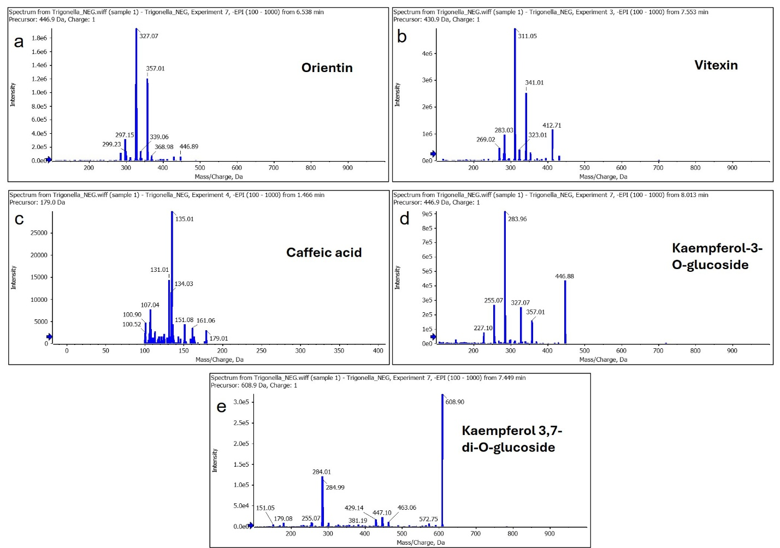

Supplementary Fig. S2. LC-MS chromatogram of fenugreek ethanolic extract (FEE) in negative (NEG) ionization mode. Major compounds detected include orientin, vitexin, caffeic acid, kaempferol-3-O-glucoside, and kaempferol 3,7-di-O-glucoside.

Abubakar, M. N., & Majinda, R. R. J. M. (2016). GC-MS analysis and preliminary antimicrobial activity of Albizia adianthifolia (Schumach) and Pterocarpus angolensis (DC). 3(1), 3.
Alabi, K., Lajide, L., & Owolabi, B. J. J. o. C. S. o. N. (2018). Biological activity of oleic acid and its primary amide: Experimental and Computational studies. 43(2).
Benabdesslem, Y., Ghomari, S., Adli, D. E. H., Mébarki, M., & Hachem, K. J. J. o. E. O. B. P. (2022). Chemical composition and antibacterial activity of essential oil derived from the leaves of Argania spinosa (L.) grown in Northwestern Algeria. 25(1), 103-110.
Choi, J. M., Lee, E. O., Lee, H. J., Kim, K. H., Ahn, K. S., Shim, B. S., . . . Kim, S. H. J. P. R. (2007). Identification of campesterol from Chrysanthemum coronarium L. and its antiangiogenic activities. 21(10), 954-959.
Dhayabaran, V. V., & Thangarathinam, J. J. J. N. P. R. (2016). Gas chromatography-mass spectroscopy analysis of Senna uniflora (Mill.) Irwin and barneby whole plant. 2(1), 37-39.
Ganesh, M., Mohankumar, M. J. J. o. f. s., & technology. (2017). Extraction and identification of bioactive components in Sida cordata (Burm. f.) using gas chromatography–mass spectrometry. 54, 3082-3091.
Guerrero, R. V., Vargas, R. A., Petricevich, V. L. J. I. J. o. P., & Sciences, P. (2017). Chemical compounds and biological activity of an extract from bougainvillea x buttiana (var. rose) holttum and standl. 9(3), 42-46.
Hasan, A., Artika, I., & Kuswandi, T. J. G. J. B. A. H. S. (2014). Analysis of active components of Trigona spp. propolis from Pandeglang Indonesia. 3, 215-219.
Hussein, H. M. J. R. J. o. P. B., & Sciences, C. (2016). Analysis of trace heavy metals and volatile chemical compounds of Lepidium sativum using atomic absorption spectroscopy, gas chromatography-mass spectrometric and fourier-transform infrared spectroscopy. 7(4), 2529-2555.
Ingole, S. N. J. W. S. N. (2016). Phytochemical analysis of leaf extract of Ocimum americanum L.(Lamiaceae) by GCMS method. (37), 76-87.
Kim, J.-S., Jun, D.-Y., Woo, M.-H., Rhee, I.-K., & Kim, Y.-H. J. J. o. L. S. (2006). Chemical composition and antitumor apoptogenic activity of methylene chloride extracts from the leaves of Zanthoxylum schinifolium. 16(3), 546-554.
Lalthanpuii, P., Laldinpuii, Z., Lalhmangaihzuala, S., Vanlaldinpuia, K., Lalruatfela, B., Lalnunfela, C., . . . Lalchhandama, K. J. J. o. E. B. (2020). Chemical profiling of alkylamides from the" herbal Botox", Acmella oleracea, cultivated in Mizoram and their pharmacological potentials. 41(4), 845-850.
Mallu, M. R., Vemula, S., Kante, R. K. J. J. o. P. S., & Research. (2019). Molecular docking studies of bioactive compounds from Stevia rebaudiana for its anti-cancer activity. 11(5), 2016-2018.
Manilal, A., Sujith, S., Kiran, G. S., Selvin, J., & Shakir, C. J. G. J. P. (2009). Cytotoxic potentials of red alga, Laurencia brandenii collected from the Indian coast. 3(2), 90-94.
Manjang, Y., Dharma, A., Darwis, D., Munaf, E. J. R. J. o. P., Biological, & Sciences, C. (2015). Steroids from n-hexane fraction of the stem bark of shorea singkawang mig and anticancer activity as tested with Murin leukemia P-388 cells. 6(2), 1315-1320.
Qais, F. A., Ahmad, I., Husain, F. M., Alomar, S. Y., Ahmad, N., Albalawi, F., . . . Technique. (2021). Interference of quorum sensing regulated bacterial virulence factors and biofilms by Plumbago zeylanica extract. 84(12), 3150-3160.
Ravi, L., & Krishnan, K. J. A. J. C. B. (2017). Research article cytotoxic potential of N-hexadecanoic acid extracted from Kigelia pinnata leaves. 12, 20-27.
Sahaya Sathish, S., Vijayakanth, P., Palani, R., Thamizharasi, T., & Vimala, A. (2014). UV-VIS AND FTIR SPECTROSCOPIC STUDIES ON THE MEDICINAL FERN VITTARIA ELONGATA SW. Conference: National Level Conference on Recent Innovation and Future Trends.
Sajjadi, S.-E., Jamali, M., Shokoohinia, Y., Abdi, G., Shahbazi, B., & Fattahi, A. J. P. r. (2015). Antiproliferative evaluation of terpenoids and terpenoid coumarins from Ferulago macrocarpa (Fenzl) Boiss. fruits. 7(4), 322.
Saravanakumar, K., Chelliah, R., Ramakrishnan, S. R., Kathiresan, K., Oh, D.-H., & Wang, M.-H. J. M. p. (2018). Antibacterial, and antioxidant potentials of non-cytotoxic extract of Trichoderma atroviride. 115, 338-342.
Siswadi, S., & Saragih, G. S. (2021). Phytochemical analysis of bioactive compounds in ethanolic extract of Sterculia quadrifida R. Br. Paper presented at the AIP Conference Proceedings.
Sudha, T., Chidambarampillai, S., & Mohan, V. J. J. o. a. p. s. (2013). GC-MS analysis of bioactive components of aerial parts of Fluggea leucopyrus Willd.(Euphorbiaceae). 3(5), 126-130.
Verhoeckx, K. C., Voortman, T., Balvers, M. G., Hendriks, H. F., Wortelboer, H. M., Witkamp, R. F. J. B. e. B. A.-M., & Lipids, C. B. o. (2011). Presence, formation and putative biological activities of N-acyl serotonins, a novel class of fatty-acid derived mediators, in the intestinal tract. 1811(10), 578-586.
Zito, P., Sajeva, M., Bruno, M., Maggio, A., Rosselli, S., Formisano, C., & Senatore, F. J. M. (2010). Essential oil composition of stems and fruits of Caralluma europaea NE Br.(Apocynaceae). 15(2), 627-638.

