Supplementary material
Rhodococcus erythropolis ICBD2 membrane and cell wall adaptation to long-chain alkane degradation
Teresa Esparza-Correa^{1,2}, Roberto E. Durán^{1,2}, Ximena Baéz-Matus^{1,2}, Meina Neumann-Schaal³, Jacqueline Wolf³, Imen Nouioui³, Yvonne Mast³, Sergio A. Álvarez⁴, Michael Seeger^{1,2*}
¹Molecular Microbiology and Environmental Biotechnology Laboratory, Department of Chemistry & Center of Biotechnology Daniel Alkalay Lowitt, Universidad Técnica Federico Santa María, Avenida España 1680, 2390123 Valparaíso, Chile
²Millennium Nucleus Bioproducts, Genomics and Environmental Microbiology (BioGEM), Avenida España 1680, 2390123 Valparaíso, Chile.
³Leibniz Institute DSMZ–German Collection of Microorganisms and Cell Cultures GmbH, 38124 Braunschweig, Germany.
⁴Department of Biochemistry and Molecular Biology, Faculty of Chemical and Pharmaceutical Sciences, Universidad de Chile, 7800003 Santiago, Chile.
* Corresponding author: michael.seeger@usm.cl; michael.seeger@gmail.com

Contents
Table S1. Accession codes of Rhodococcus AlkB enzymes compared in sequence alignment
Table S2. Primers used for RT-qPCR experiments
Table S3. Genes involved in hydrocarbon, fatty acid and mycolic acid metabolism in R. erythropolis ICBD2
Table S4. Global alignment of AlkB amino acid sequences in R. erythropolis ICBD2
Table S5. Global alignment of AlkB amino acid sequences of R. erythropolis ICBD2 and other Rhodococcus
Fig S1. Quality controls of the RNA extracted from ICBD2 cells grown on acetate or n-eicosane
Fig S2. Growth of R. erythropolis ICBD2 on n‑eicosane or acetate determined counting colony forming units
Fig S3. Cellular fatty acid composition of R. erythropolis strain ICBD2 grown on n‑eicosane or acetate as sole carbon and energy sources
Fig S4. Mycolic acid composition of R. erythropolis strain ICBD2 grown on acetate or n‑eicosane as sole carbon and energy sources

Table S1. Accession codes of Rhodococcus AlkB enzymes compared in sequence alignment
Gene | Protein | Function | Organism | Access number (Uniprot code)
alkB1 | AlkB1 | Alkane-monooxygenase | Rhodococcus sp. Q15 | AF388181 (Q93DN3)
alkB2 | AlkB2 | Alkane-monooxygenase | Rhodococcus sp. Q15 | AF388182 (Q93DM7)
alkB3 | AlkB3 | Alkane-monooxygenase | Rhodococcus sp. Q15 | AF388179 (Q93DN5)
alkB4 | AlkB4 | Alkane-monooxygenase | Rhodococcus sp. Q15 | AF388180 (Q93DN4)
alkB1 | AlkB1 | Alkane-monooxygenase | R. erythropolis NRRLB-16531 | AJ009586 (Q9XAU0)
alkB2 | AlkB2 | Alkane-monooxygenase | R. erythropolis NRRLB-16531 | AJ297269 (Q9AE68)
alkB3 | AlkB3 | Alkane-monooxygenase | R. erythropolis NRRLB-16531 | AJ301876 (Q93JS2)
alkB4 | AlkB4 | Alkane-monooxygenase | R. erythropolis NRRLB-16531 | AJ301877 (Q93JS1)
alkB1 | AlkB1 | Alkane-monooxygenase | R. erythropolis KB1 | QIP38132.1
alkB2 | AlkB2 | Alkane-monooxygenase | R. erythropolis KB1 | QIP39561.1
alkB3 | AlkB3 | Alkane-monooxygenase | R. erythropolis KB1 | QIP38598.1
alkB4 | AlkB4 | Alkane-monooxygenase | R. erythropolis KB1 | QIP39866.1
alkB5 | AlkB5 | Alkane-monooxygenase | R. erythropolis KB1 | QIP42937.1
alkB1 | AlkB1 | Alkane-monooxygenase | R. erythropolis X5 | QEX09356.1
alkB2 | AlkB2 | Alkane-monooxygenase | R. erythropolis X5 | QEX10563.1
alkB3 | AlkB3 | Alkane-monooxygenase | R. erythropolis X5 | QEX09721.1
alkB4 | AlkB4 | Alkane-monooxygenase | R. erythropolis X5 | QEX10793.1
alkB5 | AlkB5 | Alkane-monooxygenase | R. erythropolis X5 | QEX13571.1

The access codes for each alkB gene identified in Rhodococcus strains used for the comparison of alkane monooxygenases with R. erythropolis ICBD2 are presented (Whyte et al., 2002; Delegan et al., 2019; Luo et al., 2019; Huang et al., 2023). The numbering of each alkB gene copy is based on comparison with alkB genes of R. erythropolis NRRLB-16531 (Whyte et al. 2002).

Table S2. Primers used for RT-qPCR experiments
Gene |  | Oligo name | Oligo sequence (5'-3') | Product Lenght (bp) | Tm°C
rsmG |  | rsmG F | GTTGACTGGGACGAACAAGAGA | 87 | 56.8
rsmG |  | rsmG R | CGTTGCCAGGGATTGGTAGTA | 87 | 56.8
almA |  | almA F | GCGTGGAAAGTGGTCAACAA | 113 | 56.4
 |  | almA R | CTATCAGGCACGACAGGAATGT | 113 | 56.4
ladA |  | ladA F | GTCTACACGGACCCCTCCAA | 90 | 58.0
 |  | ladA R | CGGAGAAGGTTCGGAGATGTG | 90 | 58.0
alkB1 |  | alkB1 F | GCATCTGCACTAACGTCTTCCT | 151 | 57.3
 |  | alkB1 R | GGGACTGTTGCGAGCATAATCA | 151 | 57.3
alkB2 |  | alkB2 F | GTCGCAGGAATCGGGATCAA | 95 | 57.6
 |  | alkB2 R | AACGACTGAGCCAGAGTGATCT | 95 | 57.6
alkB5 |  | alkB5 F | ACTCACCGGTCGAAGCCGAAA | 134 | 60.0
 |  | alkB5 R | CCAGAACAATCCGAGACGAAGGT | 134 | 60.0
fasI |  | fasI F | GTCGACGAAGAAGAAGGTGAGA | 147 | 57.7
 |  | fasI R | CGGGTTACCGGCTACATCCA | 147 | 57.7
kasA |  | kasA F | GAAACCGAGGAACACGCAAAG | 174 | 56.8
 |  | kasA R | CTTGATGTCGGACTTCGTCAGT | 174 | 56.8
inhA |  | inhA F | ACAACTGGATGGGTGTCTCCAA | 183 | 58.4
 |  | inhA R | CGGTGTTCAGCTTGTCCAACTC | 183 | 58.4
desA1 |  | desA1 F | CCGCATGGAACACATGACAAAC | 166 | 56.9
 |  | desA1 R | CTGAAGCATCTTGTCGGCAATC | 166 | 56.9

Table S3. Genes involved in hydrocarbon, fatty acid and mycolic acid metabolism in R. erythropolis ICBD2
Rhodococcus erythropolis ICBD2 |  |  |  | Model organism
Gene | Locus tag |  | DFAST Annotation | Protein | Function | Identity (%) | Organism | Accesion N°
almA | ACV96D_26350 |  | Flavin-binding monooxygenase | AlmA | Probable FAD-binding monooxygenase AlmA | 53 | Acinetobacter sp. | A5H9N6
ladA | ACV96D_22015 |  | Monooxygenase | LadA2 | LLM class flavin-dependent oxidoreductase | 59 | Acinetobacter pittii SW-1 | NMI110 90.1
alkB1 | ACV96D_03880 |  | Alkane-1- monooxygenase | AlkB | Alkane monooxygenase | 99 | Rhodococcus erythropolis PR4 | C0ZPX6
alkB2 | ACV96D_10690 |  | Alkane-1- monooxygenase | AlkB | Alkane monooxygenase | 100 | Rhodococcus erythropolis PR4 | C0ZWY 5
alkB3 | ACV96D_26645 |  | Alkane-1- monooxygenase | AlkB | Alkane monooxygenase | 71 | Rhodococcus sp. Q15 | Q93DN5
alkB4 | ACV96D_11635 |  | Alkane-1- monooxygenase | AlkB | Alkane monooxygenase | 73 | Rhodococcus sp. Q15 | Q93DN5
alkB5 | ACV96D_31060 |  | Alkane-1- monooxygenase | AlkB | Alkane monooxygenase | 73 | Rhodococcus sp. Q15 | Q93DN5
rubA1 | ACV96D_03885 |  | Rubredoxin | Rubredoxin | Electron transfer and iron ion binding | 96 | Rhodococcus erythropolis PR4 | C0ZPX7
rubA2 | ACV96D_03890 |  | Rubredoxin | Rubredoxin 2 | Electron transfer and iron ion binding | 100 | Rhodococcus erythropolis (Arthrobacter picolinophilus) | Q9AE63
rubA3 | ACV96D_10695 |  | Rubredoxin | Rubredoxin 3 | Electron transfer and iron ion binding | 100 | Rhodococcus erythropolis (Arthrobacter picolinophilus) | P0A4E8
rubA4 | ACV96D_10700 |  | Rubredoxin | Rubredoxin 4 | Electron transfer and iron ion binding | 100 | Rhodococcus erythropolis (Arthrobacter picolinophilus) | P0A4F0
rubB | ACV96D_03895 |  | Pyridine nucleotide-disulfide oxidoreductase | Rubredoxin reductase | rubredoxin reductase activity | 45 | Rhodococcus opacus R7 | A0A059WQF1
tetR (alkU) | ACV96D_03900 |  | TetR family transcriptional regulator | TetR (AlkU) | transcriptional regulator | 99 | Rhodococcus qingshengii | WP_387385201.1
tetR (alkU) | ACV96D_10705 |  | TetR family transcriptional regulator | TetR (AlkU) | transcriptional regulator | 99 | Rhodococcus qingshengii | WP_387385201.1
ethA |  | ACV96D_23915 | Flavin monooxygenase binding family protein | Monooxygenase EthA which contains FAD | Baeyer-Villiger monooxygenase | 53 | Mycobacterium tuberculosis | P9WNF9
PA1538 |  | ACV96D_20090 | 4-Hydroxyacetophenone monooxygenase | BVMO | Baeyer-Villiger monooxygenase | 48 | Pseudomonas aeruginosa PAO1 | Q9I3H5
pamO |  | ACV96D_06685 | Cyclohexanone | PamO | Phenylacetone monooxygenase | 52 | Thermobifida fusca YX | Q47PU3
cyp125 |  | ACV96D_04380 | Cytochrome P450 | C26-steroid monooxygenase | Cholest-4-en-3-one 26- monooxygenase | 88 | Rhodococcus jostii RHA1 | Q0S7M1
cyp125 |  | ACV96D_07445 | Cytochrome P450 | C26-steroid monooxygenase | Cholest-4-en-3-one 26- monooxygenase | 88 | Rhodococcus jostii RHA1 | Q0S7M1
RER_33 720 |  | ACV96D_15935 | Cytochrome P450 | Cytochrome P450 | Cytochrome P450 monooxygenase | 99 | Rhodococcus erythropolis PR4 | C1A0E5
RER_33 790 |  | ACV96D_15970 | Cytochrome P450 | Cytochrome P450 | Cytochrome P450 monooxygenase | 100 | Rhodococcus erythropolis PR4 | C1A0F2
RER_08 960 |  | ACV96D_04225 | Cytochrome P450 | Cytochrome P450 | Cytochrome P450 monooxygenase | 99 | Rhodococcus erythropolis PR4 | C0ZQC6
RER_33 770 |  | ACV96D_15960 | Cytochrome P450 | Cytochrome P450 51 | Cytochrome P450 monooxygenase | 99 | Rhodococcus erythropolis PR4 | C1A0F0
RER_50 030 |  | ACV96D_24425 | Cytochrome P450 | Cytochrome P450 | Cytochrome P450 monooxygenase | 99 | Rhodococcus erythropolis PR4 | C0ZQE3
aldh |  | ACV96D_02325 | Aldehyde dehydrogenase | Aldehyde dehydrogenase | Dehydrogenation of aldehydes | 100 | Rhodococcus erythropolis DN1 | EQM29719.1
aldh |  | ACV96D_03370 | Aldehyde dehydrogenase | Aldehyde dehydrogenase | Dehydrogenation of aldehydes | 99 | Rhodococcus sp. AQ5-07 | WP_113682081.1
adh |  | ACV96D_09015 | Alcohol dehydrogenase | NDMA-dependent alcohol dehydrogenase | Dehydrogenation of alcohols | 100 | Rhodococcus sp. ARP2 | WP_047889524.1
adh |  | ACV96D_12540 | Alcohol dehydrogenase | Alcohol dehydrogenase | Dehydrogenation of alcohols | 100 | Rhodococcus erythropolis | AKD97438.1
fas I |  | ACV96D_18840 | Fatty acid synthase I | FAS I | Synthase of fatty acids | 100 | Rhodococcus erythropolis | WP_400823683
kasAB |  | ACV96D_17320 | 3-Oxoacyl-[acyl-carrier-protein] synthase 1 KasA | KasAB | Beta-ketoacyl ACP synthase | 100 | Rhodococcus sp. | WP_020969930
inhA |  | ACV96D_14495 | Meromycolic acid enoyl-[acyl-carrier-protein] reductase | InhA | NADH-dependent enoyl-ACP reductase | 100 | Rhodococcus sp. | WP_003944803
desA1 |  | ACV96D_23470 | Acyl-[acyl-carrier-protein] desaturase | DesA1 | Acyl-ACP desaturase | 100 | Rhodococcus sp. | WP_003940492

Table S4. Global alignment of AlkB amino acid sequences in R. erythropolis ICBD2
Sequence 1 | Sequence 2 | (%) Identity
AlkB1 | AlkB2 | 63.8
 | AlkB3 | 53.1
 | AlkB4 | 53.8
 | AlkB5 | 52.0
AlkB2 | AlkB3 | 50.4
 | AlkB4 | 53.1
 | AlkB5 | 50.8
AlkB3 | AlkB4 | 77.5
AlkB3 | AlkB5 | 92.4
AlkB4 | AlkB5 | 76.6

Global alignment of amino acid sequences performed using EMBOSS-Needle. The similarity between each of the five alkane monooxygenase copies identified in R. erythropolis ICBD2 is represented as a percentage. The highest percentage of identity between the different AlkB copies identified in R. erythropolis ICBD2 corresponds to AlkB4 and AlkB5, while the lowest percentage of identity corresponds to AlkB2 and AlkB3.

Table S5. Global alignment of AlkB amino acid sequences of R. erythropolis ICBD2 and other Rhodococcus
R. erythropolis  ICBD2 | Rhodococcus sp.  Q15 (% id) | R. erythropolis  NRRL B-16531  (% id) | R. erythropolis  KB1 (% id) | R. erythropolis X5 (% id)
AlkB1 | 100 | 99.7 | 93.1 | 100
AlkB2 | 99.3 | 98.5 | 98.8 | 99.3
AlkB3 | 70.1 | 69.8 | 69.8 | 69.8
AlkB4 | 98.7 | 99.0 | 93.8 | 99.0
AlkB5 | - | - | 91.3 | 90.5
This study | Whyte et al., 2002 | Whyte et al., 2002 | Luo et al., 2019 | Delegan et al., 2019

Global amino acid sequence alignment performed using EMBOSS-Needle. The identity (percentage) between each of the five alkane monooxygenase copies identified in R. erythropolis ICBD2 against the sequences of AlkB genes identified in Rhodococcus sp. Q15, R. erythropolis NRRL B-16531, R. erythropolis KB1 and R. erythropolis X5 is indicated (Whyte et al., 2002; Delegan et al., 2019; Luo et al., 2019; Huang et al., 2023).

Fig. S1 Quality controls of the RNA extracted from ICBD2 cells grown on acetate or n-eicosane. a) Quality control of the integrity of the RNA extracted from ICBD2 cells grown on acetate (20 mM) or n-eicosane (5 mM). RNA was extracted from ICBD2 cells grown in acetate or n-eicosane following the protocol described in Material and Methods. RNA molecular markers: RiboRuler High Range RNA Ladder (Thermo Scientific). b) DNA contamination quality control of extracted RNA from ICBD2 cells after DNase treatment. RNA extracted from ICBD2 cells grown on acetate or n-eicosane was treated with DNase as described in Material and Methods. The contamination assessment after rsmG gene amplification was analyzed by electrophoresis on agarose gel (1% w/v). DNA molecular markers: 1 kb Plus DNA Ladder (Thermo Scientific). c) Specificity of R. erythropolis ICBD2 gene primers. Amplification products using different primers (3 µL) were analyzed by electrophoresis in agarose gel 1% (w/v). C(+), positive control. C(-), negative control. DNA molecular markers: 1 kb Plus DNA Ladder (Thermo Scientific).

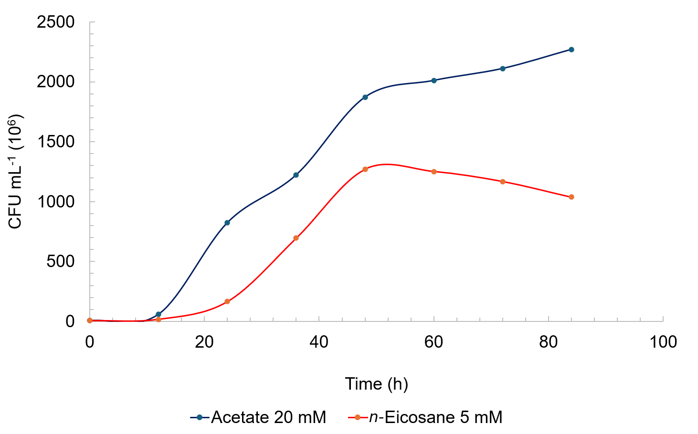

Fig. S2 Growth of R. erythropolis ICBD2 on n‑eicosane or acetate determined by counting colony forming units. Growth curve of R. erythropolis ICBD2 on acetate 20 mM (blue) or n-eicosane 5 mM (red) as sole carbon/energy sources. Colony forming units (CFU)/mL in TSA + NaCl 1.75% w/v agar plates were measured every 12 h between 0 and 84 h. The values ± standard deviation (standard deviation is not visible) of three independent replicates are presented.

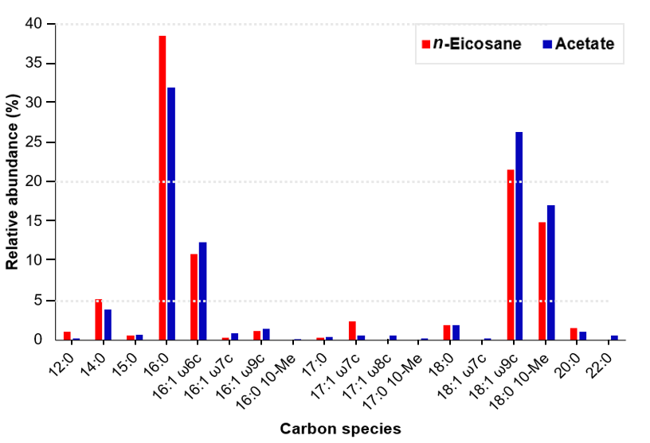
Fig. S3 Cellular fatty acid composition of R. erythropolis strain ICBD2 grown on n‑eicosane or acetate as sole carbon and energy sources. The relative abundance in percentage of each fatty acid of strain ICBD2 grown on n-eicosane 5 mM (red) or acetate 20 mM (blue) is represented. The analysis was performed for one sample per condition; no associated statistics are shown.

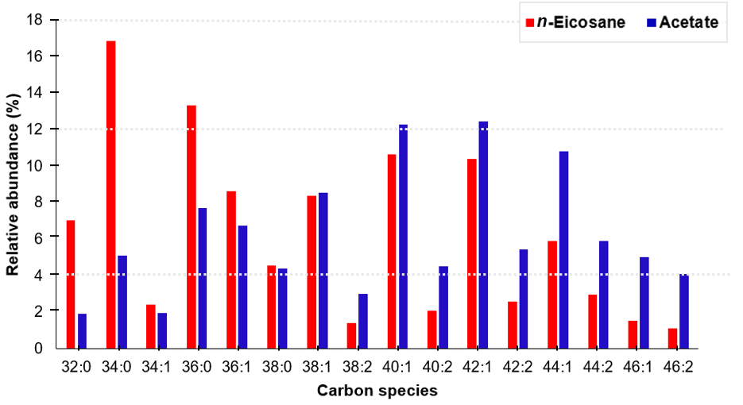
Fig. S4 Mycolic acid composition of R. erythropolis strain ICBD2 grown on acetate or n‑eicosane as sole carbon and energy sources. The relative abundance in percentage of each identified carbon species belonging to the mycolic acids of the ICBD2 strain grown on n-eicosane 5 mM (red) or acetate 20 mM (blue) is represented. The analysis was performed for one sample per condition; no associated statistics are shown.

