Supplementary Figures
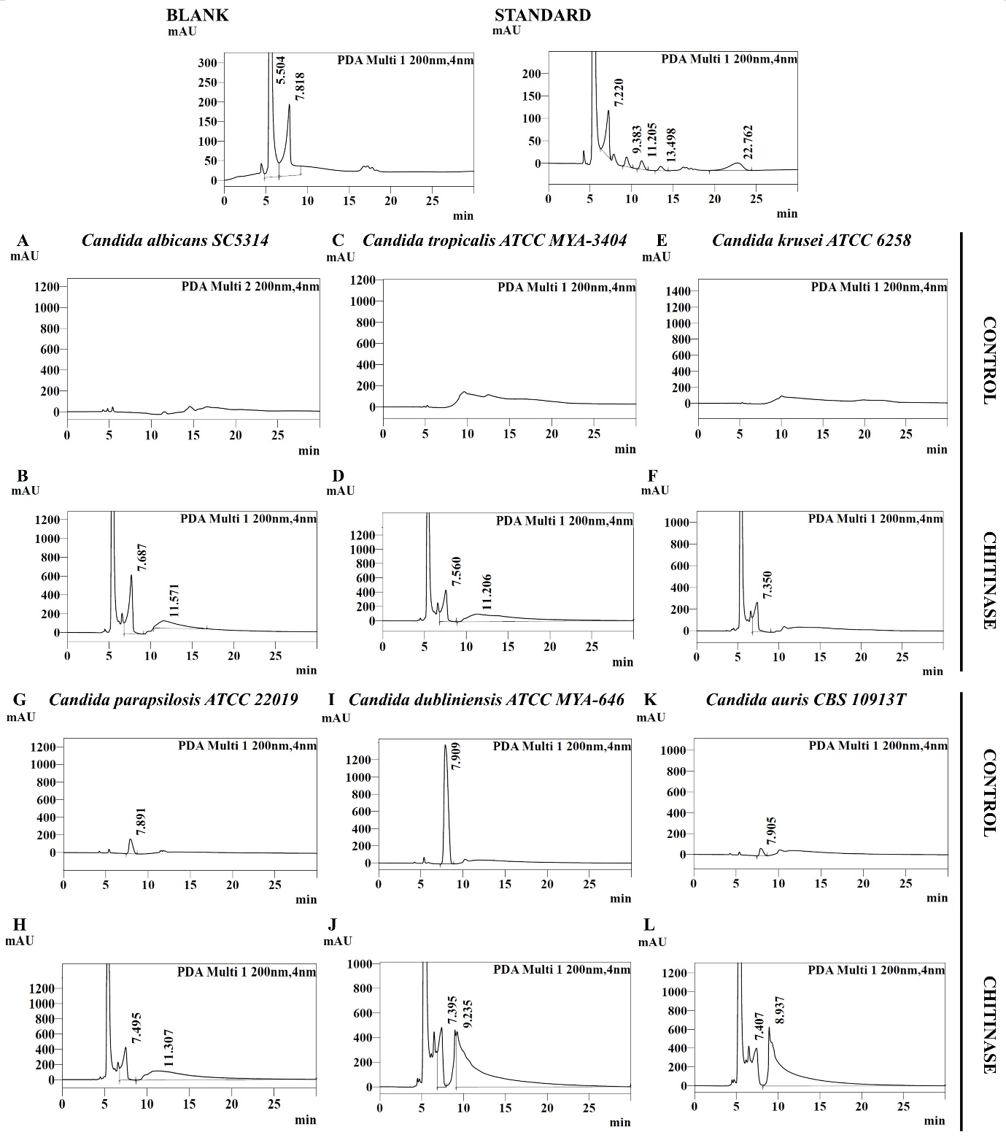

Fig. S1. HPLC analysis of chitooligosaccharides (COS) released from untreated and BtChi-treated Candida cells. The COS standard shows peaks corresponding to monomer (7.220 min), dimer (9.383 min), trimer (11.205 min), and tetramer (13.498 min). HPLC chromatograms of untreated control and BtChi-treated cells are shown for (A-B) C. albicans, (C-D) C. tropicalis, (E-F) C. krusei, (G-H) C. parapsilosis, (I-J) C. dubliniensis, and (K-L) C. auris. BtChi-treated C. albicans, C. tropicalis, and C. parapsilosis showed trimer peaks at 11.571, 11.206, and 11.307 min, respectively. C. krusei and C. auris showed monomeric COS peaks at 7.350 and 7.407 min, while C. dubliniensis showed both monomer and dimer peaks at 7.395 and 9.235 min. Untreated controls showed minor peaks corresponding to blank or unidentified cellular components.

