Supplementary file 2
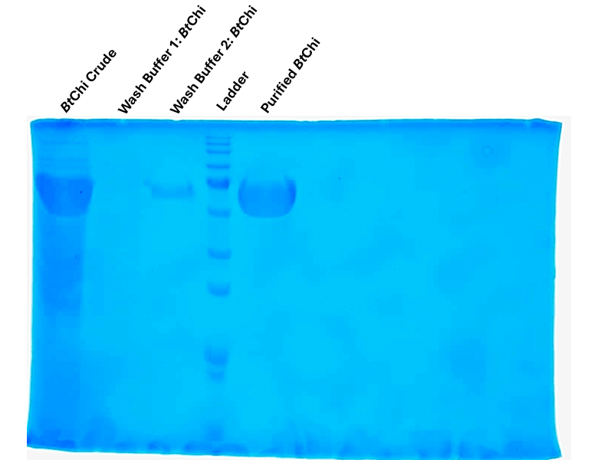

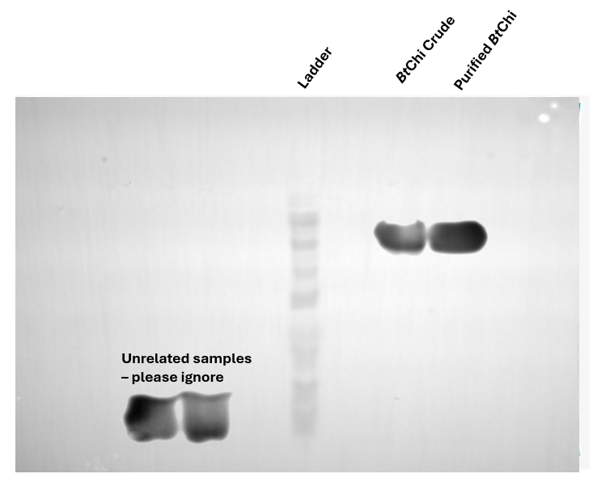

Uncropped SDS-PAGE image of Fig1. (B)

Uncropped Western Blot image of Fig1. (B)

