Supplementary Materials
Applied Microbiology and Biotechnology

Title:
Alterations of the Saccharomyces cerevisiae Proteome by Protein Production are Dependent on Strain Origins

Author List:
Ryan Wei Kwan Wong¹ (ORCID: 0000-0002-9339-2677)
Sahil Chandhok¹ (ORCID: 0009-0001-3763-1805)
Elizabeth Hui¹ (ORCID: 0009-0003-8612-5778)
Thibault Mayor¹* (ORCID: 0000-0002-9289-3939)

1. Department of Biochemistry and Molecular Biology, Michael Smith Laboratories, University of British Columbia, Vancouver, BC V6T 1Z4, Canada

* Corresponding author email:
mayor@msl.ubc.ca

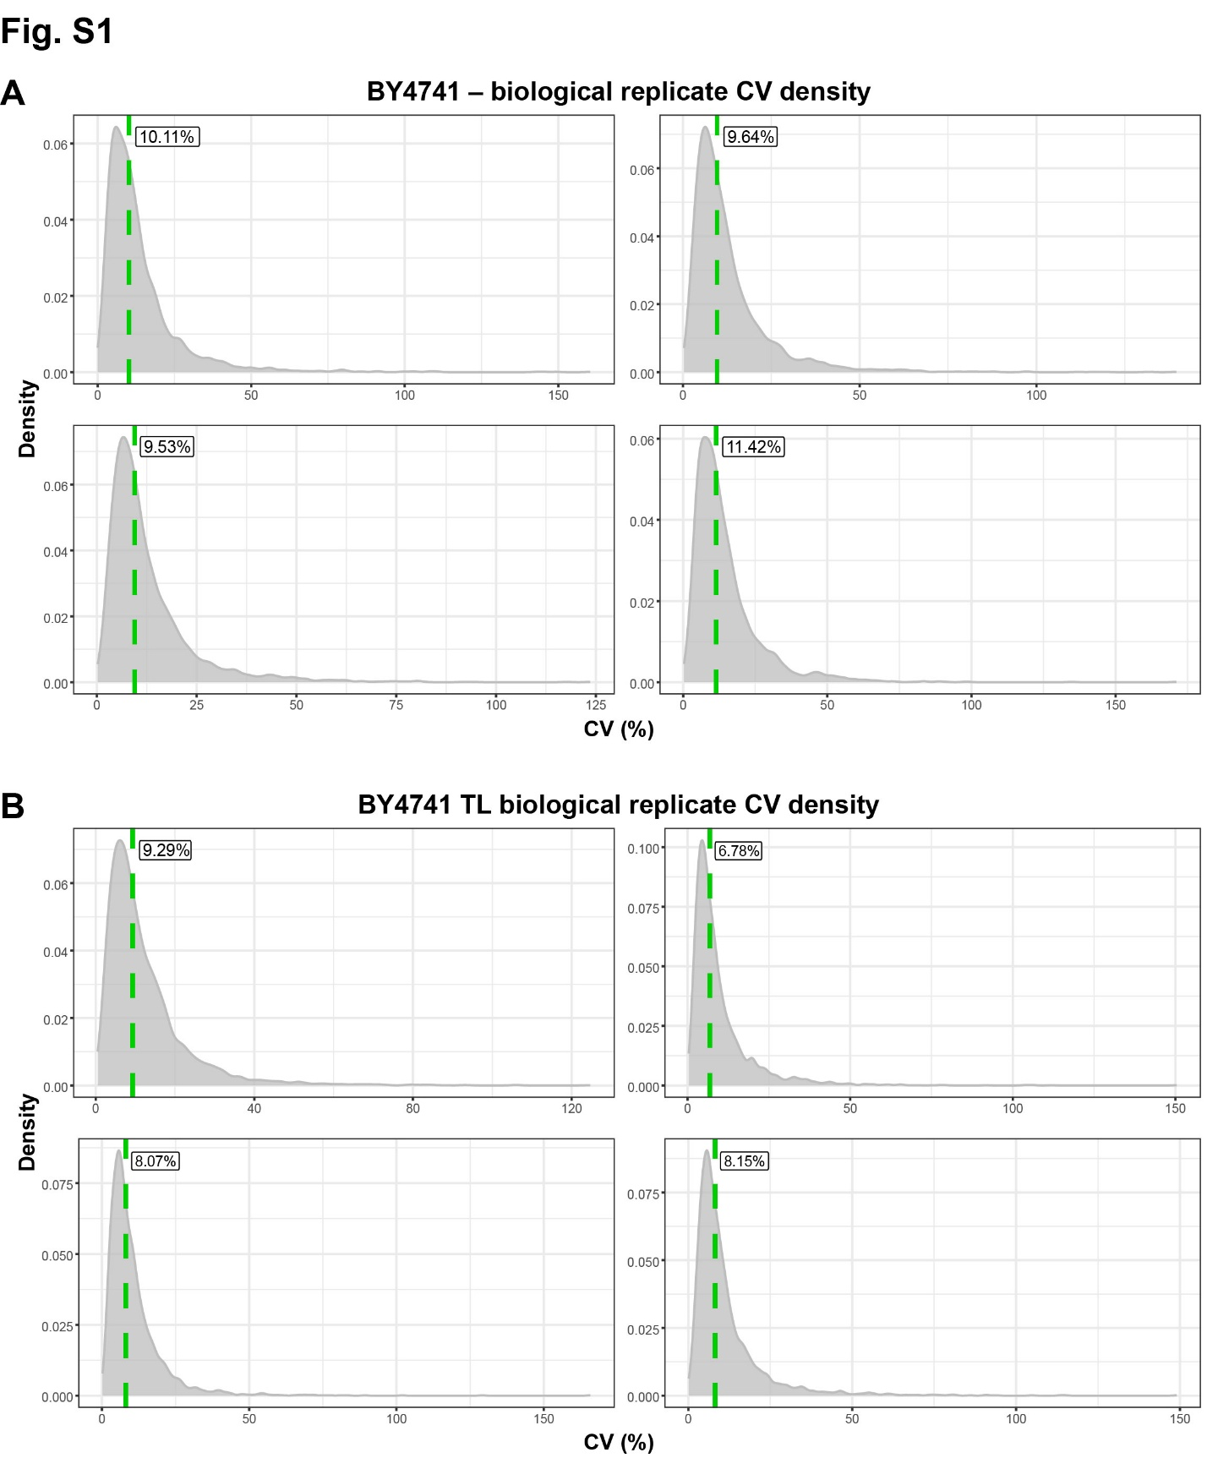
Fig. S1 Median CVs of BY4741 replicates (A) CV density plots of the non-expressing condition and (B) of the T. trogii laccase expressing condition for days 1 (upper left), 2 (upper right), 3 (lower left) and 4 (lower right). Median CVs are labeled and indicated by green dashed lines.
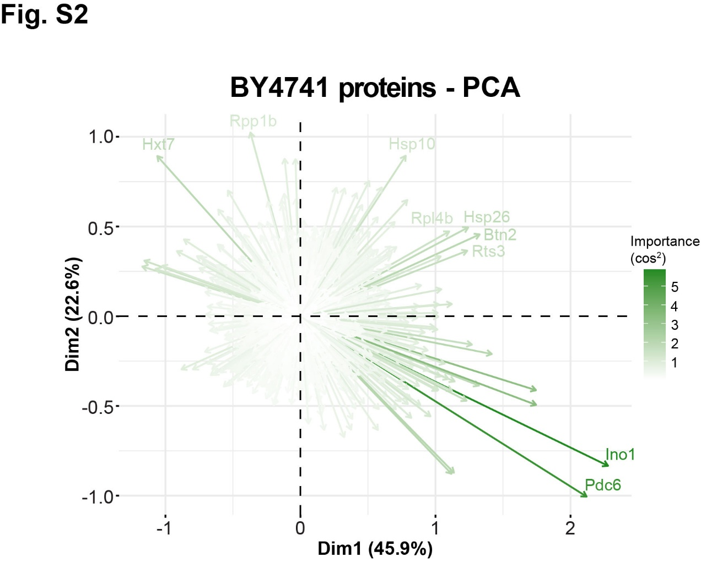
Fig. S2 Protein contributions to proteome signature Principal component analysis plot displaying the contributions of each protein towards signatures of older cultures (rightwards) and of T. trogii laccase expressing (upwards) or non-expressing (downwards).
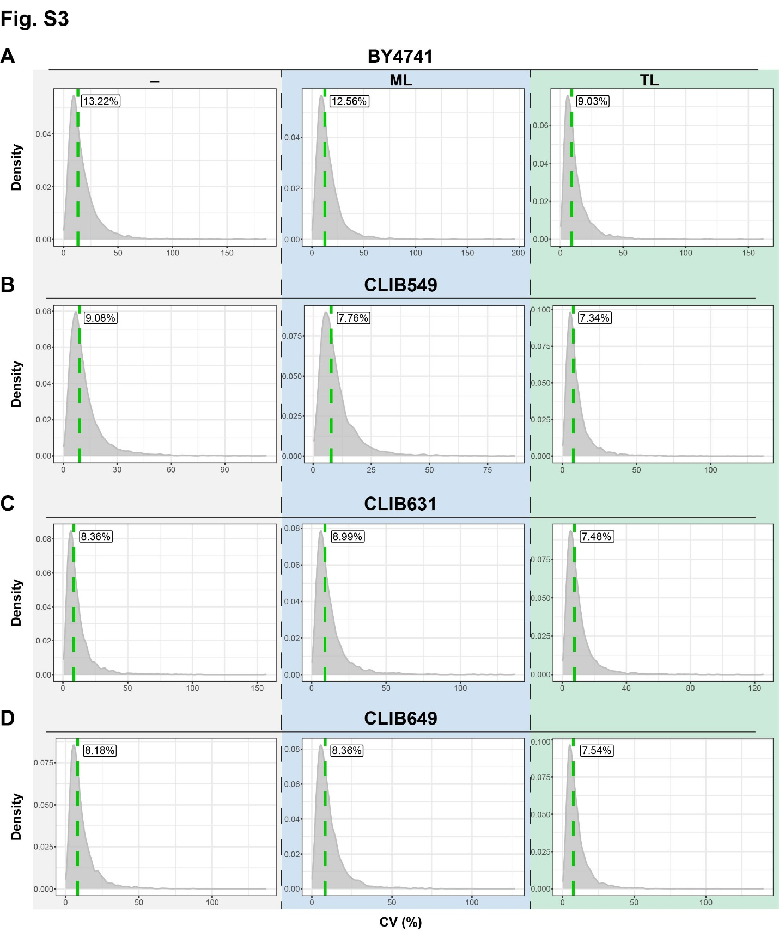
Fig. S3 Median CVs of each strain and condition CV density plots of (A) BY4741, (B) CLIB549, (C) CLIB631 and (D) CLIB649 with empty vector (-), M. thermophila laccase (ML) and T. trogii laccase (TL). Median CVs labeled and indicated by green dashed line.
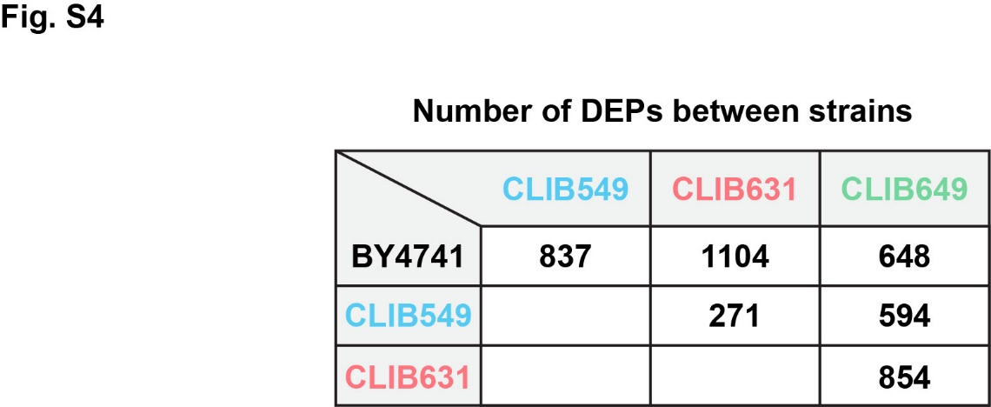
Fig. S4 Differentially expressed proteins in non-expressing conditions

Supplemental Table S1. Yeast strains utilized
YTM | Name | Genotype | Description | Source
408 | BY4741 | MAT a, his3∆1, leu2∆0, met15∆0, ura3∆0 | Laboratory strain | Dr. Phil Hieter
2357 | CLIB549 | Euploid | Dairy, cheese (camembert), Normandy, France | Dr. Joseph Schacherer; Peter et al. (2018)
2358 | CLIB631 | Aneuploid; +1 copy chromosome 10 | Dairy, cheese (camembert), Normandy, France | Dr. Joseph Schacherer; Peter et al. (2018)
2359 | CLIB649 | Euploid | Dairy, whey, Alpes, France | Dr. Joseph Schacherer; Peter et al. (2018)

Supplemental Table S2. Plasmids utilized
BPM | Name | Resistance | Backbone | Comments
1743 | pRW111 | Bacteria: Amp, yeast: G418 | pRS416 | Modified pRS416 with kanMX6 module instead of URA3, generated in Wong et al. (2025)
1747 | pRW111-ttLCC1 | Bacteria: Amp, yeast: G418 | pRS416 | Modified pRS416 with codon optimized ttLCC1 with a N-terminal native secretion signal and kanMX6 module instead of URA3, generated in Wong et al. (2025)
1752 | pRW111-mtLCC1 | Bacteria: Amp, yeast: G418 | pRS416 | Modified pRS416 with codon optimized mtLCC1 with a N-terminal native secretion signal and kanMX6 module instead of URA3, generated in Wong et al. (2025)

