Applied Microbiology and Biotechnology
Supplementary Information

l-Glutamate production from nitrogen gas by co-culturing Corynebacterium glutamicum with Azotobacter vinelandii
Yusuke Ito^{1,2}, Daisuke Yoshidome^{1,2}, Yasuko Araki², Kotaro Ito², Makoto Hidaka¹, Saori Kosono^{1,3}, and Makoto Nishiyama^{1,3*}

¹Department of Biotechnology, Graduate School of Agricultural and Life Sciences, The University of Tokyo, 1-1-1 Yayoi, Bunkyo-ku, Tokyo 113-0032, Japan
²Research & Development Division, Kikkoman Corporation, 338 Noda, Noda, Chiba 278-0037, Japan
³Collaborative Research Institute for Innovative Microbiology, The University of Tokyo, Bunkyo-ku, Tokyo, Japan.

*Corresponding author: Makoto Nishiyama, umanis@g.ecc.u-tokyo.ac.jp

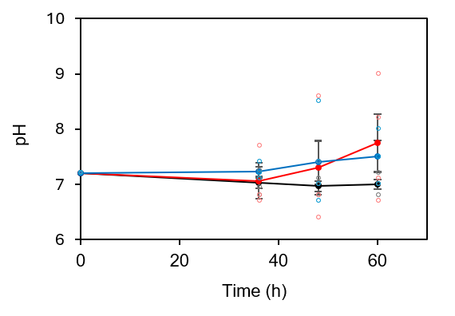
Fig. S1 Time-course profiles of culture medium pH in SC4 and SC5 cultures.
A. vinelandii DJ, SC4 and SC5 strains were grown in 5 mL Burk’s medium in test tubes with shaking at 300 rpm. Black, red, and blue lines represent the wild-type A. vinelandii, SC4, and SC5, respectively. The cells were inoculated into test tubes at an initial OD600 of 0.1. 0.3 mM IPTG was added at the beginning of cultivation, and the pH of the medium was measured at each time point. Data are presented as the mean ± SE of four biological replicates. Statistical significance of pH at 60 h was evaluated using one-way ANOVA followed by Tukey’s multiple comparison test.

Fig. S2 Confirmation of the nifA overexpression cassette integrated into the genomes of SC4 and SC5 strains
Graphical representation of the nifLA locus in WT, SC4, and SC5 strains (a). PCR analysis was performed to confirm the integration of the nifA overexpression cassette in SC4 and SC5 using the primer sets listed in Table S2. Amplified fragments were 935 bp in WT and 5938 bp in SC4 and SC5. PCR-amplified fragments using pre-culture broth (b) and main culture broth (c) were analyzed through 1% agarose gel electrophoresis and visualized through ethidium bromide staining

Fig. S3 Confirmation of the nifA overexpression cassette integrated into the genomes of DC3 strain
Graphical representation of the algU locus in WT and DC3 strains (a). PCR analysis was performed to confirm the integration of the nifA overexpression cassette in DC3 using the primer sets listed in Table S2. Amplified fragments were 2955 bp in WT and 6,647 bp in DC3. PCR-amplified fragments using pre-culture broth (b) and main culture broth (c) were analyzed through 1% agarose gel electrophoresis and visualized through ethidium bromide staining

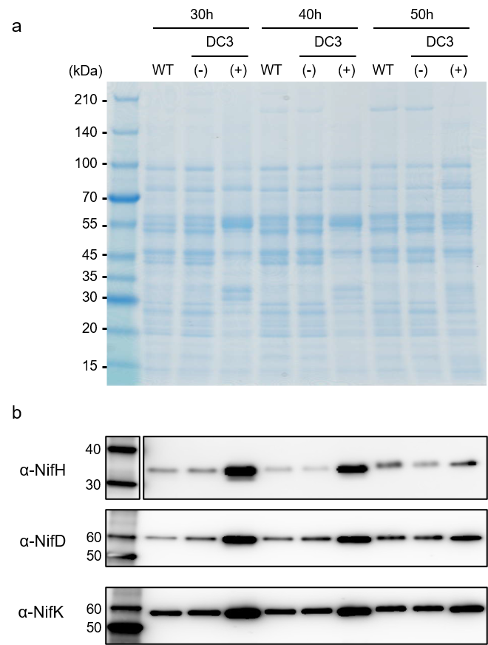

Fig. S4 The expression of nitrogenase in A. vinelandii DC3
A. vinelandii DJ and DC3 were grown in 100 mL Burk’s medium in 500 mL Erlenmeyer flasks with shaking at 100 rpm. IPTG was added 20 h after inoculation and cells were harvested at 30, 40, and 50 h after inoculation. (a) SDS-PAGE analysis of soluble protein fractions prepared from Wild type, DC3 without IPTG induction, and DC3 induced with 0.3 mM IPTG harvested at 30, 40, and 50 h after inoculation. A total of 2.5 μg of soluble protein from each sample was subjected to SDS-PAGE analysis. (b) Western blot analysis of soluble protein fractions using anti-NifH, anti-NifD, and anti-NifK antibodies. Wild-type, DC3 without IPTG induction, and DC3 induced with 0.3 mM IPTG were analyzed. A total of 0.8 μg of soluble protein from each sample was separated by SDS-PAGE and subjected to Western blot analysis.

Fig. S5 Defoaming effect by soy sauce oil addition in fed-batch culture
Culture broth after 60 h cultivation without antifoam addition (a) and with 0.05% (v/v) soy sauce oil. Soy sauce oil was added with 0.3 mM IPTG and 30 g L⁻¹ sucrose after depletion of the initial carbon source by 27 h cultivation

Fig. S6 Effect of penicillin addition on ammonium production by Azotobacter vinelandii DC3
Ammonium production (a) and cell number (b) were measured after the addition of penicillin at 0 µM (black line), 0.5 µM (red line), 2 µM (blue line), 4 µM (green line), and 10 µM (orange line) during the fed-batch cultivation of A. vinelandii DC3 in a jar fermenter. Arrows indicate the timing of 0.3 mM IPTG, 30 g L⁻¹ sucrose, and penicillin addition in fed-batch culture

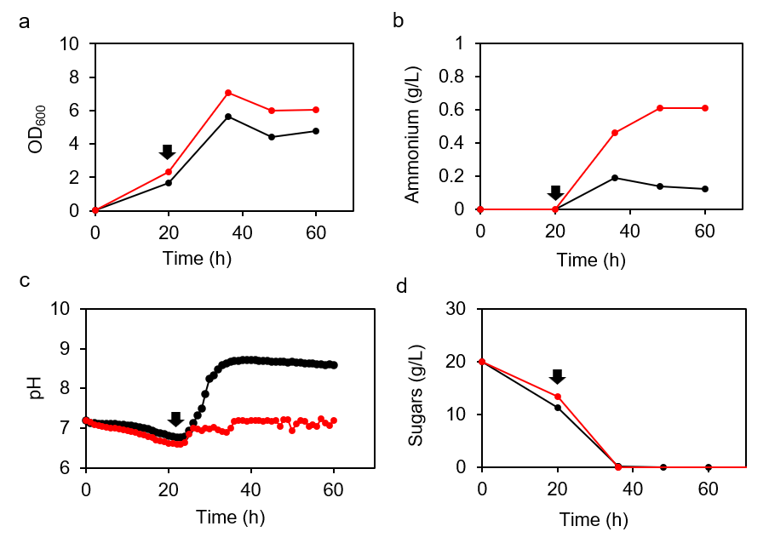

Fig. S7 Effect of lactic acid addition on ammonium production in Azotobacter vinelandii DC3 batch culture
The pH was maintained at 7.2 throughout cultivation using a 10% (v/v) lactic acid solution in A. vinelandii DC3 batch culture. Arrows indicate the timing of IPTG induction. The OD₆₀₀ (a), ammonium (b), pH (c), and sugars (d) were measured at each time point

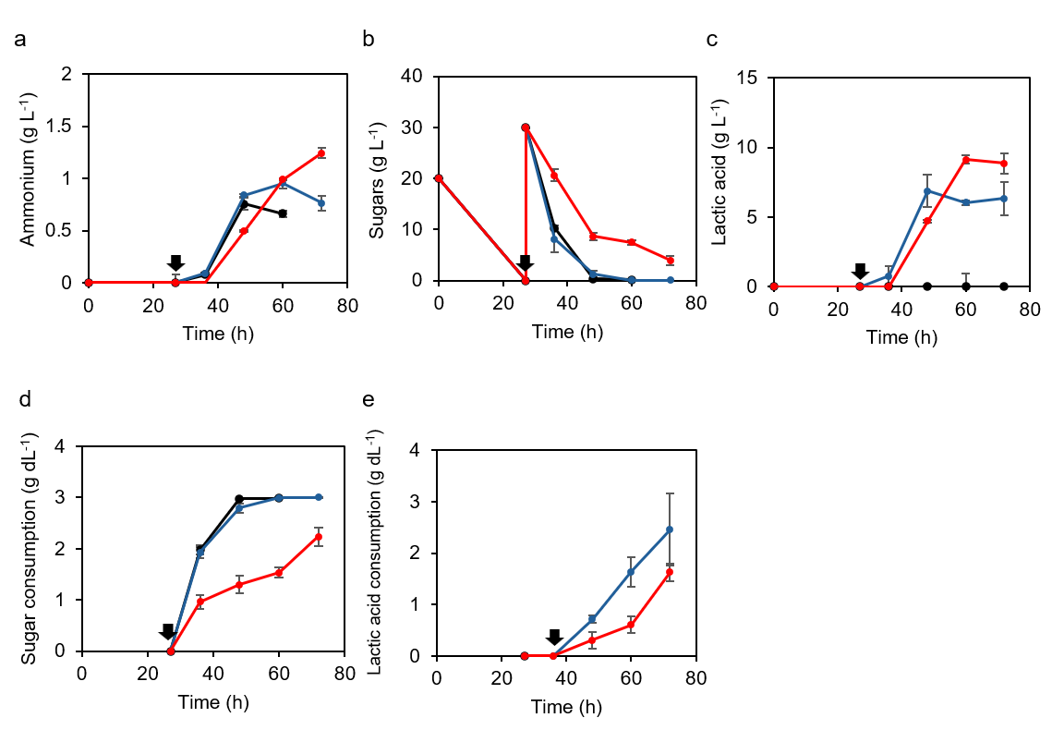
Fig. S8 Effect of lactic acid supplementation on ammonium production, sugar consumption, and lactate utilization during fed-batch cultivation of Azotobacter vinelandii DC3 in a jar fermenter
Lactic acid (blue line) or a combination of lactic acid and soy sauce oil (red line) was added to the fed-batch culture of A. vinelandii DC3 in a jar fermenter. The black line indicates the absence of additives. Arrows indicate the timing of IPTG induction and addition of sucrose, lactic acid, and soy sauce oil. Ammonium production (a), residual sugar concentration (b), residual lactate concentration (c), cumulative sugar consumption (d), and cumulative lactate consumption (e) were measured at each time point. Data are presented as the mean ± SE of three biological replicates. Statistical significance of ammonium production at 60 h between no additive (black lines) and lactic acid supplemented condition was evaluated using the using Student's t-test (P < 0.05).

Table S1. Primers used for the construction of plasmids
Primer | Sequence (5′–3′) | Target | Note
PSC1(vec)-F- | GACGAGTTCTTCTGAAAGGATCTAGGTGAAGATC | pTrcHis2-TOPO/lacZ vector | PSC1
PSC1(vec)-R- | AGCCTTCGCGCATGCTGTTTCCTGTGTGAAATTG | pTrcHis2-TOPO/lacZ vector | PSC1
PSC1(nifLA)-F- | AGGAAACAGCATGCGCGAAGGCTGCCGGATC | Region spanning from 51 bp upstream of the stop codon of nifL to 804 bp downstream of the start codon of nifA open from A. vinelandii | PSC1
PSC1(nifLA)-R- | AGTGAGGGTTAATTTCAGTTCAGGCGCACGAAG | Region spanning from 51 bp upstream of the stop codon of nifL to 804 bp downstream of the start codon of nifA open from A. vinelandii | PSC1
PSC1(Km^{R})-F- | CGTGCGCCTGAACTGAAATTAACCCTCACTAAAG | Kanamycin resistance gene from FRT-PGK-gb2-neo-FRT cassette  (Gene Bridges, Heidelberg, Germany) | PSC1
PSC1(Km^{R})-R- | TTCACCTAGATCCTTTCAGAAGAACTCGTCAAG | Kanamycin resistance gene from FRT-PGK-gb2-neo-FRT cassette  (Gene Bridges, Heidelberg, Germany) | PSC1
PSC1(Ptac)-F- | TAATCATCGGCTCGTATAATGTGTG | trc promoter region from PSC1 (for site-directed mutation of trc promoter to tac promoter) | PSC2
PSC1(Ptac)-R- | ACGAGCCGATGATTAATTGTCAACAGCTCATTTC | trc promoter region from PSC1 (for site-directed mutation of trc promoter to tac promoter) | PSC2
PSC2(vec)-F- | AAGGATCTAGGTGAAGATCC | pTrcHis2-TOPO/lacZ vector harboring nifLA from PSC2 | PSC3
PSC2(vec)-R- | TCAGTTCAGGCGCACGAAG | pTrcHis2-TOPO/lacZ vector harboring nifLA from PSC2 | PSC3
PSC2(Km^{R})-F- | GTGCGCCTGAACTGATCAGAAGAACTCGTCAAG | Kanamycin resistance gene from FRT-PGK-gb2-neo-FRT cassette  (Gene Bridges, Heidelberg, Germany) | PSC3
PSC2(Km^{R})-R- | TTCACCTAGATCCTTCTACCGGGTAGGGGAGGC | Kanamycin resistance gene from FRT-PGK-gb2-neo-FRT cassette  (Gene Bridges, Heidelberg, Germany) | PSC3
pSTV-algU(vec)-F- | GCTTATCGATGATAAGCTG | pSTV29 | pSTV-algU
pSTV-algU(vec)-R- | AGCTGTTTCCTGTGTGAAATTG | pSTV29 | pSTV-algU
pSTV-algU(algU)-F- | TTATCATCGATAAGCTCGCGGGTGAAAGGAACAC | algU from A. vinelandii | pSTV-algU
pSTV-algU(algU)-R- | ACACAGGAAACAGCTCCTTGGAAGAAGGCTCCTG | algU from A. vinelandii | pSTV-algU
PDC1(vec)-F- | CCTTCATCAAAGCCTATCGTG | pSTV-algU | PDC1
PDC1(vec)-R- | TCAGATCTTGCGCATGTGGATG | pSTV-algU | PDC1
PDC1(Ptac)-F- | TGCGGGAGGTGGATCGTTTGACAGCTTATCATCG | tac promoter region from PSC2 | PDC1
PDC1(Ptac)-R- | GATGGTTGCATTCATCATGCTGTTTCCTGTGTG | tac promoter region from PSC2 | PDC1
PDC1(nifLA)-F- | ACAGGAAACAGCATGATGAATGCAACCATCCCTC | Region spanning from 51 bp upstream of the stop codon of nifL to the entire nifA open reading frame from A. vinelandii | PDC1
PDC1(nifLA)-R- | TAGTGAGGGTTAATTTCAGATCTTGCGCATGTGGATG | Region spanning from 51 bp upstream of the stop codon of nifL to the entire nifA open reading frame from A. vinelandii | PDC1
PDC1(Km)-F- | ATGCGCAAGATCTGAAATTAACCCTCACTAAAGGGC | Kanamycin resistance gene from FRT-PGK-gb2-neo-FRT cassette  (Gene Bridges, Heidelberg, Germany) | PDC1
PDC1(Km)-R- | ACAGCTTGTCTGTAAGTCAGAAGAACTCGTCAAG | Kanamycin resistance gene from FRT-PGK-gb2-neo-FRT cassette  (Gene Bridges, Heidelberg, Germany) | PDC1
PDC1(lacIq)-F- | GACGAGTTCTTCTGACTTACAGACAAGCTGTGAC | lacI^{q} gene from pTrcHis2-TOPO/lacZ vector | PDC1
PDC1(lacIq)-R- | AGGCTTTGATGAAGGTCACTGCCCGCTTTCCAGTC | lacI^{q} gene from pTrcHis2-TOPO/lacZ vector | PDC1

Table S2. Primers used for colony PCR
Primer | Sequence (5'-3') | Target | Note
DJ nifLA colony PCR-F- | ATGGTGCACGTAGACACCGACTATC | Region spanning from 94 bp upstream of the start codon of nifL to 841 bp downstream of the start codon of nifA | For checking the genome integration in SC4 and 5
DJ nifLA colony PCR-R- | AGAGTTCGGACTCGAGCAGGGTTTC | Region spanning from 94 bp upstream of the start codon of nifL to 841 bp downstream of the start codon of nifA | For checking the genome integration in SC4 and 5
DJ algU colony PCR-F- | GGCGAGTAGAGTCTTGAAGATGG | Region spanning from 795 bp upstream of the start codon of algU to 520 bp downstream of the stop codon of algU | For checking the genome integration in DC3
DJ algU colony PCR-R- | TGTTGACGAAGATAGGTGGGAAGC | Region spanning from 795 bp upstream of the start codon of algU to 520 bp downstream of the stop codon of algU | For checking the genome integration in DC3

